Automatic irrigation in paddy fields: a farm-scale application in Northern Italy
Fabiola Gangi¹, Giovanni Ottaiano¹, Andrea Galli¹, Olfa Gharsallah¹, Arianna Facchi¹, Daniele Masseroni¹
¹ Department of Agricultural and Environmental Sciences, University of Milan, 20133, Milan, MI, Italy
* Corresponding author. E-mail address: fabiola.gangi@unimi.it

Keywords. Rice, automation, monitoring system, sustainability.
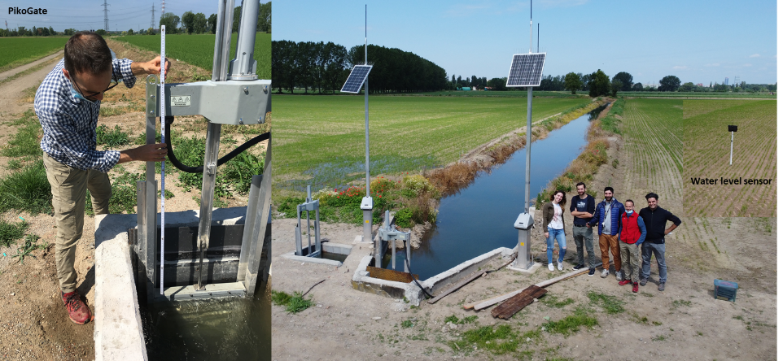
Abstract. Rice is one of the major staple food crops in the world. In Europe, Italy is the main producer, with almost all of the production concentrated in the north of the country. Traditionally rice is grown in fields flooded from before seeding to close to harvest. This water management technique requires a huge labor for farmers who have to manually adjust inlet and outlet gates in order to maintain a constant ponding water level in the fields. A new water soft-path strategy based on the introduction of automatic water flow rate regulation systems is under investigation in a rice farm of about 40 ha located south of Milan, in northern Italy. The purpose of the experimental activity is to assess the environmental and economic sustainability of the introduction of innovative water flow monitoring and automation systems at the farm level. The installed instrumentation is constituted by four PikoGate® automatic gates positioned in strategic points of the farm irrigation network and Ferit® water level sensors installed in five groups of fields. In the first year of the experimentation (2021) automatic gates and water level sensors were installed and tested; agro-meteorological, soil, crop and groundwater level data for the computation of a farm water balance were moreover collected. In the 2022 agricultural season, a newly developed irrigation algorithm will allow the automatic management of the farm gates to maintain a predetermined ponding water level in the fields, which may change in time based on site-specific conditions. Results achieved so far in the experimentation will be discussed in terms of economic and environmental sustainability, whereas the technical scalability of these automatic systems will be analyzed in cooperation with local irrigation agencies and farmers.

