Monitoring and numerical modeling of border irrigation: lesson learned in northern Italy
Fabiola Gangi^{1*}, Andrea Galli¹, Carmelina Costanzo², Pierfranco Costabile², Claudio Gandolfi¹, Daniele Masseroni¹
¹Deparment of Agricultiral and Environmental Engineering, Via Celoria 2, University of Milan, 20133 Milan (MI). ² Department of Environmental Engineering, University of Calabria, Via P. Bucci, 87036 Rende (CS)
*Corresponding author: fabiola.gangi@unimi.it

Keywords. border irrigation, shallow water equation, uniformity distribution, application efficiency
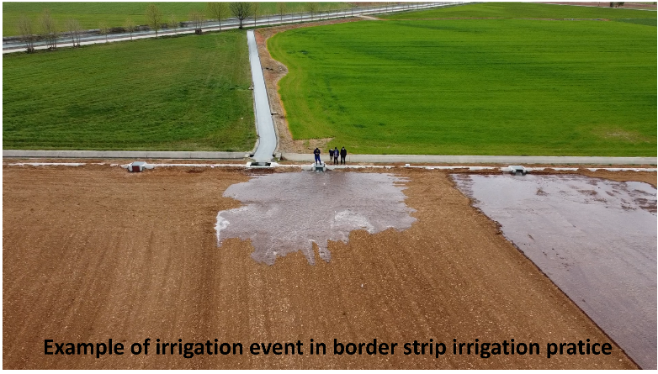
Abstract. Achieving a good irrigation performance is not straightforward in border irrigation practices. This is almost always due to a lack of balance between natural factors (i.e. soil texture, infiltration characteristics), geometrical features (field length, slope and border strip width) and management elements (flow rate and cut-off time). Such lack of balance makes it difficult to reach an optimal water depth across the field and a uniform intake opportunity time to satisfy crop water requirements at every point. In light of these concerns, studies exploring sagacious practical approaches to field design and irrigation management are needed to understand how we can keep this ancient but still crucial irrigation practice alive. In this work, the results of an intensive monitoring campaign carried out in 2021 over three maize fields located in the Padana Plain (North Italy) and aimed to detect actual flow rate, cut-off time and distance, advance and recession trajectories were used to calibrate an hydrodynamic model based on the combination of 2D Shallow Water Equations and Green-Ampt approach for describing infiltration process. The model was tested on real-world case studies by evaluating its reliability in reproducing the actual dynamics of the watering within the examined fields. The results of the numerical experiments will be presented for different initial soil conditions and infiltration proprieties, and the effects on application efficiency and water distribution uniformity of different field geometries (i.e.field length, slope and border strip width), flowrates and cut off-times will also be discussed.

