Interception/Evaporation Measurements for Lemon Tree
Giorgio Baiamonte¹*, Samuel Palermo²
^{1*}Dipartimento di Scienze Agrarie, Alimentari e Forestali, viale delle Scienze, 90128 Palermo, Italy. Phone ​+39 091 23897054, Email: giorgio.baiamonte@gmail.com ²Dipartimento di Scienze Agrarie, Alimentari e Forestali, viale delle Scienze, 90128 Palermo, Italy. Email: samupalermo.sp@gmail.com.

Keywords. Interception, evaporation, lemon tree, experimental tests, thermal imaging.
Abstract. It is known that at the event scale, evaporation losses of rainfall intercepted by canopy are a few millimetres, which is often not much in comparison to other stocks in the water balance. Nevertheless, at yearly scale, the number of times that the canopy is filled by rainfall and then depleted can be so large that the interception loss may become an important fraction of rainfall. Recently, a simplified interception/evaporation model has been proposed (Baiamonte, 2021), which considers a modified Merrian model to compute interception during wet spells, and a simple power-law equation to model evaporation by wet canopy during dry spells. Thus, the model can be applied for continuous simulation, according to the sub-hourly rainfall data that is appropriate to study both processes. Modelling evaporation process required the two-parameters of the power-law, describing the initial condition and the evaporation rate. In this paper, for lemon tree and for different temperature, T, and relative humidity, RH, conditions (Fig. 1), numerous experimental testes were carried out to derive the aforementioned two parameters. The results obtained in this work help understanding the studied process and could be implemented in the recently introduced interception/evaporation model to quantify this important component of the hydrologic cycle.
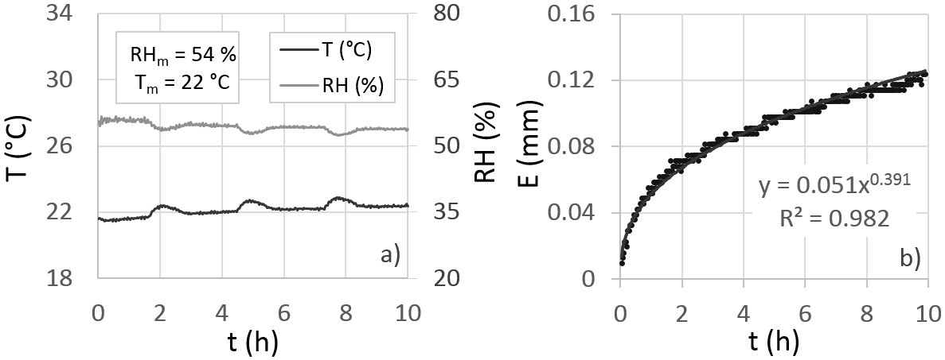
Fig. 1 – For lemon tree, and a) for a temperature and relative humidity scenario, b) time-varying evaporation loss by the wet canopy and the corresponding power-law.
References
Baiamonte, G. (2021). Simplified interception/evaporation model. Hydrology, 8(3), 99. https://doi.org/10.3390/hydrology8030099.

