TREATMENT OF DOMESTIC WASTEWATER THROUGH NATURE-BASED SOLUTIONS FOR IRRIGATIONAL REUSE

Chioggia F*., Lavrnić S., Mancuso G., Drei P., Toscano A.
Alma Mater Studiorum - University of Bologna, Department of Agricultural and Food Sciences, Section of Agricultural Engineering, Viale Fanin 50, 40127 Bologna, Italy. E-mail: francesco.chioggia2@unibo.it

Keywords. Nature-Based Solutions; Constructed wetlands; Wastewater treatment; Wastewater reuse

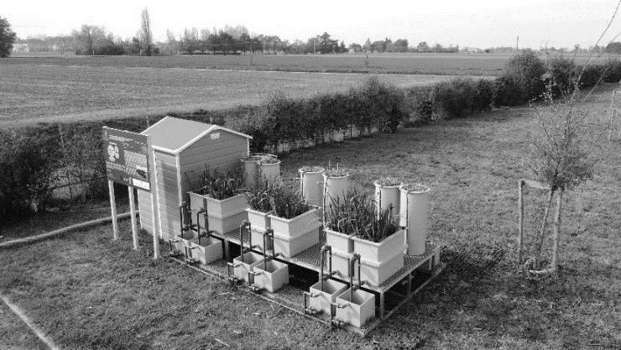
Abstract. The depletion of water resources induced by climate change, anthropic activities and pollution has rendered the implementation of technologies for the treatment and the recovery of wastewater an essential focus. Due to the high energy inputs and the expert maintenance required by the traditional centralised wastewater treatment plants, more sustainable alternatives have greatly gained interest of the research community. Nature-based solutions (NBS), particularly constructed wetlands (CWs), are simple solutions based on natural processes and suitable for the agricultural context. These systems demand lower economic and environmental resources than their traditional counterparts. Price-competitive and decentralised, this kind of technology promotes the closure of the water and nutrients cycles, through their recycle and re-evaluation. Within the framework of the FIT4REUSE project, the present work deals with the use of CWs to treat municipal wastewater and to reach an output quality sufficient for its reuse in agricultural irrigation. To study the system treatment capacity and to reach the effluent quality required by wastewater reuse regulations, a pilot plant (Figure 1) consisting in three vertical and three subsurface horizontal CWs was established in Granarolo dell’ Emilia (Northern Italy). Two plant species, namely Phragmites australis and Iris pseudacorus have been cultivated on six different substrates, i.e. pumice, agriperlite, gravel, vermiculite, sand and cork, to study their influence on the overall performance of each system. The treatment efficiency of each CW has been evaluated on the reduction of different pollutants typical of domestic wastewater. The preliminary results indicated average removals of 80.7 % for COD, 35.3 % for TN, 65.3 % for NH₄⁺-N, 36.1 % for NO₃⁻-N, 34.9 % for PO₄³⁻, 98.4 % for Total coliforms and 99.1 % for E. coli. Although further studies are necessary, this technology can be considered as capable to reach the project aims in terms of wastewater treatment.
Figure 1: Granarolo dell’Emilia pilot plant

