Simulation of the heating load in a NZEB winery building
Antonino Ciappa^{1,2}, Giovanni Puglisi³, Fabiana Convertino¹, Ileana Blanco⁴, Giuliano Vox¹, Evelia Schettini^{1*}
¹Department of Agricultural and Environmental Science (DISAAT), University of Bari “Aldo Moro”, Via Amendola 165/A, 70126 Bari, Italy
²Enea UfficiTerritoriali PALERMO
³ENEA – Italian National Agency for New Technologies, Energy and Sustainable Economic Development, Technical Unit Energy Efficiency, C.R. Casaccia (Roma), via Anguillarese 301, 00123 S. M. di Galeria, Rome, Italy
⁴Department of Biological and Environmental Sciences and Technologies (DiSTeBA), University of Salento, S.P. 6 Lecce - Monteroni, 73100 Lecce, Italy
*corresponding author: evelia.schettini@uniba.it; phone: +39 080 5443060;
fax: + 39 080 5442977

Keywords. Agro-industry, energy efficiency, architectural elements, CO₂ emission
Abstract. The study concerns a NZEB building in the agro-industrial sector. A building was designed integrating architectural and plant engineering solutions for the purpose of containing thermal requirement and obtaining low CO₂ emission. In the building activities of production, aging and marketing of wine take place, and, accordingly, the building is divided into three different areas: commercial, production and seasoning. The cellar is placed underground. A model was developed for obtaining the heat load profiles of the building in winter. The software simulation was performed both in steady state UNI-TS 11300 and in dynamic hourly regime, according to UNI-EN ISO 52016. Figure 1 shows the values of the average hourly power used for the purposes of thermal heating on the coldest day of the season.
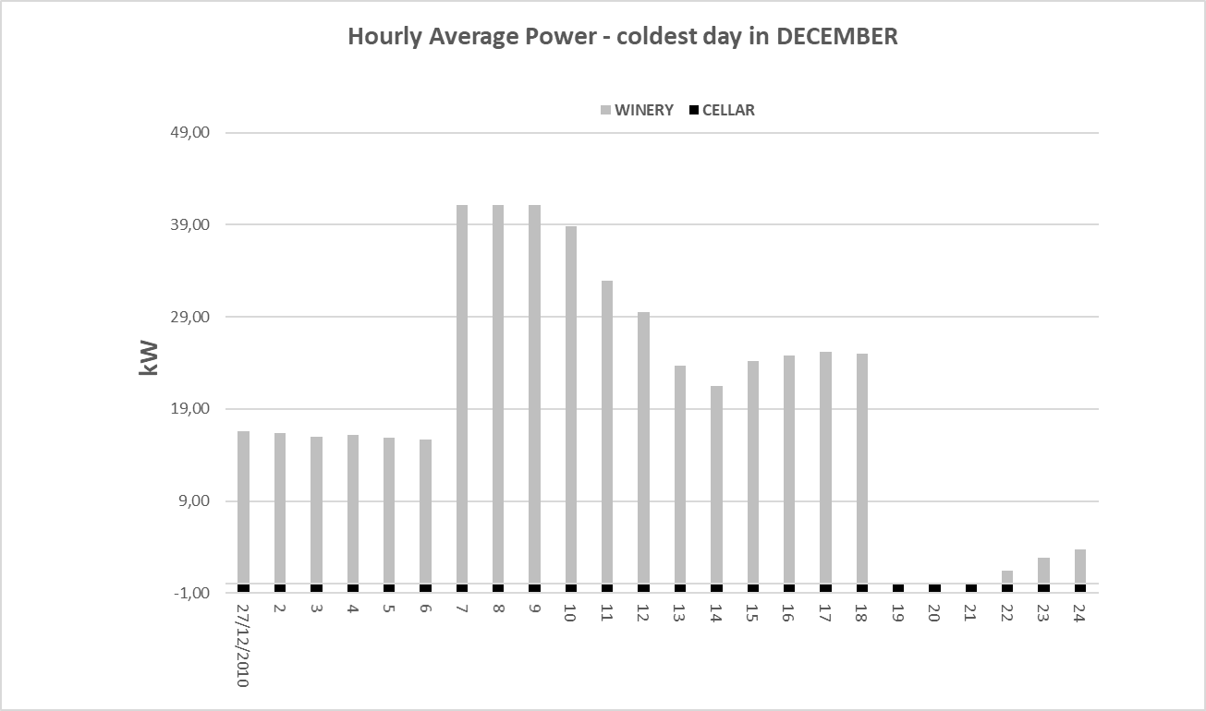
Figure 1: Average power per hour evaluated for the coldest day of the season.

