Deep Learning Approach To In-Situ Sustainable Weed Management (SSWM)
Mariano Crimaldi^{*1}, Marco Esposito¹, Valerio Cirillo¹, Albino Maggio¹, Fabrizio Sarghini¹
¹ University of Naples “Federico II”, Department of Agricultural Sciences, via Università 100, Portici (NA), Italy.

Keywords. UAV, Deep Learning, SSWM, weeds.
Abstract. Biotic threats such as insects, weeds, fungi, viruses, and bacteria can broadly affect crop yield and quality. Among these, weeds are the most impacting problem causing remarkable yield loss worldwide. The most characterized effect of weeds is competition for resources such as light, water, space, and nutrients [1]. Precision agriculture can be effectively applied to weed management using Unmanned Aerial Vehicles (UAV) to gather and process data [1] as well as the application of artificial intelligence to weed control. This work proposes a deep learning approach for selective weed recognition in real time from aerial images that enables targeted treatment of certain weeds, using artificial intelligence to select in the field and in real time the weeds to be treated and/or removed and those to be kept in the field. The developed deep learning algorithm will be able to be used on self-driving rovers (UTVs) for automatic in-field weed treatment according to site-specific weed management (SSWM) principles. The method shows good accuracy in recognizing and discerning the various weeds in the field, as shown in an example in Figure 1 where we can see how the algorithm recognizes and classifies weeds by separating them from the crop (wheat). Further studies are underway to improve the algorithm by training it to the different phenological states of the weeds as well as increasing the training dataset, also expanding it with the spectral signatures of the weeds of interest, through acquisition of multispectral images.
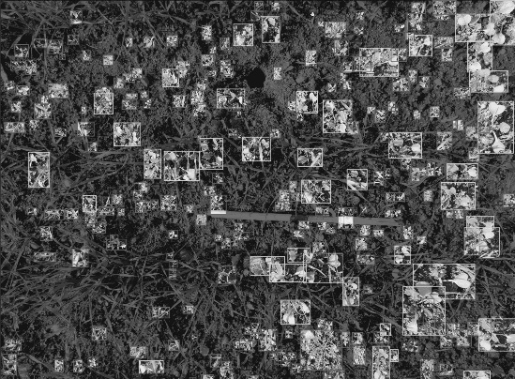
Figure 1 - Weeds classification through Deep Learning approach
[1] M. Esposito, M. Crimaldi, V. Cirillo, F. Sarghini, and A. Maggio, “Drone and sensor technology for sustainable weed management: a review,” Chem. Biol. Technol. Agric., vol. 8, no. 1, p. 18, Mar. 2021, doi: 10.1186/s40538-021-00217-8.

