UAVs As A New Tool For Forestry Management: Does Aerial Multispectral Imaging Speed Up the In-Field Operations?
Mariano Crimaldi¹, Rossella Piscopo¹, Alberto Assirelli², Salvatore Faugno¹ Maura Sannino^{*1}
¹ University of Naples “Federico II”, Department of Agricultural Sciences. Portici (NA), Italy.
² Consiglio per la ricerca in agricoltura e l’analisi dell’economia agraria, Centro di Ingegneria e Trasformazioni agroalimentari (CREA-IT). Monterotondo, Rome, Italy.

Keywords. UAV, forestry management, multispectral imaging.
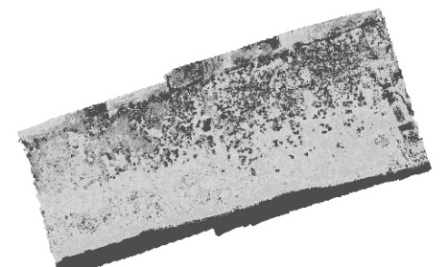
Abstract. In silviculture historically, forest management has been practiced mainly with field surveys on sample areas that are representative of the entire forest. In recent decades, thanks to the introduction of new devices in precision agriculture, it has been possible to facilitate and speed up some measurement operations in the field (1). There are several tools that allow to obtain information on forests such as the use of specific sensors used on UAVs (unmanned aerial vehicles). The use of drones has allowed a more integrated and optimized approach for various forestry activities, in addition to the typical precision agriculture activities, such as for the detection of tree physiological stress, forest mapping, forest management planning, creation of canopy height models and estimation of woody biomass production. The objective of this work is to demonstrate that UAVs equipped with a multispectral camera can speed up operations by producing multispectral orthomosaics over a test field of a 22 he plot within a mediterranean forest. The drone, equipped with an on-board multispectral camera, can measure and assess green living vegetation. From the first surveys carried out, an example of which is shown in Figure 1, it was possible to perform forestry surveys that are usually done with measurement campaigns on the ground, with longer times and not always feasible due to the difficulties of access to the area, in about 20 minutes. The use of expeditive surveys by UAVs has allowed the forest management of the area under examination, speeding up operations and facilitating the measurement in areas where it would have been difficult to access. In addition, thanks to multispectral images, it was possible to detect, through the calculation of vegetation indices, the general health of the area that allows, according to the principles of precision agriculture, a precise and aimed forest management, saving on operational time and on operational staff in the field.

Figure 1 - Multispectral orthomosaic for forestry management
1. Tiberiu Paul Banu, Gheorghe Florian Borlea, Constantin Banu. The Use of Drones in Forestry. J Environ Sci Eng B. 2016

