Can a variable-rate sprayer be efficient and economic? Testing and economic analysis in viticulture
Pagliai Andrea¹*, Sarri Daniele¹, Perna Carolina¹ and Vieri Marco¹
¹DAGRI, University of Florence, Piazzale delle Cascine 15, 50144 Firenze
*Corresponding author: Andrea Pagliai, andrea.pagliai@unifi.it,

Keywords. VRA, optimization spraying, pesticide, ultrasound sensor, specialty crops
Abstract. The European Union pointed out ambitious goals in terms of the reduction of pesticides in agriculture. These goals could be achieved in different ways e.g. by variable-rate application (VRA) technologies. Present work aims to assess the spraying performance of a VRA sprayer and its economic sustainability. To evaluate the operating performance, three trials (BBCH 65, BBCH 73, BBCH 83) were performed in a vineyard following a profile sampling strategy (BS ISO 22522:2007). A randomized complete block design was performed with three replications for each treatment (uniform and variable - UA and VRA). The variables (normalized deposition and coverage) from artificial targets by spectrophotometry and image analysis techniques respectively, were extracted. Moreover, the economic performance of VRA sprayer compared to UA one was performed for the whole vegetative season in two plots.
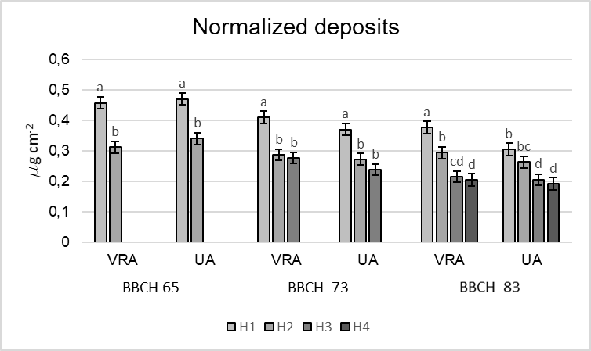 | 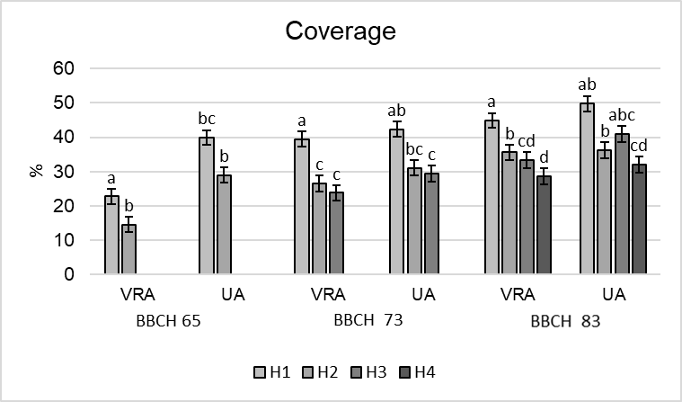
Results of the two-way ANOVA for the normalized deposits (mg cm⁻²) and spray coverage (%). Different letters mean statistical differences (Tukey HSD test; α = 0.05).
Normalized deposit results showed differences between detection heights (H1, H2, H3, H4) rather than between treatments (VRA vs UA). Therefore, VRA and UA efficacy was confirmed, given the similar values of deposit. The same trend was shown in coverage results, even if UA coverages were higher than VRA, usually exceeding the overspray threshold [1]. The economic performance highlighted for VRA average volume saving of 35%, ranging from 76% in the first session to 10% in the last one. The resulting economic saving was €2600.0, consisting in: €2502.5 of pesticides, €52.7 of water and €44.8 of fuel. Overall, VRA system showed good spraying performances reducing the application volume significantly and enhancing economic sustainability.
1. Grella, M.; Gioelli, F.; Marucco, P.; Zwertvaegher, I.; Mozzanini, E.; Mylonas, N.; Nuyttens, D.; Balsari, P. Field assessment of a pulse width modulation (PWM) spray system applying different spray volumes: duty cycle and forward speed effects on vines spray coverage; Springer US, 2021; ISBN 0123456789.

