Concept of a Foldable Transmission Chain Used on Tobacco Leaves Harvesting Machine
Simone Pascuzzi*, Francesco Vicino, Francesco Santoro
Department of Agricultural and Environmental Science, University of Bari Aldo Moro, Via Amendola 165/A, 70126 Bari
* simone.pascuzzi@uniba.it; Tel.: +39-0805442214.

Keywords. joint; roller chain, transmission efficiency, tobacco harvesting.
Abstract. In several mechanical applications are used different kinds of articulated chains and within these probably the most used is the articulated roller chain. In a typical roller chain, a sequence of external and internal links is alternately arranged, and solids pins are used to link each of the plates of these links. Internal links are made up of two plates separated by mean of two bushes on which two rollers are free to rotate (Figure 1).
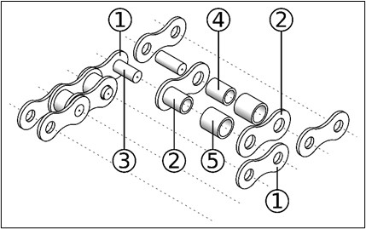
Figure 1. Main components of roller chain. 1 outer (external) plate; 2 inner (internal) plate; 3 solid pin; 4 bushing; 5 roller.
This paper highlights the main characteristics, the study and the engineering phase of a simple and low-cost different kind of joint that allows to fold any articulated roller transmission on a plane different from the operative one. The effectiveness and performance of this kind of joint, the modified roller chain has been used on tobacco leaves harvesting aiding machine during Kentucky Black tobacco harvesting operations. A Finite Element Analysis using Ansys Mechanical 2019 R3 software (Ansys, Inc., Canonsburg, PA, USA) was performed on the modified roller chain used in the work-aid machine employed in field tests by mean of a 3D model of two roller chain links and of the first element of the ring chain at the interface between roller and ring. The good performance of the tobacco leaves work-aid harvester in which roller chains fitted with the created articulated joint have been mounted, did not show any deterioration in terms of productivity, strength, efficiency, and reliability and therefore highlighted the correct behavior of the aforementioned device.

