Monitoring forest condition in a protected Mediterranean coastal area by the analysis of diachronic NDVI data
Recanatesi F^{(*)}., Marucci A., Boccia L., Caputi E., Gatti L., Patriarca A., Ripa M.N.
(*) fabio.rec@unitus.it - Department of Agricultural and Forestry Sciences – Tuscia University. Via San Camillo de Lellis (Viterbo),
(marucci@unitus.it; lorenzo.boccia@unina.it; caputi.eros@gmail.com; gatti@unitus.it; nripa@unitus.it)

Keywords. Remote Sensing, Protected Area, NDVI, Sentinel-2, Vegetation indexes
Abstract. Climate change and human activities in particular, are important causes of the possible variations in Mediterranean basin forest health conditions. As a consequence, today, increased forest vulnerability is being reflected in a larger number of severe decline episodes associated mainly with drought. In this context, the Mediterranean area shows high forest vulnerability and a subsequent decline in its natural renewal rate.
In this scenario, multi-spectral analysis of remote sensing data today represents an efficient tool for monitoring vegetation in a Mediterranean environment, where spatial resolution often represents a limiting factor due to high fragmentation and spatial distribution of forest stand.
The aim of this study has been to map the health conditions of the Castelporziano coastal pinewood forest (Roma). To this aim, we used a diachronic NDVI index, provided by ESA Sentinel-2 images and field observations, to monitor the health status in a historic pinewood forest that has recently been affected by a rapid diffusion of pests (Tomicus destruens Woll.).
The monitoring performed allowed us to map the pinewood forest in risk classes and at the same time to provide data concerning the localization of areas showing a strong decline. Thus, we provide information useful for the correct management and planning of forestry thinning to preserve those areas of the pinewood forest not involved in the decline process.
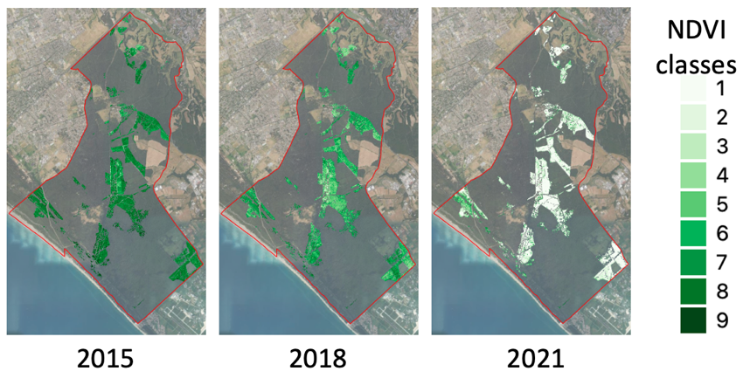
Figure 1. Pinewood forest: NDVI classes and their evolution for the period 2015-2021

