Sustainability performance of mountain food value chains
P Sacco¹*, D Don¹, L Becce², G Carabin³, A Mandler³ and F Mazzetto³
¹ Fraunhofer Italia Scarl, Bozen-Bolzano; ²Competence Center for Plant Health of the Free University of Bozen-Bolzano, ³ Free University of Bozen-Bolzano, Faculty of Science and Technology
*Fraunhofer Italia, Via Volta 13 A, 39100 Bolzano, Italy. (corresponding: pasqualina.sacco@fraunhofer.it)

Keywords. Mountain agriculture, cereal value chain, LCA, multicriteria analysis
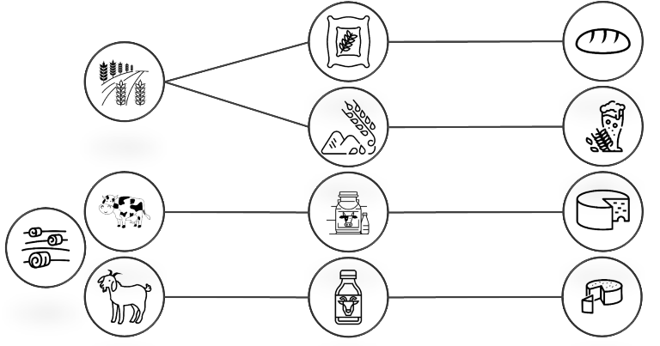
Abstract. In the framework of the Brotweg project ("The bread route for mountain areas"), the performance of some alternative supply chains was evaluated. Geomorphological considerations on the territory, namely the high slopes and highly uneven terrain, meant that the chosen sites are suitable for the cultivation and processing of different types of cereals and for animal husbandry. For this reason, four alternative supply chains were considered: 1) rye-bread, 2) barley-beer, 3) cow's milk-cheese, 4) goat's milk-cheese. Regarding the cereal cases, the innovative cultivation and post-harvest methods developed during the Brotweg project were considered. For the dairy farming ones, the haymaking phase was also included. Two methodologies were used to assess the performance of the supply chains: Lifecycle Analysis (LCA) and Multi-Criteria Analysis (MCA). Both approaches present pros and cons, hence affecting their applicability depending on the context and decision-making processes that they must support.
The paper introduces the preliminary results of the supply chain analysis with a related critical discussion. In particular:
- For both approaches there is a need for consistent knowledge of the performance of different alternative supply chains.
- For territories as the one here studied, a further assessment of short supply chains (all on-farm) and cooperative models (e.g. sharing of plants and machinery) is necessary; in addition, logistics considerations must be even integrated.
- The short cereal-bread chain is an interesting and valuable alternative from operational, environmental and economic standpoints; unfortunately, its main cons is related to metereological risks – e.g. loss of primary production. Alternative systems linked to animal husbandry are less risky, although more critical in relation to the major standpoints (in particular, environmental and operational).

