CHEMICAL ENGINEERING TRANSACTIONS  VOL. | A publication of
The Italian Association
of Chemical Engineering
Online at www.cetjournal.it
Guest Editors:
Copyright © AIDIC Servizi S.r.l.
ISBN 978-88-95608-xx-x ISSN 2283-9216

ICT based system to monitor hazmat road transportation and a rapid mapping technique for accident scenarios
Angela Maria Tomasoni*, Chiara Bersani, Roberto Sacile, Enrico Zero

Department of Informatics, Bioengineering, Robotics and Systems Engineering. University of Genova, 16145, Italy.
angela.maria.tomasoni@unige.it

Hazardous materials (hazmat) transportation represents, since decades, one of the main issues in the accidental risk assessment and management on road network, above all, in urban areas. This kind of transport counts a small share in respect to the overall freight transport by road in EU-28, but it continues to arouse interest due to the catastrophic consequences that its involvement may concern in case of accidents.
This paper presents the development of an ICT based system to detect constantly the hazmat vehicles on the roads and to map, in real time, the potential impact area generated by the specific transported product in case of road accident. The proposed system has been realized in the framework of the European Project “LOSE+”, (Logistic and Safety of freight transport) financed by the European Regional Development Fund (FESR) in the framework of the Interreg Italy-France Maritime Programme 2014-2020.
The LOSE+ system consists of two main components: firstly, a network of cameras has been installed on the main arterial roads in the city of Genoa, regional capital of Liguria Region (Italy), along the coastal area near the port gates; secondly, a web-GIS platform, which in real time, provides the users with georeferenced maps related to the potential impact area of a possible accident, which involved the identified hazmat vehicles. Furthermore, the map images may be overlapped to other significant layers related to the land use and to sensible and vulnerable targets on the territory, such as hospitals or schools, modelled by the (Short-Cut Method, 2005) for the computation of the consequences analysis. The proposed LOSE+LAB system aims at providing to Public Authorities a smart tool to monitor and control hazmat circulation.

- Introduction
Hazardous materials (hazmat) transportation counts a small share in respect to the overall freight transport by road in EU-28 (Benza et al., 2012). According to Eurostat, the hazmat class mainly transported is the flammable liquids, taking over more than 50% of the hazmat freight transport by road. It may be, due to the petrol products adopted as fuel in the automotive sector, which are daily, and capillary distributed to service stations. The other two main classes are the gases (compressed, liquefied, or dissolved under pressure) and corrosives, accounted for 12.9 % and 11.8 % respectively (EU, Energy, transport, and environment statistics 2019). In Italy, the 80% of dangerous goods distribution concerns fuels and flammable liquid, 10% gas; 7% corrosive materials and substances and, the 3% is others. In this context, regarding the modalities of transport, 54,5% is carried out by road, 29,4% by sea, 10,7% by train, 4,8% by pipeline, and 0,6% by plane (ISTAT, Road incident 2020). For different modes of transport, in 2019, in Italy, the numbers of incidents decreased for 0,3% in respect to 2018 but 99.8% of them are due to transport by road. Among 172.183 incidents on road, 6.7% (+ 10.8% compared to 2018) involved road freight vehicles and 11.6% of them happened on state roads or highways. When a transport accident involved hazmat goods, it may generate different kinds of scenarios as release, fire, or explosion. The implementation of ICT tools represents one of the main important elements to be adopted for a safer and risk reduction approach in the hazmat management and transportation (Zero et al., 2019). The consequences in case of accident may affect the quality of life and the welfare for people living in the community and cities, where hazmat is produced, moved, and used (Weng et al., 2021).
This paper presents the design and the development of an ICT based system to detect, in real time, the hazmat vehicles on the roads in an urban district and to map, the potential impact area which may be generated by the specific transported hazmat product in case of accident.
This case study referred to hazmat road transport in Liguria Region, Italy. The city of Genoa has one of the main important ports in the Mediterranean Sea and the logistic activities incoming and outcoming the port represent a significant economic sector for the entire region. The port of Genoa moved the 17% of container traffic in Italy due to its strategic position in respect to the sea and the hinterland: in the pre-pandemic period from 2010 to 2018, it increased its throughput by over 5% (Lupi at al., 2021).
Besides, the specific chorography of the territory, the geographical characteristics, and infrastructure network in this specific coastal area forced the vehicle fleets to transit in the urban area to reach the main inland connections towards the Padan Plain and the Northern Europe. The road transport, in most cases, is the only possible way to deliver goods, also hazmat, to the end-users. The environmental impact of road transport is higher than the other modality except air transport. According to literature, the accidents which involve hazmat vehicles may be classified as LPHC (Low-probability and High Consequence) events, in fact, those unexpected happening, whose occurrence statistic is fewer, may generate catastrophic losses for people, environment and properties in the surrounding area (Mohri et al., 2021).
The proposed LOSE+LAB system aims Public Decision Makers to monitor and control hazmat circulation, included the one to improve the knowledge on the dimension and on the classification of the hazmat traffic, which transit in the urban road network giving a significant support to the decision makers for a conscious assessment and management of risk.

- Web-GIS platform design and implementation for the LOSE+LAB system
The LOSE+LAB system consists of two main components. Firstly, a network of cameras has been installed on the main arterial roads in the city of Genoa along the coastal area near the port gates. The cameras provide the possibility for the local Public Authority to manage efficiently the traffic, with an accurate and timely view of the vehicular situation. Besides, the acquired images are processed to identify the vehicle classification and to recognize the dangerous goods plates according to ADR standard. This smart system makes available the data about the specific hazmat transported by trucks, which cover the monitored road sections, as show in Figure 1.

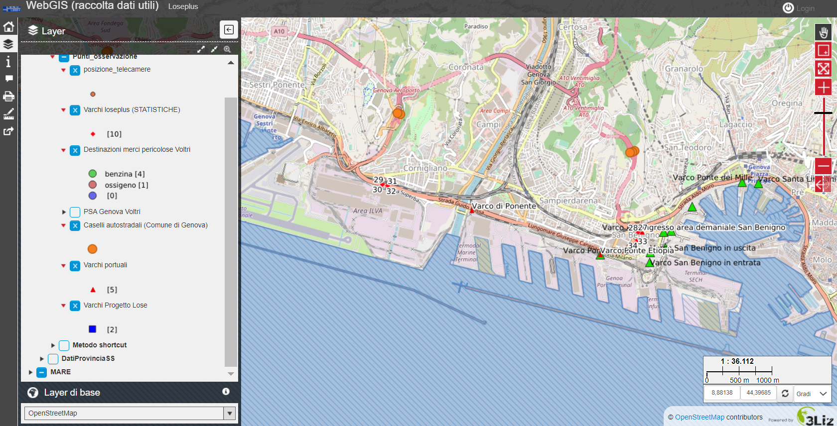
Figure 1. LOSE+LAB platform visualization: zoom of the in-land Web-GIS visualisation. Networks of devices and cameras installed to monitor hazmat vehicles in the city of Genoa (Legend: Points of monitoring - cameras position; statistics on point of monitoring; Dangerous goods points of delivery in Voltri, e.i. gasoline, oxygen, and other substances; Highway gates (Municipality of Genova); port gates).
Secondly, the system includes a web-GIS platform, which in real time, provides the users with georeferenced maps related to the monitored traffic and to the potential impact area generated by possible accident scenarios which involved the identified hazmat vehicles.
For an incident that produces an outcome to toxic or flammable release, the definition of the impact area means to estimate the extension of the physical effects resulting from the accidental development following the loss of containment. In detail, the impact or the damage area represent the zones over which the hazmat concentration equals or exceeds some reference threshold levels in terms of lethality. The related consequence analysis refers to the expected effects of incident outcome cases independently from the frequency or probability of occurrences.
In the proposed system, the computation of the consequences analysis related to potential hazmat events is based on a speditive-method (called “Short-Cut”) which considers the specific involved material (hazmat), the amount of transported product, the current weather conditions, and the type of containment for the transport. Furthermore, the map images may be overlapped to other significant layers related to the land use and to the location of sensible and vulnerable targets on the territory, such as hospitals or schools.

  - LOSE+LAB Web-GIS platform: data collection and visualization
In the proposed WEB-GIS platform, the data coming for the cameras network have been stored in a central server and then processed and elaborated. For each installed camera, the acquired data referred to monitoring point ID, monitored event ID (vehicle transit), date and hour of the detected transit, vehicle description, identified Kemler code, UN (United Nations) number and proper shipping name of the transported hazmat.
The data, managed by the Municipality of Genoa, may be accessed only by accredited users.
Besides, the proposed system provides the users with the possibility to download the information or related statistics in different formats. Maps, statistics, graphs, and trends useful for a risk-based decision support system have been implemented for the public authorities of the territory.
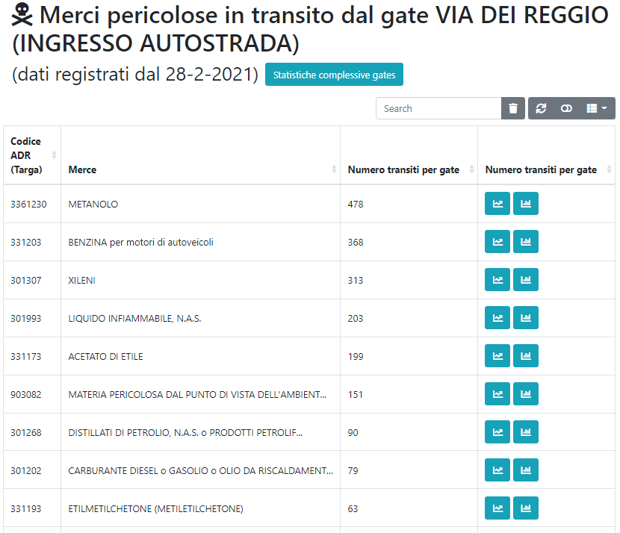 | a)  b)
Figure 2. Statistic concerning the flows of hazmat vehicles monitored for one specific gate 25 (on the left of the figure) until the 28.02.2021, date of the LOSE+LAB system activation (a), the related average hourly values of transits (on the right of the figure) (b).

The proposed LOSE+LAB Web-GIS platform includes a module for the consequence analysis of the different potential accident scenarios generated by the hazmat transport in the roads located in the study area.
This module aims at providing the users with a smart tool able to quickly compute and quantify the size of impact areas characterized by high lethality and irreversible injuries for people in case of hazmat accident.
The module is based on an expeditious method called ShortCut implemented by the Agency for the Protection of the Environment of Tuscany Region (Italy) published at the ISPRA (The Italian Institute for Environmental Protection and Research) website (ShortCut Method, 2005).
In Figure 3, the blue area indicates the schools of Genova District as elements exposed to hazard and risk, the red cross points represent hospitals, the red lines are roads while the dot-red-line are highways and the black ones the municipal in-land and on-the-sea cross-borders. The Red circle represent the area of sure impact derived from a release of chlorine hypothesized as study scenario along a define link of road infrastructure. The yellow circles represent the area of damage.

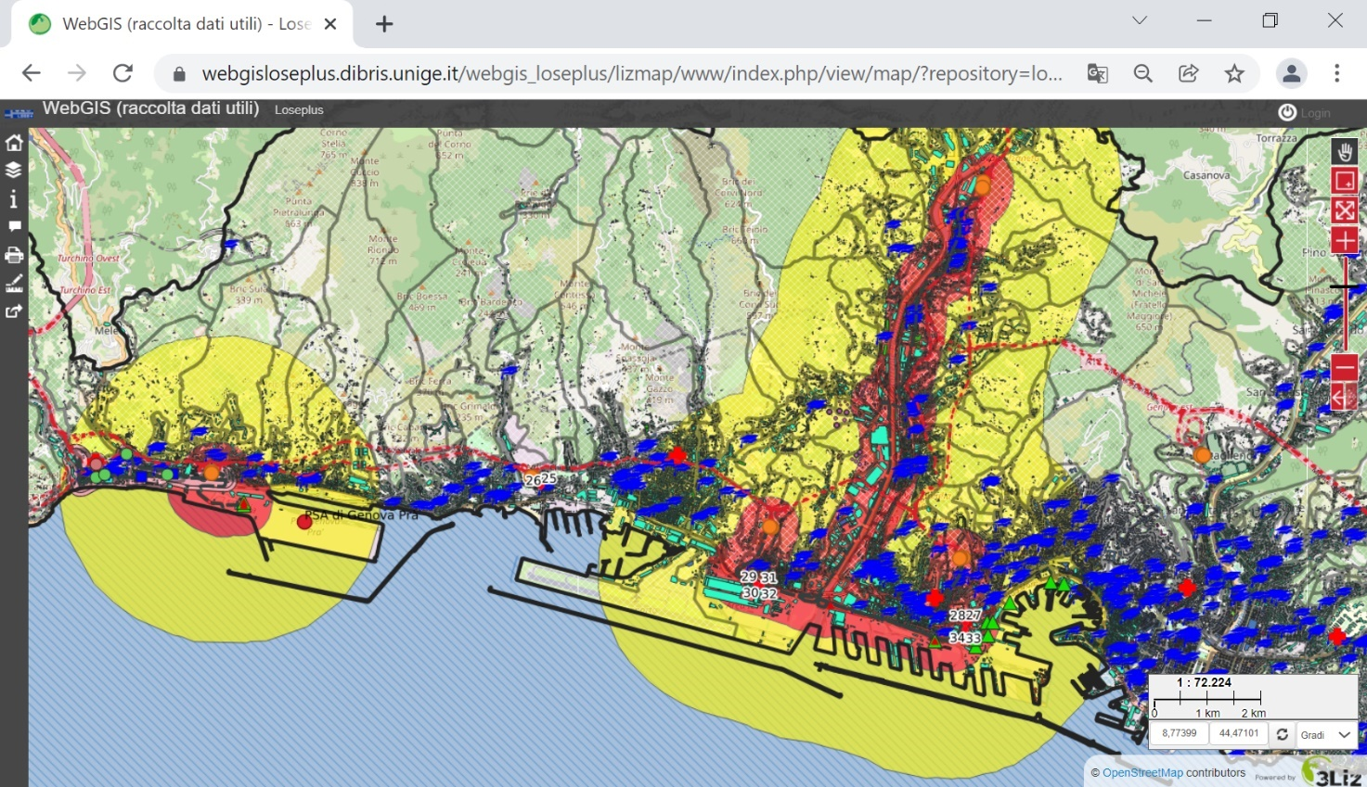
Figure 3. LOSE+LAB platform visualization: zoom of the in-land Web-GIS representing two scenario of event studied, according to the legend of Figure 1.

  - Decision support system for consequence and risk analysis
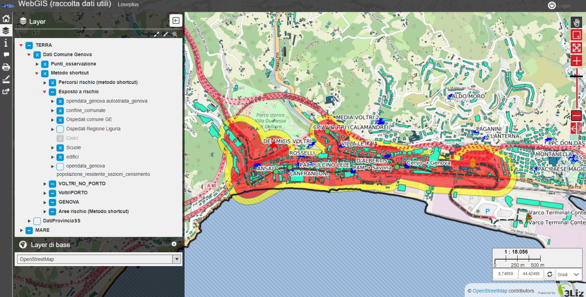

Figure 4. Rapid mapping for consequence analysis in case of hazmat accident which involves liquified gas. The proposed system overlaps also significant exposed elements, infrastructures, and land use layers.

The Shortcut Method such as the other expeditious methods allows to estimate the distances of damage related to accidents involving the hazmat releases in different kinds of containments: stored in confined containments, or transported by vessel, by truck tanker, by rail tanker and pipeline (those latter types are excluded from the field of application of Legislative Decree 334/99). It classifies flammable and toxic substances according to their generally significant hazard characteristics for the purpose of evaluating the consequences. For each class of risk, the method provides the indication of the accident scenarios with most and medium probability of occurrence (the typical outcomes of the hazmat accident may be referred to pool fire, flash fire, Vapor Cloud Explosion (VCE) or toxic cloud).
The consequence distances are reported in tabular form in respect to hazmat classes, different amounts of product, four thresholds of lethality and for two categories of weather conditions according to Pasquill classification (D5 and F2). Those obtained distances represent the radius of circular area which approximate the potential impact zone of the accident event. In the figure below, the accident scenario for the liquefied gas, which belongs to the class 3 in the ADR regulation, appears (Figure 4).
In this representation, the radius of the impact area has been used to identify a buffer, under and over the selected road, drawn as a circle which moves along the road. The red area represents the impact zone with high lethality while the yellow one may be associated to the damage area, where consequences may generate irreversible injuries. The user can also access to data and layers which provides information about population density or about other potential exposed and vulnerable receptors on the territory such as schools, hospitals, people gathering centers (factories, stadiums, auditoriums, dormitory districts, and so on).

  - Hazmat maritime transport
The consequence module has been implemented also in the maritime context. This application is based on the Short-Cut Method, and it provides the impact area considering the hazmat stored on the vessels which transit in the ports. According to the data coming from the Port Authority related to the loading and unloading hazmat products handled in the port terminals, the system provides the rapid mapping of the hazard next to the coastal area. The module makes available for the user the visualization of the possible accident outcomes drawing the impact area along the trajectories of the vessels entering, staying, or leaving the ports.

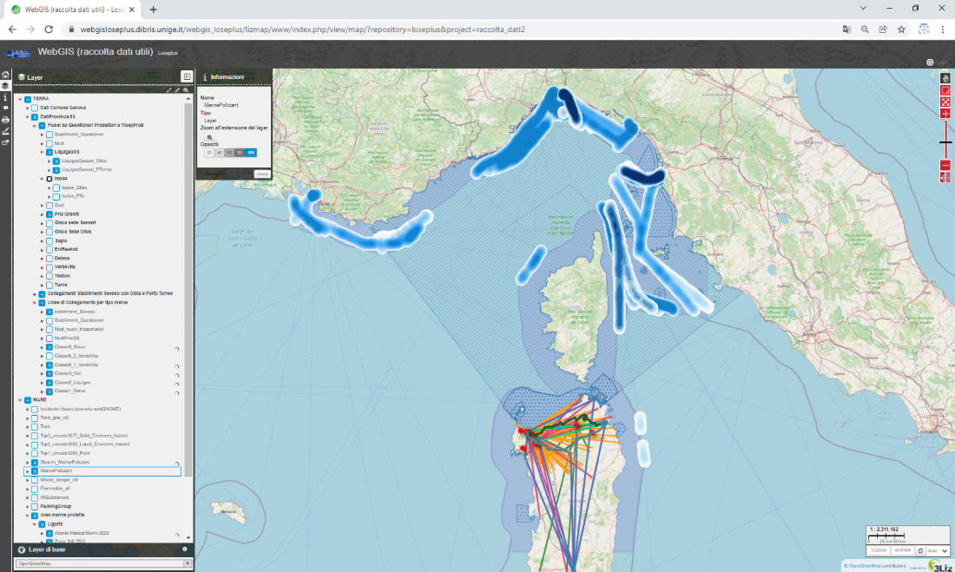

Figure 5. Rapid-mapping for risk assessment extended to the coast areas.

  - Further ICT integrations to the LOSE+LAB system
The Web-GIS system represent a decision support system for the territorial governance in case of an accident and to increase the level of knowledge on the dangerous goods flows passing through the Municipality of Genoa areas. This system has a Mediterranean scale dimension. The system has been furtherly improved by the integration of other innovated technologies. The following equipment are used to increase the safety on the road network thanks to the support and the well-coordinated operational work of the Local Police of the Municipality of Genoa.
A drone may be used to monitor in real time the traffic and the risk situations in case of road accidents involving hazmat vehicles. It may be adopted to acquire images of the event and to control and evaluate online the consequences to manage the phase of intervention of the emergency medical responders and firefighters.
Besides, a road-fighter – a mobile devices – may be used to transit on the road in order to detect and recognize the orange license plates of the ADR vehicles. This special device acquires the images which are transmitted via Wi-Fi to a tablet provided to the operators of the Public Authorities. Images, OCR identification, and information are stored and then managed by the policemen which may access to geo-referred and timely data about the traffic and possible risky situation on the monitored road sections.
The safety system has already permitted to elaborate the first set of data observed to produce some statistics.
Conclusions
This paper presents the preliminary version of the ICT based system dedicated to monitor hazmat road transportation in Liguria Region developed in the framework of the Interreg Maritime Italia-Francia project LOSE+. The added value of the proposed system is the integration of the innovative ICT solutions with the development of a WEB-GIS platform which provides the user with a smart tool able to support the analysis of hazmat detection and risk analysis by the powerful use of GIS for Public Safety. The main result of this system is to integrate the data about hazmat flows, locations, and information about potential hazard into an online WEB-GIS format to be shared internally among the Public Authorities involved in the control of this particular kind of transport. Focus here should be on timely reporting the data about hazmat transportation in the urban areas or in strategic locations such as in the proximity of the port gates or highways integrating the information already available about the common traffic and shared them with neighboring municipalities. Specific interest by the Public Authorities has been demonstrated also for the module realized by a rapid mapping technique for hazmat accident scenarios generation. The proposed LOSE+LAB system and the Web-GIS platform have the ambition to become the reference tools to Public Authority to create a safety common system at interregional level, between Italy and France, to improve the knowledge and the consciousness about the importance of the monitoring and control of hazmat transportation in term of risk prevention and public safety.
Acknowledgments
This research is supported by the Project LOSE+ (Logistic and Safety of freight transport) co-financed by the European Regional Development Fund in the framework of the Interreg Italy-France Maritime Programme 2014-2020, available, at http://interreg-maritime.eu/web/lose/progetto (Last access December 2021).
The LOSE + project with six other projects of this call is included in a CLUSTER of Axis 2, Lot 2, "Risk management linked to climate change" whose Liguria Region is the coordination and leader of the OMD (Observatory of hazmat maritime transport) project. We thank you the policemen of the Local Police of Genoa City (Liguria Region, Italy); Liguria Region and the Partners of LOSE+ project and the projects of the Cluster “Greg&MARtine”.

References
Benza, M., Bersani, C., D'Incà, M., Roncoli, C., Sacile, R., Trotta, A., ... & Ridolfi, R. (2012, July). Intelligent transport systems (its) applications on dangerous good transport on road in Italy. In 2012 7th International Conference on System of Systems Engineering (SoSE) (pp. 223-228). IEEE.
Bersani, C., Minciardi, R., Tomasoni, A. M., & Sacile, R. (2010). Risk averse routing of hazardous materials with scheduled delays. In Security and Environmental Sustainability of Multimodal Transport (pp. 23-36). Springer, Dordrecht.
Energy, transport and environment statistics, 2019 Edition, Eu Commission. Available at https://ec.europa.eu/eurostat/documents/3217494/10165279/KS-DK-19-001-EN-N.pdf/76651a29-b817-eed4-f9f2-92bf692e1ed9?t=1571144140000. Latest access September 2021.
Italian National Institute of Statistics (ISTAT), Road incident (2020).
Lupi, M., Pratelli, A., Seminara, L., & Farina, A. (2021). The Development of Deep and Short Sea Shipping Container Routes Departing from Italian Ports. IL NOSTRO MARE: Rivista di scienze marine, 68(2), 83-92.
Mohri, S. S., Mohammadi, M., Gendreau, M., Pirayesh, A., Ghasemaghaei, A., & Salehi, V. (2021). Hazardous material transportation problems: A comprehensive overview of models and solution approaches. European Journal of Operational Research.
Shortcut Method for the accident consequences evaluation. ARPAT - Agenzia regionale per la protezione ambientale della Toscana, 2005. Access at https://www.isprambiente.gov.it/contentfiles/00003400/3472-mlg-35-2006.pdf.
Weng, J., Gan, X., & Zhang, Z. (2021). A quantitative risk assessment model for evaluating hazmat transportation accident risk. Safety science, 137, 105198.
Zero, L., Bersani, C., Paolucci, M., & Sacile, R. (2019). Two new approaches for the bi-objective shortest path with a fuzzy objective applied to HAZMAT transportation. Journal of hazardous materials, 375, 96-106.

