CHEMICAL ENGINEERING TRANSACTIONS  VOL. 91, 2022 | A publication of
The Italian Association
of Chemical Engineering
Online at www.cetjournal.it

Guest Editors: Valerio Cozzani, Bruno Fabiano, Genserik Reniers
Copyright © 2022, AIDIC Servizi S.r.l.
ISBN 978-88-95608-89-1; ISSN 2283-9216

On the Mechanical Energy Involved in the Catastrophic Rupture of Liquid Hydrogen Tanks
Federico Ustolin^{a,}*, Leonardo Giannini^{a,b}, Gianmaria Pio^{b}, Ernesto Salzano^{b}, Nicola Paltrinieri^{a,b}
ªDepartment of Mechanical and Industrial Engineering, Norwegian University of Science and Technology NTNU, Richard Birkelands vei 2B, 7034 Trondheim, Norway
^{b}Dipartimento di Ingegneria Civile, Chimica, Ambientale e dei Materiali, Università degli studi di Bologna, Via Terracini 28, 40131 Bologna, Italy
federico.ustolin@ntnu.no
Hydrogen can play a central role in the energy transition thanks to its unique properties. However, its low density is one of the main drawbacks. The liquefaction process can drastically increase its density up to virtually 71 kg m⁻³ at atmospheric pressure and -253°C (NIST, 2019). The safety knowledge gap on physical explosions is still broad in the case of liquid hydrogen (LH₂). For instance, it is unclear what are the consequences yields as well as the probabilities of a catastrophic rupture of an LH₂ tank. A boiling liquid expanding vapour explosion (BLEVE) might arise after this top event. In this case, the expansion of the compressed gaseous phase is followed by the flashing of a fraction of the liquid. Moreover, combustion may occur for hydrogen since it is highly flammable. This complex phenomenon was not widely explored for LH₂ yet.
This study focused on the physical explosion by also considering the combustion process. Many integral models were adopted to estimate the mechanical energy developed by the explosion. The tank pressure prior to the rupture was considered below the critical one (1.298 MPa (NIST, 2019)). It was assumed that both liquid and gaseous phases are present inside the tank. The influences of the filling degree of the tank (liquid level) and the temperatures of the liquid and gaseous phases on the explosion energy were analysed. The results were compared with the ones of a previous study where similar models were employed to estimate the mechanical energy of an LH₂ tank with different initial conditions (Ustolin et al., 2020a). In particular, the effect of the combustion process on the explosion energy and shock wave overpressure was not accounted for. The aim of this study is to conduct a comparison between different models and assess which are the most and the least conservative. The outcomes of this work provide critical suggestions on the consequence analysis of cryogenic liquefied gas vessels explosions.
  - Introduction
Considerable quantities of hydrogen are foreseen to be consumed in many applications if hydrogen technologies will be deployed on a large scale. The employment of liquid hydrogen (LH₂) is predicted for mobile applications in the maritime and aviation sectors (DNV, 2021). LH₂ can broadly increase the low hydrogen density. Emerging risks must be avoided when hydrogen is employed in new applications. One of the worst-case scenarios might be the catastrophic rupture of the LH₂ vessel. From this critical event, a physical explosion called boiling liquid expanding vapour explosion (BLEVE) might arise. A thorough description of this phenomenon for LH₂ tanks can be found in (Ustolin et al., 2020a) where it was attempted to simulate its consequences (shock wave, missiles, and fireball) by means of integral and empirical models. In that study, an underestimation of the BLEVE shock wave overpressure was found when comparing the simulated results with the experimental data. Therefore, it was speculated that the sudden combustion of hydrogen might influence the blast wave overpressure. This hypothesis was also proposed by Molkov and Kashkarov (2015) who modelled the shock wave created after the rupture of compressed gaseous hydrogen vessels by considering the combustion process. Hence, the aim of this study was to investigate how hydrogen combustion affects the energy generated by the explosion and the blast wave overpressure.
  - Methodology
The mechanical energy generated by the explosion which may occur after the catastrophic rupture of liquefied gas vessels was assessed by means of integral models. The focus was placed on cryogenic vessels containing LH₂. However, the same models were already applied to different substances such as methane and propane (Ustolin et al., 2020b). Both ideal and real gas behaviour models were employed in this analysis to estimate the abovementioned mechanical energy. The considered ideal gas behaviour models were developed by the following authors: Brode (1959); Smith and Van Ness (1996); Crowl (1992, 1991), thermodynamic availability (TA) model; Prugh (1991); while the selected real gas behaviour models were proposed by: van den Bosch and Weterings (2005), TNO model; Planas-Cuchi et al. (2004); Genova et al. (2008); Birk et al. (2007).
These models were already applied to LH₂ vessels by Ustolin et al. (2020a), and a description of the equations of the models can be found there. In this work, the superheating energy model (Casal and Salla, 2006) was not considered because it is usually employed to directly estimate the overpressure of the blast wave and not the mechanical energy. It was assumed that the hydrogen contained in the vessel was at saturation conditions to obtain the most conservative estimations. The CoolProp package (Bell et al., 2014) was used to retrieve the hydrogen thermodynamic properties.
Barely the fraction of energy that contributes to the shock wave should be considered to determine its overpressure. Hemmatian et al. (2017) suggested that only 40% or 80% of the mechanical energy determined by the ideal gas behaviour models contribute to the blast wave if the tank fracture is ductile or fragile, respectively. However, it was assumed that 100% (α = 1) of this energy transforms to overpressure since underestimations were obtained by Ustolin et al. (2020a) when comparing the simulation outcomes with experimental data. On the other hand, different factors were suggested by the authors of real gas behaviour models. For instance, the TNO and Birk models account for the reflection on the ground of the blast wave, and van den Bosch and Weterings (2005) recommend multiplying the mechanical energy by a factor of 2. The factors to estimate the mechanical energy contribution to the shock wave for the real gas behaviour models are collected in Table 1.
Table 1: Factors (α) to estimate the mechanical energy contribution to the shock wave for the real gas behaviour models
Model | α |  | Model | α
TNO | 2.00 |  | Planas | 0.40
Birk | 2.00 |  | Genova | 0.07

As previously mentioned, fireball is one of the BLEVE consequences in the case of flammable substances. Ustolin et al. (2020a) employed the abovementioned models to estimate the mechanical energy generated by the physical explosion (BLEVE) without considering the potential contribution of the combustion. In this study, the chemical energy contribution to the explosion energy is considered by following the methodology proposed by Molkov and Kashkarov (2015). In particular, these authors accounted for the combustion process by adding the chemical energy contribution to the physical one. This method was applied to the explosion of high-pressure gaseous hydrogen tanks explosion and validated with experimental results. The chemical energy contribution (E_{ch}) was estimated with Eq(1):
$E_{ch}=β∙{\left(\frac{r_{sh}}{r_{b}}\right)}^{3}∙LHV$ | (1)
where β is the chemical energy coefficient (0.052 for compressed gaseous hydrogen (Molkov and Kashkarov, 2015)), r_{sh} and r_{b} are the radii of the hemispheres where the turbulent non-premixed combustion occurs and the chemical energy is released and the hemisphere potentially occupied by the combustion products in m, respectively, and LHV stands for lower heating value (119.96 MJ kg⁻¹ for hydrogen (McAllister et al., 2011)). The parameter r_{b} can be calculated with Eq(2):
$r_{b}={\left(\frac{3∙V_{b}}{2∙π}\right)}^{1/3}$ | (2)
where V_{b} is the volume of the hemisphere potentially occupied by the complete combustion products of air and hydrogen released from the vessel in m³ estimated with Eq(3):
$V_{b}=V_{u}∙E_{i}$ | (3)
where V_{u} is the volume of unburned stoichiometric mixture of air with released hydrogen (see Eq(4)), and E_{i} is the expansion coefficient of combustion products, equal to 6.85 for 30% hydrogen-air mixture (Molkov, 2012).
$V_{u}=\left(n_{air}+n_{H2}\right)∙V_{M}$ | (4)
where n_{H2} and n_{air} are the numbers of moles occupied by hydrogen and air, respectively, while V_{M} is the molar volume, i.e., the volume occupied by one mole of any ideal gas at standard conditions (22.4 × 10⁻³ m³ mol⁻¹). The number of hydrogen moles which participates in the combustion can be assessed with Eq(5):
$n_{H2}=\frac{m_{H2}}{M_{H2}}$ | (5)
where m_{H2} is the mass of hydrogen which is burnt when released (equal to the hydrogen mass content) in kg, and M_{H2} is the hydrogen molar mass (2.016 × 10⁻³ kg mol⁻¹ (NIST, 2019)). On the other hand, the number of air moles, n_{air}, is estimated with Eq(6):
$n_{air}=n_{H2}∙2.38$ | (6)
where 2.38 are the moles of air required to burn one hydrogen mole in stoichiometric conditions (Molkov and Kashkarov, 2015). Therefore, the chemical energy contribution (E_{ch}) is summed to the mechanical energy (E_{me}) as indicated in Eq(7), to calculate the total energy (E_{TOT}) generated by the explosion.
$E_{TOT}=α∙E_{me}+E_{ch}$ | (7)
The overpressure of the blast wave was then assessed by using the TNT equivalent mass method as explained by Ustolin et al. (2020a). The mechanical energy employed to assess the shock wave overpressure was the one estimated with the TNO model since it was demonstrated to be the most conservative method.
    - BMW safety tests
The BMW bursting tank scenario tests described in (Pehr, 1996) were selected as a case study. During the tests, ten single walled LH₂ vessels insulated with a layer of foam were destroyed by means of explosive charges at different initial conditions. In particular, the internal pressure were varied in the range of 2 – 15 bar and the measured LH₂ mass was 1.8 – 5.4 kg (Pehr, 1996). A thorough description of the BMW experiments and their uncertainties can be found in (Ustolin et al., 2020a) where these tests were simulated by neglecting the contribution of the combustion process to the explosion energy. As a result of that analysis, an underestimation of the blast wave overpressure was obtained by employing the models previously described. In this study, the tests in which the hydrogen temperature and pressure prior to the explosion were below the critical point (8 out of 9 tests) were considered in order to employ also the models which account for the liquid phase.
  - Results
The total energy (mechanical + chemical) generated by the BLEVE explosion estimated with the different ideal and gas behaviour models (described in Sec. 2) is depicted in Figure 1.

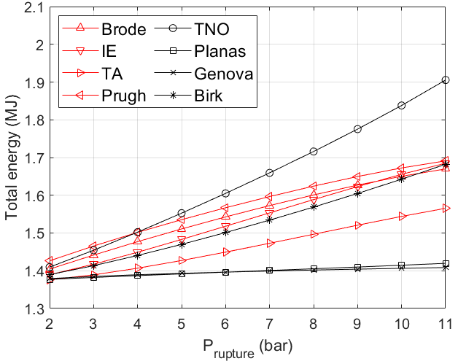 | 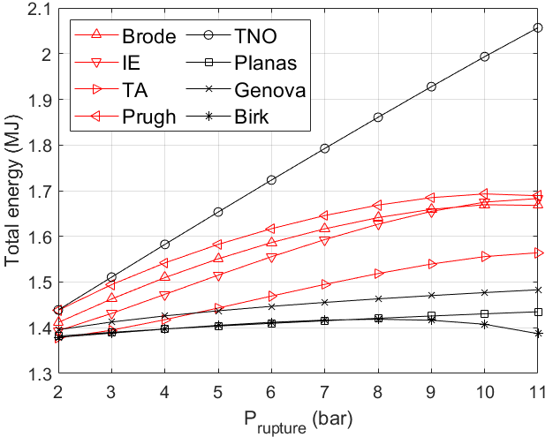
(a) | (b)
Figure 1: Total energy (mechanical + chemical) which contributes to the pressure wave generation estimated with the ideal and real gas behaviour models when the tank is filled with (a) 1.8 and (b) 5.4 kg of LH₂.
In particular, the total energy was estimated for different initial tank pressures and LH₂ amounts. In fact, the tank was considered filled with 1.8 kg (Figure 1a) and 5.4 kg (Figure 1b) of LH₂ which were respectively the minimum and maximum masses measured during the BMW experiments. It can be noticed that the TNO model is the most conservative one as already noticed by Ustolin et al. (2020a). As expected, the maximum value of energy (2.06 MJ) was estimated by this model when the tank has an initial pressure of 11 bar and is filled with 5.4 kg of LH₂. The maximum value of mechanical energy estimated by the same model by neglecting the combustion process was one order of magnitude lower (0.35 MJ) (Ustolin et al., 2020a). On the other hand, the Planas and Genova models seem to be the least conservative. Curiously, the Birk method is highly affected by the LH₂ amount before the explosion since it considers only the compressed gaseous phase contribution. This is demonstrated by observing that this model becomes the least conservative when the LH₂ mass contained by the tank increases
The blast wave overpressures provoked by different initial tank pressures at 3 m from the tank centre are shown in Figure 2a, while the overpressure trend for an initial pressure of 11 bar at different distances from the tank is depicted in Figure 2b. The overpressures were estimated by employing the total energy calculated by means of the TNO model when the tank is holding 1.8 and 5.4 kg of LH₂ (solid and dashed curves, respectively). The LH₂ amount contained in the vessel has virtually no influence on the simulated overpressure. Furthermore, the slight difference caused by the different LH₂ masses in the near field (3 m) already disappears at 8 m. The values of overpressure measured during the BMW tests are also reported in the charts of Figure 2 (red circles) as a comparison. A good agreement was found between the prediction obtained by the TNO model and the maximum shock wave overpressure (470 mbar) measured in one of the BMW tests where the rupture pressure was equal to 11 bar. Instead, an overprediction was attained if the simulated values are compared against the other BMW tests.

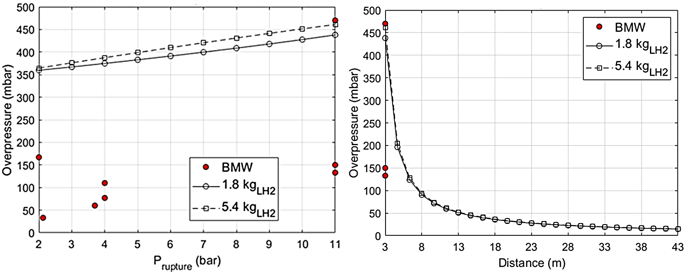
(a) | (b)
Figure 2: (a) overpressure of the blast wave calculated through the TNO model at 3 m from the tank centre for different initial tank pressures, and (b) at different distances when the initial tank pressure is 11 bar.
In Table 2, the comparison between the highest blast wave overpressures measured during the BMW experiments at different rupture pressures and the simulated ones with and without considering the combustion process is reported. From this comparison, it can be observed that when only the physical explosion was considered, the overpressure had been underestimated with the exception of the tests where the LH₂ tanks were wrecked at 4 bar.
Table 2: Comparison between the maximum blast wave overpressures measured during the BMW experiments and the simulated ones with and without considering the combustion process
 | Overpressure (mbar)
Rupture pressure  (bar) | BMW test | Without combustion  (Ustolin et al., 2020a) | With combustion (this study)
2 | 167 | 118 | 365
4 | 110 | 194 | 388
11 | 470 | 362 | 461
  - Discussion
As already noticed by Ustolin et al. (2020a), the LH₂ mass has not a large influence on the mechanical energy and the blast wave overpressure. Contrarily, the initial tank pressure affects the most yield of the explosion. This was observed also in this study where the chemical energy contribution was considered. The combustion process has a large influence on the estimation of the energy generated by the explosion, thus on the overpressure of the shock wave. The total energy is one order of magnitude larger than the mechanical energy if a small fraction of the chemical energy released during the hydrogen combustion is considered to contribute to the blast wave. In this study, it was assumed that 5.2 % of this energy contributes to the shock wave as proposed by Molkov and Kashkarov (2015) for compressed gaseous hydrogen tanks explosions. A good agreement was obtained only with one of the BMW tests while a broad overprediction was attained when compared against the other overpressure measurements. It might be speculated that the combustion effect superimposed onto the physical explosion only in the test where the overpressure was the highest, as suggested by Pehr (1996). However, the chemical energy coefficient may be tuned to include the non-idealities due to extremely low temperatures and to consider the non-infinitely fast reactions that occur, only when additional experimental data will be available for LH₂ tanks. In this sense, a comparison of the characteristic time of each phenomenon potentially involved in the analysed scenario can be essential for the determination of the energy and overpressure generated by an accidental release of LH₂.
In this study, the TNT equivalent mass method, which is usually extremely conservative in the near field, was employed. As previously mentioned, the shock wave was measured at 3 m from the tank centre which should be already in the far-field for the size of the tested tanks (0.120 m³ (Pehr, 1996)). Therefore, the TNT method should not have provided high conservative overpressure estimations. Nevertheless, a comparison with other methods, such as the Sachs scaling law (Sachs, 1944) or the one suggested by Baker et al. (1983), should be conducted in future studies.
Since hydrogen has a low critical pressure compared with other gases, the explosion of the tank at supercritical conditions should be further investigated. This might be a possible scenario when the tank is exposed to an external fire and not wrecked by explosives as during the BMW tests. In any case, the combustion process should be accounted for due to the presence of an ignition source. Ustolin et al. (2020a), who considered supercritical BLEVEs, assumed that the entire tank content was in supercritical conditions, hence it was not possible to distinguish the liquid and gaseous phases. However, the liquid phase could exist even though the pressure is higher than the critical one thanks to the super insulation of the LH₂ double-walled tank and the high LH₂ specific heat capacity. In this case, the requisite for the liquid phase to exist is to have a temperature lower than the critical one. The effect of the liquid in supercritical conditions on the explosion yield should be investigated in future studies. Eventually, the contribution to the overall energy budget of the significantly endothermic conversion from para-hydrogen to ortho-hydrogen should be analysed. As described by Salzano et al. (2020), the neglection of this phenomenon on the characterization of scenarios involving LH₂ might lead to a non-conservative result.
  - Conclusions
An analysis of the energy generated by a BLEVE caused after the complete rupture of the LH₂ vessels was carried out in this study. The contribution of the combustion process to the explosion energy and the shock wave overpressure was considered since previous studies obtained an underestimation by accounting only for the mechanical energy. A good agreement between the simulation and the experimental outcomes was achieved by the most conservative model (TNO). The most relevant hypotheses were analysed to identify possible phenomena causing the observed discrepancies. Further studies on the modelling of the BLEVE phenomenon for LH₂ were suggested as well as additional tests on the LH₂ tank explosions.
Nomenclature

E_{ch} – chemical energy, MJ

E_{i} – combustion products expansion coefficient, -
LHV – lower heating value, MJ
M_{H2} – hydrogen molar mass, kg mol⁻¹
V_{b} – combustion products hemisphere volume, m³
V_{M} – molar volume, m³
V_{u} – H₂-air mixture hemisphere volume, m³
m_{H2} – hydrogen mass, kg
n_{air} – number of air moles, -
n_{H2} – number of hydrogen moles, -
r_{b} – combustion products hemisphere radius, m
r_{sh} – shock wave radius, m
α – mech energy coefficient, -
β – chemical energy coefficient, -

Acknowledgments
This work was undertaken as part of the research project Safe Hydrogen Fuel Handling and Use for Efficient Implementation (SH₂IFT), and the authors would like to acknowledge the financial support of the Research Council of Norway under the ENERGIX programme (Grant No. 280964).
References
Baker W.E., Cox P.A., Kulesz J.J., Strehlow R.A., Westine P.S., 1983, Explosion Hazards and Evaluation. Elsevier Science, New York.
Bell I., Wronski J., Quoilin S., Lemort V., 2014, Pure and Pseudo-Pure Fluid Thermophysical Property Evaluation and the Open-Source Thermophysical Property Library CoolProp. Industrial & Engineering Chemistry Research, 53, 2498–2508.
Birk A.M., Davison C., Cunningham M., 2007, Blast overpressures from medium scale BLEVE tests, Journal of Loss Prevention in the Process Industries, 20, 194–206.
Brode H.L., 1959, Blast Wave from a Spherical Charge, Physic Fluids, 2, 217–229.
Crowl D.A., 1991, Using thermodynamic availability to determine the energy of explosion, Plant/Operations Progress, 10, 136–142.
Crowl D.A., 1992, Calculating the energy of explosion using thermodynamic availability, Journal of Loss Prevention in the Process Industries, 5, 109–118.
DNV, 2021. Energy Transition Outlook 2021 - A global and regional forecast to 2050.
Genova B., Silvestrini M., Leon Trujillo F.J., 2008, Evaluation of the blast-wave overpressure and fragments initial velocity for a BLEVE event via empirical correlations derived by a simplified model of released energy, Journal of Loss Prevention in the Process Industries, 21, 110–117.
Hemmatian B., Planas E., Casal J., 2017, Comparative analysis of BLEVE mechanical energy and overpressure modelling, Process Safety and Environmental Protection, 106, 138–149.
McAllister S., Chen J.-Y., Fernandez-Pello A.C. (Eds.), 2011, Fundamentals of Combustion Processes, Springer Science +Business Media, LLC, New York.
Molkov V., Kashkarov S., 2015, Blast wave from a high-pressure gas tank rupture in a fire: Stand-alone and under-vehicle hydrogen tanks, International Journal of Hydrogen Energy, 40, 12581–12603.
Molkov V. (Ed.), 2012, Fundamentals of hydrogen safety engineering, bookboon.com.
NIST, 2019, NIST Chemistry WebBook 69, National Institute of Standards and Technology <webbook.nist.gov/chemistry/> accessed 19.03.2019.
Pehr K., 1996, Aspects of safety and acceptance of LH2 tank systems in passenger cars, International Journal of Hydrogen Energy, 21, 387–395.
Planas-Cuchi E., Salla J.M., Casal J., 2004, Calculating overpressure from BLEVE explosions, Journal of Loss Prevention in the Process Industries, 17, 431–436.
Prugh R.W., 1991, Quantitative Evaluation of “BLEVE” hazards, Journal of Fire Protection Engineering, 3, 9–24.
Sachs R.G., 1944, The dependence of blast on ambient pressure and temperature, BRL Report no. 466, Aberdeen Proving Ground, Maryland.
Salzano E., Carboni M., Pio G., 2020, The effects of low-temperature phenomena on rapid phase transition of liquid hydrogen. International Journal of Hydrogen Energy, 45, 32676–32685.
Smith J.M., Van Ness H.C. (Eds), 1996, Introduction to Chemical Engineering Thermodynamics, McGraw-Hill, Inc, NewYork.
Ustolin F., Paltrinieri N., Landucci G., 2020a, An innovative and comprehensive approach for the consequence analysis of liquid hydrogen vessel explosions, Journal of Loss Prevention in the Process Industries, 68, 104323.
Ustolin F., Salzano E., Landucci G., Paltrinieri N., 2020b, Modelling Liquid Hydrogen BLEVEs: A Comparative Assessment with Hydrocarbon Fuels, Proceedings of the 30th European Safety and Reliability Conference and 15th Probabilistic Safety Assessment and Management Conference (ESREL2020 PSAM15).
Ustolin F., Paltrinieri N., 2020c, Hydrogen fireball consequence analysis, Chemical Engineering Transaction, 82, 211–216.
van den Bosch C.J.H., Weterings R.A.P.M., 2005, Methods for the Calculation of Physical Effects - Due to Releases of Hazardous Materials (liquids and gases), “Yellow Book.” The Committee for the Prevention of Disasters by Hazardous Materials, Director-General for Social Affairs and Employment, The Hague.

