CHEMICAL ENGINEERING TRANSACTIONS  VOL. 91, 2022 | A publication of
The Italian Association
of Chemical Engineering
Online at www.cetjournal.it

Guest Editors: Valerio Cozzani, Bruno Fabiano, Genserik Reniers
Copyright © 2022, AIDIC Servizi S.r.l.
ISBN 978-88-95608-89-1; ISSN 2283-9216

Preliminary Study on Oxidation of Nuclear Grade Graphite
Martina Mazzi¹, Riccardo Chebac², Fabrizio Campi², Marco Ricotti², Gintautas Poškas³, Marco Derudi^{1,*}, Alessandro Porta²
¹Politecnico di Milano, Dip. di Chimica, Materiali e Ingegneria Chimica “G. Natta”, Via Mancinelli 7, 20131 Milano - Italy
²Politecnico di Milano, Dip. di Energia, Via Lambruschini 4, 20156 Milano - Italy
³Lithuanian Energy Institute, Nuclear Engineering Laboratory, Breslaujos str. 3, LT-44403 Kaunas - Lithuania
*marco.derudi@polimi.it

A test methodology has been defined in order to assess the risk of bulk-oxidation of nuclear graphite with a focus on particular operations, such as cutting of graphite components during decommissioning of nuclear reactors. Graphite is used for its properties in nuclear reactors, as a fuel element matrix, moderator, structural and reflector material.
The experimental tests have been performed using a horizontal TGA-DTA furnace and both isothermal and non-isothermal tests were performed on non-irradiated specimens.
In isothermal tests, testing temperature range was 550 – 750 °C, the selected temperature has been reached heating the furnace under N₂ atmosphere at 5 °C/min, then oxidation has been evaluated at constant temperature in air (100 mL/min) for at least 180 min. Non-isothermal tests have been performed either under N₂ atmosphere or air and samples have been heated at 5 °C/min from 30 to 950 °C.
As several properties may affect the oxidation resistance of nuclear graphite, such as impurities, grain size, pore structure, graphitization degree, antioxidation treatments, the testing protocol has been preliminary applied to non-irradiated graphite samples from two different graphite reactors.
Preliminary experimental results revealed the excellent ability of the tested graphite samples for oxidation resistance with lower oxidation rates and longer oxidation times compared with some literature results.
  - Introduction
This research was carried out in the scope of a European project called Inno4Graph, which aims to provide different kinds of innovative tools and methods that can be used during graphite reactor dismantling operations and during pre-dismantling phase for feasibility assessments (EU H2020 Inno4Graph Project). In particular, a preliminary experimental campaign was carried out to validate a testing procedure to evaluate oxidation behaviour of different graphite samples obtained from different cutting technologies. Indeed, it is worth to test each type of graphite sample since the oxidation behaviour is strongly affected by the specific microstructure of a nuclear grade graphite (Smith et al., 2021).
After validation, the test procedure could be used to select the most appropriate tools to cut reactors graphite components, such as graphite bricks or metallic parts in presence of graphite, to plan safe and efficient decommissioning operations, avoiding the formation and dispersion of contaminated dust (Copelli et al., 2019).
In addition, oxidation tests are also necessary to assess the properties of the selected graphite to design a reactor since graphite can rapidly oxidise in the extremely unlikely case of air ingress during operation (Matthews et al., 2021) or in the case of chronic oxidation of graphite due to the presence of radiolytic products or impurities in the coolant. Relevant cases are coolant radiolysis reactions in GCRs (Gas Cooled Reactors), AGCRs (Advanced GCRs) and RBMK reactors that can lead to degradation of graphite. Indeed, GCRs and AGCRs are graphite-moderated reactors cooled by CO_{2;} during operational life, radiolysis of CO₂ leads to the formation of species such as C, O, CO and O₂. RBMK are graphite-moderated reactors cooled by water, and, as a result of water radiolysis, species such as OH⁻, O₂, H₂O₂ can form (Féron, 2012).
Concerning general oxidation behaviour of graphite, three different temperature regions with a different rate controlling mechanism in each temperature range can be defined (Propp, 1998). The first regime, usually not obtained above 550 °C, is controlled by rate of chemical reaction, the observed reaction rates are low and orders of magnitude lower than the mass transport, and oxidation occurs uniformly through the open pore structure. In the second regime both diffusion and chemical reaction play an important role, and oxidation is not uniform and usually may not occur in the whole open pore structure. The third regime, that usually occurs above 800 °C, is controlled by rate of diffusion of reactant and products. Since reaction rate is orders of magnitude faster than gas diffusion, reaction usually occurs at the outer surface and shrinkage of the surface can be detected (Kane et al., 2017).
In the following paragraphs, testing procedure and results obtained from two different types of graphite are presented and compared; it is possible to notice the strong dependence of oxidation behaviour on graphite grade characteristics.
  - Materials and methods
The equipment used for this study was SDT Q600 horizontal TGA-DTA furnace.
During non-isothermal tests, specimens were heated from 30 to 950 °C either in air or N₂ with a heating rate of 5 °C/min. Several isothermal tests were also carried out; temperature of interest was reached heating the chamber with a rate of 5 °C/min in N₂ and then oxidation in air (100 mL/min) was evaluated for at least 180 min, test temperatures ranged between 550 and 750 °C, according to the prescription of ASTM D7542-15 standard. Several tests were performed three times at the same temperature to evaluate the reliability of the experimental procedure.
Data about weight loss in function of time and temperature were real time collected during the TG analysis, and oxidation kinetic parameters were then calculated following the procedure described in ASTM D7542-15.
Specimens were non-irradiated graphite cylinders of length 10 mm and diameter 5 mm, coming from two reactors involved in Inno4graph studies.
One is the research reactor of Politecnico di Milano (Polimi), which was shut down in 1979 after 20 years of operation. Average density of its virgin graphite samples is 1.687 g/cm³ and the average porosity 26.4 %.
The second is Lithuanian nuclear power plant Ignalina NPP, which consists of two RBMK-1500 units, one shut down in 2004 and the other in 2009.
Average density of its virgin graphite is 1.675 g/cm³ and average porosity is 22.8 %.The density values of the two graphites are the typical of early nuclear graphites (Marsden, 2001).
  - Results and discussion
Experimental results of the preliminary tests were compared with results found in literature to validate the testing procedure, and the values were coherent with previous oxidation studies about nuclear graphite.
Non – isothermal tests were performed in air and N₂, Figure 1 shows weight (%) and temperature difference (°C/mg) plotted against temperature (°C) in air.
Concerning Polimi samples, it was observed from the results of tests in air that weight loss extent is lower than 5 wt% at temperature below 740°C, while with the increase of temperature (above 700 °C), the oxidation rate sharply increased, and the weight recorded at the end of the test was 26 % of the starting weight. In addition, a strong size reduction of the samples was evidenced (different from the behaviour observed during isothermal tests).
In N₂ atmosphere, the weight loss recorded after the test was negligeable, being the maximum weight loss extent of about 0.7 wt%.
Also, in the case of Ignalina NPP graphite the oxidation in air was low at temperatures below 700 °C. At the end of the test, at 950 °C, the weight of the sample was about 21 % of the starting weight. However, also in this case a strong reduction and deformation of samples was noticed.
In N2 atmosphere, the weight loss recorded after the test was negligeable, being the maximum weight loss extent of about 0.3 wt%.

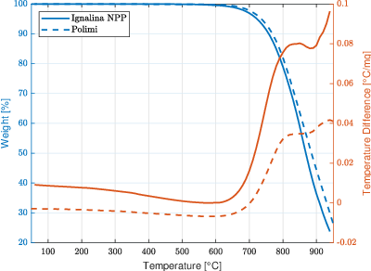
Figure 1: weight and temperature difference vs temperature, Polimi and Ignalina NPP graphite (non - isothermal tests)
From the plot of weight percentage against temperature (Figure 1) it is possible to observe that at temperatures of about 860 °C there is a decrease in the reaction rate. This phenomenon could be likely a consequence of the change of the oxidation regime or samples geometry and shrinkage of the surface area, since oxidation rate is proportional to the specimen surface area at high temperatures (Luo et al., 2004).
Isothermal tests were performed at the kinetic-controlled regime temperature range to better understand the oxidation behaviour of samples.
The plots of the weight loss variation (%) as a function of temperature (°C) after 60 min. in air are reported for both non-irradiated graphite samples in Figure 2.

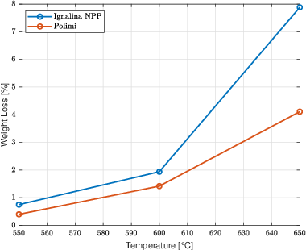
Figure 2: weight loss vs temperature (isothermal tests – after 60 min. in air)
As expected, for both kinds of graphite, the oxidation extent increased with temperature, being the most important parameter. For both graphite grades, after one hour of test in air, the extent of mass loss was quite low at temperatures below 600 °C, but it was possible to notice a faster degradation for Ignalina NPP samples. At 650 °C it was possible to observe a clearer difference between the extents of oxidation of the two types of samples, indeed after one hour of test, the oxidation extents of Polimi and Ignalina NPP graphite were respectively about 4 % and 8 % by weight.
In Table 1, a comparison between the weight loss extents recorded for the two graphites at the end of isothermal tests (after 180 min. in air) at the same temperatures are reported.

Table 1: comparison between weight loss extents at the end of the tests (isothermal tests – after 180 min. in air)
Temperature  [°C] | Weight loss Polimi [%] | Weight loss Ignalina NPP [%]
550  600  650 | 1.3  4.0  14.2 | 1.8  9.8  24.8

Concerning graphite samples from the Polimi reactor, weight loss was quite stable at 550 - 600 °C, being the values reached at the end of tests, after 180 min, less than 4 wt%. Oxidation rates sharply increased at temperatures above 650 °C, mass losses at the end of tests at 700 °C and 725 °C were respectively 53 wt% and 85 wt% with oxidation rates of an order of magnitude higher than the one calculated at 650 °C.
Ignalina NPP samples showed a good resistance to oxidation at 550 °C, indeed, also in this case the percentage of weight loss at the end of the test was lower than 2 wt%, but from 600 °C samples oxidised with a faster rate, reaching a weight loss of about 10 wt% at the end of the test. Concerning data collected after the test at 650 °C, the loss extent was about 25 wt% at the end. In Figure 3 the comparison of the oxidation behaviours of the two graphite grades during the isothermal test at 650 °C is shown.

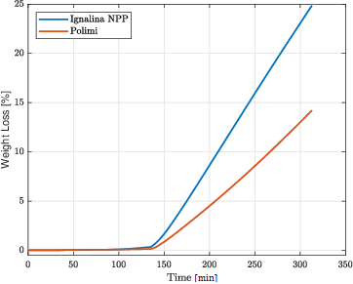
Figure 3: comparison between oxidation behaviours (isothermal tests – after 180 min. in air at 650 °C)
From data collected during isothermal tests, it was also possible to calculate the kinetic parameters of the oxidation reaction, such as oxidation rates and activation energies.
Calculations were done in compliance with the procedure described by ASTM D7542-15, so kinetic parameters and Arrhenius equation were assessed from the temperature dependence of oxidation rates measured over the temperature range where Arrhenius plots are linear, usually from 500 – 550 °C to 700 – 750 °C.
Rates of weight loss were calculated by a linear fit of the weight plotted against time, the most linear part is usually between 5 % and 10 % of the starting mass, since weight loss below 5 % includes an induction period where reactive surfaces is created. On the other hand, for weight losses above 10 %, the samples dimensions could be significantly distorted.
Weight-normalized oxidation rate (OR_{w}) was calculated dividing the slope of weight loss by the initial weight of specimen, and area-normalized oxidation rate (OR_{A}) was calculated dividing the slope of weight loss by the initial area of the specimen.
The rates calculated for Polimi and Ignalina NPP graphite are reported in the Table 2 and 3. The temperatures at which Ignalina NPP graphite was tested are lower due to its lower resistance to high temperature oxidation, exhibited during isothermal tests.
Activation energies in kJ/mol were calculated using Eq(1) from Arrhenius plots (examples shown in Figure 4):
$E_{a}= -0.019138∙Slope$ (1)
where the numerical factor 0.019138 = 2.303 × 8.314 × 0.001 includes the gas constant and the conversion factor of natural to decimal logarithms.
Table 2: oxidation rates Polimi graphite
Temperature  [°C] | Slope of weight loss [g/h] | Weight-normalized oxidation rate  [gg⁻¹h⁻¹] | Area-normalized oxidation rate  [gh⁻¹m⁻²]
550  600  650  675  700  725 | 0.001  0.004  0.016  0.029  0.052  0.089 | 0.003  0.012  0.050  0.087  0.158  0.268 | 5.095  20.382  82.548  147.771  266.497  456.051

Table 3: oxidation rates Ignalina NPP graphite
Temperature  [°C] | Slope of weight loss [g/h] | Weight-normalized oxidation rate  [gg⁻¹h⁻¹] | Area-normalized oxidation rate  [gh⁻¹m⁻²]
550  600  625  650 | 0.002  0.007  0.011  0.026 | 0.006  0.026  0.038  0.087 | 8.662  38.216  55.541  131.465

a) Ignalina NPP b) Polimi
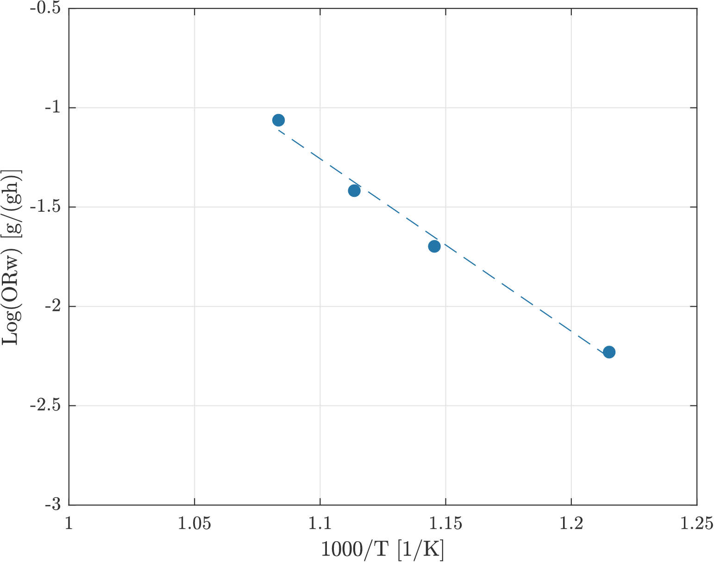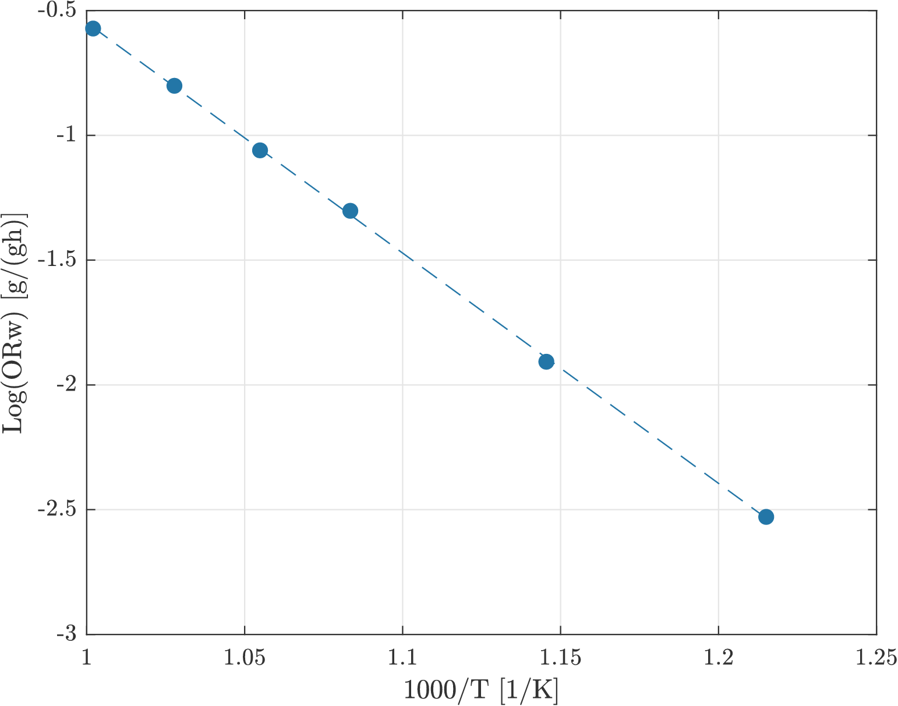
R²= 0.9998

y= -9.2299x + 8.6811

R²= 0.9903

y= -8.6863x + 8.2951

Figure 4: Arrhenius plots of weight-normalized oxidation rates for Ignalina NPP (a) and Polimi (b) samples
The value of activation energy computed from linear Arrhenius plots for Polimi graphite was about 176 kJ/mol, while the value calculated for Ignalina NPP graphite was about 166 kJ/mol.
The values found are coherent with oxidation studies in literature at the same temperatures, where examples of activation energy values ranges are: 150 – 160 kJ/mol (Lu et al., 2019); 170 – 210 kJ/mol (Kane et al., 2017); 190 – 210 kJ/mol (Zhou et al., 2017).
From data collected it can be observed that oxidation behaviours of the two materials are similar, even if Ignalina NPP graphite samples show a slightly lower resistance to oxidation. Lower oxidation resistance may cause a larger change and increase in porosity. Higher porosity means more reaction surface, and the oxidation reaction leads to a further change in porosity and to an increase in oxidation rate (Chen et al., 2012). However, the oxidation behaviour of each nuclear graphite is unique and related to several characteristics, such as impurities, grain size, pore structure, graphitization degree, antioxidation treatments.
  - Conclusions
This paper aims to describe a procedure that was validated to test different graphite specimens obtained from different cutting technologies during dismantling operations of nuclear reactors, and to compare results obtained from tests on two different graphites.
Results obtained from preliminary tests on two types of graphite samples were comparable with the ones found in literature achieved also with different experimental setups.
The oxidation behaviours of the two materials are similar, even if Ignalina NPP graphite samples show a slightly lower resistance to oxidation.
As expected, temperature is the parameter with the highest effect on oxidation behaviour, during non-isothermal tests in air, oxidation reaction was evidenced at temperatures above 700 °C for both graphites with a very high increase in oxidation rate. At the end of tests, it was observed a high degradation for both with high shrinkage and changing of dimensions, due to the higher rate of reaction in comparison with the rate of gas transport at very high temperatures.
On the other side, in N₂ mass loss extent was negligeable. So, in the case of dismantling operations, an option could be a nitrogen assisted thermal cutting technology.
In isothermal tests oxidation reaction was detectable at temperatures higher than 600 °C for both graphites. At temperature above 600 °C, higher oxidation rates were recorded for Ignalina NPP graphite which easily degrades at 650 °C. Activation energies were quite high for both kinds of graphite, meaning a quite good resistance to oxidation at the test temperatures.
Acknowledgments
This project has received funding from the Euratom research and training programme 2019-2020 under grant agreement No 945273 (Inno4Graph).
Disclaimer: This dissemination of results reflects only the authors’ view; the Commission is not responsible for any use that may be made of the information it contains.
References
ASTM D7542-15, 2015, Standard Test Method for Air Oxidation of Carbon and Graphite in the Kinetic Regime, ASTM International.
Chen D, Li Z., Miao W., Zhang Z., 2012, Effects of porosity and temperature on oxidation behaviour in air of selected nuclear graphites, Materials Transactions, 53, 1159-1163
Copelli S., Barozzi M., Fumagalli A., Derudi M., 2019, Application of a Gaussian model to simulate contaminants dispersion in industrial accidents, Chemical Engineering Transactions, 77, 799 - 804
Féron D., 2012, Overview of nuclear materials and nuclear corrosion science and engineering, Nuclear Corrosion Science and Engineering, 31-56
Inno4graph, n.d., Objectives & Results, Inno4graph <inno4graph.eu/objectives-results/> accessed 24.11.2021
Kane J.J., Contescu C.I., Smith R.E., Strydom G., Windes W.E., 2017, Understanding the reaction of nuclear graphite with molecular oxygen: Kinetics, transport, and structural evolution, Journal of Nuclear Materials 493, 343-367
Lu W., Li M.Y., Li X.W., Wu X.X., Sun L.B., Li Z.C., 2019, Experimental study on the oxidation behavior and microstructural evolution of NG-CT-10 and NG-CT-20 nuclear graphite, Nuclear Science Techniques, 30:165
Luo X., Robin J.C., Yu S., Effect of temperature on graphite oxidation behaviour, 2004, Nuclear Engineering and Design, 227, 273-280
Marsden B.J., 2001, Nuclear graphite for high temperature reactors, International Atomic Energy Agency, 177-192
Matthews A.C., Kane J.J., Swank W.D., Windes W.E., 2021, Nuclear graphite strength degradation under varying oxidizing conditions, Nuclear Engineering and Design 379, 111245
Propp W.A., 1998, Graphite Oxidation Thermodynamics/Reactions, U.S. Department of Energy
Smith R.E., Kane J.J., Windes W.E., 2021, Determining the acute oxidation behavior of several nuclear graphite grades, Journal of Nuclear Materials 545, 152648
Zhou X., Contescu C.I., Zhao X., Lu Z., Zhang J., Katoh Y., Wang Y., Liu B., Tang Y., Tang C., 2017, Oxidation Behavior of Matrix Graphite and Its Effect on Compressive Strength, Science and Technology of Nuclear Installations, 4275375

