CHEMICAL ENGINEERING TRANSACTIONS  VOL. 91, 2022 | A publication of
The Italian Association
of Chemical Engineering
Online at www.cetjournal.it

Guest Editors: Valerio Cozzani, Bruno Fabiano, Genserik Reniers
Copyright © 2022, AIDIC Servizi S.r.l.
ISBN 978-88-95608-89-1; ISSN 2283-9216

A comparative inherent safety assessment of innovative CO₂-based production processes of Dimethyl ether and Methanol
Mariasole Cipolletta*, Valeria Casson Moreno, Valerio Cozzani
Alma Mater Studiorum - Università di Bologna, Department of Civil, Chemical, Environmental and Materials Engineering, via Terracini 28, 40131 Bologna, Italy
*mariasole.cipolletta@unibo.it

Dimethyl ether (DME) and methanol are proposed as synthetic fuels prone to substitute present fossil propellants in the energy transition framework.
Methanol and DME are traditionally synthesised starting from syngas but nowadays new production processes based on the efficient catalytic hydrogenation of CO₂ have been introduced. Multiple catalysts, reaction conditions and reactor configurations have been tested to enhance the production performance of both fuels, especially for the case of DME. In fact, DME can be produced indirectly from CO₂, i.e. after methanol synthesis and purification. Alternatively, it can be synthesised in a one-pot conversion mode by means of bifunctional catalysts directly receiving CO₂. The latter route, avoiding several intermediate separation operations, appears promising from the process intensification viewpoint, thus favouring DME production with respect to methanol.
Since safety plays an important role from the standpoint of societal acceptability, it needs to be considered in the selection of sustainable alternatives, especially when dealing with novel processes in the context of energy transition. This contribution aims to address an inherent safety assessment for the comparison of the production processes of methanol and DME production via CO₂ hydrogenation. Inherent safety is evaluated through a consequence-based approach using specific Inherent Safety Key Performance Indicators, which proved to be effective in several applications to early process design. The results obtained shed light on the inherent safety performance of these alternative routes, thus helping decision-makers in accounting for process safety issues in the assessment of the sustainability of these alternative energy vectors for Power to Liquid (PtL) applications and in the selection of the best technological alternative.
  - Introduction
Methanol and DME are alternative fuels gaining increasing interest as energy vectors in the framework of energy transition as they can be obtained from PtL processes. They may find application also in transportation, considering the minor modifications that commercial engines need to undergo for their safe use, as well as in daily applications, as substitutes of natural gas or LPG for cooking (Bizzo et al., 2004).
Both these substances present several advantages when used as energy vectors. However from the safety viewpoint, DME and methanol have quite different hazard characteristics. The GHS classification reports DME to be extremely flammable (H220), dangerous in its storages under pressure (H280) and worth of warning (H336) regarding health hazards (PubChem, 2021). On the counterpart, methanol liquids and vapours are highly flammable (H225) and present several danger statements concerning acute toxicity and health hazards (H301, H311, H331, H370) (WebWISER, 2022). Given these differences, the risk implications deriving from DME and methanol presence in chemical processes are non-obvious and always need detailed investigation.
Traditionally, they are obtained from syngas according to well-known technologies as the MegaMethanol® and MegaDME® Lurgi processes which are based on methane or petroleum-derived fuels. However, the potential implementation of alternative processes based on direct synthesis from CO₂ has been reported in the literature for several years (Pontzen et al., 2011). In fact, abandoning fossil fuels as raw materials and energy sources towards the valorisation of Renewable Energy Sources (RESs) is a key factor entering any anthropic activity, included the sector of novel fuels (Bonan and Doney, 2018). Therefore, pathways for the production of Methanol and DME from CO₂ and green H₂ have been under intensive investigation as a manner to avoid Greenhouse Gases emissions by Carbon Capture and Utilisation (CCU) and to reduce environmental impacts, as demonstrated by Matzen and Demirel (2016). An explicative example of the concept is the system designed by DinAli and Dincer (2019) where a solar cogeneration system is coupled with a DME production plant, with similar applications abounding in literature and searching for the sustainability convenience (Cipolletta et al., 2020b).
DME is typically obtained from methanol through dehydration on acidic catalytic sites, generally provided by ferrierite zeolites (Sheng et al., 2020). Lately, DME one-step production from CO₂ and H₂ is receiving increasing attention as a direct pathway intensifying the production process, as Kartohardjono et al. (2020) report, highlighting the higher energy savings and improved performances with respect to the indirect alternative performing separately methanol synthesis and dehydration. In this attempt, the main issue stays in the combination of different catalysts for the synthesis of both methanol and DME, thus in the preparation of hybrid catalysts (Mota et al., 2021). Sheng et al. (2020) prepared hybrid catalysts for the direct DME synthesis with different procedures and performed an experimental campaign testing several operating conditions for the one-pot DME production reaction; similarly; Kornas et al. (2017) tested the possibility to drug the activators with metals finding an improvement in DME selectivity.
The principles of substitution and intensification belong to procedures including approaches of inherent safety in early process design (Wallace, 2007), therefore the novel DME synthesis process demonstrate high potential to perform more safely than the “parent” methanol process, always starting from CO₂ and H₂. Nevertheless, the intensification occurring in some operations does not imply the overall process being improved under the inherent safety aspect, therefore dedicated assessments should be performed to clarify the comparison. Among the existing methodologies for inherent safety assessment, consequence-based ones provide quantitative and significant insights over the safety performance of any process scheme, enabling to identify critical equipment and process conditions. As a consequence, the apparent benefits of the one-pot DME synthesis may make this vector more convenient than methanol in terms of process safety, thus scoring a point against methanol when decision-making has to be performed among energy vectors processes in order to store additional renewable energy while employing captured CO₂ in the frame of CCU.
This study aims at comparing methanol and DME production processes based on CO₂ hydrogenation from the inherent safety viewpoint due to their relevance as synthesis routes to be coupled with renewable energy storage by PtL. The assessment is carried out through the application of a well-known inherent safety assessment method, originally proposed by Tugnoli et al. (2007), which is based on Inherent Safety Key Performance Indicators (IS-KPIs) obtained from consequence assessment. This methodology was proved effective in different applications, suiting the designer’s need of a safety-evaluating tool in the early steps of process design (Tugnoli et al., 2012).
  - Methodology
To run the inherent safety analysis on the above described production processes, the methodology of Inherent Safety Key-Performance Indicators (IS-KPIs) as introduced by Tugnoli et al. (2007), was applied.
The conceptual process design of the production plants for methanol and DME synthesis is performed selecting the most performing reaction systems for both products and adapting the process to a small industrial scale with productivity of 500 t/y, in line with a study previously performed by the same authors (Cipolletta et al., 2020a).
Optimal process operating conditions and parameters are identified for each process by means of the Aspen HYSYS v.10 software (AspenTech, 2020). Preliminary equipment design is carried out and chemical inventories are calculated in order to identify the Potentially Hazardous Equipment (PHE). Three types of critical events involving the loss of containment of the equipment are associated to each PHE (Uijt de Haag and Ale, 1999): catastrophic rupture, large and small bores (LOC 1, 2 and 3 respectively).
The releases are then simulated by the application of source models to quantify the flowrates (Van den Bosch et al., 1997) while Credit Factors (C_{f}s), representing the yearly occurrence frequencies, are assigned to each LOC. C_{f}s are derived by baseline values suggested for equipment failure, as per Uijt de Haag and Ale (1999).
Then Release Accident Scenarios (RASs) deriving from the critical events are identified by means of event trees which are associated to the j-th LOC considered for the i-th unit.
Each RAS effect is quantified through the evaluation of its damage distance (DD), which is the distance at which the consequences of the scenario of concern equal a threshold value for the human target, which is specific for each dangerous phenomenon (radiation, overpressure, toxic concentration). The threshold values for fires, explosions and toxic clouds are reported by Tugnoli et al. (2007); being the IDLH for DME not yet determined, the limit toxic concentration considered is 144000 ppm, value found to provoke loss of conscience after 26 minutes of exposure (PubChem, 2021).
For the calculation of the DDs, the software PHAST v.6.5.4 (DNV-GL, 2020) for consequences evaluation is used, applying reference environmental conditions (average wind speed of 1.5 m/s, Pasquill category F (i.e. night time, air temperature of 25 °C with 70 % of relative humidity, and surface temperature of 10 °C). Hazardous inventories less than 1 kg were not simulated; effects were registered at 1 m height from the ground level. Then after, IS-KPIs are calculated for the i-th PHE as in Eqs. 1 to 4. The Unit Potential hazard Index (${UPI}_{i}$) [m²] is based on the comparison of all maximum damage distances h_{i,j} associated to the i-th PHE and derived by any j-th LOC, thus this indicator is a metric of the maximum impact area that could be affected by the worst-case scenario generated by the i-th PHE. The Unit inherent Hazard Index (${UHI}_{i}$) [m²/y] considers also the likelihood of the worst release scenario through the C_{f}s, thus being an expression of the risk associated to the equipment item. In order to deepen the consequence understanding, also the maximum fire scenario-derived DD and toxic dispersion DD are associated to the i-th PHE and j-th LOC and tagged as f_{i,j} and t_{i,j} respectively. These distances determine the quantification of the related indices in Eqs. 3 and 4, namely Unit Flammability inherent Hazard Index (${UFHI}_{i}$) [m²/y] and Unit Toxicity inherent Hazard Index (${UTHI}_{i}$) [m²/y].
$${UPI}_{i}={π max}_{j}\left({h_{i,j}}^{2}\right)$$ | (1)
$${UHI}_{i}= π\sum_{j}^{LOC}{C_{fi,j}∙{{ h}_{i,j}}^{2}}$$ | (2)
$${UFHI}_{i}= π\sum_{j}^{LOC}{C_{fi,j}∙{{ f}_{i,j}}^{2}}$$ | (3)
$${UTHI}_{i}= π\sum_{j}^{LOC}{C_{fi,j}∙{{ t}_{i,j}}^{2}}$$ | (4)
Finally, the unit metrics are unified in overall process IS-KPIs ($PI,$ $HI$, $FHI,$ $THI$) through a summation on all PHEs identified, which allow the discussion about process alternatives and their ranking from the inherent safety standpoint.
  - Process Schemes
The design of the processes for the production of methanol and DME from CO₂ hydrogenation was based on a productivity equal to 500 t/y and on a products purity of 98 % molar basis.
The simplified process schemes are reported in Figure 1 and Figure 2, where PHEs, i.e. equipment containing hazardous inventories, are highlighted.

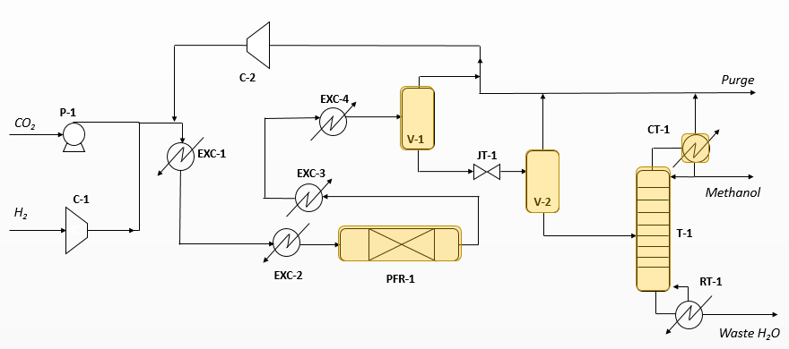
Figure 1: Process scheme for methanol production (adapted from Matzen et al., 2015).
In Figure 1 the catalytic hydrogenation of CO₂ to methanol is run in a low-pressure isothermal packed reactor operating at 235 °C and 50 bar (Matzen et al., 2015). The catalyst used is Cu/ZnO/Al₂O₃ and the H₂/CO₂ ratio at the reactor inlet is 2.8. The achieved CO₂ pass conversion is 47 % with 99.7 % methanol selectivity. In the upstream section, H₂ and CO₂ are pressurized up to 50 bar, mixed and pre-heated to gain the reactor temperature. In the downstream section, the process stream is cooled in order to obtain methanol’s and water’s condensation in two steps (Matzen et al., 2015). H₂ and CO₂ present in the vapor phase are recycled back to the reactor, whereas the liquid phase is gradually expanded to ambient pressure and methanol purified in the final distillation column.
The optimized conditions and parameters for the DME process design (in Figure 2) were found in the study of Kartohardjono et al. (2020) for DME one-pot synthesis, as previously reported also by Ateka et al. (2018). The reactor operates at 40 bar, 267 °C in presence of a hybrid catalyst and an optimal H₂:CO₂ ratio of 2.3; the CO₂ pass conversion is 14 %, the selectivities to DME and methanol are 59 % and 38 % respectively.
Similarly to the methanol process, the substrates are heated and compressed up to the reactors conditions; the stream exiting the reactor is gradually cooled down and undergoes distillation to recover DME with separation from the methanol solution at the bottom and from the light gases at the top. To improve DME purity a sequence of expansions and cooling is furtherly needed (Hosseininejad et al., 2012).
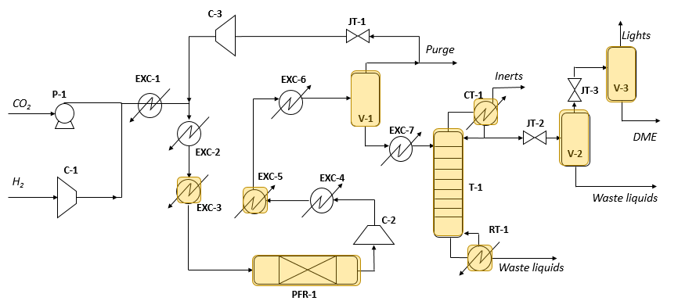
Figure 2: Process scheme for DME production (adapted from Kartohardjono et al. 2020).
  - Results and discussion
From Figure 3, reporting the resulting IS-KPIs, it can be observed that in each index category the inherent safety performance of the DME process is worse than the methanol process’ one. It is due to both presence of DME, absent in the methanol scheme, and to the higher number of PHEs, i.e. higher inventories, as displayed in Figure 2. Although the core operation conditions for one-pot DME synthesis occur at similar conditions of the methanol scheme, the yield in the desired product is scarcer, thus the ether is diluted in the reaction mixture made of unreacted compounds and by products. Therefore the intensification performed in the DME reactor leads to the design of a complex downstream section for the product purification, also considering that DME is extremely miscible with methanol but is also very volatile to be easily lost with light compounds.

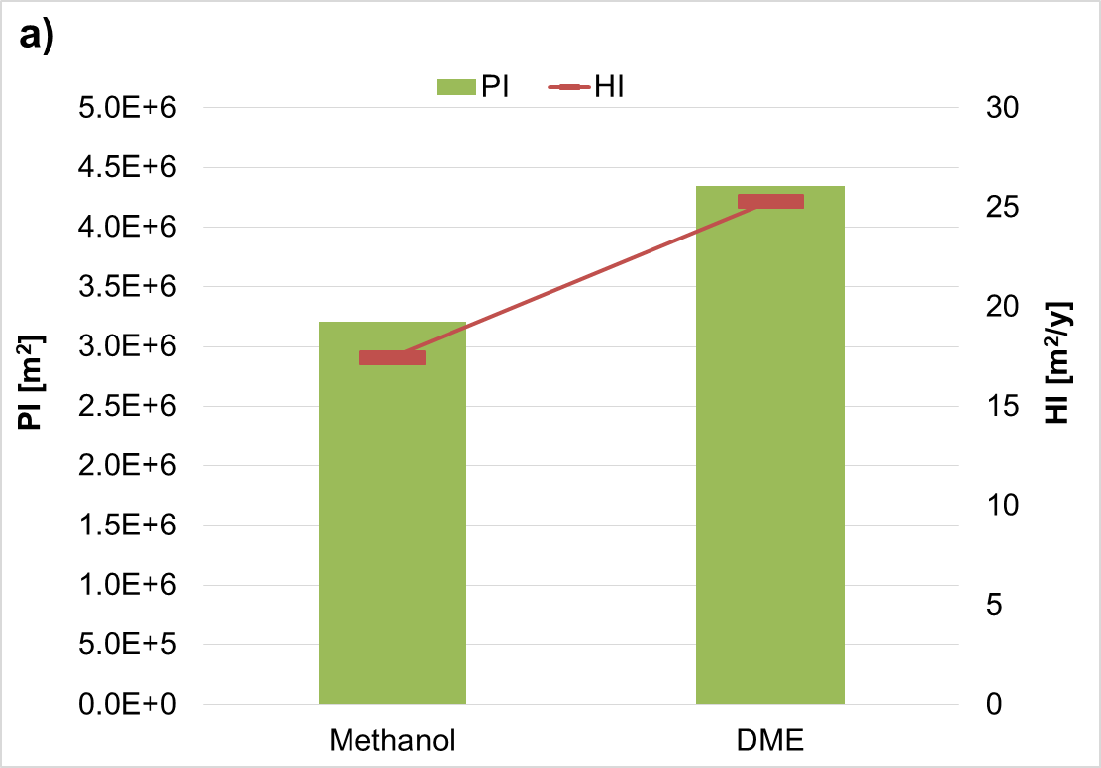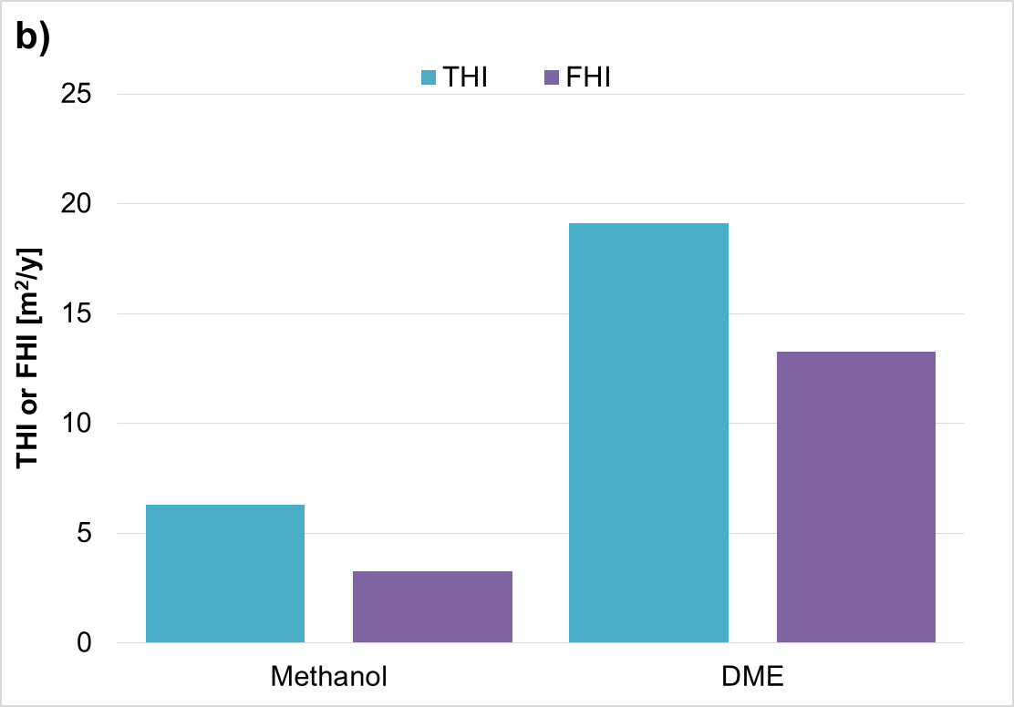
Figure 3. IS-KPIs for the two processes considered: a) PI and HI; b) THI and FHI.
The breakdown of the HI overall indices according to each originating PHE is reported in Figure 4a, highlighting that in the methanol process there are two main equipment items responsible for the whole risk picture of the scheme, namely the reactor PFR-1 and the first separation knock-out drum V-1; on the counterpart, several equipment determine the overall process risk in the DME facility, with the separator V-1 and the distillation tower T-1 presenting the worst UHIs. It is also important to identify the RAS mostly contributing to PI, HI and FHI as displayed in Figure 4b (for THI the only scenario is toxic cloud dispersion).
In fact, the acknowledgement of the consequences of highest entities helps in adopting proper safety preventive actions in the control strategy of the equipment. Among the worst fire scenarios accounted in the FHI index, jet fires are the riskiest RASs in both process schemes, due to methanol’s presence. In the HI and PI indices, in contrast, toxic clouds represent both the most severe and risky final scenarios for both production processes, with a higher impact in the methanol scheme; in the DME process scheme toxic dispersion scenarios contribute up to 70 % and 80 % in HI and PI indices respectively, the remaining parts being due to possible occurrences of jet fires.
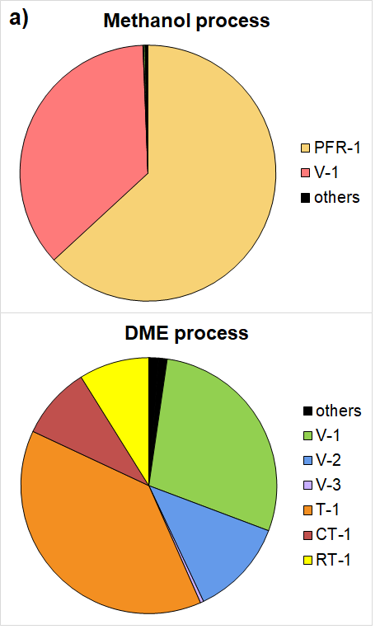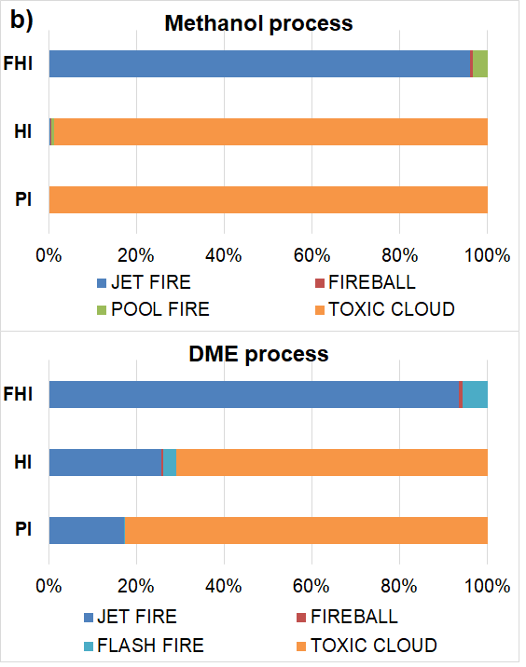
Figure 4. a) Contribution of the PHEs to the process HI indices; b) Percentage contribution of each RAS to the final indices FHI, HI and PI.
  - Conclusions
The investigation on novel production processes for alternative fuels is essential in the framework of the present energy transition. Methanol and DME have huge potentialities as substitutes of traditional fuels within PtL strategies integrated to renewable energy harvesting and as CCU products. Given these reasons, several research efforts have been oriented to their sustainable synthesis from CO₂ and H₂ via catalytic hydrogenation. The one-pot DME synthesis appears a very promising route applying reaction intensification. Nevertheless, only a quantitative consequence-based inherent safety assessment can effectively depict the safety performance of the one-pot DME production with respect to the base methanol process, starting from the same substrates.
This study, by applying the aforementioned approach, revealed the criticalities hidden behind the full process design of the DME facility, where the numerous downstream equipment items are characterized by non-negligible risks at the eventual verification of loss of containments. The inherent safety assessment was confirmed again as an extremely useful tool helping the decision-makers under the societal aspect, towards the selection of the most sustainable process alternative.
References
AspenTech, 2020, Aspen HYSYS, version 11
<www.aspentech.com/en/products/engineering/aspen-hysys> accessed 04.01.2020.
Ateka A., Ereña J., Bilbao J., Aguayo A. T., 2018, Kinetic modeling of the direct synthesis of dimethyl ether over a CuO‑ZnO‑MnO/SAPO‑18 catalyst and assessment of the CO₂ conversion, Fuel Processing Technology, 181, 233–243.
Bizzo W. A., de Calan B., Myers R., Hannecart T., 2004, Safety issues for clean liquid and gaseous fuels for cooking in the scope of sustainable development. Energy for Sustainable Development, 8(3), 60–67.
Bonan G. B., Doney S. C., 2018, Climate, ecosystems, and planetary futures: The challenge to predict life in Earth system models, Science, 359(6375).
Cipolletta M., Moreno V. C., Cozzani V., 2020, Inherent safety assessment for two solar-based fuels production processes: Methanol via CO₂ catalytic hydrogenation and biodiesel from microalgal oil, Chemical Engineering Transactions, 82(August), 85–90.
Cipolletta M., Moreno V. C., Tugnoli A., Cozzani V., 2020, Comparing energy efficiency for emerging fuel production technologies: 3rd generation biodiesel vs methanol from solar power, Chemical Engineering Transactions, 80, 355–360.
DinAli M. N., Dincer I., 2019, Performance assessment of a new solar energy based cogeneration system for dimethyl-ether and electricity production, Solar Energy, 190, 337–349.
DNV-GL, 2020, PHAST - Process Hazards Analysis Software, version 6.4
<www.dnvgl.com> accessed 04.01.2020.
Hosseininejad S., Afacan A., Hayes R. E., 2012, Catalytic and kinetic study of methanol dehydration to dimethyl ether, Chemical Engineering Research and Design, 90(6), 825–833.
Kartohardjono S., Adji B. S., Muharam Y., 2020, CO₂ Utilization Process Simulation for Enhancing Production of Dimethyl Ether (DME), International Journal of Chemical Engineering, 2020, 16–19.
Kornas A., Grabowski R., Śliwa M., Samson K., Ruggiero-Mikołajczyk M., Żelazny A., 2017, Dimethyl ether synthesis from CO₂ hydrogenation over hybrid catalysts: effects of preparation methods. Reaction Kinetics, Mechanisms and Catalysis, 121(1), 317–327.
Matzen M., Alhajji M., Demirel Y., 2015, Chemical storage of wind energy by renewable methanol production : Feasibility analysis using a multi-criteria decision matrix. Energy, 93, 343–353.
Matzen M., Demirel Y., 2016, Methanol and dimethyl ether from renewable hydrogen and carbon dioxide: Alternative fuels production and life-cycle assessment, Journal of Cleaner Production, 139.
Mota N., Ordoñez E. M., Pawelec B., Fierro J. L. G., Navarro R. M., 2021, Direct synthesis of dimethyl ether from co2: Recent advances in bifunctional/hybrid catalytic systems, Catalysts, 11(4).
WebWISER, 2022, Methanol, NIH-National Library of Medicine, website: <webwiser.nlm.nih.gov/substance?substanceId=19&catId=242> accessed: 2.22.22
Pontzen F., Liebner W., Gronemann V., Rothaemel M., Ahlers B., 2011, CO₂-based methanol and DME - Efficient technologies for industrial scale production, Catalysis Today, 171(1), 242–250.
PubChem, 2021, Dimethyl ether, National Library of Medicine website: <pubchem.ncbi.nlm.nih.gov/source/hsdb/354#section=Human-Toxicity-Excerpts-(Complete)> accessed: 15.12.21
Sheng Q., Ye R. P., Gong W., Shi X., Xu B., Argyle M., Adidharma H., Fan M., 2020, Mechanism and catalytic performance for direct dimethyl ether synthesis by CO₂ hydrogenation over CuZnZr/ferrierite hybrid catalyst, Journal of Environmental Sciences (China), 92, 106–117.
Tugnoli A., Cozzani V., Landucci G., 2007, A Consequence Based Approach to the Quantitative Assessment of Inherent Safety, A.I. Chemical Engineering Journal, 53(12), 3171–3182.
Tugnoli A., Landucci G., Salzano E., Cozzani V., 2012, Supporting the selection of process and plant design options by Inherent Safety KPIs, Journal of Loss Prevention in the Process Industries, 25, 830-842.
Uijt de Haag P. A. M., Ale B. J. M, 1999, Guidelines for quantitative risk assessment (Purple Book), the Hague, Netherlands.
Van den Bosch C. J. H., Weterings R. A. P. M., TNO, 1997, Methods for the calculation of physical effects: due to releases of hazardous materials (liquids and gases), Yellow book, The Hague, Netherlands.
Wallace S. J., 2007, The case for inherent safety: A review of the principles of inherent safety and case studies of tragedies, ASSE Professional Development Conference 2007, (513).

