CHEMICAL ENGINEERING TRANSACTIONS  VOL. 91, 2022 | A publication of
The Italian Association
of Chemical Engineering
Online at www.cetjournal.it

Guest Editors: Valerio Cozzani, Bruno Fabiano, Genserik Reniers
Copyright © 2022, AIDIC Servizi S.r.l.
ISBN 978-88-95608-89-1; ISSN 2283-9216

Prediction of Condensed Phase Formation during an Accidental Release of Liquid Hydrogen
Federico Ustolinª*, Federica Ferrari^{a,b}, Nicola Paltrinieri^{a,b}
ªDepartment of Mechanical and Industrial Engineering, Norwegian University of Science and Technology NTNU, Richard Birkelands vei 2B, 7034 Trondheim, Norway
^{b}Dipartimento di Ingegneria Civile, Chimica, Ambientale e dei Materiali, Università degli studi di Bologna, Via Terracini 28, 40131 Bologna, Italy
federico.ustolin@ntnu.no
Hydrogen can be adopted as a clean alternative to hydrocarbons fuels in the marine sector. Liquid hydrogen (LH₂) is an efficient solution to transport and store hydrogen onboard of large ships. LH₂ will be implemented in the maritime field in the near future. Additional safety knowledge is required since this is a new application and emerging risk might arise. Recently, a series of LH₂ large-scale release tests was carried out in an outdoor facility as well as in a closed room to simulate spills during a bunkering procedure and inside the ship’s tank connection space, respectively (Aaneby et al., 2021). The extremely low boiling point of hydrogen (-253°C (NIST, 2019)) can cause condensation or even solidification of oxygen and nitrogen contained in air, and thus enrich with oxygen the flammable mixture. This can represent a safety concern since it was demonstrated that a burning mixture of LH₂ and solid oxygen may transition to detonation (Litchfield and Perlee, 1965). In this study, the experimental data of an LH₂ release test series recently carried out were analysed by means of an advanced machine learning approach. The aim of this study was to provide critical insights on the oxygen condensation and solidification during an LH₂ accidental release. In particular, a model was developed to predict the possibility and the location of the oxygen phase change depending on the operative conditions during the bunkering operation (e.g. LH₂ flowrate). The model demonstrated accurate and reliable predicting capabilities. The outcomes of the model can be exploited to select effective safety barriers such as a water deluge system to prevent the oxygen change phase.
  - Introduction
The employment of hydrogen as alternative fuel in the maritime sector has been suggested by different authors in the past and it is now becoming a reality (Taccani et al., 2018). This is demonstrated by the recent safety tests carried out by DNV on liquid hydrogen (LH₂) releases to simulate potential accident scenarios in the maritime field (Aaneby et al., 2021). It is critical to focus on the hydrogen safety aspects when it is employed in new applications (Ustolin et al., 2020a). In fact, atypical accident scenarios, which are phenomena with low probability to occur and that are not considered by conventional risk assessment techniques, must be avoided during the deployment of hydrogen technologies (Ustolin et al., 2020b). For instance, the rapid phase transition (RPT) is a physical explosion that might arise when cryogenic fluids are spilled onto water during bunkering operations (Ustolin et al., 2020c). The possibility and consequences of an RPT in the case of LH₂ releases were investigated by (Odsæter et al., 2021).
The aim of this work is to determine if an LH₂ release may cause air component’s liquefaction or solidification, and whether the resulting cloud has a hydrogen concentration higher than the lower flammability limit (LFL). An advanced machine learning approach was employed for this investigation and a good agreement with experimental results was achieved.
  - Liquid hydrogen release consequences
When released onto the ground, the cryogenic liquid initially flashes to gas due to the large temperature difference and the consequent heat transfer between the fluid and the ground surface. Then, the surface cools down enough to allow the formation of an LH₂ pool within few minutes. Therefore, the pool formed on the ground is composed of LH₂. It is also possible to observe the formation of a solid deposit which might be a mixture of solid air since its components (oxygen and nitrogen) have melting and boiling points higher than the hydrogen ones (Royle and Willoughby, 2014). Therefore, air condenses and freezes on the pool surface and at the edges. Eventually, the solid deposit impedes the liquid to flow further on the ground. Not all the condensed air droplets fall on the pool. Many of them fall outside the pool due to the restriction of the liquid extent caused by the solid deposit. In this manner, condensed air accumulates on the previously deposited material forming a larger solid deposit by freezing at a temperature higher than the hydrogen boiling point. The main problem connected to the condensation and freezing of air components on the ground is related to the behaviour of the flammable mixture in case of ignition: a condensed phase explosion might occur. Condensed phase explosions can have harmful consequences to both buildings and people which manifest as: shock wave, fragments, thermal radiation. The condensed phase explosion may or may not occur if a liquid hydrogen-condensed air mixture is ignited depending on some conditions. Many experimental tests were performed in the past in order to investigate the behaviour of the flammable mixture composed by liquid hydrogen and oxygen. Those tests established that in case of ignition of a liquid hydrogen-solid oxygen mixture, a rapid deflagration to detonation transition occurs and can still be observed if the solid oxygen is diluted with nitrogen to 50 % wt/wt (Atkinson, 2021). For higher nitrogen contents the mixture burns without exploding. This means that if air condenses on the surface of a cryogenic liquid spill, the resulting flammable mixture may or may not lead to a condensed phase explosion if ignited. The outcome depends on the composition of the frozen air and the extent to which it has been enriched by oxygen. In fact, oxygen has higher melting and boiling temperatures than nitrogen, therefore it may condense faster than nitrogen, leading to oxygen enrichment in the solidified deposit (Atkinson, 2021). However, only the quantity of solid material in contact with LH2 in the pool reaches temperatures close to -253°C. Therefore, only a proportion of the solid deposit might form a detonable mixture with LH₂. More recent studies about large spills scenarios onto concrete pads have shown significant condensed phase explosion following the initial ignition (secondary explosion), revealing that some flow conditions such as hydrogen to air ratio and wind conditions lead to oxygen enrichment and facilitate the deflagration to detonation transition.
Other consequences connected to the leakage of LH₂ are related to the vapour cloud which is formed immediately after the release. As previously mentioned, part of the cryogenic liquid flashes forming a flammable aerosol (Liu et al., 2019). Despite hydrogen has no colour, the cloud is visible due to the condensation of water vapour present in air during the release. Moreover, the hydrogen dispersion highly depends on the wind speed and direction. Therefore, a flammable atmosphere develops if the hydrogen concentration reaches the lower flammability limit (LFL). If it is immediately ignited a jet fire continuously fed by the leakage is originated. On the other hand, if an immediate ignition is not present and the dilution is fast enough, the cloud disperses safely, while a fire or an explosion are generated if the cloud encounters a delayed ignition (1-5 minutes after the release began):
- vapour cloud fire: fire with no explosive effects
- vapour cloud explosion (VCE): fire with explosive effects.
A VCE occurs when the flame front accelerates to a velocity higher than 40 m/s in presence of partial confinement (Thomas et al., 2014). Since the consequences of an explosion event are extremely severe, the prediction of the hydrogen concentration in the cloud is crucial.
    - Mitigation measures
Once the release has occurred, some safety procedures should be automatically activated. Typically, sensors and detectors can be used to detect hydrogen leakages. These sensors are able to shut down systems, limiting the amount of liquid hydrogen released, and activate alarms to warn the operators. It is suggested to set the set point of the detector to a hydrogen concentration of 1%vol in air, which corresponds to 25% of the lower flammability limit (LFL) (HydrogenTools, 2022). Sensors and detectors might also be designed so that they could activate mitigation tools, such as sprinklers, water curtains or release inert gases in case of hydrogen leakage detection, as well as ventilation.
  - Methodology
An advanced machine learning approach was adopted in this study to provide critical insights on the oxygen condensation and solidification, and hydrogen dispersion (concentration) during an LH₂ accidental release in the vicinity of the leakage. In machine learning, the supervised learning approach is used when the model is fed with both input and output data to perform a task, such as classification (for categories or classes prediction) or regression (to predict a continuous outcome). In this work, the supervised learning method was employed only with the classification task since the aim was to investigate if the cryogenic LH₂ release can provoke liquefaction or solidification of air components, and if a flammable gaseous cloud develops, i.e. if the hydrogen concentration is higher than the LFL. In particular, a linear model was used in the framework of the python library Tensorflow.
The first step in developing a machine learning model is to build a database (matrix) containing both features and labels. The features are vector of attributes associated to an instance of data. In order to predict the liquefaction or freezing of air components due to liquid hydrogen leakage, and the hydrogen concentration close to the release point, the features selected to build the database were the following parameters measured during the experimental tests:
- the timestamp which corresponds to the sampling rate of the sensors;
- LH₂ release flowrate and orientation;
- atmospheric conditions: pressure, relative humidity, wind direction and speed;
- hydrogen tank internal pressure and temperature;
- temperature and hydrogen concentration;
- spatial coordinates of the instrumentation (x, y, z).
The labels defined in the database are the parameters (values or categorise) that the model have to predict. In this study, the labels were defined for each sensor location and time as following:
- oxygen condenses or not
- oxygen freezes or not
- hydrogen concentration > or < LFL
If these phenomena occur, the correspondent label will have a value of 1, while this will be 0 if it will not manifest. This method is called supervised learning binary classification problem. Hence, the database rows are composed by the LH₂ release features, listed above, for each sensor and the related label. The databases have been developed by considering a row for each temperature or concentration value measured by every single thermocouple or sensor for each instant of time, for the entire duration of the experimental test. This has been repeated for every test and all the data collected for each of them have been merged. The data were pre-processed by using the MinMaxScaler normalization method (scikit-learn developers, 2022) in order to avoid the different impact of the features due to their different scales. The normalization method used in this work has been selected among others as it is the most utilised in various fields of application with good results. Therefore, all the variables were rescaled to fit in the range [0,1] through Eq(1):
$x_{norm}=\frac{x-x_{min}}{x_{max}-x_{min}}$ | (1)
The database was then shuffled to avoid poor data distribution and split into two parts: the first one was used to train the model and the second one to evaluate the performance (prediction capability) of the trained model.
To evaluate the performance of the model, performance metrics were used. The confusion matrix is usually adopted in binary classification problems to depict the total number of predictions dividing them in four possible outcomes: (i) true positive (TP) when both the real label and the predicted label of a sample are positive (1), (ii) true negative (TN) when both the real label and the predicted label of a sample are negative (0), (iii) false positive (FP) when the real label is negative and the predicted label is positive and (iv) false negative (FN) when the real label is positive and the predicted label is negative (Jiao and Du, 2016). Therefore, the classifier performance metrics were obtained combining these four values as suggested by Seliya et al. (2009). Based on the definitions above, three basic performance metrics can be estimated: accuracy, precision and recall. In particular, accuracy expresses the fraction of predictions correctly performed by the model and can be estimated by means of Eq(2) (Google Developers, 2022). Precision which expresses the fraction of correct positive predictions and is calculated with Eq(3), while recall expresses the fraction of real positive label correctly predicted and is assessed with Eq(4) (Google Developers, 2022).
$Accuracy=\frac{TN+TP}{TN+FN+TP+FP}$ | (2)
$Precision=\frac{TP}{TP+FP}$ | (3)
$Recall=\frac{TP}{FN+TP}$ | (4)
Thus, the precision-recall curves were obtained and the area under the precision-recall curve (AUCpr), another important performance metric. This is represented by a single value ranging from 0 to 1. The higher the AUCpr the better the classifier’s performance (Seliya et al., 2009). Another performance metric used in this work is the F_measure (Eq(5)), that can be calculated as a function of precision and recall (Chinchor, 1992):
$F_measure=\frac{\left(1+β^{2}\right)∙Precision∙Recall}{β^{2}∙Precision+Recall}$ | (5)
where β = 1 if precision and recall are of equal weight, and the F_measure in this case would be their harmonic mean, β = 1.5 if recall’s optimisation is more important than precision’s optimisation, and β = 0.5 if recall is half as important as precision (Chinchor, 1992). The maximum value of the F_measure corresponds to the best threshold value, that optimises precision or recall or both the parameters. Finally, hydrogen sensors activated systems with a response time of 200 s has been considered in this work to predict the condensation or freezing of air components or the formation of a flammable atmosphere. Therefore, the model is able to carry out a prediction of the label after 200 s from the beginning of the release test.
    - Case study: liquid hydrogen release experiments
The Norwegian Defence Research Establishment (FFI) has performed a series of experimental tests with the objective of understanding the liquid hydrogen behaviour to facilitate its introduction as fuel for ships. The release tests were carried out by varying the flowrate and duration to simulate realistic accidental spills for maritime applications (Aaneby et al., 2021). Two different kinds of tests have been performed: (i) outdoor leakage studies and (ii) closed room and ventilation mast studies. In this work, only the outcomes of the outdoor leakage studies described in the following were considered to train and validate the model.
3.1.1 Outdoor leakage studies
The outdoor leakage tests consisted in the release of liquid hydrogen on the ground on a pad above which many sensors and thermocouples were placed. A total number of seven tests were performed. These tests aimed to simulate liquid hydrogen spills from bunkering operations. The liquid hydrogen release flowrates were varied up to 50 kg/min – which reproduce real accidental release rates – and two intermodal containers were placed close to the release point to simulate obstacles. As stated by Aaneby, Gjesdal and Voie (2021), this study aimed to (i) provide information about the formation, propagation and duration of a cryogenic liquid pool, (ii) evaluate the gas cloud generated by such leakage and (iii) describe the cloud behaviour in case of ignition as a simple burning, a deflagration or a detonation event.
As emerged from the tests, the formation of the liquid pool on the ground depended on the orientation of the release hose (vertical downwards or horizontal) and it only extended up to 0.5 m from the release point. The release of a cryogenic fluid may lead to condensation and freezing of air components on the ground due to the ultra-low boiling point of hydrogen (20 K). These phenomena are particularly critical since they might enhance the risk of explosion of the flammable mixture in case of ignition. Moreover, the concentration of hydrogen within the gas cloud generated by the partial vaporization of the released liquid hydrogen exceeded the lower flammability limit (LFL) within 50 m from the release point. In none of the tests a spontaneous ignition was observed.
  - Results and discussion
The performance metrics provided by the linear model are collected in Table 1 for all the three labels. The highest and lowest accuracies are achieved by the hydrogen concentration and liquid oxygen labels, respectively. On the other hand, the highest precision, recall and AUCpr are obtained for the latter label. This means that the built model is very good at predicting the condensation or solidification of air components on the ground
Table 1: Performance metrics resulting from the evaluation of the linear model trained over the raw outdoor leakage studies database for the three defined labels
Label | Accuracy | Precision | Recall | AUCpr
Liquid oxygen | 0.902 | 0.848 | 0.936 | 0.949
Solid oxygen | 0.957 | 0.830 | 0.613 | 0.807
H2 concentration > LFL | 0.988 | 0.649 | 0.184 | 0.366

The obtained confusion matrices are displayed in Figure 1. These matrices show that the linear model predicted less false negatives (bottom left) than false positives (top right) for the liquid oxygen formation label, while the opposite occurred for the other two ones. Instead, the number of true negatives (top left) is always higher than the true positives (bottom right).

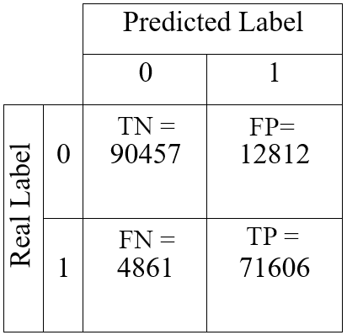 | 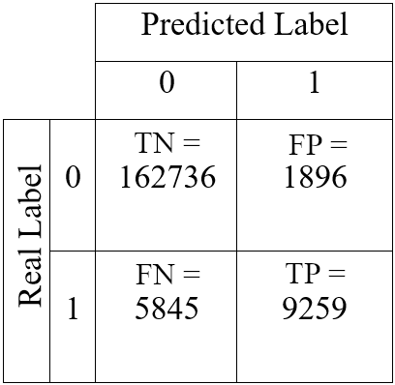 | 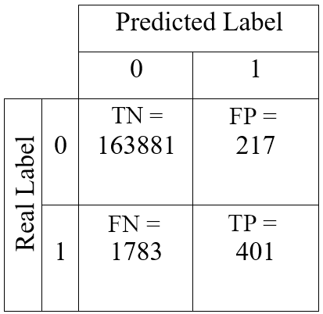
(a) | (b) | (c)
Figure 1: Confusion matrices obtained by the linear model for the labels (a) liquid oxygen, (b) solid oxygen and (c) hydrogen concentration > LFL (abbreviations: TN: true negative, FP: false positive, FN: false negative, TP: true positive, LFL: lower flammability limit)
The precision-recall curves obtained varying the threshold between 0 and 1 associated to the linear model for the three different labels are reported in Figure 2. The curve in Figure 2a (liquid oxygen formation label) exhibits a higher precision and recall compared to the other two curves of Figure 2b and 2c. This is demonstrated by the AUCpr values collected in Table 1.

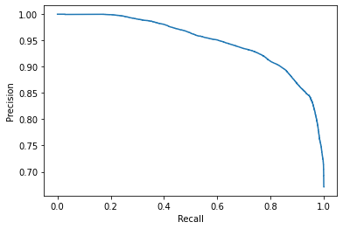 | 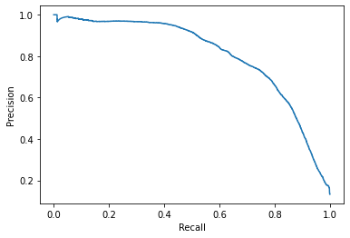
(a) | (b)
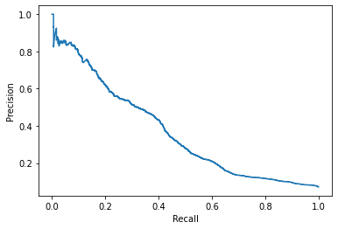
(c)
Figure 2: Precision-recall curves of the Linear Model for the labels (a) liquid oxygen, (b) solid oxygen and (c) hydrogen concentration > LFL (lower flammability limit)
The precision-recall curve displayed in Figure 2 and the performance metrics collected in Table 1, show that the linear model cannot make accurate predictions on hydrogen concentration in air. The obtained metrics are characterised by high accuracy and low precision and recall. This behaviour is typical of imbalanced datasets. By analysing the initial database, the number of data associated to a positive label is much lower than the one to a negative label (only 1.25% of positive labels over the entire database). This results in poor performances. In order to improve these results, the threshold might be lowered to achieve a higher recall by minimising the number of false negatives. This is crucial in this case where the hydrogen concentration is rarely higher than the LFL but may lead to severe consequences. It can be concluded that by training and evaluating the linear model with this database, the condensation of air component (mainly oxygen) can be well predicted. Therefore, the condensed phase explosion phenomenon may be avoided or mitigated by properly designing the bank where the bunkering operation is carried out and adopt the mitigation measures discussed in Sec. 2.1. On the other hand, the prediction of the hydrogen concentration label was unreliable for the reasons previously discussed. As future studies, it is suggested to either modify the database according to the provided indications or employ different machine learning models such as the Deep and Wide&Deep ones to compare their outcomes with the linear model adopted in this study.
  - Conclusions
The main LH₂ release consequences were highlighted and described in this study. Furthermore, an advanced machine learning approach was adopted to analyse the experimental data of an LH₂ release test series recently carried out. In particular, a model had been developed to predict the consequences of an LH₂ release. The model is able to predict the condensation of air component, thus it can be exploited to avoid condensed phase explosions. On the other hand, the model is not reliable in foreseeing the formation of flammable hydrogen-air clouds during the outdoor leakage. Future studies such as the adoption of different machine learning algorithms were proposed.
References
Aaneby J., Gjesdal T., Voie Ø., 2021, Large scale leakage of liquid hydrogen (LH2) - tests related to bunkering and maritime use of liquid hydrogen - FFI-RAPPORT 20/03101.
Atkinson G., 2021, Condensed phase explosions involving liquid hydrogen, in: 9th International Conference on Hydrogen Safety (ICHS)
Chinchor N., 1992. MUC-4 EVALUATION METRICS, in: Proceedings of the 4th Conference on Message Understanding. pp. 22–29.
Google Developers, 2022, Machine Learning Crash Course, Classification <developers.google.com/machine-learning/crash-course/classification/> accessed 11.01.2022.
HydrogenTools, 2022, Hydrogen Leak Detection <h2tools.org/hydrogen-leak-detection> accessed 12.01.2022.
Jiao Y., Du P., 2016, Performance measures in evaluating machine learning based bioinformatics predictors for classifications, Quantitative Biology, 4, 320–330.
Litchfield E.L., Perlee H.E., 1965, Fire and Explosion Hazards of Flight Vehicle Combustibles, Technical Report AFAPL-TR-65-28.
Liu Y., Wei J., Lei G., Chen H., Lanc Y., Gao X., et al., 2019, Spread of hydrogen vapor cloud during continuous liquid hydrogen spills, Cryogenics, 103, 102975.
Odsæter L.H., Skarsvåg H.L., Aursand E., Ustolin F., Reigstad G.A., Paltrinieri N., 2021, Liquid Hydrogen Spills on Water—Risk and Consequences of Rapid Phase Transition, Energies, 14, 4789.
Royle M., Willoughby D., 2014, Releases of unignited liquid hydrogen - RR986 - Health and Safety Laboratory. Harpur Hill (Buxton).
scikit-learn developers, MinMaxScaler, 2022 <scikit-learn.org/stable/modules/generated/sklearn.preprocessing.MinMaxScaler.html> accessed 11.01.2022
Seliya N., Khoshgoftaar T.M., Van Hulse J., 2009, A Study on the Relationships of Classifier Performance Metrics, in: 2009 21st IEEE International Conference on Tools with Artificial Intelligence, 59–66.
Taccani R., Ustolin F., Zuliani N., Pinamonti P., Pietra A., 2018, Fuel cells and shipping emissions mitigation, in: NAV International Conference on Ship and Shipping Research.
Thomas J. K., Eastwood C., Goodrich M., 2015, Are unconfined hydrogen vapor cloud explosions credible?, Process Safety Progress, 34, 36–43.
Ustolin F., Paltrinieri N., Landucci G., 2020a, An innovative and comprehensive approach for the consequence analysis of liquid hydrogen vessel explosions, Journal of Loss Prevention in the Process Industries, 68, 104323.
Ustolin F., Salzano E., Landucci G., Paltrinieri N., 2020b, Modelling Liquid Hydrogen BLEVEs: A Comparative Assessment with Hydrocarbon Fuels, in: 30th European Safety and Reliability Conference and 15th Probabilistic Safety Assessment and Management Conference (ESREL2020 PSAM15).
Ustolin F., Odsæter L.H., Reigstad G., Skarsvåg H.L., Paltrinieri N., 2020c, Theories and Mechanism of Rapid Phase Transition. Chemical Engineering Transaction, 82, 253–258.

