CHEMICAL ENGINEERING TRANSACTIONS  VOL. 91, 2022 | A publication of
The Italian Association
of Chemical Engineering
Online at www.cetjournal.it

Guest Editors: Valerio Cozzani, Bruno Fabiano, Genserik Reniers
Copyright © 2022, AIDIC Servizi S.r.l.
ISBN 978-88-95608-89-1; ISSN 2283-9216

Assessment of Failure Frequencies of Pipelines in Natech Events Triggered by Earthquakes
Fabiola Amaducci, Alessio Misuri, Ernesto Salzano, Valerio Cozzani*
Department of Civil, Chemical, Environmental, and Materials Engineering – DICAM, University of Bologna, Bologna, Italy
valerio.cozzani@unibo.it
During a seismic event, underground pipelines can undergo to significant damages with severe implications in terms of life safety and economic impact. This type of scenarios falls under the definition of Natech. In recent years, quantitative risk analysis became a pivotal tool to assess and manage Natech risk. Among the tools required to perform the quantitative assessment of Natech risk, vulnerability models are required to characterize equipment damages from natural events. This contribution is focused on the review of the pipeline vulnerability models available for the case of earthquakes. Two main categories of models have been identified in the literature. A first category proposes the repair rate as performance indicator for the damage of pipeline due to seismic load, and gives as output the number of required repairs per unit length. A second category proposes fragility curves associated with risk states depending on the mechanism of ground failure. In the framework of Natech risk assessment, the latter have the important advantage of having clearly and unambiguously defined the risk status (and thus the extent of the release) with which they are associated. A subset of vulnerability models deemed more appropriate to be applied in the framework of Natech risk assessment is then identified. Their application to the assessment of the expected frequencies of release events due to pipeline damage is provided, enabling their comparison and the discussion of the relative strengths and weaknesses.
  - Introduction
Earthquakes can cause severe damages to fixed installation and transport systems, as pipelines, possibly leading to the release of hazardous materials and triggering major accidents as fires, explosions and toxic releases. Such cascading events are called Natech events (Krausmann et al., 2017). For example, the rupture of a pipeline near the Santa Clara River, Colorado, during the 1994 Northridge earthquake caused a large oil spill on the ground and into the river (Leveille et al., 1995), producing severe environmental damages and complicating disaster management activities. Natech scenarios are considered important sources of risk because of their possibly serious consequences. Indeed, such technological events may directly affect humans, damage the company assets, and impact the health of the surrounding environment. It is thus clear that the capability to quantify the risk due to Natech accidents is crucial to effectively manage the related risk. This is the reason why in recent years a relevant effort was dedicated to the development of approaches to integrate Natech scenarios in quantitative risk assessment (QRA). One of the key-enabling elements required to allow a QRA of pipelines is the availability of vulnerability models to correlate the intensity of the natural event (expressed by a limited number of parameters) with the expected damage to the structure expressed in terms of failure probability. This paper focuses on the vulnerability models developed to assess earthquake damage to pipelines. Since 1975, researchers have been studying the relationships between the earthquake intensity and the damage to buried pipelines based on the pipeline characteristics (Katayama et al., 1975). These relationships are also known as seismic fragility functions. However, the assessment is not a simple task due to the variety of factors involved, as, for instance, the characteristics of the pipeline segments (e.g., material, diameter, wall thickness), connections and other variables such as corrosion, soil morphology and operating conditions. The aim of this study is to provide a comprehensive overview of the vulnerability models available in the literature for earthquake damage to pipelines, and a comparison of the features of the ones deemed more suitable for the application to the QRA. An overview of the methodology used to retrieve vulnerability models from the literature, and a summary of the references collected are given in Section 2, while in Section 3 they will be described and compared in more detail, showing their main commonalities and differences. Then, in Section 4 the suggested models for a Natech QRA are implemented and in Section 5 the merits and shortcomings of the suggested models are discussed. Finally, the conclusions of the contribution are given in Section 6.
  - Methodology
A review of the academic literature was carried out in order to find empirical vulnerability models for pipelines. For this purpose, the "ScienceDirect" database was mainly used. The search focused on the Natech area using keywords such as “pipeline”, “earthquake”, “fragility curves”, “vulnerability model” and “Probit” and their combination. In addition, more references were found through the snowball method, that is, extending the search looking at each reference cited by the retrieved contributions (Fatemi et al., 2017). The set of models identified through this procedure is shown in Table 1 and Table 2. As can be seen, two main classes of models are identified, the former expressing the result in terms of repair rate (Table 1) and the latter based on fragility curves (Table 2). In addition, in both tables the seismic intensity parameter required as input and the number of past earthquakes on which the models have been developed (N) are indicated.
Table 1 Summary of models expressing the result in terms of repair rate. N = Number of past earthquakes used to develop the models.
Reference | Seismic intensity parameter | N |  | Reference | Seismic intensity parameter | N
(Katayama et al., 1975) | PGA | 6 |  | (Eidinger and Avila, 1999) | PGV, PGD | 3
(Katayama et al., 1977) | PGA | 6 |  | (O’Rourke and Jeon, 1999) | PGV | 1
(Isoyama and Katayama, 1982) | PGA | 1 |  | (Isoyama et al., 2000) | PGA | 1
(Barenberg, 1988) | PGV | 3 |  | (ALA, 2001) | PGV, PGD | 12
(Eguchi et al., 1991) | MMI | 4 |  | (Jui Huang Hung, 2001) | PGA | 1
(Hamada, 1991) | PGA | 2 |  | (Chen et al., 2002) | PGA, PGV | 1
(O’Rourke et al., 1991) | MMI, PGD | 7 |  | (Pineda-Porras and Ordaz-Schroeder, 2003) | PGV | 1
(Porter et al., 1992) | PGD | 2 |  | (Hwang et al., 2004) | PGA, PGV | 1
(O’Rourke and Ayala, 1993) | PGV | 6 |  | (O’Rourke and Deyoe, 2004) | PGV | 5
(Eidinger et al., 1995) | PGV | 7 |  | (Jeon and O’Rourke, 2005) | PGV | 1
(Heubach, 1995) | PGD | 5 |  | (Yeh et al., 2006) | PGA | 1
(Eidinger, 1998) | PGV | 7 |  | (Pineda-Porras and Ordaz, 2007) | PGV²/PGA | 1
(O’Rourke et al., 1998) | PGA, PGV, PGD, MMI | 4 |  | (Maruyama and Yamazaki, 2010) | PGV | 4
(Toprak, 1998) | PGA, PGV | 1 |  | (Sakai et al., 2017) | PGV | 2
Table 2 Summary of models expressing the result in terms of fragility curves. N = Number of past earthquakes used to develop the models.
Reference | Seismic intensity parameter | N
(Lanzano et al., 2013) | PGV | 40
(Lanzano et al., 2014) | PGA, PGV | 20
  - Description of the main features of the current key-enabling models
This section aims to shed light on the type of model, the input parameters needed by the models (whether related to pipelines or earthquake) and finally the damage states and risk states for which the probability of failure is predicted.
    - Types of vulnerability model
Vulnerability models for pipelines fall into two main categories, as anticipated in Section 2. The first, to which most models belong, provides the probability of damage through the calculation of a repair rate, $RR$. For example, in the case of the model presented in (ALA, 2001), the $RR$ parameter is derived through Eq(1):
$RR \left(\frac{n° repairs}{unit of length}\right)=a*IM^{b}$ | (1)
where a and b are two are constants which depend on pipeline design and characteristic, and $IM$ is an intensity indicator for the seismic action in the segment considered. In order to assess the probability to have a total number of n damages (i.e., leaks or breaks) and repairs for a segment of length $L$, a Poisson distribution is implemented, as per Eq(2). Assuming that the pipeline fails when at least one break along its length has occurred, the probability $ψ$ can be calculated by Eq(3).
$ψ= \frac{{\left(RR*L\right)}^{n}}{n!}e^{-RR*L}$ | (2)
$ψ=1-e^{-RR*L}$ | (3)
The models belonging to the second category instead provide the results in terms of fragility curves based on the assumption of a lognormal distribution of damage probability data with respect to IM. In this case, the median $e^{μ}$ and standard deviation of the distributions are provided ($μ$is the mean). The failure probability $ψ$ can be thus obtained by the lognormal cumulative distribution function approximated by Eq(4).
$ψ=\frac{1}{2}\left[1+erf⁡\left(\frac{\ln{IM}-μ}{β\sqrt{2}}\right)\right]$ | (4)
It is not always specified how to determine segment $L$, a good solution is to identify the stretch between two consecutive shutdown valves.
Once $ψ$ is obtained through one of these two approaches, the frequency of loss of containment ($f_{LOC}$) associated to the damage induced by a reference earthquake may be calculated using Eq(5), given a frequency $f$ for the occurrence of earthquake event having a given intensity.
$f_{LOC}=f ψ$ | (5)
    - Input parameters
The models listed in Table 2 distinguish the models only between a set applicable to continuous (CP) pipeline and one to segmented (SP) pipelines (see (Lanzano et al., 2014) for more details on this classification). In addition, it should be noted that (Lanzano et al., 2013) restricts the applicability of their curves to natural gas pipes, and, if desired, one can discern according to the pipeline diameter. On the contrary, those in Table 1 often define specific coefficients according to pipeline material, type of joint and type of soil. For what concerns the seismic intensity, as can be noticed from Table 1 and Table 2, the most common parameters adopted are the peak ground acceleration (PGA), the peak ground velocity (PGV), the peak ground displacement (PGD) and the Modified Mercalli Intensity (MMI). Among the parameters listed, the MMI is used the least since its definition is not objective and it is not easy to accurately predict pipeline damage on its basis (Tsinidis et al., 2019). The other three parameters or combinations of them are very common, and the PGA is particularly easy to find from the hazard maps provided by the authorities (e.g., see (Woessner et al., 2015)). A detailed discussion on this point can be found in (Pineda-Porras and Najafi, 2010). A final comment is given regarding the type of ground movement, since it is usual to distinguish between strong ground shaking (SGS) (i.e., soil deformation, which surrounds the pipeline, without breaks or ruptures in the soil depending on the earthquake intensity) and ground failure (GF) (i.e., phenomenon in which the surrounding soil is affected by failure phenomena caused by the earthquake).
    - Damage states and risk states
As said, the models based on the RR associate the damage with the number of repairs needed to return to operation. The only available recommendation to define the expected damage level on the pipeline for these models is provided by (FEMA, 2020). It assumes that damage due to seismic waves consists of 80% leaks and 20% breaks, while damage due to ground failure consists of 20% leaks and 80% breaks. This method does not provide a complete definition and needs to be further verified (Moschonas et al., 2014). Whereas the other type of model (Table 2) adopts a strategy that provide a damage probability not for a single failure mode but according to a damage state classification that describes the generic structural damage and its reparability. There are three classes: DS0, investigated sections with negligible damage or pipe buckling; DS1, longitudinal and circumferential cracks or compression joint break; DS2, tension cracks for continuous pipelines or joint loosening in the segmented pipelines. For the purpose of QRA, it was found that it would be more useful to relate the probability of damage to the release of the hazardous substance and thus to the severity of the final accidental scenario (Fabbrocino et al., 2005). For this reason, a second classification into risk states (RS) has been devised which makes it possible to discern among failures leading to a negligible loss, medium scale loss or the loss of the entire content. The definition of RS depends also on factors as the physical state of the substance carried by the pipeline, as discussed in (Lanzano et al., 2014).
  - Selection and comparison of the models most suitable for the Natech QRA
- Unfortunately, many of the vulnerability models found have the characteristic of being developed on only a few empirical data. This is the main reason why only the models proposed by (ALA, 2001) (12 earthquakes), by (Lanzano et al., 2014) (20 earthquakes) and by (Lanzano et al., 2013) (40 earthquakes) are suggested. In this section, this subset is implemented to compare their relative merits and shortcomings. The curves for SGS (strong ground shaking) and GF (ground failure) are shown in Figure 1 and Figure 2, specifying the material and (where present) also the types of joints and the damage state. (Lanzano et al., 2014, 2013) also report Probit functions but they are not reported here because they are derived from the fragility curves, so it would not add any extra value in this study.
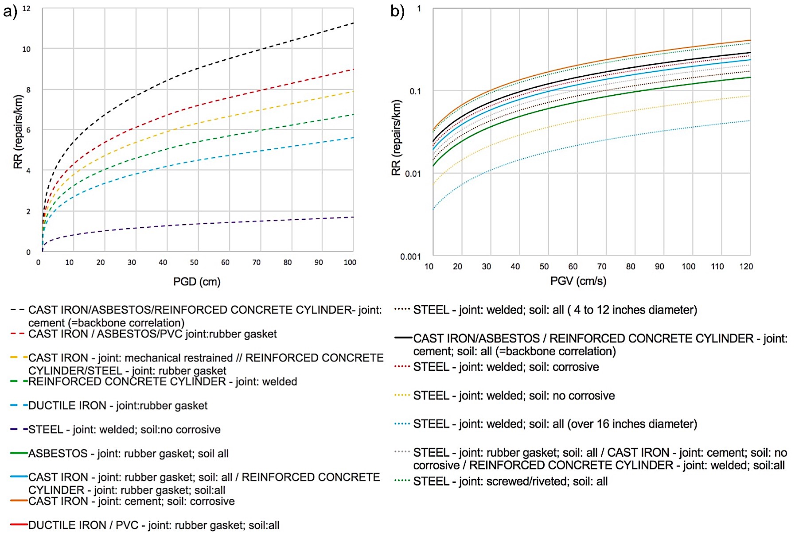
Figure 1 Vulnerability model for buried pipes developed in (ALA, 2001) for a) GF and b) SGS.
  - Discussion
The models implemented above are developed from the observation of a significant number of past seismic events, and thus can be considered applicable in general in a variety of situations. On the other side, this leads to the inevitable differences between them. For the selection of the most suitable option to be applied in the context of the Natech QRA, some specific points should be considered. The models proposed by ALA have been originally conceived for water-carrying pipelines, whereas the curves developed in the works of (Lanzano et al., 2014, 2013) are possibly more generalizable. In addition, the former is more detailed in the type of soil and joint material, and through their application it is also possible to account for the different vulnerability of various factors as the typology of joint material and of soil corrosivity. On the contrary, the sole classification criterion adopted in (Lanzano et al., 2014, 2013) is based on CP and SP pipeline types, as mentioned in Section 3.2. For what concerns the definition of risk states, which are important in the Natech QRA for the characterization of the technological scenarios following substance release, the works of (Lanzano et al., 2014, 2013) are more rigorous and specific, while the models by ALA give only thumb rules on the typology of expected failures. But in spite of this, the models by ALA (2001) are suggested because to use the models of Lanzano et al. (2014, 2013) it is necessary to make strong assumptions about the unit length for which the failure probability is calculated. This is not the case with ALA standard which gives us a specific probability once the length of the segment and the number of breaks expected in it are defined.
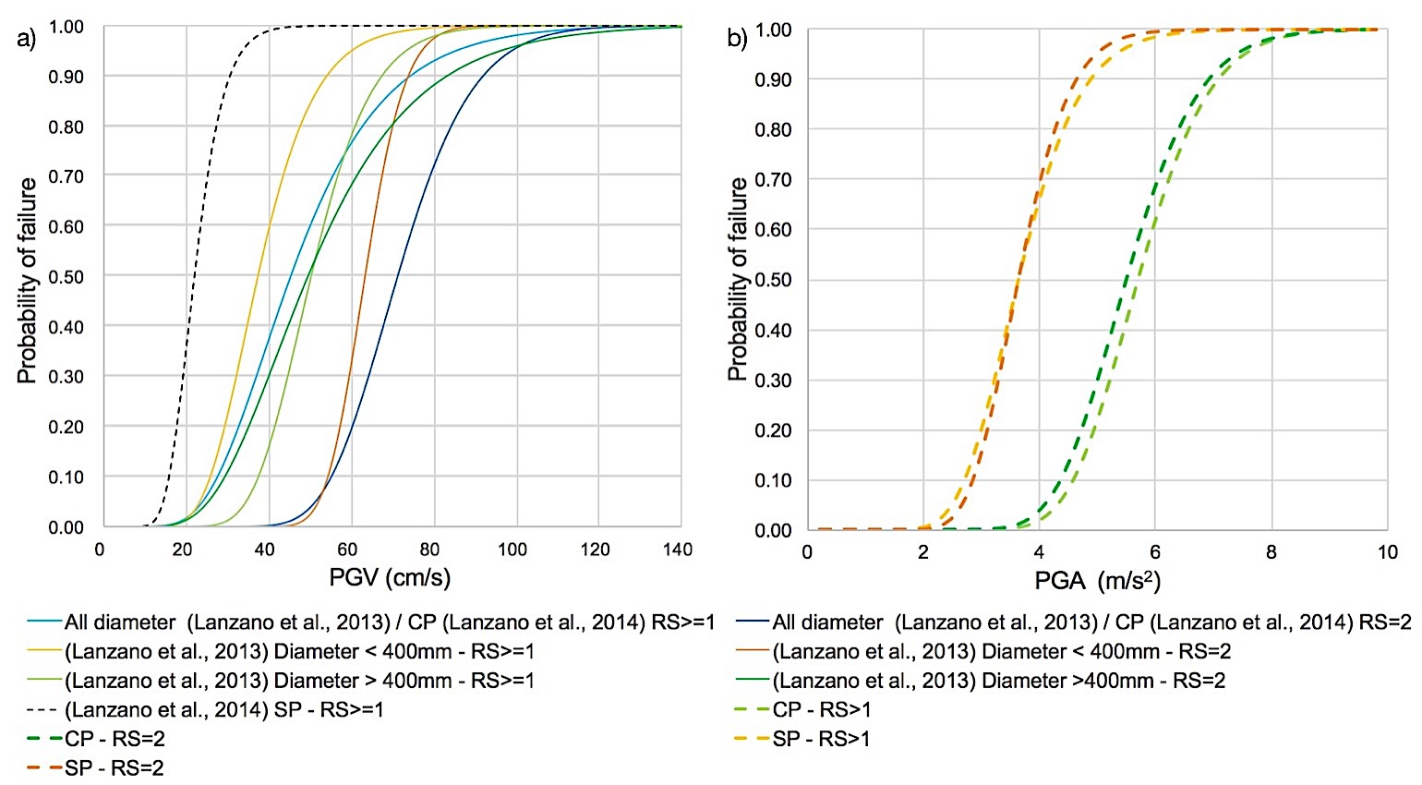
Figure 2 Vulnerability model for buried pipes: a) for SGS (Lanzano et al., 2014, 2013), and b) for GF (Lanzano et al., 2014).
  - Conclusions
A comprehensive review of vulnerability models for pipelines subjected to seismic events is presented. The retrieved models are briefly described and grouped according to shared characteristics. The models deemed most suitable for a Natech QRA are implemented and discussed. Finally, a subset of suggested models is provided together with a summary of their peculiarities.
Acknowledgments
The study was funded by Italian Ministry for Scientific Research (MIUR) under the “PRIN 2017” program (grant 2017CEYPS8).
References
ALA, 2001, Seismic fragility formulation for water systems, guideline and appendices, American Lifelines Alliance.
Barenberg M.E., 1988, Correlation of Pipeline Damage with Ground Motions. Journal of Geotechnical Engineering 114, 706–711.
Chen W.W., Shih B., Chen Y.C., Hung J.H., Hwang H.H., 2002, Seismic response of natural gas and water pipelines in the Ji-Ji earthquake, Soil Dynamics and Earthquake Engineering 22, 1209–1214.
Eguchi R.T., Chrostowski J.D., Tillman C.W., Ayala A.G., 1991, Rapid post-earthquake damage detection method for underground lifelines, Publ by ASCE, 714–724.
Eidinger J., Avila E., 1999, Guidelines for the seismic evaluation and upgrade of water transmission facilities, American Society of Civil Engineers.
Eidinger J.M., 1998, The Loma Prieta, California, Earthquake of October 17, 1989 - lifelines, US Gov. Print. Off.
Eidinger J.M., Maison B.F., Lee D., Lau B., 1995, East Bay Municipal Utility District Water Distribution Pipe Damage in 1989 Loma Prieta Earthquake, Presented at the Technical council on lifeline earthquake engineering monograph, New York, NY; ASCE, 240.
Fabbrocino G., Iervolino I., Orlando F., Salzano E., 2005, Quantitative risk analysis of oil storage facilities in seismic areas, Journal of Hazardous Materials 123, 61–69.
Fatemi F., Ardalan A., Aguirre B., Mansouri N., Mohammadfam I., 2017, Social vulnerability indicators in disasters: Findings from a systematic review, International Journal of Disaster Risk Reduction 22, 219–227.
FEMA, 2020. Hazus Earthquake Model Technical Manual 4.2.
Hamada M., 1991, Estimation of earthquake damage to lifeline systems in Japan, Proceedings of the Third Japan-US Workshop on Earthquake Resistant Design of Lifelines Facilities and Countermeasures for Soil Liquefaction.
Hung J.H., 2001, The Analysis of Water Pipeline Damages of Wufeng Shiang in the 921 Ji-Ji Earthquake.
Heubach W.F., 1995, Seismic Damage Estimation for Buried Pipeline Systems. Presented at the Technical council on lifeline earthquake engineering monograph, New York, NY; ASCE, 312.
Hwang H., Chiu Y.H., Chen W.Y., Shih B.J., 2004, Analysis of Damage to Steel Gas Pipelines Caused by Ground Shaking Effects during the Chi-Chi, Taiwan, Earthquake. Earthquake Spectra 20, 1095–1110.
Isoyama R., Ishida E., Yune K., Shirozu T., 2000, Seismic damage estimation procedure for water supply pipelines, Anti-seismic measures on water supply (Tokyo, 15-18 November 1998), 63–68.
Isoyama R., Katayama T., 1982, Reliability evaluation of water supply systems during earthquake, Report of the Institute of Industrial Science, University of Tokyo, 30, 64
Jeon S.S., O’Rourke T.D., 2005, Northridge Earthquake Effects on Pipelines and Residential Buildings, Bulletin of the Seismological Society of America 95, 294–318.
Katayama T., Kubo K., Sato N., 1977, Quantitative Analysis of Seismic Damage to Buried Utility Pipelines, Proceedings Sixth world conference earthquake engineering institute association 3369–3375.
Katayama T., Kubo K., Sato N., 1975, Earthquake damage to water and gas distribution systems, 396–405.
Krausmann E., Cruz A.M., Salzano E., 2017, Natech risk assessment and management: reducing the risk of natural-hazard impact on hazardous installations, Elsevier, Amsterdam; Boston, Massachusetts.
Lanzano G., Salzano E., de Magistris F.S., Fabbrocino G., 2013, Seismic vulnerability of natural gas pipelines, Reliability Engineering & System Safety 117, 73–80.
Lanzano G., Salzano E., Santucci de Magistris F., Fabbrocino G., 2014, Seismic vulnerability of gas and liquid buried pipelines, Journal of Loss Prevention in the Process Industries 28, 72–78.
Leveille T.P., Shane D., Morris J., 1995, Northridge earthquake pipeline rupture into the Santa Clara river, International Oil Spill Conference Proceedings 1995, 489–494.
Maruyama Y., Yamazaki F., 2010, Construction of fragility curve for water distribution pipes based on damage datasets from recent earthquakes in Japan, in: 9th US National and 10th Canadian Conference on Earthquake Engineering 2010, Including Papers from the 4th International Tsunami Symposium. 781–790.
Moschonas I.F., Karakostas C., Lekidis V., Papadopoulos, S.P., 2014, Investigation of seismic vulnerability of industrial pressure vessels, 2nd European Conference on Earthquake Engineering and Seismology, Istanbul, 25-29 August 2014
O’Rourke T., Jeon S.S., 1999, Factors Affecting the Earthquake Damage of Water Distribution Systems. Technical Council On Lifeline Earthquake Engineering Monograph. 379-388.
O’Rourke M., Ayala G., 1993, Pipeline Damage Due to Wave Propagation, Journal of Geotechnical Engineering 119, 1490–1498.
O’Rourke M., Deyoe E., 2004, Seismic Damage to Segmented Buried Pipe, Earthquake Spectra 20, 1167–1183.
O’Rourke T.D., Gowdy T.E., Stewart H.E., Pease J.W., 1991, Lifeline and geotechnical aspects of the 1989 Loma Prieta earthquake, International Conference on Recent Advances in Geotechnical Earthquake Engineering and Soil Dynamics [Proceedings] 2, Vol. 2, 1601–1612.
O’Rourke T.D., Toprak S., Sano, Y., 1998, Factors affecting water supply damage caused by the Northridge earthquake, Proceedings of the Sixth US National Conference on Earthquake Engineering.
Pineda-Porras O., Najafi M., 2010, Seismic Damage Estimation for Buried Pipelines: Challenges after Three Decades of Progress. J. Pipeline Syst. Eng. Pract. 1, 19–24.
Pineda-Porras O., Ordaz M., 2007, A New Seismic Intensity Parameter to Estimate Damage in Buried Pipelines due to Seismic Wave Propagation, Journal of Earthquake Engineering 11, 773–786.
Pineda-Porras O., Ordaz-Schroeder M., 2003, Seismic Vulnerability Function for High-Diameter Buried Pipelines: Mexico City’s Primary Water System Case, in: New Pipeline Technologies, Security, and Safety, Presented at the Pipeline Engineering and Construction International Conference 2003, American Society of Civil Engineers, Baltimore, Maryland, United States, 1145–1154.
Porter K.A., Scawthorn C., Honegger D.G., O’Rourke T.D., Blackburn, F., 1992, Performance of water supply pipelines in liquefied soil (Report), Publ by Natl Inst of Standards & Technology.
Sakai H., Pulido N., Hasegawa K., Kuwata Y., 2017, A new approach for estimating seismic damage of buried water supply pipelines: New Water Supply Pipeline Damage Estimation Approach, Earthquake Engng Struct. Dyn. 46, 1531–1548.
Toprak S., 1998, Earthquake effects on buried lifeline systems, PhD Cornell University (USA).
Tsinidis G., Di Sarno L., Sextos A., Furtner P., 2019, A critical review on the vulnerability assessment of natural gas pipelines subjected to seismic wave propagation. Part 1: Fragility relations and implemented seismic intensity measures. Tunnelling and Underground Space Technology 86, 279–296.
Woessner J., Laurentiu D., Giardini D., Crowley H., Cotton F., Grünthal G., Valensise G., Arvidsson R., Basili R., Demircioglu M.B., Hiemer S., Meletti C., Musson R.W., Rovida A.N., Sesetyan K., Stucchi M., 2015, The 2013 European Seismic Hazard Model: key components and results, Bull Earthquake Eng 13, 3553–3596.
Yeh C.H., Shih B.J., Chang C.H., Chen W.Y.W., Liu G.Y., Hung H.Y., 2006, Seismic Damage Assessment of Potable Water Pipelines, Presented at the Proceedings of the 4th International Conference on Earthquake Engineering, Taipei (Taiwan), 2-13 October 2006

