CHEMICAL ENGINEERING TRANSACTIONS  VOL. 92, 2022 | A publication of
The Italian Association
of Chemical Engineering
Online at www.cetjournal.it

Guest Editors: Rubens Maciel Filho, Eliseo Ranzi, Leonardo Tognotti
Copyright © 2022, AIDIC Servizi S.r.l.
ISBN 978-88-95608-90-7; ISSN 2283-9216

Air deterioration gases in the social confinement period by COVID-19 in Bogotá, Quito, Lima, Santiago de Chile and Buenos Aires
Manuel A. Ortega Mamani, Carlos A. Castañeda-Olivera*, Elmer G. Benites Alfaro
Universidad César Vallejo, Campus Los Olivos, Lima, Perú
*caralcaso@gmail.com
Restrictions on industry and vehicular and pedestrian traffic during the COVID-19 public health emergency were explored to determine associations with increases or decreases in air-impairing gases. Social immobilization is one method of controlling infectious diseases in an emergency and/or quarantine context, resulting in a decrease in environmental contamination. Therefore, this research evaluated the influence of CO, NO₂, O₃ and SO₂ gases in the cities of Bogota, Buenos Aires, Lima, Quito and Santiago. Data from Sentinel-5P netCDF files were used with the help of SNAP Desktop and Qgis software, and governmental regulations dictated by the different governments of each country were also reviewed. The results showed that the cities of Bogota, Buenos Aires, Lima and Quito had significant negative decreases and associations for CO, NO₂ and O₃ gases, and SO₂ gas was statistically disregarded. In addition, the city of Santiago de Chile showed an increase in CO gas. Finally, it is concluded that social immobilization positively influenced the reduction of air pollutant gases and consequently improved the environmental quality of each city.
1. Introduction
Traditional energy consumption, population density, urban agglomeration, infrastructure and transportation cause the reduction of air quality and are responsible for PM10, CO, CO₂, SO_{X}, NO_{X} and volatile organic compounds, exposing the population to different air pollutants (Wang et al. 2019; Islam et al. 2020). These activities were prevented by the governments of each country in the presence of SARS-CoV-2, as a social mobility control measure to avoid the proliferation of contagions in the human population (Kraemer et al. 2020). With this measure of social confinement by COVID-19 there was a significant favourable correlation because there was a reduction in the concentrations of pollutants present in the air, determining that there is a positive impact on environmental quality (Abdullah et al. 2020; Zhu, Xie, Huang and Cao, 2020; Fareed et al. 2020).
Different studies mention that algorithmic models can quantify air pollutants, and their implementation in monitoring is of vital importance because they are accurate in achieving replication of observed concentrations through proper characterization of the stochastic nature of atmospheric processes (Lee et al. 2020; Araki, Shima and Yamamoto, 2020; Rao et al. 2020). Other studies used land-use regression (LUR) models to assess the influence of air pollution on lung function, inflammation and aging (Altuğ et al. 2020), as well as regional air quality models such as CHIMERE, LOTOS-EUROS, EMEP MSC-W, etc. to investigate atmospheric composition on a regional scale (Blechschmidt et al. 2020).
Social restrictions improve environmental quality, reducing atmospheric emissions and consequently improving air quality (Cheng et al. 2020; Raffaelli et al. 2020; Dantas et al. 2020). Moreover, these partial and total blocking measures to social mobility generally reduce air deterioration gases (Collivignarelli et al. 2020). These environmental policies are framed in environmental improvement and minimization of negative environmental impacts. The implementation of these control measures in gaseous emissions regulates and reduces pollution, identifying exposure risks and preventing the increase of volatile organic compounds and aerosols (Biggart et al. 2020; Calla and Lujan 2018; Islam et al. 2020). Also as an environmental policy, there is the reduction of greenhouse gases (GHG) that involves the management of friendly alternatives in energy production that are embodied in the improvement of the environment (Akdag and Yildirim, 2020; Ma and Kang, 2020; Shi and Brasseur, 2020).
Incomplete combustion of hydrocarbons from sources such as transportation, industry and living areas produce secondary pollutants that pose a risk to ecosystems through so-called acid rain (Panagi et al. 2020; Feng et al. 2020). This exposure to harmful particles and gases contributes to the presence of cardiovascular and respiratory diseases, and also contributes to increased cases of COVID-19 contagion, which has generally been found to be associated with more severe coronavirus outcomes (Moelling and Broecker, 2020; Isaifan, 2020; Fareed et al. 2020). Transportation and industrial activity constitute the most important sources of CO, NO_{X}, hydrocarbon, PM, and smog emissions, causing air quality decline in urban cities (Aguilera et al. 2018; Angatha and Mehar, 2019). On the other hand, emissions from vehicular traffic during the period of social confinement by COVID-19 were decreased and showed positive effects on air quality (Gautam, 2020; Andersson et al. 2020).
For the aforementioned reasons, the research determined the level of reduction of gases that deteriorate the atmosphere with the use of satellite images obtained from the Sentinel-5P sensor of the European Space Agency (ESA) Copernicus platform, in the context of social confinement by COVID-19 in the cities of Bogota, Quito, Lima, Santiago de Chile and Buenos Aires. For this purpose, the governmental regulations issued in each of the study countries were reviewed and the SNAP Desktop and Qgis programs were used for data and information analysis.
2. Materials and methods
2.1 Study area
The study area included the most important cities (capitals) of the countries of Colombia, Ecuador, Peru, Chile and Argentina, which are located in the South American region of the American continent. These cities correspond to Bogotá, Quito, Lima, Santiago de Chile and Buenos Aires.
2.2 Obtaining the concentration values of the gases
The main sources of NO_{X} emissions are industries and transportation; for CO, transportation and power generation; for CO₂ and SO₂, fossil fuel, construction cement, vehicle combustion and power generation; for particulate matter (PM10, PM 2.5 and others), emissions from vehicle exhaust, construction, improper disposal of solid waste, among others. The concentration values of air-deteriorating gases (SO₂, NO₂, O₃ and CO) were obtained from the .netCDF files of the Copernicus platform. These files store the information of the different atmospheric components obtained by the Copernicus program of the European Space Agency that has the Sentinel-5P Pre-Operations Data Hub service (Richter, 2015). In the research, 4 groups with different study periods were worked to make the comparisons and determine the increase and/or decrease of gas concentrations in each city (Table 1).
Table 1: Range of dates studied in the research
Groups | Date range | Time (weeks)
1 | 15-03-2019 / 28-03-2019 | 2
2 | 01-03-2020 / 14-03-2020 | 2
3 | 15-03-2020 / 28-03-2020 | 2
4 | 29-03-2020 / 11-04-2020 | 2

2.3 Sentinel-5P image processing
The Sentinel-5P images were downloaded taking into consideration the processing level, the detection period and the quadrant of the study area. SNAP Desktop Software was used to extract the information from the .netCDF files and project them to the WGS-84 system. In addition, Qgis software was used to create the point shape of the cities and store the data in the .dbf files to be later worked in Microsoft Excel. Finally, data recording was performed with the values of the gases studied to perform the statistical analysis.
2.5 Descriptive and inferential statistical analysis
The Shapiro-Wilk statistic was used for normality and Levene's statistic for data homogeneity. In addition, Pearson's correlation was used for parametric data and Spearman's correlation for nonparametric data.
3. Results and discussion
3.1 Pearson's and Spearman's correlations
For the statistical analysis, NO₂ and O₃ gases were used in the cities of Bogotá, Quito, Lima, Santiago de Chile and Buenos Aires. The CO gas was worked in the cities of Bogota, Quito, Lima and Santiago de Chile. For SO₂ gas, the data were disregarded because they did not have a good significance. Table 2 shows the Pearson and Spearman correlation coefficients for the gases studied in the different cities.
Table 2: Summary of correlation coefficients
Gas | City | Correlation |  |  |  | Regression
 |  | Pearson | Sig | Spearman | Sig | R² | Sig ANOVA
NO2 | Lima | -0.569 | 0.000 | - | - | 0.511 | 0.000
 | Quito | -0.632 | 0.000 | - | - | 0.370 | 0.003
 | Bogotá | -0.604 | 0.000 | - | - | 0.333 | 0.005
 | Santiago | -0.318 | 0.048 | - | - | 0.101 | 0.048
 | Buenos Aires | - | - | -0.678 | 0.000 | 0.462 | 0.899
SO2 | Lima | - | - | 0.187 | 0.171 | 0.083 | 0.163
 | Quito | -0.020 | 0.896 | - | - | 0.007 | 0.692
 | Bogotá | 0.123 | 0.431 | - | - | 0.041 | 0.334
 | Santiago | - | - | 0.153 | 0.273 | 0.191 | 0.029
 | Buenos Aires | -0.017 | 0.924 |  |  | 0.009 | 0.654
CO | Lima | - | - | -0.400 | 0.010 | 0.174 | 0.007
 | Quito | -0.636 | ,000 | - | - | 0.410 | 0.001
 | Bogotá | -0.663 | ,000 | - | - | 0.501 | 0.000
 | Santiago | 0.455 | ,001 | - | - | 0.364 | 0.003
 | Buenos Aires | - | - | -0.221 | 0.299 | 0.051 | 0.287
O3 | Lima | -0.534 | 0.000 | - | - | 0.325 | 0.002
 | Quito | - | - | -0.410 | 0.003 | 0.372 | 0.001
 | Bogotá | -0.542 | 0.000 | - | - | 0.225 | 0.014
 | Santiago | -0.663 | 0.000 | - | - | 0.532 | 0.000
 | Buenos Aires | -0.620 | 0.000 | - | - | 0.423 | 0.000

From Table 2 it was observed that the Pearson correlation showed a strong negative association for NO₂ gas in all cities and a moderate negative association in Santiago. For SO₂ gas, no city met the significance level. For CO gas, there was a strong negative association in Quito and Bogota and a moderate positive association in Santiago. For O₃ gas, the cities of Lima, Bogota, Santiago and Buenos Aires had a strong negative association. On the other hand, Spearman's correlation showed a strong negative association for NO₂ gas in the city of Buenos Aires. For SO₂ gas, the city of Santiago did not meet the significance level. For CO gas, the city of Buenos Aires did not meet the significance level. For O₃ gas, the city of Quito had a moderate negative association and met the significance level.
3.2 Level of increase or decrease in NO₂, CO and O₃ gases
Figure 3 shows the average concentration of the medians of the gases in each city studied. Concerning the concentration of NO₂ gas, it is observed that the medians are reduced as the sanitary measures are implemented in the cities of Lima, Quito, Bogota, Santiago and Buenos Aires. In addition, it is shown that the city with the highest NO₂ concentration is Santiago and the city with the lowest concentration is Quito.
For the concentration of CO gas, it was observed that the concentration values are decreasing in the cities of Lima, Quito, Bogota, and only in Santiago is there a pattern of increase in the medians. In the case of Santiago, the increase in CO is due to the social mobilizations (marches, strikes, demonstrations or others) carried out during the months of October 2019 until March 2020. These protests revolved around the constituent process of drafting a new constitution until March 18, 2020 when the Chilean government decreed a state of constitutional exception of catastrophe for a period of 90 days. In addition, it is shown that the city with the highest concentration of CO is the city of Lima and the city with the lowest concentration is Santiago.
Finally, concerning concentration of O₃ gas, the values reflected that the medians have greater variability and decrease in the fourth group, as in the cities of Lima, Quito, Bogota, Santiago and Buenos Aires. In addition, it is shown that the city with the highest O₃ concentration is the city of Buenos Aires and the city with the lowest concentration is Quito.
Air quality during the COVID-19 pandemic was also analyzed in 22 Indian cities for the period 2017 to 2020, showing insufficient changes in SO₂, a decrease of 10% in CO and 18% in NO₂, and an exceptionally increase by 17% in O₃ (Sharma et al. 2020). Similarly, analysis of air quality in 120 cities in China, in the period from January 23 to February 29, 2020, showed positive associations in CO, NO₂ and O₃, and a negative association in SO2 (Zhu, Xie, Huang and Cao, 2020). In Rio de Janeiro, air quality during the period from March 2 to April 16, 2020 showed significant levels of reduction in CO and NO₂ generated by industrial activity and diesel, in addition to the increase in O₃ due to the decrease in NO_{X} levels (Dantas et al. 2020). Likewise, the air quality in Milan for the period from January 1 to April 10, 2020, determined a significant reduction in CO and NO_{X}, an increase in O₃, and also SO₂ remained unchanged in the peripheral areas (Collivignarelli et al. 2020). Some meteorological variables such as wind and temperature were considered in the mentioned studies, and the changes in SO2 could be due to the restrictions applied in power plants, non-suspended industrial activities and the operation of some hydrocarbon companies during the quarantine (Sharma et al. 2020).

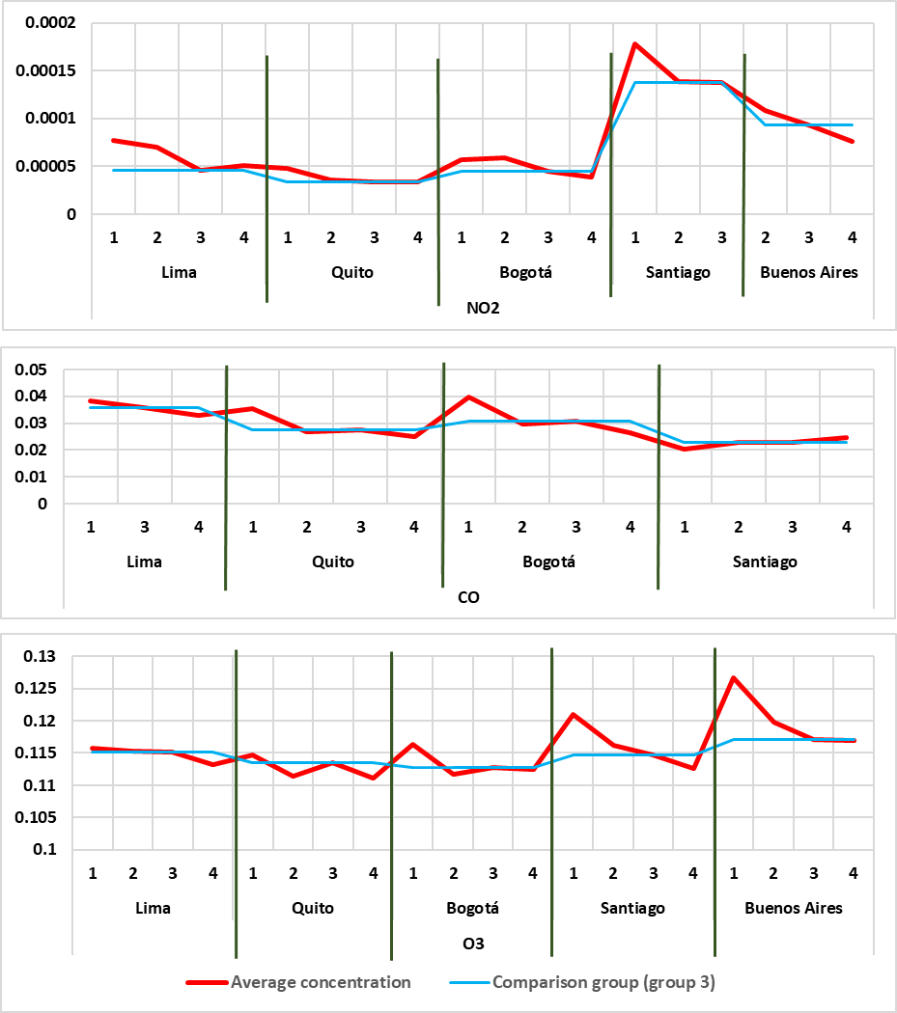
Figure 1: Increase or decrease in the concentration of air pollutant gases (NO₂, CO and O₃) during the range of dates (groups 1, 2 and 3) studied

Public policies applied as a measure to reduce polluting gases must integrate industrial processes in CO₂ emissions and absorption, since energy resource consumption in the industrial and transportation sectors is based mainly on coal, oil and/or natural gas. Therefore, socioeconomic indicators (energy consumption) and transport demand contribute to estimate air pollutants (NO_{X}, CO, SO₂, O₃, particulate matter) in order to develop scenarios to reduce and control greenhouse gas emissions (Geng and Meng, 2018; Atkins et al., 2018; Tran, 2019; Wang et al., 2019).
4. Conclusions
NO₂, CO and O₃ gases decreased in all cities except for the city of Santiago where CO gas increased. Pearson and Spearman statistics showed significant negative associations between strong and moderate. On the other hand, the values for SO₂ gas were disregarded because they did not present significantly important values. It was observed that there are associations in the concentrations of gases that deteriorate the air and compliance with the policies and/or regulations issued by the different governments. Regarding the concentration of NO₂ gas, it was observed that the values of the concentrations were decreasing, with the city of Santiago de Chile having the highest concentration and the city of Quito having the lowest concentration. For the concentration of CO gas, it was observed that the concentration values also decreased, with the city of Lima having the highest concentration and the city of Santiago de Chile having the lowest concentration. Finally, concerning the concentration of O₃ gas, the values reflected that the concentrations had greater variability, with the city of Buenos Aires having the highest concentration and the city of Quito having the lowest concentration.
Acknowledgments
The authors would like to thank "Investiga UCV" of the Universidad César Vallejo for financial support for the publication of this research.
References
Abdullah, S., Mansor, A. A., Napi, N. N. L. M., Mansor, W. N. W., Ahmed, A. N., Ismail, M., Ramly, Z. T. A., 2020, Air quality status during 2020 Malaysia movement control order (MCO) due to 2019 novel coronavirus (2019- nCoV) pandemic, Science of the Total Environment, 729, 139022.
Aguilera Sammaritano, Mariela; Bustos, D.; Poblete, A., Wannaz, E., 2018, Elemental Composition of PM2.5 in the Urban Environment of San Juan, Argentina, Environmental Science & Pollution Research, 25 (5), 4197–4203.
Akdag, Saffet, Yildirim, Hakan, 2020, Toward a sustainable mitigation approach of energy efficiency to greenhouse gas emissions in the European countries, Heliyon, 6 (3), e03396.
Altuğ, Hicran; Fuks, Kateryna; Hüls, Anke; Mayer, Anne-Kathrin; Tham, Rachel; Krutmann, Jean; SchikowskI, Tamara, 2020, Air pollution is associated with depressive symptoms in elderly women with cognitive impairment, Environment International, 136, 105448.
Andersson, Eva; Ögren, Mikael; Molnár, Peter; Segersson, David; Rosengren, Annika; Stockfelt, Leo, 2020, Road traffic noise, air pollution and cardiovascular events in a Swedish cohort, Environmental Research, 185, 109446.
Angatha, Rama Kanth, Mehar, Arpan, 2019, Impact of vehicles on urban air quality: predictive assessment with an application to Tirumala. International Journal for Traffic and Transport Engineering, 9 (4), 397-407
Araki, Shin; Shima, Masayuki; Yamamoto, Kouhei, 2020, Estimating historical PM2.5 exposures for three decades (1987 2016) in Japan using measurements of associated air pollutants and land use regression, Environmental Pollution, 263, 114476.
Atkins, M. J., Neale, J. R., Wu, Y. H., Walmsley, M. R., 2018, Regional and national greenhouse gas emissions reduction planning, Chemical Engineering Transactions, 70, 19-24.
Biggart, Michael, Stoker, J., Doherty, R., Wild, O., Hollaway, M., Carruthers, D., Li, J., Zhang, Q., Wu, R., Kotthaus, S., Grimmond, S., Asquires, F., Lee, J., SHI, Z., 2020, Street-scale air quality modelling for Beijing during a winter 2016 measurement campaign, Atmospheric Chemistry & Physics, 20 (5), 2755-2780.
Blechschmidt, Anne-Marlene; Arteta, J.; Coman, A.; Curier, L.; Eskes, H.; Foret, G.; Gielen, C.; Hendrick, F.; Marécal, V.; Meleux, F.; Parmentier, J.; Peters, E.; Pinardi, G.; Piters, A.; Plu, M.; Richter, A.; Segers, A.; Sofiev, M.; Valdebenito, A.; Roozendael, M.; Vira, J.; Vlemmix, T.; Burrows, J., 2020, Comparison of tropospheric NO2 columns from MAX-DOAS retrievals and regional air quality model simulations, Atmos. Chem. Phys. Discuss, 20, 2795-2823.
Calla DurandaL, Lucía, Luján Pérez, Marcos, 2018, Inventario de emisiones de fuentes móviles con una distribución espacial y temporal para el área metropolitana de Cochabamba, Bolivia., Acta Nova, 8 (3), 322- 353.
Collivignarelli, M. C., Abbà, A., Bertanza, G., Pedrazzani, R., Ricciardi, P., Carnevale Miino, M., 2020, Lockdown for CoViD-2019 in Milan: What are the effects on air quality? The Science of the Total Environment., 732, 139022.
Dantas, G., Siciliano, B., França, B. B., Da Silva, C. M., & Arbilla, G., 2020, The impact of COVID-19 partial lockdown on the air quality of the city of Rio de Janeiro, Brazil. Science of the Total Environment., 729, 139085
Fan, C., Li, Y., Guang, J., Li, Z., Elnashar, A., Allam, M., De Leeuw, G., 2020, The impact of the control measures during the COVID-19 outbreak on air pollution in China, Remote Sensing, 12 (10), 1613
Fareed, Z., Iqbal, N., Shahzad, F., Shah, S. G. M., Zulfiqar, B., Shahzad, K., Shahzad, U., 2020, Co-variance nexus between COVID-19 mortality, humidity, and air quality index in Wuhan, China: New insights from partial and multiple wavelet coherence. Air Quality, Atmosphere and Health, 13, 673-682.
Feng, Jian; Chan, Elton, Vet, Robert., 2020, Air quality in the eastern United States and Eastern Canada for 1990–2015: 25 years of change in response to emission reductions of SO2 NOx in the region. Atmospheric Chemistry & Physics, 20 (5), 3107-3134.
Gautam, S., 2020, The influence of COVID-19 on air quality in India: A boon or inutile. Bulletin of Environmental Contamination and Toxicology, 104 (6), 724-726.
Geng, S., Meng, W., 2018, Chemical absorption and mass transfer of grennhouse gas carbon dioxide, Chemical Engineering Transactions, 71, 1-6.
Isaifan, R.J., 2020, The Dramatic Impact of Coronavirus Outbreak on Air Quality: Has it Saved as Much as it has Killed so Far? Global Journal of Environmental Science and Management, 6 (3), 275-288.
Islam, M., Jayarathne, T., Simpson, I., Werden, B., Maden, B., Maben, J., Gilbert, A., Praveen, P., Adhikari, S., Panday, A., Rupakheti, M., Blake, D., Yokelson, R., DE Carlo, P., Keene, W., y Stone, E., 2020, Ambient air quality in the Kathmandu Valley, Nepal during the premonsoon: Concentrations and sources of particulate matter and trace gases. Atmospheric Chemistry & Physics., 20 (5), 2927-2951.
Kraemer, Moritz Ug, Yang, C.; Gutierrez, B.; Wu, C.; Klein, B.; Pigott, D.; Plessis, L.; Faria, N.; Li, R.; Hanage, W.; Brownstein, J.; Vespignani, A.; Tian, H.; Dye, C.; Pybus, O.; y Scarpino, S., 2020, The effect of human mobility and control measures on the COVID-19 epidemic in China. Science, 368, 493-497.
Lee, Kyunghwa, Yu, J., Lee, S., Park, M., Hong, H., Park, S., Choi, M., Kim, J., Kim, Y., Woo, J., Kim, S., Song, C., 2020, Development of Korean Air Quality Prediction System version 1 (KAQPS v1) with focuses on practical issues. Geoscientific Model Development, 13 (3), 1055-1073.
Ma, C. & Kang, G., 2020, Air quality variation in Wuhan, Daegu, and Tokyo during the explosive outbreak of covid-19 and its health effects. International Journal of Environmental Research and Public Health, 17 (11), 1-14.
Moelling K., Broecker F., 2020, Air microbiome and pollution: Composition and potential effects on human health, including SARS coronavirus infection, Journal of Environmental and Public Health, 2020, 1-14.
Panagi Marios, Fleming Z., Monks P., Asfold J., Wild O., Hollaway M., Zhang Q., Squires F., D. Vande J., 2020, Investigating the regional contributions to air pollution in Beijing: a dispersion modelling study using CO as a tracer. Atmospheric Chemistry and Physics, 20 (5), 2825-2838.
Raffaelli, K., Deserti, M., Stortini, M., Amorati, R., Vasconi, M., Giovannini, G., 2020, Improving Air Quality in the Po Valley, Italy: Some Results by the LIFE-IP-PREPAIR Project. Atmosphere, 11 (4), 429.
Rao, S. T., Luo, H., Astitha, M., Hogrefe, C., Garcia, V., y Mathur, R., 2020, On the limit to the accuracy of regional-scale air quality models. Atmos. Chem. Phys, 20 (5), 1627-1639.
Richter, A., 2015, S5P/TROPOMI Science Verification Report. S5P-IUP-L2-ScVRRP. Versión 2.1.
Shi, X., Brasseur, G. P., 2020, The response in air quality to the reduction of Chinese economic activities during the COVID-19 outbreak. Geophysical Research Letters, 47 (11), e2020GL088070
Tran, T. T., 2019, Mitigating greenhouse gas emissions from passenger transport sector in megacities: a case of Ho Chi Minh City, Chemical Engineering Transactions, 72, 85-90.
Wang, X. C., Klemes, J. J., Dong, X., Sadenova, M., Varbanov, P. S., Zhakupova, G., 2019, Assessment of greenhouse gas emissions from various energy sources, Chemical Engineering Transactions, 76, 1057-1062.
Wang, Shijin; Hua, Guihong, Li, Cunfang, 2019, Urbanization, Air Quality, and the Panel Threshold Effect in China Based on Kernel Density Estimation. Emerging Markets Finance and Trade, 55, 3575-3590.
Zhu, Yongjian, Xie, Jingui, Huang, Fengming, Cao, Liqing., 2020, Association between short-term exposure to air pollution and COVID-19 infection: Evidence from China, Science of The Total Environment, 727, 138704.

