CHEMICAL ENGINEERING TRANSACTIONS  VOL. 91, 2022 | A publication of
The Italian Association
of Chemical Engineering
Online at www.cetjournal.it

Guest Editors: Valerio Cozzani, Bruno Fabiano, Genserik Reniers
Copyright © 2022, AIDIC Servizi S.r.l.
ISBN 978-88-95608-89-1; ISSN 2283-9216

LNG Release in storage area: Multiphase Modelling and CFD Simulation for Consequences Analysis in Risk Assessment
Katia CASSANO^{a,*}, Alessio PIERROª, Raffaella PERINIª, Paolo FARINELLIª
ª TECHFEM SpA – Human and Sustainable Engineering, Via Toniolo, 1/D, Fano (PU), 61032, ITALY
k.cassano@techfem.it
The aim of this work is to evaluate the consequences of Liquefied Natural Gas (LNG) release from the pumps connected to a storage vessel during the loading phase. This phenomenon is relevant for determining the hazardous areas for workers and asset, and in turn for assessing risk on a consequences based methodology. For this purpose, different hazard zones are identified based on different scenarios of accidental events. In particular, when a fire scenario is developed, the hazard area is delimited by the inflammable limits of natural gas in air and by the dimension of the LNG pool. Another important scenario is related to thermal effect. When LNG is released, a liquid pool with very low temperature (around -160°C) is formed and instantly evaporation of this liquid starts. Since Natural Gas cloud is characterized by extremely low temperature, the hazardous area is delimited by the isotherms of the LNG vapour in air. The investigation of the LNG behaviour starts with computing the evaporation case when containment area of pumps is filled with LNG at different wind velocity. In particular, a multi-phase and multi-component incompressible solver based on a Volume Of Fluid (VOF) method is implemented. To perform this investigation, Computational Fluid-Dynamic (CFD) simulations are carried out using the open-source software OpenFOAM®. The methodology introduced in this work allows to evaluate fire scenario and tank structural embrittlement scenario due to low temperatures, as it takes into account the mutual interactions among all the phases present in the system in transient mode, i.e. released Liquified Natural Gas, vapours of LNG and air. As main results, the shape of the LNG vapour flammable limits and isothermal curves are precisely evaluated as a function of wind conditions, determining the evolution of the methane dispersion in the air, which is crucial in the description of the scenario resulting from the consequences analysis.
  - Introduction
LNG is fuel used in power generation, mobility, residential, industrial and chemical application to promote energy conservation and emission reduction. Its combustion produced a minor amount of carbon dioxide than oil and coil. The demand for natural gas is growing and that has led to the construction of new liquefied natural gas terminals, also located within the proximity of populated area. For this reason, it is necessary to understand essential hazards and propose safety measures to minimize the risks (Ikealumba et al. 2016). Storage, transfer, and transport of LNG may originate leaks from tanks, pipes, hoses, and pumps in onshore plants and in LNG transport vessels and vehicles. Different LNG accidents have been happened in production and storage site, but they are less than other fuel accidents. Most of these have occurred during the loading/unloading of cargo (Metallinou 2019).
LNG is a cryogenic flammable liquid with liquefaction temperature of -163°C at 1 bar. Lower Flammable Limit (LFL) is 5 %(vol) and Upper Flammable Limit (UFL) is 15 %(vol). The accidents caused by LNG leak lead to explosions, fire or other hazardous scenario (Shi-er Dong et al., 2020). In particular, LNG release events are part of accidental scenarios included in the risk assessment of onshore installations. LNG leaks may occur in case of ruptures, during maintenance work or loading/unloading phases. If LNG is spilled on the ground, temperature gradient triggers boiling with high rate of vaporization. The gas vapours mix with air and form a cloud, able to be transported in different zone of the plant and over the fence due to the wind. In addition, a small part of vapour comes from instantaneous flash of LNG close to the leak. However, during the spill, temperature difference between liquid and ground come down, leading to a reduced rate of vaporization. Therefore, a liquid pool of LNG is formed, that could result in pool fire in case of immediate ignition. When late ignition occurs, explosion and flash fire are potential accidental scenarios. Another hazard of LNG leak is cryogenic damage to asset, that could induce brittle failure of tank supporting structures and injuries to people (Metallinou 2019). To evaluate acceptable level risk, risk assessment is necessary. Risk is defined through magnitude of potential accidental events and the probability of its occurrence. When the risk level is elevated, safety measures are considered to reduce probability of event occurrence or its magnitude.
Possible preventive measures, reducing occurrence probability, should be systems to limit ignition sources, as sparks of static electricity, lightning, open flames, and the installation of fire & gas detectors. The main barriers to reduce magnitude of events may be active and passive fire protection. Possible approaches to model LNG spill and/or evaporation are integral models, box or top-hat models and Navier-Stokes models (CFD). The CFD models can solve three-dimensional geometry with time dependent conservation equations of mass, momentum, energy and species. These models are the most complete than any other computational methods (Ikealumba et al. 2016).
In this case, CFD is used to evaluate consequences of flash fire (distance of LEL) and cryogenic damage to asset with evaluation of temperatures reached in correspondence of items in the plant area. Scope of this work is to develop an innovative approach to study the magnitude of consequences to equipment and people linked to LNG release.
  - Description of the system
The area of LNG plant involved in this study is the storage area. A vessel with diameter of approximately 4 m and length of 13 m is installed at 0.2 m above the ground on rigid support. Near the vessel is installed a pump, which has the function to load vessel with LNG from tanker truck, in presence of operators. Under the pump is present a pit to gather flammable liquid in case of ruptures. This pit has 0.5 m depth and 5,5m length and 5,5 m width(see Figure 1). Around the vessel and pump are installed concrete barriers with height of 2.5 m to limit extension of consequences for accidental release. LNG vessel operates at 2 bar and –147° C.
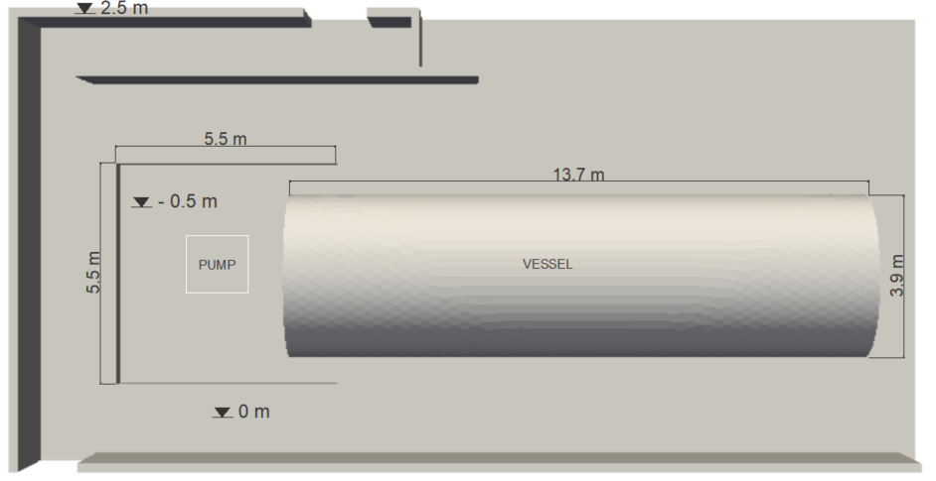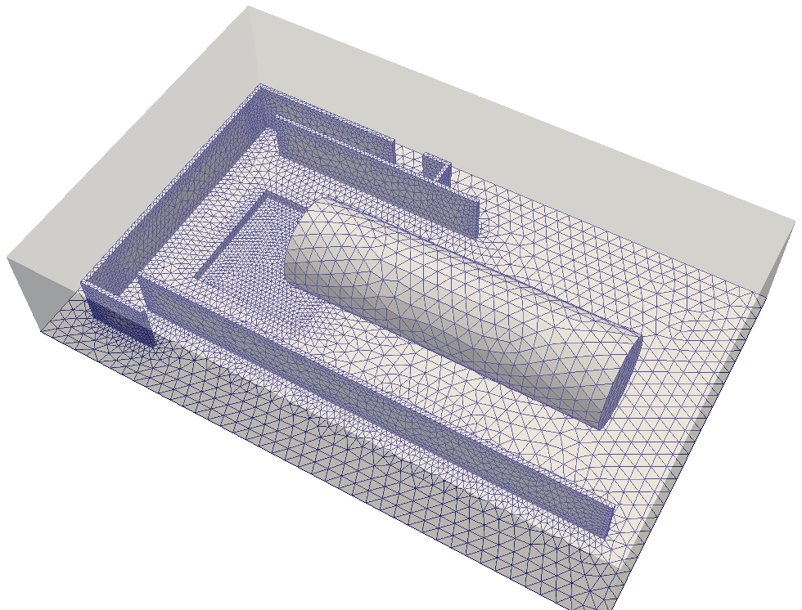
Figure 1: 3D model of storage area and computational mesh

The analyzed phenomenon is the release of LNG from pump in loading phase of storage tank. At the time 0 s, the simulation starts with pit of the pumps full of LNG, as results of catastrophic rupture. Therefore the cryogenic liquid temperature inside the basin is -147° C.
  - Numerical Approach
The multiphase solver used to evaluate evaporation of LNG and dispersion of vapors is IcoReactingMultiphaseEulerFoam. This solver is a subcategory of multiphaseInterFoam solver, which allows studying multitude of phases. Approach used to solve continuity and momentum equations for each fluid is Volume of Fluid approach (VoF), evaluating phase fraction with interphase equation between fluid boundaries.
(Jennifer Lundkvist 2019). The volume of ﬂuid method, Eq(1), is important to capture boundaries between ﬂuids and other phases, as gas bubbles travelling within a ﬂuid.
$$\frac{dα_{phase}}{dt}+\frac{d{(α}_{phase}u_{j})}{dx_{j}}=0$$ | (1)
In this solver, three different phase models are implemented: the pure moving phase model, the pure static phase model and the multi component moving phase model. For this case study was considered pureMovingPaseModel for liquid phase and multiComponentMovingPhaseModel. The first model is used to model pure moving phase like a fluid. For gas, phase multicomponent model is necessary, given the presence of air and LNG vapors. For the mass transfer model, Eq(2) , kineticGasEvaporation has been chosen and used both for condensation and evaporation.
$$F=C_{β}\sqrt{\frac{M}{2πRT_{sat}}(p^{*}}-p_{sat})$$ | (2)
In the above equation F represents the mass flux rate [kg/(m²/s)], $C_{β}$ is the accommodation coefficient, M is the molecular weight [kg/mol], $T_{sat}$ is the activation temperature [K], R is the universal gas constant [J/(mol K)], $p_{sat}$ is the saturation pressure and $p^{*}$ the vapour partial pressure [Pa]. The accommodation coefficient takes into account the molecules going into liquid phase. Clausius-Clapeyron equation is used to obtain correlation between temperature and pressure in the saturation conditions (V. P. Carey, 2020). In addition, inter-phase porosity model,. Voller Prakash method solves an additional momentum source that influences the phases behavior during solidification and melting. These models are added to Navier-Stokes equations, composing to momentum, heat and mass conservation equations,.
- Mass conservation
$$\frac{du}{dx}+\frac{dv}{dy}+\frac{dw}{dz}=0$$ | (3)
- Momentum conservation
$$\frac{d(ρu)}{dt}+div \left(ρ\vec{u}u\right)=div \left(µ grad u\right)-\frac{dP}{dx}+Sx$$ | (4)
$$\frac{d(ρv)}{dt}+div \left(ρ\vec{u}v\right)=div \left(µ grad v\right)-\frac{dP}{dy}+Sy+Sb$$ | (5)
$$\frac{d(ρw)}{dt}+div \left(ρ\vec{u}w\right)=div \left(µ grad w\right)-\frac{dP}{dz}+Sz$$ | (6)
In a three-dimensional flow, velocity has three components$\vec{u}=(u,v,w)$, four sources terms are implemented, namely$Sx, Sy, Sz, Sb$. P is pressure, $ρ$ is density and $µ$ liquid viscosity. $Sx, Sy$ and $Sz$ consider the actual fluid velocity. The $Sb$ is a buoyancy term to induce natural convection.
- Heat conservation
$$\frac{d(ρh_{s})}{dt}+div \left(ρ\vec{u}h_{s}\right)-div \left(α grad h_{s}\right)-Sh=0$$ | (7)
  - Computational Mesh
in this work, three dimensional geometry are considered to study evaporation of LNG following a catastrophic rupture of pumps. The vessel, pump and concrete barriers are contained in a box having 18.6 m length and 25 m width and 5 m depth. This dimensions have been taken as the computational domain. This box is meshed with OpenFOAM. In Figure 1 an example of computational mesh is reported. All around the pit, where evaporation starts, mesh is finer and coarser towards the domain limits.
Boundary conditions
The no slip condition (fluid velocity = 0 m/s) is applied at ground and wall. At the domain limits, condition of pressure dependant velocity for air and LNG has been set. Wind velocity is parameter that has influence on evaporation rate of LNG and dispersion of its vapours. Considered wind velocity is equal to 2 m/s. Case studies are two, with the same wind velocity along the same direction but in two opposite ways, as show in Figure 2. Pit of pump at time 0 s is full of LNG at -160°C, to simulate a catastrophic rupture, through the setFields tool.
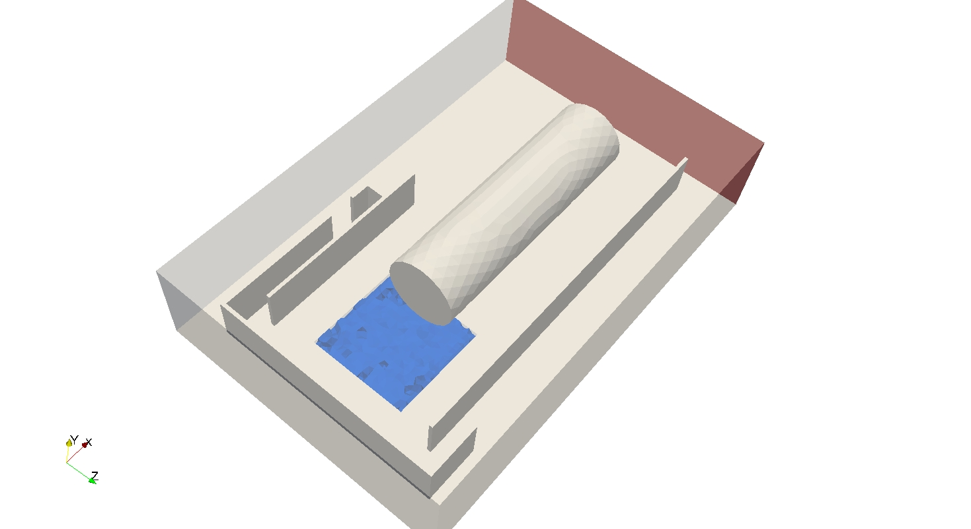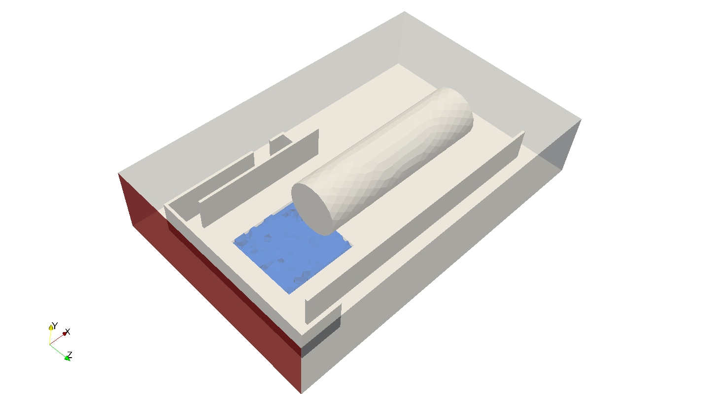
Case 1
Case 2
Wind
Wind
LNG pool
LNG pool
Figure 2: Boundary conditions for Case 1 and Case 2
  - Model Validation
The model has been validated against CEI 31-35 (2012), guide for classification of hazardous areas for the presence of gas in application of CEI EN 60079-10-1 (CEI 31-87). Evaporation rate ($Q_{g}$) from pool of cryogenic liquid could be evaluated in CEI 31-35 with equation (8), if boiling temperature ($T_{b}$) is lower than ground temperature ($T_{g}$). In this equation, $S$ is pool surface,$C_{lv}$ porosity coefficient of ground, $k_{t}$ thermal conductivity of substrate, $α$ thermal diffusivity of substrate, $t_{e}$ time passed since start of evaporation.
$$Q_{g}=\left[S\frac{2∙X_{g}∙k_{t}}{C_{lv}}{\left(\frac{1}{π∙α}\right)}^{0.5}∙\left(T_{g}-T_{b}\right)∙{10}^{3}\right]/t_{e}^{0.5}$$ | (8)
Evaporation rate from LNG pool was also obtained from CFD. Results are compared in Figure 3.
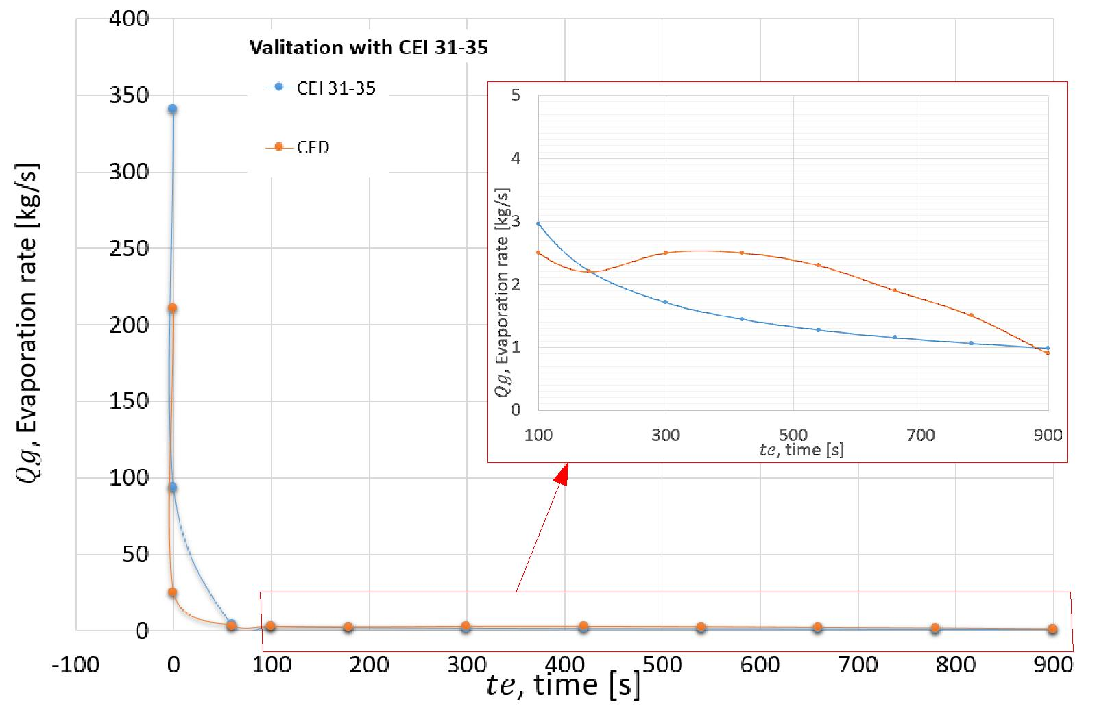
Figure 3: Comparison of results obtained with CEI 31-35 and CFD
The greatest difference between values obtained with equation (8) and CFD is in the first seconds of evaporation. At 0.1 seconds, a deviation between curves of 73% was found. After 60 seconds, percentage errors on evaporation rate decreases and varies between 45% and 8%. In Table 1 difference between evaporation rates, evaluating with CEI 31-34, and evaporation rates, evaluating with CFD simulations.
Table 1: Difference between evaporation rates
$t_{e}$ [s] | $Q_{g}$(CEI 31-35) [kg/s] | $Q_{g}$(CFD) [kg/s] | $Q_{g}$(CEI 31-35) -$Q_{g}$(CFD) [kg/s]
60 | 3.82 | 3.03 | 0.786
100 | 2.96 | 2.50 | 0.455
180 | 2.20 | 2.20 | 0.003
300 | 1.71 | 2.50 | 0.794
420 | 1.44 | 2.50 | 1.06
540 | 1.27 | 2.30 | 1.03
660 | 1.15 | 1.90 | 0.750
780 | 1.06 | 1.50 | 0.442
900 | 0.99 | 0.90 | 0.085

It is important to highlight that equation (8) in CEI 31-35 is a simplified equation to establish dimensions of classified hazardous area and not to exactly describe the physical phenomena
.
  - Results
In Figure 4 is shown the temperature profile in two different areas of domain. To analyse the effects of temperature on the supports of the cryogenic vessel, results have been obtained below the cryogenic vessel. Over the containment walls, workers evacuating the plant are probably present. The most dangerous area for workers during evacuation phase has been indicated in the figure by symbol of operator (orange). Therefore, the temperature over time pattern has been extracted for this area.
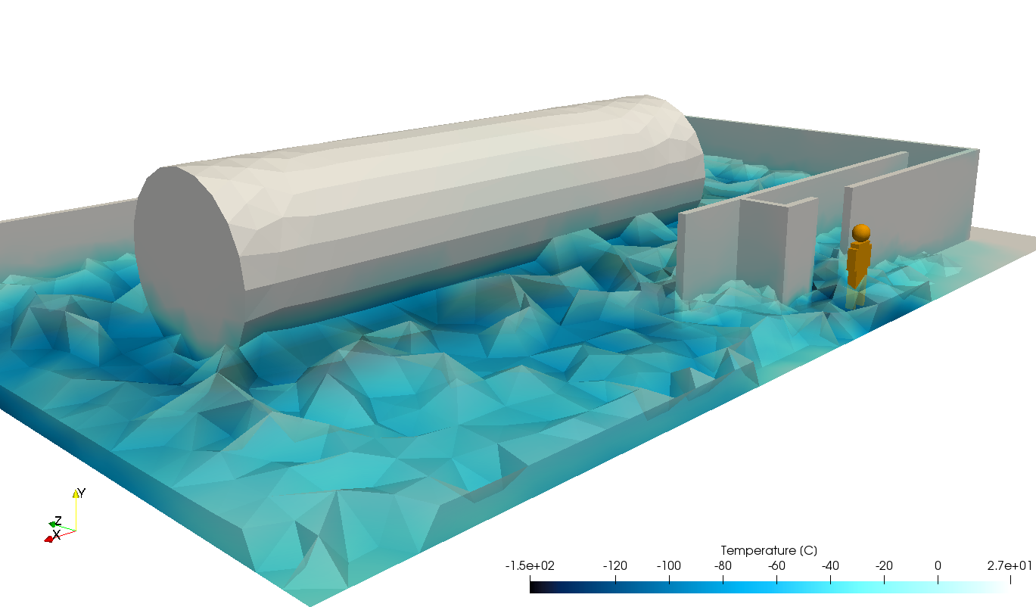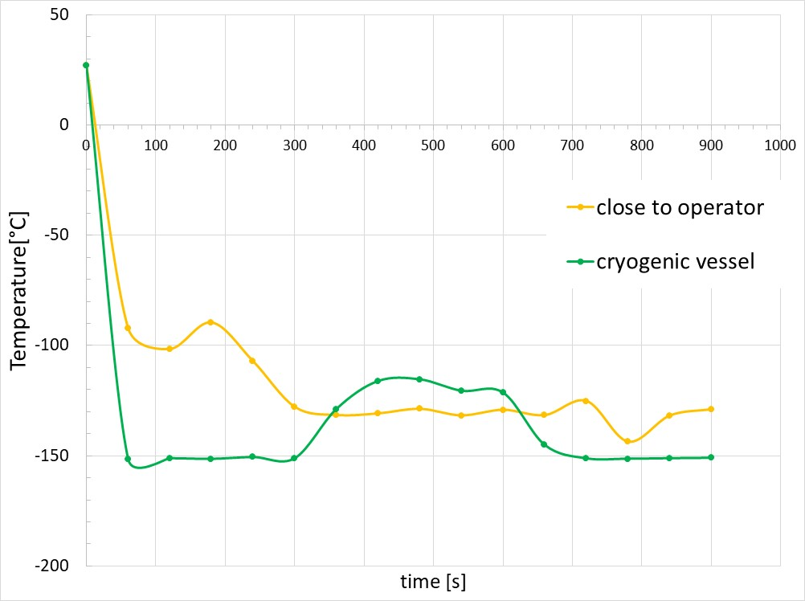
900 s

Figure 4: Temperature achieved close to operator (orange) and at cryogenic vessel (green) in case 1
The case 2 is implemented with a wind direction opposite to that prevailing (case 1). From Figure 5 you can see the importance of containing walls, in particular, the efficacy of a correct design for walls to protect operators and assets. In these ambient conditions, LNG vapors are not confined in the loading area, they can spread towards the near units of the plant.

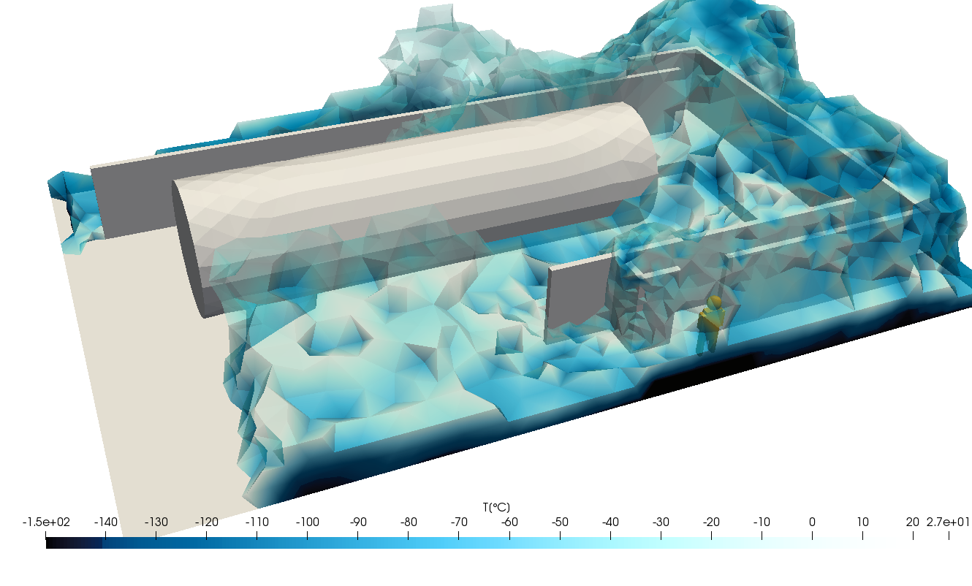
Figure 5: Temperature of LNG vapour in case 2
In case of risk analysis, as QRA, EERA, etc., extension of cloud considering LEL (or LEL/2) concentration is the basis to evaluate consequences for flash fire scenarios. The methane cloud, with concentration of gas between LEL (4.4%_{vol}) and LEL/2(2.2%_{vol}), at 0.5 m from the ground is reported in Figure 6 for case 1.
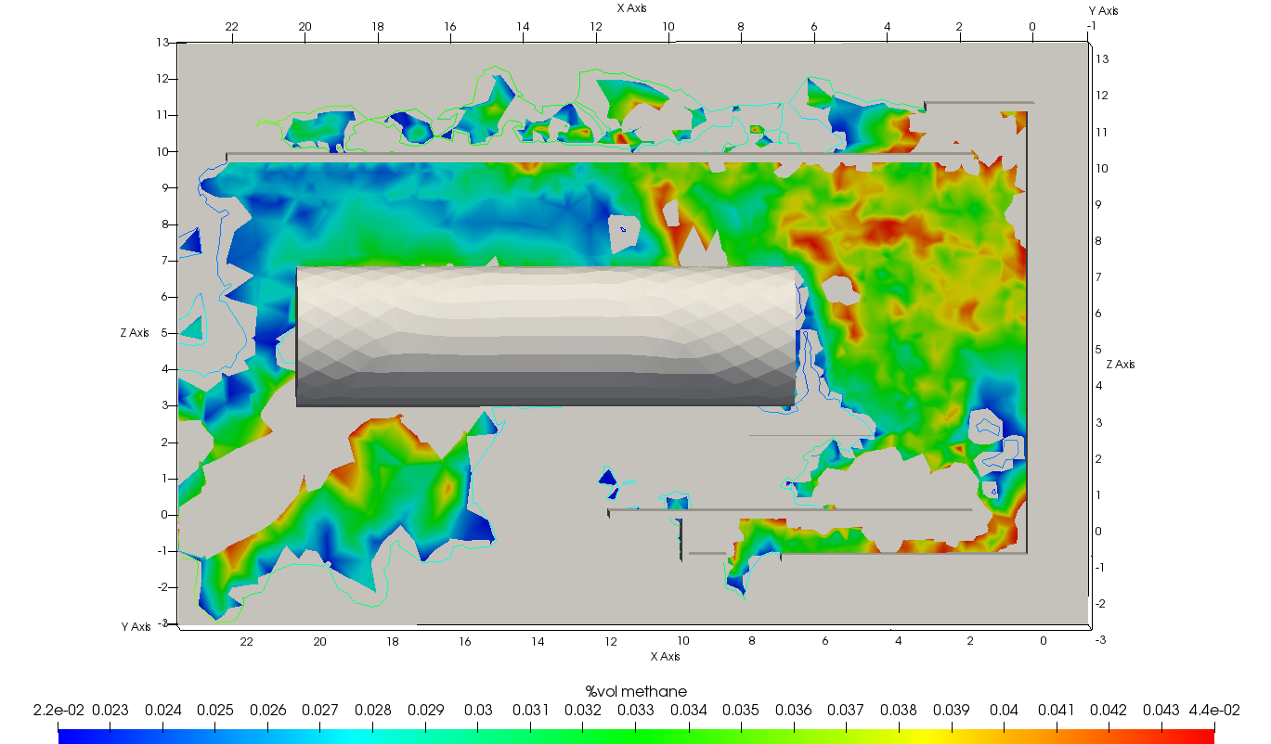
LEL/2
LEL
Figure 6: Concentration of methane in process area
  - Conclusions
The purpose of this work was to study the LNG vapours release in loading phase due to a catastrophic rupture, through CFD simulations, carried out by the open-source software OpenFOAM® for different conditions. The proposed work gives a more accurate prediction of hazardous zones in case of LNG leak, considering both LEL and temperature issues. With the CFD approach it is possible obtain a precise description of vapour cloud dimensions for each value of temperature and concentration. The results shown above indicate the correct design of the walls, that ensure the protection to operators and assets. In addition, the temperature contour obtained from the simulation is a powerful indication for the correct material selection of LNG tank, in order to mitigate the effects of cryogenic temperature on supports. At the end of the simulations, it is possible to evaluate the magnitude of flash fire scenario through the definition of gas concentration between LEL and LEL/2. In addition to the study of the consequences, this analysis is very useful for the positioning of F&G sensors. These types of mitigating measures are highly influenced by environmental conditions such as wind direction and speed. CFD analysis allows to be taken into account environmental variables. The simulation results allowed to quantify the extension of LEL (lower explosive limit) and UEL (upper explosive limit) for gas concentration and the dangerous temperature levels. The prosed work gives to the safety engineer a more accurate prediction of hazardous zones in case of LNG leak, for example during the risk assessment analysis of methane liquefaction or LNG vaporization plants.
Nomenclature
F – mass flux rate, kg/(m²/s)

$C_{β}$ – accommodation coefficient
M – molecular weight, kg/mol
$T_{sat}$ – activation temperature, K
R – universal gas constant, J/(mol K)
$p_{sat}$ – saturation pressure, Pa
$p^{*}$ – vapour partial pressure, Pa
P – pressure, Pa
$ρ$ – density, kg/m³
$µ$ – liquid viscosity, cP
T– temperature, K
$Q_{g}$ – Evaporation rate, kg/s
$T_{b}$ – boiling temperature, K
$T_{g}$ – ground temperature, K
$S$ – pool surface, m²
$k_{t}$ – thermal conductivity of substrate W/m²K
$α$ – thermal diffusivity of substrate, m²/s

References
Jennifer Lundkvist, 2019, ‘CFD Simulation of Fluid Flow During Laser Metal Wire Deposition using OpenFOAM’, Engineering Physics and Electrical Engineering, master's level.
Maria-Monika Metallinou, 2019, ‘Liquefied Natural Gas as a New Hazard; Learning Processes in Norwegian Fire Brigades’, Safety, 5,11.
Shi-er Dong, Yiqing He,*, Jingya Dong, Zhouyu Peng and Guohua Fu, ‘A Review of Leakage and Dispersion of LNG on the Ground’, Energy Engineering, DOI:10.32604/EE.2020.012362.
Van P. Carey, 2020, ‘Liquid-Vapor Phase-Change Phenomena: an Introduction to the Thermophysics of Vaporization and Condensation Processes in Heat Transfer Equipment’, 3rd Edition, doi.org/10.1201/9780429082221.
Walter Chukwunonso Ikealumba and Hongwei Wu, 2016, ‘Modeling of Liqueﬁed Natural Gas Release and Dispersion:Incorporating a Direct Computational Fluid Dynamics Simulation Method for LNG Spill and Pool Formation’, American Chemical Society, DOI: 10.1021.

