CHEMICAL ENGINEERING TRANSACTIONS  VOL. 92, 2022 | A publication of
The Italian Association
of Chemical Engineering
Online at www.cetjournal.it

Guest Editors: Rubens Maciel Filho, Eliseo Ranzi, Leonardo Tognotti
Copyright © 2022, AIDIC Servizi S.r.l.
ISBN 978-88-95608-90-7; ISSN 2283-9216

Vulnerability and disaster risk assessment of a cliff: The case of the Costa Verde cliffs in Lima, Peru
Yarixza J. Monge Salinas, Carlos A. Castañeda-Olivera*
Universidad César Vallejo, Campus Los Olivos, Lima, Perú
*caralcaso@gmail.com
Currently, the world has undergone structural, geographic and morphological changes that are generated by physical, chemical and biological agents. Thus, this research evaluated the degree of vulnerability and risk in the cliffs of the Costa Verde in Lima - Peru, determining and identifying risk levels and scenarios. For the evaluation, field data was collected using the observation technique at 35 points in the study area comprising the districts of San Miguel (zone 1, Z1), Magdalena del Mar (zone 2, Z2), San Isidro (zone 3, Z3), Miraflores (zone 4, Z4), Barranco (zone 5, Z5) and Chorrillos (zone 6, Z6), and its analysis was carried out according to the manual of the National Institute of Civil Defense (INDECI). The field evaluation identified 6 hazard scenarios such as rock falls, earthquakes, construction, environmental contamination, lack of vegetation and soil quality, which were analyzed according to their causes and consequences. From this, it was obtained that Z1, Z2, Z4 and Z6 present a high level of danger with values of 54.31, 54.17, 51.53 and 59.17%, respectively. Meanwhile, Z3 and Z5 present a medium level of danger with values of 40.28 and 48.61%, respectively. On the other hand, the vulnerability analysis showed values of 61.69% (high vulnerability), 53.08% (high vulnerability), 33.89% (medium vulnerability), 42.04% (medium vulnerability), 64.57% (high vulnerability) and 68.26% (high vulnerability) for Z1, Z2, Z3, Z4, Z5 and Z6, respectively. Therefore, in the absence of an assessment of all the districts that are close to the cliffs of the Costa Verde, the study provided plans and strategies to minimize and prevent the impacts that could be generated by natural and/or anthropogenic disasters.
1. Introduction
Human beings have been exposed to natural and anthropogenic hazards, with the potential to cause disasters that generate impacts on various sectors of the population (Omena et al., 2021). Likewise, these disasters have caused modifications in the territory, geographically, structurally and morphologically in the face of exposure to risks from physical, chemical, biological and technological agents (UNDRR, 2017). Economic development and territorial expansion are factors that have generated exposure to disaster events to increase. In Japan, the risk of natural hazards is increasing proportionally to the growth of population density (Choi et al., 2021). For this reason, in the face of urban expansion, large and modern constructions were built, with infrastructures that are located in certain points that, in the short, medium or long term, will be places of potential risk for residents. Therefore, understanding and mitigating disaster risks has become an essential task (Zhao et al., 2020).
Peru has a territory with natural and geological characteristics that are vulnerable to natural disasters (INDECI, 2006). Vulnerability is the degree to which the population, economic and social activities and physical infrastructure are exposed to a threat or hazard that can cause damage (Nguyen et al., 2016). Moreover, vulnerability originates through the interaction of external and internal factors that shape its situation in situ and in a punctual space (Thomasz and Eriz, 2018). On the other hand, natural disaster risk is the probability that a community will experience changes that cause loss of human life and property due to hazardous natural events in a specific period (IPCC, 2018). Risk is a process that incorporates mitigation, transmission and prevention, in addition to disaster preparedness, rehabilitation, reconstruction and emergency response to minimize impacts (MTC, 2016).
The country (Peru) has policies for land use planning; however, urban growth has been developed horizontally, opting to occupy areas with risk and vulnerability levels. Likewise, there has been an increase in the construction of real estate, tourism, clubs, hotels, shopping centers, among others, triggering impacts of different types over the years (IGP, 2019). The city of Lima has a wide coastline that had modifications of the territory due to the need of the citizens to be able to access the seaside resorts. In the 1960s, a coastal road was built that covered a total of 22.5 km from the district of San Miguel to the district of Chorrillos. These events caused the area to lose its original structure; in addition, the combination of anthropogenic effects (construction, tourism activities, pollution) and natural effects (wind erosion, temperature, seismic movements) have affected the Costa Verde, generating various rock falls from the cliffs (SIGRID, 2019).
In accordance with the above, this research evaluated the evaluated the degree of vulnerability and risk in the different sections in the cliffs of the Costa Verde in Lima - Peru, determining and identifying risk levels and scenarios. This, due to the misuse of the territory, has increased the conditions for the development of new risks in the area. The Costa Verde area presents geological-geodynamic conditions, being considered as a critical area with the presence of landslides, rock falls and landslides, before the occurrence of disasters (COEN, 2019).
2. Materials and methods
2.1 Study area
The study area consisted of the cliffs of the Costa Verde, which has an extension of 22. 5 km, covering the districts of San Miguel (272643 E - 8662677 N), Magdalena (274271 E - 8661893 N), San Isidro (276418 E - 8660317 N), Miraflores (279151 E - 8659142 N), Barranco (279629 E - 8656725 N) and Chorrillos (279697 E - 8655354 N) located in Lima, Peru. For the study, each district was zoned with its respective codification, being San Miguel (Z1), Magdalena (Z2), San Isidro (Z3), Miraflores (Z4), Barranco (Z5) and Chorrillos (Z6).
2.2 Data collection and processing
Data collection was carried out in situ and was obtained using the observation technique by walking through the study area. The data obtained through field instruments were processed using Microsoft Excel 2016 software. In addition, thematic maps regarding risk, vulnerability and hazard were produced using Arcgis 10.5 software.
2.3 Hazard estimation
The estimation of hazard levels was performed on a scale of 4 levels: low, medium, high and very high. The National Institute of Civil Defense Guide (Indeci, 2006) was used for the estimation, in which each scale is detailed with the respective characteristics and description.
2.4 Vulnerability estimation
The vulnerability estimate was processed in Microsoft Excel 2016 software, classified by type (environmental and ecological, scientific, cultural and ideological, economic, educational, physical, political and social). In order to stratify the vulnerability levels, it was performed on a scale of 4 levels: low, medium high and very high. The Indeci (2006) guidelines were used to estimate vulnerability.
2.5 Risk estimation
The risk calculation corresponds to an analysis to determine the probabilities of hazard and vulnerability. The criteria used to calculate the risk were analytical and descriptive. In addition, the hazard and vulnerability matrix was used to identify the level of risk.
3. Results and discussion
3.1 Hazard scenario
The study identified 48 points, which allowed the determination of 06 scenarios. The points identified in the study area are shown in Figure 1.

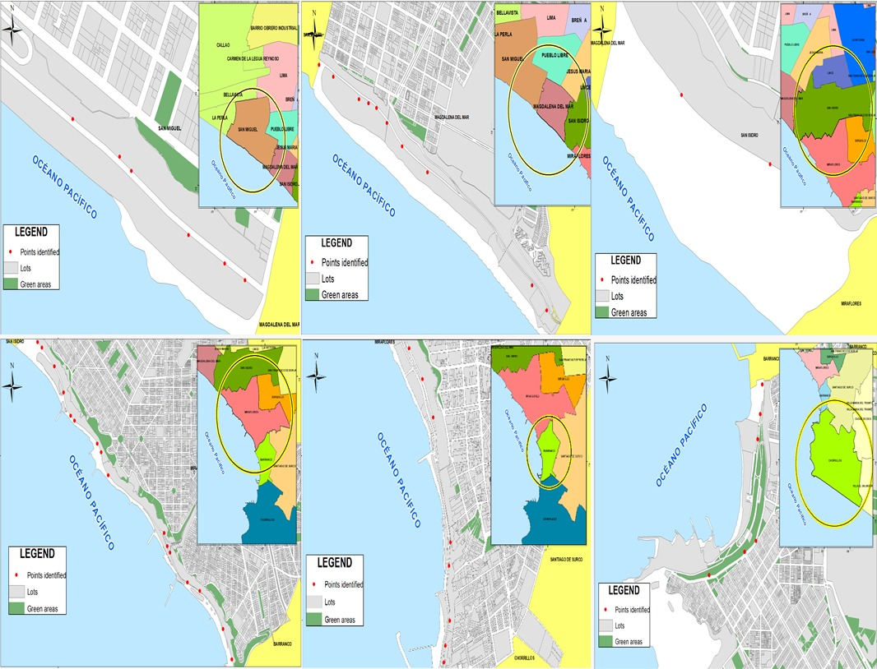
Figure 1: Drawings of the identified points
The 06 thematic maps represent the hazard points by zone according to the analysis performed. Similarly, Xu et al. (2021) evaluated the risk exposure zone by analyzing data in order to create thematic maps showing the location of risk points that can be used as a method of prevention and effective planning for decision making in the face of risk events.
The 06 hazard scenarios evaluated coincide with the study conducted by Garcia (2020), who identified 05 hazard scenarios based on typology. On the other hand, the most frequent scenario in the cliffs of Costa Verde is rockfall and landslides. To this, Ya et al. (2021) states that landslides and rock slides are generated by meteorological factors.
It should be noted that the study area was divided into zones for better identification of hazard scenarios, allowing the critical points to be located in order to generate thematic maps that can show the location of the exposed zone. Similarly, Thiery et al. (2020) identified the hazard scenarios through quantitative analysis and produced thematic maps of the identified points. Table 1 shows the hazard scenarios identified in the Costa Verde cliffs, the causes and possible consequences.

Table 1: Hazard scenarios
Zone | Event | Identified Scenarios | Causes | Consequences
Cliffs of Costa Verde | Mass movement | Rock falls from the cliff | Unstable slope | Falling rocky material causing vehicular and pedestrian accidents
 | Earthquakes | Landslides due to seismic movement | Earthquakes in the area | Due to tectonic movements, landslides are generated in the cliffs
 | Constructions | Construction in areas of untouchable soil | Construction of buildings and houses | Possibility of landslides and a risky area to live in
 | Environmental contamination | Solid waste contamination | Poor waste segregation | Waste accumulated on the cliffs weakens the structure and contaminates the soil
 | Lack of vegetation | Little vegetation | Cliffs without vegetation | Lack of vegetation makes them more prone to erosion
 | Soil quality | Soil cracking | Meteorological agents | Loss of stability, soil fracture and landslides

3.2 Hazard stratification
Table 2 shows the predominant hazard zones. Zones Z1, Z2, Z4 and Z6 present a high hazard level with values of 54.31, 54.17, 51.53 and 59.17 %, respectively. Meanwhile, zones Z3 and Z5 present a medium hazard level with values of 40.28 and 48.61 %, respectively. Regarding the level of danger in the cliffs, it was obtained that they present a medium and high level of danger. The high hazard level was also identified by Rusk et al. (2021) in their study in the Himalayan mountain zone, highlighting that growth and the need for human habitation increased exposure to hazards. Both investigations were carried out in areas with intangible area characteristics and population growth that generates an increase in housing construction.
Table 2: Hazards by zone
Zone | Results
 | Hazard | Classification
Zone 1 | 54.31% | High hazard
Zone 2 | 54.17% | High hazard
Zone 3 | 40.28% | Medium hazard
Zone 4 | 51.53% | High hazard
Zone 5 | 48.61% | Medium hazard
Zone 6 | 59.17% | High hazard
3.3 Vulnerability analysis
Table 3 shows the vulnerability of the study zones. Zones Z1, Z2, Z4 and Z6 present a high vulnerability level with values of 61.69, 53.08, 64.57 and 68.26 %, respectively. Meanwhile, zones Z3 and Z5 present a medium vulnerability level with values of 33.88 and 42.03 %, respectively. These results show that the cliffs in Costa Verde present high and medium vulnerability level. In the study conducted by Irham et al. (2021) in the coastline of the west coast of Aceh Besar - Indonesia pointed out that the area presents high vulnerability and very high vulnerability with values 23.18 and 20.60%, respectively. On the other hand, Tragaki et al. (2018) assess the physical and social vulnerability of the Peloponnese (Greece) to coastal hazards, obtaining as a result high and very high vulnerabilities.
Table 3: Vulnerability by zone
Zone | Results
 | Vulnerability | Classification
Zone 1 | 61.69% | High vulnerability
Zone 2 | 53.08% | High vulnerability
Zone 3 | 33.88% | Medium vulnerability
Zone 4 | 42.03% | Medium vulnerability
Zone 5 | 64.57% | High vulnerability
Zone 6 | 68.26% | High vulnerability
3.4 Risks assessment
Table 4 shows the risk assessment results by analytical criteria for each of the study zones. Zones Z1, Z2, Z5 and Z6 presented a medium risk level with values of 34, 29, 31 and 40 %, respectively. Meanwhile, zones Z3 and Z4 presented a low risk level with values of 14 and 22 %, respectively.
Table 4: Risk by zone - analytical criteria
Zone | Results |  |  | Classification
 | Hazard | Vulnerability | Risk
Zone 1 | 54% | 62% | 34% | Medium risk
Zone 2 | 54% | 53% | 29% | Medium risk
Zone 3 | 40% | 34% | 14% | Low risk
Zone 4 | 52% | 42% | 22% | Low risk
Zone 5 | 49% | 65% | 31% | Medium risk
Zone 6 | 59% | 68% | 40% | Medium risk
Table 5 shows the risk assessment results by descriptive criteria for each of the study zones. Zones Z1, Z2 and Z6 showed a high risk level and zones Z3, Z4 and Z5 had a medium risk level. In the study conducted by Scavia et al. (2020), they analyzed the risks with the descriptive criterion in reference to landslides in the Cels-Morlière hamlet of the municipality of Exilles (Piedmont), identifying that the area has containment methods, but they lack maintenance. This methodology was similar for the analysis and the situation of the study area, which has geogrids and retaining walls, but in some areas there was no evidence of containment methods. Similarly, Chiara et al. (2010) identified the high-risk failure sections in a gas pipeline and described the causes that generate the occurrence of the risk. Therefore, the identification of risk scenarios and the correct consequence analysis is important (Cozzani, 2010).
Table 5: Risk by zone - descriptive criteria
Very high hazard | High risk | High risk | Very high risk | Very high risk
High hazard | Medium risk | Medium risk (Miraflores) | High risk (San Miguel, Magdalena and Chorrillos) | Very high risk
Medium hazard | Low risk | Medium risk (San Isidro) | Medium risk (Barranco) | High risk
Low hazard | Low risk | Low risk | Medium risk | High risk
 | Low High vulnerability | Vulnerabilidad media | High vulnerability | Very high vulnerability
4. Conclusions
The field assessment in the Costa Verde cliffs identified 6 hazard scenarios such as rock fall, earthquakes, construction, environmental contamination, lack of vegetation and soil quality. The hazard in the study area was of medium level in zones Z3 (San Isidro) and Z5 (Barranco), and of high level in zones Z1 (San Miguel), Z2 (Magdalena del Mar), Z4 (Miraflores) and Z6 (Chorrillos). The vulnerability analysis showed that zones Z3 and Z5 have a medium level of vulnerability, and zones Z1, Z2, Z4 and Z6 have a high level of vulnerability. Likewise, the risk estimation in the analytical aspect determined that zones Z1, Z2, Z5 and Z6 presented a medium level, and zones Z3 and Z4 presented a low level. Already, the descriptive aspect showed that Z3, Z4 and Z5 have a medium risk level, while Z1, Z2 and Z6 have a high risk level.
Acknowledgments
The authors would like to thank "Investiga UCV" of the Universidad César Vallejo for financial support for the publication of this research.

References
Chiara B., Citro L., Gagliardi R., Sacile R., Tomasoni A., 2010, Accident ocurrance evaluation in the pipeline transport of dangerous goods, Chemical engineering transactions, 19, 1-6.
Choi E., Ha J., Hahm, D., Kim M., 2021, A review of multihazard risk assessment: Progress, potential, and challenges in the application to nuclear power plants, International Journal of Disaster Risk Reduction, 53, 1 - 13.
COEN, 2019, Reporte de peligro inminente por derrumbe en los acantilados de la Costa Verde - Lima. Centro de operaciones de emergencia nacional <indeci.gob.pe/wp-content/uploads/2019/11/REPORTE-DE-PELIGRO-INMINENTE-N%C2%BA-008-8NOV2019-PELIGRO-INMINENTE-POR-DERRUMBE-EN-LOS-ACANTILADOS-DE-LA-COSTA-VERDE-LIMA-08.pdf> accessed 20.05.2021.
Cozzani V, 2010, Towards the inclusion of external factors in quantitative risk assessment: the analysis of Natech accident scenarios, Chemical engineering transactions, 19, 1-6.
Garcia, J., 2020, Risk Perception and Fear of Urban Hazard. Instituto de Geografía, 1, 2448-7279.
IGP, 2019, Plan estratégico institucional. Instituto Geofísico del Perú<cdn.www.gob.pe/uploads/document/file/489868/IGP_PEI_2020-2024.pdf> accessed 10.05.2021.
INDECI, 2006, PERÚ: Manual Básico para la Estimación del Riesgo. Instituto Nacional de Defensa Civil <bvpad.indeci.gob.pe/doc/pdf/esp/doc319/doc319_contenido.pdf>accessed 04.03.2021.
IPCC, 2018, Intergovernmental Panel On Climate. Climate Change Adaptation. A Special Report of Working Groups I and II of the Intergovernmental Panel on Climate Change, Geneva Switzerland <ipcc.ch/>accesed 30.07.2021.
Irham M., Rusydi H., Haridhi H,.Setiawan I., Ilhamsyah Y., Deli, A., Rusdi M., Mardiah, A, 2021, Coastal vulnerability of the west coast of aceh besar: A coastal morphology assessment, Journal of Marine Science and Engineering, 9, 1-15.
MTC, 2016, Operación e implementación de mantenimiento de sistema de mensajería de alerta temprana de emergencias <extwprlegs1.fao.org/docs/pdf/per160730.pdf>accessed 09.09.2021.
Nguyen T., Bonetti J.,Rogers K., Woodroffe C.,2016, Indicator-based assessment of climate-change impacts on coasts: A review of concepts, methodological approaches and vulnerability indices, Ocean and Coastal Management, 123, 18 - 43.
Omena, B., Goldenfum, J., Michel, G., Albuquerque, R., 2021, Terminology of natural hazards and disasters: A review and the case of Brazil. International Journal of Disaster Risk, 52, 1- 22.
Rusk J.,Mahajan A., Tiwari P., Chen T., Shneiderman S., Turin M., Seto K .,2021, Multi-hazard susceptibility and exposure assessment of the Hindu Kush Himalaya, Science of The Total Environment. 804, 1- 14.
Scavia C., Barbero M., Castelli M., Peila D., Torsello G., Vallero G., 2020, Evaluating rockfall risk: Some critical aspects, Geosciences (Switzerland), 10, 1-29.
SIGRID, 2019, Plan de prevención y reducción del riesgo de desastres de Lima Metropolitana 2019 – 2022. Sistema de Información para la Gestión del Riesgo de Desastres<sigrid.cenepred.gob.pe/sigridv3/storage/biblioteca//7679_plan-de-prevencion-y-reduccion-del-riesgo-de-desastres-de-lima-metropolitana-2019-2022.pdf>accessed 01.04.2021.
Thiery Y., Terrier M., Colas B., Fressard M., Maquiare O.,Grandjean G., Gourdier S. ,2020, Improvement of landslide hazard assessments for regulatory zoning in France: STATE–OF–THE-ART perspectives and considerations, International Journal of Disaster Risk Reduction, 47, 1- 25.
Thomansz O., Eriz M., 2018, Medición de la vulnerabilidad socioeconómica: desde el indicador de NBI a los índices de vulnerabilidad al riesgo climático, Repositorio Digital Institucional de la Universidad de Buenos Aires, <bibliotecadigital.econ.uba.ar/download/libros/Thomasz-Eriz_Medicion-de-la-vulnerabilidad-socioeconomica-2018.pdf> accessed 08.08.2021.
Tragaki, A., Gallousi, C., Karymbalis, E., 2018, Coastal Hazard Vulnerability Assessment Based on Geomorphic, Oceanographic and Demographic Parameters: The Case of the Peloponnese (Southern Greece), Land,7, 1 - 16.
UNDRR, 2017, United Nations Disaster Risk Reduction -Terminology—UNDRR <unbonn.org/UNISDR#:~:text=(%20UNDRR%20),coordination%20of%20disaster%20risk%20reduction>accessed 09.09.2021.
Zhao J., Zhang Q., Zhu X., Shen Z., Yu H ., 2020, Drought risk assessment in china: Evaluation framework and influencing factors, Geography and Sustainability, 1,1-9.
Xu S., Zhang M., Yu M., Liu J., Wang Y.,Ma X., Chen J., 2021, Multiclassification Method of Landslide Risk Assessment in Consideration of Disaster Levels: A Case Study of Xianyang City, Shaanxi Province, ISPRS International Journal of Geo-Information, 10, 1-20.

