CHEMICAL ENGINEERING TRANSACTIONS  VOL. 91, 2022 | A publication of
The Italian AsSoCiation
of Chemical Engineering
Online at www.cetjournal.it

Guest Editors: Valerio Cozzani, Bruno Fabiano, Genserik Reniers
Copyright © 2022, AIDIC Servizi S.r.l.
ISBN 978-88-95608-89-1; ISSN 2283-9216

Investigation on Effective fighting technology for LIB fire
Sofia Ubaldiª, Cinzia Di Bari^{b}, Armando De Rosa^{c}, Michele Mazzaro^{c}, Paola Russo^{a,}*
ªDipartimento Ingegeneria Chimica Materiali Ambiente, Sapienza Università di Roma, Roma, Italia
^{b}Laboratorio Sistemi e Tecnologie per la Mobilità e l’Accumulo, ENE DTE-PCU-STMA, CR Casaccia, Roma, Italia
^{c}Direzione Centrale per la Prevenzione e la Sicurezza Tecnica, Corpo Nazionale dei Vigili del Fuoco, Roma, Italia
*Corresponding author: paola.russo@uniroma1.it

Lithium-Ion Batteries (LIBs) convert the chemical energy obtained from the intercalation of lithium ions in the cathode material of the cell into electrical energy. They are called secondary batteries because are rechargeable. They are currently applied in portable applications (e.g., smartphone, tablet, personal computer), in mobility (e.g., Electrical Vehicles (EVs) and Plug-in Hybrid Electric Vehicles (PHEVs)) and Energy Storage Systems (ESS) for the higher energy and power densities than traditional batteries. LIBs due to their energy content and chemical composition are considered dangerous products that must be handled and used according to the manufacturer's safety indication, defined by the safety window (voltage and temperature ranges). If LIBs are used in conditions outside that window, they are subject to external and/or internal abuse, classifiable as mechanical, electrical, and thermal abuse. These conditions lead to a change in the chemical composition, due to melting of the separator and subsequent chemical reactions, and in the internal pressure, with consequent opening of the safety valve, when present, or of an area of the cell with less resistance welding. Because of the exothermicity of the reactions, the temperature of the system drastically increases in a short time giving rise to release of gas, vapours, fire and/or explosion with the projection of fragments. Due to the complexity of battery components and the diversity of conditions of use, the LIB fire classification is controversial. In view of the uncertainty, there are currently no unified and specific requirements for LIB fire suppression and effective LIB fire fighting technology is still a challenge. The suppression of the LIB fire involves the extinction of the open flame and the decrease in the temperature of the battery. If the battery temperature is sufficiently high after the flame has gone out, there is still a chance that the battery will reignite. To investigate how LIB fire can be effectively suppressed, Kokam lithium-ion batteries with a capacity of 25 Ah and 40 Ah were exposed to an open flame of propane and then extinguished using different agents (i.e., water mist, F500, and CO₂). The cell temperature is monitored by thermocouples and the tested sample is recorded by a camera to obtain complete information on major events, such as venting, and thermal runaway in terms of temperature and time.
  - Introduction
Lithium-ion batteries (LIBs) are rechargeable devices, secondary batteries, which allow to obtain chemical energies by transferring Li-ions through the electrodes. Being involved in different applications, such as portable applications, mobility and energy storage, these devices have a different shape and internal chemical composition due to the required performance. The possible shapes are cylindrical, prismatic, pouch or button. In general, the cells are composed by: two electrodes, anode and cathode, separator, and electrolytic solution. The anode, negative electrode, is generally made up of a layer of graphite on a copper collector while the cathode, positive electrode, is made up of different metal oxides (e.g., Lithium Cobalt Oxide, LiCoO₂ (LCO); Lithium Cobalt Manganese Nickel Oxide, LiMnNiCoO₂ (NMC); Lithium Iron Phosphate Oxide, LiFePO₄ (LFP)) on an aluminum collector. The two electrodes are electrically separated by a porous polymeric membrane (separator) to allow the passage of the Li-ions dissolved in the electrolytic solution. The electrolytic solution consists of a mixture of organic carbonates (i.e., dimethyl carbonate C₃H₆O₃ (DMC), ethylmethyl carbonate C₄H₈O₃ (EMC), propylene carbonate C₄H₆O₃ (PC)), and a lithium salt, such as hexafluorophosphate (LiPF₆), tetrafluorobarate (LiBF₄) or lithium perchlorate (LiClO₄).
Due to that configuration, LIBs are characterized by high energy density (100-200 Wh/kg), high power density (360 W/kg) and long life (500-2000 cycles) respect to traditional batteries, such as lead acid (20-35 Wh/kg; 180 W/kg; 200-2000 cycles), nickel-cadmium (Ni-Cd) (40-60 Wh/kg; 140-180 W/kg; 500-2000 cycles) and nickel-metal hydride (Ni-MH) (60-80 Wh/kg; 220 W/kg; <3000 cycles) (Williamson et al., 2011). This increase in use has also marked a negative aspect of the Li-ion batteries: the problem of safety. Indeed, the internal components define a safe and reliable operation, limited by temperature and voltage, in the so-called safety window (Lu et al., 2012). Outside the safety window the cell is subjected to abuse that can be divided in mechanical, electrical, and thermal. Mechanical abuse is caused by deformation or penetration of the cell or package, electrical abuse can be induced by an internal or external short-circuit, while the thermal abuse is related to external heating or cooling (Ouyang et al., 2019). Although different in nature, the effect is the same and can be divided into 3 phases: heating, venting or package opening, and thermal runaway (TR) (Wu et al., 2019). The first phase is characterized by heating which leads to a degraded performance. The heat from the first phase triggers chain reactions within the battery causing the electrolyte to volatilize, the separator to melt and the electrolyte to decompose. During this phase the cell undergoes an increase in internal pressure with subsequent, depending on the shape of the cell, opening of the vent valve for cylindrical cell or of an area, placed between the two terminals, with a less resistance welding for pouch cell. The TR is characterized by a self-accelerating exothermic reaction inside the cell with high temperature and heating rate (10°C/min or higher), gas ejection, projection of fragments, fire and/or explosion (Wang et al., 2012). The reactions that take place inside are spontaneous and uncontrolled exothermic chain reactions and are due to the decomposition of protecting layer on the anode called SEI (solid electrolyte interphase) (>70°C), reaction between intercalated lithium and electrolyte (90-230°C), melting of the separator (130-190°C), metal oxide cathodes decomposition with production of oxygen (>160°C) which oxidizes the electrolyte (Essl et al., 2020). The level of danger of events depends on the chemical composition, the capacity and the State of Charge (SoC) of the cell (Abdi et al., 2017).
Due to the complexity of battery components and the diversity of conditions of use, the LIB fire classification is controversial. Different extinguishing agents are available: water-based, water mist and F500, gaseous, CO₂ and Novec 1230, and dry powders, depending on their physical state (Yuan et al., 2021). As water-based fire-extinguishing agents, the most common are water mist and F500, water with micellar additive. Water is the most used and cheapest means of fighting fire and, in the case of water mist, the smallest droplets allow a large surface to be cooled by absorbing thermal energy more quickly. F500 is a large molecule divided into two parts, one polar and one non-polar, placed far enough apart to allow both to act independently. The F500 molecules create the micelles around the hydrocarbon molecules, thus preventing contact with the comburent and the consequent combustion reaction. As gaseous extinguishing agents the most used are carbon dioxide and Novec 1230. CO₂ is highly suitable for electrical fires (class E) thanks to its non-conductive properties. This agent inhibits flame by a combination of smothering, isolation, and cooling. Novec 1230, perfuoro(2-methyl-3-pentanone), is a fluid extinguishing agent with a boiling point of 49.2°C. This agent extinguishes fire by a combination of physical suppression, absorption of heat content, and chemical suppression by thermal decomposition products such as CF₃ and CF₂ which could lower radicals’ concentrations (Yuan et al., 2021). Ultrafine dry powder has a different composition depending on the type of fire (i.e., ABC, D or BC powder) (Zhao et al., 2021). ABC powder, for solid (class A), liquid (class B) and gas (class C) fires, consists mainly of ammonium dihydrogen phosphate (NH₄H₂PO₄) or ammonium sulfate ((NH₄)₂SO₄). For metal fires (class D) the powder is made of sodium chloride (NaCl) while the BC powder is composed of sodium bicarbonate (NaHCO₃). These agents have a fire extinguishing ability by flooding, filling the entire space. Comparing the results of the different studies showed that water-based agents have a high cooling capacity and excellent anti-reignition performance for fire (Yuan et al., 2021). The addition of F500 to the water reduces the temperature of the fire in a very short time. CO₂ inhibits combustion of the combustible gases and jet fire of gases emitted by the cell but is not an ideal extinguishing agent for LIB fires due to its low cooling capacity (Ghiji et al., 2020). Dry powder and Novec failed the thermal runaway propagation (Xu et al., 2020), but Novec inhibited occurrence of fires and the generation of toxic gas (Zhao et al., 2021). Dry powder could only extinguish LIB fires under certain specific conditions (Russo et al., 2018).
It can be concluded that there are currently no unified and specific requirements for LIB fire suppression and effective LIB firefighting technology is still a challenge. In this framework, the aim of this work is to study the efficiency of different extinguishing agents on fire due to thermal abuse of Li-ion cells. To this end, fire tests were performed by exposing single NMC cells from Kokam, with two different capacities 25Ah and 40 Ah, to an open flame of propane. During the test the cell temperature is monitored by thermocouples and the tested sample is recorded by a camera to obtain complete information on the main events, such as venting and thermal runaway in terms of temperature and time. The data obtained using three fire extinguishing agents, such as: water mist, F500 and CO₂, were compared to evaluate the efficiency.
  - Materials and methods
    - Materials
The Kokam Superior Lithium Polymer Battery (SLPB), with two different capacities (25Ah and 40Ah), was used for the fire tests (Figure 1). From material safety data sheet (MSDS SLPB, 2006) (Figure 1b), the main chemical composition of Li cells is as follows: the negative electrode is made of carbon (15-35%) while the positive electrode is made of Lithium Cobalt Manganese Nickel Oxides, LiNi_{x}Co_{y}Mn_{z}O₂ (NMC) (20-50%). The electrodes were immersed in a solution of lithium hexafluorophosphate (LiPF₆) in a mixture of organic solvents, such as ethylene carbonate (EC) and ethyl methyl carbonate (EMC) (10-20%). Information on the electrical characteristics were obtained from the technical specification, as reported in Table 1.
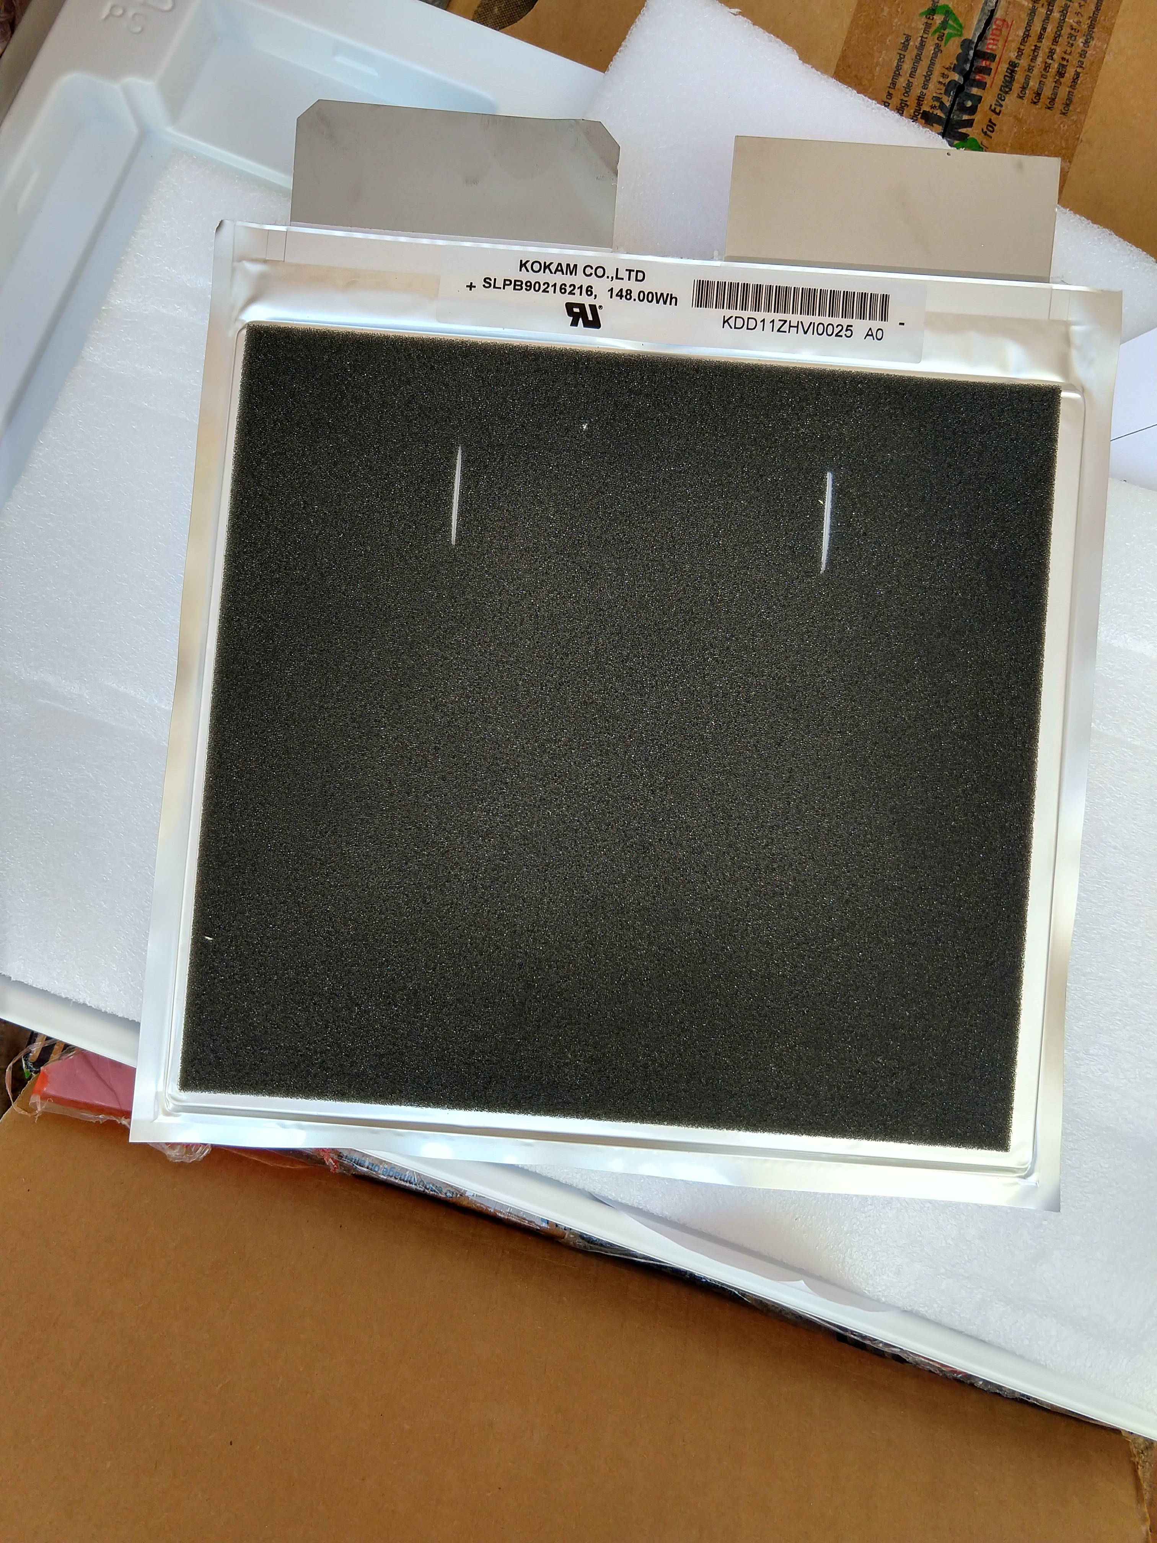
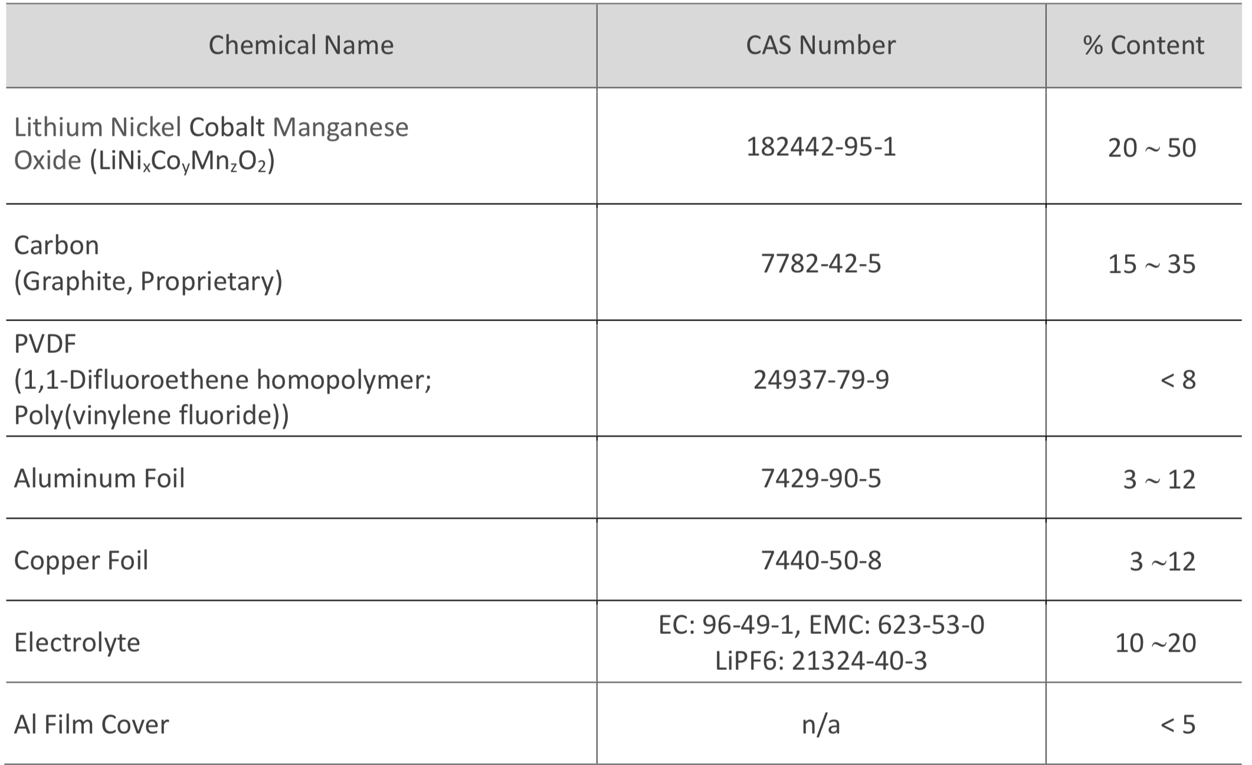
a)
b)
Figure 1: a) a picture of Kokam cell and b) its chemical composition from MSDS
Table 1: Cells specifications
Cell | Weight  [g] | Height  [mm] | Length  [mm] | Thickness  [mm] | Capacity  [Ah] | Voltage  [V]
Kokam 25Ah | 555 | 226 | 227 | 6.0 | 25 | 3.7
Kokam 40Ah | 835 | 226 | 227 | 9.1 | 40 | 3.7
Before being tested, each cell was charged using an Elektro-Automatik (EA) PS 8000 2U series power supply to a 100% state of charge (SoC).
Two water-based extinguishing agents were used, water mist and F500, and one gas, CO₂ (Figure 2). From the figure it is also possible to observe that, in addition to the internal chemical composition of the extinguishing agent, the diffuser for the application also differs.
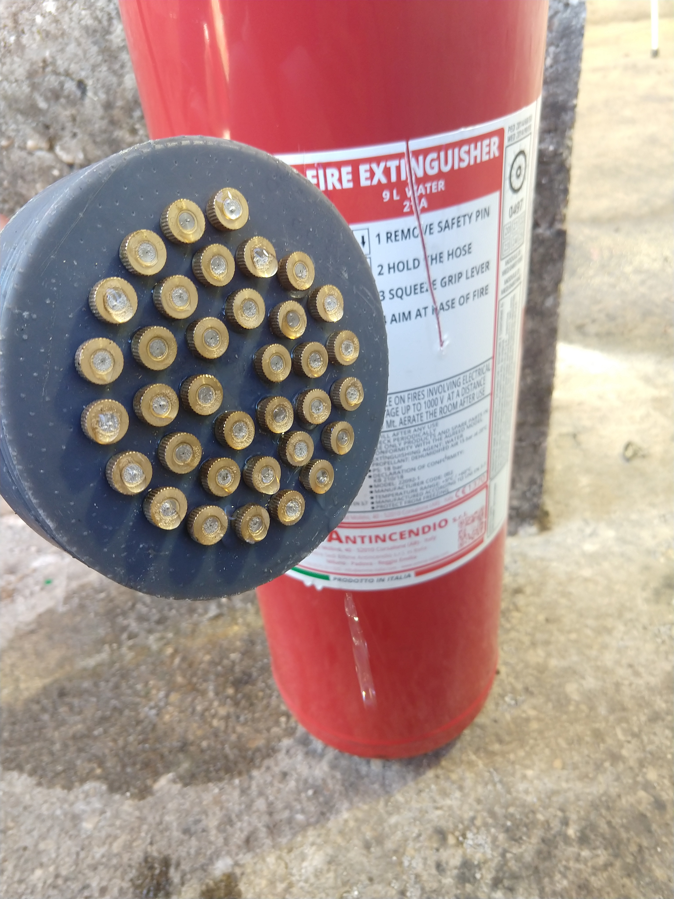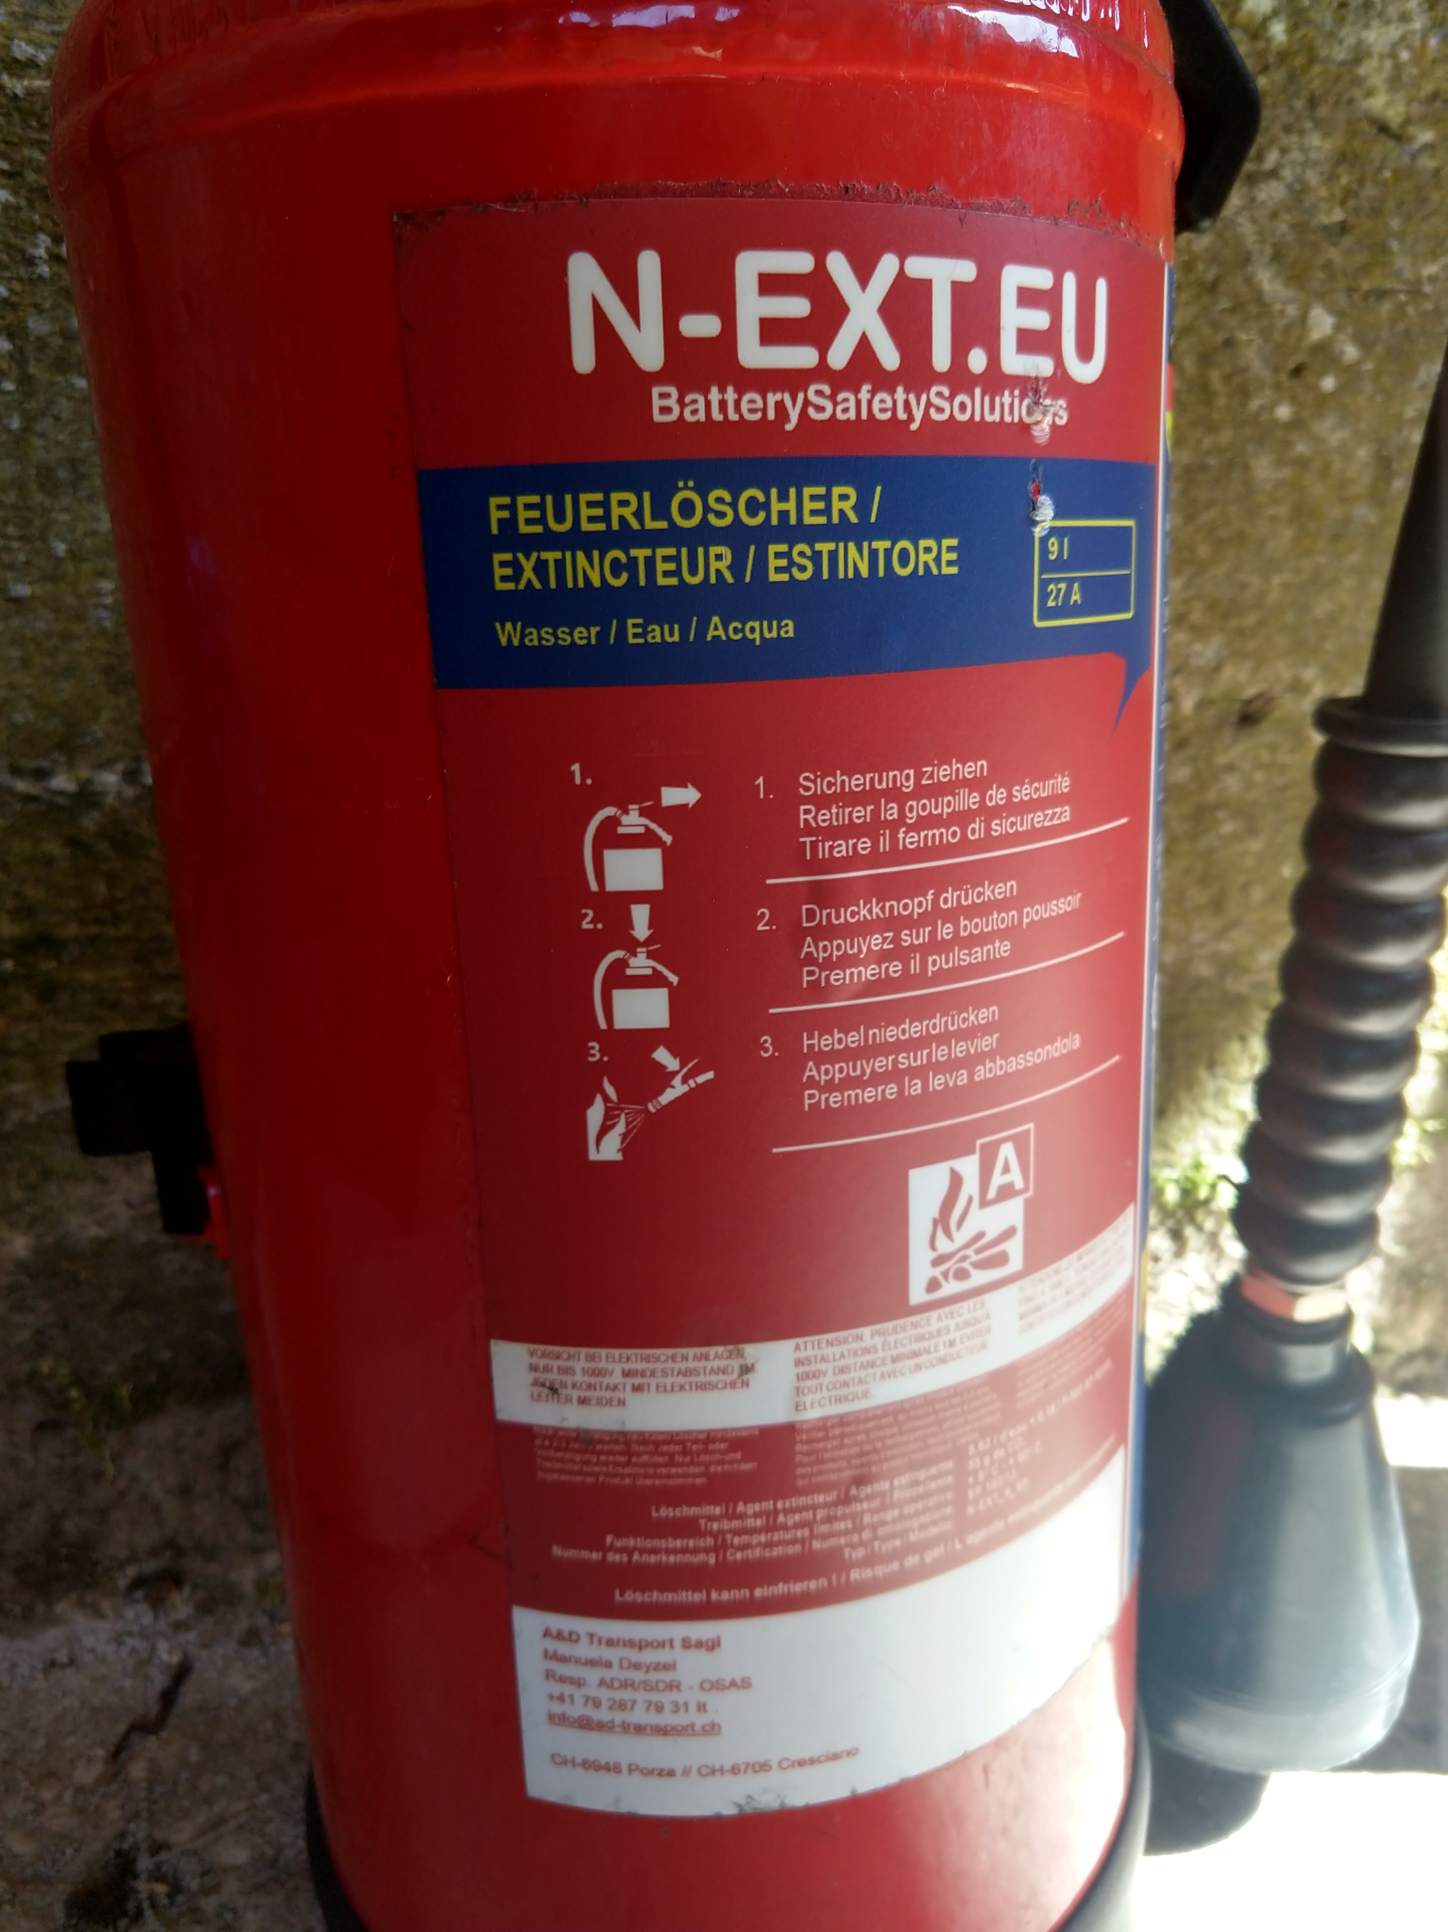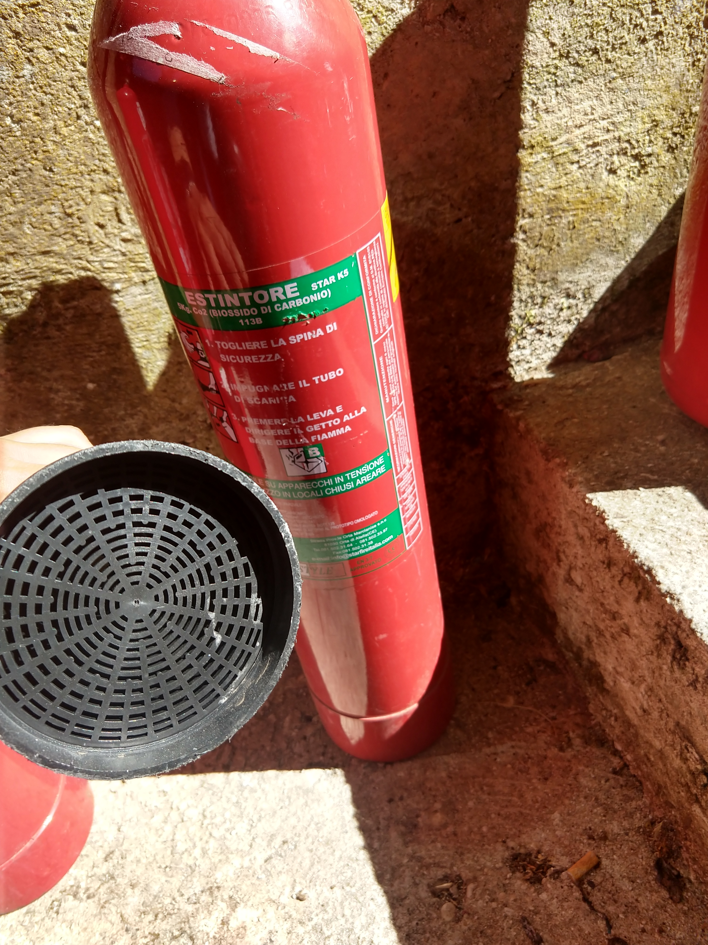
c)
b)
a)
Figure 2: Fighting technology: a) water mist; b) F500; c) CO₂.
    - Test conditions
The tests were carried out in an open space surrounded by perimeter walls and protective mesh as a ceiling to minimize the risk of projection of solid fragments. The cell was placed on a grate placed over a propane flame burner, Figure 3a. Table 2 shows a summary of the test conditions.

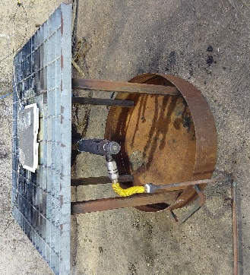
Table 2: Test conditions
TC
TC
b)
a)
Test id | Cell | Burner | Extinguisher
K25-W | Kokam 25Ah | Propane | Water mist
K25-F | Kokam 25Ah | Propane | F500
K25-C | Kokam 25Ah | Propane | CO₂
K40-W | Kokam 40Ah | Propane | Water mist
K40-W | Kokam 40Ah | Propane | F500
K40-W | Kokam 40Ah | Propane | CO₂

Figure 3: a) experimental setup for fire tests and b) relative position of the thermocouples.
For each test, two thermocouples were placed on the upper cell surface, according to the positions reported in Figure 3b. Thermocouples were connected to a data logger. The test was recorded with a video camera, and photos were taken with a thermal imaging camera.
  - Results
By combining the data recorded by the thermocouples with those of the thermal imaging camera and recorded video information is obtained on the main events occurring during the fire exposure, such as venting and TR, and the effect of the extinguishing agent during its application (from Start Ext. to End Ext.) (Table 3).
Table 3: Time, in seconds, and temperature, in °C, at which the main events occur during fire tests.
 | K25-W |  | K25-F |  | K25-C |  | K40-W |  | K40-F |  | K40-C
 | t [s] | T [°C] | t [s] | T [°C] | t [s] | T [°C] | t [s] | T [°C] | t [s] | T [°C] | t [s] | T [°C]
Start | 0 | 25 | 0 | 26 | 0 | 29 | 0 | 25 | 0 | 26 | 0 | 26
Venting | 45 | 150 | 40 | 88 | 10 | 35 | 90 | 132 | 40 | 100 | 10 | 31
TR | 65 | 419 | 55 | 396 | 40 | 406 | 100 | 379 | 85 | 475 | 60 | 406
Start I Ext. | 65 | 419 | 55 | 396 | 40 | 406 | 110 | 370 | 90 | 459 | 65 | 512
End I Ext. | 75 | 78 | 65 | 80 | 50 | 195 | 120 | 98 | 100 | 45 | 75 | 319
Start II Ext. | - | - | - | - | 115 | 345 | - | - | - | - | 295 | 289
End II Ext. | - | - | - | - | 125 | 295 | - | - | - | - | 305 | 187
Start III Ext. | - | - | - | - | 175 | 300 | - | - | - | - | 500 | 207
End III Ext. | - | - | - | - | 185 | 91 | - | - | - | - | 510 | 101
From the data reported in Table 3 it is possible to make some considerations both on the effect of the cell capacity, 25 and 40 Ah, and on the efficacy of the various extinguishing agents: water mist, F500 and CO₂. To evaluate the effect of the capacity, it is necessary to compare the time of events such as venting and TR, for the two capacity values. For the effectiveness of the extinguishing agents, on the other hand, the cooling rate and the temperature maintained at the end of the application of the extinguishing agent are evaluated.. From the comparison of the data between the cells with different capacities, it comes that the average time and temperature to reach the venting are 32s and 91°C for 25 Ah, while 47s and 88°C for K40. Even the average temperature for reaching thermal runaway does not differ significantly, in fact 407°C is reached in 53s for the K25 and 420°C in 82s for the K40. Thus, the different capacities, 25 and 40 Ah, of the cells did not significantly affect the venting and TR. The effectiveness of the extinguishing agents is evaluated by the number of extinction steps necessary and the cooling rate, v_{c}, calculated by the following Eq (1):
$v_{C}= \left|\left(T_{end extinction}- T_{start extinction}\right)/ (t_{end extinction}- t_{start extinction})\right|$ (1)
From the experimental data it emerges that the first significant difference between water-based and gaseous extinguishing agents lies in the number of extinguishing phases required. For the water mist, the thermal profile of the cell reported in Figure 4 shows that a single application of the extinguishing agent is sufficient to cool the temperature of the cell, while for CO₂, the thermal profile of the cell in Figure 5 indicates that more applications are required. In particular, the first two extinguishing applications (I Ext. and II Ext.) were performed using CO₂ as agent, while for the third (III Ext.) it was necessary the use water mist to cool the cell.
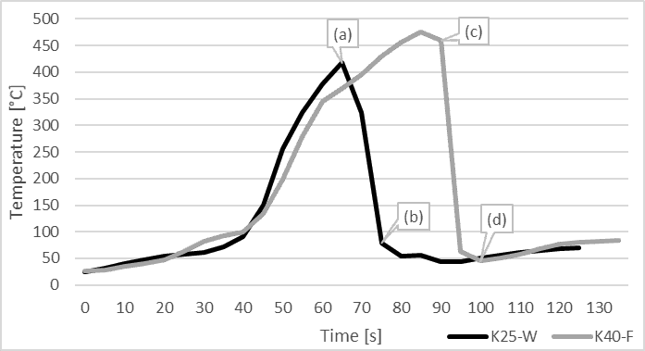
Figure 4: Thermal profile of the cell during fire tests extinguished by water mist (K25-W) and F500 (K40-F).
Both water-based extinguishing agents, water mist and F500, cool the cell efficiently after only one application without reheating of the cell (Figure 4). In the case of water mist, in the test K25-W, during the extinction phase, represented by the segment a-b, the temperature passed from 419°C to 78°C in 10 s with a cooling rate of 34°C/min, while in the case of F500, in the test K40-F, the temperature in the segment c-d passed from 459°C to 45°C in 10 s with a slightly higher cooling rate of 41°C/min.
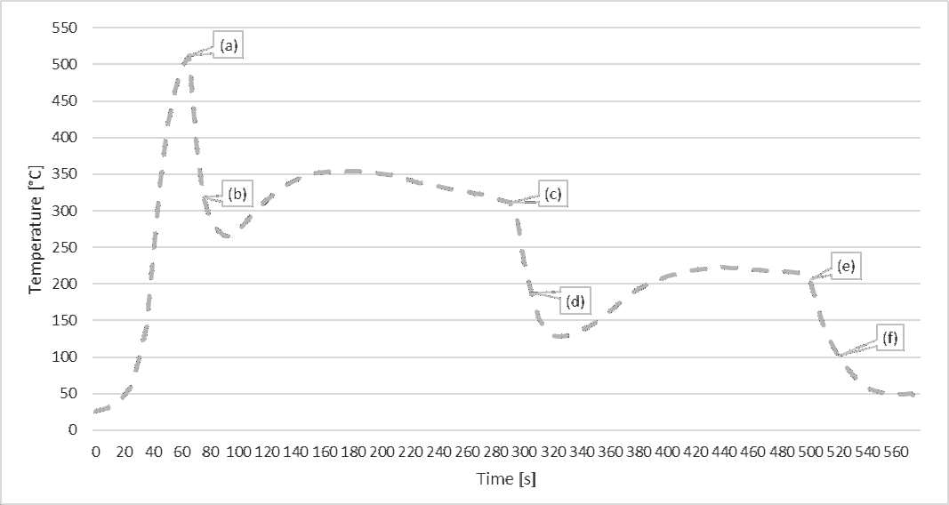
Figure 5: Thermal profile of the cell during fire tests extinguished by CO₂: K40-C.
A different trend was observed in the CO₂ test. In fact, from the thermal profile it is possible to observe that several extinguishing phases were necessary: two with CO₂ and one with water mist, to cool the cell definitively. The various extinguishing phases have the following cooling rate: 19°C/min between a-b, 10°C/min between c-d, both for CO₂ application and 11°C/min between e-f, respectively for water mist.
Furthermore, while in the case of water-based agents it is observed that the temperature drops to 50°C, the temperatures reached are higher in the case of CO₂ and are not maintained over time. In fact, after the two-extinguishing phases with CO₂, a rise in temperature is observed in a short time. After the first extinguishing phase, a minimum temperature of 266°C (at 90 s) is recorded, but then in about 60 s the temperature increases up to a maximum of 354°C. The same behaviour is observed in the second extinguishing phase, where a minimum temperature of 127°C (at 330 s) is reached and then rise to 223°C in 90 s. The third phase, with water mist, allows instead to lower the temperature below 50°C and to maintain it.
Another important aspect that must be considered, especially for the safety of the rescue team, is that after the extinguishing the temperature increase is not linked to a reappearance of the flame or to a significant increase in the vapours and/or gases emitted. In any case, the temperature rises rapidly, and this can pose a great risk in terms of toxic emissions and heat propagation. The increase in temperature is due to the exothermic reactions that continue to occur between the components inside the battery. Therefore, CO₂ has only a surface cooling effect, as can be observed by the temperatures recorded by thermal imaging camera on the surface of the cell during the test with CO₂ agent (Figure 6).
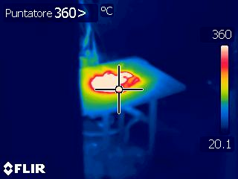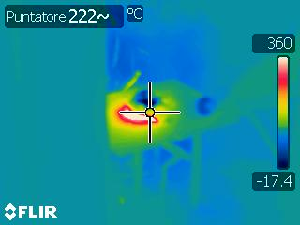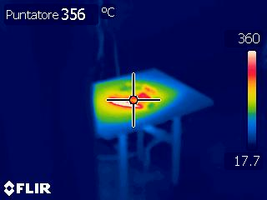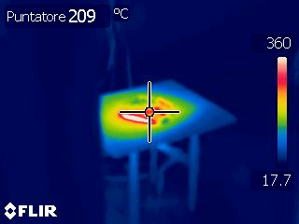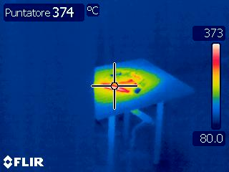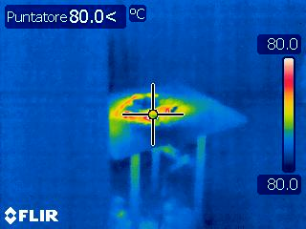
(d)
(e)
(f)
(c)
(b)
(a)
Figure 6: thermal images of K40-C: start (a) and end (b) of I extinction phase, start (c) and end (d) of II extinction phase, start (e) and end (f) of III extinction phase.
  - Conclusions
To evaluate the efficiency of fighting technology for LIB fires, fire tests were performed on single Kokam NMC cells with different capacities (25 and 40Ah) and three different extinguisher agents were applied: water mist, F500 and CO₂. Comparing the results of tests conducted on cell it is observed that the capacity does not significantly influence the temperature at which venting and thermal runaway occur. Significantly different behaviour was shown for the applied extinguishing agent, by comparing the number of applications, the cooling rate and temperature once the extinguishing is over. Considering the cooling rate, it goes from 36°C/min for F500, to 31°C/min for water mist to a lower value, 20°C/min, for CO₂, at the first extinction. These values highlight the greater efficiency of the water-based agents (i.e., water mist and F500) compared to gaseous agent ( i.e., CO₂)
References
Abdi A., Mohammadiivatloo B. Javadi S., Khodaei A. R., Dehnavi E., 2017, Chapter 7 - Energy Storage Systems, Distributed Generation Systems, 333-368.
F-500 Encapsulator Technology, <https://www.f-500.it/incapsulazione/> accessed 29.12.2021.
Ghiji M., novozhilov V., moinuddin K., Joseph P., Burch I., Suendermann B., Gamble G., 2020, A review of Lithium-Ion Battery Fire Suppression, Energies, 13, 5117.
Kokam SLPB Safety Data Sheet, 2006,< https://www.swe.com/media/files/files/a8e04d60/kokam-lc-cell-msds_8fusKnZ.pdf> accessed 29.12.2021
Lu L., Han X., Li J, Hua J., Ouyang M., 2012, A review on the key issue for lithium-ion battery management in electric vehicles, Journal of Power Sources, 226, 272-288.
Ouyang D., Chen M., Huang Q., Weng J., Wang Z., Wang J., 2019, A review on the Thermal Hazards of the Lithium-Ion Battery and the Corresponding Countermeasures, Applied Science, 9, 2483.
Russo P., Di Bari C., Mazzaro M., De Rosa A., Morriello I., 2018, Effective Fire Extinguishing Systems for Lithium-ion Battery, Chemical Engineering Transactions, 67.
Wang Q., Ping P., Zhao X., Chu G., Sun J., Chen C., 2012, Thermal runaway caused fire and explosion of lithium ion battery, Journal of Power Sources, 208, 210-224.
Williamson S.S., Cassani P.A., Lukic S., Blunier B., 2011, Power Electronics Handbook (Third Edition), Butterworth-Heinemann, 1331-1356.
Wu X., Song K., Zhang X., Hu N., Li L., Li W., Zhang L., Zhang H., 2019, Safety Issue in Lithium Ion Batteries: Materials and Cell Design, Frontiers in Energy Research, 7, 65.
Xu J., Guo P., Duan Q., Yu X., Zhang L., Liu Y., Wang Q., 2020, Experimental study of the effectiveness of three kinds of extinguishing agents on suppressing lithium-ion battery fires, Applied Thermal Engineering, 171.
Yuan S., Chang C., Yan S., Zhou P., Qian X., Yuan M., Liu K., 2021, A review of fire-extinguishing agent on suppressing lithium-ion batteries fire, Journal of Energy Chemistry, 62, 262-280.
Zhao J., Xue F., Fu Y., Cheng Y., Yang H., Lu S., 2021, A comparative study on the thermal runaway inhibition of 18650 lithium-ion batteries by different fire extinguishing agents, iScience, 24.
3M Italia, <https://www.3mitalia.it/3M/it_IT/novec-it/applications/fire-suppression/> accessed 29.12.2021.

