|  |  |
| --- | --- |
| cetlogo ***CHEMICAL ENGINEERING TRANSACTIONS***  ***VOL. 91, 2022*** | A publication of  aidiclogo_grande |
| The Italian Association  of Chemical Engineering  Online at www.cetjournal.it |
| Guest Editors: Valerio Cozzani, Bruno Fabiano, Genserik Reniers  Copyright © 2022, AIDIC Servizi S.r.l. **ISBN** 978-88-95608-89-1; **ISSN** 2283-9216 | |

Explosion Behavior of Ethanol-Ethyl Acetate/Air Mixtures

Francesco Cammarotaa, Valeria Di Sarlia,\*, Ernesto Salzanob

aIstituto di Scienze e Tecnologie per l’Energia e la Mobilità Sostenibili (STEMS), Consiglio Nazionale delle Ricerche (CNR), Via G. Marconi 4, 80125, Napoli, Italy

bDipartimento di Ingegneria Civile, Chimica, Ambientale e dei Materiali, Alma Mater Studiorum - Università di Bologna, Via U. Terracini 28, 40131, Bologna, Italy

\* valeria.disarli@stems.cnr.it

Alcohol-ester mixtures and, among them, ethanol-ethyl acetate mixtures are widely used as solvents in the packaging industry. For the safe use of such mixtures, it is essential to characterize their explosion behavior. Specifically, knowledge is required about maximum pressure and the maximum rate of pressure rise (i.e., the deflagration index), which are among the most important parameters for the assessment of process hazards and the safe design of process equipment. To this aim, in this work, closed-vessel explosion tests were carried out for an ethanol-ethyl acetate composition (mole fraction of ethanol in ethanol + ethyl acetate equal to 0.62) of interest to the packaging industry, varying the fuel/air equivalence ratio from 1.0 to 1.7. Tests were also extended to ethanol/air and ethyl acetate/air to quantify the effects of the possible interaction between the two fuels in the mixture. All tests started from 25°C and 1 bar.

Experimental results show that, as the fuel equivalence ratio is increased, a transition occurs from a regime in which synergistic effects arise making the explosion behavior of ethanol-ethyl acetate more severe (i.e., making the rate of explosion pressure rise of ethanol-ethyl acetate higher) than both ethanol and ethyl acetate, to a regime in which, as a result of a completely different interaction between ethanol and ethyl acetate, the explosion behavior of their mixture is less severe than both the individual components. The maximum rate of pressure rise falls within an intermediate regime in which non-linear interaction effects substantially disappear and, thus, the value of deflagration index for the mixture can be obtained by averaging the values of the two fuels according to their molar proportions.

* 1. Introduction

Alcohol-ester mixtures and, specifically, ethanol-ethyl acetate mixtures are widely used as solvents in the packaging industry. Such mixtures are flammable and, thus, in order to design adequate prevention and mitigation measures for the industries where they are stored, handled and used, reliable safety data are required.

According to the National Fire Protection Association, the key parameter for classifying flammable liquids is the flash point (NFPA 30, 2003). However, although liquid fuels are not explosive by themselves, explosive conditions may arise at temperatures higher than the flash point: fuel evaporation and subsequent mixing with air may result in the formation of a flammable cloud, the accidental ignition of which may lead to explosion (Venart, 2004). Hence, in some conditions, explosion parameters — maximum pressure and the maximum rate of pressure rise (i.e., the deflagration index) — for flammable liquids in their vapor state are also needed. The flash point is 12.8°C for ethanol and − 4.4°C for ethyl acetate (Crowl, 2003). This means that both ethanol and ethyl acetate are prone to generate explosive conditions at ambient temperature or higher.

Recent research efforts have been focused on predicting the flash point for ethanol and ethyl acetate — even at pressures different from the atmospheric pressure — and their mixtures (Di Benedetto et al., 2018a; 2018b). For ethanol-ethyl acetate, it has been found that, over a rather wide range of mixture compositions, synergistic effects arise resulting in the so-called “minimum flash point behavior”: the flash point of the mixture is below the flash points of the individual components (Di Benedetto et al., 2018a). This behavior increases the explosion risk for ethanol-ethyl acetate mixtures compared to ethanol and ethyl acetate.

Explosion data for ethanol and, above all, for ethyl acetate are rather scarce (Cammarota et al., 2012; Mitu and Brandes, 2017; Oppong et al., 2021), whereas there is a complete lack of data for ethanol-ethyl acetate mixtures. Non-linear effects could affect the explosion behavior of such mixtures. Thus, in principle, this behavior cannot be extrapolated from the individual components, but it requires a dedicated investigation.

The present paper fits in this framework focusing on the explosion behavior of ethanol-ethyl acetate in air. Closed-vessel explosion tests were carried out for an ethanol-ethyl acetate composition of interest to the packaging industry, varying the fuel/air equivalence ratio. Tests were also extended to ethanol/air and ethyl acetate/air to quantify the effects of the possible interaction between the two fuels in the mixture. All tests started from 25°C and 1 bar.

* 1. Experimental

Figure 1 shows a schematic representation of the experimental set-up used in this study for explosion tests, the core of which is the reactor, a closed cylindrical chamber (volume of 5 l and length-to-diameter ratio of around 3) made of AISI 316 stainless steel, with pressure equipment directive (PED) certification for maximum allowable working pressure (MAWP) of 200 bar at 300°C. This set-up was used in previous works (Cammarota et al., 2012; 2019).

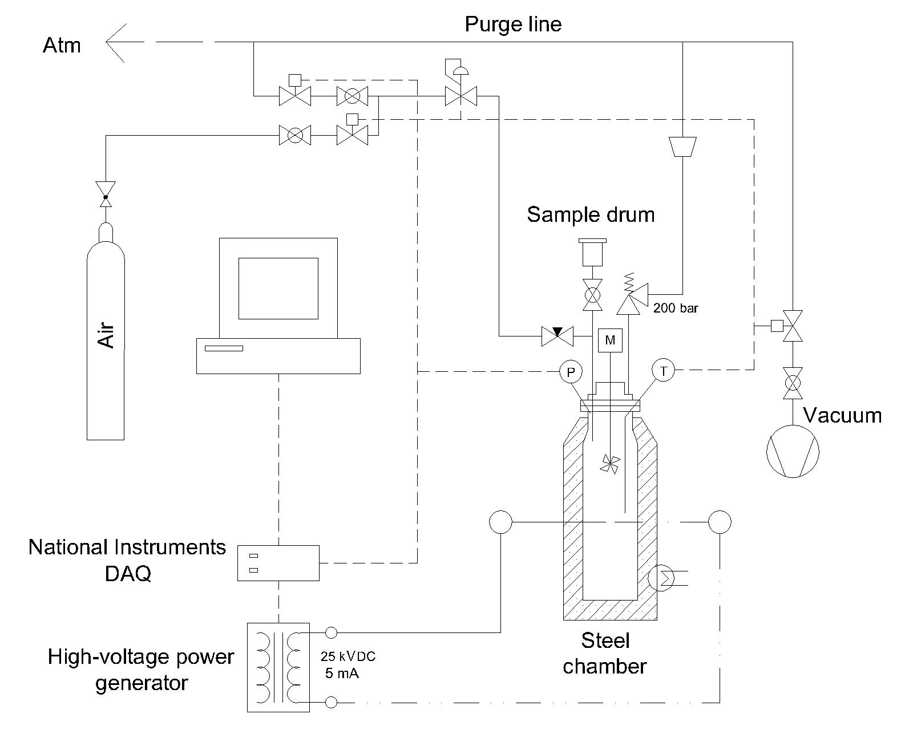

*Figure 1. Schematic representation of the experimental set-up used in this study for explosion tests.*

Spark ignition was provided at the center of the reactor by using an electric arc produced by a high-voltage power generator (25 kV DC, 5 mA — spark generator produced by Kühner (model KSEP 320)). The circuit was controlled by solid-state relays through an electrical board. The spark gap was set to 6 mm, while the spark discharge time was adjusted to a value of 0.2 s–1.0 s (BS EN 15967:2011, 2012).

For pressure measurements, a high-precision KULITE piezoelectric transducer (type ETS-IA-375M-350 BARA) was installed at the top of the reactor. A high-resolution acquisition system (National Instruments USB-6251 — 1.25 MS/s) was employed. The initial temperature of the chamber was obtained by using an external PID-controlled heater. The gas temperature was checked by a type-K thermocouple positioned at the center of the chamber.

Explosion tests on ethanol, ethyl acetate and ethanol-ethyl acetate — the latter with mole fraction of ethanol in the mixture equal to 0.62 — were performed varying the fuel/air equivalence ratio from 1.0 to 1.7. Ethanol (purity: 99.8%) and ethyl acetate (purity: 99.8%) were purchased from Sigma Aldrich. In all tests, the initial temperature and pressure of the chamber were set to 25°C and 1 bar, respectively. For each condition, tests were run in triplicates.

The ethanol/air, ethyl acetate/air and ethanol-ethyl acetate/air mixtures were obtained by using the partial pressure methodology. The reactor was first heated to 25°C and, after a vacuum of about 20 mmHg was achieved, a liquid sample was fed through a sample drum connected to the vessel. Finally, air was added until the initial pressure of 1 bar was reached. A top rotating fan, moved by a magnetic rotor, ensured good mixing between reactants. Stirring was produced just a few seconds before ignition in order to get homogeneous mixtures.

From recorded pressure-time (P-t) histories, the plots of explosion pressure, Pex, and the rate of explosion pressure rise, (dP/dt)ex, versus fuel equivalence ratio were obtained. From these plots, maximum pressure, Pmax, and the maximum rate of pressure rise, (dP/dt)max, were quantified. (dP/dt)max was normalized to get the deflagration index, KG, according to the classical cubic-root equation:

$K_{G}={\left(\frac{dP}{dt}\right)}_{max}∙\sqrt[3]{V}$ (1)

where $V$ is the volume of the explosion vessel (and $\sqrt[3]{V}$ is its characteristic length).

Due to intensive work, the experimental set-up was continuously calibrated by testing stoichiometric mixtures of methane in air. The typical (average) value of (dP/dt)max estimated is equal to about 140 bar/s. When assuming $\sqrt[3]{V}$ equal to the length of the vessel (= 0.4 m) in Eq(1), a value of KG equal to 56 bar m/s is obtained, which is very close to the tabulated value (55 bar m/s) (NFPA 68, 2002).

* 1. Results

Figure 2 shows the results of explosion tests on stoichiometric ethanol/, ethyl acetate/ and ethanol-ethyl acetate/air. Specifically, Figure 2a shows the plots of pressure, P, versus time, t, whereas Figure 2b shows the plots of dP/dt versus t.



*Figure 2. Explosion tests on stoichiometric ethanol/, ethyl acetate/ and ethanol-ethyl acetate/air: a) pressure, P, versus time, t; b) dP/dt versus t.*

For all three systems, the trends of P and dP/dt with time follow the typical explosion behavior of low-reactivity gases in non-adiabatic closed cylindrical vessel (Di Benedetto et al., 2009). Following central ignition, the first phase is that of quasi-spherical flame propagation. This phase lasts until the flame approaches the wall of the reactor. Its end corresponds approximately to the inflection point of the sigmoidal P-t curve and, thus, to the peak of the dP/dt-t curve. Once the wall has been reached, dP/dt strongly decreases. This is due to the fact that the direction of flame propagation becomes axial and, thus, the flame loses heat to the surroundings through the wall until it reaches the top and bottom ends of the vessel.

Figure 2 also shows that, although qualitatively similar, the behavior of the three systems is quantitatively different. This is especially evident from the time histories of dP/dt.

In Figure 3, Pex (mean value and standard deviation) (Figure 3a) and (dP/dt)ex (mean value and standard deviation) (Figure 3b) are plotted as a function of the fuel equivalence ratio for ethanol, ethyl acetate and their mixture.



*Figure 3: a) Explosion pressure, Pex, and b) rate of explosion pressure rise, (dP/dt)ex, versus fuel equivalence ratio for* ethanol/, ethyl acetate/ and ethanol-ethyl acetate/air*. The linear trend obtained by averaging the (mean) values of the two fuels according to their molar proportions in the ethanol-ethyl acetate mixture is also shown (dashed line with empty square symbols).*

Let us focus on Figure 3b. For the ethanol-ethyl acetate mixture, as the fuel equivalence ratio is increased, a regime transition occurs. At stoichiometric conditions, synergistic effects arise making the explosion behavior of ethanol-ethyl acetate more severe (i.e., making the rate of explosion pressure rise of ethanol-ethyl acetate higher) than both ethanol and ethyl acetate. Conversely, at the highest value of fuel equivalence ratio explored (1.7), as a result of a completely different interaction between ethanol and ethyl acetate, the explosion behavior of their mixture is less severe than both the individual components.

Figure 3b also shows the linear trend obtained by averaging the (mean) values of the two fuels according to their molar proportions in the ethanol-ethyl acetate mixture:

${\left(\frac{dP}{dt}\right)}_{ex_Linear}={x_{Ethanol}∙\left(\frac{dP}{dt}\right)}_{ex_Ethanol}+{x_{Ethyl Acetate}∙\left(\frac{dP}{dt}\right)}_{ex_Ethyl Acetate}$ (2)

The distance between the solid line with filled square symbols (ethanol-ethyl acetate) and the dashed line with empty square symbols (liner trend) allows the quantification of non-linear interaction effects between the two fuels in the mixture. As the fuel equivalence ratio is increased, these effects first decrease and then increase. Interestingly, the maximum rate of pressure rise, (dP/dt)max, falls within an intermediate regime in which non-linear interaction effects substantially disappear. As a consequence, the value of deflagration index, KG, of the ethanol-ethyl acetate mixture can be obtained as a mole-fraction average of the values of the two fuels (Table 1).

Table 1: Deflagration index, KG, for the three systems investigated

|  |  |  |
| --- | --- | --- |
| System | KG [bar m/s] (Eq(1))\* | KG [bar m/s] (mole-fraction average)\*\* |
| Ethanol | 73.80 ± 2.82 | - |
| Ethyl Acetate | 64.99 ± 1.19 | - |
| Ethanol-Ethyl Acetate | 69.88 ± 2.45 | 70.45 |

\* computed assuming $\sqrt[3]{V}$ equal to the length of the vessel (= 0.4 m)

\*\* computed from the mean values of ethanol and ethyl acetate

It is worth highlighting that, for common alkanes, maximum pressure and the maximum rate of pressure rise occur at fuel equivalence ratios slightly higher than stoichiometric. For all investigated systems, Figure 3 shows that Pmax and (dP/dt)max occur at the same value of fuel equivalence ratio, 1.2, which is significantly higher than the stoichiometric ratio. In other words, the stoichiometric composition is far from being conservative for both the individual components and their mixture. This behavior has already been found for both ethanol (Mitu and Brandes, 2017) and ethyl acetate (Oppong et al., 2021).

Finally, for all three systems, chemical equilibrium calculations were performed at different fuel equivalence ratios to compute the maximum adiabatic pressure, Pad\_max, i.e., the maximum theoretical pressure produced by combustion occurring in a thermally insulated closed vessel. To this end, the Gaseq program (extended equilibrium scheme) (Morley, 2005) was used. The program was coupled to the thermodynamic data of the kinetic mechanism presented in Morsch et al. (2022). In Table 2, the calculated values of Pad\_max are given for ethanol, ethyl acetate and ethanol-ethyl acetate, along with the experimental values of Pmax.

Table 2: Maximum pressure, Pmax, and maximum adiabatic pressure, Pad\_max

|  |  |  |
| --- | --- | --- |
| System | Pmax [bar] | Pad\_max [bar]\* |
| Ethanol | 7.52 ± 0.12 | 9.78 |
| Ethyl Acetate | 7.56 ± 0.05 | 9.89 |
| Ethanol-Ethyl Acetate | 7.55 ± 0.07 | 9.84 |

\* Gaseq calculations

Both Pmax and Pad\_max slightly vary over the three systems investigated. The experimental values (of Pmax) are always lower than the computed values (of Pad\_max). This is surely due to the effect of heat losses towards the external environment. However, as Pmax, Pad\_max was found at the same value of fuel equivalence ratio, 1.2, for all three systems.

* 1. Conclusions

Alcohol-ester mixtures and, specifically, ethanol-ethyl acetate mixtures are widely used as solvents in the packaging industry. The ethanol-ethyl acetate system exhibits the so-called “minimum flash point behavior”: the flash point of the mixture is below the flash points of the individual components. This behavior increases the explosion risk for ethanol-ethyl acetate mixtures compared to ethanol and ethyl acetate. However, in the literature, while explosion data for ethanol and, above all, for ethyl acetate are rather scarce, there is a complete lack of data for their mixtures.

In this work, for the first time, the explosion behavior of ethanol-ethyl acetate/air has been characterized. To this end, closed-vessel explosion tests were carried out. A wide range of fuel equivalence ratios (1.0–1.7) was explored for an ethanol-ethyl acetate composition of interest to the packaging industry (mole fraction of ethanol in ethanol + ethyl acetate equal to 0.62). Tests were also extended to ethanol/air and ethyl acetate/air to quantify the effects of the possible interaction between the two fuels in the mixture. All tests started from 25°C and 1 bar.

Experimental results have shown that:

− For the ethanol-ethyl acetate mixture, as the fuel equivalence ratio is increased, a regime transition occurs. At stoichiometric conditions, synergistic effects arise making the explosion behavior of ethanol-ethyl acetate more severe (i.e., making the rate of explosion pressure rise of ethanol-ethyl acetate higher) than both ethanol and ethyl acetate. Conversely, at the highest value of fuel equivalence ratio explored (1.7), as a result of a completely different interaction between ethanol and ethyl acetate, the explosion behavior of their mixture is less severe than both the individual components;

− The maximum rate of pressure rise for the ethanol-ethyl acetate mixture falls within an intermediate regime in which non-linear interaction effects between the two components substantially disappear. Thus, the value of deflagration index for the mixture can be obtained by averaging the values of ethanol and ethyl acetate according to their molar proportions;

− For all three systems investigated, maximum pressure and the maximum rate of pressure rise occur at the same value of fuel equivalence ratio, 1.2, which is significantly higher than the stoichiometric ratio. Thus, differently from common alkanes, for these systems, the stoichiometric composition is far from being conservative.

Understanding the different nature of the interaction between ethanol and ethyl acetate as the fuel equivalence ratio varies requires further investigation and will be the subject of future research.

References

BS EN 15967:2011 — Determination of Maximum Explosion Pressure and the Maximum Rate of Pressure Rise of Gases and Vapours, 2012.

Cammarota F., Di Benedetto A., Di Sarli V., Salzano E., 2012, The effect of hydrogen addition on the explosion of ethanol/air mixtures, Chemical Engineering Transactions, 26, 405–410.

Cammarota F., Di Benedetto A., Di Sarli V., Salzano E., 2019, Influence of initial temperature and pressure on the explosion behavior of *n*-dodecane/air mixtures, Journal of Loss Prevention in the Process Industries, 62, 103920.

Crowl D.A., 2003, Understanding Explosions, American Institute of Chemical Engineers, New York, USA.

Di Benedetto A., Di Sarli V., Salzano E., Cammarota F., Russo G., 2009, Explosion behavior of CH4/O2/N2/CO2 and H2/O2/N2/CO2 mixtures, International Journal of Hydrogen Energy, 34, 6970–6978.

Di Benedetto A., Sanchirico R., Di Sarli V., 2018a, Flash point of flammable binary mixtures: Synergistic behavior, Journal of Loss Prevention in the Process Industries, 52, 1–6.

Di Benedetto A., Sanchirico R., Di Sarli V., 2018b, Effect of pressure on the flash point of various fuels and their binary mixtures, Process Safety and Environmental Protection, 116, 615–620.

Mitu M., Brandes E., 2017, Influence of pressure, temperature and vessel volume on explosion characteristics of ethanol/air mixtures in closed spherical vessels, Fuel, 203, 460–468.

Morley C., 2005, Gaseq — A Chemical Equilibrium Program for Windows, Version 0.79, <www.gaseq.co.uk/> accessed 10.01.2022.

Morsch P., Döntgen M., Heufer K.A., 2022, Kinetic investigations on the high- and low-temperature chemistry of ethyl acetate, Combustion and Flame, doi: 10.1016/j.combustflame.2022.111995.

NFPA 30 — Flammable and Combustible Liquids Code, 2003 Edition, National Fire Protection Association, Quincy, Maryland.

NFPA 68 — Guide for Venting of Deflagrations, 2002 Edition, National Fire Protection Association, Quincy, Maryland.

Oppong F., Zhongyang L., Li X., Xu C., 2021, Investigations on explosion characteristics of ethyl acetate, Journal of Loss Prevention in the Process Industries, 70, 104409.

Venart J.E.S., 2004, Flixborough: The explosion and its aftermath, Process Safety and Environmental Protection, 82, 105–127.