CHEMICAL ENGINEERING TRANSACTIONS  VOL. | A publication of
The Italian Association
of Chemical Engineering
Online at www.cetjournal.it
Guest Editors:
Copyright © AIDIC Servizi S.r.l.
ISBN 978-88-95608-xx-x ISSN 2283-9216

Contributions and Consequences coming from Human and Organizational Factors to the Accidents
Shuo Yang^{a,}*, Micaela Demichelaª, Jie Geng^{b},Ling Wang^{b}, Zhangwei Ling^{c}
Department of Science Application and Technology, Politecnico di Torino, Torino, Italy
Zhejiang University of Finance and Economics, Hangzhou, China
Zhejiang Academy of Special Equipment Science, Hangzhou, China
shuo.yang@polito.it
Human and Organizational Factors (HOFs) are usually the root causes of complex system failures. Human reliability analysis (HRA) methods to build the structure of HOFs have been proposed. However, they typically lack validated data. To address this limitation, learning from the past has been considered regarding the EU Major Accident Reporting System’s (eMARS) records. Category data analysis has been applied to support the quantitative analysis. With the HOFs related near-miss and major accidents recorded by eMARS reports, the obtained results show deep insights about the co-influence and contributions of HOFs to the accidents and the possibility to predict the hazards to the process safety, environment, and cost consequences. Our framework contributes to enhancements in HOFs accidents control and mitigation by enabling risk awareness.
  - Introduction
Safety is always a significant subject for the process industry. Its inherent attributions with many hazardous chemical materials and reactions may lead to severe consequences affecting people, property, and the environment. Human and Organizational Factors (HOFs) are significant contributors to the overall risk of a complex human-machine system. To find the HOFs’ influencing mechanism, there have been nearly 50 Human Reliability Analysis (HRA) methods that guide identifying human errors and assessing Human Error Probabilities (HEPs) (Xing et al., 2021). These methods have proposed many sets of HOFs, such as safety culture, training, staffing, procedures. But the long-standing question is the lack of data to validate factors. Learning from the past may be a possible way. (Mourad, 2021) using logistic regression, decision trees, neural networks, support vector machine, naive Bayes classifier and random forests to forecast the occurrence of the human, environmental and material consequences of industrial accidents. Machine learning methods also have been already adopted to analyse accident databases as in (Comberti et al., 2018.) and (Comberti et al., 2015.), accident precursors as in (Baldissone et al., 2019.) and (Comberti et al., 2015.) Category data analysis has been applied to support the quantitative analysis in this work. The research questions of this study are:
- Are there correlations between the HOFs and accidents' consequences?
- What are the contributions of HOFs to the accidents’ consequences?
  - Research Method
    - eMARS data collection
In this research the eMARS database is used to do the data analysis. eMARS contains reports of chemical accidents and near misses provided to the Major Accident Hazards Bureau (MAHB) of the European Commission’s Joint Research Centre (JRC) from EU, EEA, OECD, and UNECE countries (under the TEIA Convention). Among the 73 columns of data of eMARS database, seven columns are selected, including Accident ID, Human, Organizational Causative Factor Type, Human On site Quantity/Effect, Environmental On site Quantity/Effect, Cost On site Quantity/Effect, Disruption Off site Quantity/Effect. To focus on the HOFs cases analysis, 1128 cases are filtered out those not containing/identified ‘Human’ or ’Organizational Causative Factor Type’ factors, then only 532 cases related to the HOFs are selected.
    - Categorical data analysis
This study applied the categorical data analysis method to investigate the HOFs contributions to accidents. Categorical data analysis is data analysis where the response variable has been grouped into a set of mutually exclusive ordered or unordered categories. (Watson, 2014). Categorical data transformation is shown in Table 1. IBM SPSS Statistics 24® are used for data analysis.
Table 1: Categorical data transformation
Causes | Disordered categorical variables |  | Consequences | Disordered categorical variables
Human Error Mode | ①operator error | 1 | Human  On/Off Site Effect | At risk | 1
 | ②malicious intervention | 2 |  | Injury | 2
 | ③wilful disobedience/failure to carry out duties | 3 |  | Fatalities | 3
 | ④operator health (includes ailments, intoxication, death, etc.) | 4 |  | not known / not applicable | 4
 | ⑤failure to carry out duties not identified | 5 | Environmental On/Off Site Effect | Freshwater Pollution | 1
 | ⑥not known / not applicable/empty | 6 |  | Inland Pollution | 2
 | ①design of plant/equipment/system | 1 |  | Offshore Pollution | 3
Organizational Causative Factor | ②Installation/construction | 2 |  | Atmosphere Pollution | 4
 | ③process analysis | 3 |  | not known / not applicable | 5
 | ④maintenance/ testing/inspecting | 4 | Cost On/Off Site Effect | material losses | 1
 | ⑤training/instruction | 5 |  | response, cleanup, restoration costs | 2
 | ⑥Supervision/staffing | 6 |  | fine and legal costs | 3
 | ⑦user-unfriendliness (apparatus, system, etc.) | 7 |  | Production loss/ System Interruption | 4
 | ⑧management attitude problem | 8 |  | Profit Failure | 5
 | ⑨organized procedures/  management organization  inadequate | 9 |  | not known / not applicable/  empty | 6
 | not known / not applicable/empty | 0 | Social Effect | Infrastructure influence (telecommunication, roads, railways, waterways, air transport etc.) | 1
 | -- | -- |  | nearby factories, offices, small shops | 2
 | -- | -- |  | schools, hospitals, institutions | 3
 | -- | -- |  | nearby residences, hotels | 4
 | -- | -- |  | Other places of public assembly | 5
    - Correlation between unordered categorical data
The Chi-square test is often used to analyse the correlation between disordered categorical variables. It can also be used to analyse the relationship between binary categorical variables. The Chi-square test is the degree of deviation between the observed value and the theoretical value regarding the statistical sample. If the chi-square value is more significant, the greater the degree of deviation between the two. On the contrary, the smaller the deviation is. If the two values are exactly equal, the chi-square value is 0, indicating that the theoretical value is completely consistent. Meanwhile, the chi-square test always tests the null hypothesis, which states no significant difference between the expected and observed results (Fisher and Yate, 1971).
  - Results
    - HOFs Contributions to the recorded accidents
Table 2 shows the HOFs contributions to the recorded accidents. Human errors contributed to 40% of recorded accidents with these causative factors. Besides, organisational causative factors contributed to 92.97% of recorded accidents. Mainly, organisational factors “⑨①⑤③④” contributes to 76.83%.
Table 2: HOFs Contributions to the recorded accidents
Organizational Causative Factors | Frequency | % | Human Error Mode | Frequency | %
①design of plant  /equipment/system | 167 | 16.53% | ①operator error | 199 | 37.41%
②Installation/construction | 21 | 2.08% | ②malicious intervention | 5 | 0.94%
③process analysis | 124 | 12.28% | ③wilful disobedience  /failure to carry out duties | 19 | 3.57%
④maintenance/testing  /inspecting/recording | 124 | 12.28% | ④operator health (includes ailments, intoxication, death, etc.) | 1 | 0.19%
⑤training/instruction | 138 | 13.66% | ⑤failure to carry out duties not identified | 1 | 0.19%
⑥Supervision/staffing | 93 | 9.21% | ⑥not known / not applicable/empty | 317 | 59.59%
⑦user-unfriendliness (apparatus, system, etc.) | 18 | 1.78%
⑧management attitude problem | 31 | 3.07%
⑨organized procedures/  management organization  inadequate | 223 | 22.08%
not known / not applicable//empty | 71 | 7.03%
    - Correlation analysis
Table 3: Correlations between HOFs causative factors and consequences
Correlations between HOFs causative factors and consequences | Case validity |  | Chi square test
 | N | Percentage | Pearson Values | df | sig.  (Two-tailed)
Human On-site Effect * Human Error | 532 | 100.0% | 130.311 | 48 | 0.000***
Human On-site Effect *  Organizational Causative Factor | 532 | 100.0% | 657.069 | 552 | 0.001***
Human Off-site Effect * Human Error | 532 | 100.0% | 36.104 | 32 | 0.283
Human Off-site Effect *  Organizational Causative Factor | 532 | 100.0% | 417.018 | 368 | 0.039*
Environmental On-site Effect * Human Error | 532 | 100.0% | 4.960 | 24 | 1.000
Environmental On-site Effect * Organizational Causative Factor | 532 | 100.0% | 257.267 | 276 | 0.785
Environmental Off-site Effect * Human Error | 532 | 100.0% | 5.895 | 24 | 1.000
Environmental Off-site Effect * Organizational Causative Factor | 532 | 100.0% | 562.628 | 276 | 0.000***
Cost On site Effect * Human Error | 532 | 100.0% | 47.326 | 32 | 0.040*
Cost On site Effect *  Organizational Causative Factor | 532 | 100.0% | 400.022 | 368 | 0.121
Cost Off site Effect * Human Error | 532 | 100.0% | 267.519 | 64 | 0.000***
Cost Off site Effect *  Organizational Causative Factor | 532 | 100.0% | 1529.436 | 736 | 0.000***
Disruption Off site Effect * Human Error | 532 | 100.0% | 51.965 | 64 | 0.860
Disruption Off site Effect *  Organizational Causative Factor | 532 | 100.0% | 726.563 | 736 | 0.591
Note: * sig<0.05，** sig<0.01, *** sig<0.001
Table 3 shows the correlation between HOFs causative factors and accidents’ consequences. Chi-square test has been applied. Regarding the significance values (sig.), the most significant influences from Human Errors to the results are the pairs: 1) Human On-site Effect * Human Error (sig=0.000***), and 2) Cost Off-site Effect * Human Error (sig=0.000***). Besides, the most significant influences from Organizational Factors to the consequences are the pairs: 1) Human On-site Effect * Organizational Causative Factor (sig=0.001***), 2) Environmental Off-site Effect * Organizational Causative Factor (sig=0.000***), and 3) Cost Off-site Effect * Organizational Causative Factor (sig=0.000***).
    - The Most Significant Human Errors’ Contributions
To have an in-depth study on the most significant influences from Human Errors to the consequences, “Human On-site Effect” and “Cost Off-site Effect” have been further investigated. Figure 1a shows that the human error mode of “①-operator error” contributed to 190 accidents (88.37%; excluded the ‘Not known/not applicable’ cases). After that, “③-willful disobedience” contributed to 9%, and remains contributed to 3.26%. Figure 1b further shows the significant influences of operator errors on the human on-site effect. The consequences of “injury (37.03%)”, “injury & fatalities (28.40%)”, and “fatalities (24.69%)” are highlighted.
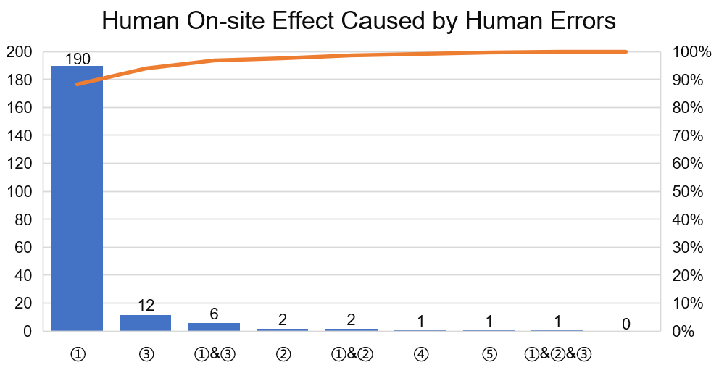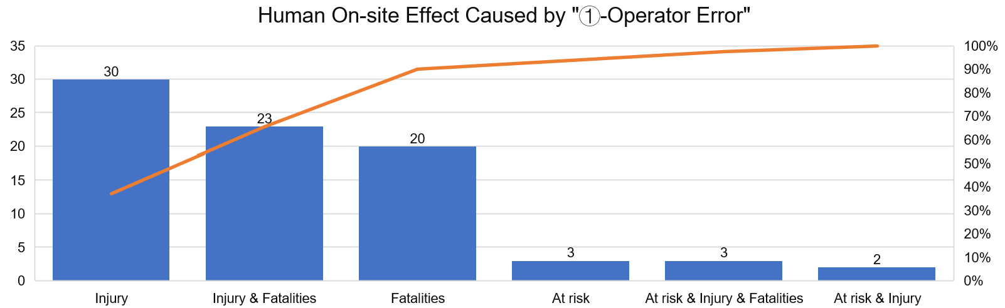
a b
Figure 1. Human On-site Effect * Human Error (sig=0.000***)
Figure 2a shows that the combined human error mode of “①-operator error” and ②-malicious intervention contributed to 59.70% of the cost off-site effect. Apart from “unknown” recorded accidents, Figure 2b shows that ①-Material losses (58.33%) and ②-Restoration costs (25%) are the major consequences of cost off-site effect caused by human errors.
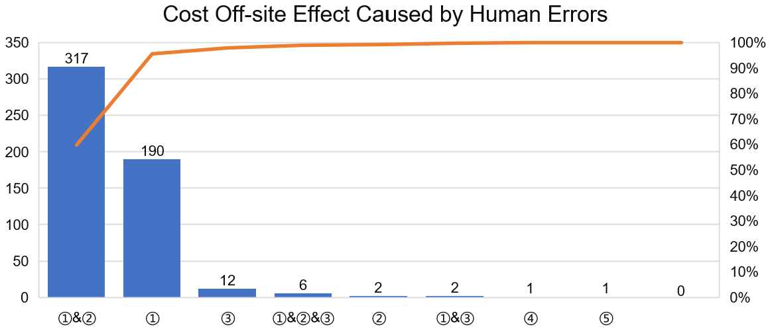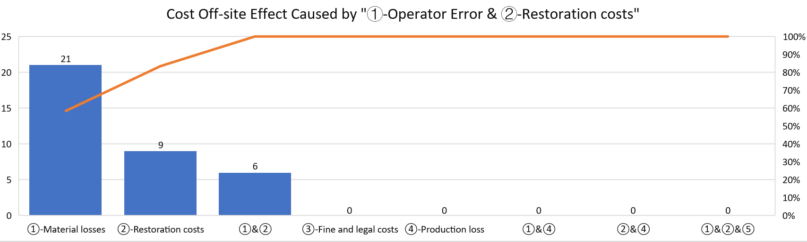
a b
Figure 2. Cost Off site Effect * Human Error (sig=0.000***)
    - The Most Significant Organizational Causative Factors’ Contributions
To have an in-depth study on the most significant influences from Organizational Factors to the consequences, “Human On-site Effect”, “Environmental Off-site Effect”, and “Cost Off-site Effect” have been further investigated. Figure 3a shows that the organisational causative factors of “①③④⑤⑨” contributed to 75.11% of the human on-site effect. Figure 3b further shows the major influences of the organisational causative factors of “①③④⑤⑨”. The consequences of “injury” (33.17% of all human on-site effect from “①③④⑤⑨”), “at-risk” (28.65%), and “injury & fatalities (22.71%)” are highlighted. Meanwhile, the factor of “⑨-organized procedures/management organisation inadequate” contributed the largest numbers of accidents (27.4%), followed by “①-design of plant/equipment/system” (22.44%), “④-maintenance/inspecting” (17.43%), “⑤-training/instruction” (16.45%), and “③-process analysis” (16.29%).
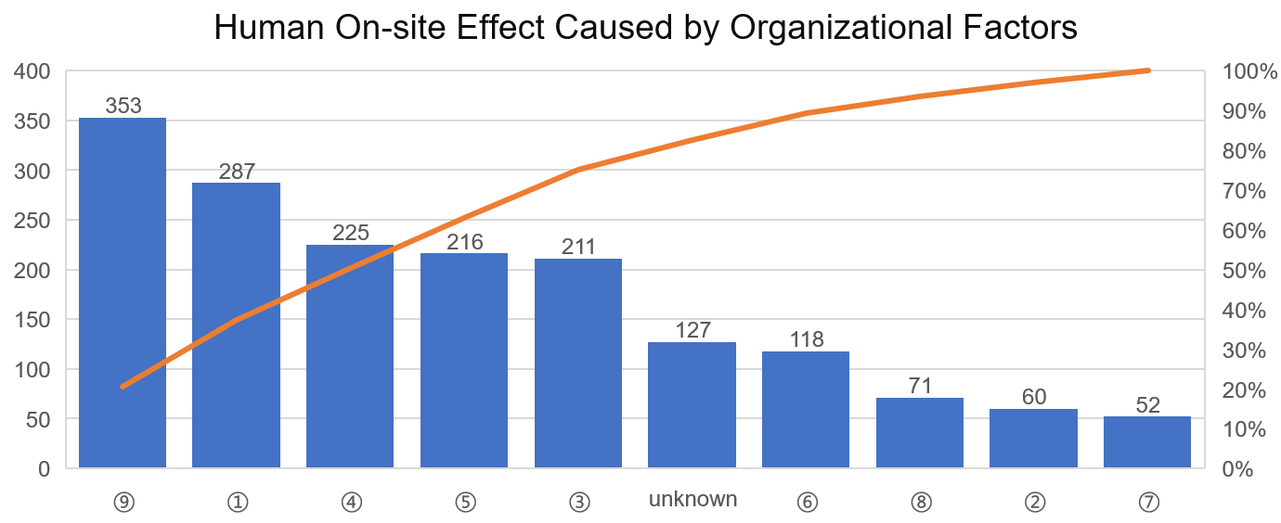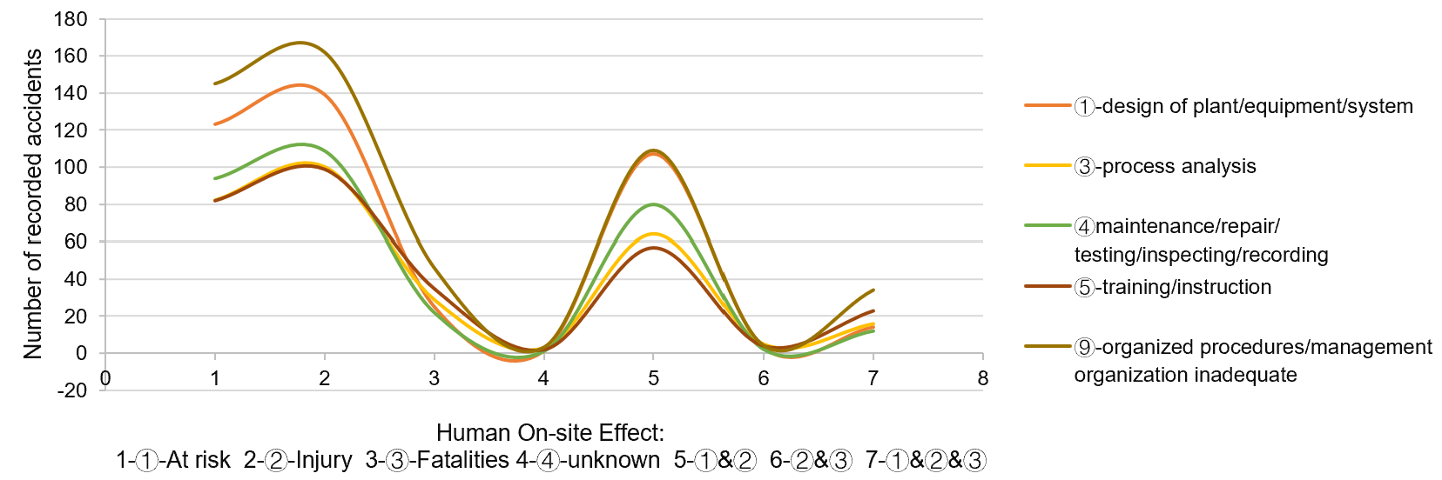
a b
Figure 3. Human On-site Effect * Organizational Causative Factor (sig=0.001***)
Figure 4a shows that the organisational causative factors of “①③④⑤⑨” contributed to 76.95% of the environmental off-site effect. Figure 4b further shows the major influences of the organisational causative factors of “①③④⑤⑨”. The consequences of “atmosphere pollution” (98.34% of all off-site environmental effects from “①③④⑤⑨”) are highlighted. Meanwhile, the factor of “⑨-organized procedures/management organisation inadequate” contributed the largest numbers of atmosphere pollution (27.99%), followed by “①-design of plant/equipment/system” (23.05%), “⑤-training/instruction” (17.06%), “③-process analysis” (16.15%), and “④-maintenance/inspecting” (15.76%).
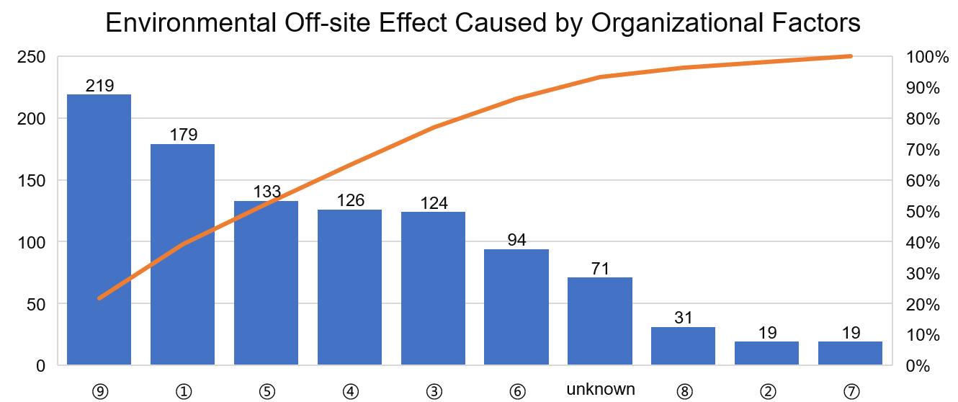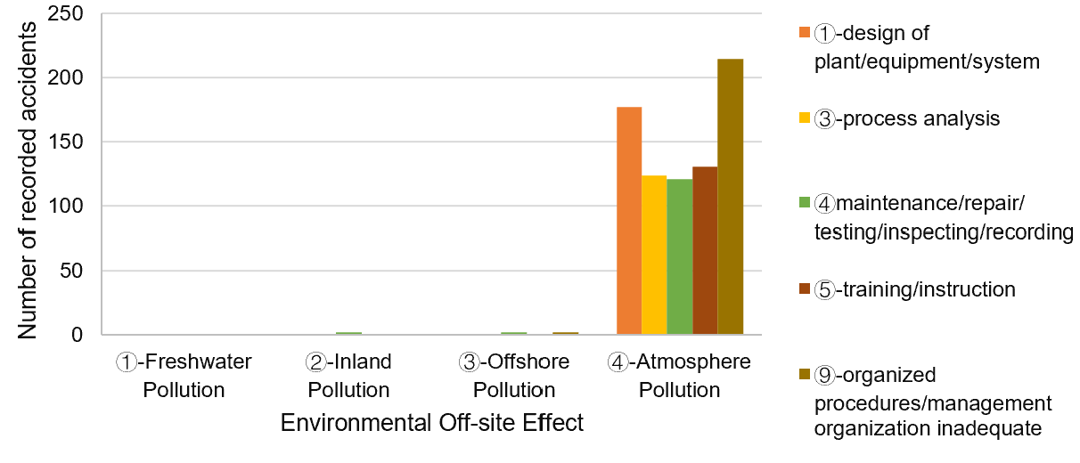
a b
Figure 4. Environmental Off-site Effect * Organizational Causative Factor (sig=0.000***)
Figure 5a shows that the organisational causative factors of “①②③④⑤” contributed to 64.82% of the cost off-site effect. Figure 5b further shows the major influences of the organisational causative factors of “①②③④⑤”. The consequences of “material losses” (72.86% of all cost off-site effect from “①②③④⑤”) are highlighted. Meanwhile, the factor of “①-design of plant/equipment/system” contributed the largest numbers of “material losses” (32.41%), followed by “②-Installation/construction” (22.07%), “③-process analysis” (17.93%), “④-maintenance/inspecting” (14.48%), and “⑤-training/instruction” (13.10%).
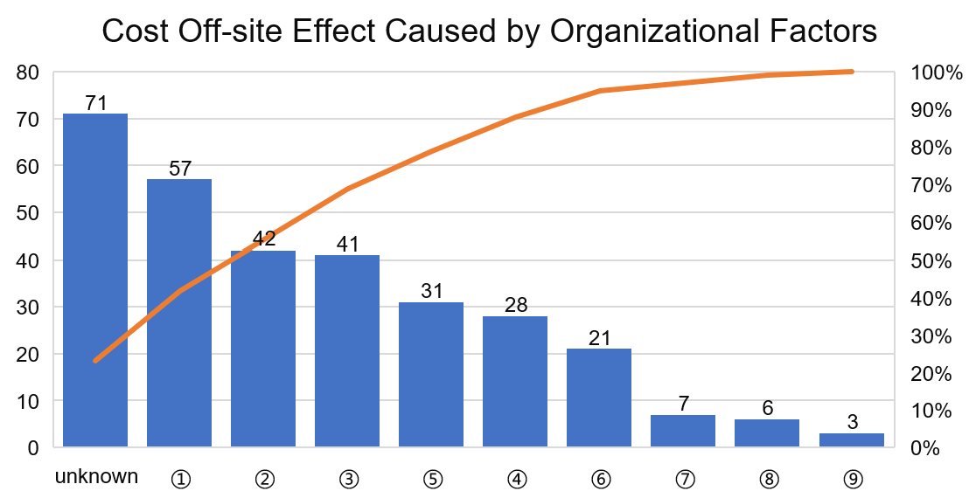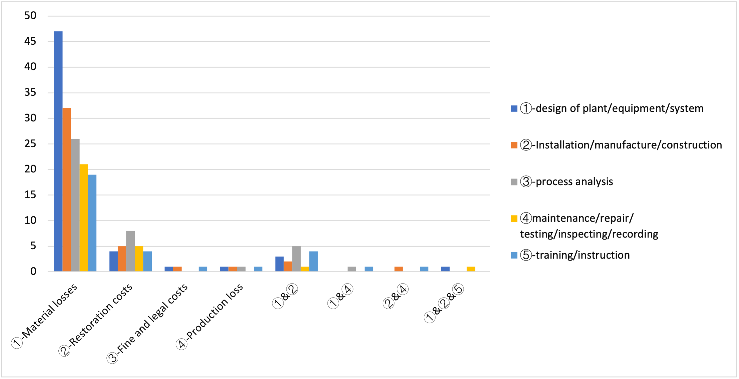
a b
Figure 5. Cost Off site Effect * Organizational Causative Factor (sig=0.000***)
  - Discussion and Conclusions
    - HOFs Contributions to the recorded accidents
The eMARS database provided an effective data resource to investigate the HOFs influences on those reported accidents. Using the eMARS database, this study applied categorical data analysis and correlation analysis. The results show that human errors contributed to 40% of recorded accidents. Within all labelled human error modes, “①operator error” contributed to 88% when the unknown cased were excluded. Organisational causative factors contributed to 92.97% of recorded accidents. Especially, organisational factors “⑨①⑤③④” contributes to 76.83%. The results indicated that operator error should be the most important consideration for human error control. Further, since organisational factors nowadays become the major causative factor, “⑨organized procedures/management organisation inadequate”, “①design of plant/equipment/system”, “⑤training/instruction”, “③process analysis”, and “④maintenance/testing/inspecting/recording” should pay more attention.
    - Correlations of the HOFs and accidents' consequences
According to the Chi-square test, five pairs of the most significant influences from HOFs to the consequences have been figured out. For the human on-site effect, both human errors and organisational factors have contributions. Human errors contributed to the accident consequences of “injury” (37.03%), “injury & fatalities” (28.40%), and “fatalities” (24.69%). Organisational factors contributed to the consequences of “injury” (33.17% of all human on-site effects from “①③④⑤⑨”), “at-risk” (28.65%), and “injury & fatalities” (22.71%). For the environmental off-site effect, only organisational factors contributed to the consequences of “air pollution” (98.34% of all ecological off-site effects from “①③④⑤⑨”). For the cost off-site effect, both human errors and organisational factors have contributions. Human errors contributed to the major accident consequences of “material losses” (58.33%) and “restoration costs” (25%). In comparison, organisational factors contributed to the major results of “material losses” (72.86% of all cost off-site effects from “①②③④⑤”).
    - Limitation and future work
This research is based on the simplifying hypothesis that human error and organizational factors are independent. The future work can discuss the relationship between them more deeply.
Acknowledgements
The work is supported by China Scholarship Council.
References
Baldissone, G., Comberti, L., Bosca, S., Murè, S., 2019, The analysis and management of unsafe acts and unsafe conditions, Data collection and analysis, Safety Science, 119, pp. 240-251.
Comberti, L., Demichela, M., Baldissone, G., 2018, A combined approach for analysing sizeable occupational accident databases to support accident-prevention decision making, Safety Science, 106, pp. 191-202.
Comberti, L., Baldissone, G., Demichela, M.,2015, Workplace accidents analysis with a coupled clustering method: S.O.M. and K-means algorithms, Chemical Engineering Transactions, 43, pp. 1261-1266.
Comberti, L., Baldissone, G., Bosca, S., Demichela, M., Murè, S., Petruni, A., Djapan, M., Cencetti, S., 2015, Comparison of two methodologies for occupational accidents pre-cursors data collection, Safety and Reliability of Complex Engineered Systems - Proceedings of the 25th European Safety and Reliability Conference, ESREL 2015, pp. 3237-3244.
EMARS (Major Accident Reporting System), Major Accident Hazards Bureau, European Commission, https://emars.jrc.ec.europa.eu/?id=4, accessed 14.10.2021.
Fisher R.A., Yates F., 1971, Statistical Tables for Biological Agricultural and Medical Research, 6th ed., Table IV, Oliver & Boyd, Ltd., Edinburgh.
Jing Xing, James Chang, Jonathan DeJesus, 2021, NUREG-2198, "The General Methodology of an Integrated Human Event Analysis System (IDHEAS-G)"
Mourad Chebila, 2021, Predicting the consequences of accidents involving dangerous substances using machine learning, Ecotoxicology and Environmental Safety, Volume 208, 111470, ISSN 0147-6513
Watson K.B., 2014, Categorical Data Analysis. In: Michalos A.C. (eds) Encyclopedia of Quality of Life and Well-Being Research. Springer, Dordrecht.

