CHEMICAL ENGINEERING TRANSACTIONS  VOL. | A publication of
The Italian Association
of Chemical Engineering
Online at www.cetjournal.it
Guest Editors:
Copyright © AIDIC Servizi S.r.l.
ISBN 978-88-95608-xx-x ISSN 2283-9216

A quantitative framework for resilience assessment of complex engineered systems under uncertainty
Sunyue Geng^{a,b}, Ming Yang^{b,}*, Sifeng Liuª
ªCollege of Economics and Management, Nanjing University of Aeronautics and Astronautics, Nanjing 211106, China
^{b}Safety and Security Science Section, Faculty of Technology, Policy and Management, Delft University of Technology, Delft, The Netherlands
m.yang-1@tudelft.nl
Complex engineered systems with various components and dynamic behaviors are connerstones to develop resilient cities and societies. These systems are robust but also vulnerable to adverse events and inevitably suffer performance degradation. An immediate question would be, “how can we manage and improve the resilience of a complex engineered system?”. This study proposes a quantitative framework to assess the resilience of complex engineered systems. The proposed framework focuses on figuring out the impact of functionality implementation on the capability of complex engineered systems to anticipate, absorb, adapt to, and restore from disruptive events. It is composed of three parts, including functionality analysis, performance evaluation, and resilience measure. Firstly, various functions are analyzed at the system level, where a functional tree is employed to investigate the relationship between functions. Then the actual performance of the system is evaluated while uncertain implementation of system functionality is considered. Finally, system resilience is measured from the perspectives of anticipation, absorption, adaptation, and restoration. Anticipation, absorption, adaptation, and restoration are critical capacities of complex engineered systems to ensure normal operation in the event of disruptions. The proposed framework provides a general approach for resilience assessment of complex engineered systems, which figures out functionality implementation and system performance under uncertainty.
  - Introduction
There is a wide range of complex engineered systems in the society, such as manufacturing systems, electronic equipment, and industrial processes. A complex engineered system made up of multiple components aims to provide the desired functionality, where independent components interact with each other (Soleimani et al., 2021). The complicated relationships between components cause the system to present the characteristics of nonlinearity, emergence, spontaneous order, and feedback. Therefore, it is difficult for researchers and practitioners to analyze complex engineered systems.
Engineered systems are becoming more complex with the frequent occurrence of external and internal disruptions. They are susceptible to natural disasters and intentional attacks, leading to performance degradation and the loss of functionality (Patriarca et al., 2021). A typical example was that power systems were paralyzed as a result of Hurricane Sandy in 2012. More than 6.5 million households suffered temporary blackouts in the eastern United States. There were still 45 thousand customers without electricity supply two weeks after the hurricane. Directed economic losses were estimated at 30 billion dollars. Such disruptions give rise to social and economic damage to complex engineered systems.
Resilience engineering has attracted more attention due to the complexity and vulnerability of engineered systems recently (Orosz et al., 2020). System resilience is referred to as the capability of maintaining the required functionality under disruptive events (Hollnagel et al., 2011). The resilience of the complex engineered system lies in its capacity to anticipate unexpected events, absorb the adverse effect of disruptions, adapt to the dynamic environment, and restore the desired functionality (Shakou et al., 2019).
Resilience assessment has been the subject of intense scholarly debate, which indicates whether a system can operate normally in the event of disruptions. Tong et al. (2020) carried out probabilistic assessment of system resilience based on a dynamic Bayesian network approach, where the Markov Chain was employed to describe different states of engineered systems. The probability of a system to keep in steady states was taken into account during resilience analysis. After modeling system operation, Patriarca et al. (2021) represented resilience in terms of absorption, adaptation, and recovery. The reliability of components was deemed as an indirect indicator to reflect system performance. Cheng et al. (2021) highlighted the randomness and dynamics of disruptive events. System resilience was quantified with the consideration of availability and recovery time. With the concept of reliability and maintainability, Yarveisy et al. (2020) developed a set of resilience metrics for general engineered systems. The authors focused on absorptive capacity, restorative capacity, and adaptive capacity instead of anticipative capacity. Anticipative capacity should not be overlooked, which may affect the other capacities of system resilience of a complex engineered system.
There are multiple functions for a complex engineered system to ensure normal operation, and the implementation of these functions is uncertain. However, the existing literature cannot figure out the complicated relationship between functions. The effect of component behaviors on system functionality is not addressed. To that end, this study proposes a quantitative framework of complex engineered systems under uncertainty. It is made up of three parts, functionality analysis, performance evaluation, and resilience measure. The proposed framework illustrates system functionality before evaluating the actual performance and assesses the resilience from the perspectives of anticipation, absorption, adaptation, and restoration.
  - Methodology
In this section, resilience assessment of complex engineered systems is carried out under uncertainty. The resilience assessment framework comprises three parts: functionality analysis, performance evaluation, and resilience measure.
    - Functionality analysis
Complex engineered systems tend to execute all kinds of tasks at different times. It is necessary to figure out specific functions of these systems according to task requirements. A complex engineered system consists of multiple components, where independent components collaborate with others to carry out the overall task of the system. Nonlinearity, emergence, spontaneous order, and feedback arising from the interaction between components make the system complex. Functional tree is a powerful tool to show the relationship between functions of a system (Schmittner et al., 2014). In order to reflect the effect of component behaviors on system functionality, functionality analysis is conducted at the system level using a functional tree. The functionality analysis procedure for a complex engineered system contains six steps as follows.
Step 1: Define system boundary
A complex engineered system contains several components which correlate with each other. In general, system boundary determines which component belongs to the system (Helfgott, 2018). The remaining components that lie outside the system boundary make up the environment. The actual performance of the engineered system is related to its interaction with the environment.
Step 2: Determine the overall objective of this system
A complex engineered system is required to achieve the overall objective in the environment. The system may be equipped with various objectives for different tasks (Ebadat-Parast et al., 2022). A single objective is supposed to be described quantitatively to determine the required functions of the system.
Step 3: Identify the system functions needed for this objective
To accomplish the overall objective, the complex engineered system needs to perform specific functions. That is to say, it carries out internal processing and transformation using the available resources from the environment. After that, it outputs the desired material, energy, and information.
Step 4: Identify sub-functions of the primary function
System functionality is divided into two categories, primary function, and sub-function. The former one is defined at the system level, which is provided by the whole system. A single component or multiple components is responsible for implementing the latter one. The primary function integrating several sub-functions generates desired performance in the operational environment.
Step 5: Identify the association of system components with these sub-functions
Dynamic behaviors of components have a direct effect on functionality implementation. After identifying all kinds of sub-functions, it is necessary to determine which components perform these functions. The execution of these sub-functions is supported by the related components, and functionality implementation is judged according to the reliability of components.
Step 6: Organize the identified functions in a hierarchical structure
All functions, including the primary function and sub-functions, are organized into a hierarchical tree structure, as shown in Figure 1. The primary function is placed at the highest level, while sub-functions are set at the second level. The lowest level accommodates the components of the complex engineered system.
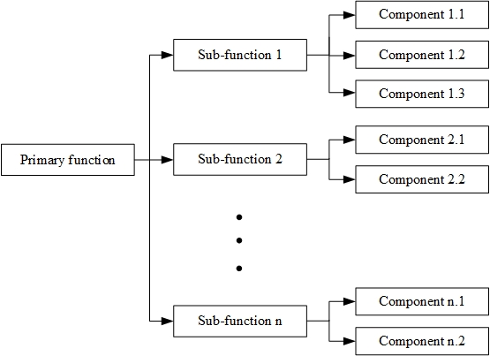
Figure 1: Functional tree.
    - Performance evaluation
In order to assess the resilience of a complex engineered system, system performance should be evaluated. Given the interdependencies and interactions of functions, the actual performance of the engineered system is affected by many factors. The failure of components is likely to hinder sub-functions, and further, the engineered system cannot achieve its overall objective. As components fail randomly in the changing environment, how many sub-functions implement together is indeterminate. Therefore, system performance needs to be measured under uncertainty. Implementing the desired functionality is up to the successful operation of components, which can be quantified employing the Functional Resonance Analysis Method (FRAM) (Zinetullina et al., 2021) or stochastic network analysis technique (Geng et al., 2021).
FRAM is a systematic method to reflect all functions of the system using six elements, namely input, output, preconditions, resources, control, and time (Nemeth, 2013). Graphical representation of the system can describe the coupling between functions. When the upstream function changes its output, the input of the downstream function varies accordingly. The changes of sub-functions tend to impair the actual performance of the system, which FRAM can address. In addition, Stochastic network analysis techniques model the system as a directed graph, denoted by nodes and edges (Tao et al., 2017). Considering that system functions are conducted under uncertainty, probability branches and loops express the system's dynamic characteristics. Functionality variability is represented by a probability distribution, and the order in which functions are implemented is described using network logic. Both two methods are employed to evaluate the potential performance of the system.
    - Resilience measure
System resilience is referred to as the capability of maintaining the desired functionality in the case of disruptions (Hollnagel et al., 2011). Complex engineered systems are susceptible to natural disasters and intentional attacks, leading to performance degradation and even system breakdown. A resilient engineered system can predict adverse events, absorb the negative effect of disruptions, adapt quickly to the changing environment, and restore to the sub-optimal state after disruptions (Francis and Bekera, 2014). After figuring out the actual performance of a system, we can assess resilience from the perspectives of anticipation, absorption, adaptation, and restoration. These four capacities are critical to depict resilience in complex engineered systems.
- Anticipation. Performance degradation of engineered systems is likely to result from unexpected events. Good preparation for disruptions enables the system to minimize the impact of disruptions. The system also can learn from useful experience in previous events, leading to robustness improvement.
- Absorption. Once a disruptive event occurs, a complex engineered system had better absorb the negative effect of the disruptive event. Under the circumstance of disturbance, the engineered system aims to implement the primary function and maintain the desired services.
- Adaptation. The complex engineered system sustains normal operation without taking any restorative actions after disruptions. The system makes fast adaptation to disruptions through adjusting system structure and operation strategies. In this way, system disturbance does not interfere with functionality implementation.
- Restoration. When disruptive events destroy components and impair system functionality, the engineered system recovers to a stable state when system functionality is provided successfully. Restorative actions are employed to achieve the overall objective of the system in an effective manner.
As for each capacity, the difference between the actual performance and target performance is used to measure resilience. It is worth noting that target performance for four capacities is different due to various requirements. Let P(D₁), P(D₂), P(D₃), and P(D₄) be target performance for anticipation, absorption, adaptation, and restoration. P(t) is the actual performance of the complex engineered system. The initial performance of the system is P(t₀), where t₀ is the start time for system operation. At time t_{r}, anticipation resilience (R₁), absorption resilience (R₂), adaptation resilience (R₃), and restoration resilience (R₄) can be expressed by Eq.1 to 4.
(1)
(2)
(3)
(4)
R₁, R₂, R_{3,} and R₄ range from zero to one. A large value means the system is equipped with great resilience. The higher the value of R₁, the better the anticipation capacity of the system. The same principle can be used for absorption, adaptation, and restoration capacities.
  - Analysis and discussion
The resilience of complex engineered systems is a multidimensional capacity measured by anticipation, absorption, adaptation, and restoration capabilities. In terms of four types of resilience, Figure 2 shows the actual performance of a complex engineered system varies as time goes on. Noted that these capacities of the engineered system are measured at different phases of system operation.
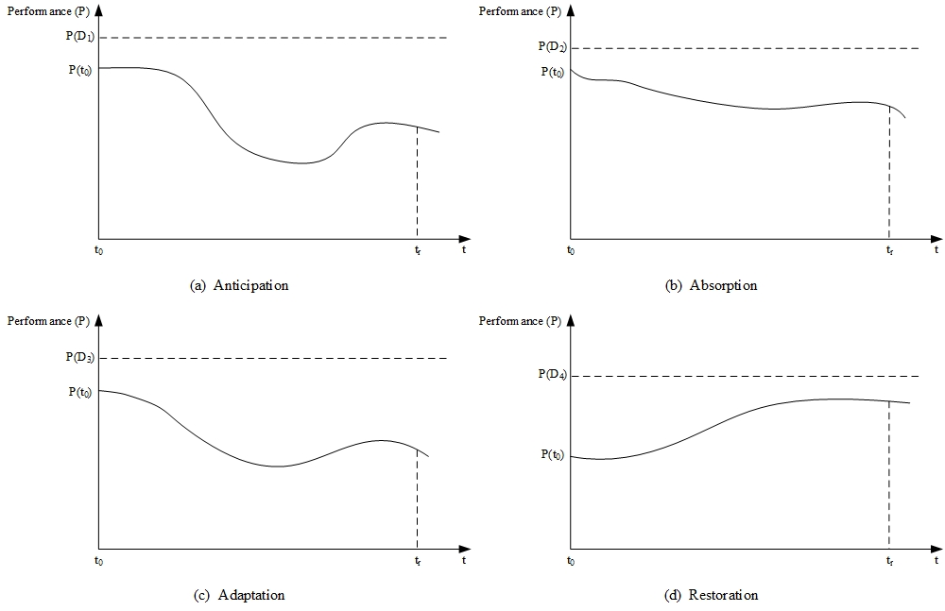
Figure 2: System performance in terms of anticipation, absorption, adaptation, and restoration.
Anticipation resilience and adaptation resilience are reflected in the whole process of system operation. The system suffers performance degradation and performance improvement on account of anticipation capacity and adaptation capacity. Predicting impending disruptions accurately is beneficial to improve anticipation capacity. The system, which is equipped with effective operation strategies, has great adaptation capacity.
On the other hand, absorption and restoration are demonstrated in the disruptive and restorative phases, respectively. The system intends to maintain the required functionality when a disruptive event happens, absorbing the adverse effect of the disruption. Resilience actions like maintenance and repair are taken to enhance restoration capacity after disruptions.
  - Conclusions
A quantitative framework of complex engineered systems is proposed to assess the resilience of complex engineered systems under uncertainty. The proposed framework consists of functionality analysis, performance evaluation, and resilience measures. Firstly, system functionality is described by means of a functional tree, where the relationship between the primary function and sub-functions is shown. The effect of component behaviors on system functionality is also reflected. In addition, considering the uncertainty in implementing various functions, the actual performance of systems is quantified using FRAM or stochastic network analysis technique. System performance is affected by the complicated interdependencies between functions. Finally, system resilience is measured from the perspectives of anticipation, absorption, adaptation, and restoration capabilities. Anticipation and adaptation capabilities capture system performance during the whole operation process, whereas absorption and restoration capabilities are shown after disruptive events. The proposed framework is a universal resilience assessment approach which can be applicable to all complex engineered systems. The prominent characteristic is that it can describe system functionality in detail according to task requirements. It figures out the complicated relationships between functions when there are multiple functions for a system to ensure normal operation.
For future research direction, restorative activities should be selected according to the intensity of disruptions. Different kinds of disruptions have diverse effect on system operation, resulting in performance degradation and even complete failures.
Acknowledgments
This work was supported by the Postgraduate Research and Practice Innovation Program of Jiangsu Province, China (No. KYCX19_0147).
References
Cheng, Y., Elsayed, E.A., Chen, X., 2021. Random Multi Hazard Resilience Modeling of Engineered Systems and Critical Infrastructure. Reliability Engineering and System Safety 209.
Ebadat-Parast, M., Nazari, M.H., Hosseinian, S.H., 2022. Distribution system resilience enhancement through resilience-oriented optimal scheduling of multi-microgrids considering normal and emergency conditions interlink utilizing multi-objective programming. Sustainable Cities and Society 76.
Francis, R., Bekera, B., 2014. A metric and frameworks for resilience analysis of engineered and infrastructure systems. Reliability Engineering and System Safety 121, 90-103.
Geng, S., Liu, S., Fang, Z., Gao, S., 2021. An agent-based clustering framework for reliable satellite networks. Reliability Engineering & System Safety 212, 107630.
Helfgott, A., 2018. Operationalising systemic resilience. European Journal of Operational Research 268, 852–864.
Hollnagel, E., 2015. Introduction to the Resilience Analysis Grid (RAG) RAG-Resilience Analysis Grid.
Nemeth, C., 2013. Erik Hollnagel: FRAM: The functional resonance analysis method, modeling complex socio-technical systems. Cognition, Technology & Work 15.
Orosz, Á., Pimentel, J., Friedler, F., 2020. General formulation for the resilience of processing systems. Chemical Engineering Transactions 81, 859–864.
Patriarca, R., de Paolis, A., Costantino, F., di Gravio, G., 2021. Simulation model for simple yet robust resilience assessment metrics for engineered systems. Reliability Engineering and System Safety 209, p.107467.
Schmittner, C., Gruber, T., Puschner, P., Schoitsch, E., 2014. Security application of Failure Mode and Effect Analysis (FMEA), in: Lecture Notes in Computer Science (Including Subseries Lecture Notes in Artificial Intelligence and Lecture Notes in Bioinformatics). Springer Verlag, pp. 310–325.
Shakou, L.M., Wybo, J.L., Reniers, G., Boustras, G., 2019. Developing an innovative framework for enhancing the resilience of critical infrastructure to climate change. Safety Science 118, 364–378.
Soleimani, M., Campean, F., Neagu, D., 2021. Integration of Hidden Markov Modelling and Bayesian Network for fault detection and prediction of complex engineered systems. Reliability Engineering and System Safety 215, p.107808.
Tao, L., Wu, D., Liu, S., Lambert, J.H., 2017. Schedule risk analysis for new-product development: The GERT method extended by a characteristic function. Reliability Engineering and System Safety 167, 464–473.
Tong, Q., Yang, M., Zinetullina, A., 2020. A Dynamic Bayesian Network-based approach to Resilience Assessment of Engineered Systems. Journal of Loss Prevention in the Process Industries 65, p.104152.
Yarveisy, R., Gao, C., Khan, F., 2020. A simple yet robust resilience assessment metrics. Reliability Engineering and System Safety 197.
Zinetullina, A., Yang, M., Khakzad, N., Golman, B., Li, X., 2021. Quantitative resilience assessment of chemical process systems using functional resonance analysis method and Dynamic Bayesian network. Reliability Engineering and System Safety 205.

