CHEMICAL ENGINEERING TRANSACTIONS  VOL. 91, 2022 | A publication of
The Italian Association
of Chemical Engineering
Online at www.cetjournal.it

Guest Editors: Valerio Cozzani, Bruno Fabiano, Genserik Reniers
Copyright © 2022, AIDIC Servizi S.r.l.
ISBN 978-88-95608-89-1; ISSN 2283-9216

Accident investigation of a real-case fire in a waste disposal facility through numerical simulation
Elena Battiston ª, Chiara Vianello ^{a, b}, Guido Rebuffi ^{c}, Paolo Mocellin ^{a,}*
ª Dipartimento di Ingegneria Industriale, Università degli Studi di Padova. Via Marzolo 9, 35131 Padova, Italia
^{b} Dipartimento di Ingegneria Civile, Edile e Ambientale, Università degli Studi di Padova. Via Marzolo 9, 35131 Padova, Italia
^{c} Unisafe S.r.l., Via Paruta 31/a, 30172 Venezia-Mestre, Italia
paolo.mocellin@unipd.it

The data about illegal activities connected to the waste cycle refer to an alarming situation linked to the development of waste fires in Italy and the world in the last few years. Hence the interest in implementing new methodologies to study fires in piles of waste, understand the incidental dynamics, and draw scientific evidence on the nature of combustion is crucial. The investigation focused on a real case waste disposal fire in a company in northern Italy. Initially, the trigger involved a heap of unsorted municipal waste, with flames spreading to other heaps of twigs, wood, and paper and plastic storage areas. The damage was limited by the prompt intervention of the Fire Brigade, who took a few hours to tame and extinguish the flames. The entire dynamic was captured by internal security cameras and made available for investigations. This key element made it possible to compare the real evolution to model estimations. Therefore, the present work aimed to approach an actual case study via numerical simulation to give insight into the fire accident. To this end, it was decided to use the Fire Dynamics Simulator (FDS) for an open field application. The application produced interesting results and paved the way for further research questions and debates regarding the effectiveness of this strategy for investigating incidental scenarios. In particular, it was possible to recreate the incidental dynamics assuming different compositions of the initial fuel matrix and their impact on the fire dynamics. However, some issues have emerged, including the lack of reliable data concerning fuel matrixes and their behaviour in open spaces. Another limitation is linked to the software unsuitability to implement heterogeneous material properly. On the contrary, internal safety distances among piles of stored waste were defined through empirical models and compared to what is embodied in the technical fire prevention rule draft concerning waste disposal facilities.
  - Introduction
Waste production has grown in recent decades due to improved economic and living conditions. In fact, in parallel with technological progress and industrial development, increased consumption and consumer goods have produced related waste. Therefore, the problems associated with the integration of activities related to the management of the entire waste chain have also grown in equal measure (INAIL, 2014). Furthermore, attention to environmental problems has also grown among consumers, prompting companies to introduce sustainability as a strategic variable in their business (Xu et al., 2018). The development of more comprehensive solutions such as the life cycle approach and the circular economy model aims at reducing environmental impacts rather than shifting environmental burdens and are at the heart of the Europe 2020 strategy. However, the current production and consumption systems do not realize the true potential available through a circular economy, and necessary changes are often not achievable and convenient goals for citizens and organizations (Mazzi, 2019). For these reasons, a problem related to managing the end of life of waste persists. In Italy, but not only, this often incurs the illegal burning of outdoor waste deposits (Vianello et al., 2020). This phenomenon originated in the early 90s due to the increased use of landfills to replace incinerators. Even today, urban wastes are managed through four main strategies (recovery, landfill, treatment, and incineration) (ISPRA, 2019), which envisage landfills as the final destination of 22 % of the total waste produced.
Having to manage ever-larger quantities of waste and with little space available because of full landfills, many thought it was good to get rid of excess waste by burning it. Although the first significant episodes of outdoor fires in Italy occurred in Campania, mainly in the area known as Terra dei Fuochi, it is not a circumscribed phenomenon. On the contrary, it represents an environmental concern that affects the national territory in all its extension. Despite introducing new regulations, the number of accidental or illegal waste fires continued inexorably to rise in Italy, with a peak in 2017 of 1182 fires (Vigili del Fuoco, 2018). Furthermore, waste constitutes the second solid fuel most involved in fires, with a percentage equal to 10.5 % of the total (Vigili del Fuoco, 2018). In particular, almost all fires of this type occurred in waste plants, illegal areas, ecological islands or compactors, landfills, incinerators and other sensitive plants (Giliberto, 2018). The authorities monitor criminal actions, but accidental causes can also trigger waste fires. According to the literature (Panza, 2020), typical causes of fire in waste management plants are the presence of hot or hazardous waste (31 %); self-combustion (24 %); actions causing friction (9 %); electrical faults (7 %); hot surfaces leading to ignition (5 %); hot-working (5 %), and other causes (19 %). Depending on the type of fire, there are various consequences for human health and the environment. According to EEA data, one of the leading causes of air pollution is linked to waste landfills and their fires (EEA, 2017). These events must be avoided with preventive actions and related effects limited with mitigation and prompt intervention actions.
aste fires are not always intentional and can often be ascribed to poor management of spaces and workplaces. This is also because it has not been possible to appeal to a regulatory reference that combines fire prevention and warehouse management for many years. For example, in Italy, Presidential Decree 151/2011, which regulates the provisions relating to fire prevention, does not include a section dedicated to the storage and treatment of waste. In 2019, the Central Technical and Scientific Committee (CCTS) presented the draft Vertical Technical Regulations (RTV) for the storage and treatment of waste. However, the inclusion of this RTV in the Italian Fire Prevention Code (Section V) has not yet occurred. Currently, the content of Annex I remains valid.
The present work discusses the analysis of a fire that occurred in a waste storage site. The stages are considered within a post-incidental study. The analysis begins with observing the incidental sequence described by the video surveillance images. From this source, and according to available data, we tried to reconstruct the event using computational fluid dynamics (CFD) (Mocellin et al., 2016), and considerations on safety distances are discussed.
  - The study area and the fire accident
The fire accident occurred at an Italian company that collects, transports, and disposes of municipal waste and other waste produced by client companies. The company is divided into two functional elements: the first, a building in which the administrative offices and the shed dedicated to compaction and sorting of waste reside; the second, the external area in which the waste is stored, the means of transport are parked and the containers are temporarily placed. Figure 1a is a recent overhead photograph of the company followed by an enlargement of the area affected by the fire, which also indicates the arrangement of the surveillance cameras (Figure 1b).
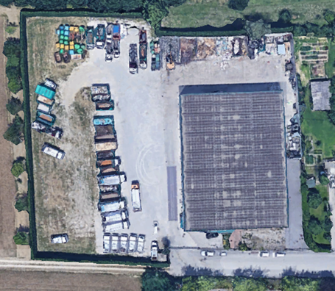
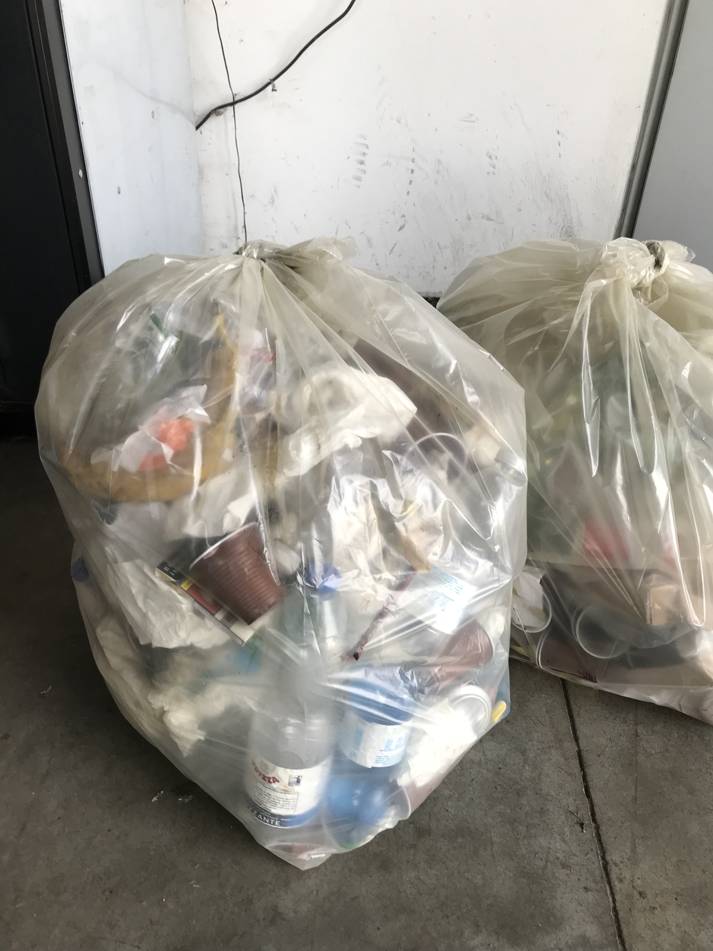

Figure 1: (a) Recent overhead photograph of the study area; (b) Zoom of the area affected by the fire, indicating the surveillance cameras. The material that initiates the event is highlighted.
The videos from the company's security cameras make clear the entire incidental dynamic that originated from the triggering of a bag placed near one of the heaps (in yellow). The fire first involved the pile of mixed waste and then affected the bales of paper and plastic. Finally, the pile of lignocellulosic material also caught fire. In addition, ten minutes later, the contents of the containers stored in the parking lot also caught fire. Considering the distance between the first pile and the containers and given that the matrix was not easily flammable by radiation, it can not be stated that the second fire is a direct consequence of the first. Therefore, the proper sequences of events are considered separately in the following two timelines (Figure 2).
During the morning, no element disturbs the mounds located in the storage area.

11:57 a.m.
A person throws a bag of plastic near the undifferentiated pile of urban waste.

4:01 p.m.
The plastic bag triggers.

4:06 p.m.
The flames flare up and involve the surface of the heap.

4:08 p.m.
The fire spreads to the top from the heap and flames also affect the pile of paper nearby

4:10 p.m.
The fire involves the front façade cumulus of the bale of paper and the plastic ones to the side.

4:12 p.m.
Flames spread to multiple stacked paper bales.

4:14 p.m.
The fire also affects the wooden heap.

4:18 p.m.
The fire increase and some pieces of burning material move in the domain.

The flames are tamed only in the night thanks to Fire Brigade.

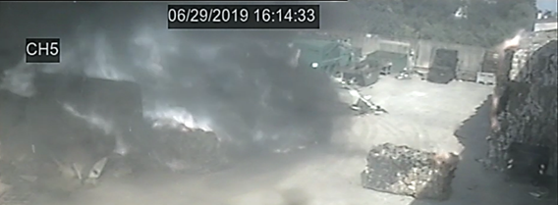
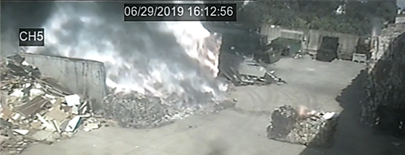
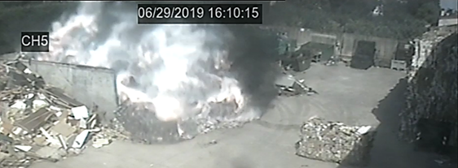

-

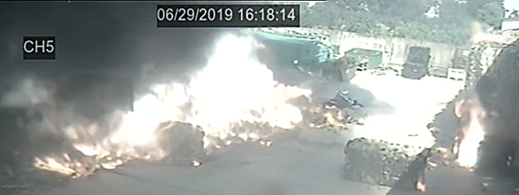

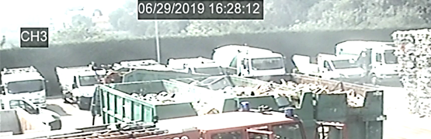
4:28 p.m.
The contents of a container in the parking lot are triggered.
Few minutes later, first flames occur.

4:36 p.m.
The flames increase and the black smoke makes the fire visible.

Then flames are tamed.

Figure 2: Timeline of the events involved in the fire.
  - Methodology
The simulation was performed with the aid of a computational fluid dynamics tool. In particular, FDS (Fire Dynamics Simulator, NIST) was used along with the graphical interface Pyrosim. Different input data and requested output were set. The data source included the inspection of the video of the surveillance cameras and the company floor plan. Subjective information is derived from employee testimonials, and further data were retrieved from the scientific literature (Table 1). The domain matches the perimeter of the company (Fig. 3).
Figure 3: (a) 2D view and (b) 3D view of the study area.
Table 1: Properties of materials in the case study domain (Morgan et al., 2016).
Colour | Element | Material | Density  [kg m⁻³] | Specific Heat  [kJ kg⁻¹ K⁻¹] | Thermal Conductivity  [W m⁻¹ K⁻¹] | Absorption coefficient  [m⁻¹]
Black | Building | Reinforced concrete | 2,200 | 0.88 | 2.3 | 5x10⁴
Light grey | Partitions | Lightweight concrete | 2,000 | 1 | 0.7 | 5x10⁴
Dark grey | Scrap | Iron and steel | 7,865 | 0.475 | 45.8 | 5x10⁴
Brown | Bales of paper | Kraft paper | 104 | 1.355 | 66 | 5x10⁴
Light blue | Bales of plastic | PE, PP, PS, PVC | 1,254 | 1.67 | 0.26 | 5x10⁴
Yellow | Wooden pile | Yellow pine | 640 | 2.85 | 0.14 | 5x10⁴
All surfaces with no contribution to the fire are considered inert. The others are identified as burner or layered. The environmental conditions were recovered from the nearest meteorological survey station with T_{amb} 30 °C and wind speed u_{wind} of 0.8 m/s. The sensitivity analysis of the mesh and the evaluation of the calculation times led to refinement with cubic cells with a characteristic size of 0.45 m for a total of 2,660,000 cells. The computational burden amounted to about one week for each simulation performed (Intel i7 quad-core, 16 Gb ram). The source term (orange in Figure 3) consists of mixed municipal waste. It was approached via a set of preliminary simulations in which those materials that could have constituted the heap were simulated. In particular, assuming a source term consisting of a matrix of lignocellulosic material; a matrix of lignocellulosic material arranged in pallet; a polyethylene matrix (PE); a polypropylene matrix (PP); a polystyrene matrix (PS) and a polyvinyl chloride matrix (PVC). In each simulation, the combustion reaction has been described through the simple chemistry approach with mixing-controlled combustion whose reaction takes the form reported in Eq. (1):
$C_{x}H_{y}O_{z}N_{v}+air → v_{{CO}_{2}}{CO}_{2}+v_{H_{2}O}H_{2}O + v_{CO}CO + v_{soot}soot + v_{N_{2}}N_{2}$ (1)
Combustion yields ($y_{CO} , y_{soot}$) and other thermal properties (specific heat, thermal conductivity, ${ΔH}_{comb}$, heat release rate HRR, and heat release rate per unit area HRRPUA) of materials were defined. According to the simulations, a similarity between the actual sequence and that simulated was obtained with the pile made of mixed plastics. A coherent plume of fumes and flames was retrieved from what was simulated. The mixed matrix is composed of the same amount (25%) of PE, PET, PP and PS. Massive properties were averaged on pure materials, while non-massive based properties were selected from the most conservative values (Table 2).
Table 2: Physical properties of the fuel made of mixed plastics representing the case study.
Material | Density  [kg m⁻³] | Specific heat  [kJ kg⁻¹ K⁻¹] | Thermal Conductivity  [W m⁻¹ K⁻¹] | HRRPUA  [kW m⁻²] | Emissivity  [-] | Absorption coefficient  [m⁻¹]
Mixed matrix | 1,050 | 2.73 | 0.273 | 450 | 0.9 | 5x10⁴

The HRR in time was retrieved from Newmann's experiment (Morgan et al., 2016) in which a cube of plastic material was burned, reaching at 200 s a peak of HRR = 18 MW. In Pyrosim, an HRRPUA of 450 kW m⁻² was set along with a TAU_Q value of 210 s since the experimental curve does not reach the peak value instantly.
  - Case-study, results
The FDS software can numerically solve the Navier-Stokes equations defined for a low speed and thermally powered flow, focusing on the smoke and heat transported by the fire. In addition, the ability to visually reproduce the results provides the user with a proper insight into the simulated phenomena. However, a set of input data is required, including properties of fuel matrices and materials and environmental conditions (Mocellin et al., 2021). The simulation is approached via Large Eddy Simulation (LES), and to ensure accurate results in a reasonable time, the analyzes were carried out in a reduced domain, halved along the y-direction. Cells of size equal to 0.75 m x 0,75 m x 0,75 m were adopted, for a total of 440,000 cells. Results were checked as mesh-insensitive, and graphical results are reported in Figure 4.
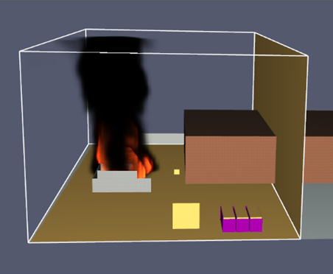
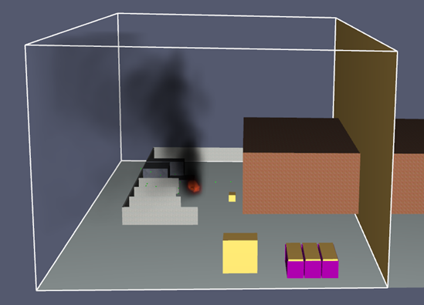
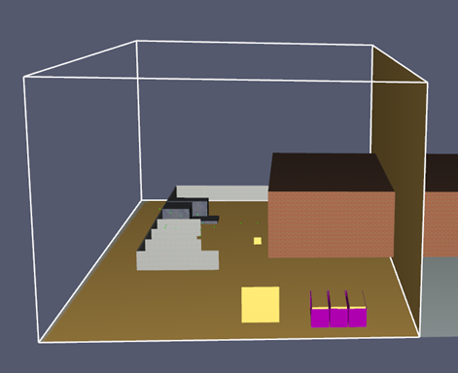

Figure 4: Fire simulation at time (a) t = 0 s ; (b) t = 100 s ; (c) t = 200 s ; (d) t = 1,000 s.
At time t = 0 s, the burner is activated, and at t = 100 s, the flames spread to the surface of the mixed material in contact and towards the rest of the waste pile. At t = 200 s, the plastic bales and the accumulation of lignocellulosic materials are also triggered. The simulated sequence of ignition is given in Figure 5-b. The match and the timing are not confirmed once compared to the real occurrence recorded by video surveillance cameras. This is probably ascribed to inaccuracies in modelling the fuel matrix and the effects induced by the arrangement of materials. The latter was discarded for the complexity, and the waste pile was modelled as a solid body.
2
2
Figure 5: (a) Real incidental sequence and (b) simulated sequence with FDS.
5
4
7
6
5
4
3
1
3
1

What has emerged is that an ignition sequence comparable to what was observed is obtained with threshold radiation of 1 kW m⁻² that is inconsistent if typical materials are expected (5-10 kW m⁻²). In this case, piles numbered 5 and 6 in Figure 5-a were ignited from the primary fire. It is clear that inaccuracies deriving from approximations on input data severely affects the final results by distorting the incidental sequence. These consist in how the fuel matrix is approached in terms of materials, properties, and arrangement. In the present case, the material of the primary fire was not known, and what was inferred from the video footage will require further refinement. Furthermore, FDS does not consider moving ignition sources carried by the wind, i.e. firebrands, that may have played a role in determining the final sequence. In any case, a posteriori analysis is essential to understand what changes in the spatial arrangement of the heaps would have been appropriate in the company to avoid such an event. In order to estimate the effects associated with the different types of fire, various mathematical models have been developed that allow the evaluation of the consequences expressed in terms of incident thermal radiation.
In the present study, the solid body emitter was applied to estimate the radiated power and the safety distance between the pairs of source and target described in Table 3, in which numbering refers to Fig.5.
The more complex formula used in the issuer solid course model is simplified according to Eq.(2):
$E_{r} = E_{av}(F_{21}{}_{a})$ (2)
Table 3 gives the average thermal emissivity $E_{av}$ obtained from the literature (De Ris, 1979), the atmospheric transmissivity${}_{a}$ calculated at an ambient temperature of 30 °C and relative humidity equal to 38 % (as retrieved by local weather conditions during the event), and the view factor $F_{21}$. In conclusion, $E_{r(1 → 6)} = 20.79 kW m^{-2}$ and $E_{r(1 → 8)} = 5.28 kW m^{-2}$. Comparing these results with the thermal radiation threshold value defined in the technical regulation and with the NFPA 555 standard, the same conclusions are drawn. The bales of paper stored on the wall are located at a distance from the heap of first ignition such that the radiation causes the spread of the flames while the containers are placed far enough away not to be ignited by the first heap on fire.
Table 3: Input data for the solid body emitter model (numbering refers to Fig. 6).
Bodies | Description | $E_{av}$ [kW m⁻²] | $$F_{21}(X/R;L/R;inclination)$$ | ${}_{a}$[-]
1→6 | Heap firstly ignited and wall storage of paper bales | 33 | 0.7 | 0.9
1→8 | Heap firstly ignited and storage in containers of wood | 33 | 0.2 | 0.8
Such as indicated in Figure 6-a and 6-b, the safety distance between the first ignited pile of wastes (1-2 in Figure 5-a) and paper bales (6 in Figure 5-a) is 12 m, and the safety distance between the first ignited pile and containers (8 in Figure 6-b) is 9 m. Also, the calculation of the safety distances through the technical regulation for waste storage and treatment leads to similar conclusions.
1
6
10
80

Figure 6: Safety distances (a) heap - paper bales and (b) heap - container.
  - Conclusions
The study concerned a real fire scenario simulation in waste treatment and disposal activity. The primary purpose was to apply and test the suitability of a numerical approach for fire investigation to reproduce the event. Given the frequency of such fires, the adoption of this investigation strategy is of interest. The fire dynamics was successfully recreated in Fire Dynamic Simulator (FDS), but results deviated from expected results coming from the video recording. Despite a triggering sequence calibrated on observed data, the simulation could not correctly address the fire propagation to surrounding piles. This is likely to be ascribed to uncertainty and limitations in defining combustible matrices, whose actual properties were unknown. Although the main constituents were inferred, the generalized lack of data concerning such fires' thermal and chemical aspects in open fields has widely undermined the implementation. Although the detail was lacking, safety distances among piles of wastes were estimated and compared to the actual layout. An improper arrangement (reduced safety distance) of some combustible materials emerged as a crucial factor for fire propagation.
The present study shows the need for an accurate definition of the properties of waste materials in terms of behavior under unconfined windy conditions. Further activities must focus on experimental campaigns to retrieve essential properties and input data for numerical simulations. Among these, the properties and fire behavior of piles made of mixed waste materials are generally lacking. For example, particular focus must be given to the impact of size and arrangement on fire hazard and pile composition for the associated environmental pollution. Criteria for ranking waste piles from low to high-risk are required. These should be based not only on fire properties and fuel source but also on geometric parameters, external conditions and management schemes. In this way, numerical simulations will support fire prevention, comparing different management strategies and recreating post-incidental settings.
Nomenclature

$E_{r}$ – radiation thermal intensity, $Wm^{-2}$
$E_{av}$ – average thermal intensity, $Wm^{-2}$
$F_{21 }$– source-target view factor, -
L/R – flame length/radius, -
T_{amb} – ambient temperature, °C
u_{wind} – wind speed, m s⁻¹
X – distance from flame centre to target, m
${}_{a}$ – atmospheric transmissivity, -

References
De Ris, J., 1979, Fire Radiation – a review, Tab. III Comparative burning rates.
European Environment Agency, 2017, Air pollution sources.
Giliberto, J., 2018, Raccolta rifiuti, l’Italia sommersa verso la paralisi totale, In: Il Sole 24 ore.
INAIL, Guercio A., 2014, La gestione dei rifiuti e la situazione europea, In: La gestione dei rifiuti in Italia.
ISPRA, 2019, Rapporto Rifiuti Urbani – Edizione 2019.
Mazzi, A., 2019, Environmental Sustainability to Support Competitiveness: From Theory to Practice in Customer, Chapter In: Satisfaction and sustainability initiatives in the fourth industrial revolution.
Morgan, J.H., Gottuk, D., HallJr., J.R., Harada, K., Kuligowski, E., Puchovsky, M., Torero, J., WattsJr., J.M., Wieczorek, C., 2016. SFPE Handbook of Fire Protection Engineering, Appendix III Fuel properties and Combustion Data, Tab. A.36: Thermal properties and thermal response parameter values of polymers.
Mocellin, P., Maschio, G., 2016. Numerical modeling of experimental trials involving pressurized release of gaseous CO₂. Chemical Engineering Transactions, 53, 349-354.
Mocellin, P., Vianello, C., Maschio, G., 2021. Addressing waste disposal fires in open fields through large eddy simulations. Chemical Engineering Transactions, 86, 529-534.
Panza, D., 2020. Le principali cause di incendio.
Ufficio Normazione ordinamentale e tecnica, collegamento beni culturali, referente sicurezza e statistica, 2019, Annuario Statistico del Corpo Nazionale dei Vigili del Fuoco, (Periodo di riferimento: 2018).
Vianello, C., Mocellin, P., Maschio, G., Bottacin, G., Dattilo, F., 2020. Waste disposal facilities fires: Prevention and management. The Veneto region experience. Proceedings of the 30th European Safety and Reliability Conference at the 15th Probabilistic Safety Assessment and Management Conference, 3995-4000.
Xu, X., Zeng, S., Chen, H., 2018. Signaling good by doing good: How does environmental corporate social responsibility affect international expansion? Business Strategy and the Environment, 27(7), 946–959.

