CHEMICAL ENGINEERING TRANSACTIONS  VOL. 91, 2022 | A publication of
The Italian Association
of Chemical Engineering
Online at www.cetjournal.it
Guest Editors: Valerio Cozzani, Bruno Fabiano, Genserik Reniers
Copyright © 2022, AIDIC Servizi S.r.l.
ISBN 978-88-95608-89-1 ISSN 2283-9216

A Methodology for the evaluation of the VOC Abatement Capacity of Different Species of Potted Ornamental Plants in Phytoremediating Indoor Air
Valentina Di Talia, Giacomo Antonioni*
University of Bologna, CIRI Fonti Rinnovabili, Ambiente, Mare ed Energia, Via Sant’Alberto 163, 48123, Ravenna
*giacomo.antonioni3@unibo.it
Since the end of the ’80s, it has been known that potted ornamental plants can remediate Volatile Organic Compounds (VOCs) from indoor air and, to date, a significant number of species have been tested in controlled environments to quantify their abatement capacity concerning specific VOCs. However, the experimental methodologies are not standardised yet, and different units and approaches are used to quantify the removal capacity of the species. Consequently, in most cases, the results obtained are not comparable and, most importantly, directly exploitable to set up phytoremediation interventions in real settings.
This study proposes a new method for evaluating and comparing the VOC removal capacity of different plant species and a review, produced according to this methodology, of the results obtained in previous studies. Considering that the VOC abatement is related to the entire plant system and that the uptake cannot be considered neither a zero nor a first-order removal process but a hybrid of the two, the proposal consists in modelling the removal analogously to biological processes. In the first instance, this approach allows a simple but effective assessment of the results obtained in different tests, making possible an objective choice of the best performing species for phytoremediation applications in real settings. While applying this methodology to existing experimental studies, it was considered essential to rigorously review their protocols as the removal depends on many factors, inter alia the chamber dimensions, the environmental conditions, the initial pollutant concentrations and the metabolic characteristics of the tested species. This application has aimed to set the basis for an accurate and more complete comparison of the results obtained in controlled environment experimentations and, also, to prepare the way to a standardization of the methodologies.
Plant-based remediation interventions could be a simple, green and innovative solution to address the complex indoor air pollution problem. The approach proposed in this paper is an essential step towards a rational design of these interventions, allowing, in particular, the assessment of the actual remediation capacity of different plant species tested in various conditions.
  - Introduction
Indoor air pollution is recognised globally as a public health hazard with substantial social and economic repercussions (Soreanu et al., 2013). Volatile Organic Compounds (VOCs) are an important class of indoor air pollutants as they are ubiquitous and are known to determine a wide variety of adverse health effects, even at low concentrations (Bernstein et al., 2008). Despite this, to date, the techniques available for removing VOCs from indoor air are often ineffective, especially for gaseous contaminants (Suárez-Cáceres et al., 2021).
The idea of using potted ornamental plants to phytoremediate indoor air from VOCs was introduced at the end of the ‘80s (Wolverton and McDonalds,1982; Wolverton et al., 1984; Wolverton et al., 1989). These pioneering studies quantified the VOC removal capacity of a group of plant species for the first time, providing the basis for the following empirical research on this subject. In recent years, the interest in plant-based solutions for air depuration has been growing and, to date, the abatement capacity of a significant number of plant species has been tested in controlled environments (Han and Ruan, 2020).

The abatement capacity of a plant species concerning a specific VOC, generalising from the literature (Kim et al., 2018), can be assessed with tests in closed environments where a known pollutant concentration is injected in a sealed chamber to quantify the abatement of a specimen over a defined time period. As the experimental methodologies are not standardised yet, and different approaches and units to describe the removal are used, the results obtained are often not comparable and directly usable.
The principal factors that can influence the plant VOC abatement need to be evaluated to read the results rigorously.
The initial and final pollutant concentration in the chamber, the tested specimen leaf area, and the controlled chamber volume are the minimal data required to model the depletion capacity of a species for a selected contaminant (Di Talia and Antonioni, 2021) appropriately. The leaf area is often the most used parameter to quantify the dimensions of the plants and, consequently, the uptake. It is in fact well known that the principal VOC removal pathway concerns the plant leaves (i.e. stomata and cuticle), but it has also been proven that the microorganisms residing in the roots and in the growing medium play an essential role in the abatement. To date, it is still difficult to assess the actual incidence of these pathways for each species and at different environmental conditions rigorously, mainly because of the complexity of the overall plant removal process in which the contaminants are “captured” by the different parts of the plant and then translocated and metabolised (Dela Cruz et al.2014).The review of Dela Cruz et al.(2014) just cited provides an interesting overview of the additional factors that should be considered while evaluating the plant VOC abatement. Among them, the most important are the plant metabolic and morphological features and environmental conditions (temperature, relative humidity, and presence of light). Species peculiarities can strongly affect the removal, and they should be regarded to read the results of the tests correctly. To give an example, plants with Crassulacean Acid Metabolism (CAM) perform the uptake through the stomata also in conditions of darkness (Gong et al., 2019), which is evidently a considerable advantage while applying this mitigation strategy in real environments.
This work proposes a methodology for comparing, straightforwardly, the abatement capacities of different plant species obtained with different experimental protocols. The purpose is to support the designer in selecting the best species to remediate a specific contaminant, knowing its initial concentration in the indoor environment to address. Starting from the selection of plant species with superior VOC purifying ability presented by Kim et al. (2018), the methodology was applied to produce an immediately usable database, , of the results achieved in previous tests. To conclude, an example of how this database can be employed will be illustrated. The contaminant chosen for this last application is formaldehyde, one of the most investigated and common indoor air contaminants.
  - Methodology
Potted plants are proven to remediate indoor air from VOCs; nevertheless, currently, there is no standardised method to assess their abatement capacity in controlled environments univocally. The number of studies regarding the topic is increasing, and the necessity to define a methodology to compare the results already obtained ad to give a direction for further studies is evident.
A straightforward approach is proposed for this intent. The idea is to consider a plant as a system and model the VOC abatement analogously to biological removal processes.
It is well known that the VOC removal occurs predominantly through the plant aerial part (i.e. the plant leaves), but the action of microorganisms residing in the root zone should also be regarded. Due to the differences in the pathways involved in the removal, the overall plant VOC abatement kinetics cannot be seen exclusively as a pseudo first-order or a zero-order removal process. The idea of modelling it as a hybrid of the two, as for biological processes, seems the most reasonable approach to follow. The fact that it is still challenging to determine the relative importance of the VOC uptake pathways in the overall phytoremediation process also has to be acknowledged.
In order to quantify the abatements obtained in experimentations univocally, the volume of the controlled chamber, the total plant area of the specimen tested and the initial and final pollutant concentrations in the chamber after a defined time period are the essential parameters to consider, since they can be used, according to this methodology, to calculate the species and pollutant specific removal rates per unit leaf area η₀ and η₁ as shown in Eq(1).
$$η_{i}= k_{i} \frac{V}{A}$$ | (1)
being V the volume of indoor air in the control chamber (m³), A the entire plant area (m²) and k_{i} the removal rate of zero or first order (i=0,1). To better characterise the specimens and consider this study's aims, the total plant area A (m²) is calculated as the sum of the leaf area and the root zone area, the latter approximated for simplicity to the area of the pot’s base (this last term was enclosed to partially regard the contribution of the microorganism residing in soil and roots). Concerning the removal rates of zero or first-order k₀ (μg/m³h) and k₁ (1/h), they can be easily determined considering only the depletion term of a simple indoor air model as the GIOAP (Moschandreas and Stark, 1978), as shown in Eq(2) and Eq(3)
$$k_{1}=- \frac{\ln\left(\frac{c_{f}}{c_{0}}\right)}{t}$$ | (2)
$$k_{0}= \frac{\left(c_{0}- c_{f}\right)}{t}$$ | (3)
In these equations, c₀ and c_{f} are the initial and final concentrations in the control chamber (μg/m³), and t is the experimental time (h). Evidently, the zero and first-order removal rates per unit leaf area η₀ and η₁ defined by Eq(1) are then expressed in μg/m³h and m/h, respectively.

In analogy with the biological removal processes and considering the elements just presented, the overall VOC abatement velocity, expressed in μg/m³h, can be written as function of indoor pollutant concentration c as shown in Eq(4).
$$r=\frac{k_{0} c}{\frac{k_{0}}{k_{1}}+c}= \frac{η_{0} \frac{A}{V}c}{\frac{η_{0}}{η_{1}}+c}$$ | (4)
With this approach, it is possible to evaluate the performance of a plant species in abating a specific contaminant concentration in the indoor environment. Moreover, plotting this velocity for a defined interval of concentrations and considering more species allows immediate comparison of their performances.
Starting from the selection of plant species with superior purifying ability provided by Kim et al. (2018), a group of studies have been revised employing the methodology proposed. After the data collection phase, the removal rates described were calculated using Eq(1), Eq(2) and Eq(3), and additional information concerning mainly the plant metabolism and the environmental conditions of the experimentations were collected. The idea was to produce a review, in the form of a database, with comparable data directly usable for designing phytoremediation interventions in real environments. The results of this application will be presented in the following section, together with an example that illustrates how the database can be used.
  - Results
The application of the methodology proposed led to the definition of the structure of a database containing, for each test examined, general information regarding the study, the essential data required for the application of the methodology, the results of the calculations of the four removal rates defined, and additional details potentially useful to refine the analysis in a second phase. All the relevant database fields are reported in Figure 1. They are arranged, for clarity, in four sets.
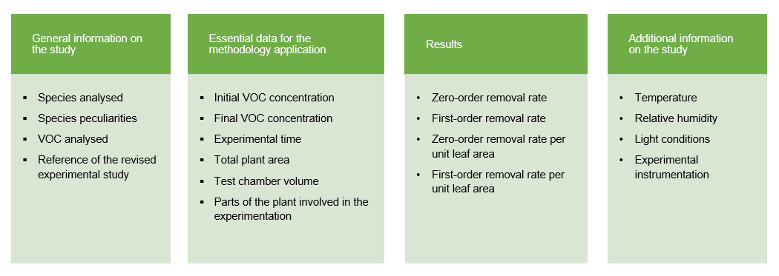
Figure 1: Fields addressed in the database obtained applying the proposed methodology to a selection of experimental tests.

Starting from the left side, the first set of fields provide general information about the tests as the species and the pollutant addressed. It is to note that peculiarities concerning mainly the species metabolism are addressed in a specific field as it is well known that they can significantly influence the VOC abatement.
The second set reports all the essential numerical data required for applying the methodology. These data are the initial and the final pollutant concentration measured in the chamber, the duration of the experiment, the plant area (A) where removal takes place, and the chamber volume. As the idea is to consider the entire plant as a system, the total plant area includes, when applicable, both the leaf and root zone area to include the contribution of all the VOC removal pathways. Finally, it is important for each test to specify if they involved the entire plant, the aerial part or the root zone. This element evidently gives to the results obtained their actual value.
The four removal rates values calculated starting from these data are reported in the third section of the database, and they provide a first harmonised indication of the actual abatement capacity of the different species concerning a specific contaminant.
As environmental conditions are known to play a significant role in VOC removal, information concerning temperature, relative humidity and light conditions are noted in the last part of the database, together with basic information about the instrumentations employed in the tests.
It is to note that, due to the lack of standardised methodologies, all this information is not always provided in the studies revised. Therefore, in the database were included only the tests where all the fields in the second and third sets could be filled. The resulting set of records formed the first version of the database.
An example of how this database can be used is presented in the following section. The idea is to demonstrate how to select the best performing species to remediate formaldehyde, the most studied and common indoor contaminant, using the methodology proposed.
A selection of the database is presented in Table 1. For the sake of brevity, this selection exclusively concerns studies referred to the contaminant of interest performed on entire specimens and in conditions of light. Different metabolisms have not been observed for this selection. Moreover, only the fields concerning the application of the methodology have been reported (the temperature field was added as this datum was employed to perform the necessary unit conversions).
Table 1: Extract from the database for formaldehyde, the studies reported were performed on entire specimens and in light conditions.
Species | Fatsia  japonica | Ficus benjamina | Scindapsus aureus | Syngonium podophyllum | Chlorophytum elatum vittatum | Dracaena messangeana
Reference | Kim et al. (2008) | Kim et al. (2008) | Wolverton and McDonald (1982) | Wolverton and McDonald (1982) | Wolverton et al. (1984) | Wolverton et al. (1989)
Species peculiarities | - | - | - | - | - | -
C₀ (μg/m³) | 2471.52 | 2471.52 | 23066.47 | 20638.42 | 17254.04 | 24144.27
C_{f} (μg/m³) | 346.01 | 271.87 | 4856.1 | 2185.24 | 2464.86 | 7243.28
t (h) | 5 | 5 | 24 | 24 | 6 | 24
A (m²) | 0.35 | 0.42 | 0.64 | 0.64 | 0.71 | 0.72
V (m³) | 1 | 1 | 0.39 | 0.39 | 0.4 | 0.88
k₁ (1/h) | 0.39 | 0.44 | 0.06 | 0.09 | 0.32 | 0.05
k₀ (μg/m³h) | 425.1 | 439.93 | 758.77 | 768.88 | 2464.86 | 704.21
η₁ (m/h) | 1.13 | 1.06 | 0.04 | 0.06 | 0.18 | 0.06
η₀ (μg/m²h) | 1222.71 | 1051.58 | 458.34 | 464.31 | 1392.5 | 862.55
T (C°) | 23 ± 2 | 23 ± 2 | 28.3 | 28.3 | 28.3 | 30 ± 1

It can be seen, analysing the results obtained, that the removal rates per unit leaf area values can give a first indication of the different performances of the species in removing the contaminant of interest from indoor air. It can be moreover proven that this extract gives an idea of the differences between the experiments analysed, proving the necessity to define an appropriate approach for their evaluation.
In order to select the best performing species in removing indoor formaldehyde, the overall abatement velocities (as defined in Eq(4)) regarding the revised studies have been calculated for a reasonable interval of concentrations using the data presented in Table 1. The entire plant area and chamber volume ratio A/V (1/m) is considered equal to one to allow an adequate comparison. The curves obtained for the six species revised are reported in Figure 2.
It can be noticed that the curves offer a clear indication of the abatement performance of each species at different concentrations and that they can be considered a practical tool to select the best species knowing the average initial VOC concentration in a specific indoor environment. From the results presented below, it is clear that Fatsia japonica is, on the whole, the best performing plant species in remediating the pollutant of interest. Clorophytum elatum vittatum and Ficus benjamina are likewise interesting species to consider, but the dissimilarities in their performances have to be taken into account. Considering that the average VOC concentrations detected indoors are usually low, Ficus benjamina should be more suitable for designing plant-based remediation interventions in indoor environments than Clorophytum. It is evident, in fact, that this last species performs better at concentrations that are not typical in indoor environments.

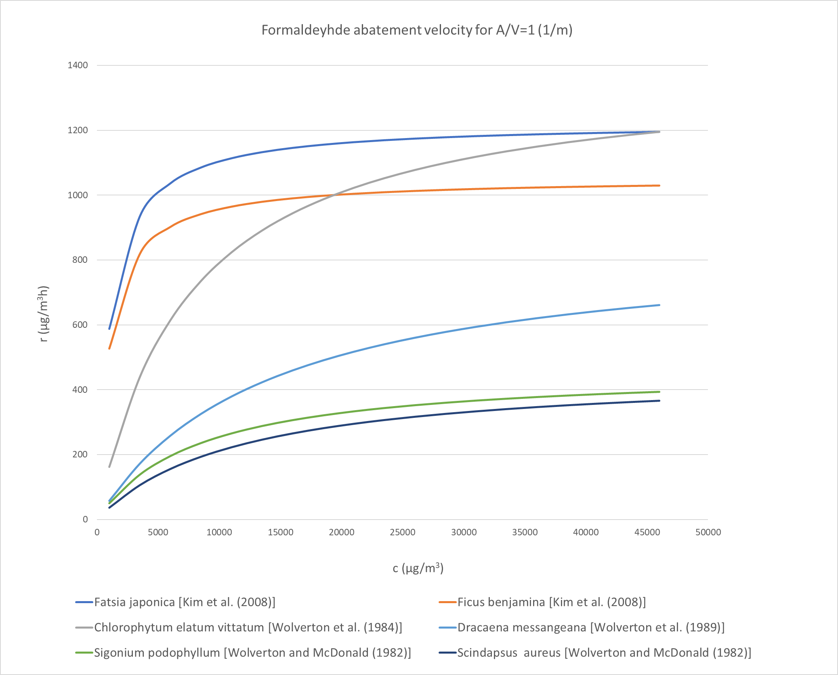
Figure 2: Formaldehyde abatement velocity curves for the studies revised in the methodology application.
  - Conclusions
Even though the attention concerning indoor air phytoremediation is rising, to date, the experimentations in controlled chambers to define the VOC abatement capacity of different species and the reviews available do not often provide comparable and usable results to design plant-based mitigation interventions in real environments.
For this purpose, a new methodology has been proposed in this work. Considering that the overall VOC plant abatement is neither a zero nor a first-order process, but rather a hybrid of the two, an abatement remediation velocity (expressed in μg/m³h) has been defined, approaching the abatement analogously to a biological process. This parameter provides a clear indication of the actual performance of the species to remediate a specific contaminant at different concentrations.
The methodology has been applied to a group of experimental studies identified as concerning the species with superior VOC purifying ability (it is to stress that this selection does not provide harmonisation of the abatement but individuates only the best removal obtained per test). This application led to the construction of a database, that can be considered a first tool to help a robust quantitative design of plant-based mitigation interventions in real environments. As a case study, an example of the usage of this database (for which only relevant fields have been shown) has been provided.
The methodology and the review of previous studies want to provide a robust basis to design plant-based mitigation interventions in real indoor settings. The proposed approach allows the assessment and the comparison of the plant abatement performances obtained using different experimental protocols, and the review provides a structure that can be considered a step ahead for the definition of standardised protocols for the experimental tests as it includes all the essential elements required to calculate the VOC removal in a harmonised way. Evidently, further studies concerning the VOC removal mechanisms of different plant species could help refine the methodology, and the database produced can be extended, including more studies and fields.
References
Bernstein J.A., Alexis N., Bacchus H., Bernstein I.L., Fritz P., Horner E., Li N., Mason S.I., Nel A., Oulette J., Reijula K., Reponen T., Seltzer J.M., Smith A., Tarlo S.M., 2008, The health effects of nonindustrial Indoor Air Pollution, American Academy of Allergy, Asthma & Immunology, 121(3), 585-591.
Dela Cruz M., Christensen J.H., Dyrauge Thomsen, Muller R., 2014, Can ornamental potted plants remove volatile organic compounds from indoor air? – A review, Environmental Science and Pollution Research, 21(24), 13909-13928.
Di Talia V., Antonioni G., 2021, A Model for the Evaluation of VOCs Abatement by Potted Plants in Indoor Environments, Chemical Engineering transactions CEt, 86, 415-420.
Gong Y, Zhou T, Wang P, Lin Y, Zheng R, Zhao Y, Xu B, 2019, Fundamentals of Ornamental Plants in Removing Benzene in Indoor Air, Atmosphere, 10(4), 221.

Han K., Ruan L., 2020, Effects of indoor plants on air quality: a systematic review, Environmental Science and Pollution Research, 26, 16019–16051.
Kim K.J., Mi J.K., Jeong S.S., Eun H.Y., Son K., Kays S., 2008, Efficiency of Volatile Formaldehyde Removal by Indoor Plants: Contribution of Aerial Plant Parts versus the Root Zone, Journal of the American Society for Horticultural Science, 133, 521-526.
Kim K.W., Khalekuzzaman M.D., Suh J.N., Hyeon J.K., Shagol C., Kim H.H., Kim H.J., 2018, Phytoremediation of volatile organic compounds by indoor plants: a review, Horticulture, Environment, and Biotechnology, 59(10),143-157.
Moschandreas D., Stark J., 1978, The GEOMET indoor-outdoor air pollution model, U.S. Environmental Protection Agency, Washington, D.C., EPA/600/7-78/106.
Soreanu G., Dixon M.A., Darlington A.B., 2013, Botanical biofiltration of indoor gaseous pollutants - A mini-review, Chemical Engineering Journal, 229, 585-594.
Sriprapat W., Thiravetyan P., 2013, Phytoremediation of BTEX from Indoor Air by Zamioculcas zamiifolia, Water, Air, & Soil Pollution, 224, article number: 1482.
Suárez-Cáceres G. P., Fernández-Cañero R., Fernández-Espinosa A.J., Rossini-Oliva S., Franco-Salas A., Pérez-Urrestarazu L., 2021, Volatile Organic Compounds Removal by Means of a Felt-Based Living Wall to Improve Indoor Air Quality, Atmospheric Pollution Research, 12(3), 224–229.
Sundell J., 2004, On the history of indoor air quality and health, Indoor Air, 14 (Suppl 7), 51-58.
Wolverton B.C., Mcdonald R.C, Watkins E.A., 1984, Foliage Plants for Removing Indoor Air Pollutants from Energy-Efficient Homes, Economic Botany, 38(2), 224-228.
Wolverton B.C., Mcdonald R.C, 1982, Foliage Plants for Removing Formaldehyde from Contaminated Air Inside Energy-Efficient Homes and Future Space Stations, NASA TM-84674
Wolverton B.C., Johnson A., Bounds K., 1989, Interior landscape plants for indoor air pollution abatement, final report, Document ID: 19930073077.
Wood R.A., Burchett M.D., Alquezar R., Orwell R.L., Tarran J., Torpy F., 2006, The potted-plant microcosm substantially reduces indoor air VOC pollution:1.office field study, Water, Air and Soil Pollution, 175(1), 163-180.

