CHEMICAL ENGINEERING TRANSACTIONS  VOL. 91, 2022 | A publication of
The Italian Association
of Chemical Engineering
Online at www.cetjournal.it

Guest Editors: Valerio Cozzani, Bruno Fabiano, Genserik Reniers
Copyright © 2022, AIDIC Servizi S.r.l.
ISBN 978-88-95608-89-1; ISSN 2283-9216

CCS Technology – CO₂ Transportation and Relief Simulation in the Critical Region for HSE Assessment
Luigi Raimondi
Process Simulation Services, Via Piave 17, 20027 Rescaldina, Italy

The implementation of the CCS (CO₂ Capture and Storage) technology is one of the solutions to capture carbon dioxide emitted from industrial and energy generation sources for mitigation of green-house effects. Carbon dioxide is classified as asphyxiant in high concentrations with occupational exposure limits of 30000 ppm. Its relief in large quantities combined with its density, higher than air, could fill populated regions with unexpected dangerous effects. This study focuses on transportation of carbon-dioxide in pipelines, at high pressure as dense phase, and its release in case of emergency conditions. For the evaluation of dispersion effects of carbon dioxide in the ambient, it is of fundamental importance being able to calculate the flowrate of the fluid dispersed in the ambient, the pressure and temperature changes in the pipeline, the time required to obtain the complete discharge of the fluid, as function of a large number of operating and ambient conditions such as the pipeline profile, thermal insulation, ambient temperature etc. This study provides an example of how this analysis can be performed, the thermodynamic models required, the solution algorithm to be applied in the two main disciplines involved i.e., process engineering and flow-assurance. During normal operations CO₂ is transported as supercritical fluid i.e., at pressure above the thermodynamic critical point pressure. The dynamic simulation applied in this study is rigorous from the thermodynamic and fluid dynamic point of view. In case of fast depressurization, the change of the fluid temperature caused by the liquid phase evaporation may result in damages to the pipeline since very low temperatures may induce metal brittle effects. The calculations are performed using a dynamic software code which has provided high quality results when compared to experimental data and results obtained by other commercial simulators.
  - Introduction
In the simulation of carbon-dioxide and CO₂-rich mixtures the selection of models is a very important aspect. From a numerical solution point of view, the simulation of pure components using temperature and pressure as independent variables (TP plane) presents a discontinuous phase change from vapor to liquid. At constant pressure below the critical point and across the vapor pressure line a small change of temperature can produce a complete shift from the vapor to the liquid phase or vice-versa. On the basis of the initial pressure and temperature the resulting T-P path may enter the gas-liquid region very near the thermodynamic critical point. This gives a chance of the analysis of two-phase flow where the vapor and liquid densities present the lowest differences, almost impossible to realize with other fluids (e.g., hydrocarbons from well bores) even at very high pressures.
Table 1: Pure carbon dioxide thermodynamic parameters
Property | Value
Critical temperature | 30.97 °C
Critical pressure | 73.773 bar
Triple point temperature | -56.6 °C
Triple point pressure | 5.18 bar
Acentric factor | 0.22394

Key chemical-physical parameters of carbon dioxide are important for the next discussion and are collected in Table 1. One of the most notable characteristics of carbon dioxide is that a normal-boiling point does not exist, no liquid phase can exist at 1 atmosphere and a solid phase is obtained when the vapor is cooled down below –78.5 °C. It means that below triple point pressure, a reduction of temperature of the vapor phase (as often found during depressurization) produces a solid phase without the transient formation of an intermediate liquid phase. In practice, pure carbon-dioxide is not obtained in the CCS capture step, so CO2 is usually accompanied by small quantities of other gases. Their effect on the phase equilibrium behavior is to lower the temperature of both the bubble point and dew point lines. The phase envelope of a rich CO2 mixture, as defined by Table 2, is shown on Figure 1 with the pure CO2 vapor pressure curve. It is this mixture that will be used in the following analysis and is the basis of all the results presented.
Table 2: Composition of the sample fluid
Component | Molar fraction
Hydrogen | 0.0050
Nitrogen | 0.0350
Argon | 0.0300
Oxygen | 0.0200
Carbon dioxide | 0.9100

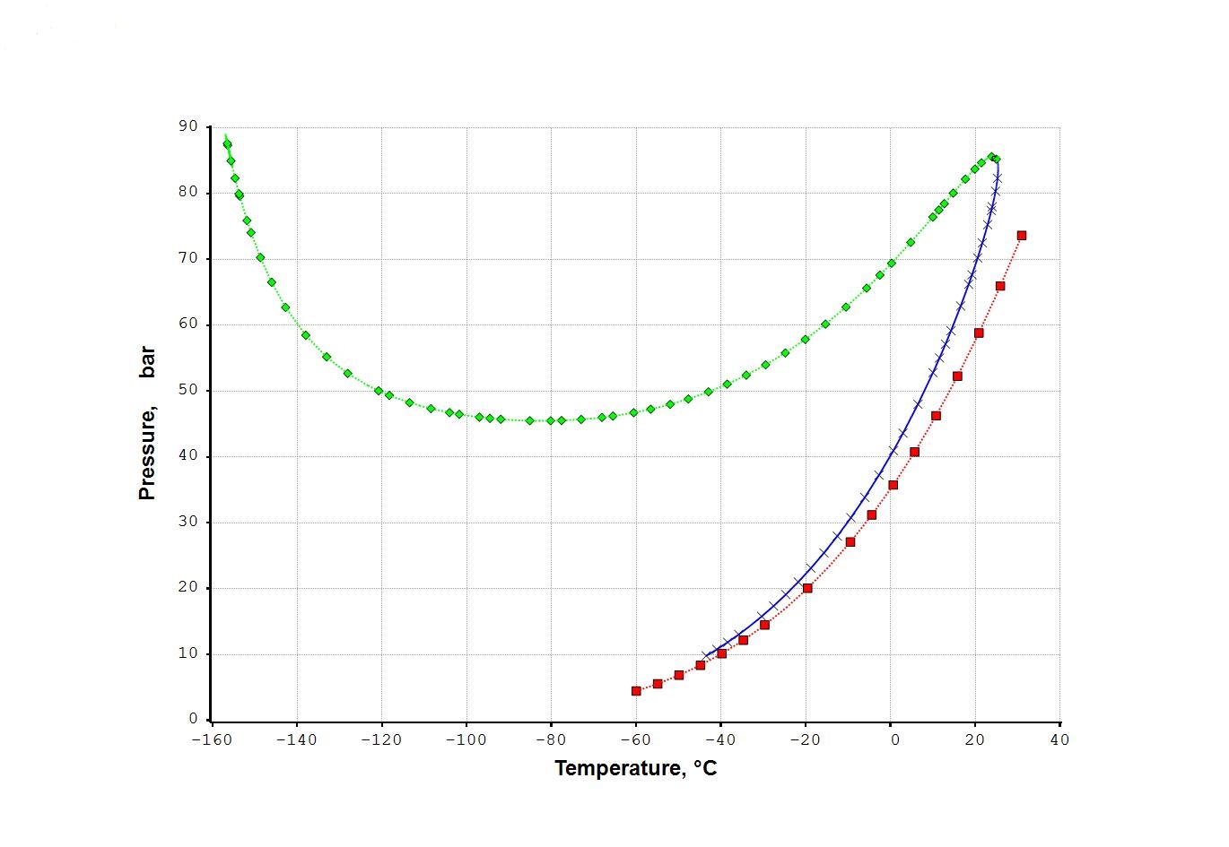
Figure. 1. Fluid phase envelope. (◊) bubble point, (×) dew point, (□) CO₂ vapor pressure.
The analysis of the two-phase flow of rich carbon dioxide mixtures presents interesting points which cannot be found in other mixtures. The most interesting is that the flow of a mixture can cross the gas-liquid coexistence region very near to the thermodynamic critical point where the density difference between the gas and the liquid phases is very low.
  - Thermodynamic and Fluid-Dynamics Models
In the design of a CCS project, the selection of thermodynamic equations of state is a very important step due to the critical impact in many areas from steady state calculations to dynamic simulations, HSE risk evaluations including pipeline depressurization either during planned operations or in case of unforeseen events. The use of standard cubic equations of state such as the Soave-Redlich-Kwong SRK (Soave, 1972) and Peng-Robinson PR (Peng and Robinson, 1978) are usually default choices in chemical engineering design. In flow-assurance engineering for the simulation of pure CO₂ transport, the Wagner equation (Span and Wagner, 1996) is often recommended by fluid dynamic commercial simulators such as OLGA or LedaFlow. However, owing to its limitations (since can be applied to pure CO₂ only), it can be replaced by the GERG models that can be applied to CO₂ mixtures containing light hydrocarbons (C1, C2, C3, etc.) and inert gases (N₂ and O₂), etc. These models are the GERG-2004 (Kunz et al., 2007) or the GERG-2008 (Kunz et al., 2012). However, the application of these equations to complex mixture present numerous problems associated to the large number of parameters required (over 100 per each pure component) with respect to more simple cubic equations of state. The results presented are calculated using the Peng-Robinson equation (PR, Peng and Robinson, 1976) for vapor-liquid equilibrium calculations and the Lee-Kesler model (LK, Lee and Kesler, 1975) for the evaluation of thermal properties i.e., enthalpy, entropy, density, heat-capacity of the vapor and liquid phases. The PR equation provide good values for the vapor-liquid equilibrium constants but gives inaccurate values of thermal properties in the critical point region. In this region the LK model provides an accuracy comparable with the GERG models.

  - Pipeline Characteristic and Depressurization Analyses
The case considered is based on a pipeline 20 km long, internal diameter of 0.36 m, carrying 300,000 kg/h of carbon dioxide rich fluid. This example comes from a real engineering project: the fluid composition is kept unchanged whereas the pipeline length has been shortened and the elevation profile simplified. It is assumed that the leak is located at a progressive distance of 15 km. More cases are calculated by varying the size of the leak and the pipeline profile. Three different pipeline profiles are considered: a) horizontal, b) leak point located at +30 m, c) leak point at -30 m. The leak point is enclosed in a horizontal 2 km long segment between 14 km and 16 km distances. The depressurization is analyzed by considering leaks of different diameters in the range from 25 mm to 60 mm. The heat transfer between the flowing fluid and the external ambient is fully modelled taking into account the metal conductivity and soil properties (density, conductivity and heat-capacity); the external ambient temperature is assumed to be 20 °C. The soil depth of the pipeline is assumed to be 1 m so the global heat transfer coefficient is found to be around 1.24 W/m²°C. The temperature profile across the pipeline metal wall, soil layers and ambient is calculated at each time step for each pipeline segment used to solve the finite volume equations. One of the main points is the calculation of the change of fluid temperatures associated to Joule-Thomson effects when the internal fluid is subject to a fast depressurization. The two-phase flow algorithms are based on the numerical developments presented by the author in recent studies (Raimondi, 2017) for the depressurization of pipelines. Mechanistic models are used to identify the flow patterns for stratified, intermittent and bubble flows, and to evaluate the liquid hold-up and pressure drop (Raimondi, 2022). The algorithms are based on the solution of the Navier-Stokes equations using a volume-of-fluid (VOF) schema and a compositional model which can track changes of fluid composition, as well as the formation and evolution of liquid waves and gas bubble along the pipeline distance and time. These models are implemented in the simulation software XPSIM (Xpsim, 2020) developed for process and flow-assurance design: a brief overview of the mathematical algorithms used to solve the two-phases transport equations are provided in a previous publication (Raimondi, 2016). Comparison of calculated and experimental results may be found in one author’s study (Raimondi, 2017) for the ‘Isle of Grain’ LPG depressurization (Richardson and Saville, 1996). The initial pipeline status is defined by a steady state simulation giving an inlet pressure of 96.4 bar and inlet temperature at 19.1 °C. The outlet pressure is calculated to be 92.3 bar with a final temperature of 18.4 °C. At the leak point, the initial pressure is 93.4 bar and the fluid is liquid at supercritical pressure. The discharged initial flowrate will be liquid and, being a critical-flow discharge, its value will depend on the hole size only. All cases assume that the leak begins 1 hour after the initial simulation time and it is detected after 60 minutes. So, the pipeline is kept operating for one additional hour before control valves are closed at both ends. During the second hour the fluid is continuously fed at the pipeline inlet and discharged at the exit point to keep the outlet pressure at a constant value. This behavior is illustrated by Figure 2, for a “25 mm” diameter leak, which shows that a leak flow almost equal to 1/3 of the normal steady flowrate can be sustained by the pipeline without a significant change of the fluid mass contained and of the outlet pressure. Only for greater leaks a significant upset on the pressure profile and of the delivered flow rate is found. When the pipeline is not horizontal, the position of the leak represents an important aspect. The initial discharged flowrate is almost the same since the initial pipeline content is always liquid, the effluent velocity is critical and the inlet pressure at the leak point is the same.
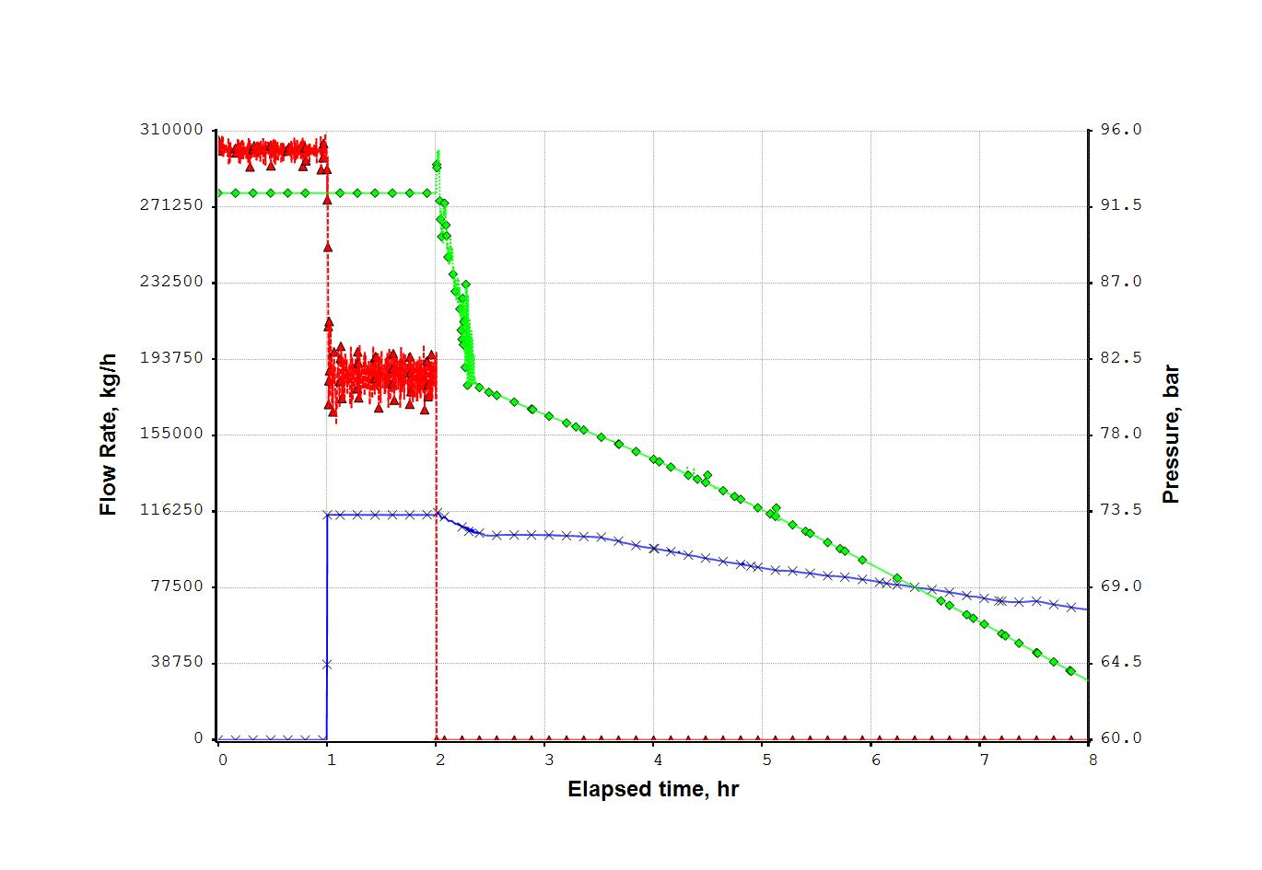
Figure. 2. Fluid flowrates, (Δ) delivered, (x) leaked. Outlet pressure (◊)
As the fluid discharge proceeds, the leak elevation becomes a critical factor and determines the time interval required to reach a complete depressurization as shown by Table 3.
Table 3. Fluid depressurization vs leak position
Profile and leak position | Horizontal | Low (-30 m) | High (+30 m)
Total initial mass, kg | 1392800 | 1392800 | 1392800
Total mass after 24 h, kg | 267270 | 181370 | 494300

When leak elevation is above the average pipeline level, the discharged fluid will enter the vapor region earlier and a lower discharged mass flowrate is established. If the leak elevation is below the average level, the discharged fluid will have a higher liquid content so the whole depressurization will be completed in a shorter time interval. Carbon dioxide and its rich mixtures are interesting fluids for studying gas-liquid two phase flow in the critical point region where the density difference between phases can be very small and cannot be obtained with other gas-liquid mixtures. Besides liquid densities become higher than water densities.
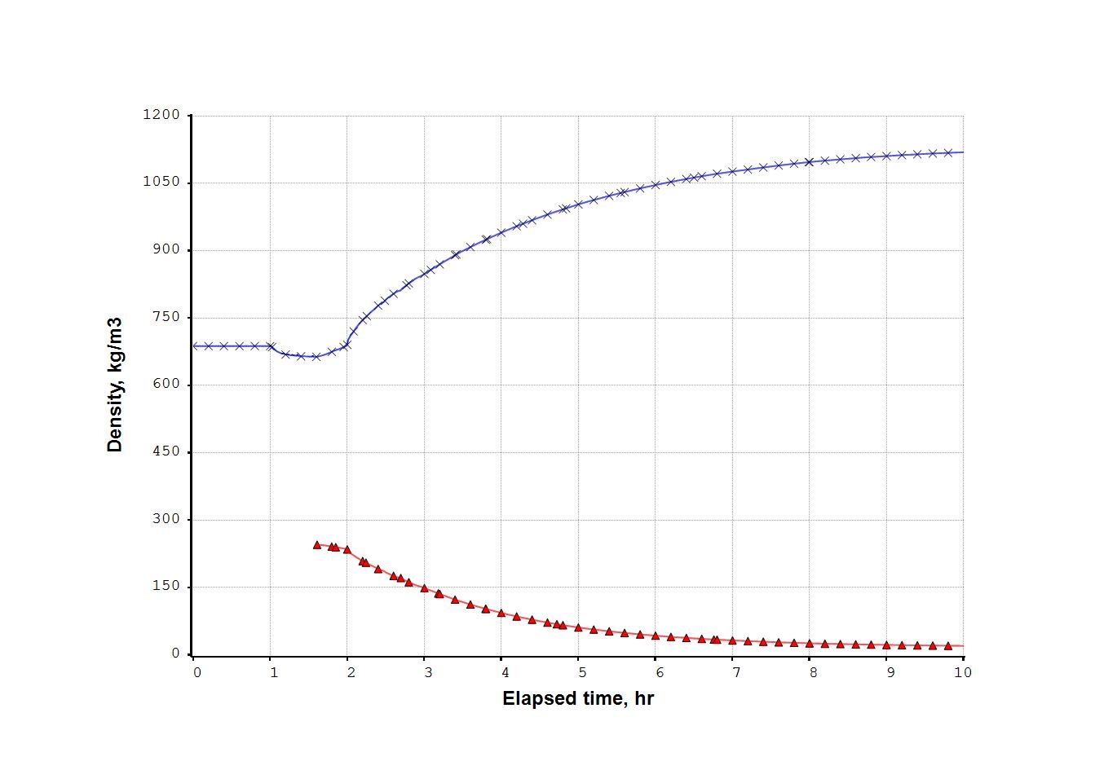
Figure 3. Gas (Δ) and liquid (×) densities change during depressurization
This behavior is summarized by Figure 3 which shows the change of phase densities during the depressurization as the system temperature and pressure decrease. The figure presents the gas and liquid densities at pipeline inlet for the case of a “60 mm” leak. The change of the phase density and compressibility has a direct effect on the sonic velocity in the two-phase system. At the beginning of the depressurization the sonic velocity is about 330 m/s while at the end of the simulation it decreases around 98 m/s. The change of the sonic speed defines the velocity of the pressure waves travelling along the pipeline during the carbon dioxide depressurization. For a leak of 60 mm diameter, the initial flowrate reaches a value equal to half of the total mass content, the pressure decrease is much faster and the depressurization is almost completed after 10 hours as shown on Figure 4 where the total mass content and the leak flowrate vs time are presented. The dynamic simulation can also provide, for each time interval selected, the internal pipeline profile of a number of key variables such as temperature, pressure, gas and liquid flowrates, velocities, densities and other fluid properties.
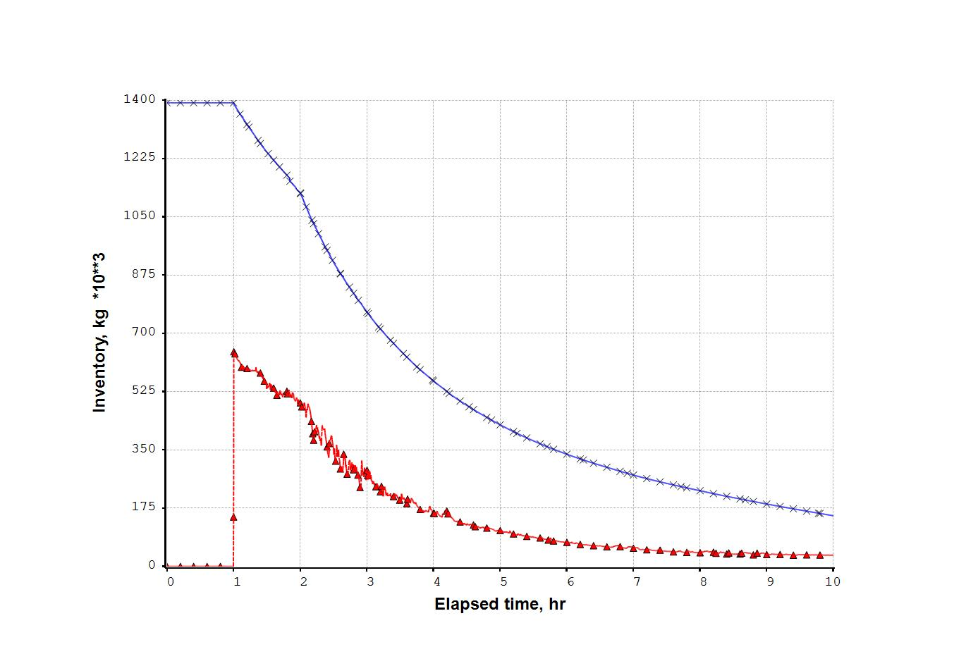
Figure 4. “60 mm” leak. Total mass content (x) and leak flowrate (Δ).
As example, the flowing internal profile captured at 7 hour is presented by Figure 5. This graph may be interpreted as showing the formation of liquid waves (pseudo-slugs) in the fluid discharged by the pipeline section preceding the leak located at 15 km.
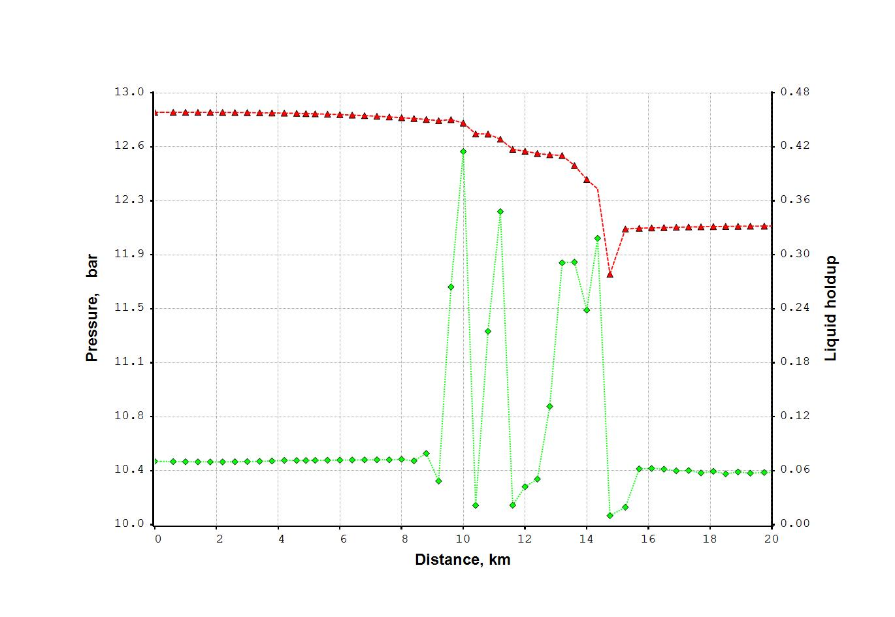
Figure 5. “60 mm” leak after 7 hr. Pressure(Δ) and liquid holdup (◊).
The effect of the discharge flowrate on the fluid temperature, related to the Joule-Thomson effect of the pressure decrease, is one of the important results calculated by the simulation. For the “25 mm” leak the effect is balanced by the heat transfer from the external ambient at 20°C and the pipeline temperature does not decrease below 0°C. For a “60 mm” leak, the decrease of temperature caused by the rapid pressure change becomes very large. This case is described by Figure 6 which presents pressure and temperature near the leak point showing that the metal temperature reaches values below -40 °C. One of the side effects to be considered by the HSE analysis is that the discharged fluid at such low temperature will prompt the condensation of the water contained in the nearby air and a subsequent ice formation.
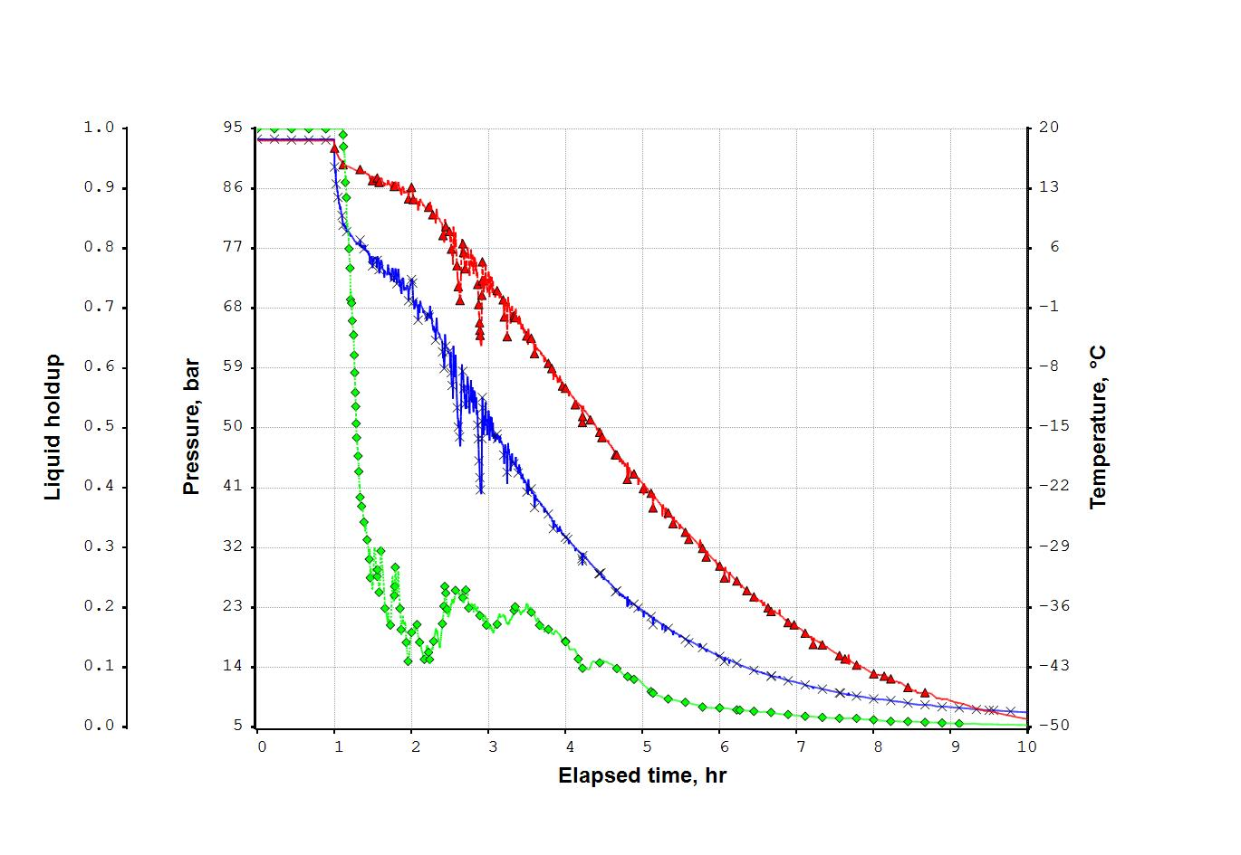
Figure 6. Pressure (x), temperature (Δ), liquid holdup (◊) at leak (60 mm) position.
  - Conclusions
The simulation approach can provide significant results for the safety analysis of the carbon dioxide transport in a CCS facility. This study presents an analysis about the leak effects on a CO₂ transfer line of 300,000 kg/h aimed at a following study of the fluid dispersion in a nearby environment. The calculation of the duration and the maximum value of fluid flowrate dispersed are the most important results for a following evaluation of dispersion effects in the nearby environment. Dispersion results of the simulations presented show that leaks with diameters of 25 mm, though the discharged mass of carbon dioxide is initially over 100,000 kg/h (about one third of the normal flowrate) has a limited effect on the pressure profile. The rigorous thermodynamic framework used provides the calculation of a large number of operating parameters such as pressures, temperatures, gas and liquid flowrates, their densities and velocities, and the local liquid holdup. The model can also provide an a-posteriori analysis of the thermal effects of the leak as the lowest temperature reached by the fluid and by the pipeline metal wall in contact. So, each case study can identify the sections of the pipeline where possible metal failures could be expected as result of the very low temperatures touched during the depressurizations.
References
Kunz O., Klimeck R., Wagner W., Jaeschke M., The GERG-2004 Wide-Range Equation of State for Natural Gases and Other Mixtures, Groupe Européen de Recherches Gazières, 2007
Kunz O., Wagner W., The GERG-2008 Wide-Range Equation of State for Natural Gases and Other Mixtures: An Expansion of GERG-2004, Journal of Chemical Engineering Data, 2012, 57, 3032-3091
Lee B.I., Kesler M.G., 1975, A generalized thermodynamic correlation based on three-parameter corresponding states, AIChE J., 21, 510-527.
Peng D.Y., Robinson D.B., 1976, A new two-constant equation of state, Ind. Eng. Chem. Fund. 15, 59–64.
Raimondi L., 2016, Simulation of Pipeline Depressurization in the Transportation of Oil & Gas with High CO2 and H2S Content, Chemical Engineering Transactions, 53, doi: 10.3303/CET1653057.
Raimondi L., 2017, Compositional Simulation of Two-Phase Flows for Pipeline Depressurization, SPE Journal, 22, 4, 1242-1253.
Raimondi L., 2022. Gas‐Liquid Two‐Phase Flow in Pipes: Slugs, classical Flow‐Map and 1‐D Compositional Simulation, SPE J. 27(01):532-551. doi: https://doi.org/10.2118/206743‐PA
Richardson S.M., Saville G., 1996, Isle of Grain Pipeline Depressurization Tests, Health & Safety Executive
Soave G., 1972, Equilibrium constants from a modified Redlich-Kwong equation of state, Chem.Eng.Sci. 27, 1197-1203
Span R., Wagner W., 1996, A New Equation of State for Carbon Dioxide Covering the Fluid Region from the Triple Point Temperature to 1100 K at Pressures up to 800 MPa, J. Phys. Chem. Ref. Data, Vol 25, no 6,1509-1596.
XPSIM (eXtended Process SIMulator), 2020, Reference Manual, Version 3.0., Process Simulation Services, www.xpsimworld.com.

