CHEMICAL ENGINEERING TRANSACTIONS  VOL. | A publication of
The Italian Association
of Chemical Engineering
Online at www.cetjournal.it
Guest Editors:
Copyright © AIDIC Servizi S.r.l.
ISBN 978-88-95608-xx-x ISSN 2283-9216

Numerical simulation of a preventative evacuation using a multi-agent framework
Cyril Orengo^{a*}, Florian Tena-Cholletª, Sophie Sauvagnarguesª,
ªLaboratory for Science of Risks (LSR), IMT Mines Alès, Alès, France
7 rue Jules Renard 30100 Alès (France)
cyril.orengo@mines-ales.fr
Enhancing knowledge of the evacuation process is still a challenging topic. Hard to exercise in real conditions, we aim to propose a numerical simulation of an entirely pedestrian evacuation at the scale of a city. The main interest of this study is to render realistic pedestrian mobility in an evacuation context. To that end, a multi-agent system framework is used, allowing intelligent agents implementation mixed with an adapted social force model (Helbing and Molnár, 1995). The simulation is applied to Alès and its agglomeration (ten municipalities), subject to a dam failure that could cause a flood wave. Evacuation times for the ten municipalities were thus calculated and analyzed.
Introduction
Because of the multiplication of hazards and the increasing number of exposed human stakes caused by soil artificialization, Because of their lack of flexibility, structural protection methods (dams, dykes..) tend to show their limit. Indeed, some hazards can manifest themselves with intensity and spatial extension exceeding the calibration of structures (especially during floods). In some cases, it is not even possible to imagine structural protection (hurricane or volcanic eruption for example). This type of event raises the specter of a "disaster" understood as an event causing massive stress on population (Kinston and Rosser, 1974) and furthermore a physical agent (hazards) hurting another physical agent (Quarantelli, 2005). Territories subject to this configuration of important and continuous risks must then prepare themselves to manage possible crises. Population evacuations take place in this context. More specifically, this article deals with a full pedestrian evacuation of the urban area of a medium-sized French city “Alès-en-Cévennes” (France), in the case of an imminent dam failure.
This article aims at building a simulation of a preventive evacuation process on a territory of application, the urban area of the agglomeration of “Alès-en-Cévennes”. The preventive evacuation of Alès would occur in the context of hydrological hazard, which can be caused by heavy rainfall, especially during the Cevenol episode. Significant risks related to the probable overflow of the Gardon goes along the triggering of an evacuation process in such a context. This makes the use of individual vehicles dangerous (Ruin and Lutoff, 2004), and complicates the use of shuttles and rescue operations.
Several simulations of pedestrian evacuations have been made through the years, but they are mainly applied to a limited size environment. This paper is organized as follows. Section 1 presents a literature review on evacuation simulation. Section 2 introduces the global approach, from the understanding of the process to the systemic modeling of it. Section 3 presents the simulation of it on a multi-agent framework (GAMA platform) and its application in the study case.
  - State of the art
The first problem encountered when simulating an evacuation is the evacuees routing (Garcia-ojeda et al., 2012). Dijkstra algorithm has been the most used method for years (Takabatake et al., 2020). Consisting in a division of the network into arcs connecting nodes, corresponding to junctions, the individual chooses the direction that will minimize his total travel time. This approach is a direct application of the work of Zipf (Zipf, 1949) who theorized travel as optimization of metabolic expenditure. The behavior of the individual within his environment is thus, in the first instance, rationalized to the extreme. It is considered that whatever the situation, it will make the best choice.
Other models, mainly in the field of distributed artificial intelligence, using agents with more or less extensive cognitive characteristics, operate based on individual strategies. Multi-Agent System (M.A.S.) technology has brought the opportunity to observe complex systems emergence from simple individual behaviors (Drogoul, 1993). The problem of pedestrian evacuation on large scale implies a multiplicity of individuals self-organizing on a network to reach shelters. These individuals are socially and physically interacting through the process, these interactions tend to modify their trip. (Chaib-draa, 2001) identify two characteristics of M.A.S. that makes it appropriate to use. First, they are situated. They have a position, at any time, in the environment. This position evolve through time according to rules. The position change of the evacuees is essential to understand pedestrian evacuation dynamics, especially in an urban context, high densities being highly probable. The second characteristic is flexibility. An agent is meant to be non-deterministic; it can adapt its behavior to its environment. In a pedestrian evacuation context, it is materialized by collision avoidance and velocity adaptation according to the density of evacuees on a route.
  - Global approach for pedestrian evacuation
Due to the multiplicity of actors involved, and the level of uncertainty emanating from human behavior in a crisis, evacuation processes, from a certain quantity of population, can be considered as complex systems. A complex system is characterized by the level of unpredictability of its global functioning from the functioning of these elementary entities. The interest here is to find the global functioning of the system from the functioning of these entities. These entities maintain interactions throughout the process, which have a consequence on the global form of the whole. An evacuation fit well as a complex system due to the multiplicity of the actors and their interactions.
Understanding the functioning of a preventive pedestrian evacuation starts with the research of precedents. The first informational material available is the REX (Experience Feedback). Experience Feedback is a transversal tool for capitalizing on knowledge (Gilbert, 2001). It is used in all types of organizations, public and private. The methods may vary but the objective remains substantially similar. Experience Feedback is an empirical practice that complements theoretical knowledge about a disaster and its management (Gauthier, 2008). It can be built around a case (case-based reasoning) or after exercises. (Marchand, 2011), our approach is obviously based on cases. The aim is to find significant cases, the synthesis of which could allow a generalization.
Experience feedback provides valuable information on the general course of the process, and particularly the performance of the organization in charge of its management. However, it is rare to find concrete data on the movement of individuals during the evacuation, and on possible deviations from the instructions given by the authorities. This information is, on the other hand, available in various research works. Concerning the displacement of pedestrians, and its mechanical characteristics, the social force model of (Helbing and Molnár, 1995) furnish a solid mechanical basis to our model. It has been used to answer several problematics such as the evacuation of metro platform (Li et al., 2014), a shipwreck (Kang et al., 2019) and even adapted to simulate bicycle flows (Rui et al., 2021). Many works conducted in the various field have shown herding effects in high-density pedestrian flows (Moussaïd et al., 2009), on the other hand, pedestrian interactions have been theorized in human sciences fields (Houdremont, 1999). The pedestrians are also interacting with their environment, in an urban context it mainly refers to roads and buildings.
The UML diagram Figure 1 conceptualizes the objects of the model (actors and infrastructures) and their interactions. The large number of actors and the importance of the contextual framework (territory considered and spatio-temporal form of the event) force us to make choices in the elements integrated into the simulation model. The simulation model starts after the transmission of the evacuation order. The initial calibration of the simulation model does not admit any heterogeneity in the reception of the latter by the populations.

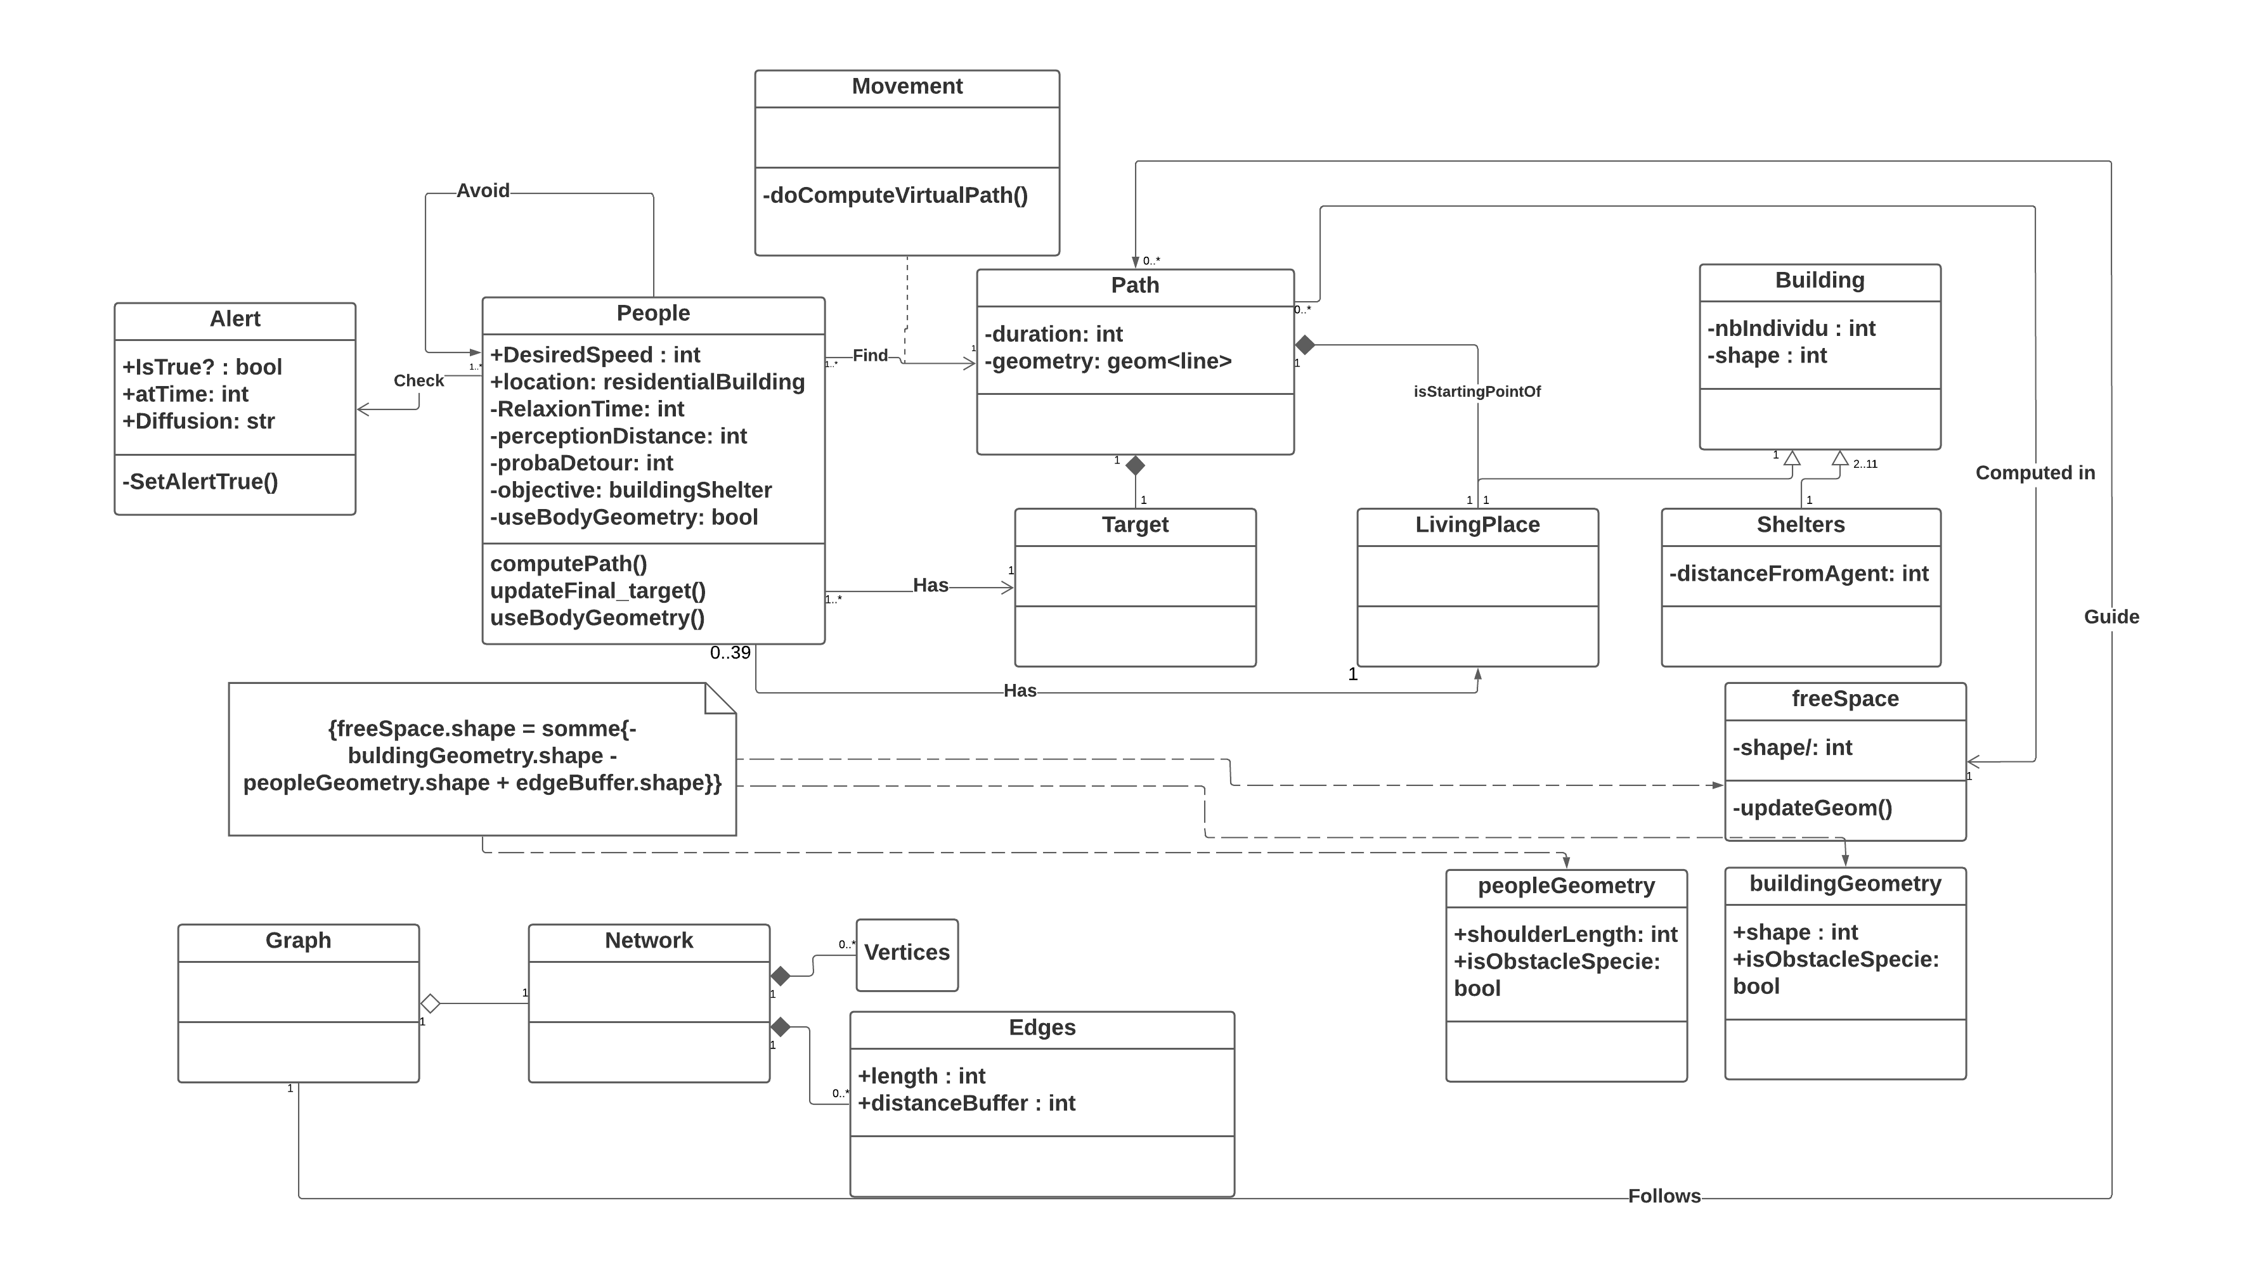
Figure 1: UML model of the simulation

Peoples are the main interest of the simulation. A specific object class “people” who is set to be the only one moving through the environment embodies them. Agent “people” possess a desired speed, a Gaussian with an average value of 1.34 meters per second and 0.25 as a standard deviation (Fahy and Proulx, 2001). They also have a perception distance, in which they collect information about the environment. The attributes of relaxation time correspond to the relaxation parameter identified by (Helbing and Molnár, 1995). Living places are set as a list of residential buildings. Each “people” agent has a living place, several “people” agents can be linked to the same living place. They choose a target destination according to their objective. The objective is a value that adapts to the situation. If the alert is launched, every agent “people” will search for the nearest shelter. Once they find it, they will build a path to reach it as quickly as possible. Thus, the agent “people” will execute a movement and reach his desired speed. His path is built thanks to the graph. The graph is calculated with the road network. The path is meant to be constant but can be modified if an agent “people” encounters an obstacle, including another agent “people” themselves.
  - Simulation core
The simulation model is based on a free plug-in available for download on the GAMA platform. This plug-in is based on the Social Force Model of Dirk Helbing (Helbing and Molnár, 1995).
3.1 Method and Model
The physical engine of our model is based on the “social force model” proposed by (Helbing and Molnár, 1995). This model defines human motion as a mix of psychological and physical aspects. It renders crowds’ behavior by computing local interactions between pedestrians. Three parameters are used to model pedestrian’s behavioral pattern in a crowded environment. The “repulsive effect” towards the physical obstacle and other pedestrians, the “attractive effect”, which can be summed up by the influence of interest points on the pedestrian move, and the “desired velocity”. Applied to our use-case, desire force represents the evacuation shelter chosen by the evacuee. The evacuees reach the objective at a certain speed (who tends to reach the desired velocity) and heading a certain direction, if it is possible. During his trip, the pedestrian will encounter obstacles, such as borders or another pedestrian. These elements apply a force on the pedestrian, and incentive him to adjust his trajectory. The path is a succession of edges; each pedestrian computes it at the beginning of the simulation.

3.2 Geographical environment of the simulation.

The geographical environment of the simulation model is generated within the GAMA platform by importing geographical data in shapefile format. A shapefile is a set of files related to one or more geographic objects (building(s), portion of network) containing information about its geometry, its actual geolocation, the method used for the two-dimensional projection, as well as various characteristics (commonly referred to as variables) that it possesses. The geographic objects we need to run the simulation model are of two types:
- Buildings: containing information about the type of building it is, the number of residents and the socio-economic profile of these residents. The number of inhabitants is estimated using French statistics institute (INSEE) data, crossed with buildings type and shape information.
- The road network: shaped as a line that contains information on the shape of the real road they represent. The width value allows the simulation to give the pedestrian the possibility to walk away from roads. This feature allows the construction of walking space.

The environment of the model is set from geographical data mostly available online on free access. The building shape is extruded from a French government database, socioeconomic information such as the number of inhabitants is integrated into the shape using spatial analysis tools. The Road network is crafted from an open street map. These data are compiled into a geodatabase, GAMA platform can read them then and built the environment.

3.3 Simulation results.

The simulation has been applied to the ten municipalities of “Agglomération Alès” Figure 4(a) threatened by a dam failure. The study area is crossed by the “Gardon d’Alès”, a river well known for regular flooding, especially during the fall. The simulation was first launched on each municipality separately, in order to point out eventually heterogeneous response capacity of the population. Shelters are set in a prevention plan related to the dam, edited by the “prefecture du Gard”, the state authority on the area. The whole area has been implemented in GAMA platform (multi-agent framework), but simulations are made on each municipality separately due to the high number of agents causing long calculation times.

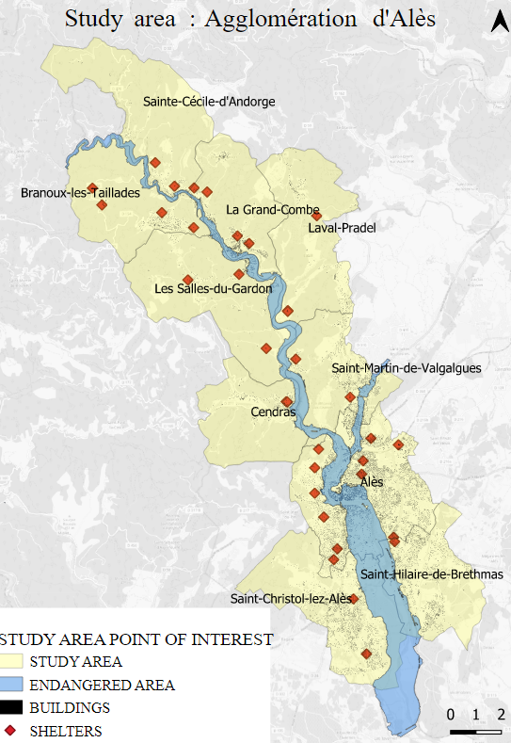 | 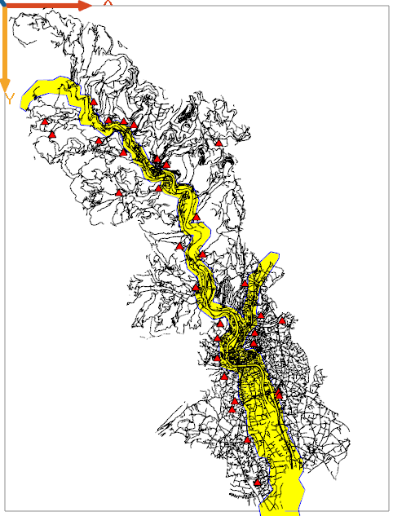
Figure 3: Study area (a) | Imported into GAMA platform (b)

Simulation output (c)

Figure 3 (b) shows the environment of the simulation and (c) the evacuees leaving their living places (residential buildings). Buildings are represented in yellow; the road network appears in black; each dot embodies a pedestrian. When an alert is emitted, pedestrians set the nearest shelter as their objective. Roads are shaped as lines, but pedestrians are able to move at a distance from the line that corresponds to the real width of each segment.
A dam breaking risk concerns ten municipalities of “Alès Agglomération”. In case of a dam-failure, the flood wave resulting is estimated to reach Alès in one hour, municipalities situated up to the north will have even less time to evacuate. Ten runs of the simulation were launched for each municipality to obtain completion rates at different steps of time Figure 4. In fifteen minutes, not any municipality reached the 100% rate. More interesting, the two municipalities situated next to the dam (Sainte-Cecile d’Andorge and Branoux-les-Taillades) obtain low rates, and even 0 for Branoux-les-Taillades.

Figure 4: Evacuation completion rate after one hour

Table 1 shows evacuation time for every municipality. With a closer look, it appears that municipality with less population for a shelter tends to evacuate faster, except for Alès, which is a markedly bigger city and then offers a denser road network. The relationship between the number of shelters and evacuation times appears to be an evidence. Indeed, a less saturated network is a token for a fast evacuation. However, it also shows that the simulation is able to render interaction effects and velocity drops due to increasing density on the network.

Table 1: Evacuation times for ten municipalities
Municipality | Number of shelters | Population concerned | Population / Shelters |  | Evacuation time
Alès | 11 | 3’673 | 334 | 65
Branoux-les-Taillades | 4 | 84 | 21 | 115
La Grande Combe | 4 | 401 | 100 | 60
Laval-Pradel | 2 | 4 | 2 | 40
Sallis du Gardon | 4 | 444 | 111 | 99
Sainte-Cécile d'Andorge | 2 | 96 | 48 | 84
Saint-Christol | 2 | 104 | 52 | 58
Saint-Hilaire de B. | 1 | 198 | 198 | 135
Saint-Martin de Val. | 2 | 568 | 284 | 121
Cendras | 2 | 153 | 77 | 42

  - Conclusion
Facing increasingly threatening hazards, civil evacuations are an efficient response to avoid casualties. Possibly involving thousands of people, they require knowledge enhancement. Launching an evacuation exercise at the scale of a city can be challenging, in terms of logistics. However, rising of artificial intelligence technology allow numerical simulation of the process. The outputs of these simulations can help crisis management organizations to improve their strategies. Enhancing knowledge on the evacuation proceeding is still a challenging topic. This work proposes a numerical simulation of the process focused on pedestrian mobility and people interactions. The main interest of this study is to include human physical interactions to render realistic mobility in a crisis context. To that end, a multi-agent system framework has been used, allowing intelligent agents implementation. The simulation has been applied on the “Agglomération d’Alès”, threatened by a flood wave that would be caused by the failure of the nearby dam of Sainte-Cecile d’Andorge. Results show heterogeneous response among the ten municipalities.
This simulation is currently simply applied on smoothed conditions. The whole population receives the alert at the same time and is compliant with the evacuation order. It is well known that the population is not systematically at their home. This will be taken into account for the development of the simulation. Eventual flooding due to meteorological events does not slow their trip through the network. Future works will then include various scenarios depicting situations that are more realistic. There is also space to enhance the psychological aspect of the behavior of agents “people”.

References
Chaib-draa B., 2001, Systèmes multi-agents: principes généraux et applications.
Drogoul, A., 1993, From Multi-Agent simulation to collective problem solving. [De la simulation Multi-Agent à la résolution collective de problèmes] (in french).
Fahy R.F., Proulx G. ,2001, Toward creating a database on delay times to start evacuation and walking speeds for use in evacuation modelling, 2nd International Symposium in Human Behaviour in Fire, (March), pp. 175–183.
Garcia-ojeda J.C., Bertok B., Friedler, F., 2012, Planning Evacuation Routes with the P-graph Framework, Chemical Engineering Transactions, 29, pp. 1531–1536. doi: 10.3303/CET1229256.
Gilbert C., 2001, Feedback: constraints [Retours d’expérience : des contraintes] (in French), Les annales des Mines, pp. 9–24.
Helbing D., Molnár, P., 1995, Social force model for pedestrian dynamics, Physical Review E, 51(5), pp. 4282–4286. doi: 10.1103/PhysRevE.51.4282.
Houdremont C., 1999, Rumor and Psychology of Crowds, [Rumeur et Psychologie des Foules] (in French), Communication.
Kang Z., Zhang L., Li, K., 2019, an improved social force model for pedestrian dynamics in shipwrecks, Applied Mathematics and Computation. Elsevier Inc., 348, pp. 355–362. doi: 10.1016/j.amc.2018.12.001.
Kinston W., Rosser R., 1974, Disaster: Effects on mental and physical state, Journal of Psychosomatic Research. Elsevier, 18(6), pp. 437–456. doi: 10.1016/0022-3999(74)90035-X.
Li F., Chen S., Wang X., Feng F., 2014, Pedestrian Evacuation Modeling and Simulation on Metro Platforms Considering Panic Impacts, Procedia - Social and Behavioral Sciences. Elsevier B.V., 138(0), pp. 314–322. doi: 10.1016/j.sbspro.2014.07.209.
Moussaïd M., Helbing D., Garnier S., Johansson A., Combe M., Theraulaz G., 2009, Experimental study of the behavioral mechanisms underlying self-organization in human crowds, Proceedings of the Royal Society B: Biological Sciences, 276(1668), pp. 2755–2762. doi: 10.1098/rspb.2009.0405.
Quarantelli, E. L. (2005) What is a disaster? A dozen perspectives on the question, What is a Disaster?: A Dozen Perspectives on the Question. doi: 10.4324/9780203984833.
Rui, Y., Tang, T. and Zhang, J. (2021) ‘An Improved Social Force Model for Bicycle Flow in Groups’, Journal of advanced transportation, 2021.
Ruin, I. and Lutoff, C. (2004) ‘Vulnérabilité face aux crues rapides et mobilités des populations en temps de crise’, Houille Blanche. doi: 10.1051/lhb:200406016.
Takabatake, T. et al. (2020) ‘Simulated effectiveness of a car evacuation from a tsunami’, International Journal of Disaster Risk Reduction. Elsevier Ltd, 47(June 2019), p. 101532. doi: 10.1016/j.ijdrr.2020.101532.
Zipf, G. K. (1949) ‘Human Behaviour and the Principle of Least effort.’, The Economic Journal. doi: 10.2307/2226729.

