CHEMICAL ENGINEERING TRANSACTIONS  VOL. 91, 2022 | A publication of
The Italian Association
of Chemical Engineering
Online at www.cetjournal.it

Guest Editors: Valerio Cozzani, Bruno Fabiano, Genserik Reniers
Copyright © 2022, AIDIC Servizi S.r.l.
ISBN 978-88-95608-89-1; ISSN 2283-9216

Safety aspects of hydrogen fuelling stations
Ján Vereš^{a,*}, Tadeáš Ochodekª, Jan Koloničnýª
ª Energy and Environmental Technology Centre, Energy Research Centre, VSB-TU Ostrava, 708 00 Ostrava Poruba, Czech Republic
jan.veres@vsb.cz

Fuel cell vehicles have been intensively developed in last years to cut dependence on fossil fuel and significantly reduce the CO₂ emissions. The hydrogen fuelling station is a complex technological unit, consisting of various devices that interact with each other and at the same time have significant interactions with the external environment and environmental influences. Legislation and standards in the field of occupational safety and health are an integral part of hydrogen technologies and the use of hydrogen as an important carrier of energy and fuel of the future, a clean, safe and efficient energy system in the world. Effective legislation in the field of hydrogen technologies and the use of hydrogen for commercial purposes is one of the conditions for the functioning of the hydrogen energy system. Ensuring safety at all stages of the development of hydrogen technologies and the use of hydrogen is a goal and a prerequisite for the creation of laws and standards. Risk assessment is a useful tool to identify, prevent and mitigate accidental risks and hazards. The purpose of this study is a basic risk analysis of the planned hydrogen station in Ostrava, Czech Republic.
  - Introduction
The main goal of the Czech Republic's hydrogen strategy is to reduce the total amount of greenhouse gases released into the atmosphere as well as to speed up the process of implementing hydrogen technologies as much as possible. The use of hydrogen in transport is a priority area and search for alternative fuel for road transport is absolutely necessary and unavoidable in the future. Fuel cell vehicles have been developed over the years to reduce dependence on fossil fuels and significantly reduce carbon dioxide emissions towards a sustainable society. One of the main problems is the completely inadequate infrastructure associated with high hydrogen prices, and therefore much other public and non-public filling stations are expected in connection with the National Clean Mobility Action Plan. Filling stations will be given strategic importance, as their development must go hand in hand with the development of hydrogen mobility. Hydrogen station systems play as a key bridgehead in commercializing fuel cells and fuel cell powered vehicles. Several studies related to the safety of hydrogen stations have been concerned with the diffusion of leakage, explosion, deflagration or detonation of hydrogen and jet flames from hydrogen fueling stations (Kim et al., 2013). Hydrogen is dangerous due to its properties of low ignition temperature, small ignition energy, wide explosion limit and fast combustion speed. In a confined space, the hydrogen is dangerous, like any other flammable gas. In an open space, the probability of hydrogen explosion is lower as compared to that occurring in a confined space, as buoyancy speed is high (Sakamoto et al., 2019). To reduce the risk, reliable risk analysis methodology is required so that appropriate control measures can be planned and required safety standards can be established. This is particularly important especially when the population at large is involved such as in the case of hydrogen stations (Al-Shanini et al., 2014). In addition, it is essential to address the safety aspects of hydrogen vehicles and service stations in order to ensure the safety of workers, customers, and the public for a stable supply of hydrogen to fuel cell vehicles.
The safe handling and use of hydrogen require an appreciation of its physical properties. Hydrogen is colour and odourless and the lightest gas. As a result of inhaling hydrogen, a flammable mixture may also form in the body. The action of hydrogen on metallic materials leads to a phenomenon known as hydrogen embrittlement. Iron is broken down by hydrogen not only during its electrolytic deposition on the metal surface, but also by the action of molecular hydrogen at higher temperatures and pressures. Hydrogen diffuses into the metal and weakens the metal lattice structure. At temperatures close to ambient temperature, many metallic materials are sensitive to hydrogen embrittlement, especially those having a cubic crystal lattice. At temperatures above 473°C, many low-alloy steels may suffer another phenomenon known as hydrogen attack. It is an irreversible deterioration of the steel microstructure caused by the chemical reaction of hydrogen and parts of carbon in the steel that result in the formation of methane.
This property impairs the ability to store hydrogen compared to other gases. Hydrogen is flammable when mixed with air; however, the small molecular size, which increases the likelihood of leakage, also results in very high dispersion, so that hydrogen dilutes very quickly. In contrast, spilled gasoline or diesel evaporates slowly, increasing the duration of the fire hazard. In the event of small leaks, the dispersion of hydrogen in the air is further enhanced by the presence of an air stream, thus reducing the risk of fire. The main physicochemical properties are shown below in table 1.
Table 1: Main physical and chemical properties of hydrogen
Field | Characteristic values
Mark | Hydrogen
CAS number | 1333-74-0
Chemical formula | H₂
Density | 0,084 kg/m³
Boiling point | -253°C
Melting point | -259°C
Auto-ignition temperature | 560°C
Explosion range | 4,7-77 vol%

Hydrogen fueling stations supply high-purity, high-pressure hydrogen fuel primarily to fuel cell vehicles. Hydrogen stations are in operation and under construction for light-duty vehicles (passenger vehicles), heavy-duty vehicles (trucks and buses), and material handling equipment. The actual map of H₂ fueling stations in EU is presented in Fig.1

Figure 1: Map of H2 fueling stations in Europe (green, red-in operation; blue–in progress) (h2.live)
Hydrogen fuelling stations dispense compressed hydrogen at two pressure levels, 700 bar for passenger cars and 350 bar for trucks, buses and all other vehicles. Stations generally have the same equipment, but the design of each station depending on how the hydrogen is produced, delivered, stored and dispensed. Each station includes, at minimum:

- Hydrogen storage equipment – based on the location and capacity, hydrogen can be stored on different pressure levels (Low - Medium - High).
- Compressor – hydrogen is compressed to reduce volume and increase pressure. Mainly the compressor is used to refill the buffer storage. Depending on the storage capacity, different and multiple compressors may use.
- Chiller – The chiller is mainly used for passenger cars to fasten the whole fuelling time. Hydrogen is cooled down to -40°C based on the standard fuelling protocol.
- Dispenser – Dispensers are similar to CNG dispensers.
  - Methodology
The fast development of the hydrogen economy is dependent on the process safety and public perception of the refuelling process and therefore the safe design of the station is essential (Eunjung et al., 2013). The whole safety philosophy means that the process has to be inherently safe and the risks need to be minimised to low practicable level. Several studies have shown that the general public perception on the use of hydrogen is neutral and only a minority relate it to the incident. The acceptance of hydrogen as the fuel of the future is strongly related to public understanding of the safety and cost of hydrogen. The hydrogen fuelling station installation should be sited to minimise risk to users, operating personnel, properties, and the environment to an acceptable level (Kikukawa et al., 2009).
The unique properties of hydrogen, which make it suitable as an energy carrier or fuel, require appropriate technical and operational measures to prevent emergencies. The combination of hydrogen properties and behaviour defines the potential hazards faced by operators.
The basic risks associated with hydrogen systems can be categorized as follows:
- risk of burning, ignition, explosion,
- risk of overpressure,
- low temperature risk,
- hydrogen embrittlement,
- the action of hydrogen on the human body through direct contact or exposure.

The hydrogen fuelling station must include measuring procedures to reduce the risk of fire, detonation, deflagration and pressure waves to an acceptable level. Risk assessment is the overall process of risk identification, analysis, assessment and mitigation. The use of risk assessments may allow for the owners and designers to flexibly and clearly define specific mitigations that achieve better level of risk than in normative recommendations. The visualization of the planned hydrogen fueling station in Ostrava, Czech Republic is presented in Figure 2.

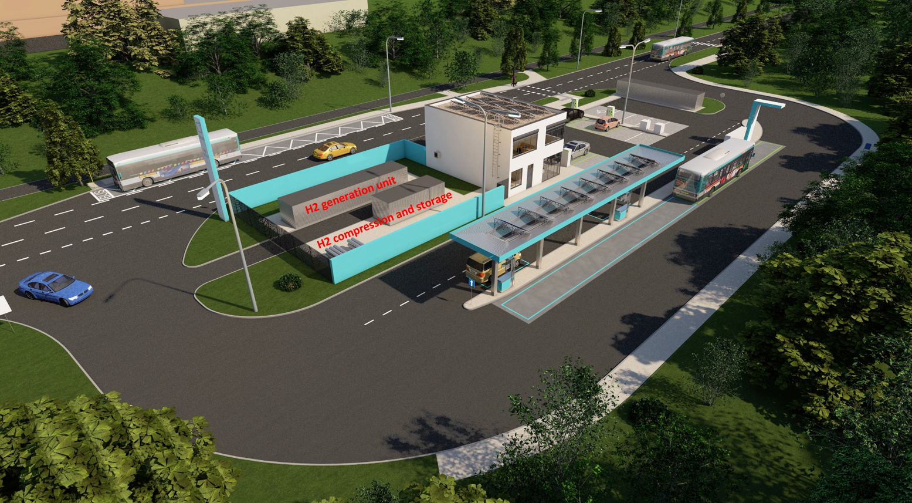
Figure 2: Visualisation of the fuelling station in Ostrava, Czech Republic
  - Results and discussion
The overall scheme of the H₂ fuelling station is highlighted on Figure 3. Hydrogen production and storage technology is designed for the production of hydrogen by electrolysis of water. The technology is located in two shipping containers and consists of pre-treatment of drinking water, a hydrogen generator, hydrogen purifier and related technology for its storage in a compressed state. Based on the overall scheme the following elements of a hydrogen fuelling station shall be considered potential hazard sources:
- on-site hydrogen production unit (PEM electrolyzer);
- hydrogen delivery system;
- compressors;
- storage;
- piping connections (non-welded);
- dispensers.
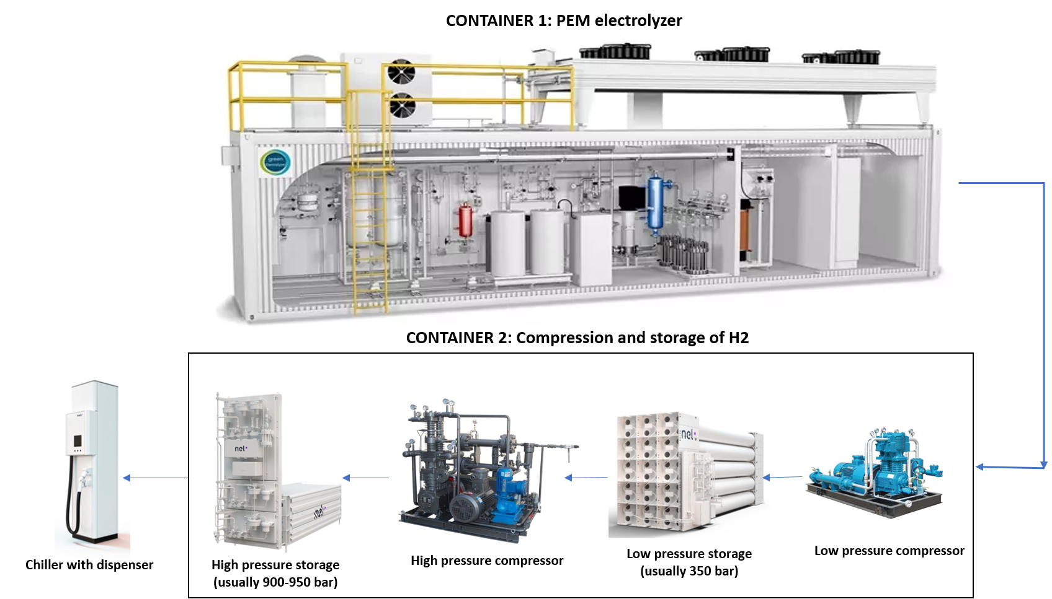
Figure 3: Scheme of the fuelling station in Ostrava, Czech Republic
The risk assessment should demonstrate that the mitigation measures applied are appropriate to achieve the required level of risk of the station. Hydrogen safety, much like all flammable gas safety, relies on five key considerations:
- Recognize hazards and define mitigation measures;
- Ensure system integrity;
- Provide proper ventilation to prevent accumulation;
- Ensure that leaks are detected and isolated;
- Train personnel.
Physical modelling (Sakamoto et al., 2019) can contribute to risk identification and consequence analysis in Figure 4.

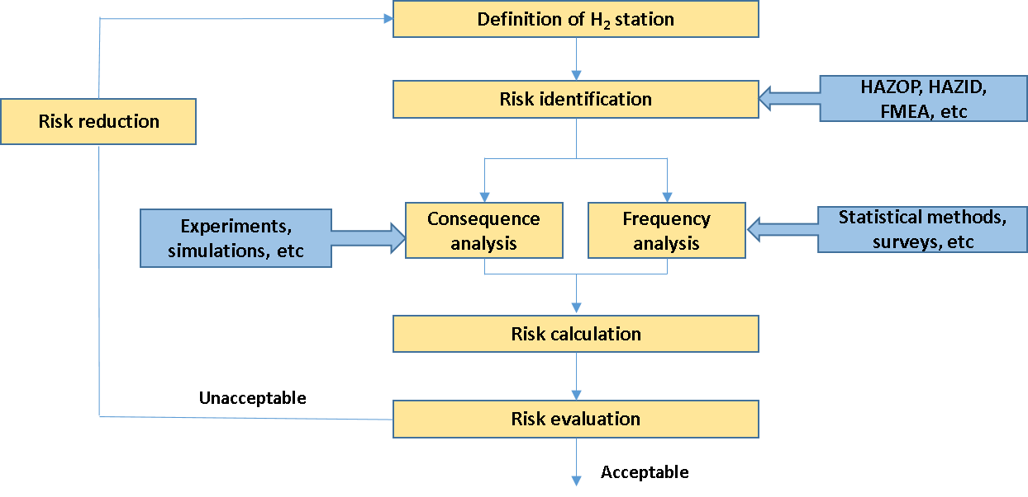
Figure 4: Risk assessment scheme for hydrogen fueling station

The choice of a suitable method for the safety study is one of the most important factors that affect the quality of the safety study. In practice, a large number of methods are used in various variants, but mostly based on only a few of the best known and most recognized methods (Table 2), from which they do not differ fundamentally.
Table 2: Overview of the most used partial methods for risk identification
Method | Abbreviation
Relative Ranking | RR
Safety Review | SR
Checklist Analysis | CL
Preliminary Hazard Analysis | PHA
What-If Analysis | WI
What-If / Checklist Analysis | WI/CL
Hazard and Operability Analysis | HAZOP
Failure Modes and Effects Analysis | FMEA
Fault Tree Analysis | FTA
Event Tree Analysis | ETA
Cause - Consequence Analysis | CCA
Human Reliability Analysis | HRA

To identify all possible hazards and possible ways of mitigation a hazard and operability study (HAZOP) was carried out. A complete HAZOP analysis needs a detailed process diagram, and with the process flow diagram a simplified HAZOP analysis was carried out to the best of our knowledge about the process and based on the historical incident record related to hydrogen refuelling stations (h2tools.org). This HAZOP analysis is presented in Table 3.
Table 3: List of possible hazards of the H₂ station
FAILURE MODE | SOURCE OF FAILURE | EFFECT | SEVERITY (1-10) | PROBABILITY OF OCCURRENCE (1-10)
Fire and explosion | Ignition in the vicinity of H2 and O2 mixture | Equipment damage and possible injuries | 10 | 2
Hydrogen leak in piping | Mechanical failure/improper joints and fittings | Potential fire and  explosion | 7 | 3
Hydrogen leak in electrolyser | Overpressure causing rupture of membrane | Potential fire and explosion | 8 | 3
Hydrogen leak in storage tank | Mechanical failure/improper joints and fittings | Potential fire and explosion | 8 | 3
Compressor failure | Equipment failure, worn out seals | Potential H2 leaks | 5 | 6
Hose pressure rating verification error | Human error | Overpressure in vehicle tank, potential H2 leaks | 6 | 3
Leak at breakaway fitting | Equipment failure at dispenser | Potential fire | 7 | 2
Improper fill speed at fuel dispenser | Failure to follow standard operating procedures, deficiency in procedures, software failure | Overheating on receiving fuel tank | 5 | 4
Incorrect check valve installation | Human error, inadequate inspections | Property damage | 7 | 2
Vehicle crashing into refuelling system | External factor | Property damage and injuries | 7 | 2

  - Conclusions
The H₂ fuelling station scenario representing significant hazards and risks. Common for all concepts are releases of hydrogen from high pressures leading to large hazard distances, and hydrogen releases in confined areas leading to risk of explosions. This is a challenge, especially in densely populated and crowded areas. Due to lack of experience and specific data, further research is needed focusing on hydrogen hazards and development of safe systems.
The following text describes the scenarios of unacceptable risks, including a discussion of their possible minimization.

Compressor unit
One of the main risks associated with a hydrogen compressor is the possibility of air (oxygen) being sucked in at its inlet part. This risk would lead to internal burn or explosion and consequent material damage to the equipment. For this reason, hydrogen compressors are specially designed to prevent air intake (in combination with temperature and pressure sensors), which significantly reduces this risk. The second risk in the case of a compressor is a hydrogen leak. To reduce this risk special high-pressure (metal) seals are used.

Hydrogen leakage from a high-pressure storage
The high pressure in the storage tank, including all piping, is a source of significantly higher amounts of hydrogen leakage compared with low pressure systems. Even in cases where the leak occurs in outdoor open spaces and the conditions for its dispersion are good, a cloud of flammable gas can be formed. The reason is that the forces associated with gas leakage are significantly higher than the buoyancy forces allowing free dispersion. The direction of a possible leakage also plays an important role in the formation of a flammable gas cloud.

Hydrogen leakage from a high-pressure source in enclosed spaces
In the case of high-pressure hydrogen leakage in an enclosed space (compressor container), the flow and low density of hydrogen will significantly affect its dispersion. In the first phase, hydrogen is trapped in the interior of the container and, due to obstacles (walls, ceiling or floor), the force of its flow is directed and reduced. In all cases, the containers must be equipped with ventilation, which have the task of preventing the accumulation of hydrogen. In some cases, the spaces can be internally adapted to possibly direct the flow of hydrogen and prevent its accumulation, eg under the ceiling. From a safety point of view, it is essential to prevent the accumulation of large amounts of flammable gas inside the container. For this reason, gas detection systems combined with automatic ventilation are used.

Hydrogen leakage into the atmosphere from safety valves
From time to time, hydrogen can be released into the atmosphere through safety valves, which are designed to prevent uncontrolled pressure rise, or serve for controlled depressurization of piping systems in the event of maintenance or service of the equipment. In these cases, a relatively large amount of hydrogen can be released with respect to the pressure level of the pipe. Although due to the high flow velocities, the flammable cloud of hydrogen can reach several meters, but there are a number of mitigation steps to minimize the risk. All operating and safety valves are usually led to the pipeline (exhaust chimney), which is usually designed and constructed with the possibility of possible controlled combustion of the mixture or inertized to prevent combustion.

Risks during vehicle fuelling
Hydrogen leakage can pose a significant risk during vehicle filling. The risk minimization measures used are can be the following: usage of certified components; regular inspections and revisions of all parts of the station; system of detection of sudden pressure drop due to leakage in combination with automatic shutdown of the hydrogen source; design and construction of the dispenser.

From the point of view of improving the safety management system, attention needs to be paid to the systematic raising of employees' awareness of risk sources and the training of emergency scenarios. In terms of ensuring effective intervention in the event of an accident, conduct tactical exercises for the integrated rescue system.
References
Eunjung K., Jaedeuk P., Jae H.C., Il M. Simulation of hydrogen leak and explosion for the safety design of hydrogen fueling station in Korea, International Journal of Hydrogen Energy 38, 2013.
Al-Shanini A., Arshad A., Faisal K. Accident modelling and analysis in process industries, Journal of Loss Prevention in the Process Industries 32, 2014.
Sakamoto J., Misono H., Nakayama J., Kasai, N., Shibutani T., Miyake A. Evaluation of Safety Measures of a Hydrogen Fueling Station Using Physical Modeling, Sustainability 11, 2019.
Kikukawa S., Mitsuhashi H., Miyake A. Risk assessment for liquid hydrogen fueling stations, International Journal of Hydrogen Energy 34, 2009.
ISO 19880-1: Gaseous Hydrogen-Fuelling stations, 2020.

