CHEMICAL ENGINEERING TRANSACTIONS  VOL. | A publication of
The Italian Association
of Chemical Engineering
Online at www.cetjournal.it
Guest Editors:
Copyright © AIDIC Servizi S.r.l.
ISBN 978-88-95608-xx-x ISSN 2283-9216

Routine Monitoring of Trace Arsenic in Water by
Lab-on-a-chip Technology: a Preliminary Study
Monica Periolatto*ª, Giulia Mossottiª, Felice Cataniaª, Andrea Piscitelli^{b}, Luciano Scaltritoª and Sergio Ferreroª
ªPolitecnico di Torino, C.so Duca degli Abruzzi, 24 10129 Torino - Italia
^{b}Microla Optoelectronics, via Gozzano, 34 10134 Chivasso (TO) - Italia
monica.periolatto@polito.it
Water contamination by Arsenic poses a serious risk for human health, due to its manifold toxic effects. The concern is mainly for drinking water, regarded as the most imperative route of Arsenic exposure to human beings. The maximum concentration limit for Arsenic in drinking water was fixed by World Health Organisation (WHO) at 10 μg L⁻¹ but in many developing nations it is increased to 50 μg L⁻¹ due to economic constraints to detect lower concentrations.
In this scenario, the design of an affordable Arsenic sensor, for routine monitoring of water, is crucial. The answer to these requirements can be the lab-on–a-chip technology applied to a microfluidic device.
Available detection methods for Arsenic are investigated, focusing on their potential application on a portable monitoring device: among them a colorimetric method, based on Rodamine B as indicator, and chronopotentiometry were selected as suitable for the required purpose. Preliminary laboratory tests were aimed to determine the limit of Arsenic concentration detectable by both the methods; the lower value of 1 μg L⁻¹ was detected by chronopotentiometry, in good agreement with the required resolution of the measurement. Moreover, a process optimization adapted the method for the microfluidic technology.
Obtained results point out the new developing lab-on-a-chip technology as good candidate to address the need for a capillary and frequent monitoring of Arsenic contamination of water by an easy and cheap portable device.
  - Introduction
The contamination of drinking water by Arsenic is a widespread problem all over the world, particularly felt but not limited to less developed areas, such as Southeast Asia or South America. Although arsenic is widespread in nature, it is a semimetal with high toxicity even at low concentrations.
Detection devices, today commercialized, are limited to the measurement phase, burdening the operator of the previous sample treatment. The development of a threshold monitoring device, designed for real time detection of As dissolved in water, was the aim of this study. The focus was on the design of an autonomous system inspired to the latest innovative techniques in the field of the microfluidic analysis, based on Lab-on-Chip concept. Such a choice is due to the unique advantages in terms of reduction of sample and reagents volumes, energy budget and analysis times, besides a strong control due to frequent sampling and analysis.
The essential characteristics for monitoring devices are the speed of response and the possibility of analyzing the samples in real time. In particular, a proper sensor for As detection should be selective, sensitive, fast with reproducible results, portable, strong, with low environmental and health risks, of simple use and low cost.
Laboratory techniques used for arsenic analysis in water include: atomic spectroscopy, mass spectrometry, neutron activation analysis, electrophoresis, chromatography, potentiometry, and voltammetry. These methods have a detection limit for arsenic in the order of 1 ppb and ensure accuracy and good reproducibility, but high costs for instruments, maintenance, consumables and professional training of technicians are required, making them not suitable for online monitoring. Also, methods based on Gutzeit reaction are avoided, since they imply the production of Arsine as intermediate. Arsine is a flammable gas highly toxic and dangerous, that entails serious risks for the health of operators and for the environment. The whole system should be confined to a closed and aspirated environment, to avoid any loss in the air. Electrophoresis and anodic stripping voltammetry are affected by other pollutants and not selective, moreover they require the frequent replacement of expensive components during maintenance. (Melamed, 2004)
Among all, colorimetry and chronopotentiometry are selected as suitable for the purpose and investigated by preliminary laboratory test.
  - Experimental results
    - Colorimetric evaluation by Rhodamine B
Colorimetry is particularly suitable for portable arsenic monitoring due to a very simple detection system. As with traditional field kits, detection can be done by the human eye or, in a more sophisticated way, with digital imaging. An advantage of colorimetry over other portable methods is that several digital detection devices are already easily transportable; for example, a camera, a UV - Vis spectrometer or even a smartphone can be used as digital detectors.
Considering the methods that do not involve arsine development, there are several reagents that confer a color variation in contact with arsenic compounds under suitable conditions.
Among others, the Rhodamine B method is worthy of note. The method is based on the discoloration of Rhodamine B, with chemical formula C₂₈H₃₁ClN₂O₃ (Figure 1a), due to the iodine produced by KI and As (III) in an acidic environment. The procedure is simple: the sample is acidified and added with a KI solution; Rhodamine B is then added, and the colour is expected to develop, finally the absorbance against distilled water at λ= 553nm is read. The measurement is carried out at room T, neutral pH and the solution remains stable for 24h, reproducible for 7 days with a SD = 1.76%. Moreover, the method is not affected by interference.
Rhodamine B (Merck) and a high-purity quality As standard for ICP-MS 1ppm (Sigma Aldrich) were used for the preliminary laboratory test. Calibration solutions with As concentration between 0 and 1ppm were prepared by proper dilution of the standard.
b)
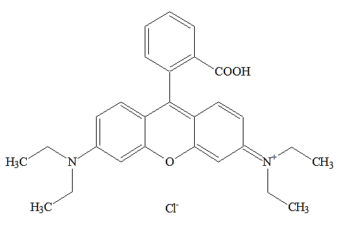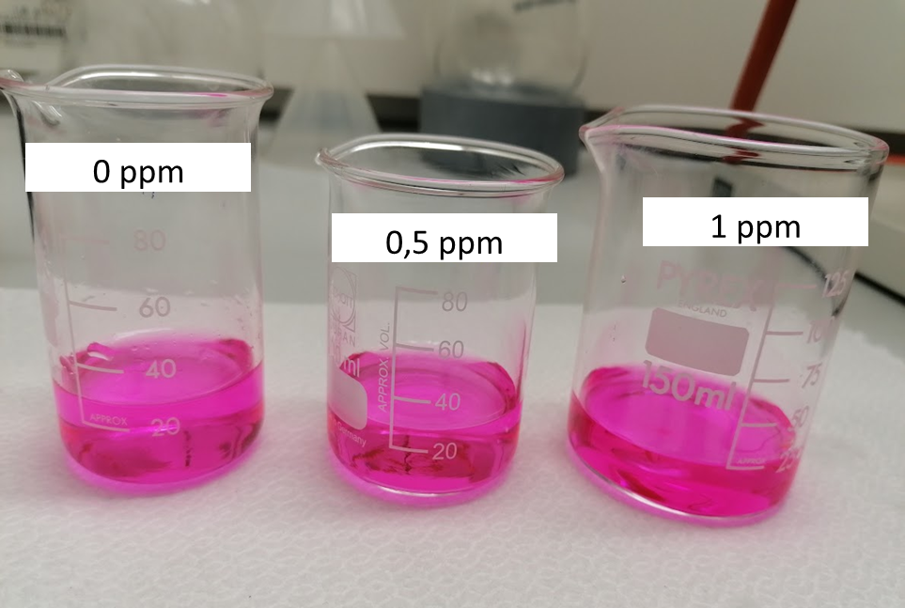
a)

Figure 1: a) Rhodamine B chemical structure; b) Rhodamine B solutions, in presence and absence of As.
a)
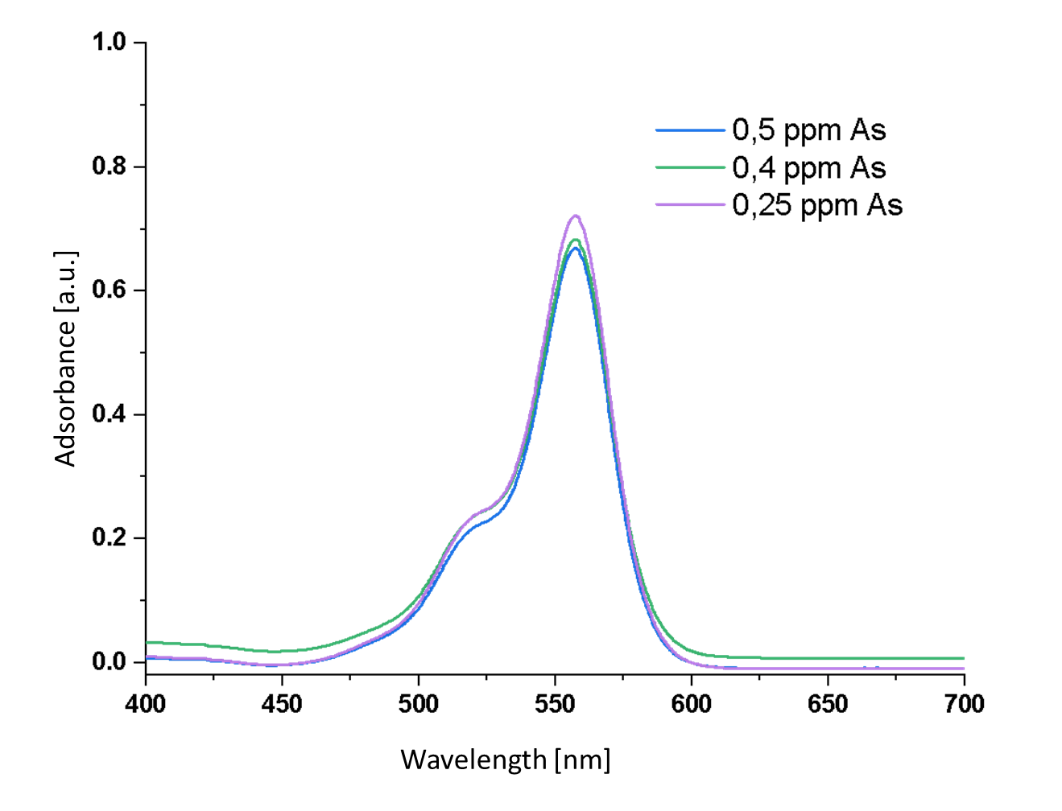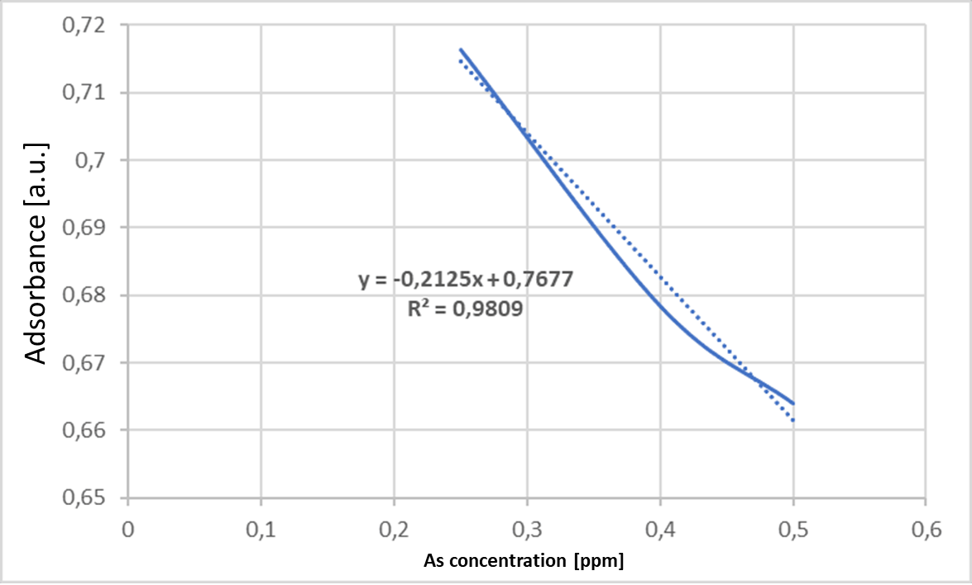
b)
Figure 2: a) Spectra of Rhodamine solutions with different As concentrations and b) Calibration curve (λ = 553 nm) for Rhodamine B method
Each sample for the calibration curve were added with 1 mL of HCl 0.4M and 2 mL of a 2%wt KI water solution; the as prepared samples were mixed and, after a rest period of few minutes to develop the final purple colour, these were spectrophotometrically analysed by a 6850 spectrophotometer (Janway). Optical glass cuvettes with an optical path of 10 mm were used while distilled water was assumed as reference. The maximum absorbance peak at 553 nm was considered for the calibration curve.
The colour attenuation of the Rhodamine B solution, due to the As presence, is not visible to the naked eye (Figure 1b). The difference is revealed by spectrophotometric analysis of the solutions, by the decrease of the adsorbance referred to the peak at 553nm. There is a good linear correlation between the adsorbance and the As concentration, as confirmed by the R² value near to 1; unfortunately, if the amount of As in the sample is too low, the decolouration of the Rhodamine solution is not appreciable neither by spectrophotometry. The testing conditions allowed to appreciate As concentrations till about 250ppb; probably this limit can be decreased working with diluted Rhodamine B solutions or decreasing the optical path, but it seems hard reaching the low As concentrations required for an efficient water monitoring. (Manachino et al., 2020) Moreover, further test showed a strong dependence of the measurement by chemical and physical parameters of the sample, such as pH or Temperature, needing a strict control of them to avoid measurement deviations. For these reasons, the Rhodamine B colorimetric method is not further considered for the proposed purpose.
Literature refers to other indicators, alternative to Rhodamine B, which however have limitations: the use of Variamine Blue further raises the detection limits to 0.2-14 ppm; ethyl violet or methylene blue, used in presence of an anionic surfactant and gold or silver particles, instead give scattering phenomena, which invalidate the goodness of the measurement. Molybdenum blue provides a simple method with good detection levels; however phosphates and silicates compete with arsenic to react with molybdenum. Since the phosphate and silicate levels in natural waters are typically much higher than the amount of arsenic present, they must be removed from the sample prior to analysis, with separation methods such as ion exchange resins or pervaporation, which require time, cost and must be conducted in a laboratory. In conclusion, spectrophotometry was definitively abandoned.
    - Chronopotentiometry
The chronopotentiometric method is similar in principle to the ASV voltammetry, with numerous advantages compared to this, which make it a much more suitable method for continuous analysis or to be carried out frequently, even outside the controlled laboratory environment.
This method is part of the electrochemical detection methods, which are of interest as they are able to measure the concentration of an analyte in solution regardless of the size of the measured sample. In electrochemistry, smaller samples allow for more accurate determinations due to a higher surface-to-volume ratio of the electrochemical probe and less interference from other species in solution. They are therefore particularly useful when the analyte concentrations can also be very low, of the order of ppb.
The measurement method is based on the principle of chronopotentiometric/coulometric stripping.
There is a gold sensor in the measuring cell; the sample to be analysed is suitably mixed with a dilute acid solution and pumped into the cell. The cathodic deposition of the As then takes place on the gold electrode, according to the reduction reactions:

As(V) + 5 e⁻ → As_{s}

As(III) + 3 e⁻ → As_{s}

Subsequently, the anodic stripping of the deposited analyte takes place, and the stripping time is measured, which will be directly proportional to the amount of analyte collected from the sample. The reactions involved are this time oxidations, bringing the As back into solution.
The quantity of analyte and the stripping time are related through the Faraday's law. In fact, the amount of As deposited on the sensor will require a proportional amount of charge, to be brought back into solution; but the quantity of charge, with the same intensity of current, is directly proportional to the passage time, therefore the time is also proportional to the stripped quantity.
The signal is evaluated according to the well-known Faraday’s law:
$$c= \frac{Q_{strip}}{R∙z∙F∙V_{sample}}$$ | (1)
Where:

c = As concentration
Q = electrical charge for stripping
R = electrochemical recovery
Z = number of charged involved in the stripping process
F = Faraday’s constant
V = sample volume

But it is also:

$$Q_{strip}= I_{strip}∙τ$$ | (2)

Where:

I = stripping current (constant)
τ = stripping time
R = 1 for complete stripping, so:

$$c= \frac{I_{strip}∙τ}{z∙F∙V_{sample}}$$ | (3)

By plotting the potential as a function of time, a curve is obtained showing a flexion corresponding to the stripping; deriving this curve, a peak proportional to the concentration of Arsenic in the sample is obtained, both considering the height of the peak or the underlying area. By a calibration line, built analyzing samples of known concentration, it will therefore be possible to uniquely determine the concentration of As in unknown samples.
Calibration solutions with concentrations ranging 0-50ppb were prepared by proper dilution of the standard 1ppm As solution (Sigma Aldrich).
A 40 mL volume of the as prepared samples are mixed with 10 mL of the reagent solution, consisting of a 3% vol. Hydrochloric acid solution; few drops of potassium permanganate KMnO₄ 0.01M solution in water are also added, acting as an oxidant to transform all As (III) present in solution into As (V). This ensures the detection of all the As present in the sample, in all its forms.
The solution thus prepared is pumped into the measuring cell; a minimum volume of approximately 5 mL is required for each measurement. Results of more repetitions on the same sample can be averaged to provide the final result. The golden sensor, suitable for nominal As concentrations 0-50ppb, was purchased by ISTRAN (Slovakia).
The electrochemical cell (Figure 3) is composed of two types of electrodes. The first is a polarizable working electrode, immersed in the analyte solution; the second one is a non-polarizable reference electrode, associated with the analyzed solution salt bridge. The circuit diagram of this circuit can be seen in Figure 3A.
Electrodes whose potential is strongly influenced by the passing current, they are polarizable; those whose potential depends little on the magnitude of the current flowing, they are non-polarizable.
The dependence of the electric current flowing through the cell on the potential of the working electrode, which changes linearly with time, is monitored. The working electrode potential is controlled from an external source. If there is no substance in the solution, which would be reduced or oxidized, the working electrode is polarized and no current flows through it. If there is a substance in solution that oxidizes or reduces at a certain potential, depolarization occurs on the electrode and current flows through it. In the case, As is the substance that cause electrode depolarization, and the magnitude of the corresponding anodic or cathodic current is a measure of its concentration on the sample.
Preliminary laboratory test on the sensor were aimed to verify the calibration process, the influence of process parameters, that is HCl solution and KMnO₄ solution, the repeatability and the accuracy of the measurements and the measurable concentration limits. Analysis were performed on samples with known As concentrations to assess the linearity of the results, to provide a useful calibration curve.
The first check on the sensor concerned the stability of the measurement. On each sample the measurement was repeated four times, recording the current intensity values provided by the sensor and evaluating the mean, absolute and relative error and standard deviation. Measurements were carried out both in presence and absence of permanganate. The tests were repeated on several samples at different As concentrations, ranging from 0 to 40ppb.
The measurements of each set, on the different samples, were highly coherent, with values ​​close to each other. The calculated percentage errors vary between 0 and 1.95%, with the largest error corresponding to the lowest concentration. In absolute terms, the error never rises above 0.6ppb, a value well below the required detection limit. The presence of the hydrochloric acid solution was essential; in its absence, in fact, the sensor does not detect anything as the conditions do not allow the electrochemical process of deposition on the sensor to take place. However, the method works even in the absence of the permanganate solution.
In the tests carried out with solutions of different concentrations, prepared by dilution starting from a 1ppm standard, concentration values ​​are obtained which are consistent with each other, both in the presence and in the absence of the salt. However, it appears that the measurement method must be the same as that used for the calibration of the instrument. Since an As (V) standard was used in the tests, the effect of permanganate is not relevant, as there is no As (III) to oxidize or, in any case, it is present in a minimal amount. In the presence of real samples, however As (III) may not be negligible, therefore it is decided to keep the addition of a few drops of salt solution, to be sure to detect all the As present, in all its states of oxidation. The amount of permanganate solution to be added can vary from one to several drops (0.02ml/drop) as long as the same quantity is also used for the calibration test. Furthermore, the measurement is not affected even if samples of different concentrations are measured consecutively, indicating that there is no contamination or residue of the previous sample that remains in contact with the next sample.
The next test plans to acquire the chronopotentiometric curves for As solutions with increasing concentrations, namely 0 – 10 – 20 - 25 – 40 ppb. The curves are reported in figure 4: the values on the abscissas, in mV, are proportional to the voltage, while those on the ordinates are proportional to the current difference, in µA. Each line of the graph represents a different concentration of arsenic expressed in ppb; the two vertical dotted lines separate the areas related to the charging and discharging process of the electrodes, not to be considered for processing. The data obtained further confirm the linearity of the results, both considering the value corresponding to the peak of the curve (Figure 5a), or considering the area subtended by the peak (Figure 5b). In both cases the linearity is confirmed, with R2 values greater than 0.99. Further tests were carried out on samples with lower As concentrations, till 1ppb, and the data were again in good agreement with the calibration curve, confirming the chronopotentiometry a good candidate for application on the lab-on-a-chip device.
A final test was carried out on a real water sample, picked up by an As polluted site in Cuneo (Italy). The sample was previously analyzed by ICP-MS, finding an As concentration of 9ppb, and then analyzed by chronopotentiometry obtaining, by the average of 5 measurements, 9.22ppb, in perfect agreement with ICP.

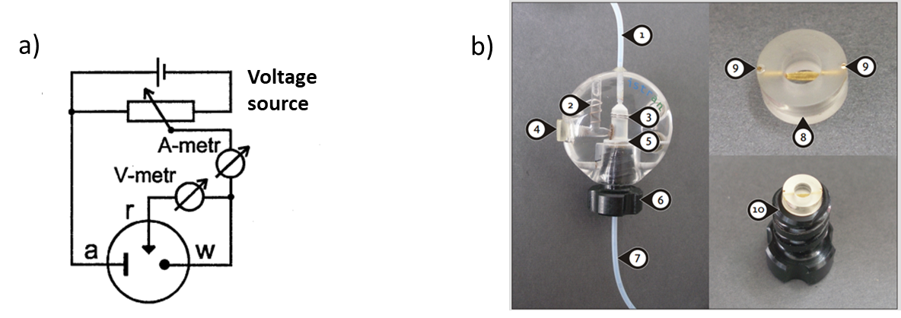
Figure 3: a) electrochemical cell arrangement (a-auxiliary electrode, r-reference electrode, w-working electrode) b) Measuring cell and electrode. 1 Drain, 2 Reference electrode, 3 Auxiliary electrode, 4 Reference solution, 5-8 Measuring electrode, 6-10 sealing screw, 7 Sample load, 9 Gold contacts.
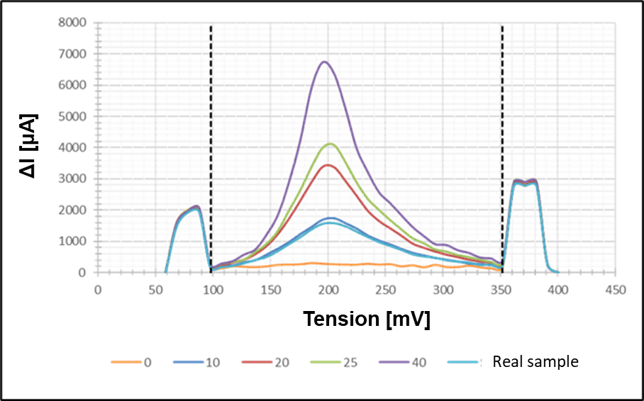
Figure 4: chronopotentiometry curves for samples with increasing As concentration [ppb].
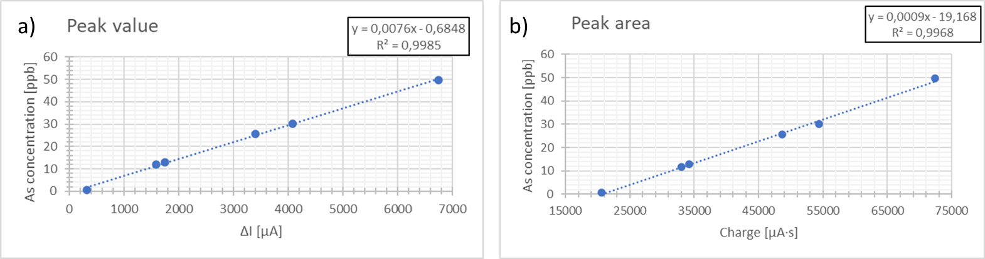
Figure 5: chronopotentiometry curves for samples with increasing As concentration [ppb].
  - Conclusions
The WHO and European Union guidelines point out three threshold values ​​for the admissible concentration of arsenic in water: the most stringent limit is 10ppb, a value that is however provisional as more exhaustive data on the effects of lower concentrations are not available; a derogation from the WHO limit was granted by EU, setting the threshold value at 20ppb; finally in the less developed areas of the world, where the presence of arsenic is very significant and it is difficult to manage timely and continuous monitoring, the limit has been set at 50ppb.
The characteristics that a sensor must have to be effective in detecting arsenic in water are evident by literature references: it should be sensitive, selective, fast, reliable, robust, safe, low cost and easy to implement, portable and automated.
Among the many methods reported in the literature, many of which are used in normal laboratory practice, those that are considered most suitable for the purpose are the spectrophotometric method with Rhodamine B and the chronopotentiometric method.
The choice was guided by several factors: avoiding the development of arsine, a toxic and lethal gas; the results are not affected by interference from other species present in the sample; the systems are robust and miniaturizable, which can be integrated into a portable device. Furthermore, microfluidics seems to be easily applied to miniaturization, also exploiting the skills acquired by the research group in previous studies on spectrophotometric detection, online and in situ, of heavy metals in water.
Both the methods were preliminary tested in laboratory, to assess the detection limits and the reliability of the measurements. Obtained results show the limits of the colorimetric method: the color attenuation due to arsenic presence in the Rhodamine B solution is not enough to be revealed by the spectrophotometer if the metal concentration is lower than 200ppb. Moreover, the process requires a stringent control of chemical and physical parameters, such as sample pH or temperature, affecting the final result. Colorimetry is therefore set aside as not suitable for the required purpose.
On the other hand, the laboratory experimentation on the Arsenic sensor in water, based on the chronopotentiometric method, provided consistent and repeatable data. An appropriate calibration line, built according the measurement process, allows for a high measurement accuracy in the 0-50ppb As concentration range. Moreover, the sensitivity of the sensor allows to detect even minimal concentrations of As in the sample, at least up to 1 ppb.
The results determine that the method is therefore a good and promising candidate for the required application, and can be implemented in a portable device based on microfluidic technology.
Acknowledgments
This research was supported by ACDA – Azienda Cuneese dell’Acqua, funding the TRACQUA “Trattamento Analisi Controllo Qualità Acqua” project.
References
Manachino M, Periolatto M, Catania F, Scaltrito L, Ferrero S, Pirri F, 2020, Miniaturization and Optimization of the Standard Spectrophotometric Analysis for Autonomous, Continuous and On-site Heavy Metal Detection in Water, Chemical Engineering Transactions, 83 ISBN978-88-95608-81-5;ISSN 2283-9216
Melamed D., 2004, Monitoring Arsenic in the Environment: A Review of Science and Technologies for Field Measurements and Sensors, NSCEP Publishing, Washington USA.
World Health Organization WHO, 2010, Arsenic in drinking water, Fact Sheet N.210.

