CHEMICAL ENGINEERING TRANSACTIONS  VOL. 91, 2022 | A publication of
The Italian Association
of Chemical Engineering
Online at www.cetjournal.it

Guest Editors: Valerio Cozzani, Bruno Fabiano, Genserik Reniers
Copyright © 2022, AIDIC Servizi S.r.l.
ISBN 978-88-95608-89-1; ISSN 2283-9216

Evaluating the influence of the leak Reynolds numbers on the behavior of underwater gas plumes: a CFD study
Maria Fernanda Oliveira*, Sávio S. V. Vianna
University of Campinas, School of Chemical Engineering, Albert Einstein Avenue, 500, 13083-852, Campinas, São Paulo, Brazil
*m103362@dac.unicamp.br
Accidental subsea releases are a matter of concern in the oil and gas industry. It may halt the production and lead to a flammable gas cloud on the sea surface close to the spider-deck of oil rigs. The ignition of the flammable cloud is not desirable. The proper prediction of flammable gas volumes from subsea releases is of paramount importance to reduce the level of risk. It also helps the elaboration of emergency plans. The use of Computational Fluid Dynamics (CFD) is proved to be an efficient, safe, and relatively low-cost tool applied to analyze the gas plume dynamics underwater. Motivated by the scenario of real accidental subsea gas releases, this work studied the behavior of submerged gas plumes in a 9 m x 7 m 2D computational domain representing a water tank. The case setup, which was validated against experimental data in previous works, considered the Eulerian-Eulerian approach with the Volume of Fluid (VOF) multiphase model. The study simulated different leak sizes and leak rates, aiming to evaluate if there was a relation between the Reynolds numbers and the geometrical features of the resultant plume, such as rising time, fountain height at the rising time, fountain heights after 15 s of the release and horizontal dispersion distance. For all the plume parameters there was a relationship between their behavior and the leak Reynolds number, and, especially for rising time, and fountain heights, this relation showed independence from the leak size. This indicates that, at least for the considered size of the water column, the Reynolds number of the can be the main parameter considered when determining these plume properties at the surface. This study is valuable to support the development of mitigating measures in the case of an accidental gas release underwater.
  - Introduction
In current times, the oil and gas industry is still essential for the maintenance of most activities necessary for human survival. However, an industry of such importance as this can be responsible for disasters of the same proportions. The most known example is the Macondo Well Blowout Disaster, in 2010. It was the largest offshore oil spill in the world’s history, which resulted in 11 fatalities and countless environmental impacts (Olsen and Skjetne 2016a; Sun et al. 2020). Although the ideal scenario is to prevent such accidents from occurring, it is often only possible to mitigate the effects caused by them. In the case of gas leaks, when they reach the surface, the main effects are the loss of stability in the buoyancy of structures, the toxicity of the gas to living beings, and the risk of the gas igniting, possibly even exploding (Cloete et al. 2009; Xinhong et al. 2018). Mitigating an incident requires, first, knowing its characteristics, and then devising a quick and effective action plan. For subsea gas releases, some of the characteristics that are important to know are the size of the plume on the surface, and the elevation of the fountain in the center of the plume.
The study of subsea gas releases can be accomplished in different approaches. Leaks that have already occurred can be studied, which provides extremely realistic data, but in limited quantity. Additionally, most of the time, it is not possible to collect such information. The experimental approach is effective for obtaining data, but it has scale, among other limited experimental parameters (Li et al. 2019; Xinhong et al. 2018). Integral methods have been used for some time, but they demonstrate to be unsatisfactory in modeling the liquid-gas interface, which would be very important in studying this type of leakage phenomenon (Cloete et al. 2009). In this context, the Computational Fluid Dynamics (CFD) methodology stands out for being able to perform numerical experiments in dimensions and conditions that the purely experimental approach cannot. Thus, they provide data on the flow of gases in liquid media so that it becomes possible to carry out an analysis aiming at predicting the properties of the plume (Pan et al. 2014; Sun et al. 2020).
Different CFD approaches have already been evaluated in describing the rising bubble plume. They are divided into Eulerian-Lagrangian, Eulerian-Eulerian, and combined Eulerian-Lagrangian and Eulerian-Eulerian methods (Olsen and Skjene 2020; Olsen et al. 2017). Each methodology offers its advantages and disadvantages, and the choice of which path to follow should depend on which aspects of the study one wishes to prioritize. The Eulerian-Eulerian approach, in particular the Volume of Fluid (VOF) method, requires higher computational power but is capable to provide extremely reliable results in a wide range of leak flows if compared to the simulations with Lagrangian approaches describing the gas phase (Olsen and Skjetne 2016b; Wu et al. 2017).
The purpose of this paper was to investigate if there was a relation between the leak Reynolds number and the behavior of plume parameters such as air rising time, fountain heights, and horizontal dispersion. To achieve this, through controlled numerical experiments low computational cost VOF two-phase simulations were completed to generate the data that would be analyzed. The obtained information in this study can influence other investigations aiming at the elaboration of emergency response plans when an accidental subsea gas release happens.
  - Methodology
    - Geometry and mesh
The simulations described in this work are based on the experimental work of Engebretsen et al. (1997) and the computational work of Cloete et al. (2009). The geometries used were the 2D representation of water tanks. Choosing a 2D setup allowed the simulations to be run much faster and without losing the reliability of their results. All the three tanks were 9 m base and 12 m high, of which the lower 7 m were filled with water, and the remaining part was filled with air. At a height of 0.33 m above the center of the tank base, there was the air inlet, which took on three different sizes: 0.34, 0.24, and 0.17 m, representing the diameters of the leaks in a 3D setup. The use of adaptive mesh was another choice made to reduce the computational cost of the simulation and, at the same time, allow the air-water interface calculations to be run in very refined cells. The default meshes were around 12000 cells for all three cases but were refined following the criteria of air volumetric fraction of 0.06 for refinement, and of 0.05 for coarsening. These criteria were evaluated every 10 iterations. The representation of the mesh for the geometry of 0.24 m leak size at two different moments is displayed in Figure 1. The other meshes have a structure similar to the presented one.

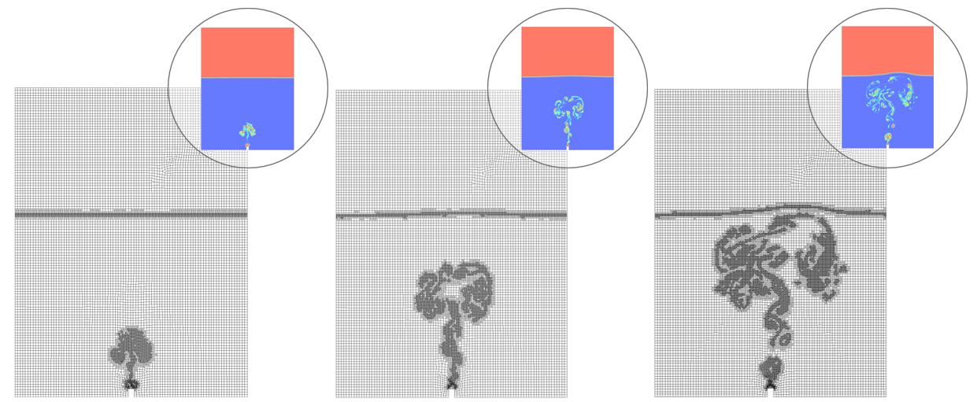
Figure 1: Meshes for the leak size of 0.24 m at different times
With the built geometries and meshes correctly representing the studied domains, the setup of the simulations was started according to the desired boundary conditions.
    - Setup and case study
The simulated cases followed an Eulerian-Eulerian setup which used the VOF approach. The methodology was previously validated using the experimental data from Engebretsen et al. (1997) and the simulated data from Cloete et al. (2009). Figure 2 brings the comparison between the rising times of three different plumes (a), and the fountain elevation at the rising time (b) and after 15 seconds of flow (c) for two different flow rates using data from two previous works. All cases were run in Ansys Fluent, version 20.2. The VOF was used with implicit formulation, and constant surface tension of 0.072 N/m between air and water was set. The turbulence model was the k-epsilon realizable.
At the center of the tank, a boundary condition of velocity inlet, with air volume fraction of 1 was defined. The choice of working with air as leaked fluid was made to reduce computational cost avoiding working with three substances (air, water, and methane) Since the analysis involves dimensionless numbers, it is expected that future works with other immiscible leaking gases will provide similar results. The velocities were calculated so the Reynolds numbers of the leak agreed with the 12 previously established values, which oscillated between 3205 and 38455. At the top of the domain, the Pressure Outlet condition was chosen, with 0 Pa of gauge pressure and 100 % of air in the backflow. All remaining boundaries were defined as walls with the default Fluent settings.
The simulations were transient and run for 15 seconds. The PISO scheme was selected for pressure-velocity coupling, and PRESTO! for pressure discretization. Second-order upwind equations were used for modeling all available continuity, momentum, and turbulence equations. Finally, each run took approximately 24 hours to run on a 128 GB RAM computer, with 24 cores. The results of the simulations are brought within the following section.

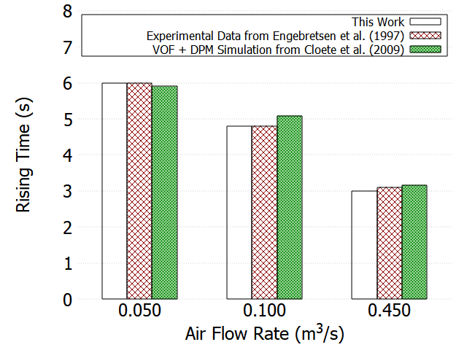 | 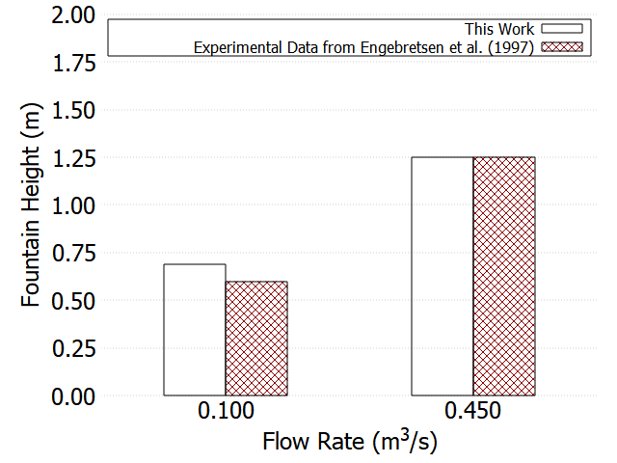
(a) | (b)
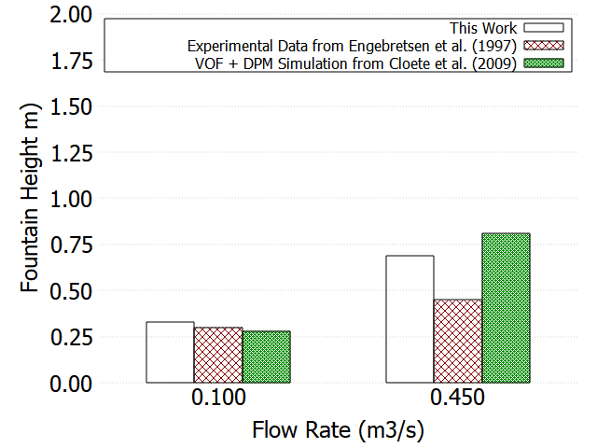
(c)
Figure 2: Rising times (a), fountain height at rising time (b) and fountain height at 15 s of flow (c) for different studies
  - Results
    - Gas volume fraction profiles
In this work, 36 transient simulations were performed. As an example of the resulting volume fraction profiles, Figure 3 displays the profile for the geometry of leak size of 0.17 m and Reynolds of 12818 at the rising time. It is possible to note the recirculation of the underwater gas. It happens due to drag forces between air and water and to the momentum transfer from vertical to horizontal. It is also possible to note the elevation of the rising fountain, which height was measured for all the simulations.
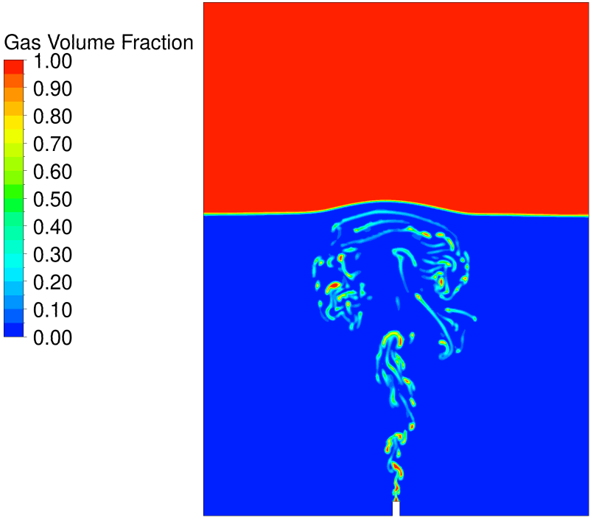
Figure 3: Example of volume fraction profile at the rising time
    - Rising times
The first measured flow parameter was the rising time of the air plume. The value considered was the time that the first air bubble took to reach the 7 m surface line. The precision of the computed value was 0.2 s. The data was taken for each initial leak size and boundary condition and organized as a function of the Reynolds number at the leak in Figure 4. The Figure shows that the data follows a logarithmic profile in which lower Reynolds numbers imply higher rising times, for the three sets of leak sizes evaluated. Also, the rising times for different flow rates and leak sizes, but same Reynolds numbers can be considered equivalent, indicating a strong relationship between the two variables. For lower Reynolds numbers, lower the turbulence and higher the interaction between the ascending air and the water, which increases the time to the air to reach the surface.

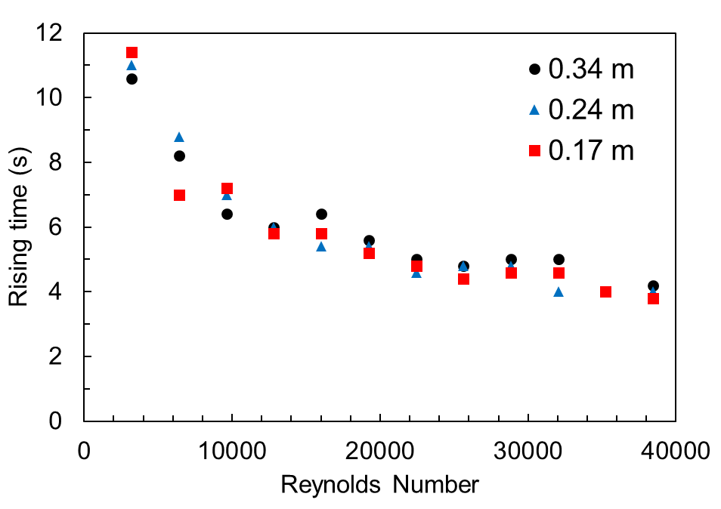
Figure 4: Rising time of the plume as function of the Reynolds number of the leak
    - Fountain heights
The initial fountain heights are the water elevation at the rise time of each case. Physically, they are probably only water splashes (Engebretsen et al. 1997), and their values have no representativity on the study of steady fountain heights. However, Figure 5 (a), presented below, brings an interesting relation between the leaks’ Reynolds number and the values of initial fountain heights. It shows that, like what happened with the rising times, the initial fountain heights are equivalent for the same leaks’ Reynolds number, irrespective of the leak size. This fact indicates that the initial amount of momentum and turbulence of the air jet underwater in fact dictates the behavior of the water plume, at least for small water depths. It is also possible to note that initially, the fountain height increases linearly with the Reynolds number. For values between 10000 and 25000, the height does not vary with the Reynolds, and between 25000 and 40000, the same behavior is observed. This formation of steps in the graph evidences some effects of interaction between the water, which is displaced by the plume, and the surface air.
The fountain heights were also measured after 15 s of flow according to the study methodology proposed by Engebretsen et al. (1997). However, some interactions between the plume and the tank walls were verified, especially for higher flow rates. Even so, the Reynolds number of the leak and the fountain heights indicated a noticeable relationship, as shown in Figure 5 (b). The Figure suggests a linear correlation between Reynolds number and fountain heights, within the analyzed range, regardless of the leakage size. The Reynolds number of the leak, along with the interactions between the plume and the water inside the tank is related to the quantity of momentum carried by the air when it reaches the surface. Therefore, higher amounts of vertical momentum can be associated with elevated fountain heights. Still, the concept of Reynolds number is associated with turbulence, which distributes the carried vertical momentum to the horizontal and determines the fountain height and its horizontal dispersion. In addition, the fountain is subjected to the action of surface tension and gravity forces. In this context, it makes sense that there is a critical Reynolds number from which the fountain reaches its maximum height and then stops to increase its value. This fact, however, was not verified for the studied Reynolds numbers but is expected for higher values.

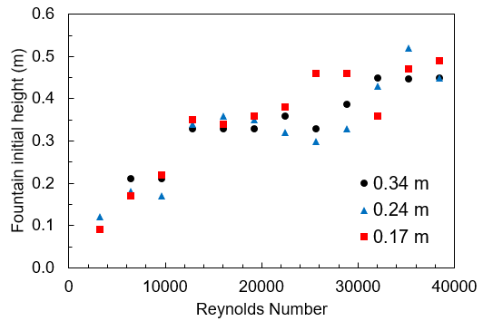 | 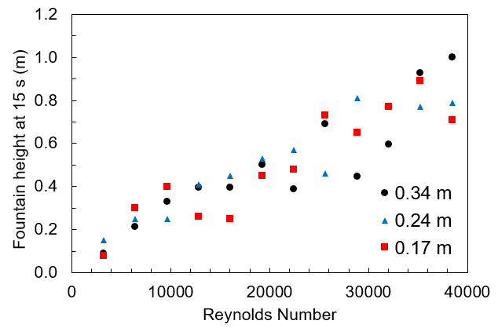
(a) | (b)
Figure 5: Fountain height at the rising time (a) and after 15 s of flow (b) for the Reynolds number of the leak
    - Horizontal dispersion distance of the plume
The horizontal spreading distances of the plumes were measured at the plume rising times to avoid that the interaction between the leaked air and the tank edges influenced the measured values. Figure summarizes the values of the dispersion distance at the air-water interface as a function of the leak Reynolds number for the three sets of points obtained when varying the leak size.
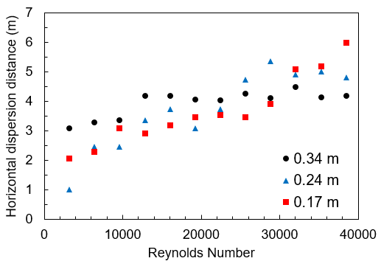
Figure 6: Horizontal dispersion distances for different leak sizes as function of the Reynolds number of the leak
It is possible to note that higher Reynolds numbers can be associated with higher values of the plume dispersion distance, following a nearly linear relationship for each set of points. However, for the leak sizes of 0,34 m and 0,24 m, there were critical Reynolds numbers of approximately 12800 and 29000, respectively, from which the values of horizontal dispersion remained practically constant. For smaller leak sizes, the critical Reynolds number was not reached, considering the evaluated range of Reynolds values. It is possible that if higher values of Reynolds were evaluated, the critical value could be determined. For each leak size separately, lower Reynolds numbers are associated with lower flow rates. The lower the flow rate, the longer the interaction of the leaked air with the forces of gravity and surface tension, which controls the growth of the water fountain. Regarding the general relationship between the Reynolds number of the leak and the width of the plume on the surface, regardless of the leak size, no observations were registered.
  - Conclusions
This work demonstrated that, at least for the considered water column size, the values of rising time and fountain heights, both for the case of initial height and for the case of height after 15 s, were independent of the leak size and revealed a relationship with the Reynolds number. This suggests that in future studies with simulations of underwater gas releases aiming to determine these parameters, the number of simulations can be reduced, saving computational cost. The study of the horizontal dispersion distance of the plume, on the other hand, has not shown a relationship with the Reynolds number independent of the leak size. However, it was possible to note that, the higher the Reynolds, the higher the horizontal distance and, for each leak size, there was a different critical Reynolds number, which indicated that the plume horizontal dispersion reached its limit value. The limit plume horizontal distance can be an important parameter to be investigated in future surveys. The forthcoming work will examine other conditions in which the discoveries of this study can be applied and try to determine if there is a critical water column size that limits the findings of this work. Moreover, it is expected in future studies the approximation between simulated conditions and real situations of gas releases, with consideration of compressibility effects, for higher water column depths, natural gas flowing instead of air, water currents acting over the computational domain, and temperature changes. This will allow the actual extrapolation of data obtained with CFD to real accident scenarios.
Acknowledgements
The authors would like to thank the Brazilian National Council for Scientific and Technological Development (CNPq) for the financial support.
References
Cloete S., Olsen J.E., Skjetne P., 2009, CFD Modeling of Plume and Free Surface Behavior Resulting from a Sub-Sea Gas Release, Applied Ocean Research, 31(3), 220–25.
Engebretsen T., Northug T., Sjoen K., Fannelop T.K., 1997, Surface Flow and Gas Dispersion from a Subsea Release of Natural Gas, Proceedings of the Seventh International Offshore and Polar Engineering Conference, 1, 566–73.
Li X., Chen G., Khan F., 2019, Analysis of Underwater Gas Release and Dispersion Behavior to Assess Subsea Safety Risk, Journal of Hazardous Materials, 367, 676–85.
Olsen J.E., Skjene P., 2020, Summarizing an Eulerian-Lagrangian Model for Subsea Gas Release and Comparing Release of CO2 with CH4, Applied Mathematical Modelling, 79, 672–84.
Olsen J.E., Skjetne P., 2016a., Current Understanding of Subsea Gas Release: A Review., The Canadian Journal of Chemical Engineering, 94(2), 209–19.
Olsen J.E., Skjetne P., 2016b, Modelling of Underwater Bubble Plumes and Gas Dissolution with an Eulerian-Lagrangian CFD Model, Applied Ocean Research, 59, 193–200.
Olsen J.E., Skjetne P., Johansen S.T., 2017, VLES Turbulence Model for an Eulerian–Lagrangian Modeling Concept for Bubble Plumes, Applied Mathematical Modelling, 44, 61–71.
Pan Q.Q., Olsen J.E, Johansen S.T., Reed M., Sætran L.R., 2014, CFD Study of Surface Flow and Gas Dispersion from a Subsea Gas Release, In 33rd International Conference on Offshore Mechanics and Arctic Engineering – OMAE, 2014-24707, 1-6.
Sun Y., Cao X., Liang F., Bian J., 2020, Investigation on Underwater Gas Leakage and Dispersion Behaviors Based on Coupled Eulerian-Lagrangian CFD Model, Process Safety and Environmental Protection, 136, 268–79.
Wu K., Cunningham S., Sivandran S., Green J., 2017, Modelling Subsea Gas Releases and Resulting Gas Plumes Using Computational Fluid Dynamics, Journal of Loss Prevention in the Process Industries, 49, 411–17.
Xinhong L., Chen G., Zhang R., Zhu H., Fu J., 2018, Simulation and Assessment of Underwater Gas Release and Dispersion from Subsea Gas Pipelines Leak, Process Safety and Environmental Protection, 119, 46–57.

