CHEMICAL ENGINEERING TRANSACTIONS  VOL. 91, 2022 | A publication of
The Italian Association
of Chemical Engineering
Online at www.cetjournal.it

Guest Editors: Valerio Cozzani, Bruno Fabiano, Genserik Reniers
Copyright © 2022, AIDIC Servizi S.r.l.
ISBN 978-88-95608-89-1; ISSN 2283-9216

Biomethane Production: Pressure Influence on Classification of Atex Zones
Roberto Lauriª
ªINAIL, Department of Technological Innovations and Safety of Plants, Products and Human Settlements, Via del Torraccio di Torrenova 7, 00133 Rome, Italy.
r.lauri@inail.it
The smart combination of renewable energy sources and technologies will be a fundamental tool for developing the energy systems of the future and achieving carbon-neutrality by 2050. Biomethane produced by biogas upgrading is a renewable alternative to natural gas and it is able to abate greenhouse gas emissions from transport, which represent 25% of the total emissions in European Union. This biofuel can be used in applications such as heating, transport and electric energy generation, since it has the same properties as natural gas. It can be directly injected into the existing gas network as a low-carbon alternative to natural gas, using the current infrastructures. The strategic biomethane role determines a particular attention to potential hazards associated with its production. In particular, one of the main hazards is the possible formation of potentially explosive atmospheres due to accidental releases from components, such as valves, flanges, compressors, etc. The biomethane compression is the most hazardous phase of its production process, because it occurs in an indoor place (compression unit) and it is characterized by the maximum pressure values, which can exceed 70-80 bar. The paper is focused on compression unit and the influence of levels of biomethane production pressure on Atex zones classification has been studied. In particular, the study is aimed at indicating the air velocity values, which allow to achieve the best dilution degree and consequently decrease the hazardousness of zone generated by the accidental biomethane emission from compressor.
- Introduction
In order to mitigate the climate change, it is essential to develop sustainable and decarbonized renewable energy systems. Heating and transport account for about 80% of final energy consumption. In particular, biomethane can have a considerable influence in future energy systems and play a key role in decarbonizing heating and transport. The biogas upgrading or the solid biomass gasification followed by methanation can produce biomethane (Molino et al., 2012). This biofuel is essential for accelerating the reduction of greenhouse gases emissions in multiple sectors, including buildings, transport and agriculture (Rafiee et al., 2021). The biomethane deployment to replace fossil fuels does not require the investment of additional resources to develop new infrastructures. Indeed, the existing gas infrastructure is biomethane-ready. This is an important key, which will accelerate the decarbonization and provide affordable renewable energy for consumers. The growing number of biomethane production plants determines a particular attention to the process safety. Indeed, one of the main hazards, associated with gaseous biofuel production, is the possible formation of potentially explosive atmospheres due to accidental releases from components, such as valves, flanges, compressors, which can become potential emission sources in case of failure. The biomethane compression is the most hazardous phase of its production process, because it occurs in an indoor place (compression unit) and it is characterized by the maximum pressure values, which can exceed 70-80 bar. Reciprocating and centrifugal compressors are generally used to increase the biofuel pressure. The Atex zones are generated by potential sources, which release flammable gas/vapour or combustible dusts. In accordance with Atex Directive 99/92/EC, the employer is obliged to classify these zones and such a classification is aimed at improving the safety of biomethane production units. The paper investigates the influence of gaseous biofuel pressure on hazardousness level of areas characterized by the possible formation of potentially explosive mixtures (air/biomethane). In particular, the study has been focused on biomethane release from reciprocating compressor and the goal consists in indicating the ventilation velocity values, which are able to achieve the best dilution degree and therefore less hazardous zones. The leak is a main source of inefficiency (Matsumura et al., 1992) in reciprocating compressors and it can become dangerous in case of flammable gases releases. Areas of high leak frequency from reciprocating compressors include flanges, valves and fittings located on compressors (Zimmerle et al., 2015). However, the highest volume of gas loss is associated with piston rod packing systems and compressor blowdown open-ended lines (Gas Processors Suppliers Association, 2004). With reference to possible formation of Atex zones in compression unit, the forced ventilation system is extremely important and has three basic functions:
1) zone extent decrease;
2) shortening of explosive atmosphere persistence time;
3) prevention of explosive mixture formation.

- Materials and methods
The technical Standard IEC 60079-10-1 has to be used to classify the areas (Atex zones), where a potentially explosive mixture could form. The zones classification depends on three following parameters (IEC, 2021):
- source release grade (continuous, primary or secondary);
- dilution degree (high, medium or low);
- ventilation availability (good, fair or poor).
The first parameter is determined by the analysis of components (valves, flanges, compressors, etc.) operating conditions, whereas the others mainly depend on natural ventilation (outdoor places) or artificial ventilation systems (indoor places). In biomethane production plants, the compressor, which has to increase the biofuel pressure, is equipped with safety valves (SV) aimed at avoiding dangerous overpressures. In particular, the compressor can be considered as a source of secondary grade (emission is not expected during the normal operating or release duration would be extremely short) release, whereas the safety valves are sources of primary grade release, because their emission can occasionally occur during the operating. In order to classify the zone (hazardous or non-hazardous) due to release from secondary grade source included in an indoor place, the mass flows (M_{i}) of all potential sources have to be summed (IEC, 2021):
In the case study, no source of continuous grade is present and the potential sources are compressor and SV. In particular, the dilution degree is determined (IEC, 2021) by the diagram (Figure 1) reported in mentioned Standard.

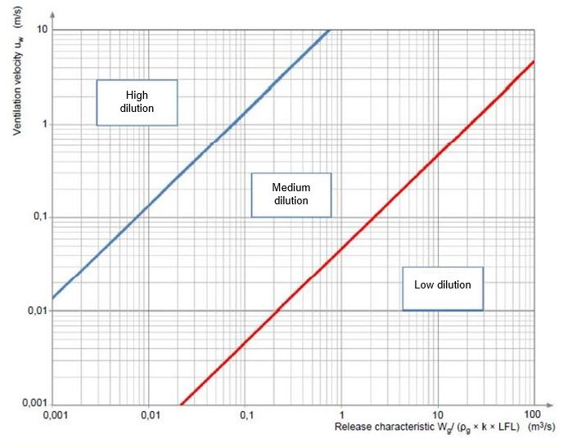
Figure 1: Dilution degree assessment

The release characteristic (RC) is calculated by the following equation:
Where:
- W_{g} (kg/s) is the mass flow of flammable compound;
- ρ_{g} (kg/m³) indicates the gas or vapour density (the parameter is linked to ambient pressure and temperature);
- k (dimensionless parameter) represents a safety factor, which ranges between 0.5 and 1;
- LFL (v/v %) is the lower flammability limit of flammable substance (biomethane).
In case of gaseous release, W_{g} depends on flow conditions (sonic or subsonic), which are determined by the following equations (Casal, 2018):
Where:
- p_{in} (Pa) is the pressure inside the vessel or component;
- p_{atm} (101325 Pa) indicates the atmospheric pressure;
- γ (dimensionless parameter) = c_{p}/c_{v} (heat capacities ratio).
The first term of Eq 3 and 4 is the sonic pressure (p_{son}). The heat capacities ratio depends on temperature and it has been calculated by the Langen equations:
With reference to methane, the values of a, a’ and b are shown in table 1.

Table 1: Langen parameters
a (J/kg K) | a’ (J/kg K) | b (J/kg K²)
1710 | 1210 | 0.276

M_{i} is calculated by the following equations (Lauri, 2018):
Where:
- A (m²) is the hole area;
- C_{d} indicates the discharge coefficient (dimensionless parameter), which is lower than 1;
- PM_{b} (16 kg/kmol) is the molecular weight of biomethane;
- Z (dimensionless parameter) is the compressibility factor;
- R (8,314 J/kmol K) is the universal gas constant;
- T represents the biofuel release temperature (K).
The technical Standard IEC 60079-10-1 suggests the hole area (A) values, which range between 10⁻⁶ m² and 5·10⁻⁶ m² in case of release from compressors (IEC, 2021). In case study, the compressor is equipped with two safety valves, which have emission area (A_{SV}) equal to 5.1·10⁻⁶ m². The biomethane compression has been assumed polytropic and therefore the biofuel release temperature (T) can be calculated by the following equation (Caputo, 1997):
Where:
- T_{i} (K) is the initial compression temperature;
- p_{out} (Pa) indicates the release pressure;
- p_{i} is the initial compression pressure;
- η_{pol} indicates the polytropic efficiency.
The compressibility factor is used to convert ideal gas properties to real gas properties. This parameter has been calculated by the diagram reported in Figure 2. T_{r} (reduced temperature) and p_{r} (reduced pressure) are given by the following equations:

T_{out} and p_{out} are referred to biomethane release condition, whereas T_{cr} and p_{cr} are critical biofuel temperature and pressure. In case of indoor place, such as the compression unit, the RC calculation is fundamental for determining the ventilation velocity values, which are able to optimize the dilution degree and consequently to decrease the zone dangerousness. The table (Figure 3), reported in International Standard IEC 60079-10-1, is generally used to classify the zone (IEC, 2021), generated by the potential release source.

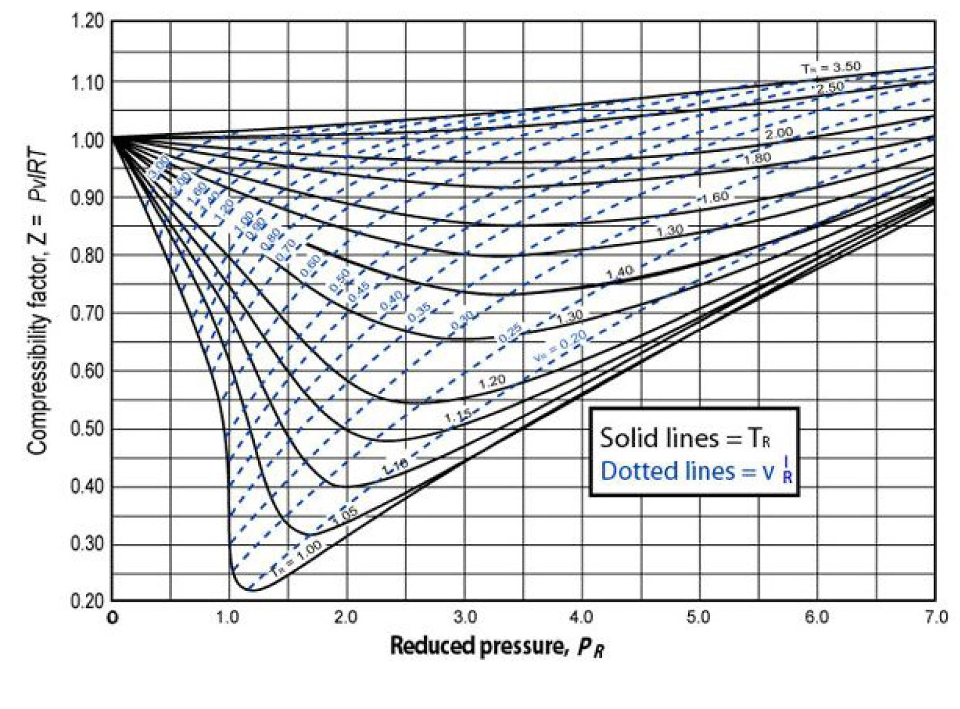
Figure 2: Compressibility factor

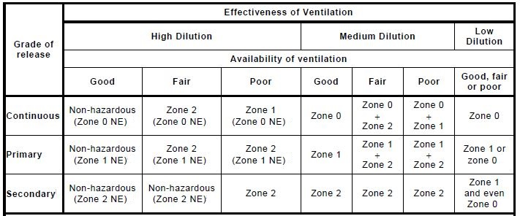
Figure 3: Atex zones classification

- The case study: the biomethane production plant

The biomethane production plant is located in North Italy. In industrial plant, organic waste undergoes an anaerobic digestion process, which produces biogas. This biofuel is successively refined and a counter-current of pressurized water separates the carbon dioxide to obtain biomethane, which is an entirely renewable source. The compression unit increases the biomethane pressure from the upgrading system outlet (about 4 bar) to natural gas injection grid (about 70 bar). In order to achieve this goal, a multi-stage reciprocating compressor is used. In particular, the gaseous biofuel compression is split into two stages (Figure 4), with an intercooler (heat exchanger) between the stages. Accordingly, the compression stages have the same initial temperature (T_{i}). The reciprocating compressor is equipped with two safety valves aimed at limiting the discharge and inter-stage pressure and ensuring a safe machine operating. The safety valves (SV) are set to open at pressures, which are slightly higher than the normal discharge pressure of compressor.
In case study, in order to assess the influence of biomethane production pressure (p_{p}) on Atex zones classification, the following values have been assumed: 50 bar, 60 bar and 70 bar. The stage compression ratio (β_{st}) is given by the following equation:

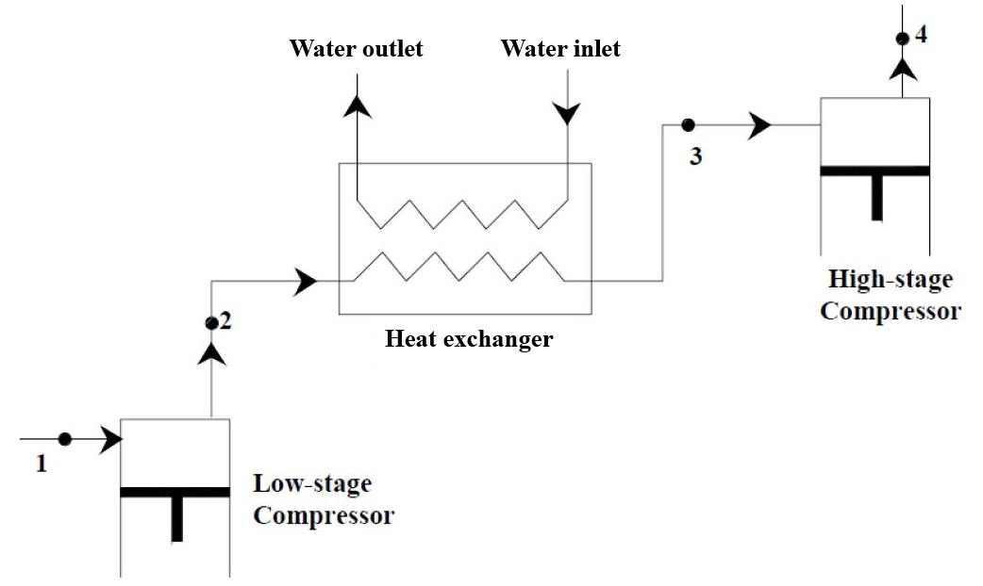
Figure 4: Biomethane compression stages

- Results and discussion
In order to calculate the biomethane release temperature (Eq. 9), it has to be highlighted that an average value of heat capacities ratio can be assumed. In this study, as the γ values variation, referred to initial compression and final compression temperature, has been about 1 %, the value calculated by T_{i} has been used. In table 2, the assumed parameters for studying the biomethane release from reciprocating compressor are reported. In particular, because of biomethane release pressures, the gaseous flow is always sonic (p_{son} is higher than atmospheric pressure) and the biofuel behaves like an ideal gas (compressibility factor is about 1). Therefore, Eq. 7 has been used to calculate the released mass flows. The fixed values of safety valves setting are shown in table 3. As suggested by manufacturer, the setting pressure of safety valve of second compression stage is 1.05 p_{p}. The study results are reported in tables 4, 5 and 6. The released flows (M₁, M₂ and M₃) increases have been significant and respectively equal to 25 %, 50 % and 33.3 %. Table 7 shows the RC and W_{g} values. The release characteristic only depends on W_{g}, because the equation 2 denominator is constant. Indeed, the biomethane density (ρ_{g}) is linked to ambient pressure and temperature. The passage from 50 bar to 70 bar has determined release characteristic (39 %) and W_{g} (37.9 %) increases. With reference to calculated values of RC, it has been noted that the best dilution degree is medium and this condition is achieved in case of ventilation air velocity, which is higher than 0.3 m/s (Figure 1). Therefore, such a threshold has to be used to set the operating of forced ventilation system and ensure a safer compression unit operating.

Table 2: Biomethane release (parameters)
Parameter | Value
T_{i} | 291.15 K
p_{i} | 400,000 Pa
A  A_{SV} | 4·10⁻⁶ m²  5.1·10⁻⁶ m²
C_{d} | 0.7
PM_{b} | 16 kg/kmol
R | 8,314 J/kmol K
LFL | 4 % (v/v)
k | 0.5
T_{cr} (critical biomethane temperature) | 190.56 K
p_{cr} (critical biomethane pressure) | 4.6 MPa
η_{pol} | 0.87

In order to classify the zone generated by compressor emission, the worst scenario has to be considered. It is due to the highest production pressure (70 bar), which causes the maximum biomethane flow. As the compressor can be considered as a secondary grade source and the best dilution is medium, the region generated by its emission is a Zone 2 for every level (good, fair and poor) of ventilation availability (Figure 3). In comparison with Zone 0 and Zone 1, Zone 2 is the less dangerous area.

Table 3: Safety valves setting
Biomethane production pressure (bar) | SV setting (first stage)  (bar) | SV setting (second stage)  (bar)
50 | 16 | 52.5
60 | 17 | 63
70 | 18 | 73.5

Table 4: Biomethane release from safety valve (first stage)
p_{out} (MPa) | T_{in} (K) | T_{out} (K) | γ | p_{son} (MPa) |  | Flow | T_{r} | p_{r} | Z | M₁ (kg/s)
1.6 | 291.15 | 455.7 | 1.39 |  | 0.86 | sonic | 2.39 | 0.35 | 1.01 | 8·10⁻³
1.7 | 291.15 | 464.7 | 1.39 |  | 0.92 | sonic | 2.44 | 0.37 | 1.01 | 8.4·10⁻³
1.8 | 291.15 | 473.3 | 1.39 |  | 0.97 | sonic | 2.48 | 0.39 | 1.02 | 0.01

Table 5: Biomethane release from compressor
p_{out} (MPa) | T_{in} (K) | T_{out} (K) | γ | p_{son} (MPa) | Flow | T_{r} | p_{r} | Z | M₂ (kg/s)
5 | 291.15 | 438.1 | 1.39 | 2.7 | sonic | 2.3 | 1.09 | 0.99 | 0.02
6 | 291.15 | 448.7 | 1.39 | 3.2 | sonic | 2.35 | 1.3 | 0.98 | 2.4·10⁻²
7 | 291.15 | 460.3 | 1.39 | 3.8 | sonic | 2.42 | 1.52 | 0.99 | 3·10⁻²

Table 6: Biomethane release from safety valve (second stage)
p_{out} (MPa) | T_{in} (K) | T_{out} (K) | γ | p_{son} (MPa) |  | Flow | T_{r} | p_{r} | Z | M₃ (kg/s)
5.25 | 291.15 | 446.2 | 1.39 | 2.8 | sonic |  | 2.34 | 1.14 | 1.02 | 0.03
6.3 | 291.15 | 457.1 | 1.39 | 3.4 | sonic |  | 2.4 | 1.37 | 0.98 | 3.2·10⁻²
7.35 | 291.15 | 469 | 1.39 | 3.97 | sonic |  | 2.46 | 1.6 | 1.01 | 0.04

Table 7: RC values
p_{out} (MPa) | ρ_{g}(kg/m³) | W_{g}(kg/s) | RC (m³/s)
5 | 0.7 | 0.058 | 4.1
6 | 0.7 | 0.064 | 4.6
7 | 0.7 | 0.08 | 5.7

- Conclusions
Since biomethane offers a great potential as an alternative source of energy, especially to fossil fuels, a particular attention has to be addressed to production process safety. Indeed, a potentially dangerous scenario is the biofuel release in indoor place, such as the compression unit. However, the knowledge of levels of biomethane production pressure allows to adjust the air flow, which has to be injected by forced ventilation system into compression unit in order to optimize the dilution degree and decrease the dangerousness of zone (Atex zone), which could be generated by the potential release from compressor. Indeed, the dilution degree optimization is able to shorten the explosive mixture persistence time and decrease the biomethane concentration to a safe level (biofuel concentration is lower than its lower flammability limit)

Acknowledgments
The Author thanks Herambiente S.p.a. for its kind collaboration.

References
Caputo C., 1997, Energy Transformation Plants, Masson, Milan, Italy.
Casal J., 2018, Evaluation of the Effects and Consequences of Major Accidents in Industrial Plants, Elsevier, Eastbourne, UK.
Gas Processors Suppliers Association (Ed), 2004, Engineering Data Book, Gas Processors Suppliers Association, Tulsa, USA.
IEC (Ed), 2021, IEC EN 60079-10-1: Classification of Areas-Explosive Gas Atmospheres, IEC, Geneva, Switzerland.
Lauri R., 2018, A Methodological Approach for the Characterization of Hazardous Zones due to Potentially Explosive Atmospheres: a Case Study, Chemical Engineering Transactions, 67, 169-174.
Matsumura M., Kato M., Hirata T., 1992, Behavior and Analysis of Reciprocating Compressor Valve, Kobelco Technology Review, 14, 20-24.
Molino A., Nanna F., Ding Y., Bikson B., Braccio G., 2012, Biomethane Production by Anaerobic Digestion of Organic Waste, Fuel, 103, 1003-1009.
Rafiee A., Khalilpour K.R., Prest J., Skryabin I., 2021, Biogas as an Energy Vector, Biomass and Bioenergy, 144, 1-20.
Zimmerle D.J., Williams L., Vaughn T.L., Quinn C., Subramanian R., Duggan G.P., Willson B., Opsomer J.D., Marchese A.J., Martinez D.M., Robinson A.L., 2015, Methane Emissions from the Natural Gas Transmission and Storage System in the United States, Environmental Science and Technology, 49, 9374-9383.

