CHEMICAL ENGINEERING TRANSACTIONS  VOL. 91, 2022 | A publication of
The Italian Association
of Chemical Engineering
Online at www.cetjournal.it

Guest Editors: Valerio Cozzani, Bruno Fabiano, Genserik Reniers
Copyright © 2022, AIDIC Servizi S.r.l.
ISBN 978-88-95608-89-1; ISSN 2283-9216

An Experimental Study on Geometrical Features of Horizontal Sonic and Subsonic Jet Fires
Vahid Foroughiª, Adriana Palacios^{b}, Christian Mata^{c}, Alba Àguedaª, Elsa Pastorª, Eulàlia Planasª, Joaquim Casal^{d,a}*
ª Centre for Technological Risk Studies (CERTEC), Universitat Politècnica de Catalunya. EEBE, Eduard Maristany 16, 08019 Barcelona. Catalonia, Spain.
^{b} Universidad de las Américas. Sta. Catarina Mártir s/n, 72810. Puebla, México.
^{c} Department of Automatic Control, Universitat Politècnica Catalunya. E. Maristany 16, 08019 Barcelona. Catalonia, Spain.
^{d} Institut d’Estudis Catalans. C/del Carme 47, 08001-Barcelona. Catalonia, Spain.
Corresponding author: joaquim.casal@upc.edu
Among the major accidents that can occur in process plants and in the transportation of hazardous materials, those involving fire are the most frequent ones. And one type of fire which has been the origin of severe accidents are the jet fires, which originated by the ignition of a flammable gas/vapour or spray, released through a hole, a broken pipe, a flange, etc. Jet fires often occur in rather compact processes or storage plants, and the probability of flame impingement on other equipment is rather high. In such a case, very high heat fluxes can exist, with quick and severe effects on that equipment implying a probable domino effect. The present study aims to contribute to the knowledge and prediction of the main features of jet fires, focusing on the distance over which flames impingement can occur. New expressions are proposed to predict this distance for the case of horizontal subsonic and sonic hydrocarbon jet fires, from both experimental data and the mathematical and computational modelling of the main geometrical (size, reach, elevation) features of the flame.
  - Introduction
According to a historical survey of 6099 accidents (Planas et al., 1997) occurred in process plants and in the transportation of hazardous materials, approximately 47% involved fire, 40% involved an explosion and 13% were related to a gas cloud. As for the different types of fires, jet fires had a quite (5%) low frequency as compared to that of pool and tank fires (66%) and flash fires (29%). However, it should be taken into account that the frequency of jet fires is probably significantly higher than the one given by this type of survey. As often jet fires are relatively small and their thermal radiation intensity decreases quickly with the distance, in many cases they are not associated with severe effects; thus, they are probably underrepresented in accident databases. However, they have been the origin of domino effect in severe accidents. A survey on jet fire accidents found that in 50% of reported cases they caused another event. The heat flux to the affected equipment depends on whether there is or not flames impingement, and on the zone of the jet in contact with it.
If there is jet flames impingement on an equipment – a vessel, a pipe– the heat flux on it can be very high due to both the radiative and convective contributions (Birk et al., 2006; Landucci et al., 2013; Scarponi et al., 2018). In this situation, the failure of this equipment can occur in a very short time, with the consequent domino effect. Jet fire impingement in a parallel pipelines system could result as well in a domino effect: the probability that a jet from one pipe impinges on another one will be a function of the jet release direction and length, the diameter of both pipelines, and the distance between them; if the target pipe conveys a gas and it is not thermally insulated or the insulation has been damaged, the pipe wall temperature can quickly reach a high and dangerous value. Some cases of these incidents including such scenarios have been recently reviewed (Foroughi et al., 2021).
In the present study, expressions to predict the reach of the possible impingement effects of sonic and subsonic propane jet fires, based on the experimental data and the modelling of the main geometrical features of the flames, are proposed. Experiments on propane jet fires were performed, with horizontal flames of up to 3 m in length. The experiments were filmed with IR and video cameras. The resulting images were used to determine the geometrical features of the jet flames: lift-off distance, reach, and elevation. Mathematical expressions for estimating the size of the flames and reach as a function of several variables have been proposed and compared with previously suggested correlations. These expressions, together with the associated heat fluxes in the case of flames impingement, allow the prediction of the possible effects of a jet fire on a given area.
  - Experimental Set-up
The size, geometry, and behavior of a jet fire depend on the exit velocity and the mass flow rate of the fuel. For most gases, in the event of a release from an equipment to the atmosphere, sonic velocity will be reached when the release occurs at P_{i}/P_{a} ≥ 1.9; for propane, this situation happens when P_{i}/P_{a} ≥ 1.73.
Sonic and subsonic horizontal jet fires were obtained in an experimental set-up (Figure 1), with different gas pressures and an orifice diameter of 8 mm (Foroughi et al., 2019). Mass flow rate, pressure, and temperature of the propane feeding jet were measured. The stagnation pressure of propane was measured with a pressure transmitter located 12 cm upstream of the release point. The jet temperature at the release point was measured with a K-type thermocouple (Ni-Cr vs. Ni-Al). Another set of 9 B-type thermocouples were located across the length of the flame axis, allowing the measurement of the jet flame temperature at different zones during the tests. CCD and IR cameras were used to record the experiments. The Optris PI 640® IR used camera had a spectral range of 8–14 μm. The jet ﬂame boundary was deﬁned as corresponding to T= 800 K (Palacios et al., 2011), and an emissivity value 0.35 through the whole flame was used (Palacios et al., 2012).

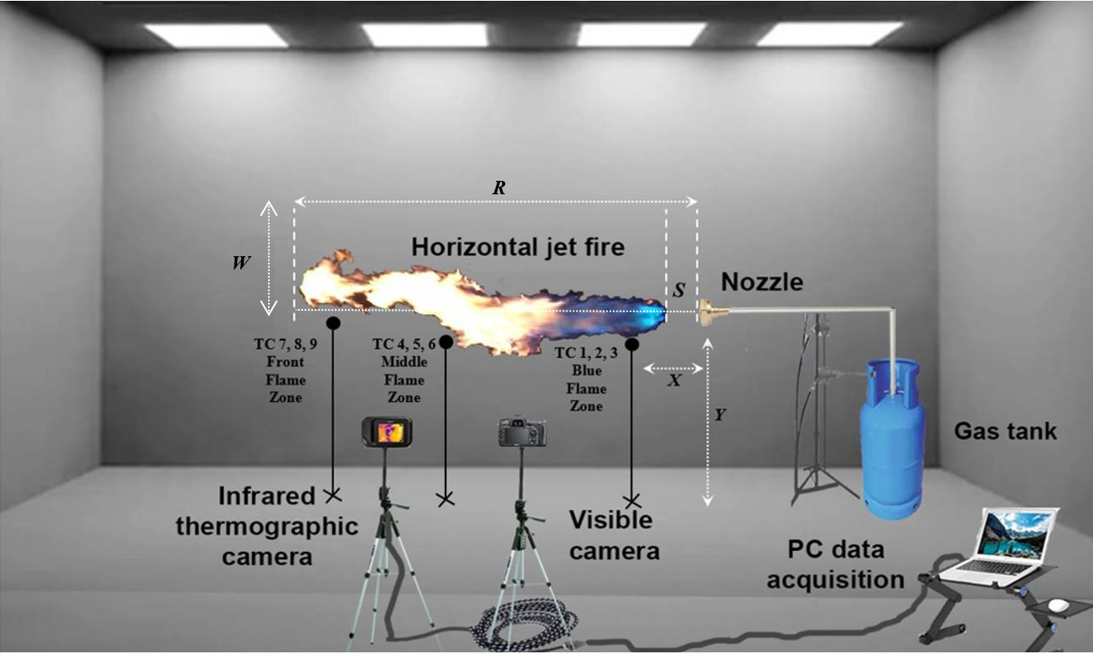
Figure 1: The experimental set-up.
  - Methodology
The division of an image into meaningful structures using image segmentation is an essential step for the analysis of the flames. The segmentation of the flames areas of interest can be accomplished based on infrared imaging (IR) by applying different techniques. In the present work, the methodology involved three steps: 1) creation of a segmentation mask; 2) calculation of discretization areas; and 3) obtaining the main geometrical values.
    - Creation of a segmentation mask
As a first step, a threshold temperature (Th) segmentation technique was used to separate the jet flame contour of the background area (Figure 2); any point (x,y) of the image, according to a threshold function such as f(x,y) > Th, is called an object point; otherwise, the point is called background point. So, by the global thresholding, the segmented image g(x,y), is given by:

g (x,y) = 1, if f(x,y) > Th, 0 if f(x, y) ≤ Th (1)
Moreover, a normalization step was performed in the present algorithm; the Th value was used as a minimum value (T_{min}), and a max value (T_{max}) for each image was calculated using a maximization function to normalize the image according to T. In fact, I is an image that uses temperature values (K) as pixels. Then, every value of the image is normalized with Eq. (2) obtaining the normalization matrix of the IR image T_{Norm}:
T_{min} = T , T_{max} = max (I) , T_{norm} = (I-T_{min})/(T_{max}-T_{min}) | (2)

a
b

Figure 2: Flame contour of a horizontal jet flame obtained with the threshold segmentation technique.
    - Calculation of the discretization areas
The next stage was to calculate the discretization of flames zones according to the thermal temperature ranges, taking into account the three temperature zones found in the jet fires (Foroughi et al., 2021): blue (beginning) zone, middle zone and flame front zone. Two steps were performed: quantize a thermal segmentation approach (Tyagi, 2018) and apply a Gaussian filter distribution (Thilagamani et al., 2014). The present purpose was to segment the three internal flame zones with multiple threshold levels and values. Three quantization levels were specified in the matrix image to convert IR image to output-segmented image. Figure 3 represents an example of the original IR image with the temperature interval range and the jet fire zones.

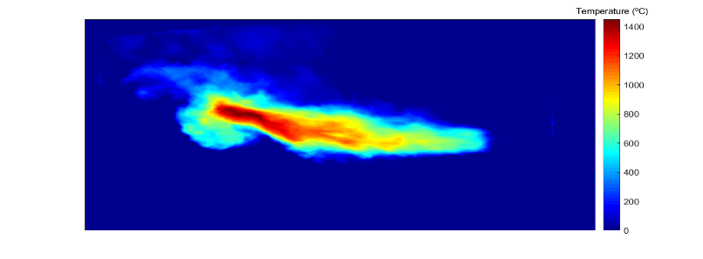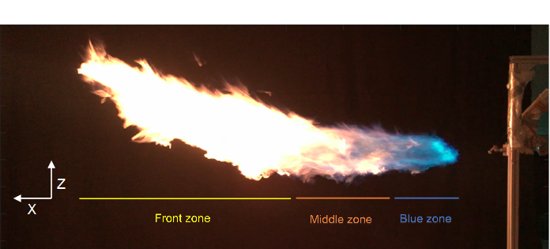
b
a
Figure 3: An IR image of a jet flame with its temperature range (a). The three jet flame zones (b).
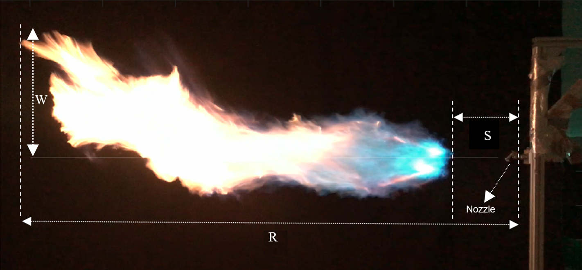
Figure 4: Jet flames’ geometrical features obtained through the discretization technique: R, S and W.
A second step was then performed applying a Gaussian filter, expressed as the normal distribution, which is the limiting distribution of the normalized sum of random variables. The Gaussian filter has the highest value in the center of a standard deviation, decreasing rapidly in the area three times of standard deviation away. A Gaussian filter was used as a low pass filter for smoothing or de-noising. Finally, an improved and efficient approach based on Gaussian and Gabor Filter (Thilagamani and Shanthi., 2014) read the given input image and performed filtering and smoothing operations. The region occupied by the object was extracted from the image by performing various operations like bilateral filtering, Edge detection, Clustering, and Region growing. Figure 4 shows the main geometrical features thus obtained from each jet flame image: the lift-off distance (S), the total jet flames reach (horizontal projection, R) and the jet flame elevation (W).
  - Results and Discussion
The operating conditions and data range of the present experimental data set are summarized in Table 1.
Table 1: Parameter range spanning the present experimental data.
P_{i} (bar abs) | u (m/s) | R (m) | S (m) | W (m) | Fr | Re
1.1 ‒1.8 | 104 ‒ 251 | 1.7 ‒ 2.5 | 0.16 ‒ 0.3 | 0.16 ‒ 0.3 | 1.3·10⁵ ‒ 8·10⁵ | 1.9·10⁵ ‒ 4.8·10⁵
    - Lift-off correlations
The lift-off, a function of the fuel exit speed and the nozzle diameter, has been correlated by several authors for vertical jet flames (Santos and Costa, 2005, Rokke et al., 1994) and horizontal jet flames (Wang et al., 2019) with the fuel jet exit velocity, both variables normalized by the nozzle diameter (S/D, u/D). In the present study, the following expression has been found to correlate the lift-off of horizontal jet flames (Figure 5a):
S/D=0.12 (u/D)^{0.54} | (3)
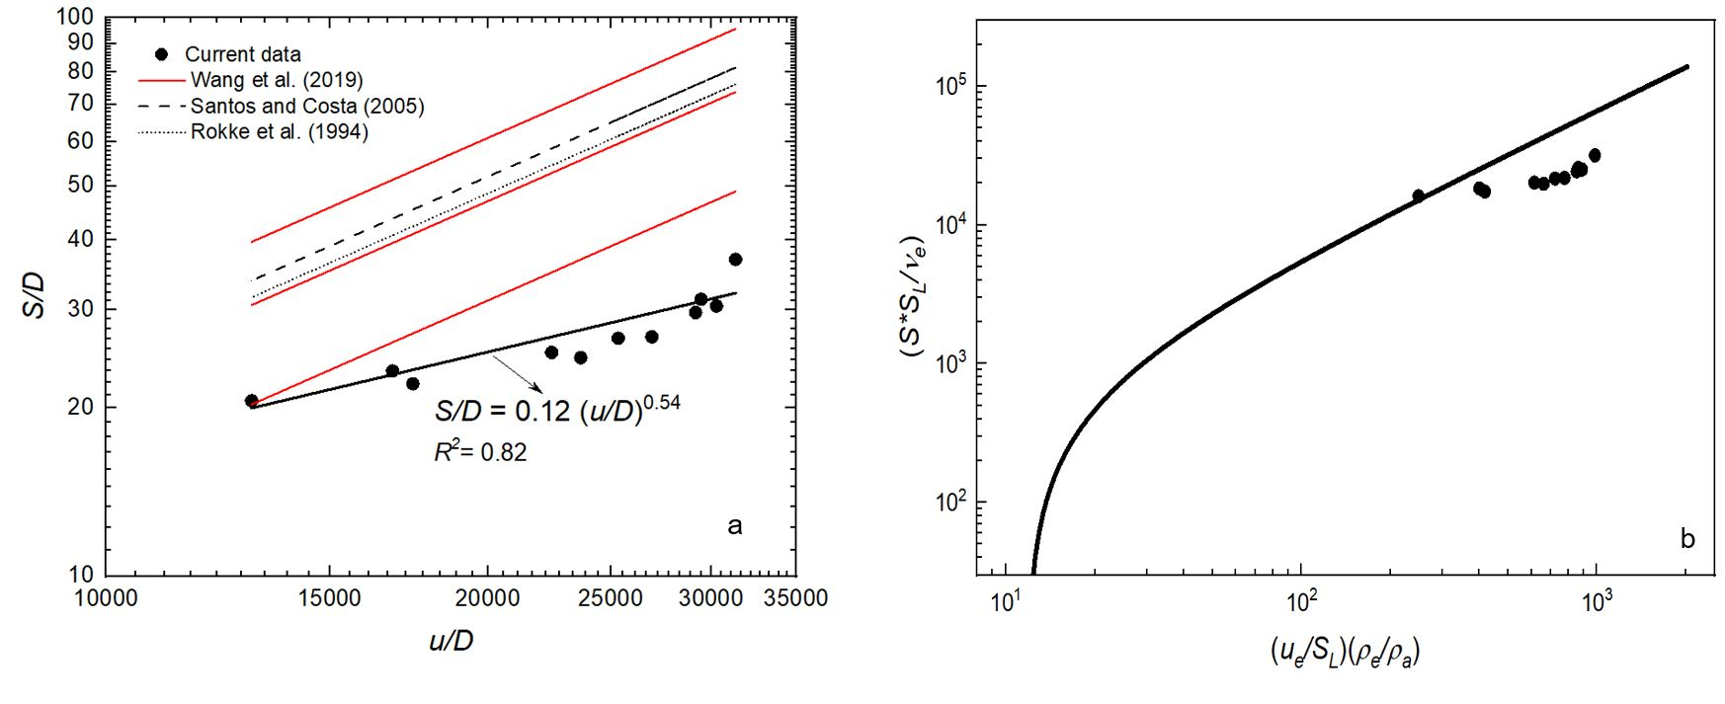
Figure 5: a) Variation in the normalized lift-off distance (S/D) as a function of the normalized jet fuel exit velocity (u/D, s⁻¹): experimental results and previously suggested correlations. b) Comparison between the present experimental lift-off values with the Kalghatgi (1984) suggested correlation.
It can be seen that the expressions proposed previously by other authors for the lift-off of both vertical and horizontal jet fires overestimate the values of the present horizontal jet flames; the influence of the fuel exit velocity on the lift-off is also smaller in the present experimental data.
Kalghatgi (1984) suggested an expression to predict vertical lift-off distances, involving the dimensionless grouping S∙S_{L}/ν_{e}, based on the maximum laminar burning velocity, S_{L}, which value is 0.43 m/s for propane (Palacios and Bradley, 2017), and a dimensionless group parameter (u_{e}/S_{L}) (ρ_{e}/ρ_{a}), u_{e} being the fuel flow mean velocity, and (ρ_{e}/ρ_{a}) the ratio of the fuel and air densities. This expression was later on modified by Bradley et al. (2016). Figure 5b shows it together with the current experimental lift-off values. Although the present sonic and subsonic experimental data follow a similar trend (with, again, a slightly different influence of the fuel exit speed), they are overpredicted by the correlation suggested for vertical jet flames.
    - Flames reach correlations
The experimental values obtained for the total flame reach-horizontal projection (R, Figure 4) of sonic and subsonic jet flames, have also been compared with the expressions previously proposed by Rokke et al. (1994) and Sonju and Hustad (1984); these authors correlated the jet flames reach R/D with the Froude number. Figure 6a shows their predictions, together with the present experimental data.
The expression obtained in the present study for the horizontal jet flames (Eq. (4)) is similar to the one proposed by the previously cited authors:
R/D = 21 Fr^{0.2} | (4)
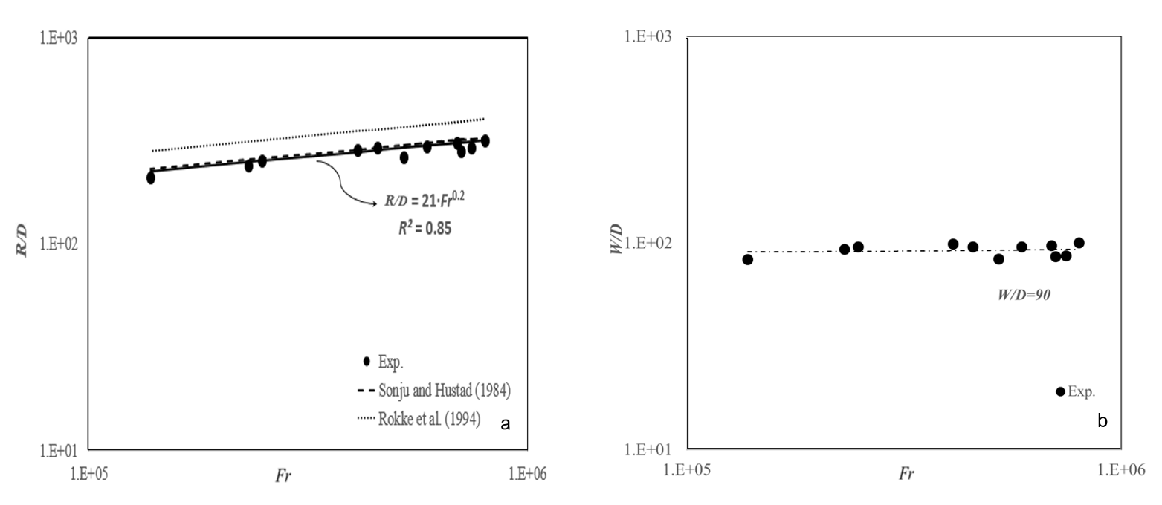
Figure 6: a) Normalized ﬂame reach horizontal projection (R/D) as a function of the nozzle’s Froude number. Previous suggested correlations are also plotted. b) Variation of the normalized ﬂame maximum elevation (W/D) as a function of the nozzle’s Froude number.
    - Flames elevation
In the case of horizontal –or, better, not vertical- jet fires, the combined action of the floatability and the loss of the linear velocity due to the turbulent mixing with air and the combustion, originates a change in the flames shape (Figures 3 and 4), with an elevation of them; this does not happen in the case of vertical jet fires, even though their shape can also be modified if they undergo the influence of wind.
The flames elevation in horizontal jet fires can be important from the point of view of their possible impingement on some equipment. So, to predict the real possible reach of the flames of such jet fires both magnitudes, the reach horizontal projection and the flames elevation should be considered. Figure 6b shows the maximum flame (W) elevation as a function of the Froude number. From this figure, it can be seen that the elevation of the horizontal flames is a practically constant value for a given nozzle diameter, essentially independent from the jet exit velocity.
  - Conclusions
The experimental results and the associated data treatment have allowed obtaining expressions that can be used for the prediction of the probable lift-off distance and reach (horizontal projection) of horizontal sonic and subsonic jet fire flames. These two magnitudes are important because, together with the flames elevation, they will establish the distance over which there could be impingement –which is the worst situation concerning a possible domino effect, due to the extremely high heat fluxes that flames impingement can imply- on some equipment in the event of a jet fire.
The main findings can be summarized as follows:
i) The values obtained for the flames lift-off (a distance which usually is much shorter than the flames themselves) of horizontal jet fires are smaller than those predicted by other authors for both horizontal and vertical jet fires
ii) The experimental values of the flames reach (i. e. the projection of flames length on the horizontal axis of the nozzle plus the lift-off distance) are essentially the same as those obtained by other authors for the case of vertical jet fires.
iii) However, in the case of horizontal jets there is a significant change in the jet fire shape, so the flames elevation must be also considered because they can have an influence on the zone possibly affected by flames impingement.
iv) This is something that should be taken into account when performing a risk analysis involving the possibility of jet flames impingement on an equipment, being therefore logical taking always a conservative approximation not limited to the expressions obtained from vertical jet fires.

Nomenclature

D – nozzle diameter, m
Fr – nozzle Froude number, u²/(gD), -
f (x,y) – threshold function, -
g (x,y) – threshold function, -
R – flame reach (horizontal projection), m
I – image using temperature values (K) as pixels
P_{i} – pressure inside vessel or pipe, Pa
Re – Reynolds number, Duρ_{f}/μ_{f}, -
S – lift-off distance, m
S_{L} – maximum laminar burning velocity of the fuel-air mixture, m/s
T – temperature, K
Th – threshold temperature, K
u – fuel exit velocity, m/s
u_{e} – fuel flow mean velocity, m/s
X – thermocouple distances from the nozzle, m
Y – thermocouple distances from the ground level, m
W –flame elevation from the nozzle centreline, m

Greek
ν – kinematic viscosity (m²/s)
μ – viscosity, (kg/m∙s)
ρ – density, (kg/m³)
Subscripts
a – ambient
e – with fuel isentropically expanded to atmospheric pressure
f – fuel
min – minimum value
max – maximum value
Norm – normalized
η
Acknowledgments
This research was funded by the project PRO2018-SO3 of Institut d’Estudis Catalans and the project PID2020-114766RB-100 of MCIN/ AEI /10.13039/501100011033.
References

Birk, A. M., Poirier, D., Davison, J., 2006, On the thermal rupture of 1.9 m³ propane pressure vessels with defects in their thermal protection system, Journal of Loss Prevention in the Process Industries, 19, 582–597.
Bradley, D., Gaskell, P.H., Gu, X.J., Palacios, A., 2016, Jet flame heights, lift-off distances, and mean flame surface density for extensive ranges of fuels and flow rates, Combustion and Flame, 164, 400–409.
Foroughi V., Cavini, A., Palacios, A., Albó, K., Àgueda, A., Pastor, E., Casal, J., 2019, Domino effect by jet fire impingement in pipelines, Chemical Engineering Transactions, 77, 931-936.
Foroughi V., Palacios A., Barraza C., Àgueda A., Pastor E., Casal J., 2021, Thermal effects of a sonic jet fire impingement on a pipe. Journal of Loss Prevention in the Process Industries, 71, 104449, 1-10-
Kalghatgi G.T., 1984, Lift-off Heights and Visible Lengths of Vertical Turbulent Jet Diffusion Flames in Still Air, Combustion Science and Technology, 41, 17-29.
Landucci G., Cozzani, V., Birk, M., 2013, Heat radiation effects, in: G. Reniers and V. Cozzani (Eds.), Domino Effects in the Process Industries: Modelling, Prevention and Managing, 70-115.
Palacios A., Muñoz M., Casal J., 2011, Assessment of the shape of vertical jet fires, Fuel, 90 (2), 824-833.
Palacios A., Muñoz M., Darbra R. M, Casal J., 2012, Thermal radiation from vertical jet fires, Fire Safety Journal, 51, 93-101.
Palacios A., Bradley D., 2017, Generalised correlations of blow-off and flame quenching for sub-sonic and choked jet flames, Combustion and Flame, 185, 309-318.
Planas E., Montiel H., Casal J., 1997, A survey of the origin, type and consequences of fire accidents in process plants and in transportation of hazardous materials, Transactions IchemE, 75 Part B (3), 3-8.
Rokke, N.A., Hustad, J.E., Sonju, O.K., 1994, A study of partially premixed unconfined propane flames, Combustion and Flame, 97 (1), 88-106.
Santos, A., Costa, M., 2005, Reexamination of the scaling laws for NOx emissions from hydrocarbon turbulent jet diffusion flames, Combustion and Flame, 142, 160-169.
Scarponi, G. E., Landucci, G., Birk, A. M., Cozzani, V., 2018, LPG vessels exposed to fire: scale effects on pressure build-up, Journal of Loss Prevention in the Process Industries, 56, 342-358.
Sonju, O.K., Hustad, J., 1984, An experimental study of turbulent jet diffusion flames, Norwegian Maritime Research, 4, 2-11.
Thilagamani, S., and Shanthi, N., 2014, Gaussian and Gabor filter approach for object segmentation. ASME Journal of Computing and Information Science in Engineering (JCISE), June 2014, 14 (2), 021006.
Tyagi, V., 2018, Understanding Digital Image Processing (1st ed.). CRC Press.
Wang Z., Zhou K., Liu M., Wang Y., Qin X., Jiang J., 2019, Lift-off Behavior of Horizontal Subsonic Jet Flames Impinging on a Cylindrical Surface, Proceedings of the 9th International Seminar on Fire and Explosion Hazards (ISFEH9), 831-842. ISBN: 978-5-7422-6498-9 DOI: 10.18720/spbpu/2/k19-79.

