CHEMICAL ENGINEERING TRANSACTIONS  VOL. 91, 2022 | A publication of
The Italian Association
of Chemical Engineering
Online at www.cetjournal.it

Guest Editors: Valerio Cozzani, Bruno Fabiano, Genserik Reniers
Copyright © 2022, AIDIC Servizi S.r.l.
ISBN 978-88-95608-89-1; ISSN 2283-9216

Resilience assessment of chemical process systems under uncertain disruptions based on Catastrophe Theory (CT) and Dynamic Bayesian Network (DBN)
Hao Sun^{a,b}, Haiqing Wang^{a,}*, Ming Yang^{b,}*, Genserik Reniers^{b,c,d}
ªCollege of Mechanical and Electronic Engineering, China University of Petroleum (East China), Qingdao, China
^{b}Safety and Security Science Section, Department of Values, Technology, and Innovation, Faculty of Technology, Policy, and Management, Delft University of Technology, The Netherlands
^{c}Faculty of Applied Economics, Antwerp Research Group on Safety and Security (ARGoSS), Universiteit Antwerpen, 2000, Antwerp, Belgium.
^{d} CEDON, KULeuven, 1000 Brussels, Belgium
wanghaiqing@upc.edu.cn; m.yang-1@tudelft.nl
Due to the rapid development of technology, process systems become dynamic, automated, and complex, resulting in the strong interdependence and interaction among components and ensuring system safety by conventional methods a challenge. Compared with traditional risk assessment methods, resilience assessment is a more appropriate method for ensuring the safety of process systems under uncertain disruptions. Resilience refers to absorbing and adapting to changing conditions and recovering from disruptions. This paper presents a comprehensive assessment model that combines the catastrophe theory (CT) with the dynamic Bayesian network (DBN) to measure dynamic resilience. Firstly, the CT is employed to quantify the intensity of disruptions. Subsequently, the performance response function (PRF) of the system is determined by DBN. A resilience metric is then introduced to measure system resilience under uncertain disruptions. The method is demonstrated through a release prevention barrier system.
  - Introduction
To ensure the safety of chemical process systems, researchers have proposed many kinds of models and methods to analyze and quantify systems risk to prevent and predict disruptions and accidents (Ji et al., 2021). Chen et al. (2019) developed a Dynamic Vulnerability Assessment Graph (DVAG)-based approach to integrate safety and security to reduce the risk of intentional damages. Casciano et al. (2019) proposed an algorithm to classify chemical industrial clusters based on risks and enhance the efficiency of reducing risk. Landucci et al. (2017) came up with a Bayesian Network (BN)-based method to quantify attack likelihood to quantify the security risk of the system. Liu et al. (2021) presented a DBN-based dynamic risk assessment approach to evaluate the risk of the process for operations. Yang (2020) defined the concept of safety entropy and combined it with the Functional Resonance Analysis Method (FRAM) to evaluate the safety of a process system. The works described above show the significant progress on risk assessment in process systems. However, recurring accidents show that only performing a conventional risk assessment is insufficient to ensure system safety in the changing environment. Hence, making a system more resilient is ideal for dealing with uncertain disruptions (Sun et al., 2021).
Compared with conventional safety management, which focuses on identifying and reducing hazards in a system, resilience thinking believes that the time, position, and type of disruptions are difficult to predict. Thus, practitioners should focus on enhancing system resilience to respond to uncertain disruptions rather than only discovering and eliminating dangers. Moreover, resilience assessment is wider than safety management because it can identify system hazards and quantify the system's ability of absorption, adaptation, and restoration after uncertain disruptions. As a novel paradigm, resilience has been drawn into consideration by researchers. Tong et al. (2020) developed a comprehensive method based on DBN to quantify the process system resilience. Sun et al. (2021) introduced a novel approach based on DBN to assess the resilience of safety barriers for the processing system. Zhang et al. (2021) used DBN to measure the dynamic resilience of an engineering system after a disruptive event. Cai et al. (2021) presented a DBN-based method to quantify the dynamic resilience of an engineering system in the context of multi-disruptions. However, few researchers consider the influence of disruption intensity when quantifying system resilience. As a solution to make up for the problem, the present study aims to develop a comprehensive approach, which combines CT with DBN, to measure system resilience and ensure system safety under uncertain disruptions. Firstly, an evaluation index system is developed to analyze the potential disruptions. CT is then utilized to quantify the comprehensive intensity of disruptions to determine the failure probability of components under the disruption. After that, the DBN model is employed to determine the performance change of the system after a disruption occurs. Finally, the PRF quantifies the system resilience. The proposed methodology is briefly presented in the next section.
  - The proposed methodology
    - Establishment of evaluation system for the disruptions
Before determining the intensity of the disruption, the first task is to develop an evaluation index system to classify the disruptions and help to determine the intensity of disruptions. The evaluation index system comprises three main layers, goal layer, criteria layer, and alternative layer. In this study, the goal layer is the comprehensive intensity of disruptions. The criteria layer is different types of disruption, which can be determined by the environment, position, and system reports of the processing system. The alternative layer is elements of the different types of disruption.
    - Catastrophe theory
Catastrophe theory (CT) was developed by Thom et al. (1973), a mathematical theory describing the relationship between state variables and control variables in the system when external conditions change. CT can be utilized to research catastrophic phenomena characterized by discontinuous variation. Besides, it can describe the dynamic process to prevent catastrophes. Compared with Analytical Hierarchy Process (AHP) and Fuzzy Analytical Hierarchy Process (FAHP), CT can determine the evaluation results without assigning weights to indexes. Based on the mechanism of the normalized function, CT can ensure reasonable results.
Potential function f(x_{n}, y_{m}) is employed to describe the relationship between variables and system states, where x_{n} illustrates the system state variables, n is the number of state variables, y_{m} indicates system control variables, m represents the number of control variables. The term “potential” indicates the system has a trend capability, which is determined by the interaction and relationship among the system variables and relative relationship with the external condition.
When n and m are equal to 1, which means there are one system state variable and one control variable, the model of CT is called fold catastrophe. The expression of the potential function is shown in Eq(1), and its normalized formula is expressed as Eq(2) (Thom et al., 1973).
(1)
(2)
Likewise, when n=1 and m=2, the model of CT is called cusp catastrophe. The expression of the potential function is shown in Eq(3), and its normalized formula is expressed as Eq(4).
(3)
(4)
When n=1 and m=3, the model of CT is called swallowtail catastrophe. The potential function and its normalized formula are shown in Eq(5) and Eq(6), respectively.
(5)
(6)
When n=1 and m=4, the model of CT is called butterfly catastrophe. The potential function and its normalized formula are shown in Eq(7) and Eq(8), respectively.
(7)
(8)
When n=1 and m=5, the model of CT is called wigwam catastrophe. The potential function and its normalized formula are shown in Eq(9) and Eq(10), respectively.
(9)
(10)
Once the values are obtained by normalized formulas, two situations that should be determined: i) complimentary, which means that the control variables are correlated, and they may influence each other. In this situation, the membership function value is the mean value of the normalized value; ii) non-complementary, indicating the control variables are not relevant. In this case, the membership function value is the minimum value of the normalized value. The specific description of CT can be seen in Wu et al. (2021) and Chen et al. (2018). The current study uses CT to measure the comprehensive intensity of disruption based on the evaluation index system.
    - Dynamic Bayesian network (DBN)
As an extension of Bayesian Networks (BN) in the time domain, DBN can be used to quantify the dynamic probability of consequence (Khan et al., 2015). The relationship among time slices can be described by transition probabilities, which can be calculated by expert knowledge or failure rate and repair rate. The structure of DBN is shown in Figure 1.
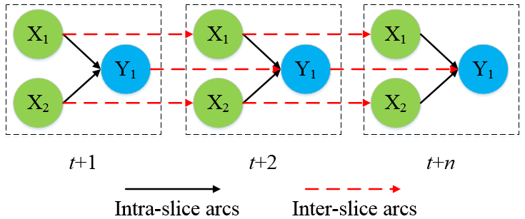
Figure 1: The structure of DBN
When disruption occurs, the prior probability of basic events will increase rapidly. The magnitude of the increase depends on the intensity of the disruptions (I) determined by CT. The greater the I, the higher the prior probability. The prior probability of nodes can be determined by Eq. (11). When the prior probability of each component is determined, the system performance can be obtained. Thus, the resilience metric developed by Sun et al. (2021) is used to quantify the resilience of the RPB.
(11)
where P_{I} indicates the prior probability of nodes under the disruption, I represent the intensity of the integrated disruption.
  - Case study
On August 6, 2012, a leakage accident originated from a pipe rupture in a crude distillation unit in the Chevron Richmond refinery occurred, resulting in a fire accident eventually (CSB, 2014). The release prevention barrier of the Chevron Richmond refinery crude unit is employed to demonstrate the proposed methodology. The specific information of the process is shown in Figure 2.
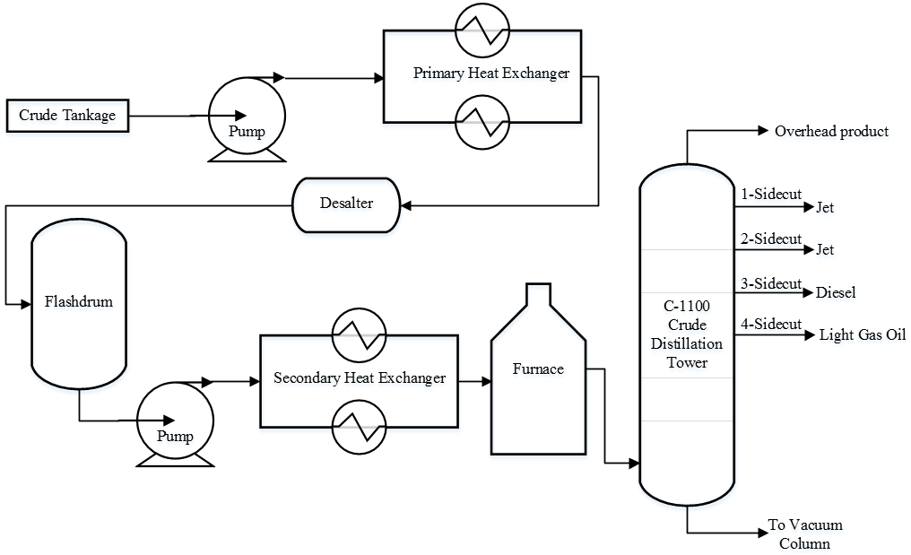
Figure 2: Schematic diagram of the Chevron Richmond refinery crude unit
    - Identifying disruptions and intensity based on CT
Before determining the intensity of disruptions (I), the category of disruptions should be identified first. The evaluation index system aims to determine and classify the elements of each category in detail.
(1) Selection of goal layer. The goal layer is the top layer, which is the main target of the evaluation system. The comprehensive intensity (I) of the disruptions is set as the goal layer in this case. (2) Selection of criteria layer. The disruptions are divided into four primary categories based on published works of peer researchers, including geophysical factors, climatological factors, meteorological factors, hydrological factors (Ricci et al., 2021). Note that when practitioners decide to employ the proposed method, they can determine the category of disruptions based on the system’s characteristics, details, process, etc. For example, the potential natural events should be identified by the position and environment of the system or plant. (3) Selection of an alternative layer. Those four main categories have their elements. For example, natural events comprise geophysical factors (e.g., earthquake, landslide, volcano, etc.), meteorological factors (e.g., storm and lighting), hydrological factors (e.g., flooding), and climatological factors (e.g., wildfire) (Ricci et al., 2021).
The disruption evaluation index system of the Chevron Richmond refinery crude unit consists of three criteria layers and 10 alternative layers. These indexes cover the main disruptions that affect the plant. The specific evaluation index system is shown in Figure 3.
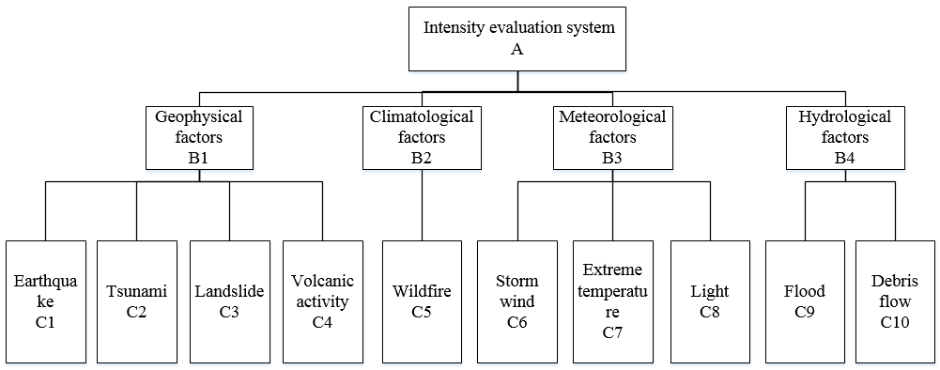
Figure 3: The evaluation index system of disruption intensity for the system
The CT method is employed to determine the intensity of disruptions. In the beginning, the overall analysis of the comprehensive disruptions for the Chevron Richmond refinery crude unit is carried out by experts. According to the characteristics of geographic position and corresponding climatic conditions, plant reports, and relative documents, each index of the evaluation system is scored by experts. The score range from 0 to 1, and the higher the score, the greater the impact of the disruption on the system and the greater the comprehensive intensity (I) of the disruption. The disruption intensity (I) grade consists of five degrees, very low (VL), low (L), moderate (M), high (H), and very high (VH). The specific degrees are shown in Table 1.
Table 1 The grade of the disruption intensity (I)
Grade | Meaning | Range of disruption intensity (I)
I | Very low | (0,0.2)
II | Low | (0.2,0.4)
III | Moderate | (0.4,0.6)
IV | High | (0.6,0.8)
V | Very | (0.8,1.0)

In the light of the abovementioned conditions, the score of each index identified by experts is shown in Table 2. The normalized formulas are utilized to determine the normalized value of each index based on the CT. Due to the variables of criterion layer B₁, B₂, B₃, and B₄ having 4, 1, 3, and 2 variables, respectively, the normalized values of indexes can be determined by Eq(8), Eq(2), Eq(6), and Eq(4) respectively. Owing to the correlation between these four indexes, the non-complimentary principle is selected to determine the membership function value of the criterion. The specific process is shown in Table 2. It can be seen that the comprehensive disruption is 0.94. In accordance with the Eq. (11), the prior probability of the factors in DBN affected by the disruptions can be determined.
Table 2 Evaluation results of the disruption intensity (I)
Evaluation index |  | Score of index  (C) | Normalized value of index (C) | Value of criterion layer (B) | Normalized value of criterion layer (B) | Comprehensive value of goal layer (A)
Geophysical factors  (B1) | C1 | 0.99 | 0.99 | 0.92 | 0.96 | 0.94
 | C2 | 0.87 | 0.95
 | C3 | 0.66 | 0.90
 | C4 | 0.41 | 0.84
Climatological factors  (B2) | C5 | 0.79 | 0.89 | 0.89 | 0.94
Meteorological factors  (B3) | C6 | 0.69 | 0.83 | 0.90 | 0.95
 | C7 | 0.76 | 0.91
 | C8 | 0.90 | 0.97
Hydrological factors  (B4) | C9 | 0.89 | 0.94 | 0.95 | 0.97
 | C₁₀ | 0.90 | 0.97
    - Quantification of the system resilience
The DBN model for the release prevention barrier (RPB) is developed and shown in Figure 4, which is employed to quantify the performance change of the RPB. The system performance under the normal condition (i.e., before the disruption) should be identified by the DBN. The initial data (i.e., prior probability, failure rate, and repair rate) of each component of the DBN model are identified by historical data (e.g., OREDA and relevant literature) and expert judgment (Cai et al., 2021). The comprehensive intensity (I) of the natural disruption is employed to measure the prior probability of each component under the disruption condition. Thus, the PRF of the system under the normal and disruption condition can be determined. According to the aforementioned above, the resilience of the RPB can be presented in Figure 5.
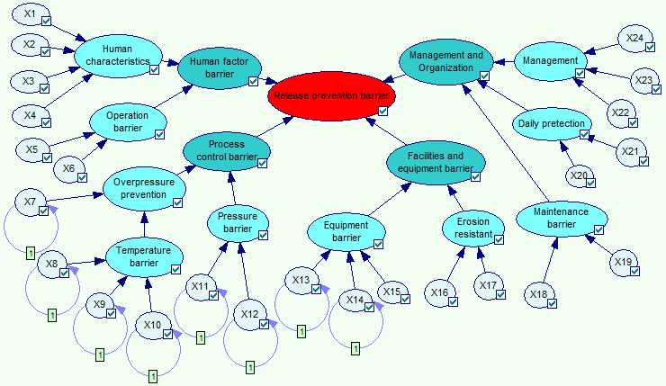
Figure 4: The DBN model for the RPB
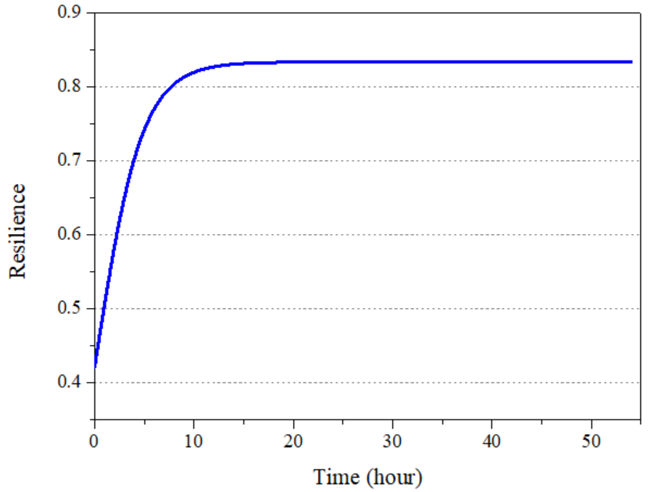
Figure 5: The resilience for the RPB
The performance of the system under the normal condition (i.e., without the disruption) is 0.775, which is determined by the developed DBN model. The steady value of the system performance is less than 1, caused by the degradation of components. When the disruption occurs, the components of the system will be affected, leading to the performance suddenly dropping to 0.327. After that, with the intervention of maintenance activities, the system performance gradually restored to equilibrium. The performance curve can be determined by the developed DBN and fitting technology. According to the performance curve, the system resilience of the RPB can be determined, as shown in Figure 5. The system resilience starts from 0.422 (i.e., the minimum value), which can be employed to indicate the absorptive capacity of the system. The stronger the absorptive capacity of the system, the higher the minimum value. Moreover, the system resilience is also subject to its capability of adaptation and restoration. For instance, it takes the system 15 hours to restore to an equilibrium state (i.e., 0.831), which is determined by the capability of adaptation and restoration of the system. The stronger the capability to adapt and restore the system, the shorter the time required for the system to recover to the equilibrium state.
  - Conclusions
The proposed methodology integrates the evaluation index system with the Catastrophe theory (CT) to determine the comprehensive intensity of disruption and the failure probability of basic factors under the disrupted condition. The dynamic Bayesian network (DBN) is then used to calculate the performance curve in two different conditions (i.e., normal and disrupted conditions). Based on the performance response function (PRF), the system resilience is determined by the proposed resilience metric. The main contribution of the proposed methodology is to develop a way to take the disruption intensity into account when measuring system resilience. The presented approach can determine the disruption intensity and quantify the system performance and resilience under uncertain conditions. Based on which, the system resilience can be enhanced to address uncertain disruptions to ensure system safety.
References
Cai, B.P., Zhang, Y.P., Wang, H.F., Liu, Y.H., Ji, R.J., Gao, C.T., et al., 2021, Resilience evaluation methodology of engineering systems with dynamic-Bayesian-network-based degradation and maintenance. Reliab. Eng. Syst. Saf. 209, 107464.
Casciano, M., Khakzad, N., Reniers, G., Cozzani, V., 2019, Ranking chemical industrial clusters with respect to safety and security using analytic network process. Process. Saf. Environ. Prot. 132, 200–213.
Chen, C., Reniers, G., Khakzad, N., 2019, Integrating safety and security resources to protect chemical industrial parks from man-made domino effects: A dynamic graph approach. Reliab. Eng. Syst. Saf. 191, 106470.
Chen, H.Y., Zhang, Y.S., Liu, H., Meng, X.B., Du, W.Z., 2018, Cause analysis and safety evaluation of aluminum powder explosion on the basis of catastrophe theory. J. Loss Prev. Process. Ind. 55, 19–24.
CSB, 2014, Chevron Richmond Refinery Pipe Rupture and Fire California, CA, August 6, 2012 Final Report Finding, http://www.csb.gov/, (last checked 17.11.14).
Ji, Z.Z., Yang, S.H., Cao, Y., Wang, Y.C., Zhou, C.C., Yue, L., et al., 2021, Harmonizing safety and security risk analysis and prevention in cyber-physical systems. Process. Saf. Environ. Prot. 148, 1279–1291.
Khan, F., Rathnayaka, S., Ahmed, S., 2015, Methods and models in process safety and risk management: Past, present and future Process. Saf. Environ. Prot. 98, 116–147.
Landucci, G., Argenti, F., Cozzani, V., Reniers, G., 2017, Assessment of attack likelihood to support security risk assessment studies for chemical facilities. Process. Saf. Environ. Prot. 110, 102–114.
Liu, Z.K., Ma, Q., Cai, B.P., Liu, Y.H., Zheng, C., 2021, Risk assessment on deepwater drilling well control based on dynamic Bayesian network. Process. Saf. Environ. Prot. 149, 643–654.
Ricci, F., Moreno, V., Cozzani, V., 2021, A comprehensive analysis of the occurrence of Natech events in the process industry. Process. Saf. Environ. Prot. 147, 703–713.
Sun, H., Wang, H., Yang, M., Reniers, G., 2021, Resilience-based approach to safety barrier performance assessment in process systems. J. Loss Prev. Process. Ind. 73, 104599.
Thom, R., English Translation of Stabilite Structurelle et Morphogenese, 1973, Translated by D. H. Fowler. W. A. Benjamin, Inc.
Tong, Q., Yang, M., Zinetullina, A., 2020, A Dynamic Bayesian Network-based approach to Resilience Assessment of Engineered Systems. J. Loss Prev. Process. Ind. 65, 104152.
Wu, J.S., Bai, Y.P., Zhao, H.H., Hu, X.F., Cozzani, V., 2021, A quantitative LNG risk assessment model based on integrated Bayesian-Catastrophe-EPE method. Saf. Sci. 137, 105184.
Yang, M., 2020, Safety system assessment using safety entropy. J. Loss Prev. Process. Ind. 66, 104174.
Zhang, Y.P., Cai, B.P., Liu, Y.L., Jiang, Q.Q., Li, W.C., Feng, Q., et al., 2021, Resilience assessment approach of mechanical structure combining finite element models and dynamic Bayesian networks. Reliab. Eng. Syst. Saf. 216, 108043.

