CHEMICAL ENGINEERING TRANSACTIONS  VOL. 91, 2022 | A publication of
The Italian Association
of Chemical Engineering
Online at www.cetjournal.it

Guest Editors: Valerio Cozzani, Bruno Fabiano, Genserik Reniers
Copyright © 2022, AIDIC Servizi S.r.l.
ISBN 978-88-95608-89-1; ISSN 2283-9216

Modelling of the plume rise phenomenon due to warehouse or pool fires considering penetration of the mixing layer
Boot, Hansª, Ruiz Pérez Sonia^{b*}
ªGexcon Netherlands BV, Princenhof Park 18, Driebergen, 3972 NG, The Netherlands
^{b}Gexcon Australia, Level 14, 172 St Georges Terrace, Perth 6000 WA, Australia
hans.boot@gexcon.com, sonia.ruiz.perez@gexcon.com
Smoke plumes containing toxic combustion products will initially rise due to the density difference between the hot combustion products and the ambient air. This density difference is caused by the fact that the plume temperature is significantly higher than the air’s ambient temperature. The theory behind this plume rise phenomenon foresees that there will be a height at which the finally cooled down plume will be in equilibrium with the density of the air at that height, leading to a maximum plume height. The trajectory of the plume and the hazard distances to specific concentration threshold levels will be mainly influenced by the windspeed, atmospheric stability class and the fire’s convective heat production, where the combination of these parameters leads to potential penetration of, or even reflection against the mixing layer.

Typical models that describe the mathematics behind rising of hot plumes include the effects of atmospheric turbulence. However, the plume’s potential penetration of the mixing layer and reflection of the plume is often neglected.

The present study has led to the development of a dedicated model, implemented in Gexcon’s software package EFFECTS, to simulate the plume rise phenomenon due to warehouse and pool fires. The model is based on Briggs’ study of the plume rise phenomenon (Briggs, 1969), the theory of the Yellow Book (Yellow Book, 1992) and uses Mills’ correction for burning fires (Mills, 1987). This model not only calculates the maximum height, plume path, and concentration threshold contours of toxic combustion products at any height, but also includes the effects of the penetration and reflection phenomena. The model has been validated against the experimental data presented by (Hall et al., 1995) and Briggs (1969), as well as other validated mathematical models, to ensure its good performance.
  - Introduction
Although warehouse fires are hardly being recognized as “hazardous accidents”, they are, in fact, one of the most recurring toxic exposure events. Due to the formation of highly toxic combustion products, these situations often lead to large scale alarming and evacuation actions towards potentially exposed populations.

Warehouses may contain large quantities of either liquid or solid combustible products, varying from fertilizers and pesticides to cleaning agents. Upon a warehouse fire a smoke plume will be generated, which can potentially produce a large range of different toxic combustion products, such as NO_{x}, HCl, HF, SO₂, etc. This smoke plume will initially rise into the atmosphere but will eventually stabilize in height and spread-out toxic combustion products that can be harmful for both humans and the environment. These toxic combustion products can reach dangerous concentrations up to large distances, requiring alarming or even evacuation actions by emergency response teams.

That is the reason why nowadays there is a growing interest in simulating the effects of rising smoke plumes. The assessment of the toxic concentration levels of these combustion products transported along the plume trajectory is of utmost importance, allowing safety professionals to use this information for hazard identification, safety analysis and emergency planning. Figure 1 below shows a hot smoke plume due to a warehouse fire.
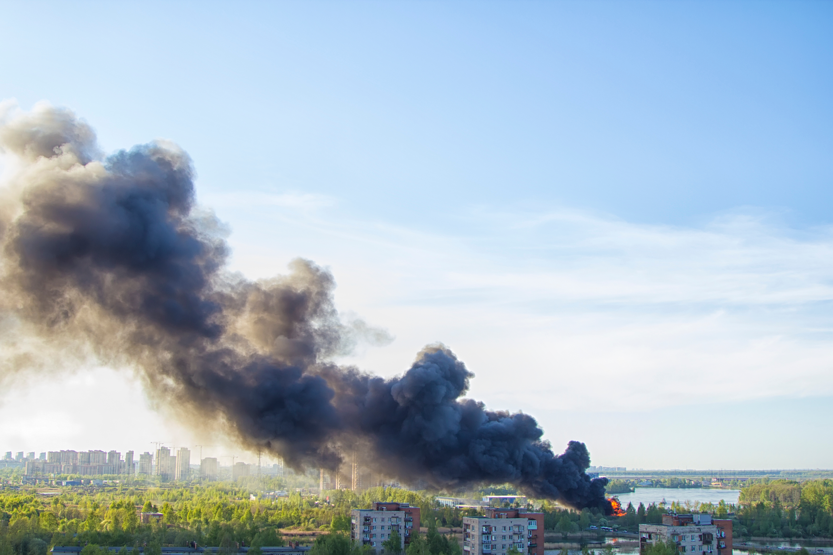
Figure 1: Smoke plume generated upon a warehouse fire
Typical models that describe the mathematics behind rising of hot plumes, such as those described by Briggs (Briggs, 1969), include the effects of atmospheric conditions. However, the plume’s potential penetration of the mixing layer is often neglected. The importance of the plume penetration is that all mass that has risen above the mixing layer, will never disperse back into the mixing layer. Therefore, toxic combustion products trapped above the mixing layer height can never create chemical exposure at ground level. Apart from penetration of the mixing layer height, the potential reflection of the plume should also be considered. This can play an important role for plumes that remain below the mixing layer height as reflection will be the responsible phenomena to trap the (toxic) combustion products below the mixing layer height, thus, creating chemical exposure at ground level.

The present study has led to the development of a dedicated model, implemented in Gexcon’s software package EFFECTS, to simulate the plume rise phenomenon due to warehouse or pool fires. The aim of this model is to provide safety professionals with valuable information for hazard identification, safety analysis and emergency planning.
  - Methodology
    - Plume rise modelling
The “plume rise from fires” model is based on Briggs’ study of the plume rise phenomenon (Briggs, 1969), the theory of the Yellow Book (Yellow Book, 1992) and uses Mills’ correction for burning fires (Mills, 1987).

The rising of the plume with distance and the maximum height of the plume can be calculated in two different ways, depending on the atmospheric stability. The atmospheric stability is the tendency of atmosphere to resist or enhance vertical motion. According to the Yellow Book (1992) and Briggs (1969), for Pasquill stability class A, B, C and D, the rising of the plume with distance and the maximum height of the plume can be calculated with Eq(1), Eq(2) and Eq(3), respectively. The corresponding distance to the maximum height of the plume (x_{f}) can be calculated with Eq(4) and Eq(5), depending on the value of the initial heat flux (Q₀).
if x < xf $h_{BRIGGS}=z_{s}+1.6·Q_{0}^{\frac{1}{3}}·u_{w}{\left(z_{s}\right)}^{-1}·x^{\frac{2}{3}}$ |  | (1)
if x $≥$ xf $h_{BRIGGS}=z_{s}+1.6·Q_{0}^{\frac{1}{3}}·u_{w}{\left(z_{s}\right)}^{-1}·{x_{f}}^{\frac{2}{3}}$ |  | (2)
$$h_{max}=z_{s}+1.6·Q_{0}^{\frac{1}{3}}·u_{w}{\left(z_{s}\right)}^{-1}·{x_{f}}^{\frac{2}{3}}$$ | (3)
$$x_{f}=49·Q_{0}^{\frac{5}{8}} for Q_{0}<55$$ | (4)
$$x_{f}=119·Q_{0}^{\frac{2}{5}} for Q_{0}≥55$$ | (5)
For the other Pasquill stability classes E and F, the rising of the plume with distance and the maximum height of the plume can be calculated with Eq(6) and Eq(7), respectively. The 2/3 relation results from treating the time average profile of the bent over plume as an extension of the model of (Morton et al., 1956).
$$h_{BRIGGS}=z_{s}+2·Q_{0}^{\frac{1}{3}}·u_{w}{\left(z_{s}\right)}^{-\frac{1}{3}}·N^{- \frac{2}{3}}·{\left(1-\cos{\frac{N·x}{u_{w}(z_{s})}}\right)}^{\frac{1}{3}}$$ | (6)
$$h_{max}=z_{s}+2.52·Q_{0}^{\frac{1}{3}}·u_{w}{\left(z_{s}\right)}^{-\frac{1}{3}}·N^{- \frac{2}{3}}$$ | (7)

According to (Mills, 1987) the rising height of smoke plumes from free burning fires can be predicted by altering the Briggs formula as shown in Eq(8).
$$h_{MILLS}={\left[{\left(h_{BRIGGS}\right)}^{3}+{\left(\frac{D}{2·γ}\right)}^{3}\right]}^{\frac{1}{3}}-\frac{D}{2·γ}$$ | (8)

Mills assumes that the 30 % of the heat released in the combustion process is dispersed as thermal radiation in the surrounding area and/or lost due to conduction or non-ideal combustion. Thus, the 70 % of the heat combustion is devoted to the plume rise. The initial heat flux (Q₀) is an input parameter of the model that dominates the influence on the plume trajectory. The consequence modelling tool EFFECTS already provides a dedicated model (i.e., the “combustion and toxic combustion products” model), that calculates this initial heat flux based on the combustion rate of the chemical burning, its heat of combustion, and the fraction of the heat radiated from the flame surface. Thus, the plume rise model is suitable for all types of burning materials and for both warehouse and pool fire situations.
    - Calculation of the plume concentration
In order to determine concentration contours of the plume, the plume centreline path and its mass distribution need to be assessed. A rising plume entrains air into its own volume, thereby, increasing its radius. The Gaussian Plume Model as described in the Yellow Book (1992) can be applied to describe passive dispersion if the dispersing cloud is either neutral or positively buoyant. Therefore, the Gaussian Plume Model is selected to calculate the dispersion phenomena for all scaling regions in the mixing layer, which is valid for dispersion calculations over flat and uniform terrain.

The Gaussian mathematical equations to calculate the plume concentration for continuous releases can be found in the Yellow Book (1992), and account for the lateral (crosswind) dispersion F_{y}(x,y) and vertical dispersion F_{z}(x,z). The calculation of the lateral dispersion is straightforward. However, the mathematical expression to calculate the vertical dispersion needs to be adapted to account for potential penetration and reflection phenomena. These two phenomena had never been mathematically described before and are both unique for this model approach.

The penetration fraction P(x) is the fraction of mass that has risen above the mixing layer height and it is calculated assuming a Gaussian distribution of mass in the vertical direction. It is assumed that at the top of the mixing layer, there is a region (at the temperature inversion height) where there is no vertical turbulence. Hence, there is no turbulent exchange of mass through this inversion layer height.
$$P(x)=\frac{1}{2}+\frac{1}{2}∙Erf\left(\frac{h_{max}-MH}{\sqrt{2}∙σ_{z}(X_{d})}\right)$$ | (9)
Reflection is the phenomenon in which concentrations get “bounced back” against a non-penetrable boundary, such as the ground level or temperature inversion layer. Reflection is also calculated assuming a Gaussian distribution of mass in the vertical direction. For plumes near the ground level, the reflection against the ground needs to be accounted for. For plumes near the mixing layer height, the reflection against the mixing layer needs to be considered as the mixing layer might act as a ceiling for the smoke plume.

Once the plume has reached its maximum height, the plume centreline can be situated either below or above the mixing layer height. That is the reason why the calculation of the vertical dispersion needs to consider two different situations, as described below.

The maximum height of the plume is situated below the mixing layer height
In this case the penetration fraction is expected to be small (Figure 2a) or zero (Figure 2b). This is because the plume does not have sufficient momentum to fully penetrate the mixing layer due to its heat of combustion. In this situation the reflection of the plume against the mixing layer height needs to be accounted for (as shown in both Figure 2a and Figure 2b).
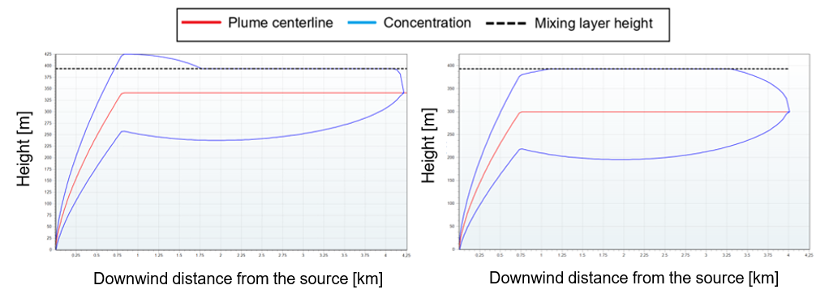
Figure 2: EFFECTS side view contours for two plumes with a maximum height situated below the mixing layer height with (a) a very small penetration fraction and (b) with no penetration.
On the other hand, while the plume is rising, the penetration fraction might still be increasing as a function of distance. Therefore, the final (maximum) penetration factor will be reached once the plume reaches its maximum height. Any part of the plume reaching this mixing layer boundary, will always penetrate through the mixing layer height due to the density differences. The only additional correction required in the calculation of vertical dispersion is the reflection against the ground (as shown in Figure 3). The part of the plume that penetrates the mixing layer is no longer affected by additional mass getting dispersed upwards. That is because all mass that initially did not get through this “ceiling” will later get reflected downwards.
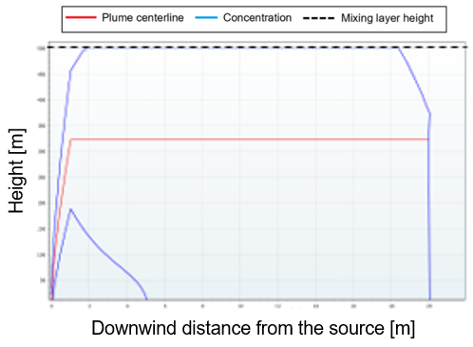
Figure 3: EFFECTS side view contours for a rising plume with a maximum height situated below the mixing layer height which is experiencing reflection against both the mixing layer height and the ground
The maximum height of the plume is situated above the mixing layer height
In this other case, the penetration fraction needs to be evaluated as it is highly relevant for the dilution of the plume concentration. In the situation where full penetration occurs (P = 1), the smoke plume will be fully trapped above the mixing layer (see Figure 4a). Thus, the (toxic) combustion products will not disperse back below the mixing layer. However, in some other cases the plume will not fully penetrate the mixing layer (P < 1). In those cases, for the mass fraction below mixing layer, a different contour is obtained because vertical transportation through the mixing layer is blocked (see Figure 4b).
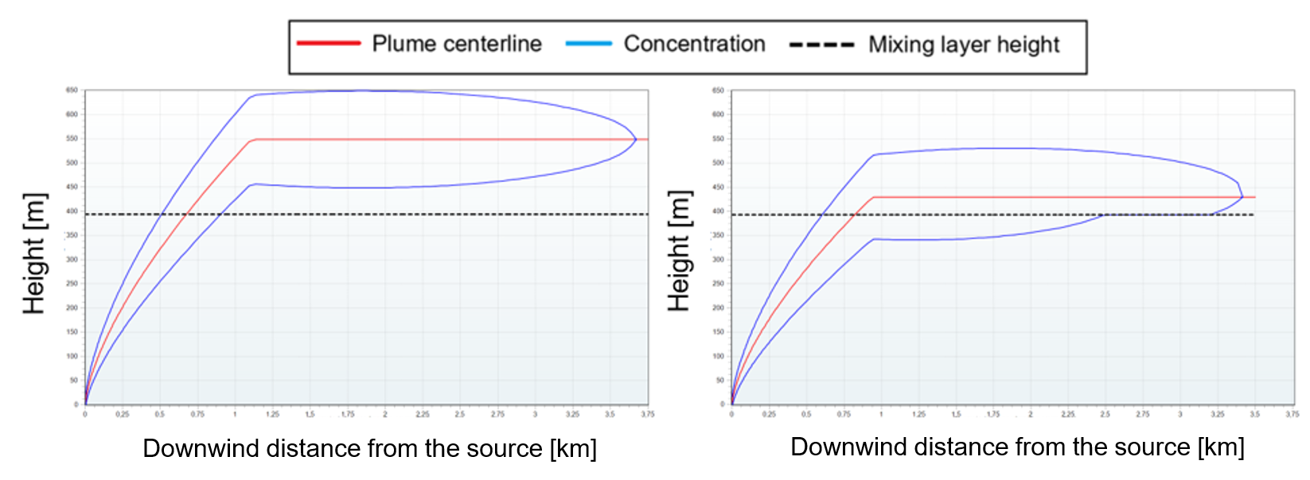
Figure 4: EFFECTS side view contours for a rising plume with a maximum height situated above the mixing layer height with (a) full penetration and (b) partial penetration with reflection against the mixing layer height
  - Validation
The validation of the “plume rise from fires” model is performed by comparing the results provided by the model with measurements from field experiments and with other already validated mathematical models.

The investigation presented by (Hall et al., 1995) is used to validate the concentration of the rising plume given by the model. This investigation examines a variety of fire plume discharges in a small-scale wind tunnel. Figure 5a shows experimental ground level concentrations downwind of the source for discharges with buoyancy only, where S, T, U, V, W, and X correspond to different experimental conditions. The simulation of S, T, U, V and W present good agreement with the experimental data. The simulation of X shows over-predicted values for downwind distances very close to the source.

On the other hand, Briggs (1969) collected a series of experimental data for rising plumes and presented a series of already validated theoretical formulas. Both the experimental data and the results from the different validated theoretical formulas, are used to assess the performance of the model to calculate the maximum height of the plume. The validation in Figure 5b shows that the simulation with the “plume rise from fires” model presents very good agreement with experimental data. Moreover, from all the theoretical formulas collected in the Briggs’ publication (Briggs, 1969), the equations implemented (see chapter 2) present the best agreement with experimental data.

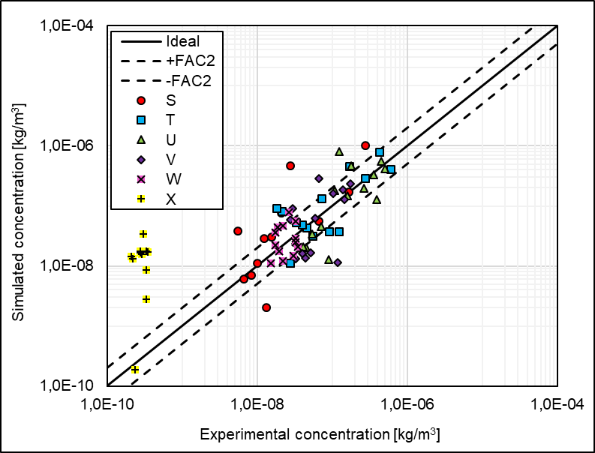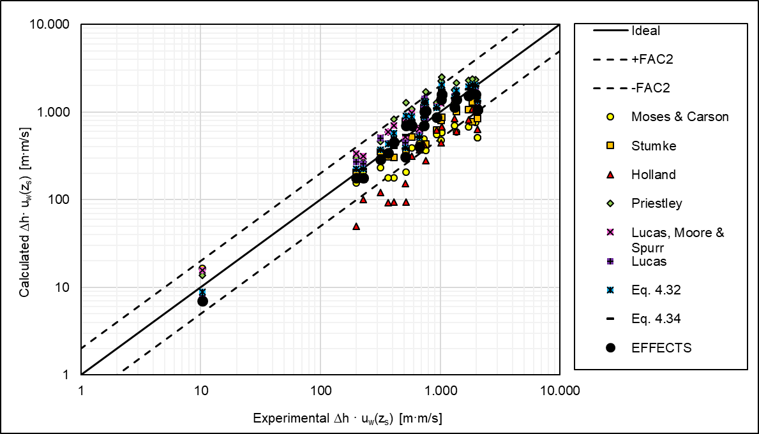
Figure 5: Validation against (a) Hall’s experimental data and (b) experimental data and validated theoretical formulas
  - Conclusions
The “plume rise from fires” model is a dedicated model now implemented in the software package EFFECTS to calculate the plume rise phenomenon of potential toxic combustion products. The model is based on the theory presented on Briggs’ study (Briggs, 1969), the theory in the Yellow Book (1992) and adapted with Mill’s correction for burning fires (Mills, 1987).

The model includes a mathematical approach for the calculation of the potential penetration of the plume through the atmospheric mixing layer. This approach includes an assessment of plume mass “lost” above the mixing layer, and inclusion of the plume’s fraction that gets reflected. This reflection phenomenon is highly relevant because if the plume is “trapped” below the mixing layer, this could lead to more severe consequences for individuals at ground level exposed to toxic combustion products.

The model provides safety professionals with valuable information for hazard identification, safety analysis and emergency planning. For instance, if a warehouse fire has enough convective heat production, a toxic smoke plume may rise high enough and even penetrate the mixing layer, not providing any danger at ground level. Although potential escalation must be avoided, trying to extinguish the fire would decrease the heat production, leading to more danger of toxic exposure at ground level.

The results of the validation of the “plume rise from fires” model present not only very good agreement with experimental data but also the best agreement compared to other already validated mathematical formulas.
Nomenclature
D – Diameter of the fire, m
Erf – Gauss error function, -
F_{y}(x,y) – Lateral (crosswind) dispersion, -
F_{z}(x,z) – Vertical dispersion, -
h_{BRIGGS} – plume rise according to Briggs, m
h_{max} – maximum height of the plume, m
h_{MILLS} – plume rise for Mills’ correction, m
MH – mixing layer height, m
N – Brunt Vaisala frequency, s⁻²
P(x) – penetration fraction at distance x, -
Q₀ – initial heat flux, kcal/s
u_{w} (z_{s}) – wind speed at stack height, m/s

V_{z} – virtual source for horizontal cross-section area equivalent to actual source, m
x – downwind distance, m
x_{f} – downwind distance at which plume reaches its maximum height, m
X_{d} – x_{f} + V_{z}, m
z_{s} – stack height, m
γ – entrainment coeff. for buoyant plume rise, -
σ_{z}(x) – vertical dispersion parameter, m
Δhu_{w}(z_{s}) – product of plume rise height and wind speed, m²s

References
Briggs, Gilbert Arthur. Plume Rise. Air Resources Atmospheric Turbulence and Diffusion Laboratory. Environmental Science Services Administration. 1969. Oak Ridge, Tennessee.

Hall, D., Kukadia, V., Walker, S., & Marsland, G. Watford. Plume dispersion from chemical warehouse fires. Building Research Establishment. 1995. UK.

Mills, M.T. Modelling the release and dispersion of toxic combustion products from chemical fires. International Conference on Vapor Cloud Modelling. November 1987. Boston, Massachusetts.

Morton, B., Taylor, G., & Turnen, J. Turbulent Gravitational Convection from Maintained and Instantaneous Sources. Proceedings of the Royal Society of London. 234: 1-23. 1956. London, UK.

Yellow Book. Methods for the calculation of physical effects due to release of hazardous materials (liquids and gases). CPR14E. 2nd Edition, 1992. The Hague, The Netherlands.

