CHEMICAL ENGINEERING TRANSACTIONS  VOL. 91, 2022 | A publication of
The Italian Association
of Chemical Engineering
Online at www.cetjournal.it

Guest Editors: Valerio Cozzani, Bruno Fabiano, Genserik Reniers
Copyright © 2022, AIDIC Servizi S.r.l.
ISBN 978-88-95608-89-1; ISSN 2283-9216

Analysis of the decay curve behaviour of petroleum emulsions with different salt contents
Gabriella C. Lopes*, Felipe A. G. Santos, Andressa M. Gonçalves, Luana C., Campanharo, Ana Paula Meneguelo, Daniel D. C. Ribeiro
Universidade Ferderal do Espírito Santo (UFES). Centro Universitário do Norte do Espírito Santo (CEUNES), São Mateus, ES, Brazil
*lopesgabriella447@gmail.com

During the exploration and production chain of an oil well, the fluids undergo agitation throughout the flow, thus forming oil emulsions of both the water-oil (W/O) and oil-water (O/W) types. Emulsions are composed of two immiscible liquids and form a heterogeneous and thermodynamically unstable system, as they generate colloidal particles. However, given the economic value of oil and the importance of disposing of water into the environment in a safe and correct manner (without chemical components and without containing crude oil), it is necessary to understand the stability process of emulsions and how to separate them. In this sense, this study experimentally analyzed the decay curve of emulsions with different contents of oil and water, observing the relationship between the droplet size distribution (DSD) and the salinity of the solution. The results showed that, in the range of contents analyzed, the presence of inorganic salts, specifically barium sulphate, causes instability of the emulsion.

  - Introduction
According to projections made by the International Energy Agency (IEA), the demand for oil sources will increase until the year 2040 (ELBAZ et al., 2015). Thus, understanding the exploration and production chain in order to solve the various problems that may appear is increasingly necessary.
A problem in the oil production chain is the presence of water during the exploration and production process, which associated with oil and shear can end up generating oil emulsions. According to Arnold and Smith (1992), to form an emulsion, three requirements are necessary: the existence of two immiscible liquids, sufficient agitation to form a dispersion of one liquid in another, and an emulsifying agent capable of stabilizing the droplets.
An emulsion is formed by droplets of one liquid (dispersed phase) in a second immiscible liquid (continuous phase). The types of emulsions formed depend on several factors, such as the proportion of liquids, if the volume of one liquid is much greater than that of another, the phase with the smallest volume tends to be the dispersed phase.
Emulsions are classified according to the liquid that forms their continuous phase. It can be classified as O/W (oil in water), W/O (water in oil), W/O/W (water in oil in water) and O/W/O (oil in water in oil) emulsion.
According to Georgieva (2009), there are several factors that affect the stability of an emulsion, some of them are: solid particles, droplet size and aging of emulsions.
a) Solid particles: The solid particle (inorganic solid: like barium sulfate) can help in the formation of a thick layer, which ends up generating a rigid film, which prevents coalescence between the drops.
(AVEYARD et al., 2003)
b) Droplet size: The droplet size distribution (DSD) influences the stability of emulsions, as it controls flocculation, coalescence and resistance to sedimentation, as a consensus in the literature, the smaller the droplet size, the more stable the emulsion formed. (MORADI et al., 2011)
c) Aging of emulsions: as the emulsion ages, its stability increases through oxidation, since there is an increase in viscosity. (RAMALHO, 2000)
Emulsions, in the oil exploration and production chain, can cause problems such as an increase in the cost of operation, due to the need for separation of emulsions, corrosion in the transport system, clogging of pipelines, high cost in storage and transport, reduced value from the oil itself and contamination of the environment through discarded water (YARRANTON, ORTIZ and BAYDAK, 2010; WONG, LIM and DOL, 2015). In the environment, as emulsions can cause several problems in marine biota, such as damage to the development process, affecting habitats, the genetic chain and the life of fauna and flora (BAPTISTA, 2011). Thus, given this scenario, the chemical engineering area is looking for innovations and solutions for the most diverse segments, including the oil sector and the sphere of emulsions to be able to separate them in an increasingly correct way (BRUM e GUIMARÃES, 2015). Thus, the present article aims to experimentally analyze the stability of synthetic emulsions with different water and oil contents and how inorganic particles can affect the decay curve of these emulsions.

  - Methodology
    - Prepared of synthetic emulsions
Seven synthetic emulsions were made with a volume equal to one liter, and with 5% surfactant (Span 80 - Croda) and with different percentages of water and oil, as shown in Table 1.
Table 1: Percentage of emulsions prepared.
Emulsion | Water (%) | Oil (%)
EM1  EM2  EM3  EM4  EM5  EM6 | 5  10  20  30  40  50 | 95  90  80  70  60  50
EM7 | 60 | 40

The emulsions were prepared using a homogenizer with a rotation of 10.000 rpm and a time of five minutes.

    - Preparation of synthetic emulsions with barium sulfate
After analyzing the decay curve of synthetic emulsions prepared with water and oil, it was resolved analyze the influence an inorganic salt can have on emulsions. Thus, tests were performed stability in EM2 and EM5 emulsions with barium sulfate solution at 250ppm.
    - Emulsion analyses
Subsequently, the emulsions were placed in the reactor to follow the decay curve.
  - Results and discussions
The decay curves of synthetic emulsions were analyzed based on coalescence and sedimentation zones and droplet size distribution.
    - Barium sulfate-free synthetic emulsions
3.1.1 Coalescence zones and sedimentation zones
In each emulsion, the heights of the coalescence zones (Cz) and sedimentation zones (Sz) were analyzed thirteen times with the same spacing of time, as can be seen in Table 2 and Table 3.

Table 2: Heights (in centimeters) measured in the coalescence zone of each emulsion.
Measurements | EM1 | EM2 | EM3 | EM4 | EM5 | EM6 | EM7
 | Cz
1  2  3  4  5  6 | 0  0  0  0  0  0 | 0  0  0  0  0  0 | 0  0,5  0,7  1  1  1,2 | 0  0,3  0,4  0,6  0,9  1,1 | 0  0  0  0  0  0 | 0  0  0  0  0  0 | 0  0  0  0  0  0
7  8  9  10  11  12  13 | 0  1,2  1,4  1,8  0,9  0,9  0,9 | 0  1,2  2,1  2,2  2,8  2,8  2,8 | 1,5  1,9  2,4  3,6  5,2  5,7  6,3 | 1,3  1,4  1,6  1,6  1,8  1,9  1,9 | 0  0  0  0  0  0  0 | 0  0  0  0  0  0  0 | 0  0  0  0  0  0  0

Table 3: Heights (in centimeters) measured in the sedimentation zone of each emulsion.
Measurements | EM1 | EM2 | EM3 | EM4 | EM5 | EM6 | EM7
 | Sz
1  2  3  4  5  6 | 0  0  0  1  1,5  1,6 | 0  1,3  4,5  6,1  5,2  4,5 | 0  0  0  0  0  0 | 0  0  0  0  0  0 | 0  0  0  0  0  0 | 0  0  0  0  0  0 | 0  0  0  0  0  2,7
7  8  9  10  11  12  13 | 1,4  1,3  1,2  1,2  2,2  2,2  2,3 | 3,3  3  2,8  2,8  2,6  2,8  2,8 | 0  0  0  0  0  0  0 | 0  0  0,8  1,2  3,4  3,4  3,4 | 0  0  0  0  0  0  0 | 0  0  1,3  1,3  1,7  2,2  2,5 | 1,1  1,1  1,4  1,5  1,8  2,4  2,8

3.1.2 DSD (droplet size distribution)
It was observed that the emulsions that contained a percentage of water equal to or greater than the oil (EM6 and EM7) did not present a coalescence zone at the measured points and only presented a sedimentation zone in the eighth and sixth measurement, respectively.
Analyzing their DSD with an optical microscope at 40X, as shown in Figure 1, it is observed that the diameter of the drops produced was large, which refers to more stable emulsions, that is, they have an easier destabilization process.

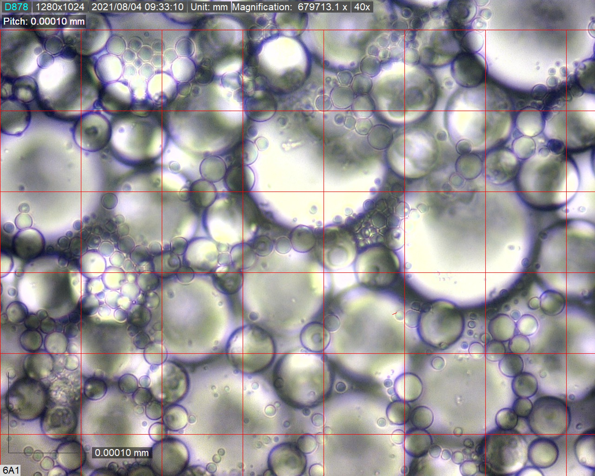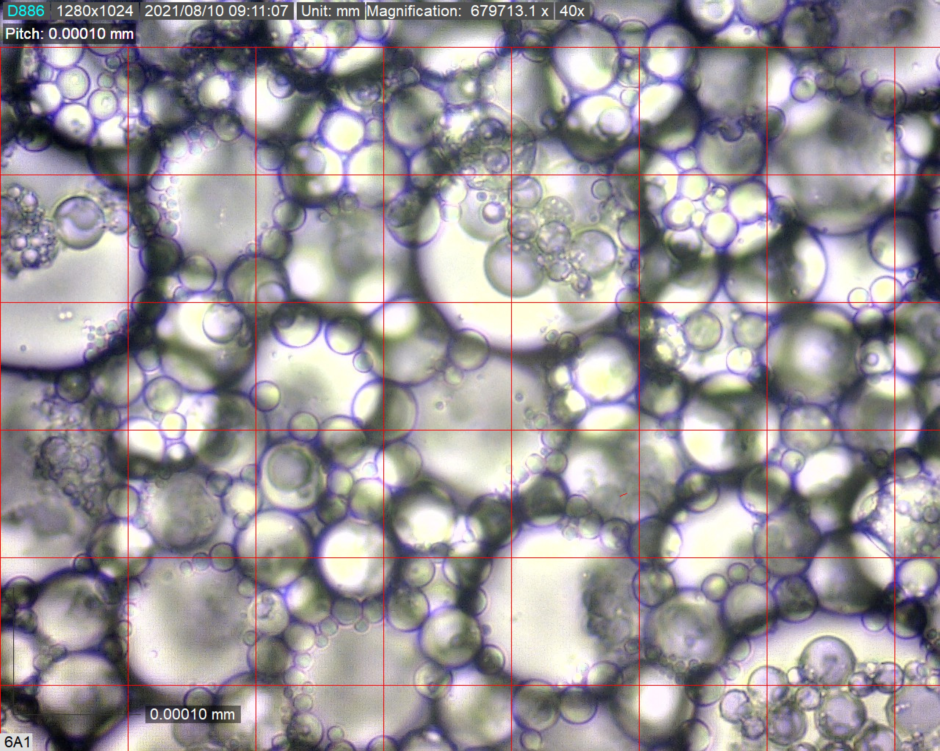
- (b)
Figure 1: Emulsion DSD (a) EM6 (b) EM7
Observing the DSG of emulsion EM5, which did not show coalescence or sedimentation zones, as shown in Figure 2, it is possible to see that it has a small droplet diameter.

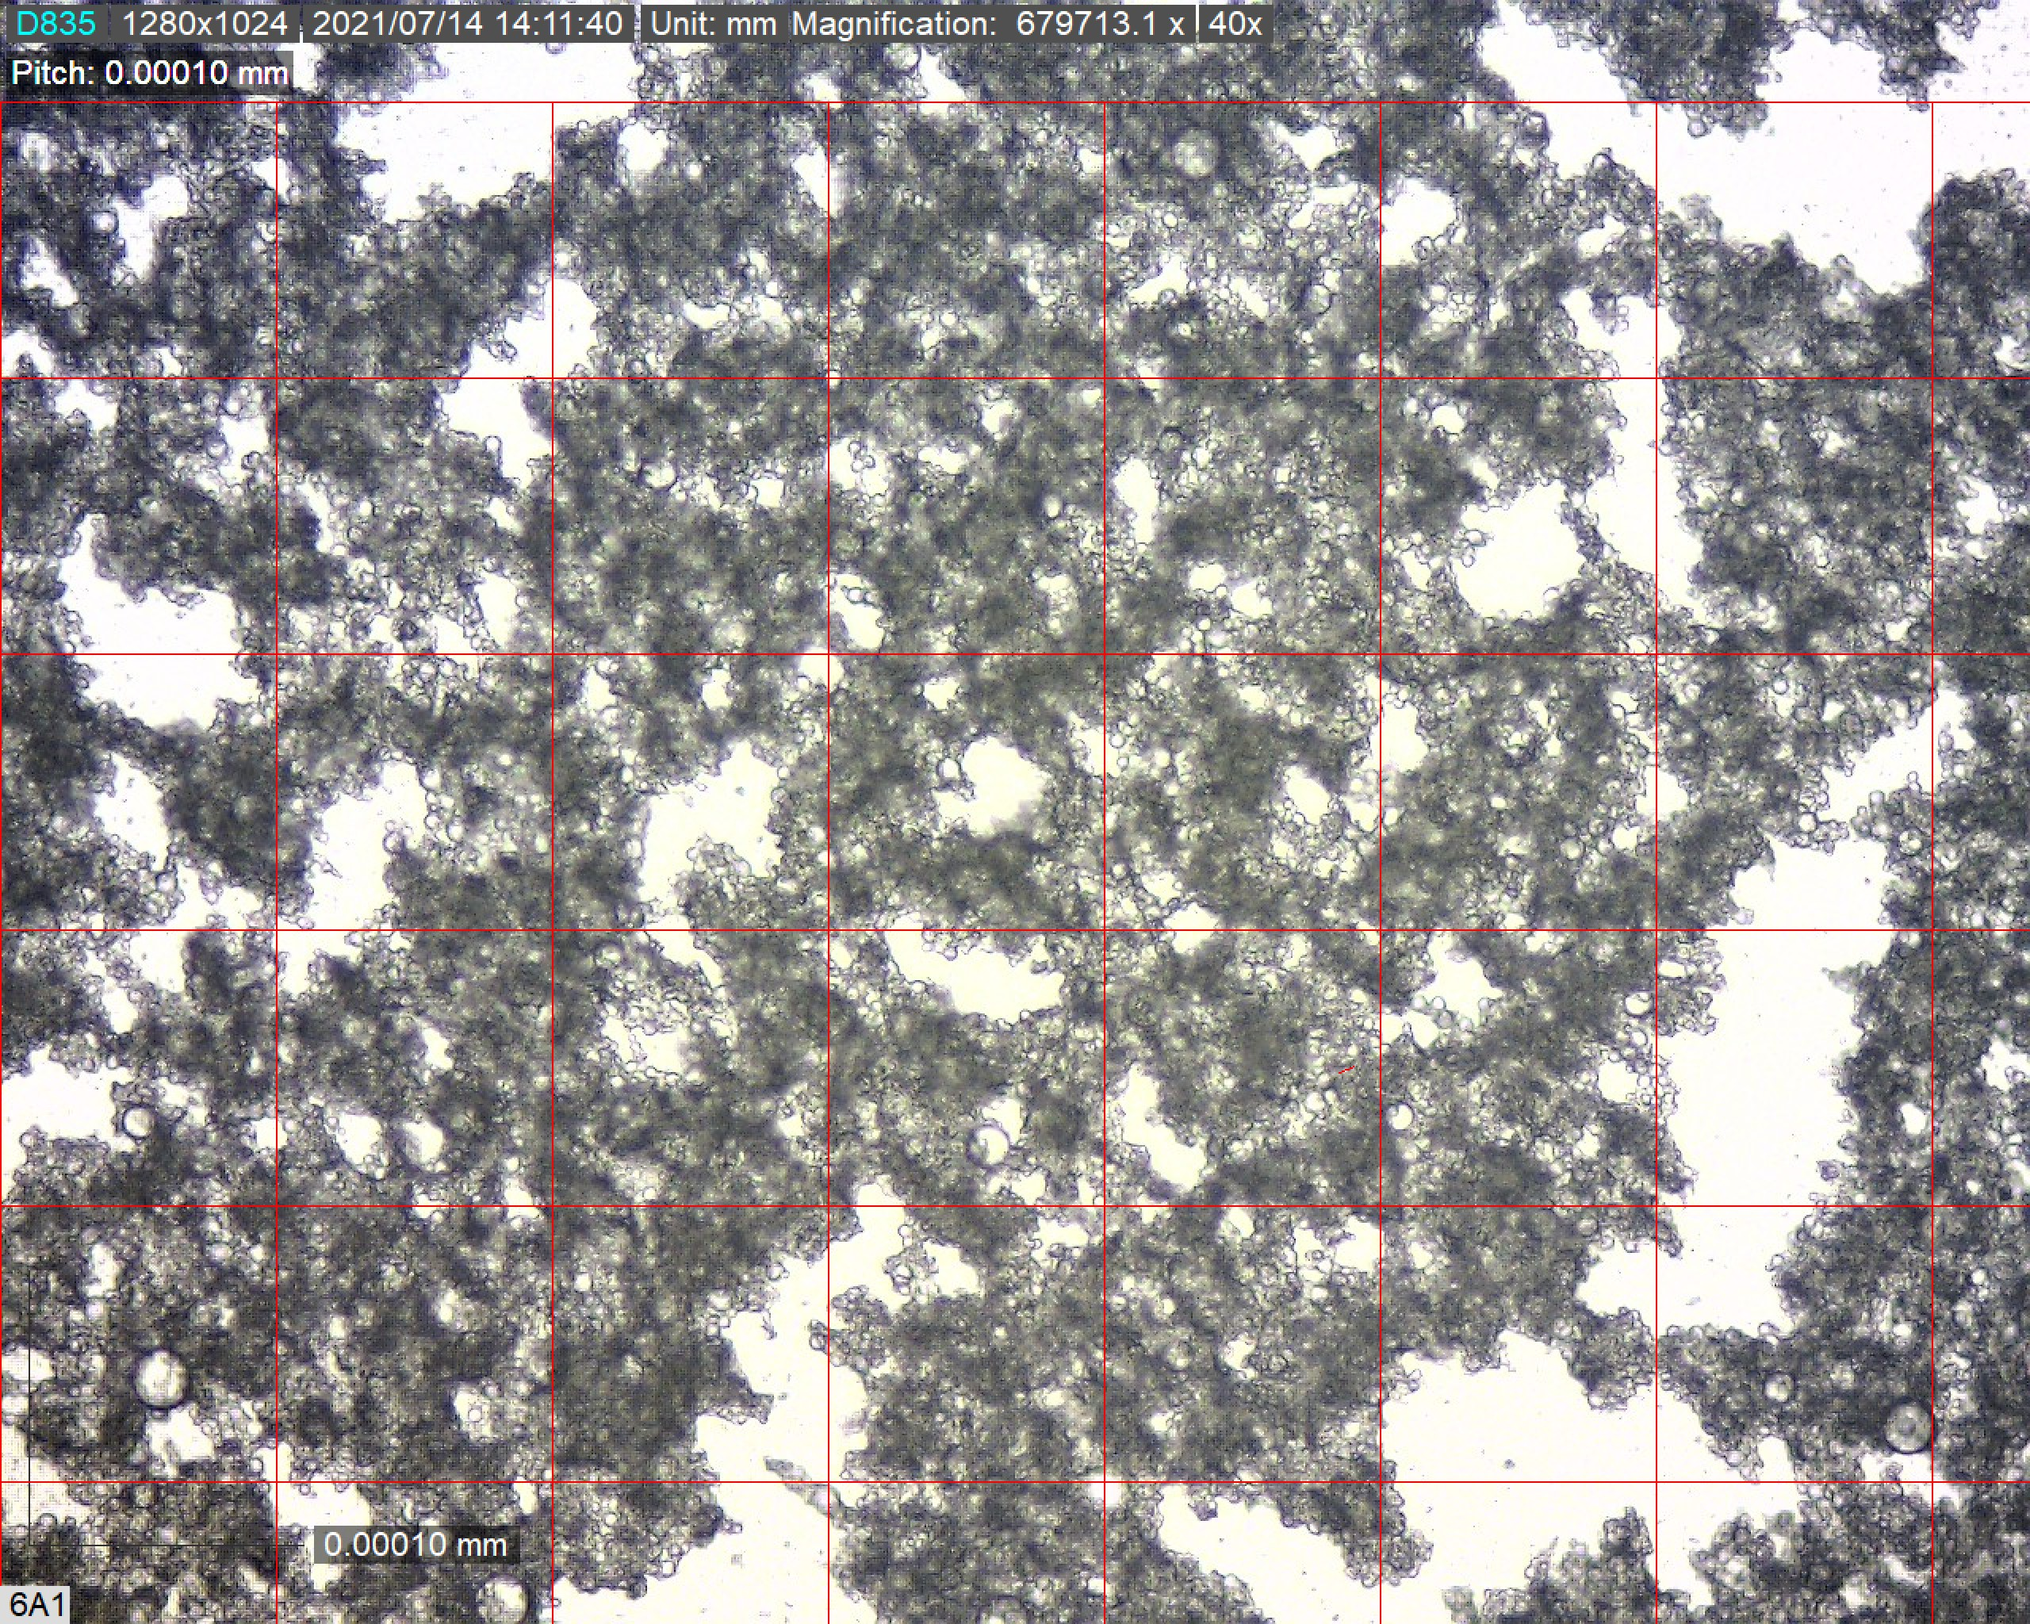
Figure 2: Emulsion DSD EM5.
Analyzing the EM2 emulsion, which presented the highest heights in the coalescence and sedimentation zones, we have the size of the droplet distribution as shown in Figure 3.

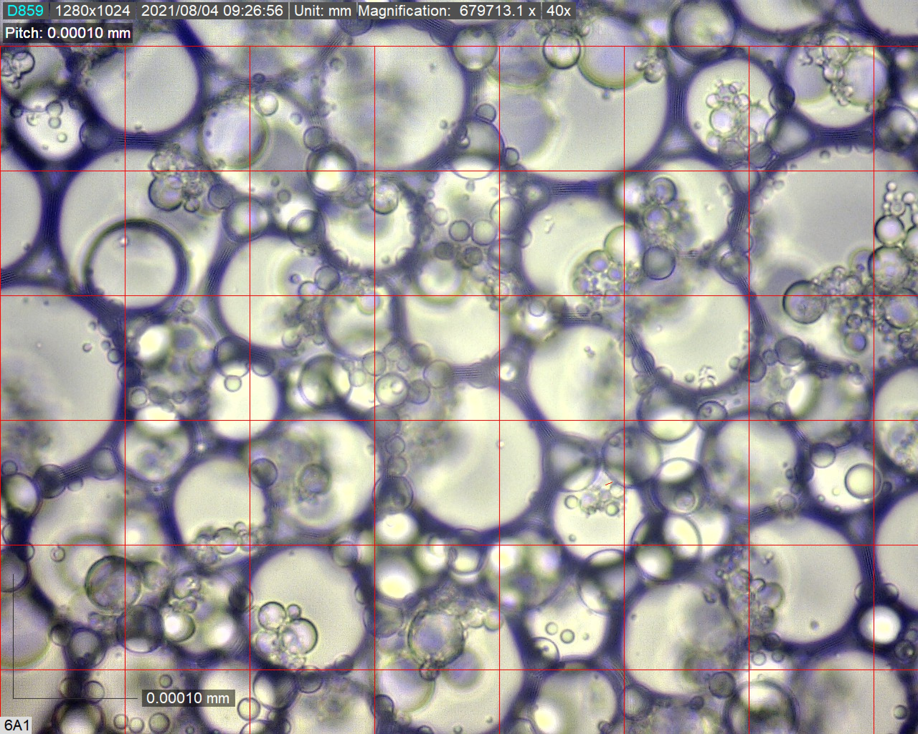
Figure 3: Emulsion DSD EM2.
In Figure 3, it is possible to see that the drops have a large diameter, that is, EM2 is an emulsion that is easy to destabilize, and in the experimental process carried out, it proved to be the most stable emulsion.
    - Synthetic emulsions with barium sulfate
EM2 and EM5 emulsions were chosen to analyze the influence of barium sulfate, because EM2 was the emulsion that presented the highest coalescence and sedimentation heights and EM5 did not present any height in these zones.
3.2.1 Coalescence zones and sedimentation zones
In EM2 and EM5 emulsions, the heights of the coalescence (Cz) and sedimentation (Sz) zones were analyzed thirteen times with the same spacing of time, as can be seen in Table 4 and Table 5.

Table 4: Heights in centimeters) measured in the coalescence zone of each barium sulfate emulsion.
Measurements | EM1 | EM2
 | Cz
1  2  3  4  5  6 | 0  2,7  4,7  6,4  7,2  7,8 | 0  0  0  0  0  0
7  8  9  10  11  12  13 | 8,1  8,4  8,5  8,5  8,6  8,7  8,9 | 0  0  0  0  0  0  0

Table 5: Heights in centimeters) measured in the sedimentation zone of each barium sulfate emulsion.
Measurements | EM1 | EM2
 | Cz
1  2  3  4  5  6 | 0  0  0  0  0  0 | 0  0  0  0  0  0
7  8  9  10  11  12  13 | 0  0  0  0  0  0  0 | 0  0  0  0  0  0  0

3.2.2 DSD
Analyzing the DSD of the synthetic emulsions with barium sulfate EM2 and EM5 with the optical microscope at 40X, as shown in Figure 4, it is observed that the diameter of the drops produced is smaller than previously in the synthetic emulsions without barium sulfate, according to the Figure 2 and Figure 3.

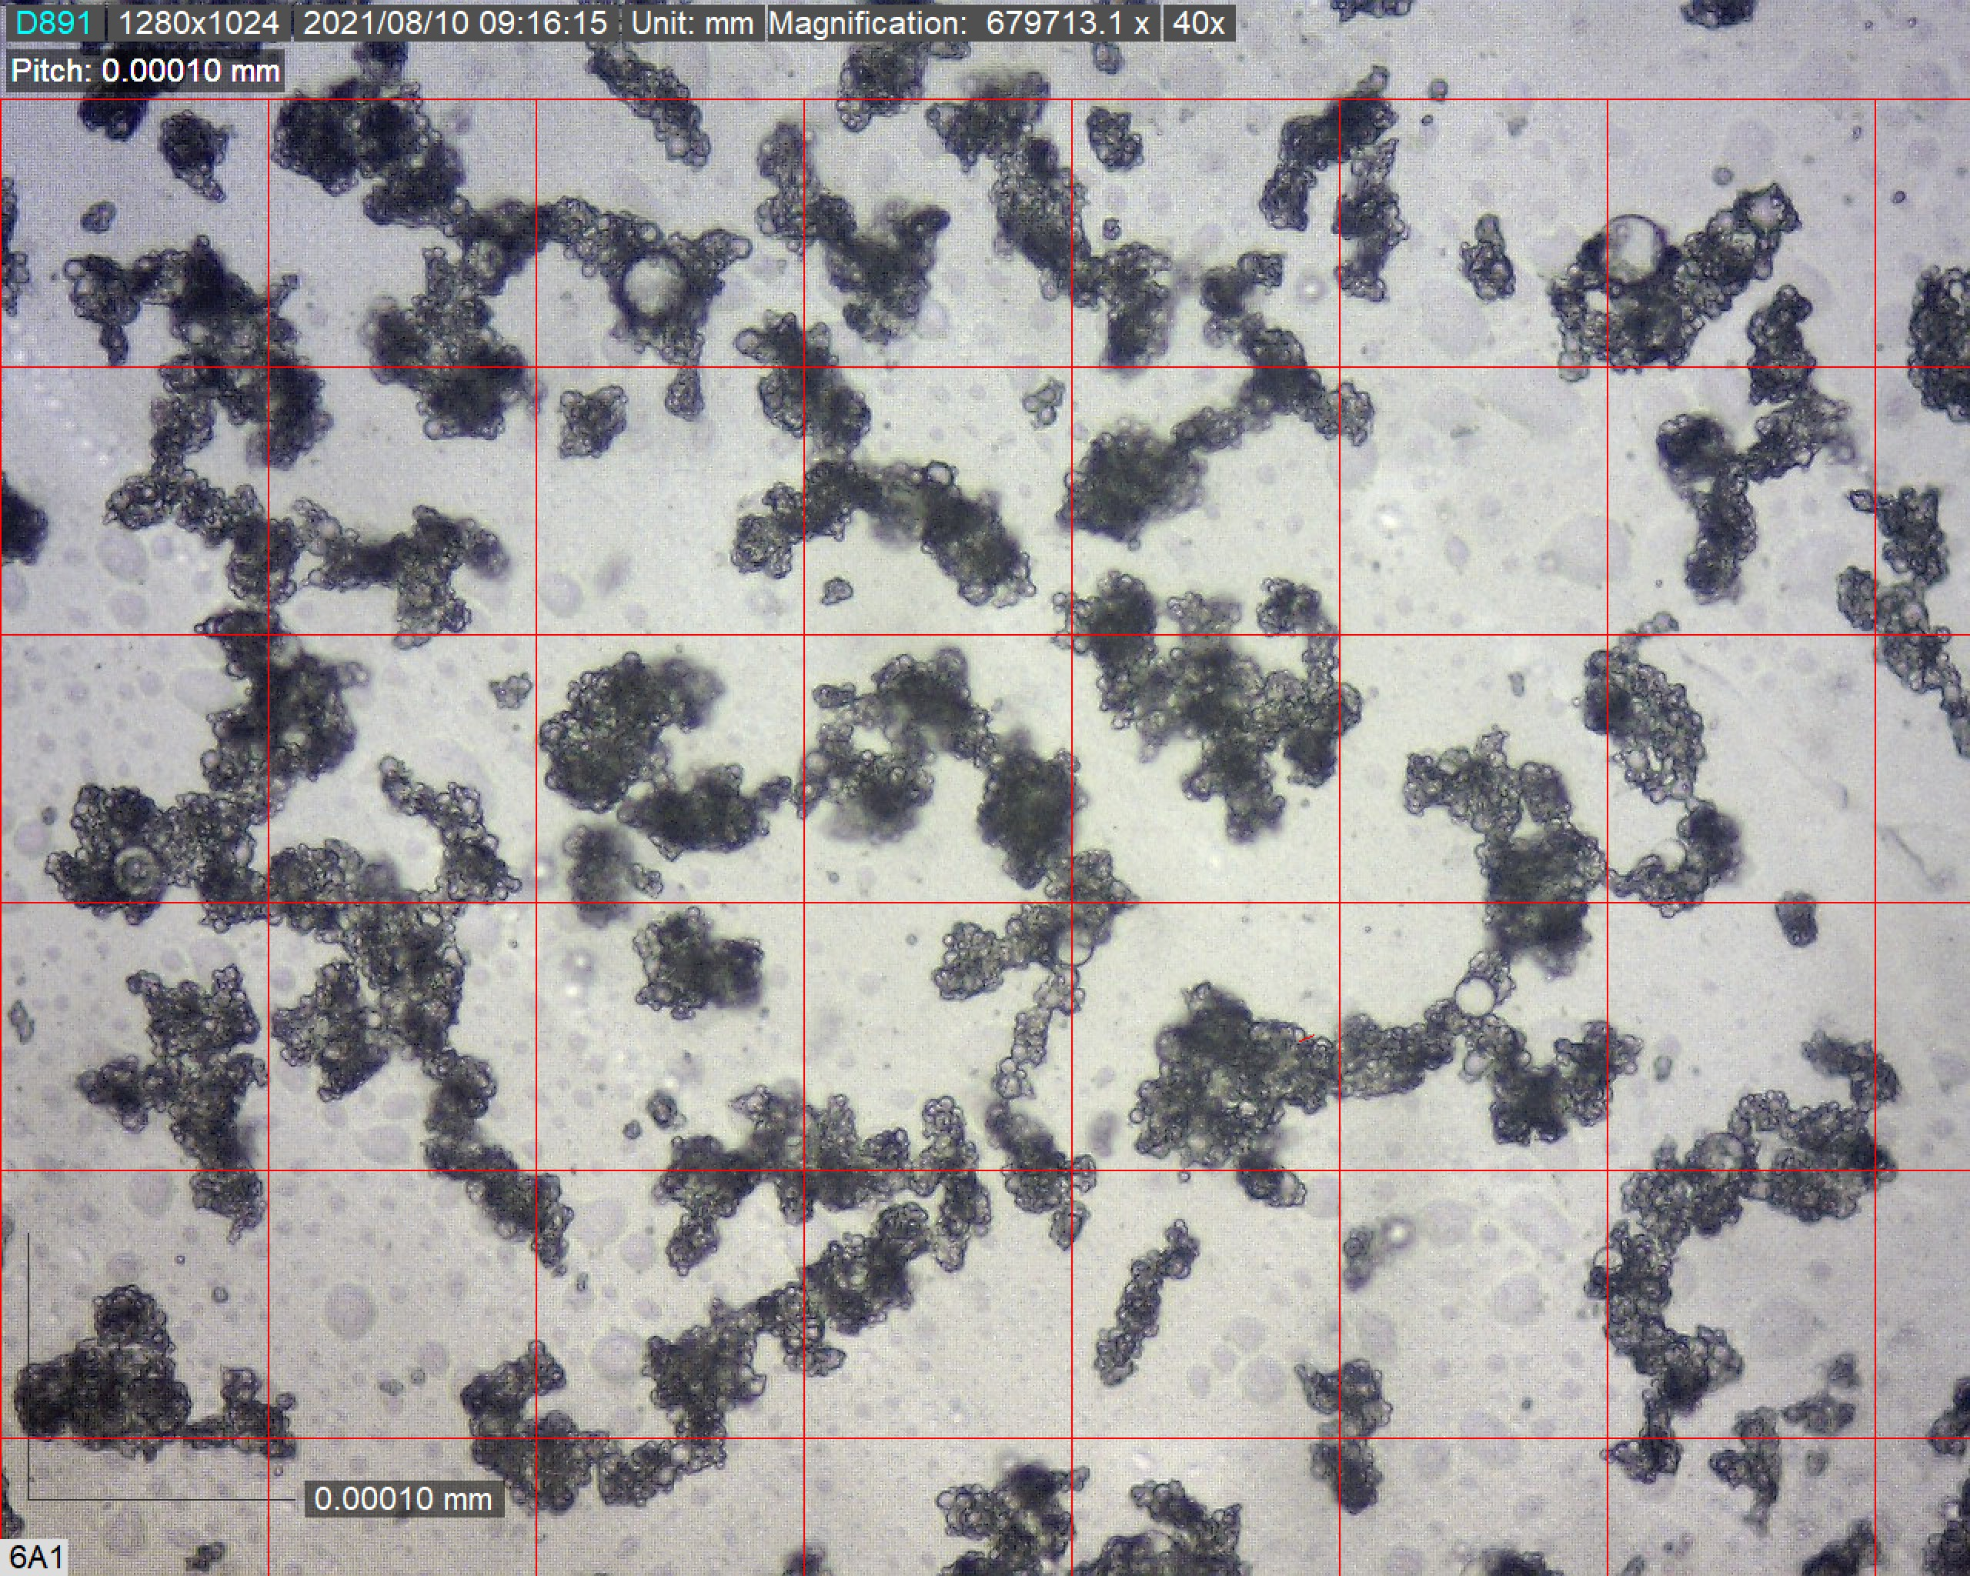
- (b)
Figure 4: DSG synthetic emulsions with barium sulfate (a) EM2 e (b) EM5.
  - Conclusions
The decay of an emulsion is directly linked to the droplet distribution (DTG), that is, the larger the diameter, the more stable the emulsion, which was observed in the synthetic emulsions EM2, EM6 and EM7, and when smaller, the more unstable it is. the emulsion, as shown in the synthetic emulsion EM5, which showed neither coalescence nor sedimentation zones, which had the smallest droplet diameters and the smallest values of coalescence and sedimentation heights.
Inorganic particles also interfere in the decay curve of emulsions, that is, because they form a layer of solid aggregates, they interfere in the formation of coalescence and sedimentation zones. Thus, with the addition of barium sulfate, we observed that the synthetic emulsions EM2 and EM5 presented DTG with smaller droplets, that is, the addition of an inorganic salt helps in the process of making the emulsion unstable.
References
Arnold, KE and Smith, HV (1992) Crude Oil Emulsion, 3rd edn. Petroleum Engineering Handbook: Bradley University.

Aveyard, R, Binks, BP and Clint. JH (2003) ‘Emulsion Stabilised Solely by Colloidal Particles, Advances in Colloid and Interface Science’, Journal of Documentation, [e-journal], vol. 100-102, pp. 503-546. <https://doi.org/10.1016/S0001-8686(02)00069-6>

Baptista CRC (2011) ‘Metodologia da Companhia de Tecnologia de Saneamento Ambiental (CETESB) Aplicada na Valorização e Precificação dos Recursos Ambientais: Análise de Derramamento de Petróleo e seus Derivados por Embarcações no Meio ambiente Marinho’, Revista Científica: Semana Acadêmica, Fortaleza, v. 000209, <https://semanaacademica.org.br/artigo/metodologia-da-companhia-de-tecnologia-de-saneamento-ambiental-cestesb-aplicada-na-valoracao-e>

Brum H and Guimarães L (2015), ‘Inovação na Engenharia Química, Um Processo que Sempre Existiu’, Revista Brasileira de Engenharia Química’ [e-journal], v. 2, pp. 6-11. <https://www.abeq.org.br/comunicacao/rebeq/REBEQ_31%2002%202015/Completo/REBEQ_v31n2.pdf>

Elbaz, AM, Abdul, J, Abdul, G, Hourani, N, Emwas, AM, Sarathy, M and Roberts, WL (2015) ‘TG/DTG, FT-ICR Mass Spectrometry, and NMR Spectroscopy Study of Heavy Fuel Oil’, Energy and Fuels, [e-journal], vol. 29, pp. 7825-7835. <http://pubs.acs.org/doi/10.1021/acs.energyfuels.5b01739>
Georgieva, D, Schmitt, V, Leal-Calderon, F and Langevin, D (2009) ‘On the Possible Role of Surface Elasticity in Emulsion Stability’, Langmuir, [e-journal] vol. 209 pp. 5565-5573. <https://pubs.acs.org/doi/abs/10.1021/la804240e>

Moradi, M, Alvarado, V and Huzurbazar, S (2011) ‘Effect of Salinity on Water-inCrude Oil Emulsion: Evaluation through Drop-Size Distribution Proxy’. Energy and Fuels, [e-journal], vol. 25, pp. 260-268. <https://pubs.acs.org/doi/10.1021/ef101236h>

Ramalho, JBVS (2000) ‘Efeito do Envelhecimento sobre Viscosidade e Estabilidade de Emulsões de Petróleo do Tipo Água-Óleo’. Boletim Técnico: Petrobras S.A., vol. 43 pp.100-103.

WONG, SF, LIM, JS and DOL, SS (2015) ‘Crude oil emulsion: A review on formation, classification and stability of water-in-oil emulsions’, Journal of Documentation, [e-journal], v. 135, pp. 498-504, 2015. <https://doi.org/10.1016/j.petrol.2015.10.006>

Yarranton, HW, Ortiz, DP and Baydak, EN (2010) ‘Effect of surfactants on interfacial films and stability of water-in-oil emulsions stabilized by asphaltenes’. Journal Documentation, [e-journal], v. 351, pp. 542-555. <https://doi.org/10.1016/j.jcis.2010.08.032>

