CHEMICAL ENGINEERING TRANSACTIONS  VOL. 91, 2022 | A publication of
The Italian Association
of Chemical Engineering
Online at www.cetjournal.it

Guest Editors: Valerio Cozzani, Bruno Fabiano, Genserik Reniers
Copyright © 2022, AIDIC Servizi S.r.l.
ISBN 978-88-95608-89-1; ISSN 2283-9216

Sustainable technology solutions for reuse of process wastewaters from fine chemical industries
Andras Jozsef Toth*, Reka Ladanyi, Huyen Trang Do Thi, Botond Szilagyi, Eniko Haaz
Environmental and Process Engineering Research Group, Department of Chemical and Environmental Process Engineering, Budapest University of Technology and Economics, H-1111, Budapest, Budafoki Street 8., Hungary
andrasjozseftoth@edu.bme.hu
In the fine chemical industries, especially in the pharmaceutical industry, production technology generates large amounts of liquid waste and industrial waste solvents. Separation of various organic substances used in industry, such as adsorbable organic halides (AOX), from industrial wastewater is an important task of environmental protection. In this work, two technologies were compared to investigate the recycling/reuse of organic material of process wastewaters. The analysis was based on real case study from fine chemical industry. The separation efficiency, operational parameters and cost analysis were carried out to examine stripping and distillation technologies. The calculation was achieved in professional flowsheet simulator environment. According to the results, it can be determined there is no significant difference in separation efficiency of wastewater output streams. However, in the case of distillation technology, the reuse of halides can be possible inside the factory, so this is the recommended procedure for environmental protection. The cost of recovery technologies is also compared with waste incineration. These calculations also demonstrate the effectiveness of the treatment methods, because with recovery technologies it is possible to obtain a reduction of up to 85% compared to incineration.
  - Introduction
A serious problem is that the solvents used in the chemical industry, especially the organic solvents applied for syntheses and purification, at the end of the process, form a residue that is very harmful to the environment. They must not be discharged into the sewage system or into rivers without treatment, but organic pollutants must be removed and regenerated beforehand. For this reason, the handling of solvents is an important problem, as they are widely used in the chemical industry on the one hand, and have dangerous properties such as high volatility or toxicity on the other hand (Toth, 2015). Therefore, when using such materials, we must take into account the impact of the use of these solvents on the environment. In many cases, we cannot avoid using them, while in other cases it may be possible to replace them with other, more environmentally friendly materials (Dursun and Sengul, 2006). Generally, it is very important to make the waste generated harmless to the environment and wildlife with the appropriate technology (Mizsey, 1994). Of course, like all technologies, the treatment of organic solvents has an impact on the environment, but a well-designed waste treatment can be very beneficial from an ecological point of view (Belis-Bergouignan et al., 2004).
In order to provide sustainable living conditions on Earth for the future, industrial processes need to be carefully planned and operated. To this end, more and more companies are paying attention to environmental awareness. This can be achieved by creating link between production, use and waste generation, so that nature and industry can enter in a closer symbiosis. This means that the waste produced by one sector can be used as raw material in another one. Figure 1 shows the flowsheet of the circular economy (Anastasio, 2016). The circular economy is a system in which no waste is generated, and in which the products of today are also the raw materials of the future (Toth et al., 2018a). It is defined as circular because, in contrast to today's - typically linear - system where products are manufactured, used and then discarded, in the circular economy the products are returned to production instead of being discarded, in the same or processed form.

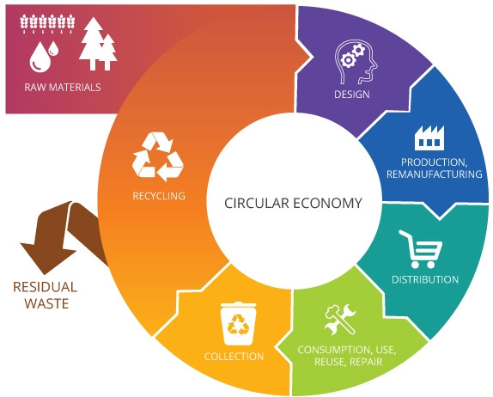
Figure 1: Flowsheet of the circular economy (Anastasio, 2016)

Waste management offers an opportunity to minimize hazardous waste generation and reduce the use of raw materials and the release of toxic substances into nature. This is all part of the design of environmentally friendly products and processes. Such hazardous waste includes highly toxic chemicals such as methanol and, in addition, adsorbable organically bound halogens (AOX), which are particularly important. Process wastewaters contain large amounts of adsorbable organically bound halogens, and this is a serious problem in the chemical industry. AOX is a generic term that contains all organic halogen compounds including chlorides, bromides, and iodides (Shestakova and Sillanpää, 2013).
Surveys show that many technologies are available for the treatment of chemical process wastewaters, but very few of them are widely used. The most commonly applied are distillation (Masango, 2005), stripping and incineration, for process wastewater containing mainly volatile organic pollutants (Brinkmann et al., 2016). However, waste solvent management is also strongly influenced by other factors such as cost, logistics, legislation, directives, storage capacity and existing technologies in production (Riese and Grunewald, 2018).
The aim of this work is to investigate in flowsheet environment (ChemCAD) and to compare the two common AOX removal technologies, namely stripping and distillation with the incineration of the raw process wastewater. The goal of the treatment is to reduce the AOX content of process wastewater to below 8 ppm (28/2004. (XII. 25.) Ministry of Environment Regulation).
  - Materials and methods
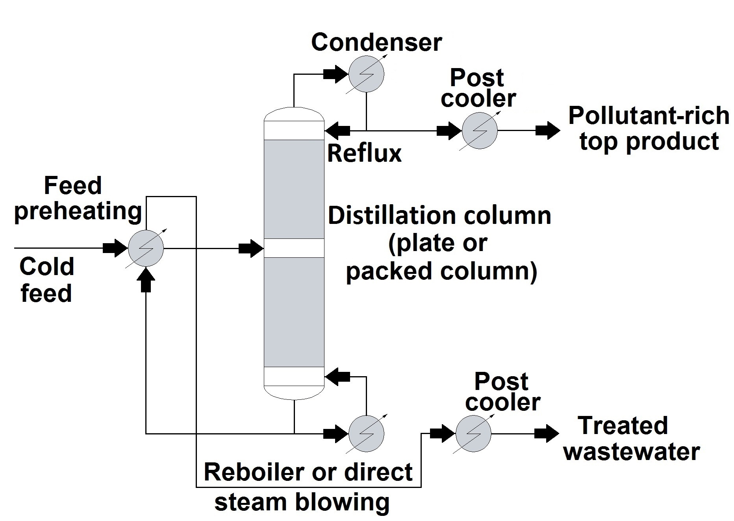
Figure 2 shows the theoretical, general schemes of stripping and distillation for treatment of process wastewater from chemical industry.
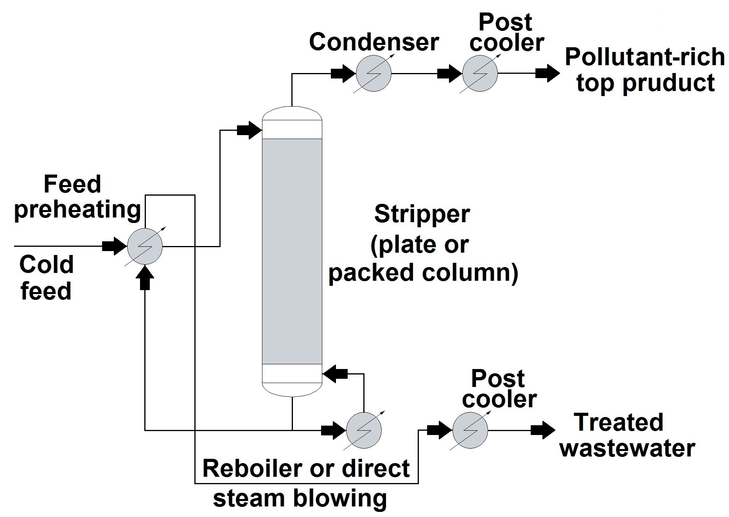
Figure 2: General schemes of process wastewater stripping (left) and distillation (right) (Toth, 2015)

Table 1 shows the composition of the process wastewater to be treated. The substance comes from pharmaceutical industry, predominantly from used solvents.

Table 1: Input composition of the initial process wastewater (Toth et al., 2018a)
AOX [ppm] | Acetone [ppm] | Methanol [ppm] | Dry substance [%]
5968 | 3252 | 2092 | 0.71
As it can be seen, the AOX content is above the discharge limit (8 ppm). Table 2 shows the components of AOX in the process wastewater and their amounts.

Table 2: AOX compounds in the initial process wastewater
Component name | CAS | ppm | AOX% | Azeotropic T-bp [°C]
Dichloromethane  Trichloromethane  1,2-Dichloroethane  Chloroform  Tetrachloroethylene  Carbon tetrachloride | 75-09-2  79-01-6  107-06-2  67-66-3  127-18-4  56-23-5 | 5956  5.4  3.0  1.8  1.2  0.6 | 99.8  0.09  0.05  0.03  0.02  0.01 | 38.1  73.1  71.6  56.3  88.5  66.8

It can be seen that 99.8% of AOX is dichloromethane (DCM), which is a toxic volatile compound found in wastewater and surface water and widely used in the chemical industry as an organic solvent. DCM is a potential carcinogen and can cause cancer in humans and animals.
The steam stripping is an alternative to air stripping, with a much simpler structure. Steam stripping was used to extract volatile contaminants. Figure 3 introduces the flowsheet of steam stripping method from ChemCAD 7.1.5 process simulator. K-values model was UNIQUAC and the Global Phase Option was V/L/L/S because of the highly non-ideal mixture and SCDS columns were used in the case of stripping and distillation too (Toth et al., 2018b).

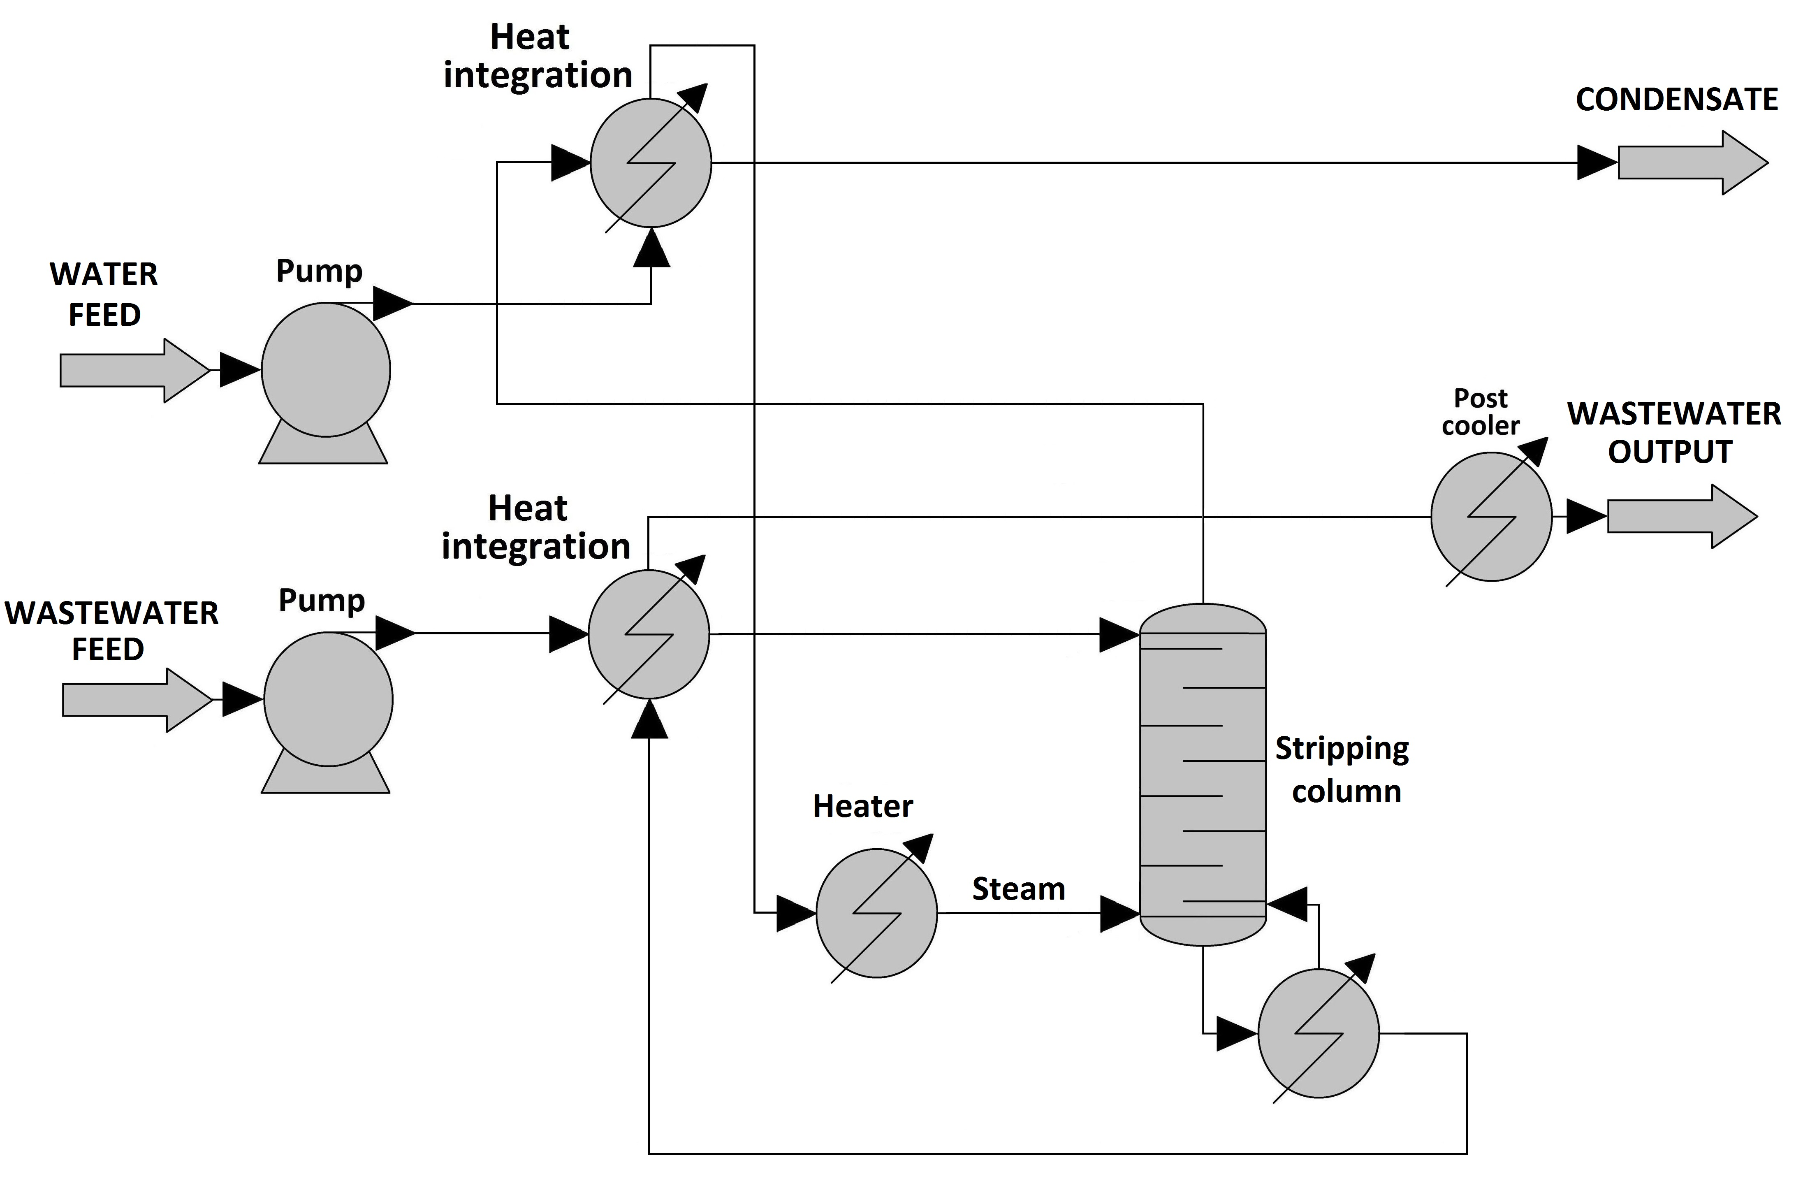
Figure 3: Flowsheet of the treatment of process wastewater with steam stripping

The model essentially consisted of a single packed stripping column into which steam was introduced, instead of air. Furthermore, when steam is used instead of gas, the volatile components are not released into the atmosphere but can be condensed and treated. In addition, in many cases, this condensed liquid contains a large amount of the volatile component, and this allows the component to be reused inside or even outside the technology. In the steam stripper model, process wastewater reached the top of the column with the volume flow of 50 m³/h. The steam flowed to the bottom of the column in countercurrent with the volume flow of 1.05 m³/h. The stripping column was 6 m high, of 0.6 m diameter with structured packing, and it had 10 theoretical plates, which was based on sizing optimization.
The incoming wastewater was heated to 95°C using the heat of the bottom product applying a heat exchanger. The water required to produce the incoming steam was preheated using the heat of the overhead product by means of a heat exchanger, and the steam was produced by an electric heater at the temperature of 120°C and the pressure of 2 bar. As it can be seen in Figure 3, energy integration takes place in the system, during which the invested heat can be recovered. The detailed calculation and optimization process of steam stripping can be found in the paper of Toth and Mizsey (2015).

The alternative to steam stripper is distillation. Figure 4 shows a column from pharmaceutical industry, which can reduce the AOX content of process wastewater below its limit. The flowsheet model of distillation and size parameters of the model column were based on this industrial column. Direct steam blowing was used to heat the bottom product of the column.

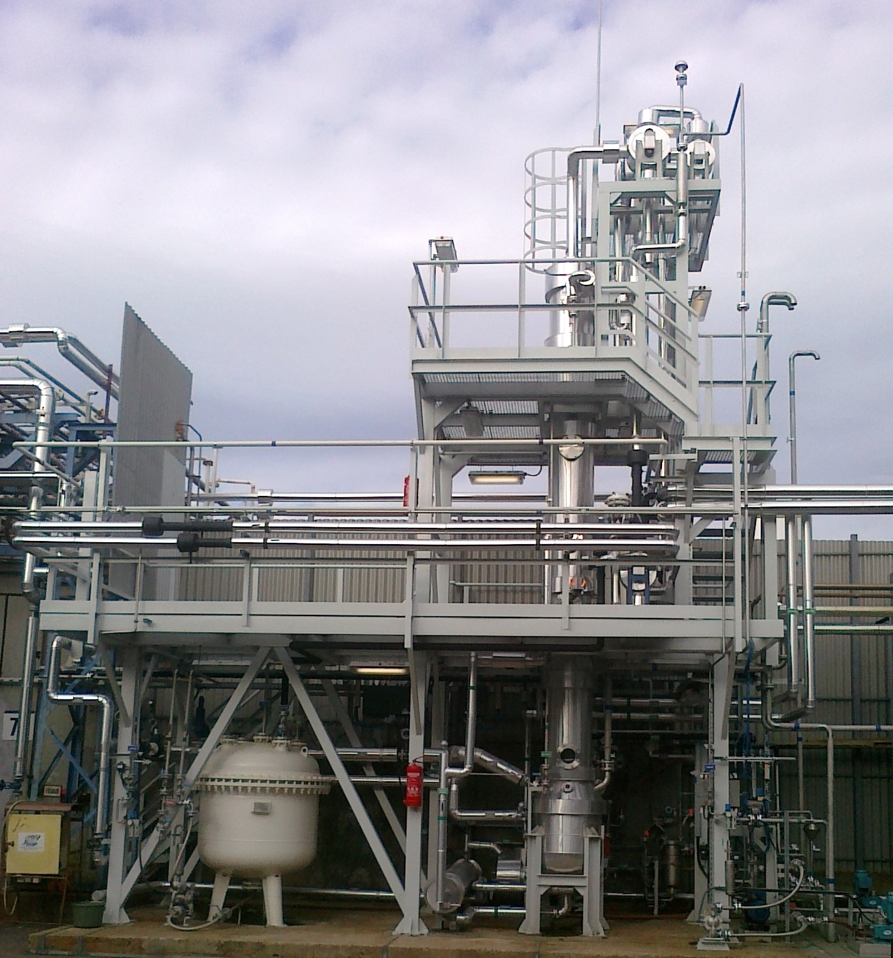
Figure 4: Industrial distillation column for treatment of process wastewater (Toth, 2015)

Figure 5 shows the ChemCAD flowsheet of distillation. The column had 15 theoretical plates. It was 5 m high with 0.4 m diameter and it had structured packing. The feed was 50 m³/h as in the stripping method and it was preheated using heat integration system (Hirata, 2009). The reflux ratio was 2 and the feed entered in the middle of the column. The detailed calculation and optimization process of steam stripping can be found in the paper of Toth et al. (2018a).
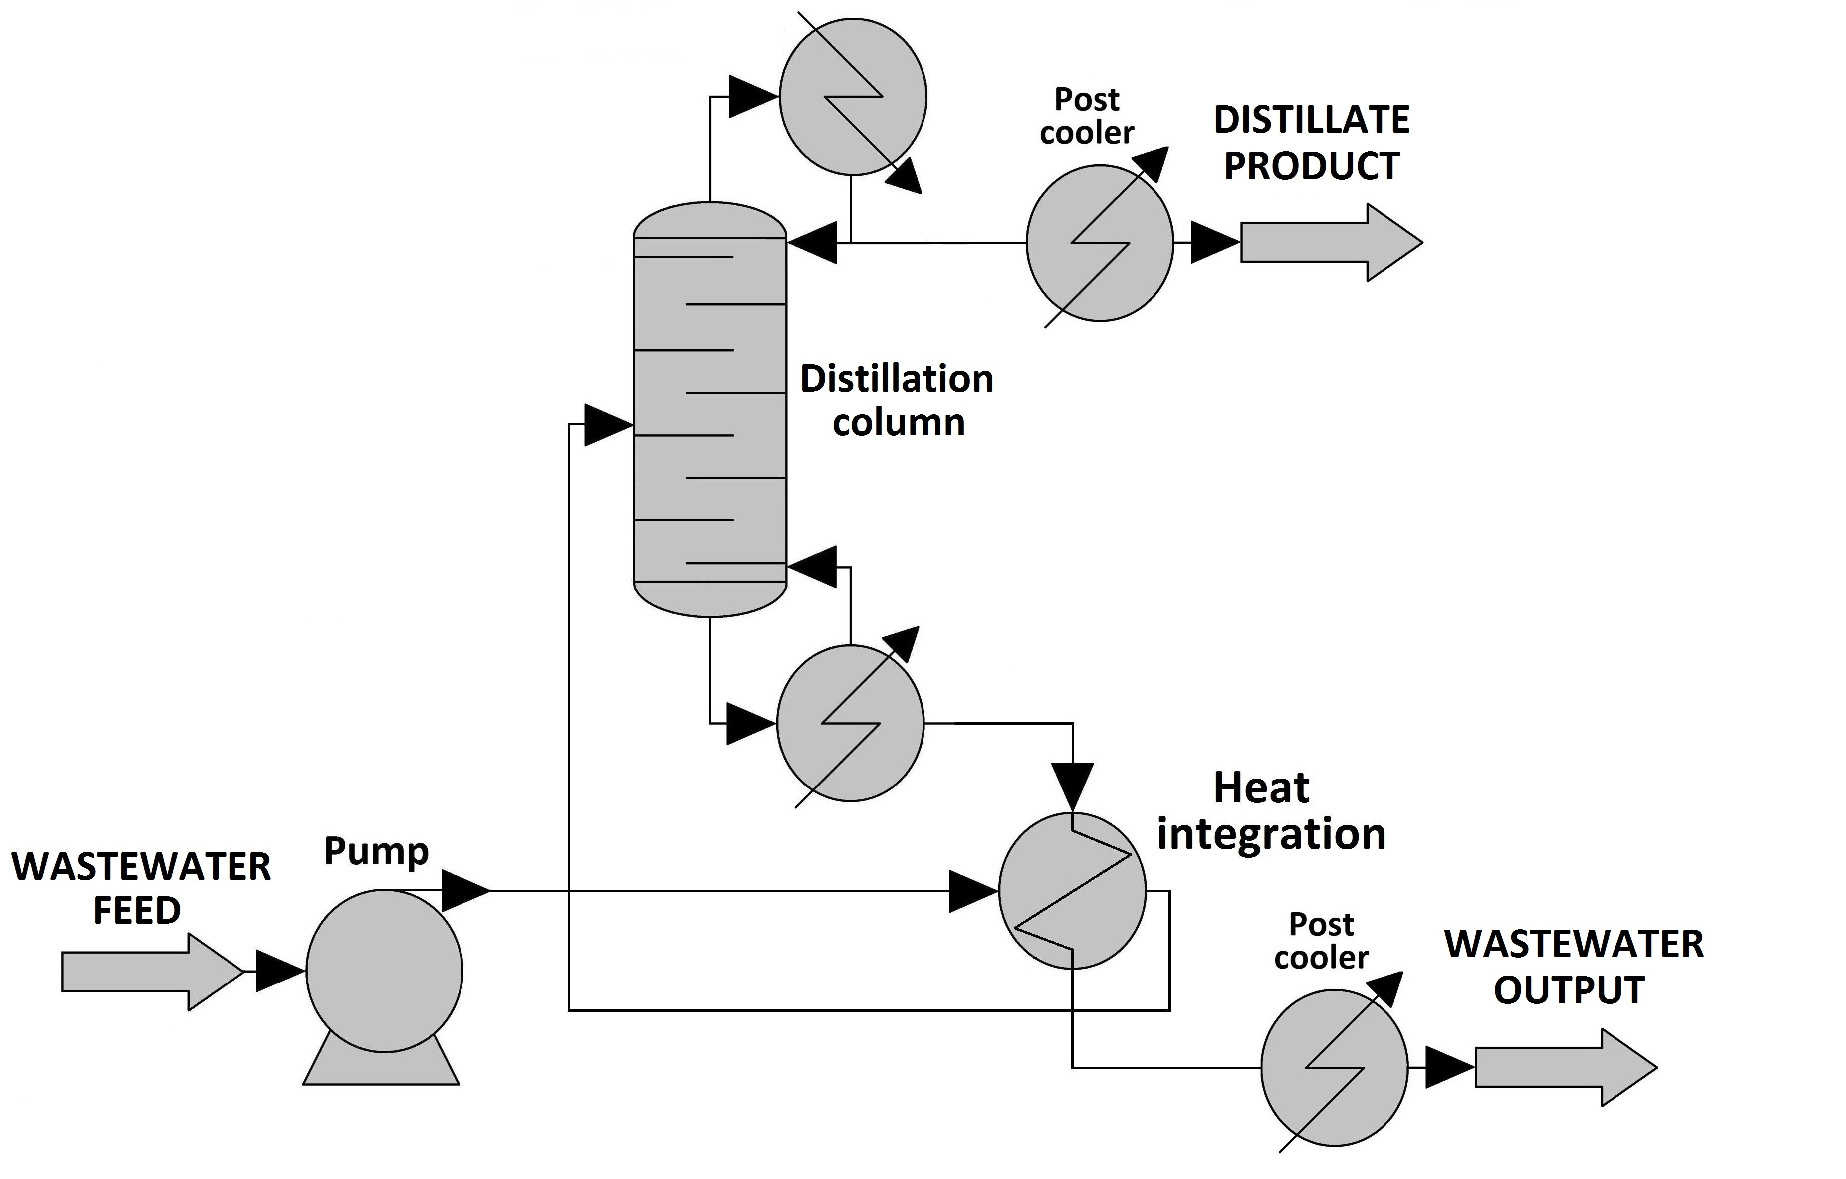
Figure 5: Flowsheet of the treatment of process wastewater with distillation

  - Results and discussion
The compositions of wastewater outputs can be seen in Table 3.

Table 3: Comparison of steam stripping and distillation methods - Composition of wastewater outputs
 | Feed | Steam stripping | Distillation
 | Process wastewater | Wastewater output | Wastewater output
AOX [m/m%] | 0.60 | 0.0002 | 0.0006
Acetone [m/m%] | 0.33 | 0.0028 | 0.042
Methanol [m/m%] | 0.21 | 0.027 | 0.039
Water [m/m%] | 98.16 | 99.26 | 99.21
Dry substance [m/m%] | 0.71 | 0.71 | 0.71

It can be seen that the AOX content is below 8 ppm in each case, therefore it can be stated that steam stripping and distillation are also capable of the reduction of the halogen content of the initial process wastewater. All the dry substance leaves with the bottom product of the column. It must be mentioned, the AOX content is 1.92 m/m% in condensate stream. In contrast, 96.15 m/m% can be reached with distillation. Thus, due to the possibility of recycling of halogen content, distillation is a more recommended procedure. Furthermore, the energy integration proves highly effective, 80% (with stripping) and 90% (with distillation) energy savings can be achieved.
The cost estimation was based on modelling results and Douglas cost equations (Douglas, 1988) with current M&S index. 5-year amortization of capital cost was assumed for the total cost estimation and 8000 hours/year continuous operation was selected for the calculation of the operating cost (Toth et al., 2017). Table 4 shows the cost estimation of two alternative methods. The calculation was based on the compositions in Table 3.

Table 4: Comparison of steam stripping and distillation methods – Cost estimation
 |  | Steam stripper |  | Distillation
 |  | 1000 euro/year | % | 1000 euro/year | %
Investment cost | Heat exchangers (Reboiler, Condenser, Post coolers) | 368 |  | 502
 | Electric heating | 227
 | Column | 91 |  | 146
 | Total - 5 years amortization | 137 | 29 | 130 | 25
Operating cost | Heating energy | 240 |  | 320
 | Water | 90 |  | 75
 | Total | 330 | 71 | 395 | 75

Table 5 shows the comparison of Total Annual Cost (TAC) of the wastewater incineration and its alternatives, steam stripping and distillation. The estimation of incineration was based on the work of Benko et al. (2006). In Table 5, the incineration means the treatment of the raw process wastewater with combustion.

Table 5: Comparison of Total Annual Cost (TAC) of the methods and the incineration
 | Total Annual Cost (TAC)
 | 1000 euro/year | %
Incineration | 3200 | 100
Steam stripping | 467 | 15
Distillation | 525 | 16
It can be seen that the Total Annual Cost can be reduced even by 85% compared to the alternative, end-of-pipe methods. Also in this case, significant difference cannot be detected between steam stripping and distillation methods. The stripping is proved to be slightly cheaper, and the operation cost represented the significant part of the total cost in both cases.
4. Conclusions
It can be stated that the procedures investigated to reduce AOX below the limit value in the residue stream were economically and technologically appropriate. By using direct steam supply for heating, the condensing steam dilutes the residue. With energy integration, hot effluent process wastewater can be used to heat the feed stream, which can result in very significant energy savings.
Each method has the appropriate separation efficiency in the aspect of AOX. However, the disadvantage of stripping is that it is difficult to extract AOX from condensate. In contrast, the distillate product, which is mainly dichloromethane, can be recycled by adding a new column. This re-use fits into the concept of the circular economy, therefore the most recommended method for the treatment of process wastewater with high AOX content is distillation with direct extraction.
Acknowledgments
This publication was supported by NTP-NFTÖ-21-B-0014 National Talent Program of the Cabinet Office of the Prime Minister, MEC 140699, OTKA 128543 and OTKA 131586. The research reported in this paper and carried out at the Budapest University of Technology and Economics has been supported by the National Research Development and Innovation Fund (TKP2020 National Challenges Subprogram, Grant No. BME-NC).
References
28/2004. (XII. 25.) Ministry of Environment Regulation https://net.jogtar.hu/jr/gen/hjegy_doc.cgi?docid=A0400028.KVV
Anastasio M., 2016, The circular economy: practical steps to enhance the EU package, Green Budget Europe.
Belis-Bergouignan M.C., Oltra V., Saint Jean M., 2004, Trajectories towards clean technology: Example of volatile organic compound emission reductions, Ecological Economics, 48, 201–220.
Benko T., Szanyi A., Mizsey P., Fonyo Z., 2006, Environmental and economic comparison of waste solvent treatment options, Central European Journal of Chemistry, 4, 92–110.
Brinkmann T., Santonja G.G., Yükseler H., Roudier S., Sancho L.D., 2016, Best Available Techniques (BAT) Reference Document for Common Waste water and Waste Gas Treatment/Management Systems in the Chemical Sector, Industrial Emisssions Directive, 2010/75/EU, Integrated Pollution Prevention and Control, JRC Science for Policy Report.
Douglas J.M., 1988, Conceptual design of chemical processes, New York, McGraw-Hill.
Dursun D., Sengul F., 2006, Waste minimization study in a solvent-based paint manufacturing plant, Resources, Conservation and Recycling, 47, 316–331.
Hirata K., 2009, Heat Integration of Distillation Column, Chemical Engineering Transactions, 18, 39–44.
Masango P., 2005, Cleaner production of essential oils by steam distillation, Journal of Cleaner Production, 13, 833–839.
Mizsey P., 1994, Waste reduction in the chemical industry: a two level problem, Journal of Hazardous Materials, 37, 1–13.
Riese J., Grunewald M., 2018, Flexibility for Absorption and Distillation Columns, Chemical Engineering Transactions, 69, 787–792.
Shestakova M, Sillanpää M., 2013, Removal of dichloromethane from ground and wastewater: A review, Chemosphere, 93, 1258–1267.
Toth A.J., 2015, Liquid Waste Treatment with Physicochemical Tools for Environmental Protection, PhD Thesis, Budapest University of Technology and Economics, Budapest.
Toth A.J., Haaz E., Nagy T., Tari R., Tarjani A.J., Fozer D., et al., 2017, Evaluation of the accuracy of modelling the separation of highly non-ideal mixtures: extractive heterogeneous-azeotropic distillation, In: Espuña A, Graells M, Puigjaner L, editors. Computer Aided Chemical Engineering, Elsevier, 40, 241–246.
Toth A.J., Haaz E., Nagy T., Tarjani A.J., Fozer D., Andre A., et al., 2018a, Novel method for the removal of organic halogens from process wastewaters enabling water reuse , Desalination and Water Treatment, 130, 54–62.
Toth A.J., Mizsey P., 2015, Comparison of air and steam stripping: removal of organic halogen compounds from process wastewaters, International Journal of Environmental Science and Technology, 12, 1321–1330.
Toth A.J., Szilagyi B., Haaz E., Solti S., Nagy T., Tarjani A.J., et al., 2018b, Separation of mixture containing maximum boiling azeotrope with extractive heterogeneous-azeotropic distillation, Chemical Engineering Transactions, 69, 571–576.

