CHEMICAL ENGINEERING TRANSACTIONS  VOL. 91, 2022 | A publication of
The Italian Association
of Chemical Engineering
Online at www.cetjournal.it

Guest Editors: Valerio Cozzani, Bruno Fabiano, Genserik Reniers
Copyright © 2022, AIDIC Servizi S.r.l.
ISBN 978-88-95608-89-1; ISSN 2283-9216

Environmental Analysis of Avocado (Laurus Persea L.) Oil Production in North Colombia using the Waste Reduction Algorithm
Tamy Herrera-Rodríguez*, Vianny Parejo-Palacio, Ángel González-Delgado
Nanomaterials and Computer Aided Process Engineering Research Group (NIPAC), Chemical Engineering Department,
Faculty of Engineering, University of Cartagena, Av. del Consulado Calle 30 No. 48-152, Cartagena, Colombia.
therrerar@unicartagena.edu.co
In North Colombia, avocado production corresponds to approximately 35,000 t/y, and a significant part of such production is waste because of the species vulnerability to climate changes, and the lack of processing infrastructure causes delays and fruit degradation. The content of oil in avocado (21-30 %) has motivated the search for alternatives of waste valorization that may improve the sustainability of the processing chain. In this sense, it is necessary to evaluate the feasibility of large-scale production of avocado oil under North-Colombian conditions under sustainability criteria. In this work, simulation of the avocado-to-oil linear production chain was performed by the Aspen Plus software, to predict the performance of the avocado pulp harvesting route on an industrial scale. Afterward, the computer-aided environmental evaluation of the process attended to using the waste reduction algorithm (WAR) via WARGUI software. The potential Environmental impacts generated and output from each process was quantified under the atmospheric and toxicological categories. Results showed low values for output of PEI (94.8 total PEI/h) and negative values for generation of PEI for some cases. These results suggested that the linear production chain to convert avocado into oil is environmentally friendly and features a promising alternative for waste valorization.
  - Introduction
The avocado is part of the five main tropical fruits of the world. In Colombia it is produced mainly in the departments of Bolivar, Cesar, Antioquia, Caldas, Santander, Valle del Cauca and Tolima. Due to its climatic conditions, the department of Bolívar grows avocados of the Creole-Antillean variety, mainly in the Montes de María. In recent years, in the Montes de María region, the deterioration of avocado plants has been observed due to mien of fungi. Likewise, the avocado has been affected when transporting it since the access roads are in poor condition. In Colombia, there is a grand availability of agro-industrial residues with high lignocellulosic content, which can be used for the production of bioenergy and biochemical products. (Poveda et al., 2021), because of this, industrially the avocado pulp is used to obtain oil for cosmetic purposes (Yabrudy, 2012).
Some of the techniques used for oil extraction involve the presence of solvents, enzymes, the applications of centrifugation or pressure. Serpa et al. (2014) extracted avocado oil using a hydraulic press with this technique
is possible to extract oil from the pulp or the avocado seed, ensuring the stability of the fatty acids and other nutrients, since they do not exceed 45 °C. This study attempts to evaluate environmentally the assembly of an avocado (Laurus Persea L) processing plant for oil production, obtaining an added value product. Therefore, the WAR waste reduction algorithm was used, which considers eight impact categories to determine the least polluting energy source, and also, allow to identify of impacts for each category that the process could generate on the environment.
  - Materials and methods
Avocado oil extraction plant modeling was based on scientific literature data collection. The waste reduction algorithm was used for the environmental evaluation, which was developed by the United States Environmental Protection Agency (EPA), to algorithm introduces the concept of potential Environmental impact balance (PEI) to allow the analysis of the effects of a chemical process. In this way, it is possible to identify the impacts generated by the process and determine the adjustments it requires from an environmental point of view.
    - Process description
Figure 1 corresponds to the production process of avocado oil using organic solvent for its extraction, in which case, the solvent used is hexane. The raw material it's washed in a sodium hypochlorite solution coming from stream 2, to remove impurities and contaminants from the avocado 200 milliliters of water for every 97 kilograms of avocado (Acosta, 2011). Once the avocado is clean, proceed to pull out the peel, and this is carried to a washing stage to recover the peel remaining pulp. In the pulp extraction stage, the seed it's separated and sent to wash to obtain seed and a pulp-water mixture.

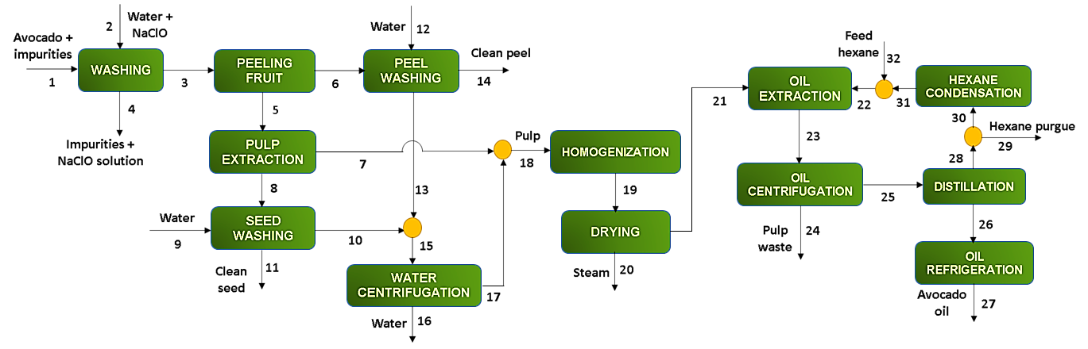
Figure 1: Process flow diagram of avocado oil extraction.
The pulp obtained from the extraction stage is mixed with the remaining pulp from the washing stages and homogenized, then it leads to the drying stage where excess water and moisture are removed from the pulp before extraction preparation. This operation occurs at 1 bar of pressure and 70 °C in order not to degrade the pulp (Ariza et al., 2011). Then the pulp is sent to the extraction stage where it is contacted with hexane, maintaining a temperature of 70 °C (Ariza et al., 2011). The resulting stream is centrifuged, obtaining pulp waste and a mixture formed by oil and the organic solvent. This mixture is sent to a flash distillation to get avocado oil and hexane separately, the recovered solvent is sent together with fresh hexane to the extraction stage.
From 10,500 tons of avocado 1,000.67 tons per year of avocado oil are obtained using hexane as a solvent for the extraction of the product.
2.2 Environmental analysis
For the avocado oil production plant environmental evaluation localized in Bolívar-Colombia, four case studies were established as shown in table 1.
Table 1: Assumptions for the environmental analysis case studies
Case studies | Assumptions
Case 1 | Excluding the impacts of the product | Excluding the impacts of the energy source
Case 2 | Including the impacts of the product | Excluding the impacts of the energy source
Case 3 | Excluding the impacts of the product | Including the impacts of the energy source
Case 4 | Including the impacts of the product | Including the impacts of the energy source

For the development of the environmental evaluation, it was necessary to know the substances involved in the process as fatty acids, water, hexane, sodium hypochlorite, lignocellulosic material, among others. Likewise, it was necessary to feed into the WARGUI software the characteristics of the mentioned above substances such as molecular weight, formula, LD₅₀, LC₅₀, global warming potential, CAS number, among others. All these characteristics are necessary so that the software can identify the effect produced by each substance in the process, taking into account four atmospheric and four toxicological categories (Herrera et al., 2017).

$$ODP=\frac{\text{δ}\left[O3\right]i}{\text{δ}\left[O3\right]FCKW-11}m_{i}$$ | (1)
$$GWP=\frac{\int_{0}^{t}{a_{i}c_{i}\left(t\right)dt}}{\int_{0}^{t}{a_{CO_{2}}c_{CO_{2}}\left(t\right)dt}}m_{i}$$ | (2)
$$PCOP=\frac{\frac{a_{i}}{b_{i}(t)}}{\frac{a_{C2H4}}{b_{C2H4}\left(t\right)}}m_{i}$$ | (3)
$$AP=\frac{(Vi/Mi )}{(V_{SO2}/M_{SO2 })}$$ | (4)
The atmospheric categories are in turn divided into global; that measure Ozone concentration (O₃) and Carbon dioxide emission (aCO₂), Eq. (1) and Eq. (2), respectively, and regionals; which evaluate the Change in ethylene emission (aC₂H₄) and Acidification potential for SO₂ (VSO₂), Eq. (3) and Eq. (4), respectively (Young and Cabezas, 1999).
$$HTPI=\frac{1}{LD_{50}}$$ | (5)
$$HTPE=\frac{1}{TLV}$$ | (6)
$$ATP=\frac{1}{LC_{50}}$$ | (7)
$$TTP=\frac{1}{LD_{50}}$$ | (8)
For their part, the toxicological categories are divided into human impacts; that measure the Acute oral lethal dose 50 (LD₅₀) and the Threshold Limit Value (TLV), Eq. (5) and Eq. (6), respectively, and ecological; which measure the Lethal concentration (LC₅₀) and the Acute oral lethal dose 50 (LD₅₀), Eq. (7) and Eq. (8), respectively.
It is also necessary to know the inputs and outputs of the process, that is, which products enter the process as raw material (avocado) or industrial services (sodium hypochlorite solution, water), and which leave the process as residues (steam, residues of avocado, water with impurities) or as a product (avocado oil).
3. Results and discussion
3.1 Environmental analysis
The waste reduction algorithm (WAR) shows the potential environmental impact of a chemical industry, which is usually caused by energy and matter that the process obtains or releases into the environment. The heat duty required by the process was 1,957.538 MJ/h. Montoya et al. (2006) qualify the WAR algorithm as a good indicator for assessing and comparing the environmental friendliness of industrial processes.
3.1.1 Potential environmental impacts
In figure 2, there are results of the output and generated impact rates for cases 1, 2, 3, and 4, used to evaluate the avocado oil production process from the pulp of this fruit. Case 1 had low generated and output impacts (PEI/h) compared to the others. In the total generation rate, low values indicate a decrease in potential impacts, since some polluting substances are recirculated to the process (Cassiani et al., 2018).
The output impacts PEI/h are greater for cases 2 and 4, according to Aguilar and Gonzalez (2021), is since energy contributes more to the increase of impacts than products. Otherwise, the generated and output impacts per kilogram of the product are low for all cases (range of 0.02 to 0.61 PEI/kg-p and 0.33 to 0.92 PEI/kg-p, respectively), that may be since the oil produced does not pose a risk to humans or ecosystems. The cases studied allow us to observe that the process has a good performance from an environmental point of view.

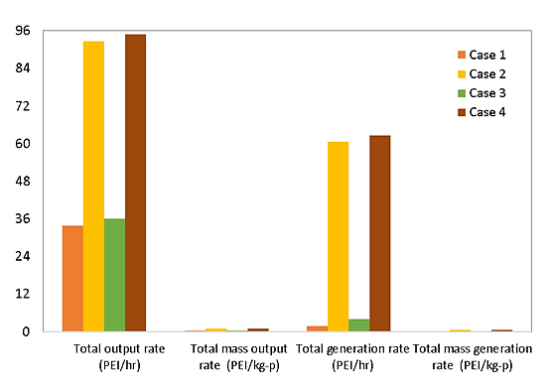
Figure 2: Total generated and output impacts of the avocado oil production process.
Montoya (2008), for the environmental evaluation of the process of obtaining biodiesel through extractive reaction, reported the highest total output impact value (4.83 E+04 PEI/h), which is above the data reported in this assessment; therefore, it is indicating that the process presents low impacts.
3.1.2 Atmospheric impacts from the process
Different categories were evaluated to determine the potential for the total environmental impact generated by the process. Figure 3 shows the generated and output atmospheric impacts. Within the atmospheric generated, there are regional impacts such as the AP acidification potential and the PCOP photochemical oxidation potential. The AP category presents equal values ​​for cases 3 and 4, both generated and output, while cases 1 and 2 present values ​​of 0 PEI/h, that is because in cases 3 and 4, the source is taken into account of energy.

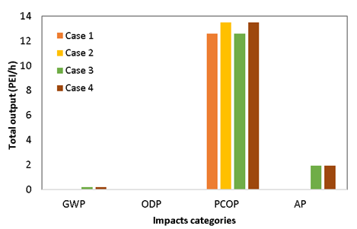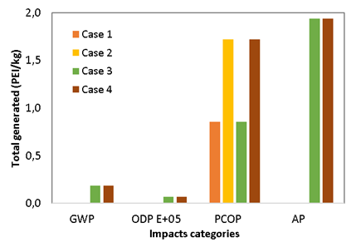
Figure 3: Total output and generated atmospheric impacts for avocado oil production in North Colombia.
Regarding the PCOP category, the values ​​related to the reduction of the potential impacts generated are observed, which occurs when substances are transformed or degraded in the processes (Herrera et al., 2018). In this case, the decrease in potential impacts compared to those of the input is due to the solvent used in the extraction being recovered and recirculated back to the process.
The global categories of atmospheric impacts show a good performance. The process shows low impacts for ODP in cases 3 and 4, as this category quantifies the decomposition of chemicals in the atmosphere. In general, for a chemical to have ODP, it must contain a chlorine or bromine atom, in this present process, NaClO is used to wash the fruit. These values take into account the decomposition of chemicals in the atmosphere. For the case of GWP, the values presented for cases 3 and 4 are small (0.19 PEI/h for both), understanding that the contribution of greenhouse gas emissions effect from the process is low.
3.1.3 Toxicological impacts from the process
The toxicological impacts generated show lower indices than the output ones; these impacts include categories that assess effects on humans and ecosystems as shown in figure 4. Cases 2 and 4 produce the highest impacts in the ATP category for generated and output impacts, these results are due to the effect that the use of hexane has in the extraction since it evaporates easily and can be deposited in the air reacting with oxygen, in the water remaining on its surface or the ground (Department of health and human services, 1999).
For cases 1 and 3, the impacts generated are negative (range of -2.78 and -2.75 PEI/h, respectively), which may be related to the reuse of streams in the process. On the other hand, HTPE presents lower values ​​than the other categories; this is a measure for the comparison of chemicals that pose a threat to human health through inhalation and dermal exposure. The values ​​obtained for the HTPE, HTPI, and TTP categories indicate that the process may have effects on humans and the terrestrial ecosystem, due to the presence of sodium hypochlorite (LD₅₀ of 8,910 mg/kg and LC₅₀ of 3 mg/L) used in the washing stage and hexane (LD₅₀ of 28,710 mg/kg and LC₅₀ of 2.5 mg/L) used as a solvent in the oil extraction stage.

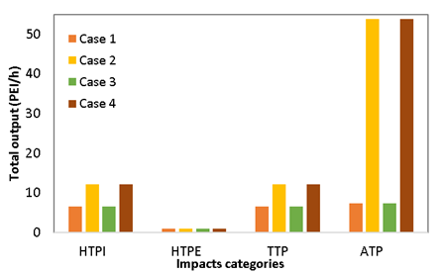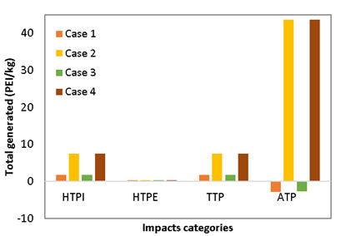
Figure 4: Total output and generated toxicological impacts for avocado oil production in North Colombia.
Pérez et al. (2021), In their feasibility study of an avocado oil production process for cosmetic use, indicates that due to the nature of the solvent, it is difficult to recover and eliminate from the process and as a sophisticated plant is needed to do so. In addition, to the fact that's, high energy expenditure is necessary since the extraction must be carried out over long periods to be efficient. The results obtained are similar to those reported by Moncada et al. (2016), where solvent extraction technologies showed the highest impacts in categories such as ATP and PCOP. The reason why is because hexane purge affects these categories due to the toxicity of the solvent and its harmful effects if it is not properly handled.
This process of obtaining avocado oil can be considered friendly from the environmental point of view since its toxicological and atmospheric impacts are lower than those reported in existing works. This evaluation allows knowing the different effects caused by the process of extracting oil from the pulp of the avocado, as a way of taking advantage of the fruits that deteriorate in the Montes de María due to the presence of fungi or the damage they suffer during transport because under these conditions they are not an attractive fruit for human consumption. The use of seed and shell is suggested to generate less waste to the environment, obtaining a process with minimal contamination.
4. Conclusions
The environmental evaluation of avocado oil production allows to obtaining satisfactory results. For a production plant built in Colombia, allowing for the characteristics and variations of the process shown in the study, it is possible to obtain a value-added product under safe environmental conditions. The impacts generated and the performance of the process are low since many reagents that can cause human or ecological damage are not used. When considering the source of energy in the process and the flow of products, an increase in toxicological impacts, both generated and produced, could be observed. Regarding the atmospheric impacts generated, the evaluation showed that the most affected category when studying cases 3 and 4 is the acidification potential (AP) since case 3 includes the product flow and case 4 the energy source and the product stream.

Nomenclature

ODP – Ozone depletion potential
GWP – Global warming potential
PCOP – Photochemical oxidation potential
AP – Acidification potential
HTPI – Human toxicity potential by ingestion
HTPE – Potential human toxicity by inhalation or dermal exposure
ATP – Aquatic toxicity Potential
TTP – Potential Terrestrial Toxicity

Acknowledgments
Authors thank to University of Cartagena for the supply of equipment and software necessary to conclude
successfully this work.
References
Acosta M., 2011, Evaluación y escalamiento del proceso de extracción de aceite de aguacate utilizando tratamiento enzimático, Universidad Nacional de Colombia.
Aguilar E., González Á., 2021, Environmental assessment for production of modified chitosan microbeads with TiO2 and magnetite using waste reduction algorithm (WAR), Revista ION, 34(1), 121–136. https://doi.org/10.18273/revion.v34n1-2021010
Ariza J., López F., Coyotl J., Ramos M., Diaz J., Martinez A., 2011, Effect of different extraction methods on the fatty acid profile in the avocado (Persea americana Mill. var. Hass) oil, Revista Venezolana de Ciencia y Tecnología de Alimentos, 2(2), 263–276.
Cassiani D., Meza D., González Á., 2018, Environmental evaluation of agar production from macroalgae Gracilaria sp, Chemical Engineering Transactions, 70, 2005–2010. https://doi.org/10.3303/CET1870335
Department of health and human services, 1999, Public health statement n-hexane CAS#: 110-54-3, In Public Health Service Agency for Toxic Substances and Disease Registry (pp. 1–7). https://www.atsdr.cdc.gov/ToxProfiles/tp113-c1-b.pdf
Herrera R., Salgado J., Peralta Y., González Á., 2017, Environmental evaluation of a palm-based biorefinery under North-Colombian conditions, Chemical Engineering Transactions, 57, 193–198. https://doi.org/10.3303/CET1757033
Herrera T., Parejo V., González Á., 2018, Technoeconomic sensibility analysis of industrial agar production from red algae, Chemical Engineering Transactions, 70, 2029–2034. https://doi.org/10.3303/CET1870339
Moncada J., Tamayo J., Cardona C., 2016, Techno-economic and environmental assessment of essential oil extraction from Oregano (Origanum vulgare) and Rosemary (Rosmarinus officinalis) in Colombia, Journal of Cleaner Production, 112, 172–181. https://doi.org/10.1016/j.jclepro.2015.09.067
Montoya M., 2008, Evaluación integral de la eficiencia económica y ambiental de proceso para la obtención de biodiesel, Universidad Nacional de Colombia.
Pérez M., Rodriguez R., Santos A., 2021, Estudio de factibilidad del proceso de producción sostenible de aceite de aguacate (Persea americana miller) para uso en la industria de cosméticos, In Universidad de El Salvador.
Poveda J., Piedrahita S., Cardona C., 2021, Life Cycle Analysis of Biotechnological Processes based on the Composition of the Raw Material, Eucalyptus, Avocado, and Plantain cases in a Biorefinery System, Chemical Engineering Transactions, 83, 397–402. https://doi.org/10.3303/CET2183067
Serpa G., Echeverri L., Lezcano C., Vélez A., Ríos A., Hincapié G., 2014, Oil extraction by cold pressing from freeze dried avocado variety “Hass” (Persea americana Mill), Revista Investigaciones Aplicadas, 8(2), 113–123.
Yabrudy J., 2012, El aguacate en Colombia: Estudio de caso de los Montes de María, en el Caribe colombiano, In Banco de la República (pp. 1–35).
Young D., Cabezas H., 1999, Designing sustainable processes with simulation: the waste reduction (WAR) algorithm, Computers & Chemical Engineering, 1354(December), 1477–1491. https://doi.org/10.1016/S0098-1354(99)00306-3

