CHEMICAL ENGINEERING TRANSACTIONS  VOL. 91, 2022 | A publication of
The Italian Association
of Chemical Engineering
Online at www.cetjournal.it

Guest Editors: Valerio Cozzani, Bruno Fabiano, Genserik Reniers
Copyright © 2022, AIDIC Servizi S.r.l.
ISBN 978-88-95608-89-1; ISSN 2283-9216

Chemical and Process Inherent Safety Evaluation of Avocado Oil Production (Laurus Persea L) in North Colombia
Tamy Herrera, Vianny Parejo, Ángel González-Delgado*
Nanomaterials and Computer-Aided Process Engineering Research Group (NIPAC), Chemical Engineering Department, Faculty of Engineering, University of Cartagena, Cartagena 130015, Colombia
agonzalezd1@unicartagena.edu.co
The largest production of Creole avocado in Colombia is found in the north zone, mainly in the Montes de María region, but due to weather conditions, the presence of pests, or transportation routes, a high percentage of the production is damaged. As a way to take advantage of the fruit not suitable for exportation, it is possible to obtain different products such as avocado oil, since this fruit contains around 30 % of crude oil. Accordingly, it is necessary to evaluate the oil production process from a safety point of view. The Inherent safety index, or ISI, allows a global measurement of safety in the early design stages of chemical processes. To carry out the process safety analysis, the risks associated with the use of chemical substances were first identified, determining their index of toxicity, corrosion, flammability, explosiveness, and the chemical reactions if necessary. Second, the risks of the process were evaluated, taking into account the equipment involved, manufacturing material, temperatures, and pressures that are handled. An Inherent safety index of 17 points was obtained, which indicates that the process is safe despite working with substances such as hexane and sodium hypochlorite and using equipment such as ovens and distillation columns.
  - Introduction
Industrial development and population growth have led to the need to seek more sustainable energy sources such as biomass (Ahmad et al., 2021). Colombia produces more than 500,000 tons of avocado, of diverse varieties, which places the country in the top third positions of worldwide production (Sánchez, 2021). The Bolivar department cultivates avocados of the Creole-Antillean variety mainly in the Montes de Maria region due to its climatic conditions (Ministerio de Agricultura, 2018). In recent years, avocado plants deterioration has been observed for fungi appearance in cultivation area; besides, harvesting transportation has been affected for roads poor condition. This fruit is sensitive to climatic conditions, suffering enzymatic darkening in pulp, whereby, industrially pulp is used to obtain cosmetic purposes oil, for example as present in figure 1 (Burbano, 2019). The use of these types of biomass becomes interesting to obtain value-added products through biorefinery schemes, mitigating the adverse environmental effects caused by the disposing methods (Poveda-Giraldo et al., 2021).
Some of the techniques used for oil extraction involve the presence of solvents, enzymes, the application of centrifugation or pressure. The solvents used correspond to hexane, ether, chloroform, acetonitrile, benzene, and ethanol. Solvent extraction increases the yield by carrying out simultaneous extractions in parallel. Generally, the process is carried out at the boiling point of the solvent for a long time. (Corzzini et al., 2017). Likewise, extraction with solvents is ideal for the production of oils for cosmetic use (Serpa et al., 2014). In this study, the assembly of an avocado processing plant (Laurus Persea L) for the production of oil will be evaluated from the point of view of process safety, obtaining a product with added value. For this, the chemical reactions of the process must be taken into account, the reagents used to identify characteristics of the substances such as flammability, corrosivity, explosivity, and toxicity. In addition, an inventory of equipment must be carried out and the construction material of the same must be considered. These characteristics of the process are identified to assign a score to each one of them, allowing to determine the inherent safety of the avocado oil production process from the pulp of this fruit.

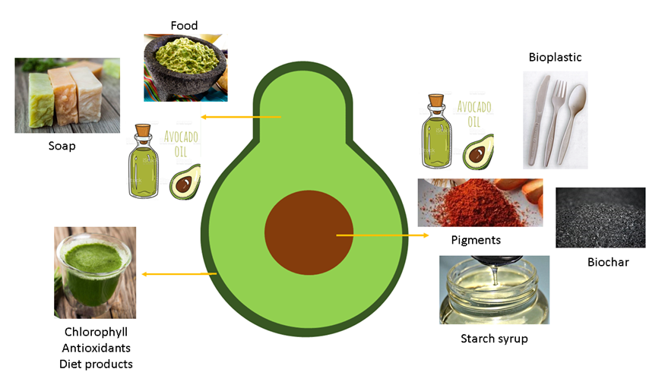
Figure 1: Potential value-added products obtainable from Creole-Antillean avocado.
  - Materials and methods
The avocado oil plant was modeled based on scientific literature data collection, the information was used to simulate a large-scale solvent extraction process; stages, streams, and operating conditions are described below.
    - Process description
For this process, the solvent oil extraction method is applied using hexane. As shown in figure 2, first of all, raw material is washed in a sodium hypochlorite solution coming from stream 2; the impurities and contaminants present in the fruit are removed from the process in this washing stage. Once the avocado is clean, the peel is pulled out and carried to the washing stage; in the washing step, the remaining pulp is recovered from the peel (stream 13). In the next stage, the seed is separated from the pulp; the pulp (stream 7), is conducted to the homogenization stage and the seed is washed to obtain a clean seed and a pulp-water mixture (stream 10).

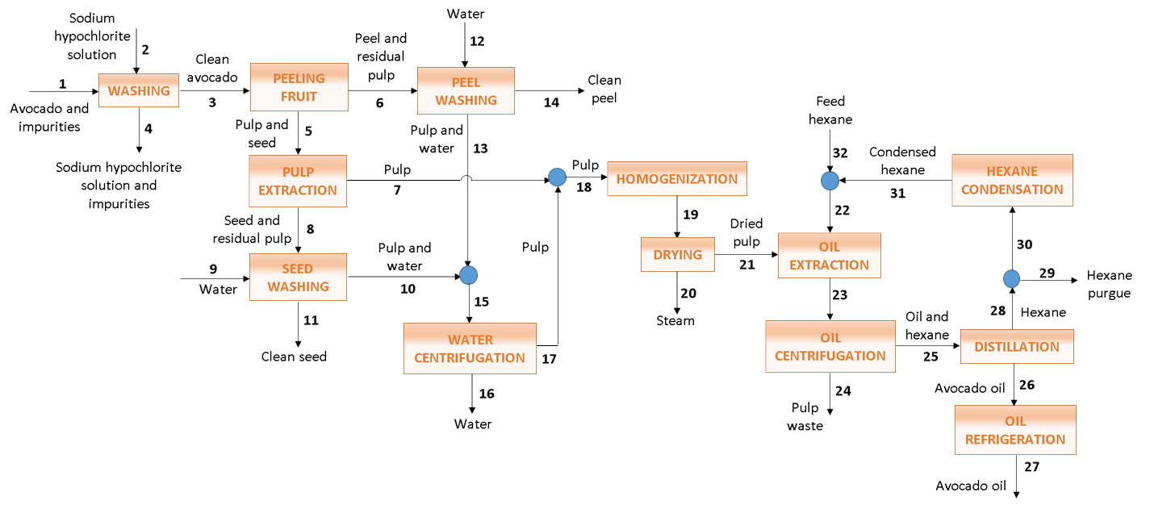
Figure 2: Process flow diagram of Creole-Antillean avocado oil extraction.
The pulp obtained from the extraction stage is mixed with the remaining pulp from the washing stage and the mixture is homogenized, then, the pulp is led to the drying stage where excess water and moisture are removed before extraction. This operation occurs at 1 bar of pressure and 70 °C in order not to degrade the pulp (Ariza Ortega et al., 2011). In the extraction stage, hexane was used to obtain oil from the pulp; the mixture is centrifuged to remove the suspended solids, which leaves the process as waste. The oil-solvent mixture goes to a flash distillation where the oil is separated as the desired product of hexane, which is condensed, and a fraction is recirculated to the extraction stage. The crude oil is cooled down to a storage temperature of 25 °C to preserve its properties (Robayo, 2017).
    - Inherent safety index (ISI)
Calculations for Inherent Safety Index (ISI) are based on the riskiest process performance, considering the worst substances chemical interaction, structure, and process variables, due to intrinsic safety is impacted by process equipment and the properties of the chemical substances implicated in the process. This indicator evaluates the potential inherent hazard related to the industrial chemical process at a conceptual design phase (Meramo et al., 2020). Therefore, the sum of the Chemical Inherent Safety Index (ICI) and the Process Inherent Safety Index (IPI) represents the Total Inherent Safety Index (ITI) as shown in Eq. (1) (Moreno et al., 2021).

$$I_{TI}=I_{CI}+I_{PI}$$ | (1)
$$I_{CI }= I_{RM, max }+I_{RS,max}+I_{NT, max}+(I_{FL}+I_{EX}+I_{TOX}{) }_{max}+I_{COR, max}$$ | (2)
$$I_{pi}=I_{i}+I_{T, max }+I_{P,max}+I_{EQ,max}+I_{ST,max }$$ | (3)
The Chemical Inherent Safety Index contains chemical factors listed in Eq. (2), determined separately for each substance in the process. The variables included are Heat main reaction (I_{RM,max}), Heat of side reaction (I_{RS,max}), Chemical interaction (I_{NT, max}), Flammability (I_{FL,max}), Explosiveness (I_{EX,max}), Toxic exposure (I_{TOX,max}), Corrosiveness (I_{COR,max}). (Meramo-Hurtado et al., 2021). The Process Inherent Safety Index includes parameters of the process itself, such as Inventory (I_{i}), Process temperature (I_{T, max}), Process pressure (I_{P,max}), Equipment safety (I_{EQ,max}), Safe process structure (I_{ST,max}), Eq. (3). Table 1 shows the safety parameters score.
Table 1: Safety parameters score.
Chemical Inherent Safety Index
Symbols | I_{RM,max} | I_{RS,max} | I_{NT, max} | I_{FL,max} | I_{EX,max} |  | I_{TOX,max} | I_{COR,max}
Score | (0-4) | (0-4) | (0-4) | (0-4) | (0-4) |  | (0-6) | (0-2)
Process Inherent Safety Index
Symbols | I_{i} | I_{T,max} | I_{P,max} | I_{EQ,max}  (0-4) OSBL |  | I_{EQ,max} |  | I_{ST,max}
Score | (0-5) | (0-4) | (0-4) |  |  | (0-3) ISBL |  | (0-5)
The flammability parameter is measured by boiling point and flashpoint, the minimum temperature for the substance solvent to ignite or burn. (Ahmad et al., 2020). Explosiveness reports the tendency of a gas to form an explosive mixture with air, which is described by lower explosion limits (LEL). Toxic exposure is classified as health hazards determined in terms of Threshold Limit Value (TLV) in ppm units, scaled in Permissible Exposure Limits issued by the Occupational Safety and Health Administration in the United States (OSHA, 2019). Corrosiveness indicator is defined by construction material, if carbon steel is plenty a cero score is assigned. Process Inherent Safety Index is measured regarding process operation and equipment. For the inventory sub-index, it is necessary to quantify material to be stored using mass flows streams. The temperature scale was selected on basis of material strength and threat to humans. Pressure parameters are indicated to fill strength vessel requirements. Furthermore, Equipment safety aims to prevent the possibility that a piece of equipment is unsafe. The process plan area is separated into onsite and offsite areas; the onsite area refers to the battery limits area (ISBL) for substantial equipment in a small section, and offsite areas are concerned to outside battery limits area (OSBL), which refers to a large inventory scattered in a space location (Heikkilä, 1999).
  - Results and discussion
    - Chemical Inherent Safety Index (I_{ch})
Sub-indexes I_{RM,max} and I_{RS,max} represents the chemical reaction indicator for main and side reactions. In crude avocado oil extraction, no reaction took place, and therefore, these indicators have a 0 score just as the I_{NT, max} that considers the unwanted reactions from process substances with materials in the plant area and n-Hexane low reactivity. Flammability, explosiveness, and toxicity are parameters considered to identify hazardous material, for avocado oil obtention using a solvent. The component with the greatest risks for the process was hexane employed in the extraction stage, among other substances within the process shown to be secure due to their non-flammability, non-toxicity, and non-explosiveness nature (Zuorro et al., 2021).
Table 2: n-Hexane hazardous indicators.
Components | Flash point | Boiling point | Explosively | TLV | Storage
Units | ° C | ° C | % | ppm | Material
Hexane | -23 | 68.5 | 7.7 | 50 | steel, aluminium

Table 2 shows information from the safety data sheet of the hexane. In the flammability parameter, the boiling point is a measure of the risk involved (Heikkilä, 1999); hexane was classified as very flammable with a flash point lower than zero. Explosiveness denotes the inclination of components to form an explosive mixture in air, related to upper and lower explosion limits, classifying hexane as not much explosive among 0-20 % values. Moreover, toxicity indicator is applied in an industrial context in order to protect employees at work. To close the chemical index, corrosiveness was defined regarding the selected material for equipment construction; considering that mild steel corrosion by fatty acids is negligible at ambient temperature (Chong, 2004), no special material is required for process equipment.
    - Process Inherent Safety Index (I_{ps})
Crude avocado oil plant processing capacity was estimated at 10,604.70 t/y of avocado to produce 1,000.66 t/y of crude avocado oil. The inventory sub-index is the total inventories of all process vessels, from inventory is calculated the total quantity of material to be stored, as shown in table 3.
Table 3: Inventory sub-index calculation.
Equipment | Flow (t/y) | Inventory (t)
Avocado wash | 32,259.00 | 3.68
Peel separation | 11,967.36 | 1.37
Pulp separation | 10,018.42 | 1.14
Seed washing | 2,953.33 | 0.34
Peel washing | 6,148.95 | 0.70
Water separation | 6,852.40 | 0.78
homogenization | 8,006.02 | 0.91
Drying | 8,006.02 | 0.91
Oil extraction | 5,383.62 | 0.61
Oil centrifugation | 5,383.62 | 0.61
Distillation hexane | 4,649.57 | 0.53
condensation hexane | 3,539.43 | 0.40
Oil cooling | 1,000.67 | 0.11
Total |  | 12.12

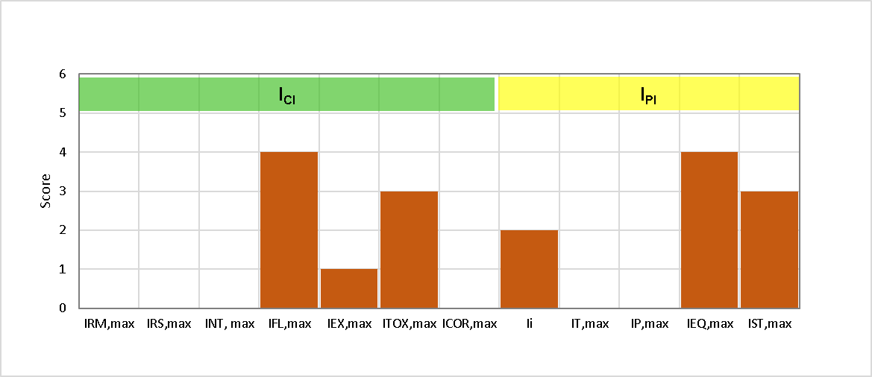
Figure 3: Inherent Safety Index for Creole-Antillean avocado oil extraction.
The temperature and pressure sub-index were decided according to the process operations conditions; the maximum temperature predicted was 70 °C at the dryer and distillation stage. Plant pressure operation is 1 bar for most stages; therefore, pressure conditions do not represent any risk. The equipment safety index, was considered ISBL area due to a distillation and drying stage that requires an oven; therefore, the assigned score is the maximum equivalent to 4. For the process secure structure sub-index, the process was classified as probably unsafe (Guillen, 2016), equal to 3. Inherent safety analysis results developed for avocado oil extraction are present in figure 3 for each safety index.
    - Total Inherent Safety Index (I_{TI})
Results revealed that process is safe under the evaluated parameters, which is below the score recommending for a safe or neutral process corresponding to a score of 24 (Meramo et al., 2019). Table 5 shows the score for chemical and process sub-index.
Table 5: Inherent Safety Index for Creole-Antillean avocado oil extraction.
Index | Score
ICH | 8
IPS | 9

Total Inherent Safety Index (I_{TI}) of 17 for the crude avocado oil plant is higher than that reported by González et al. (2021) to evaluate the crude palm oil production under the inherent safety parameters, obtaining a score of 11, showing a safe process with the highest risk in the process equipment safety sub-index due to a boiler and dryer implementation (González et al., 2021). Both processes are considered as safe, coinciding in process equipment safety sub-index with the maximum score; however, they diverge in the total safety index, the above is due to the particularity of each process, the extraction method used and solvent application in the extraction of crude oil from avocado. The process safety is necessary to support decision-making and prevent the degradation systems (Santos et al., 2019). Safety assessment is a valuable approach for hazard control and decreases its magnitude, which can be incorporated into every design and operation stage; however, employment inherent safety at process selection and conceptual design yields the greatest outcomes, achieving essential performance integrating environment, health, and safety (Khan and Amyotte, 2004).
  - Conclusions
The inherent safety analysis of crude avocado oil large-scale extraction using hexane was performed in this work. Results indicate that for a 10,604 t/y processing capacity plant, the process is inherently safe achieving a total inherent safety index score of 17, outcome below the set point for a neutral or safe process. Assessment displays an un-balanced rating for chemical and process safety inherent indexes. Operational conditions and thermodynamics of the reactions do not represent major concerns for the inherent safety of this process, 70 °C and 1 bar of pressure, do not represent any danger. However, flammability and equipment safety are risk areas in this process. It is important to consider that process may be inherently safe regarding one criteria, but unreliable from a different point of view. In the chemical sub-index, a proper selection of construction materials can prevent safety problems caused by the corrosive properties of substances and process streams. Otherwise, the safe process structure sub-index relates process security from an engineering perspective, reporting how well unit operations perform together and how they must be commanded and connected; besides, quantifying inventory is imperative, because as a plant becomes larger, hazard potential is extensive. For future works, studies can contemplate applying sustainability analysis considering the economic, and exergetic variables used to assess this process design from different criteria.
Acknowledgments
The authors would like to acknowledge University of Cartagena for providing equipment and software to conclude this work.
References
Ahmad S., Yunus N., Akbar M., Hashim H., Mustaffa A., Rashid R., 2020, Solvent design and inherent safety assessment of solvent alternatives for palm oil recovery, Journal of Loss Prevention in the Process Industries, 65, 104120.
Ahmad I., Abdullah N., Koji I., Yuzir A., 2021, The Contribution of Microalgae in Bio-refinery and Resource Recovery : A Sustainable Approach leading to Circular Bioeconomy, Chemical Engineering Transactions, 89(September), 391–396.
Ariza J., López F., Coyotl J., Ramos M., Diaz Reyes, J., Martinez A, 2011, Effect of different extraction methods on the fatty acid profile in the avocado, Revista Venezolana de Ciencia y Tecnología de Alimentos, 2(2), 263–276. http://oaji.net/articles/2017/4924-1495372756.pdf
Burbano O., 2019, West Indian avocado agroforestry systems in Montes de María (Colombia): A conceptual model of the production system, Revista Chapingo, Serie Horticultura, 25(2), 75–102.
Corzzini S., Barros H., Grimaldi R., Cabral F., 2017. Extraction of edible avocado oil using supercritical CO2 and a CO2/ethanol mixture as solvents, Journal of Food Engineering, 194, 40–45.
Chong C., 2004, Corrosion of Mild Steel by Palm Fatty Acid distillates (PFAD), PALMAS, 25, 408–417. https://publicaciones.fedepalma.org/index.php/palmas/article/download/1106/1106
González A., Barajas A., León J, 2021, Evaluating the Sustainability and Inherent Safety of a Crude Palm Oil Production Process in North-Colombia, Applied Sciences, 11(3), 1046.
Guillen J., 2016, Obtención y Caracterización Fisicoquímica Del Aceite de Palta Hass (Persea americana) extraído por método en frio (Prensado) y caliente (Soxhlet), UNIVERSIDAD NACIONAL DEL SANTA.
Heikkilä A., 1999, Inherent safety in process plant design An index-based approach 3 8 4. http://www.inf.vtt.fi/pdf/
Moreno K., Baldiris I., Gonzalez A., 2021, Inherent safety assessment of a valorization alternative for shrimp wastes under the concept of biorefinery, PROSPECTIVA, 19(1), 1–10.
Khan, F., Amyotte P., 2004. Integrated inherent safety index (I2SI): A tool for inherent safety evaluation, Process Safety Progress, 23(2), 136–148.
Meramo S., Ceballos N., Cortes J., León J., González A., González Á., 2021, Inherent Safety Assessment of Industrial-Scale Production of Chitosan Microbeads Modified with TiO2 Nanoparticles, Biomolecules, 11(4), 568.
Meramo S., Ojeda K., Sánchez E., 2019, Environmental and Safety Assessments of Industrial Production of Levulinic Acid via Acid-Catalyzed Dehydration, ACS Omega, 4(27), 22302–22312.
Meramo S., Sánchez E., Ponce J., El-Halwagi M., Ojeda K., 2020, Synthesis and Sustainability Evaluation of a Lignocellulosic Multifeedstock Biorefinery Considering Technical Performance Indicators, ACS Omega, 5(16), 9259-9275.
Ministerio de Agricultura, 2018, Cadena de Aguacate Indicadores e instrumentos. https://sioc.minagricultura.gov.co/Aguacate/Documentos/2018-08-30 Cifras Sectoriales.pdf
OSHA, 2019, Permissible Exposure Limits – OSHA Annotated Table Z-3 | Occupational Safety and Health Administration, Occupational Safety and Health Administration. https://www.osha.gov/annotated-pels.
Poveda J., Piedrahita S., Cardona C., 2021, Life Cycle Analysis of Biotechnological Processes based on the Composition of the Raw Material . Eucalyptus , Avocado , and Plantain cases in a Biorefinery System, Chemical Engineering Transactions, 83, 397–402.
Robayo A., 2017, Caracterización fisicoquímica de diferentes variedades de aguacate, Persea americana Mill. (Lauraceae) e implementación de un método de extracción del aceite de aguacate como alternativa de industrialización. https://repositorio.unal.edu.co/handle/unal/59452.
Sánchez A., 2021, Colombia es tercero en el mundo en producción de aguacate, Agronegocios, https://www.agronegocios.co/agricultura/colombia-es-tercero-en-el-mundo-en-produccion-y-area-cosechada-de-aguacate-hass-3142547#
Santos L., Haddad A., Luquetti I., 2019, Process Safety Leading Indicators in Oil Storage and Pipelines : Building a Panel of Indicators, Chemical Engineering Transactions, 77(June), 73–78.
Serpa A., Echeverri A., Lezcano M., Vélez L., Ríos A., Hincapié G., 2014, Oil extraction by cold pressing from freeze dried avocado variety “Hass” (Persea americana Mill), Revista Investigaciones Aplicadas, 8(2), 113–123.
Zuorro A., Moreno K., González Á., 2021, Inherent Safety Analysis and Sustainability Evaluation of Chitosan Production from Shrimp Exoskeleton in Colombia, Water, 13(4), 553.

