CHEMICAL ENGINEERING TRANSACTIONS  VOL. 91, 2022 | A publication of
The Italian Association
of Chemical Engineering
Online at www.cetjournal.it

Guest Editors: Valerio Cozzani, Bruno Fabiano, Genserik Reniers
Copyright © 2022, AIDIC Servizi S.r.l.
ISBN 978-88-95608-89-1; ISSN 2283-9216

A Framework towards Resource Integration and Energy Efficiency Auditing with Zero Hazardous Discharge Programme
Andrea Maffiniª*, Giorgio Bonvicini^{b}, Alessandro Venturin^{b}, Marco Morando^{b}, Antonio Saba^{b}, Bruno Fabiano^{c}
a Maffini Engineering & Consulting, via D. Somma 80 – 16167 Genoa, Italy
b RINA Consulting S.p.A., via A. Cecchi 6 - 16129 Genoa, Italy
c DICCA - Civil, Chemical and Environmental Engineering Department, Polytechnic School - Genoa University, via Opera Pia 15 - 16145 Genoa, Italy
andrea@maffiniconsulting.it

Purpose of this paper is to outline a framework for resources and energy efficiency auditing activities and present its application in field studies carried out in Italy and in Eastern Europe, to support Companies and International Financial Institutions (IFIs) in the implementation of actions to improve industrial performances and reduce global environmental impacts. Among environmental considerations, climate change mitigation and adaptation aspects are included, as well as circular economy, pollution prevention and preservation of biodiversity. Within this context, this study focuses on the peculiar case of the textile industry, which is characterized by a significant use of energy and resources, mainly water and chemicals, thus involving the respect of the Zero Discharge of Hazardous Chemicals Programme. The auditing approach is conceived as a step-by step sequence of activities, starting from the Job Assignment from the Client based on specific Terms of Reference, followed by the submission of a data collection questionnaire, tailored to the specific textile industry, site survey with company managers and concluded with the elaboration of the technical report. In order to demonstrate the capability of the approach, the applicative section of this paper will present results in terms of technical and managerial actions to reduce energy and water consumption and GHGs emissions, as well as to control water pollution and waste generation and disposal.
- Introduction
Recognizing the threats posed by climate change, 195 governments signed in December 2015 the Paris Agreement, which expresses their commitment to tackle climate change and limit the increase of global average temperature by 2100 to well below 2°C, making efforts to limit it to 1.5°C on pre-industrial levels. As amply known, the European Green Deal (EGD) outlined an action plan to boost the efficient use of resources towards clean circular economy, requiring actions on all sectors of the economy, e.g. including investing in environmentally-friendly innovative technologies, optimizing energy efficiency, improve plant and process safety and decarbonizing the energy sector (IPCC, 2005). In this context, significant efforts are carried out by the European Union, which set a series of policies, under the framework of the European Green Deal, aimed at making Europe the first climate neutral continent by 2050, which means achieving net zero greenhouse gas emissions, with an intermediate target of reducing GHG emissions by 55% by 2030 compared to 1990 values (IEA, 2021). In order to reach these ambitious targets, all sectors of the European economy are required to pursue high efforts, including the financial sector. In this regard, the EU has started a set of activities in the field of sustainable finance, which refer to the process of taking environmental, social and governance (ESG) considerations into account when making investment decisions, thus achieving a sustainable economic development in the long-term. Many challenges must be addressed in order to make further progress with a full integration the overall relevant issues of circular economy, sustainability and resource conservation within the process safety paradigm, while moving towards Industry 4.0, where the role of process engineering should include a critical and balanced application of new developments in data science and digital technology with fundamentals science and engineering principles (Pasman et al., 2021). Following the initiatives launched by the European Union, the higher attention paid by the financial players and the stakeholders worldwide to ESG topics, also several industrial sectors have mobilized towards the reduction of their environmental impacts. Among these industrial sectors, significant efforts are being made by the textile sector, which is characterized by a significant consumption of resources (energy, water, chemicals, etc.) and consequent impact on climate change and environmental aspects. According to the European Environmental Agency, consumption of textiles in the EU is the fourth highest pressure category in terms of use of primary raw materials and water (after food, housing and transport), and the fifth category for GHG emissions. Taking this into account, the European Green Deal, the Circular Economy Action Plan and the Industrial Strategy included textile sector among the priorities in which the EU has to invest to achieve carbon neutrality and circular economy. For the above-mentioned reasons, in the first quarter of 2022, the EU will release its Strategy for Sustainable Textiles (European Commission, 2022), whose aim will be to set a comprehensive framework “to boost the competitiveness, sustainability and resilience of the EU textile sector, taking into account its strengths and vulnerabilities, and also addressing its environmental and social impacts”. The Strategy will include actions aimed at making the textile ecosystem fit for circular economy, that is, focusing, among other topics, on improving textile waste collection and recycling, enhancing design for sustainability, increasing the use of secondary raw materials, reducing energy, water consumptions and tackling the presence of hazardous chemicals in textile products. Nevertheless, several initiatives aimed at increasing the sustainability and reducing the environmental impact of the textile production sector had already been launched in the last decade; in this article, two of them are worth explicitly being recalled, i.e. the US Natural Resources Defense Council (NRDC) Clean by Design initiative (Greer, 2013) and the Zero Discharge of Hazardous Chemicals initiative (ZHDC, 2021). The Clean by Design initiative was launched in 2007 and then joined by several multinational fashion brands and retailers, willing to reduce the impact of their worldwide supply chain on the environment. Based on the analysis of more than 200 textile mills of all ages and sizes, the program has proposed a set of actions characterized by excellent environmental benefits and financial return on investment. On the other hand, the ZDHC Foundation was founded in 2011 by 6 Signatory Brands that committed to a joint roadmap transforming their value chains; in 2014 the Manufacturing Restricted Substances List (MRSL) was published, i.e. a list of harmful chemical substances (cleaners, adhesives, paints, inks, detergents, dyes, colorants, auxiliaries, coatings and finishing agents) whose use needs to be removed in order to protect consumers and minimize the negative impacts on the environment as well as on the health and safety of production workers and local communities (ZHDC, 2021).
- Methodology
This paper is based on the experience of the Authors in carrying out energy and resource efficiency audits integrated with Zero Hazardous Discharge Programme procedures, on behalf of private companies and International Financial Institutions in the European Union and in developing Countries (Maffini et al., 2021). The Resources and Energy Efficiency Audits (REEA) are focused on analysing the baseline situation of the plant in terms of consumptions and environmental performance and identify opportunities to reduce the use of energy (electricity, fuels and secondary energy carriers like steam, superheated water, etc.) and resources (water, chemicals, raw materials, etc.), as well as the production of wastes and the related impacts on the environment in terms of greenhouse gases and pollutant emissions to air and water. Moreover, they aim at identifying and filling any gap towards environmental and safety laws and regulations and improve compliance with applicable legislation and regulations. Therefore, the main objectives of the REEA include:
- the collection of data related to consumptions and production of the plant, the calculation of Key Performance Indicators (KPI) and the execution of a benchmarking analysis;
- the preliminary evaluation of the baseline situation of the plant in terms of overall resource efficiency;
- the identification of a set of investment opportunities, with the execution of a technical and financial pre-feasibility study.
The REEA analysis relies on the conceptual methodology developed for energy audits in UNI CEI EN 16247-1 technical standard, which defines an energy efficiency audit as “a systematic inspection and analysis of the energy use and consumption of a plant, building, system or organization, with the aim of identifying and reporting on energy flows and the potential for energy efficiency improvements”. Unfortunately, there is no similar standard for REEA, but approach similar to energy audits was conceived to obtain the same level of results. Figure 1, adapted from UNI CEI EN 16247-1 technical standard, provides an overview of the steps involved into the ad-hoc designed audit process (Bonvicini, 2018).

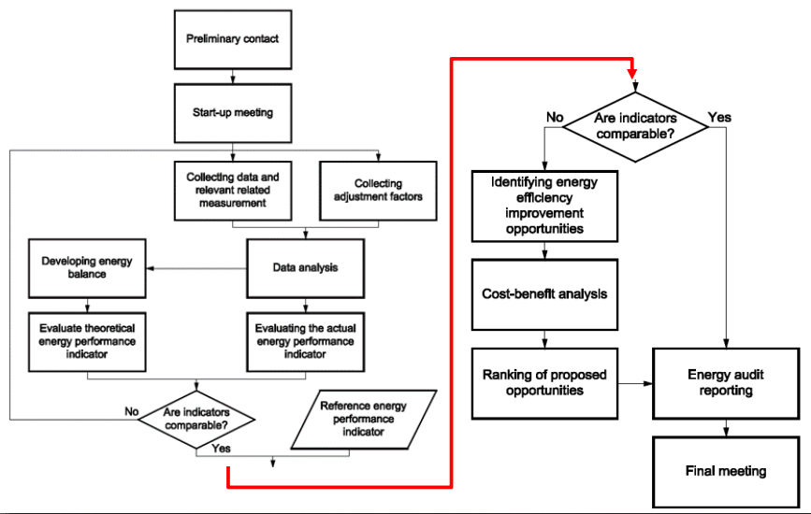
Figure 1: Schematic flow sheet developed for the energy audit process (Bonvicini, 2018).
Based on the steps presented in the technical standards, the main phases of the audit are:
- introductory contact, to set the framework of the analysis and kick-off meeting, aimed at identifying data to be collected, measurements to be done, equipment to be installed, etc.;
- data collection, regarding energy/resources consumptions and costs, characteristics and use of the equipment, general features of the processes and facilities, plant production data;
- site visit, to inspect the plant, evaluate typical uses of energy and resources, identify areas for additional data collection, take spot measurements, identify potential improvement areas;
- analysis, to draw energy and material balances, determine breakdown of consumptions, calculating Key Performance Indicators and benchmarking with international and local reference values, elaborating detailed proposals for improvement of resource efficiency;
- reporting, to produce a document summarizing the background information on the plant, its consumptions and production, energy/mass balances and analysis and an action plan for improving resource efficiency, including technical and financial aspects and recommendations for monitoring;
- final meeting, to discuss the results of the audit with the organization.
In this resource efficiency audit procedure, three main activities can be considered as the most important ones, i.e. benchmarking, gap analysis versus best practices, check of possible use of substances in MRSL, briefly described in the following lines. Benchmarking is useful since it allows calculating the specific consumption of resources and energy per unit of product, typically the unit of mass of fabric in the case of the textile industry, and comparing it over time for the same plant (“internal benchmarking”), or with reference values (“external benchmarking”) in order to evaluate the resource efficiency performance of the plant versus the best available technologies. In this context, the availability of detailed monitored data regarding consumptions and production of the plant are fundamental, whereas external reference values are generally taken from publications and reports issued by category associations or international institutions, like the BREF (EU Best Available Techniques Reference Documents) documents for the Textile Industry developed by the JRC of the European Commission (European Commission, 2003). The gap analysis versus the applicable best practices is carried out based on the outcomes of the data collection and the site visit, considering the presence of systems and/or the adoption of management practices aligned with best international standards. From the technological point of view, the most relevant list of best practices is constituted by the already mentioned BREF for Textile Industry (European Commission, 2003) and for Energy Efficiency (European Commission, 2009); in addition, the most interesting opportunities for improvement of resource efficiency that are screened are those identified in the NRDC Clean by Design project and in the experience developed in carrying out resource efficiency audits for textile mills. According to the approach defined by NRDC Clean by Design project (Greer et al., 2013), ten best practices are hereby outlined:
- Install Meters to Measure Savings, and Read Them;
- Water Leak Detection, Preventive Maintenance, Improved Cleaning;
- Reuse Cooling Water;
- Reuse Condensate;
- Reuse Process Water;
- Recover Heat from Hot Water;
- Improve Boiler Efficiency;
- Maintain Steam Traps and Steam System;
- Insulate Equipment and Tanks;
- Recover Heat from Hot Air;
- Optimize Compressed-Air System.
With specific reference to the best practice on insulation of equipment and tanks, Figure 2 provides an example of on-site assessment by infrared camera to identify potential areas where insulation needs to be improved.

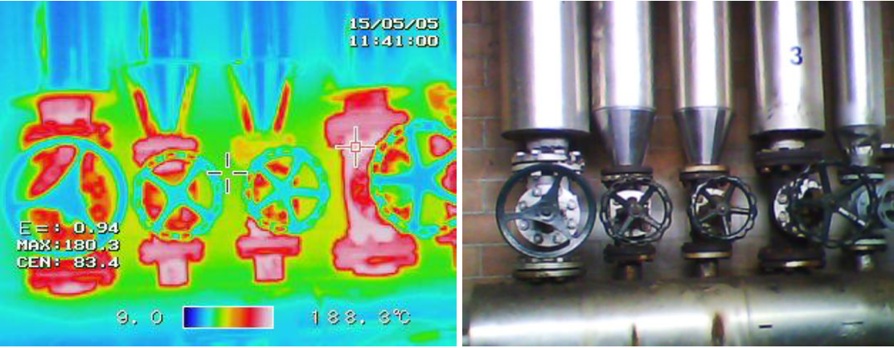
Figure 2: Infrared assessment of thermal insulation level.
Although originally conceived for China, all of the above-mentioned good practices resulted to be applicable also within the European context; based on the extensive REEA activity carried out, an additional list of five Best Practices was developed, which include:
- Enhancing Wastewater Pre-Treatment;
- Reducing the Use of Steam for Producing Low Temperature Heat;
- Exploiting High Efficiency Heat Recovery and Stratification Technologies in Heat Storage Tanks;
- Optimizing Air Conditioning Systems;
- Diffusing Variable Speed Drives on Electric Motors.
Factories pay great attention to the issues of sustainability and the rational use of energy and resources and, in this perspective, the audit activity at the suppliers of the textile industry can count on the methodological reference given by the activities started in the 2010 by the National Resource Defense Council (NRDC) as part of the Clean by Design program, to reduce the environmental footprint of the textile industry. The objective of the program is to identify a series of simple and low-cost opportunities to save water, electricity and fuels with limited investments that do not impact on the quality of the product; the measures identified must have a short payback (2-3 years). In addition to the standard approach of the Clean by Design program, in this case the list of chemical substances used was also analyzed, which was compared with the Manufacturing Restricted Substances List - MRSL, i.e. the list of substances prohibited is based on of the objectives that the group has set itself in relation to the ZDHC protocol. As part of the MRSL Implementation Survey organized by leading fashion groups among their suppliers, in which the groups have set objectives according to the ZDHC (Zero Discharge of Hazardous Chemicals) protocol, the groups provided a list of chemical subcontractors with related supplies, indicating the production phase in which they were applied and the type of product. The main chemicals used are divided into three main lines of treatments, namely dying, finishing and other processes. Subsequently the analysis on the use of substances present in the MRSL checklist is developed according to a stepwise approach, i.e.:
- LCA development of the textile plant and selection of the process units and the harmful substances from MRSL checklist; for instance, in a dying process, list of prohibited dyes would be cross-checked;
- meeting with the factory, the possible hazardous chemicals shortlisted from the MRSL on the basis of the plant process are compared with the actual substances applied in the plant;
- to conclude, should the use of one hazardous chemical be confirmed by plant operator, the possible replacement with harmless chemicals is discussed with the company and proposed in the report, according to the guideword substitution of inherent safety approach derived from the process sector. In order to attain the evaluation of the current level of resource efficiency of the plant KPI are defined and applied to each equipment and operational practices adopted. The average values found as a result of the energy and resource efficiency assessments done at integrated textile production plants (i.e. processes of warping-weaving-washing/dyeing-finishing) are summarized in Table 1. The wide value ranges are connected to the different levels of efficiency and, most of all, to the specific processes carried out to realize a high-quality final product, which may differ significantly from a plant to another depending on client requirements.
Table 1: Basic Key Performance Indicators for the textile sector assessment
KPI definition | Unit | Range
Electricity | kWh/t | 3,200 – 7,100
Thermal Energy | kWh/t | 17,700 – 41,600
Primary Energy | kWh/t | 20,500 – 59,300
Water | l/t | 90 – 450
- Results and discussion
The results of the resource efficiency audit activities can be summarised as follows:
- the evaluation of the current level of resource efficiency of the plant in qualitative (technological features of equipment, operational practices adopted) and quantitative terms (Key Performance Indicator values); Table 2 provides a detailed quantitative example of KPI analysis in the context of a REEA for an actual textile production plant in Eastern Europe and the following assessment is presented in form of immediate readability in the radar graph shown in Figure 3;
- the definition of an investment plan for resource efficiency, with a pre-feasibility study based on technical and financial aspects for each proposed improvement, including an evaluation of CAPEX and OPEX, of achievable energy/material savings, avoidable GHG emissions, financial parameters including IRR, NPV, PBT; for the largest textile plant for which this kind of analysis was carried out, the proposed improvements allowed a reduction by 5% of primary energy demand and energy-related GHG emissions, and a reduction by 35% of wastewater discharge;
- the identification of further solutions to mitigate environmental impact of the plant, which could also become part of the above-mentioned projects in form of investment in equipment and materials;
- a check of sustainability and hazard reduction of the plants process possibly according to inherent safety principles and ZDHC approach including, as well, a further assessment of the overall factory impact.
Table 2: Evaluation of KPI and relative performance evaluation
KPI | KPI site baseline | KPI site  project | High performance benchmark | Low performance benchmark | KPI score baseline [%] | KPI score project [%]
Raw material [t/t _{product}] | 1.06 | 1.06 | 1.01 | 1.25 | 88.2 | 88.2
Primary energy purchase [kWh/t _{product}] | 17,325.76 | 16,531.34 | 4,000 | 70,000 | 87.9 | 88.6
Primary energy consumption [kWh/t _{product}] | 21,963.46 | 20,934.97 | 4,000 | 70,000 | 83.7 | 84.6
GHG [kgCO₂/t _{product}] | 3,496.12 | 3,338.84 | 1,146.40 | 20,795.76 | 92.8 | 93.3
Freshwater use [l/ t _{product}] | 142.13 | 89.44 | 50.00 | 500.00 | 87.7 | 94.7
Wastewater [l/ t _{product}] | 142.18 | 92.13 | 50.00 | 500.00 | 87.7 | 94.4
Overall technical score project |  |  |  |  | 88.0 | 90.6

According to the performed auditing process, combining textile plant process and life cycle it is possible attaining a comprehensive performance profile for the protection of the global environment, especially by proper selecting the technologies at the design stage, not limiting the efforts to the conventional efforts towards CAPEX and OPEX reductions and to the local impact parameters.
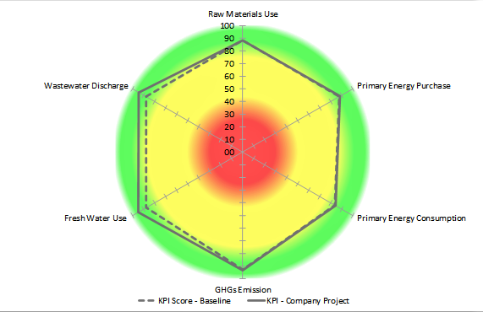
Figure 3: Results of audit expressed as weighed comparison between KPI’s and benchmarks range
Conclusions
This paper outlined a framework for performing audit activities allowing effective improvements in the sustainability of plant operation, through a range of proposals for the increase of resources and energy efficiency and the reduction of local and global environmental impact. As shown by the applicative example of the textile industry, the auditing entails a powerful methodology to boost sustainability and cut emissions, especially for GHG, managing as well main issues relevant to safety, environment and process efficiency. Additionally, as in the case of the MRSL Implementation Survey for objectives according to the ZDHC protocol, an optimized chemicals hazard control system has been integrated within the general audit structure, allowing its effective and reliable implementation in the textile product chain.
Acknowledgments
The Authors gratefully acknowledge the contribution of all the Engineers from RINA, the Consultants, the Experts from Universities, who joined them in auditing and reporting activities.
References
Bonvicini G., 2018. Requirements for Data Formats and Indicators, SoWhat project deliverable D1.4, https://sowhatproject.eu/wp-content/uploads/2018/05/Requirements-for-data-formats-and-indicators.pdf accessed 15.09.2021.
European Commission, 2003, Reference document on Best Available Techniques for Textile, https://eippcb.jrc.ec.europa.eu/sites/default/files/2019-11/txt_bref_0703.pdf accessed 15.09.2021
European Commission, 2009, Reference document on Best Available Techniques for Energy Efficiency”, https://eippcb.jrc.ec.europa.eu/sites/default/files/2019-11/ENE_Adopted_02-2009.pdf accessed 20.09.2021
European Commission, 2022, EU strategy for sustainable textile. https://ec.europa.eu/info/law/better-regulation/have-your-say/initiatives/12822-EU-strategy-for-sustainable-textiles_en accessed 10.01.2022.
from the 1st to the 16th LPS present and future of the European loss prevention and safety promotion in the
Greer L., Keane S., Lin C., Meinert J., 2013, Clean by Design - NRDC’s 10 Best Practices for Textile Mills to Save Money and Reduce Pollution, https://www.nrdc.org/sites/default/files/responsible-sourcing-guide.pdf accessed 15.11.2021
IEA, 2021, Net Zero by 2050, https://iea.blob.core.windows.net/assets/deebef5d-0c34-4539-9d0c-10b13d840027/NetZeroby2050-ARoadmapfortheGlobalEnergySector_CORR.pdf accessed 25.09.2021
IPCC, 2005. Intergovernmental Panel on Climate Change, Special Report on Carbon Dioxide Capture and Storage, https://www.ipcc.ch/site/assets/uploads/2018/03/srccs_wholereport-1.pdf accessed 25.09.2011
Maffini A., Morando M., Saba A., Bonvicini G., Fabiano B., 2021, A decade international experience into Effective resources and energy efficiency auditing, Chemical Engineering Transactions, 86, 763-768.
Pasman, H.J., Fabiano, B. 2021. The Delft 1974 and 2019 European Loss Prevention Symposia: Highlights and an impression of process safety evolutionary changes from the 1st to the 16th LPS, Process Safety and Environmental Protection 147, 80-91.
ZDHC Foundation, 2021, ZDHC MRSL Update Principles and Procedures–Version 2, https://downloads.roadmaptozero.com/input/ZDHC-MRSL-Principles-and-Procedures accessed 10.9.2021

