CHEMICAL ENGINEERING TRANSACTIONS  VOL. 91, 2022 | A publication of
The Italian Association
of Chemical Engineering
Online at www.cetjournal.it

Guest Editors: Valerio Cozzani, Bruno Fabiano, Genserik Reniers
Copyright © 2022, AIDIC Servizi S.r.l.
ISBN 978-88-95608-89-1; ISSN 2283-9216

Visualization of the bottom deterioration of atmospheric storage tanks by combining prediction and interpolation models
Giuseppa Ancione^{a,}*, Paolo Bragatto^{b}, Maria Francesca Milazzoª
ªDepartment of Engineering, University of Messina, Contrada di Dio, 98166 Messina, Italy
^{b}Department of Technological Innovation, INAIL Workers’ Compensation Authority, via Fontana Candida, Monteporzio Catone Italy
giusi.ancione@unime.it
Ageing affects the safety in chemical and oil industry, in particular the equipment containing dangerous substances. It could give rise to serious accidental scenarios, such as dispersions of toxic substances, fires, and explosions, as well as environmental contamination. In the next future, this criticality is expected to increase due to huge number of facilities that will not be replaced because of the dismission of several industries. Therefore, it is essential for both managers and supervisory authorities to plan the most efficient strategies for their management and maintenance before to put them out of service. Particular attention must be given to large atmospheric tanks used for the storage of fuels; their main cause of damage is corrosion, but the control of the bottom integrity is particularly complicated, as it is necessary to empty and clear the tank before allowing the inspector to enter inside it. To inspect the bottom is quite expensive and, in addition, it must be put out-service for a long period. Recently, a methodology has been developed to estimate the residual lifetime of storage tanks and predict the progress of corrosion with the aim to optimize the management of the maintenance. The method makes use of data collected during previous inspections and it has been implemented in a hardware and software system called "virtual sensor". A map representing the isolevel thickness curves is used as initial information to visualize the current damage state and predicted the future one. In order to better visualize the deterioration of the tank bottom, the selection of the best interpolation approach has been done by comparing deterministic and stochastic methods. A validation has been carried out to verify the best interpolating approach, which is used in the predicting model.
  - Introduction
Above Ground Atmospheric Storage Tanks (ASTs) are very common containment systems that are essential in midstream and downstream sectors of oil industry, as well as in many chemical process industries. These systems are relatively simple and highly standardized and may be used for a huge number of liquids, including crude oil, diesel, virgin naphtha, jet fuel and solvents. In oil industry, the construction, in-service, inspection and maintenance are ruled by recognized common practices including EEMUA (2014) and API (2016). There are two main types of AST, i.e. fixed and floating roof. The latter is required for more flammable fluids, including crude oil and gasoline. The expected lifetime of an AST is at least 40 years, but appropriate maintenance activities, including inspections, may safely extend this time. Further extensions may be obtained by refurbishment interventions, including the bottom replacement. Operators have to deal with various issues, including the stability of the concrete platform, deformation of the supports and the functionality of the movable roof if it is present. The main concern, however, is the integrity of the bottom, as corrosion and other related damage mechanisms may cause the formation of holes, with the consequent loss of product and possible severe consequences for safety and environment (Argyropoulos et al., 2012; Laurent et al., 2021; Ikwan et al., 2021). The bottom is made by a number of rectangular plates welded each other and surrounded by an annular ring at the border of the tank, between the outside and the inside. Bottom inspection is a highly costly activity, therefore, the typical inspection interval is 10 years, but may be extended to 15 and even to 20 years only for tanks having a double bottom. The costs of the bottom inspection include the direct cost of the measurement made by means of precision methods (“ultrasound thickness” UT and “magnetic flux leakage” MF) and the indirect cost due to the tank unavailability as well the service related to decommissioning, emptying, safeguarding, cleaning, reclamation and, at the end, commissioning. Inspections inside the tank involve important occupational risks (confined spaces and possible indoor air pollution), which require costly safety measures (EU Council, 2012). Based on the measured thicknesses, decisions can be made to replace or repair damaged plates. By using the measurements, the rate of deterioration is estimated, which in turn serves to estimate the residual useful life (RUL) taking into account the safety criteria defined for the thicknesses and, at the same time, the period of the subsequent inspection is also determined. For the calculation of the RUL there are simple methods defined in the recommended practices, a more advanced prognostic method may be found in the scientific literature (Milazzo et al., 2020). Before the following inspection, it is possible to infer the conditions of the bottom using the prognostic model, possibly supplemented by indirect measurements such as acoustic emissions or guided wave. The visual representation of the current bottom condition could be useful for the operator to have an adequate perception and make the right decisions between two full inspections. It could be valuable also for auditors, which must visit the establishment and have at a glance a trustable idea of the current condition; at the same time, it is possible in a simple way to visualize the future conditions, derived from the prognostic modelling that elaborates the measurements made in the previous inspection. It is like being able to see inside the tank what the conditions are (or better they could be), with particular attention to the localized advancement of corrosion, which manifests itself with pits of various depth. This paper focuses on this idea of visualization and, more in the detail, it discusses what and how must be represented to provide the operator with effective images representing past and future conditions of the bottom of a tank. At the end, the potential of smart glasses is also discussed that is aimed to make the visualization even more dynamic and effective.
  - Methodology
Assuming that corrosion is a continuous phenomenon on a plate of the bottom of a tank, in this paper, a comparison between deterministic and stochastic interpolation methodologies to obtain a better estimation of the deterioration of the tank bottom, starting from a set of thickness measures at n locations derived from past inspections.
A deterministic approach represents a mathematical model in which the outcomes are precisely determined through known relationships between states and events without any random variation. By using such models, a given input will always produce the same output. A deterministic model is mathematically a representation y = f(x) that allows making predictions of y based on x. By this type of model, y is completely determined if x is known. In real life, it is extremely rare to completely determine y using x because unexpected conditions often determine variability. In such cases, probabilistic (stochastic) models have to be used. It must be pointed that a deterministic assessment is relatively economical.
A probabilistic approach incorporates aspects of the random variation and is represented as Y = p(y), this notation specifically means that Y is generated randomly from a probability distribution whose mathematical form is p(y). This means that each time the model runs, it likely gets different results, even with the same initial conditions. Probabilistic models allow predicting aggregate outcomes if a large number of y is observed.
    - Interpolation approaches
The Inverse Distance Weighting (IDW) has been selected amongst the deterministic interpolation family methodologies and the Kriging along with the stochastic approaches. Both are based on a correlation between neighbouring points, but the second one, beyond considering the value of the observed variable in various nearby points and a weight coefficient based on the relative distance between the observed points, accounts for the overall spatial arrangement of the measured points. In other words, the Kriging model is based on a statistical correlation along with spatial variables of the same type.
The IDW method (Shepard, 1968) assumes that each measurement has a local influence, which decreases with the distance. It is based on the following equation:
(1)
where: z_{(So)} = value to be predicted in the location S_{o} (prediction point); N = number of locations used for the estimation (identification number for the points around the prediction point); i = 1, 2, 3, ...; z_{(Si)} = measured value of the variable at the i-th location; w_{i}=1/d_{i}² = weight coefficient for the measured value at the i-th location (d_{i} is the distance between the i-th point and s_{o}).

The Kriging is a geostatistical procedure for data interpolation (Bailey et al., 1995, Heng et al., 2004). The model computes the relationships between the measured points and then gives statistics for them which indicate how much is their weight on the estimate made for the other points. This means that it is based on a probabilistic elaboration to develop more complex predictive models. The correlation is given by:
(2)
where: λ_{i} = weight assigned to each measured value at the i-th location based on their geostatistical distribution.
    - Validation
The validation is carried out by plotting in cartesian graph the value of the variable calculated through the interpolation model (predicted value) as a function of the known value of the variable (measured value). This technique is known as cross validation (Chiles and Delfiner, 1999; Olea, 1999). The fitting of the data gives a line, its slope permits to comment about the applicability of the interpolation method. The model is applicable if the slope of the line is about 1.
  - Case Study
The case study concerns an atmospheric storage tank of diesel oil included in a Seveso establishment. The bottom is composed of 135 plates. During an inspection of the equipment, the thickness of the plates was measured in 445 points after a preliminary visive inspection. Figure 1 provides a view of the position of the sample points, furthermore a classification of thickness is given by means of a colour scale. Table 1 summarizes statistical information about data collected. The interpolation and validation have been made with the software Surfer® (Golden Software, LLC).
Table 1: Statistics information concerning the inspection of the bottom plates.
Technique adopted | Average thickness [mm] | Minimum thickness [mm] | Maximum thickness [mm] | Standard deviation
UTM | 7.15 | 6.1 | 9.2 | 0.732

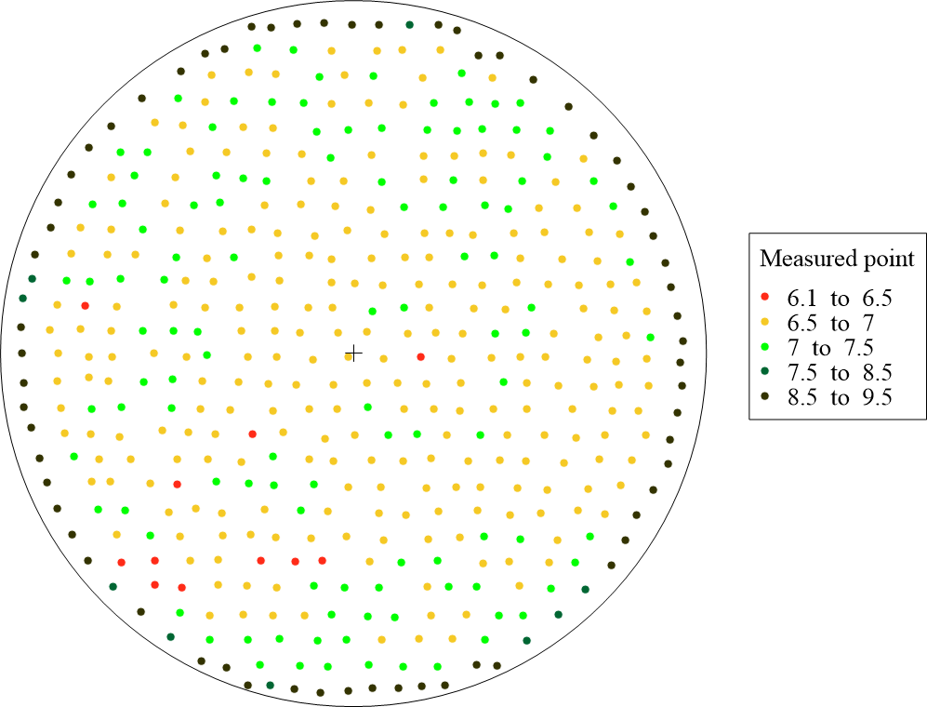
Figures 1. Location of sampled points in the bottom of the atmospheric tank and measured thickness.
  - Results and discussion
Figure 2 shows the surface resulting by the application of these two techniques to the set of measures, obtained by the Ultrasonic Thickness Measurement (UTM) technique for the case study. Figure 2(a) gives the prediction of the interpolated surface made by the deterministic approach whereas Figure2(b) shows the result of the geostatistical approach.
Estimates were made in 7616 points of a regular grid. By applying the IDW technique, the estimated value varies with respect to the true value in the range ±0.0074 with a probability of 95%, while using the Kriging, it oscillates in the range ±0.009 with the same probability.

a) 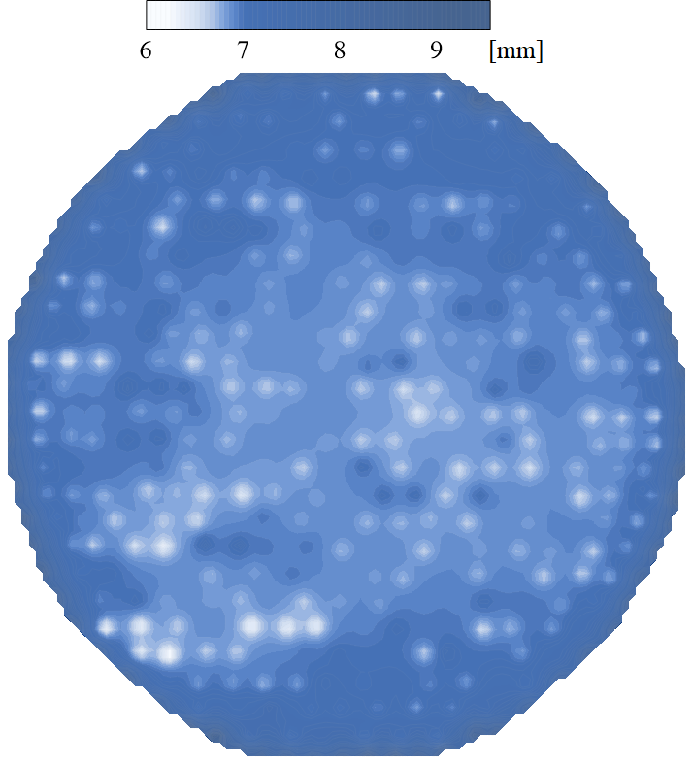 b) 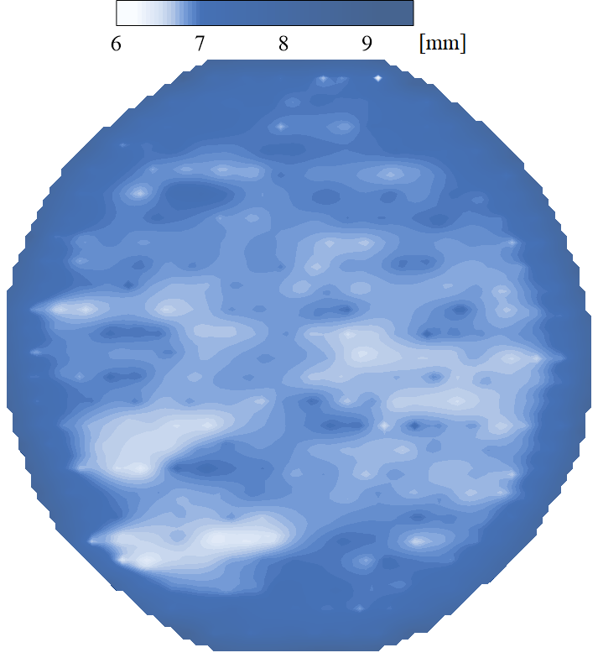
Figure 2. Interpolation contours obtained respectively with the (a) Inverse Distance Weighting and (b) Kriging.
Results have been validated to demonstrate the applicability of the model to the case-study. Figure 3 shows the validations plots. The use of the interpolation techniques is conditioned by the number of measures. The greater the number of points the more reliable the estimates, there is a minimum set of measures that gives good results. Given the limited UTM measures, in this study it was not possible to verify the numerosity of such set.

a)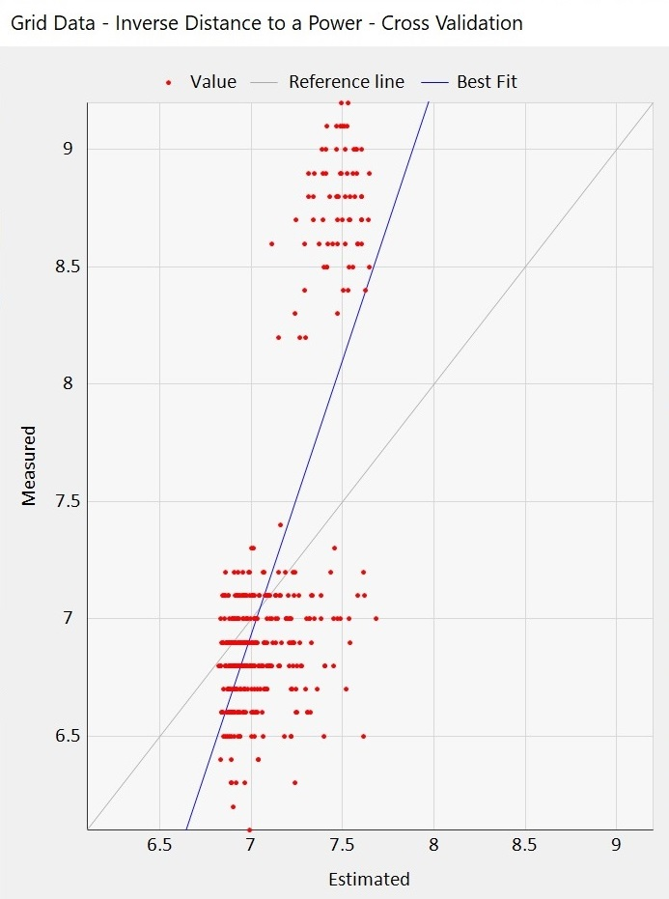 b)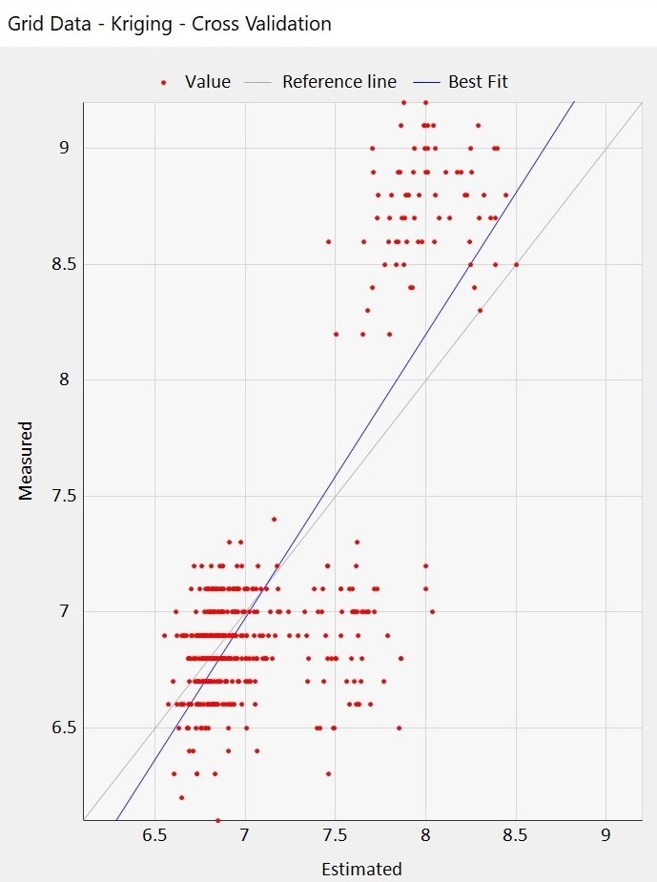
Figure 3. Validation of the predictions made with (a) IDW method and (b) Kriging method.
In Figure 3(a) and 3(b) two groups of points can be observed, the group with the greatest thickness belong to the peripheral plates, while that with the lowest values are related to the central plates of the tank bottom. The grey lines in Figures 3 represents the ideal performance of the model. The convergence of the blue line to the grey one indicates the good applicability of both models to the case study. In any case, the Kriging approach (Figure 3b) represents the best estimation of points.
The use of an interpolated surface allows to improve inspector view that, beyond seeing a set of discrete points, could also understanding with could be the trend of the phenomenon also in other areas of the bottom. This type of visual representation has been integrated in a devise named virtual sensor, i.e., a system made-up of hardware and software components for the prediction of the degradation of equipment. It has been fully developed within the MAC4PRO project. By means of the virtual sensor, the surface obtained through the appropriate interpolation technique is overlapped to a 3D geometry describing the equipment to be inspected.
During the maintenance or the inspection, the virtual sensor allows the user to observe the corrosion of the bottom of the last inspection by an Augmented Reality viewer or a portable device with a display (tablet/smartphone). Furthermore, it also supports to observe the evolution of the corrosion of the tank bottom over the time (e.g., observing a surface related to measurements from past inspections or showing the history of the thickness by table data), as well as other parameters such as the corrosion rate, the ageing index of the equipment, the residual lifetime, etc. It processes the information stored in a database through proper models. Figure 4 illustrates an example of the visualization by the virtual sensor. It shows the estimate of the corrosion trend calculated with the interpolation models and a table with the current ageing-related parameters and the predictions.

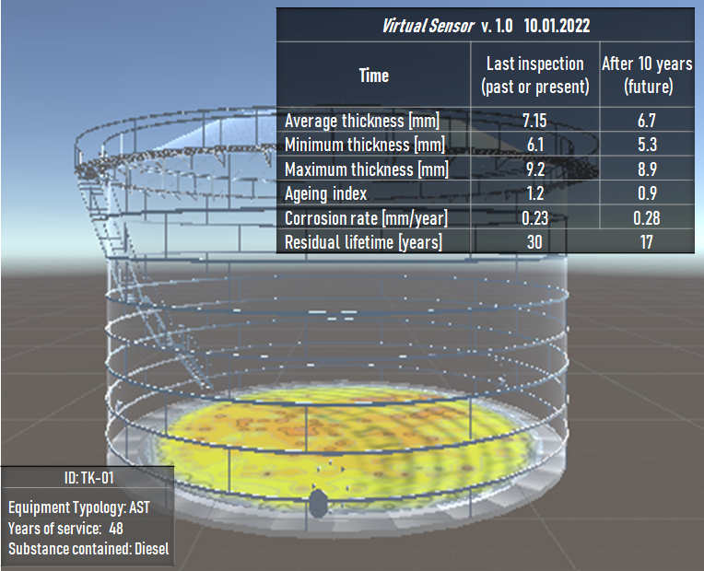
Figure 4. Screenshot of the Augmented Reality views by the virtual sensor: 3D geometry of the tank, interpolated corrosion surface and ageing related parameters and forecasts.
  - Conclusions
In this paper, a comparison between a deterministic and stochastic interpolation approach has been made to select the model that makes the best estimate of the deterioration phenomenon of the bottom tank. The stochastic approach gave back a better estimate of the interpolated surface. This validated approach is fed by the results of the predicting model to obtain future corrosion surface, which supports the monitoring and the inspection activity at major hazard establishments.
Acknowledgments
This work has been funded by INAIL within the BRIC/2018 ID = 11 project MAC4PRO and BRIC/2019 ID = 02 project DYN-RISK.
References
API, American Petroleum Institute, 2016, Risk-Based Inspection. API Recommended Practice API, RP 580, 3rd ed., New York, USA.
Argyropoulos C.D., Christolis M.N., Nivolianitou Z., Markatos N.C., 2012, A hazards assessment methodology for large liquid hydrocarbon fuel tanks. Journal of Loss Prevention in the Process Industries 25, 329-335.
Bailey T.C., Gatrell A.C., 1995, Interactive spatial data analysis, Vol 413, Longman Scientific & Technical, Essex, UK.
Bragatto P., Agnello P., Mennuti C., Milazzo M.F., 2020, Online Condition Monitoring: Sensors, Models and Software for a Safe Management of Aged Process Plants, Computer Aided Chemical Engineering, 48, 1753–1758.
Chiles J.P., Delfiner P., 1999, Geostatistics: Modeling Spatial Uncertainty, John Wiley and Sons, New York, USA.
EEMUA, the Engineering Equipment and Materials Users Association, 2014, Users’ Guide to the Inspection, Maintenance and Repair of above Ground Vertical Cylindrical Steel Storage Tanks, Standard EEMUA no. 159.
EU Council, 2012, Directive 2012/18/EU of the European Parliament and of the Council of 4 July 2012 on the control of major-accident hazards involving dangerous substances, amending and subsequently repealing Council Directive 96/82/EC Text with EEA relevance
Hengl T., Heuvelink G., Stein A., 2004, A generic framework for spatial prediction of soil variables based on regression-kriging, Geoderma, 120(1), 75-93.
Ikwan F., Sanders D., Hassan M. 2021. Safety evaluation of leak in a storage tank using fault tree analysis and risk matrix analysis. Journal of Loss Prevention in the Process Industries, 73, 104597.
Laurent A., Pey A., Gurtel P., Fabiano B., 2021. A critical perspective on the implementation of the EU Council Seveso Directives in France, Germany, Italy and Spain. Process Safety and Environmental Protection 148, 47-74.
Milazzo M.F., Ancione G., Bragatto P., Mennuti C., 2020, Simplified Modelling of the Remaining Useful Lifetime of Atmospheric Storage Tanks in Major Hazard Establishments. Chemical Engineering Transactions, 82, 175–180
Olea R., 1999, Geostatistics for Engineers and Earth Scientists. Kluwer Academic Publishers, Boston, USA.
Shepard D., 1968, A two-dimensional interpolation function for irregularly spaced data. Proceeding of the 23rd ACM National Conference, 517–524, Association for Computing Machinery, New York, United States.

