|  |  |
| --- | --- |
| cetlogo ***CHEMICAL ENGINEERING TRANSACTIONS***  ***VOL. 91, 2022*** | A publication of  aidiclogo_grande |
| The Italian Association  of Chemical Engineering  Online at www.cetjournal.it |
| Guest Editors: Valerio Cozzani, Bruno Fabiano, Genserik Reniers  Copyright © 2022, AIDIC Servizi S.r.l. **ISBN** 978-88-95608-89-1; **ISSN** 2283-9216 | |

Influence of Operational Conditions on the Bottom Corrosion of Atmospheric Storage Tanks and Predicting Model Identification

Maria Francesca Milazzoa,\*, Elpida Piperopoulosa, Amani Khaskhoussia, Giuseppe Sciontia, Paolo Bragattob, Edoardo Proverbioa

aDepartment of Engineering, University of Messina, Contrada di Dio, 98166 Messina, Italy

bDepartment of Technological Innovation, INAIL Workers’ Compensation Authority, via Fontana Candida; Monteporzio Catone Italy

mfmilazzo@unime.it

The assessment of the integrity of atmospheric storage tanks supports in preventing the release of dangerous substances with serious consequences for humans and the environment. In particular, the control of localised thickness losses in the bottom (due to pitting or other phenomena) is essential since these could lead to the perforation of the plates. The aim of this work is to investigate the influence of operational parameters on the corrosion rate of the bottom of storage tanks containing hydrocarbons. The aggressiveness of the solution, the pH and the atmospheric temperature are the investigated parameters in order to evaluate the behaviour over the time of the material used to construct the bottom plates. Carbon steel is considered as reference material. Two different solutions (pH 4 and pH 2.5) are adopted to simulate the presence of impurities in the hydrocarbon. The results represent the starting point to obtain useful information to be used in statistical models for the derivation of the probability of the critical pit. This study has been conducted within the projects “Smart maintenance of industrial plants and civil structures using 4.0 monitoring technologies and prognostic approaches” (MAC4PRO) and “Combined data-driven and experience-driven approach to systemic risk analysis” (DRIVERS), funded by INAIL, and gave a contribution to the knowledge of the evolution of the deterioration mechanism aimed at extending the residual lifetime and the time before the next inspection.

* 1. Introduction

Despite the worldwide orientation towards an ecological transition, the oil industry still plays a fundamental role in the global economy. Although the benefits and the demand of petroleum products, which cannot yet be ignored, the oil industry belongs to the category of major hazard industries (EU Council, 2012). Given the types of handled substances and the operating conditions, this type of establishments includes equipment that are exposed to several corrosion phenomena, these can cause serious losses of containment (Fabiano and Currò, 2012; Wood et al., 2013; OECD, 2017). Different types of corrosion can occur in various assets of refineries and petrochemical industries, which depend on the interaction between the material and the process fluid and even the surrounding environment. Corrosion can cause unplanned interruptions of the operations (Bennett, 2019; Pasman and Fabiano, 2021) and currently account for billions of euros per year to repair or replace corroded items (Koch et al., 2002).

Deterioration is one of the main problems encountered in atmospheric storage tanks of hydrocarbons. The damage mechanisms can be related with corrosion (internal, external and under insulation), structural issues (settling of the tanks and/or foundations, deformations of the tank shell, deformations of the roof, broken welds, etc.) and losses of functionality of the tank accessories (fire-fighting systems, grounding systems, ventilation systems, stairs, etc.). Concerning corrosion, leakages could be due to the lack of complete knowledge of the evolution of the deterioration phenomenon, which leads to inappropriate maintenance planning (Komariah et al., 2021). The monitoring of the integrity of atmospheric storage tanks is particularly critical regarding the measures of the thickness loss in the bottom due to pitting or other phenomena. The techniques to control the bottom integrity always require that tank is taken out of service, emptied, and reclaimed. The thickness measurements are repeated after a certain time interval and allow scheduling next inspection. Furthermore, the acquisition of these measures is also useful for the estimation of the probability of perforation, which represents an essential information to assess the risk associated with the release of dangerous substances as well as the environmental risk in accordance with current legislations (EU Council, 2010; EU Council, 2012).

The bottom plates of the tank are made of carbon steel, which is the most common material selected for the construction of storage systems containing hydrocarbons (Komariah et al., 2021). Steel offers affordable construction costs and good chemical resistance. Nevertheless, its corrosion is generally due to the presence of water or impurities that entered inside the equipment and it depends also on the external environment. Generalised corrosion usually occurs in areas where the water collects; the most critical bottom area is the one adjacent to the shell for tanks with slope towards the outside (cone-up) and the central one for those with a slope inward (cone-down). Localised corrosion may occur in areas of stagnation, such as the support feet or the heating coil, or in areas with the presence of dips. Another form of corrosion is pitting, usually caused by acid salts, hydrogen sulphide, water, bacteria (microorganisms), etc. High corrosion rates can be caused by localised concentrations of oxygen in the foundations or by the presence of hydrogen sulphide which locally reduces the pH of the product and may be due to the action of bacteria that reduce sulphates. Other corrosion phenomena can affect the welds.

This research aims at studying the evolution of the corrosion phenomenon of the bottom of the storage tanks, with the aim of contributing to the understanding of the deterioration mechanism and providing basic elements for the application of statistical analysis methodologies for the formulation of the probability of bottom perforation. The article is structured as follows, Section 2 illustrates the case investigated in this work, which is a storage tank containing hydrocarbons (naphtha-based solvent); Section 3 shows the methodology used for the investigation of the deterioration mechanism that is the experimental part of the work; Section 4 gives the results and discussion; and, finally, Section 5 reports the conclusions.

* 1. Case-study

The case study is a real coastal depot, its name is not mentioned for confidentiality reasons. Inside the depot, the attention has been focused on a large atmospheric tank with a floating roof, used for the storage of various light aromatic naphtha-based solvents. The tank has a maximum capacity of approximately 3000 m3 and has been in service since 1962 in a Seveso site. The study focused on the bottom of the tank, which is the most relevant part from the point of view of the losses of containment. In fact, even a modest leak could pollute the groundwater, the river, the beach, and the sea with high reclamation costs. The bottom is made up of 53 carbon steel plates, welded together to cover an area of approximately 360 m2.

To simulate the corrosion process in the laboratory, a system was created that is a glass container where some carbon steel specimens, representing the tank plates, were placed. The specimens were obtained by cutting a large sheet of the material and were submerged in the solvent mixed with the solutions that simulate hydrocarbon contamination caused by the infiltration of water and salts. Due to number of specimens (36 samples), four containers were used (Figure 1).

* 1. Methodology
     1. Experimental

To investigate the influence of operational parameters on the corrosion rate of the storage tanks bottoms, a corrosive environment was simulated. Carbon steel specimens, 20 x 30 x 3 mm (width x length x thickness) were immersed in two hydrocarbon solutions. Before the immersion, the specimens were treated in ultrasound (frequency 30 kHz), with acetone (CH₃-CO-CH₃), to remove the possible grease residues present on the surface. Subsequently, they were pickled in a Clarke solution (250 ml of hydrochloric acid (HCl), 5 g of antimony oxide (Sb2O3), 12.5 g of stannous chloride (SnCl2), in continuous stirring, at room temperature, for 35 minutes. Then, they were washed sequentially with soda, distilled water and ethanol.

Two hydrocarbon solutions were realized at different pH simulating two different corrosive environments. The hydrocarbon used is a commercial hydrocarbon, Shellsol A100 (Kremer Pigmente GmbH & Co., Aichstetten, Germany). In the first solution (A) at pH 4, hydrocarbon is mixed with an aqueous solution of NaCl, NaSO4 and acetic acid according to the concentrations used in literature (Rajasekar et al., 2005; Groysman and Erdman, 2000). In the second solution (B), at pH 2.5, hydrocarbon is mixed with Sour Water as indicated in the NACE TM0177 Test Solution B (5.0 wt.% NaCl, 2.5 wt.% glacial acetic acid and sodium thiosulphate Na2S2O3 10-1 to 10-3 M in replacement of H2S) (Calabrese et al., 2016). The ratio between the hydrocarbon and the A or B solution is in both cases 4/1. Half of the treated platelets, used for the simulation test, were immersed in the solution A and the remaining ones in solution B.

(a) 

(b)  (c) 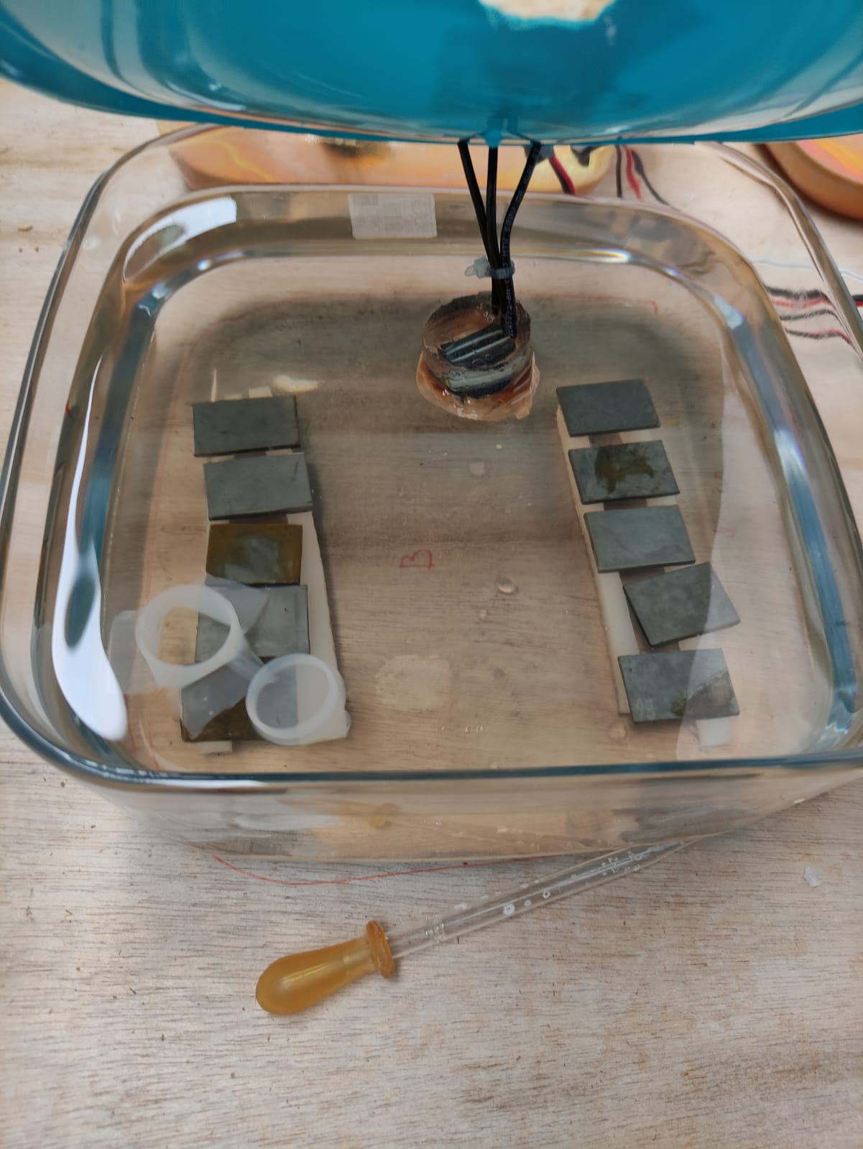

*Figure 1: (a) Carbon steel specimens; (b) Containers for the simulation; (c) Specimens placed inside a container.*

Periodically 2 platelets (one from the solution A and one from the B one) were extracted, pickled, always through Clarke solution, and structurally and morphologically characterized, respectively by X-Ray Diffraction (XRD) and Scanning Electron Microscope (SEM). During the immersion, the atmospheric temperature was monitored continuously. The XRD instrument, used for the structural analysis of the material, was a Bruker D8 Advance (Bruker, Billerica, MA, USA), in Bragg-Brentano θ–2θ configuration, with CuKα radiation (40 V, 40 mA). XRD patterns were collected in the range 10°–80° with a step of 0.1°/s. The morphological investigation was conducted through an instrument FEI Quanta FEG 450 (FEI, Hillsboro, OR, USA), operating at high vacuum with an accelerating voltage of 20 kV.

* 1. Results

After extracting the specimens, they were morphologically characterized by SEM. The results are compared with carbon steel specimens before the immersion procedure (Figure 2). The sample shows a homogeneous morphology, free of particular and relevant cracks (Figure 2a). From the XRD analysis (Figure 2b) the presence of the Fe peak (JCPDS # 04-007-9753) is evidenced, constituting more than 98 wt.% of a carbon steel.

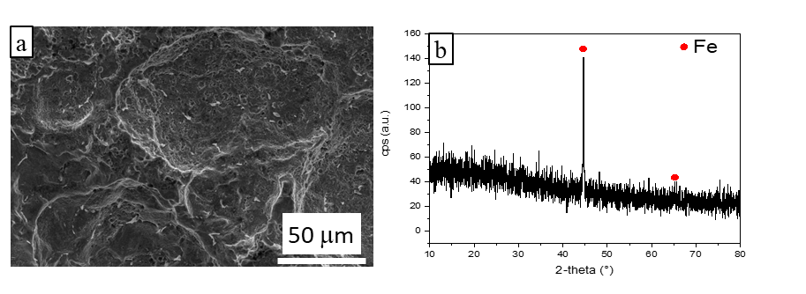

*Figure 2. SEM image (a) and XRD diffractogram (b) of carbon steel specimen before the immersion procedure.*

In Figure 3, the images of the extracted samples, respectively from A solution and from B one, after different dive times, are reported. The extractions of the specimens are conditioned by the measured corrosion rates, in this context each sample is taken when a change of trend is observed.

*Figure 3: SEM images of investigated specimens at different extraction time.*

After 10 days of immersion there is no evident attack, the morphology of both extracted samples appears to be similar to the one of not immersed specimens. At 15 days a selective attack for the sample extracted from solution A can be noted and it becomes gradually more insistent. While for samples extracted from solution B it is evident that corrosion takes place by pitting, concentrated especially in the grain boundaries. The sodium thiosulfate is probably the cause of this behaviour. At 238 days all the specimens appear homogeneously corroded.

In Figure 4, the diffractograms of the specimens extracted from solution A and from solution B at different extraction times are reported. For the solution A, the specimens show the same peaks of Fe. Regarding the solution B after 238 days of immersion, the peak of FeS (JCPDS # 04-017-5088) is evident. This is caused by the presence of sodium thiosulfate in the B solution, that favours the sulphide production (Quan et al., 2016).

*Figure 4. XRD diffractograms of specimens extracted from solution A (on the left) and B (on the right) at different extraction time (10 days and 238 days).*

* + 1. Discussion

The results of the surface characterization of the specimens show two different ways of evolving the corrosive phenomenon. A selective attack occurs in the case of solution A, while it appears in the form of pitting for the solution B. Pit depth measurements would represent useful information for quantifying the probability of the occurrence of the critical pit at the bottom of an atmospheric tank. The application of the extreme value theory (EVT), well known in the field of corrosion studies, would allow extrapolating the trend of the phenomenon to the bottom of a tank of which the simulation system is representative. The limiting depth of corrosion for safety purpose can be determined by means of widespread standards (EMMUA, 2016).

The study presents some limitations regarding the extrapolation of the corrosion model to a real bottom of a tank because the welded parts and the areas, characterized by different criticalities due to a particular shape, different thickness, and connections with other items (such as shell, roof supports, annular ring, etc.), are here not investigated. Another limit in this study could be the corrosive environment, which can be different depending on the location of the tank. For this reason, further investigations are planned.

During the execution of the experiments, the study of the influence of some variables is in progress with the aim to derive a corrosion rate model and a sensitivity analysis will be performed. Therefore, studies such as the one presented here allow the plant operator to integrate more appropriate investigations of the release scenarios due to the corrosion mechanisms within the risk assessment. These integrations are realized with the quantification of the release probability taking into account the actual evolution of the phenomenon obtained through the simulation in the laboratory; moreover, through the use of more sophisticated models, the prediction of the probability of perforation after a certain time is also possible as well as the remaining useful lifetime (RUL) of the equipment. These models combine the EVT and the Bayesian inference (Milazzo et al., 2022). The estimation of the probability of perforation and the RUL are also a way for the operator to demonstrate the adequateness of ageing management as required by the proper legislation, i.e. the Seveso Directive (EU Council, 2012).

* 1. Conclusions

The study highlights the importance of not underestimating the phenomenon of corrosion of the materials used for construction of tanks as it could be the cause of industrial accidents that generate the release of dangerous substances. In order to control and manage this problem, the plant operator usually carries out inspections and applies statistical modelling to calculate the probability of release, therefore, the investigation of the corrosive phenomenon certainly allows improving the understanding of its evolution.

The degradation of the bottoms of atmospheric storage tanks depends not only on the material they are made of, but also on the chemical composition of the stored liquids (including impurities that contaminate the hydrocarbon entering inside the equipment), as well as on environmental conditions, such as the temperature. To predict when their perforation may take place, it is necessary to have an accurate knowledge of the phenomenon acquired during experimental investigations such as those proposed in this work and the combination with appropriate forecasting models.

Acknowledgments

This work has been funded by INAIL within the BRIC/2018 ID = 11 project MAC4PRO and the BRIC/2021 ID = 3 project DRIVERS.

References

Bennett P., 2019, Rust An age old problem, Materials Today, 30, 103-104.

Quan, B.L., Li J.Q., Chen, C.Y., 2016, Effect of Additional Sulfide and Thiosulfate on Corrosion of Q235 Carbon Steel in Alkaline Solutions, International Journal of Corrosion, vol. 2016, Article ID 8549312.

Calabrese, L., Galeano, M., Proverbio, E., Di Pietro, D., Cappuccini, F., Donato, A, 2016, Monitoring of 13% Cr martensitic stainless steel corrosion in chloride solution in presence of thiosulphate by acoustic emission technique, Corrosion Science, 111, 151-161.

EEMUA, 2014, Users’ Guide to the Inspection, Maintenance and Repair of above Ground Vertical Cylindrical Steel Storage Tanks, EEMUA 159.

EU Council, 2010, Directive 2010/75/EC on industrial emissions (integrated pollution prevention and control) (Recast), Official Journal of the European Union L334(2010), 17–119.

EU Council, 2012, Directive 2012/18/EU on the control of major-accident hazards involving dangerous substances, Official Journal of the European Union L197(2012), 1-37.

Fabiano B., Currò F., 2012, From a survey on accidents in the downstream oil industry to the development of a detailed near-miss reporting system, Process Safety and Environmental Protection, 90(5), 357-367.

Groysman, A., Erdman, N., 2000, A Study of Corrosion of Mild Steel in Mixtures of Petroleum Distillates and Electrolytes, Corrosion, 56(12), 1266-1271.

Koch G.H., Brongers M.P.H., Thompson N.G., Virmani Y.P., Payer J.H., 2002, Corrosion costs and preventive strategies in the United States, NACE 2002, 1-12.

Komariah L.N., Arita S., Prianda B.E., Dewi T.K., 2021, Technical assessment of biodiesel storage tank; A corrosion case study, Journal of King Saud University - Engineering Sciences (forthcoming).

OECD, Organisation for Economic Cooperation and Development, 2017, Ageing of hazardous installations, OECD Environment, Health and Safety Publications - Series on Chemical Accidents, no. 29.

Pasman, H.J.,Fabiano, B., 2021, The Delft 1974 and 2019 European Loss Prevention Symposia: Highlights and an impression of process safety evolutionary changes from the 1st to the 16th LPS, Process Safety and Environmental Protection, 147, 80-91.

Rajasekar A., Maruthamuthu S., Muthukumar N. Mohanan S., Subramanian P., Palaniswamy N., 2005, Bacterial degradation of naphtha and its influence on corrosion, Corrosion Science, 47(1), 257-271

Wood M.H., Arellano A.V., Van Wijk L., 2013, Corrosion Related Accidents in Petroleum Refineries, European Commission Joint Research Centre Report no. EUR 26331.