CHEMICAL ENGINEERING TRANSACTIONS  VOL. 91, 2022 | A publication of
The Italian Association
of Chemical Engineering
Online at www.cetjournal.it

Guest Editors: Valerio Cozzani, Bruno Fabiano, Genserik Reniers
Copyright © 2022, AIDIC Servizi S.r.l.
ISBN 978-88-95608-89-1; ISSN 2283-9216

Jet Fires of Hydrogen-Methane Mixtures
Gianmaria Pioª, Mattia Carboni^{b}, Paolo Mocellin^{b}, Francesco Pilo^{d}, Chiara Vianello^{b,c}, Giuseppe Maschio^{b}, Ernesto Salzano^{a,*}
ªDipartimento di Ingegneria Civile, Chimica, Ambientale e dei Materiali, Università di Bologna. Via Terracini 28, Bologna
40131, Italia.
^{b}Dipartimento di Ingegneria Industriale, Università degli Studi di Padova. Via Marzolo 9, 35131 Padova, Italia.
^{c}Dipartimento di Ingegneria Civile, Edile e Ambientale, Università degli Studi di Padova. Via Marzolo 9, 35131 Padova, Italia.
^{d}Corpo Nazionale dei Vigili del Fuoco, Comando Venezia. Via Motorizzazione 7, 37100, Venezia, Italia.
ernesto.salzano@unibo.it
Developing sustainable solutions for power generation and transportation is crucial for reducing greenhouse gases (GHGs). The tendency in fundamental and practical research on this field has been characterized by investigating low or net zero-carbon sources. Among the available options, hydrogen may be employed as a possible energy carrier to reduce the local emissions of harmful gases. However, the intensive use of gaseous hydrogen is still limited by the issues related to its storage and transportation systems. In this framework, injection of compressed hydrogen into the existing natural gas pipelines is seen as a way forward to reduce the quantity of carbon-based fuel and will be studied in this work. Compared to building a dedicated hydrogen infrastructure, this solution permits lower capital costs and ensures system scalability (i.e., the possibility to add hydrogen gradually). However, the possible consequences of a gas pipeline failure can be altered.
In this paper, a numerical evaluation is conducted to characterize hydrogen-methane mixture jet fire. The analysis is performed using integral models and computational fluid dynamics (CFD). In the case of the computational fluid dynamic approach, an accurate thermodynamic properties database is employed. The distance from the releasing point at which the maximum temperature is reached (i.e., the length of the jet flame) is used as a monitoring parameter for the comparison. Results are compared with existing literature data and discussed to evaluate the safety impact of adding hydrogen to the natural gas network.
  - Introduction
Recent international debates and policies have been strongly devoted to the promotion of the use of net-zero carbon sources for energy production, posing ideal conditions for new opportunities and the expansion of innovative technological solutions. To ensure social, economic, and environmentally sustainable development, an ideal new energy source should be largely available worldwide, easy to produce and store, and produce low harmful products during its utilization. Considering the urgent need for significant variations in this field, one more key aspect is represented by the readiness level of technological solutions required for the so-called from cradle to grave path. As testified by the number of projects currently investigating this option, hydrogen has been indicated as one of the most promising solutions. Indeed, several robust and well-structured production chains exist, including steam reforming and hydrolysis. However, the bottleneck limiting the spread of this energy vector is currently represented by the safety aspects during hydrogen transportation (Vianello et al., 2020). To tackle this issue, several solutions have been analysed, such as cryogenic liquefaction (Huang and T-Raissi, 2008), the use of liquid organic hydrogen carriers (LOHC) through hydrogenation/dehydrogenation cycles (Weilhard et al., 2021), and the addition to existing gaseous fuels, i.e., the transportation and utilization of hydrogen-enriched natural gas in a compressed form through pipelines (Kong et al., 2021). The latter alternative leads to an increase in flame stability and fuel conversion, making the combustion process more effective. Besides, the addition of hydrogen reduces the overall carbon index for a given amount of produced energy without suffering significant modifications in overall reactivity and combustor design. Indeed, it has been demonstrated that the add up to 20% in volume of hydrogen in methane does not significantly affect the overall reactivity in the air of the mixture and most of the physical properties (Salzano et al., 2018). Hence, employing this solution allows to re-use the existing infrastructure, with obvious implications on the economic and technological aspects. In this perspective, additional studies are needed to guarantee an optimized and safe storage system. In particular, the characterization of the jet fire assumes a paramount significance for the realization of sustainable pipeline and storage systems (Bie and Hao, 2017). Although several experimental data and numerical models can be retrieved in the current literature to mimic the behaviour of pure methane (Bariha et al., 2017) and pure hydrogen (Cirrone et al., 2018) jet fires, a dearth of knowledge can be observed for the case of their mixtures. In addition, most investigations are focused on premixed flames, for the sake of kinetic investigations for combustion relevant conditions (Halter et al., 2005), whereas a jet fire can be intended as a scenario composed of two subsystems, the first providing the source term to the second, reproducing the combustion and heat transfer.
For jet fire description, the isothermal turbulent choked gas steady jet theory can be applied (Hess et al., 1973) to represent the velocity field (Figure 1). A stagnant regime (i.e., $u_{0}=0$) at initial pressure P₀ and temperature T₀ is commonly assumed within the gaseous reservoir. After a transition region, the released gas achieve a fully developed flow. The properties referring to this section were indicated with the subscript e in this work. The flowrate ($\dot{m}$) becomes predominantly governed by agents other than momentum, such as buoyancy and wind. Since the gaseous velocity is chocked, an increase in the upstream pressure leads to an increase in mass flow rate mainly because of a density rise. Jet gas recompression creates at the distance x_{m} the Mach disk (subscripts s) and immediately downstream, of which the flow becomes sonic and then subsonic.
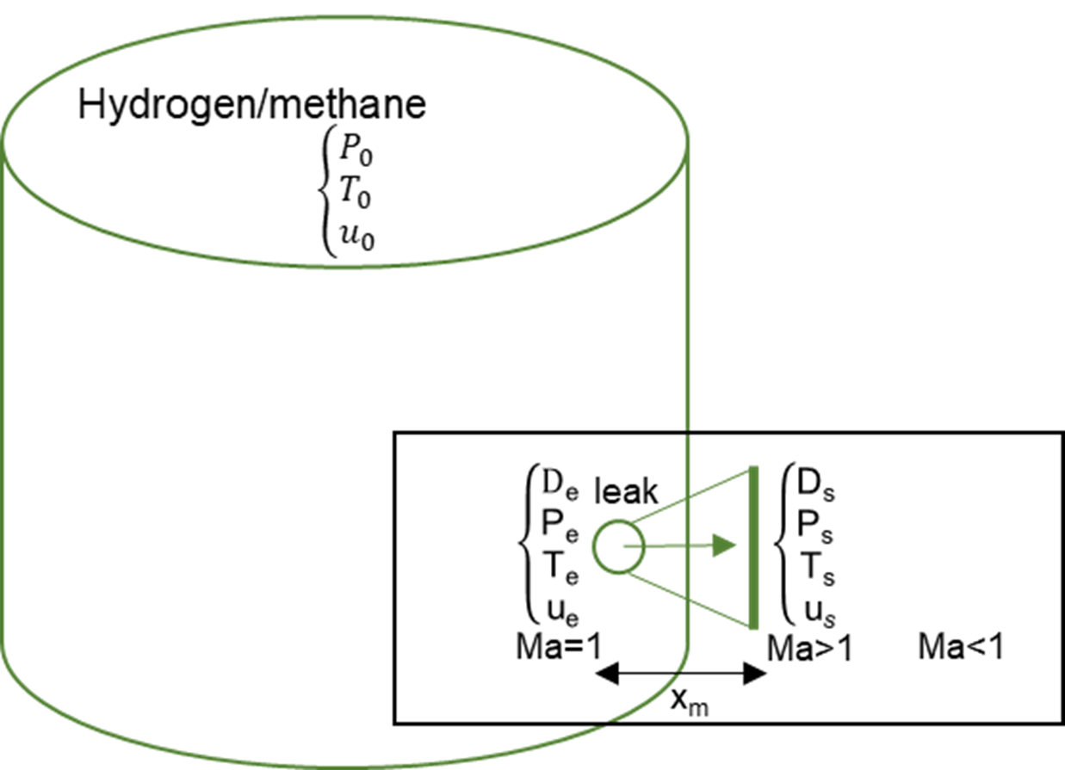
Figure 1: Isothermal turbulent choked gas steady jet theory: chocked jet and Mach disk (Hess et al., 1973). Adapted from (Benintendi, 2018).
For the sake of consequences analyses, the variability in the composition of natural gas is usually neglected, assuming natural gas as pure methane (Carboni et al., 2021). Different approaches can be implemented to account for the chemistry of the system. Among the others, simple chemistry represents an excellent trade-off for light hydrocarbons because of the robustness of the empirical values available. Indeed, this approach usually considers a single-step reaction transforming fuel and oxidant in fully oxidized species. Alternatively, yield values can be associated with the production of partially oxidized species. Hence, according to this strategy, the combustion of the investigated mixture can lead to the formation of carbon monoxide, carbon dioxide, and water, only.
Accidental scenarios can be characterized numerically either by using an integrated approach or computational fluid dynamics (CFD). A typical example for the former category is PHAST (DNV Software, UK (Det Norske Veritas (DNV), 2021)), whereas the latter includes ANSYS Fluent (Launder B. E. and B., 2013). PHAST (Process Hazard Analysis Software Tool) is a world-recognized, leading consequence modelling program developed by Det Norske Veritas (DNV). In contrast, ANSYS Fluent Software is a CFD-based software containing a large set of physical and chemical models suitable for turbulence, heat transfer, and reactions widely applied for industrial applications. ANSYS Fluent calculates the gas diffusion starting from the primitive Navier-Stokes equations. In contrast, alternative tools like PHAST are based on less expensive models (Ohba et al., 2004) and provide rapid outputs and indications of physical effects. Employing the ANSYS Fluent approach, it is possible to consider the presence of obstacles increasing the computational effort required. Both have been largely validated for jet flame scenarios (Zhang, B., Chen, 2009) (Witlox, H.W.M., Harper, M., Pitblado, 2012).
For these reasons, this work presents a numerical investigation aiming to characterize jet fire resulting from an accidental release of hydrogen-methane mixtures at different initial pressures and compositions.
  - Methodology
This work presents a comparison of different numerical approaches suitable for the characterization of jet fire of hydrogen-containing mixtures. More specifically, pure hydrogen and its mixtures containing 5 %vol, 10 %vol, and 20 %vol in methane were investigated. Pure methane was also considered for the sake of comparison. Regardless of the initial composition, the evaluation of the releasing flowrate was conducted assuming ambient temperature (i.e., 15 °C) and pressure of 100 bar as storage conditions and an orifice diameter of $D_{e}$= 5 mm.
Considering the operative conditions, a sonic regime was assumed, following the definition reported by Ishii et al. (Ishii et al., 1999). Hence, the isothermal turbulent choked gas steady jet theory was applied (Hess et al., 1973) for the calculation of the releasing flowrate ($\dot{m}$) and to evaluate the fluid dynamic data at the outlet section.
$\dot{m}=ρ_{e}∙π∙{\left(\frac{D_{e}}{2}\right)}^{2}∙\sqrt{\left(\frac{2∙γ}{γ+1}∙R∙T_{0}\right)}$ (1)
where $ρ_{e}$, $γ$, R, and T₀ are respectively the gaseous density, specific heat ratio, ideal gas constant, and initial temperature. Additional information on the adopted theory can be found elsewhere in the literature (Benintendi, 2018). Once the releasing flowrate was assessed, it was used as a boundary condition for the numerical investigation: $\dot{m}={\dot{m}}_{ANSYS}$ . For the CFD case, a numerical domain of 12 m x 5.5 m was defined to avoid significant truncation errors on flame reproduction. The domain was divided into different regions to optimize the cell size in the proximity of the release, i.e., where high-speed flows are expected and CPU time requirements. A grid sensitivity analysis determined the number and the size of the cell. SST k-omega model was employed. The kinetic was modelled by using the rate coefficients provided by the built-in database for volumetric rate. The turbulence-chemistry interactions were related by finite rate–eddy dissipation.
According to the reference guide provided by PHAST, the unimpeded flow through an orifice can be assessed as a reversible adiabatic expansion (isentropic). The general approach to modelling these flows is then to calculate the mass flow rate $\dot{m}$ through the orifice as a function of pressure in the plane of the orifice. For choked flows, the calculated flow rate initially increases with decreasing downstream pressure, reaches a maximum, and then decreases. The abovementioned software considers a series of decreasing pressures to identify the region where the flow rate reaches a maximum, based on the results obtained by two consecutive steps: if the flowrate does reach a maximum, the program uses a quadratic interpolation to set the position for this maximum; if the flow rate has not reached a maximum by the time the pressure reaches atmospheric pressure, then the flow is not choked. For compressible fluids, the method described by Bragg (1960) (Bragg, 1960) is used to calculate the discharge coefficient, generalized to any equation of state rather than being specific to the ideal gas equation of state. Equation 2 reports the model used for the evaluation of the mass flow rate based on the conditions in the orifice (subscript e) and at the initial state (subscript 0):
${\dot{m}}_{PHAST}=C_{d}∙π∙{\left(\frac{D_{e}}{2}\right)}^{2}∙ρ_{e}\sqrt{2∙(H_{0}-H_{e}})$ (2)
where $C_{d}$ stands for the discharge coefficient, H for enthalpy, and $ρ$ for the density of the discharged material.
Regardless of the implemented approaches, the absence of obstacles was assumed. A wind of 2 m s⁻¹ flowing in the perpendicular direction with respect to the releasing surface was considered. Results were compared in terms of flame length (L_{f}), intended as the distance from the releasing point where the maximum temperature is registered.
  - Results and discussion
The introduction of hydrogen in methane impacts the physical and chemical properties in different ways, with potential implications on the analysis of the consequences. In this perspective, a list of the most representative properties with the corresponding values for pure hydrogen and pure methane is provided in Table 1. Additionally, the effect of hydrogen addition on methane is qualitatively reported. The variation in gaseous density due to a hydrogen addition can be twofold based on the analysed scenario. Indeed, its decrease favours the dispersion either in a downwind direction or horizontally, thus significantly affecting the involved area, especially in the case of absent ignition. Besides, it should be considered once the releasing flow rate is considered since the speed of sound in hydrogen is approximately 2.7 times that in methane. Therefore, the volumetric flow rate from the same hole at the same pressure would be higher in the choked regime for hydrogen-containing mixtures than methane. On the other hand, the difference in density has a considerable impact on the specific energy content of the flammable mixture, as well, as testified by the lower heat of combustion reported per unit of volume.

Table 1. Properties of hydrogen, methane, and their mixture (Pio and Salzano, 2019).
Property | CH₄ | H₂ | Effect of H₂ addition
Density [kg m⁻³]* | 75.90 | 7.67 | Decrease
Lower flammability limit [%vol] | 4.40 | 4.00 | Slightly decrease
Upper flammability limit [%vol] | 15.50 | 72.00 | Increase
Fundamental burning velocity [m s⁻¹] | 0.38 | 3.0 | Slightly increase
Lower heat of combustion
per unit mass [MJ kg⁻¹] | 50 | 120 | Increase
per unit volume [MJ kg⁻¹ mol⁻¹] | 800 | 240 | Decrease
Detonation cell size [mm] | 300 | 10 | Decrease
Minimum spark ignition energy [mJ] | 0.21 | 0.016 | Decrease
Autoignition temperature [°C] | 600 | 560 | Decrease
* Properties evaluated at 25°C and 100 bar

The presence of hydrogen augments the overall reactivity. At the same time, it leads to looser conditions for the ignition of the mixture, as testified by the reported trends for minimum spark ignition energy and autoignition temperature. These trends imply that in the case of ignition, more severe consequences could be expected for hydrogen-enriched methane with respect to pure methane. However, the well-known methane-dominated regime, observable when hydrogen is added in moderate content (up to 20%v/v) for the laminar burning velocity (Salzano et al., 2018), together with the heat of combustion, suggests that the power produced by a jet fire can weakly change for the composition investigated in this work. For these reasons, numerical investigations were dedicated to the characterization of this scenario. Table 2 reports the results obtained by implementing the isothermal turbulent choked gas steady jet theory for the analysed conditions as a function of the initial composition. A comparison of the results as obtained by PHAST and ANSYS Fluent is provided in Table 3.

Table 2. Conditions resulting from the implementation of the isothermal turbulent choked gas steady jet theory for an orifice of 5 mm ($D_{e}$), initial pressure of 100 bar ($P_{0}$), ambient pressure of 1 bar ($P_{s}$), and initial temperature of 25 °C ($T_{0}$), at different compositions.
H₂ [%vol] | $P_{e}$ [bar] | $T_{e}$ [°C] | $ρ_{e}$ [kg m⁻³] | $u_{e}$ [m s⁻¹] | $D_{s}$ [mm] | $T_{s}$ [°C] | $ρ_{s}$ [kg m⁻³] | $u_{s}$ [m s⁻¹]
0 | 54.2 | -16.1 | 41.15 | 419 | 8.74 | -175.5 | 2.00 | 1328
5 | 54.1 | -16.6 | 39.24 | 429 | 8.79 | -176.7 | 1.93 | 1380
10 | 54.0 | -17.1 | 37.34 | 440 | 8.84 | -177.8 | 1.85 | 1432
20 | 53.9 | -18.1 | 33.55 | 463 | 8.95 | -180.0 | 1.70 | 1531
100 | 52.0 | -25.7 | 4.04 | 1200 | 9.77 | -195.0 | 0.24 | 2400

Table 3. Numerical results obtained in this work expressed in terms of mass flow rate ($\dot{m}$), flame length ($L_{f}$) and surface emissive power ($\dot{q}$), as calculated by PHAST and ANSYS. Calculations conducted for an orifice of 5 mm ($D_{e}$), initial pressure of 100 bar ($P_{0}$), ambient pressure of 1 bar ($P_{s}$), initial temperature of 25 °C ($T_{0}$), and wind velocity (u_{wind}) of 2.0 m s⁻¹ and neutral (D) Pasquill Stability, at different compositions.
H₂ [%vol] | ${\dot{m}}_{PHAST}$ [g s⁻¹] | ${\dot{m}}_{ANSYS}$ [g s⁻¹] | L_{f,PHAST} [m] | L_{f,ANSYS} [m] | $\dot{q_{PHAST}}$ [kW m⁻²] | $\dot{q_{ANSYS}}$ [kW m⁻²]
0 | 326 | 339 | 9.24 | 9.79 | 61 | 63
5 | 316 | 331 | 9.06 | 9.58 | 62 | 64
10 | 306 | 322 | 8.89 | 9.42 | 62 | 65
20 | 286 | 305 | 8.55 | 9.09 | 63 | 68
100 | 105 | 95 | 7.97 | 8.38 | 57 | 50
*L_{f} assumed as the maximum distance from the orifice where the maximum heat radiation and temperature are reached.
Specific consideration was given to the mass flow rate ($\dot{m}$) and the flame length ($L_{f}$) estimated at different initial compositions of the fuel. Besides, the average emissive power per unit surface ($\dot{q}$) was added for the sake of comparison. Eventually, temperature profiles with respect to the horizontal distance at the vertical level of the release as calculated by the numerical investigation performed in this work were reported in Figure 2.

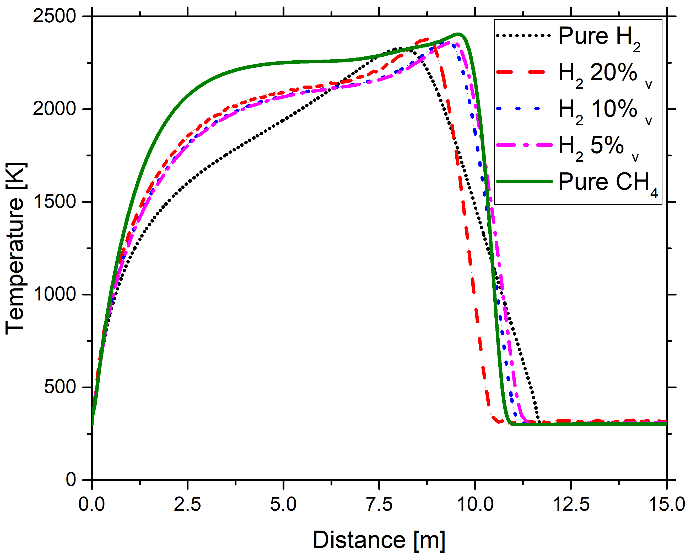
Figure 2. Temperature profile estimated by ANSYS Fluent at the release height, for different fuel compositions.

The comparison of the reported mass flowrate indicates that the isothermal turbulent choked gas steady jet theory induces more conservative results for any investigated mixtures containing methane, whereas it provides smaller values for the pure hydrogen case. However, the reported discrepancy can also be due to the use of different databases for thermodynamic properties (e.g., heat capacity) of the investigated species.
The modified fuel composition implies a variation either in the composition or the flame temperature of burned mixtures, as well. However, the peak temperature is slightly affected by the composition analyzed. Considering the possible combustion products (e.g., CO, CO₂, and H₂O) of the species constituting the analyzed mixtures, it appears evident that the hydrogen addition leads to lighter exhaust gases because of the simultaneous increase in flame temperature and reduction in molar weight of the mixture. Hence, the reduction of flame length at the level of release attributed by both numerical methods used in this work once hydrogen is added can be due to the conditions favouring the flame lift. This assumption can be corroborated by considering the difference in initial momentum and the inertia of the gaseous mixtures investigated in this work. Indeed, the temperature profile for the pure hydrogen case presents a milder decay in temperature once the peak is reached, probably due to the combined effects of inertia and the overall reaction rate. In this framework, a kinetic mechanism properly addressing the issue related to the numerical representation of the chemical phenomena in turbulent regimes represents an essential step for a robust evaluation of the investigated phenomena.
Once the surface emissive power is compared, it is worth noting that a monotonic trend cannot be observed with respect to the fuel composition. Indeed, a hydrogen addition to methane leads to an increase of this parameter either for the results obtained by PHAST or ANSYS, although both approaches indicate lower values for hydrogen than methane. This peculiar behaviour can be attributed to the properties of the reacting mixtures ruling the surface emissive power. Indeed, the hydrogen addition generates lighter but energetically denser mixtures, as previously discussed. The opposite trends determine the effect of the initial composition on the overall heat release rate, on the one side, and the area where burned species and thus generated power can spread, on the other side. Hence, it is possible to conclude that although the hydrogen has an activation effect on the kinetics of methane combustion, this does not directly imply a more critical condition for the surrounding assets (i.e., the case of engulfment).
  - Conclusions
This work presents a comparison of different numerical strategies for the characterization of Jet fire of hydrogen-containing mixtures. Specific emphasis was given to methane-rich mixtures containing up to 20 %vol of hydrogen and pure hydrogen in view of possible implementation in national and international grids. To this aim, the release rate and the consequent jet fire was calculated in the case of an accidental release from an orifice of 5 mm of diameter, considering constant and homogeneous atmospheric conditions and initial pressure of 100 bar. Results indicate that the hydrogen addition reduces the released mass flowrate since its effect on density dominates on the increase in the outlet velocity. The flame length was reduced, as well, because of the composition and temperature of the exhaust gases favouring the flame lift if hydrogen was present in the initial mixture. Eventually, the comparison of the surface emissive power showed a non-monotonic trend attributed to the opposite trend of density and energetic density. The presented analysis has also identified the introduction of a robust and accurate thermodynamic and kinetic database as key aspects for the accurate evaluation of the investigated scenarios and well-established correlations to account for the effects of turbulence on the chemistry of the system.
References
Bariha, N., Srivastava, V.C., Mishra, I.M., 2017. Theoretical and experimental studies on hazard analysis of LPG/LNG release: A review. Rev. Chem. Eng. 33, 387–432. https://doi.org/10.1515/revce-2016-0006
Benintendi, R., 2018. Source Models, in: Process Safety Calculations. https://doi.org/10.1016/b978-0-08-101228-4.00007-1
Bie, H.Y., Hao, Z.R., 2017. Simulation analysis on the risk of hydrogen releases and combustion in subsea tunnels. Int. J. Hydrogen Energy 42, 7617–7624. https://doi.org/10.1016/j.ijhydene.2016.05.263
Bragg, S.L., 1960. Effect of compressibility on the discharge coefficient of orifices and convergent nozzles. J. Mech. Eng. Sci. 2, 35–44.
Carboni, M., Pio, G., Vianello, C., Maschio, G., Salzano, E., 2021. Large eddy simulation for the rapid phase transition of LNG. Saf. Sci. 133, 105001. https://doi.org/10.1016/j.ssci.2020.105001
Cirrone, D.M.C., Makarov, D., Molkov, V., 2018. Simulation of thermal hazards from hydrogen under-expanded jet fire. Int. J. Hydrogen Energy 2–8. https://doi.org/10.1016/j.ijhydene.2018.08.106
Det Norske Veritas (DNV), 2021. Phast process hazard analysis software training [WWW Document]. Det Nor. Verit. Gr.
Halter, F., Chauveau, C., Djebaïli-Chaumeix, N., Gökalp, I., 2005. Characterization of the effects of pressure and hydrogen concentration on laminar burning velocities of methane-hydrogen-air mixtures. Proc. Combust. Inst. 30, 201–208. https://doi.org/10.1016/j.proci.2004.08.195
Hess, K., Leuckel, W., Stoeckel, A., 1973. Ausbildung von Explosiblen Gaswolken bei Uberdachentspannung und MaBnahmen zu deren Vermeidung. Chem. Ing. Tech 45, 5323–5329.
Huang, C., T-Raissi, A., 2008. Liquid hydrogen production via hydrogen sulfide methane reformation. J. Power Sources. https://doi.org/10.1016/j.jpowsour.2007.09.079
Ishii, R., Fujimoto, H., Hatta, N., Umeda, Y., 1999. Experimental and numerical analysis of circular pulse jets. J. Fluid Mech. 392, 129–153. https://doi.org/https://doi.org/10.1017/S0022112099005303
Kong, M., Feng, S., Xia, Q., Chen, C., Pan, Z., Gao, Z., 2021. Investigation of mixing behavior of hydrogen blended to natural gas in gas network. Sustain. 13. https://doi.org/10.3390/su13084255
Launder B. E., B., S.D., 2013. MAN - ANSYS Fluent User’ s Guide Releasde 15.0. Knowl. Creat. Diffus. Util. 15317, 724–746.
Niermann, M., Beckendorff, A., Kaltschmitt, M., Bonhoff, K., 2019. Liquid Organic Hydrogen Carrier (LOHC) – Assessment based on chemical and economic properties. Int. J. Hydrogen Energy 44, 6631–6654. https://doi.org/10.1016/j.ijhydene.2019.01.199
Ohba, R., Kouchi, A., Hara, T., Vieillard, V., Nedelka, D., 2004. Validation of heavy and light gas dispersion models for the safety analysis of LNG tank. J. Loss Prev. Process Ind. 17, 325–337. https://doi.org/10.1016/j.jlp.2004.06.003
Pio, G., Salzano, E., 2019. Flammability limits of methane (LNG) and hydrogen (LH2) at extreme conditions. Chem. Eng. Trans. 77, 601–606. https://doi.org/10.3303/CET1977101
Pio, G., Salzano, E., 2018. Laminar Burning Velocity of Methane, Hydrogen, and Their Mixtures at Extremely Low-Temperature Conditions. Energy & Fuels 32, 8830–8836. https://doi.org/10.1021/acs.energyfuels.8b01796
Salzano, E., Pio, G., Ricca, A., Palma, V., 2018. The effect of a hydrogen addition to the premixed flame structure of light alkanes. Fuel 234, 1064–1070. https://doi.org/10.1016/j.fuel.2018.07.110
Swanger, A.M., Jumper, K.M., Maekawa, K., Takeda, M., 2017. Zero boil-off methods for large-scale liquid hydrogen tanks using integrated refrigeration and storage, in: IOP Conference Series: Materials Science and Engineering. pp. 1–9. https://doi.org/10.1088/1757-899X/278/1/012012
Vianello, C., Carboni, M., Mazzaro, M., Mocellin, P., Pilo, F., Pio, G., Russo, P., Salzano, E. (2020). Hydrogen refueling stations: Prevention and scenario management. large scale experimental investigation of hydrogen jet-fires. Chemical Engineering Transactions, 82, 247-252. doi:10.3303/CET2082042
Weilhard, A., Argent, S.P., Sans, V., 2021. Efficient carbon dioxide hydrogenation to formic acid with buffering ionic liquids. Nat. Commun. 12, 1–7. https://doi.org/10.1038/s41467-020-20291-0
Witlox, H.W.M., Harper, M., Pitblado, R., 2012. Validation of phast dispersion modelas required for USA LNG siting applications. 12th Top. Conf. Gas Util. 2012 - Top.Conf. 2012 AIChE Spring Meet. 8th Glob. Congr. Process Saf., 31.
Zhang, B., Chen, G.M., 2009. Hydrogen sulfide dispersion consequences analysis indifferent wind speeds: a CFD based approach. Int. Conf. Energy Environ.Technol.

