|  |  |
| --- | --- |
| cetlogo ***CHEMICAL ENGINEERING TRANSACTIONS***  ***VOL. 91, 2022*** | A publication of  aidiclogo_grande |
| The Italian Association  of Chemical Engineering  Online at www.cetjournal.it |
| Guest Editors: Valerio Cozzani, Bruno Fabiano, Genserik Reniers  Copyright © 2022, AIDIC Servizi S.r.l. **ISBN** 978-88-95608-89-1; **ISSN** 2283-9216 | |

Do you really mean “safety culture”? Change behaviours, Change Mindset, Change results: the OPS model

Mauro Gotti\*, Marco Parenti

aDEKRA Italia S.r.l., Via Fratelli Gracchi, 27, 20092 Cinisello Balsamo (MI) - Italia

mauro.gotti@dekra.com

We live in turbulent times. Our hypercompetitive and dynamic labour market requires both individuals and organizations to be highly responsive to change in a way to adapt, innovate, and, ultimately, thrive.

Besides employees are increasingly being asked to contribute to organizational learning and to the continuous improvement of organizational processes and practices, feeling safe to do so. How does occupational safety change look like in such a context? How can we liberate the brilliance of the people and make them play a significant role in this change? Behavioural-Based Safety (BBS) is a process aimed to answer to these questions by creating organizational dialogue and engagement, ultimately a safety partnership and a constant dialogue between management and employees. In fact, the BBS goal is to convey people’s attention and actions on their, and others, daily safety behaviour. BBS focuses on what people do, it analyses why they do it, and then applies a research-supported intervention methodology to improve their behaviours and to anchor those behaviours to a solid corporate safety culture with related written and “unwritten” norms.

To be successful a BBS programme must include all employees, from the Board to the front-line workers, also including stakeholders (i.e. customers and suppliers) and temporary workers (i.e. agency workers, contractors, and sub-contractors). To achieve changes in safety behaviours, policies, procedures and/or systems most assuredly a BBS programme will also need to confront with a new organizational standpoint about human factors in safety and eventually catalyse a real cultural change towards occupational safety. This calls ultimately for establishing and promoting a psychologically safe workplace. High motivation and assumption of responsibility are not enough to create an all-round safety culture. Indeed, oftentimes employees do not communicate the mistakes made for fear of appearing incompetent or "losing face" or even of losing their own jobs because of a punitive organizational culture, which does not accept mistakes. In this setting employees tend to blame each other and/or to hide mistakes. BBS programmes must be underpinned by a culture of effective-error-management-approach through the means of the so called “psychological safety”. An organisational culture based on psychological safety creates the belief that employees will not be punished or humiliated for voicing their ideas, questions, concerns, mistakes, and leads to innovation by learning from mistakes and giving room and way for organizational development and real change towards total safety and wellbeing.

What are the main resistances to change? How do you work on motivating people to change behaviours so that they can change results? Is an organizational culture that monitor and punishes error the way to manage safety at work? What is helpful to our goal of total safety and wellbeing in our organizations?

These are just some of the questions and the topics we will go through DEKRA intervention.

DEKRA has developed its own methodology, called Organizational Process Safety, or OPS: it allows a detailed diagnostic of the Process Safety Management System of the organization under analysis, a clear metric to assess the Safety Culture maturity, and give strong suggestions on the path to be followed to increase performances and results.

In our presentation we will describe the main aspects of the tool, and some rale case studies on sites that experienced an high incident rate.

The model is based on 7 “workstreams”, each of them further detailed in more simple elements.

The diagnostic phase of the assessment will allow to define performances of each of the elements, of the workstreams, and of the management system as a whole.

The scoring systema, already applied to several organizations and in a wide range of sectors, will also allow the benchmarking in the same sector or in the global industry.

The main features of the methodology are:

* a detailed picture of the safety performances of the plant and of the organization
* it’s quantitative, precise, repeatable and reproducible
* identifies the actions, with clear priority scale, and can measure their efficiency and the improvements
* reliable metric, that allows benchmarking with other similar operations or in different geographic areas

We will show how the methodology gives a clear and detailed analysis and the Culture of Safety maturity of the organization, its strengths, and its weaknesses.

We will also show how it is possible to develop a tailor-made improvement plan, with quick- wins and long-term goals and actions, so that the operators will have an immediate feedback and perception of the efforts that the organization is putting in place, and will be fully involved in and committed to the improvement plan.

SAFETY CULTURE MATURITY RADAR (CASE STUDY)



DEKRA, an EHS expert, has long-standing experience in the field of behavioural analysis and cultural change. DEKRA interventions enable and most importantly integrate actions on total security with a fundamental component, too often overlooked, which was very well summarized by Drucker in his famous: "culture eats strategy for breakfast". DEKRA has a proven expertise in creating behavioural and cultural platforms to change the fates of people and the organizations that people make up.

* 1. Introduction

Strong process safety management is widely credited for reductions in major accident risk and improved industry performance with respect to catastrophic events that impact the health and safety of employees and other stakeholders. Process safety practices and formal safety management systems have been in place in most organisations for many years. Over the past 20 years, numerous government mandates for improved process safety performance have arisen, globally, which has prompted widespread implementation of a management systems approach to process safety management. After an initial surge of activity, process safety management activities appear to have stagnated within many organisations. Incident investigations continue to identify inadequate management system performance as a key contributor to many incidents. Audits and regulatory inspections reveal a history of repeat findings indicating chronic problems whose symptoms are fixed repeatedly without effectively addressing the technical and cultural root causes.

The Center for Chemical Process Safety (CCPS) created what is recognised as a leading industrial approach on process safety management framework – Risk Based Process Safety (RBPS). The RBPS approach recognises that all hazards and risks in an operation or facility are not equal; consequently, apportioning resources in a manner that focuses effort on greater hazards and higher risks is appropriate. Using the same high-intensity practices to manage every hazard is an inefficient use of limited resources. A risk-based approach reduces the potential for assigning an undue amount of resources to managing lower-risk activities, thereby freeing up resources to address higher-risk activities.

DEKRA has streamlined the CCPS RBPS system, condensing the twenty elements into seven coordinated workstreams, as detailed in Table 1. The goal in this approach was to collect information for design of recommended high priority corporate-wide improvement projects related to process safety.

Table 1. Workstreams and CCPS elements

|  |  |  |
| --- | --- | --- |
| Workstream | | CCPS RBPS Element Name |
| 1 | Capability | Compliance with Standards  Process Knowledge Management  Process Safety Competency  Training and Performance Assurance |
| 2 | Incident Response | Stakeholder Outreach  Emergency Management  Incident Investigation |
| 3 | Risk Management | Hazard Identification and Risk Analysis |
| 4 | Asset Integrity | Asset Integrity and Reliability  Management of Change |
| 5 | Accountability | Measurement and Metrics  Auditing  Management Review and Continuous Improvement |
| 6 | Operations | Operating Procedures  Safe Work Practices  Operational Readiness  Contractor Management  Conduct of Operations – Operational Discipline |
| 7 | Culture and Organisation | Process Safety Culture  CARE Culture  Workforce Involvement |

As mentioned, recommended strategic improvement of H&S rely on the workstream: “Culture of Care”, the related interventions depending upon the level of maturity assessed in the specific organization.

It has already pointed out that, despite “Capability” and “Culture and Organisation” being listed as workstreams just like the other five, a basic assumption of Organisational Process Safety (OPS) is that these workstream deserve a special consideration, as they act as the “glue” that holds together the entire system. It is also worth emphasising that these twenty elements and seven workstreams are not totally disconnected, as they have some strong interactions among them. Another basic assumption of OPS is that you cannot know where you are and the things you need to do to improve, unless you also measure. This is a fundamental principle of science, beautifully summarised by Baron William Thomson Kelvin, in his lecture “Electrical Units of Measurement”, at the Institution of Civil Engineers, London, back in 1883:

*“When you can measure what you are speaking about, and express it in numbers, you know something about it; but when you cannot measure it, when you cannot express it in numbers, your knowledge is of a meagre and unsatisfactory kind: it may be the beginning of knowledge, but you have scarcely, in your thoughts advanced to the stage of science.”*

Any implementation must start, therefore, with an assessment to obtain a picture of the current status and categorise each of the twenty elements of the process safety management in the site or organisation into one of the maturity levels shown in Figure 1.

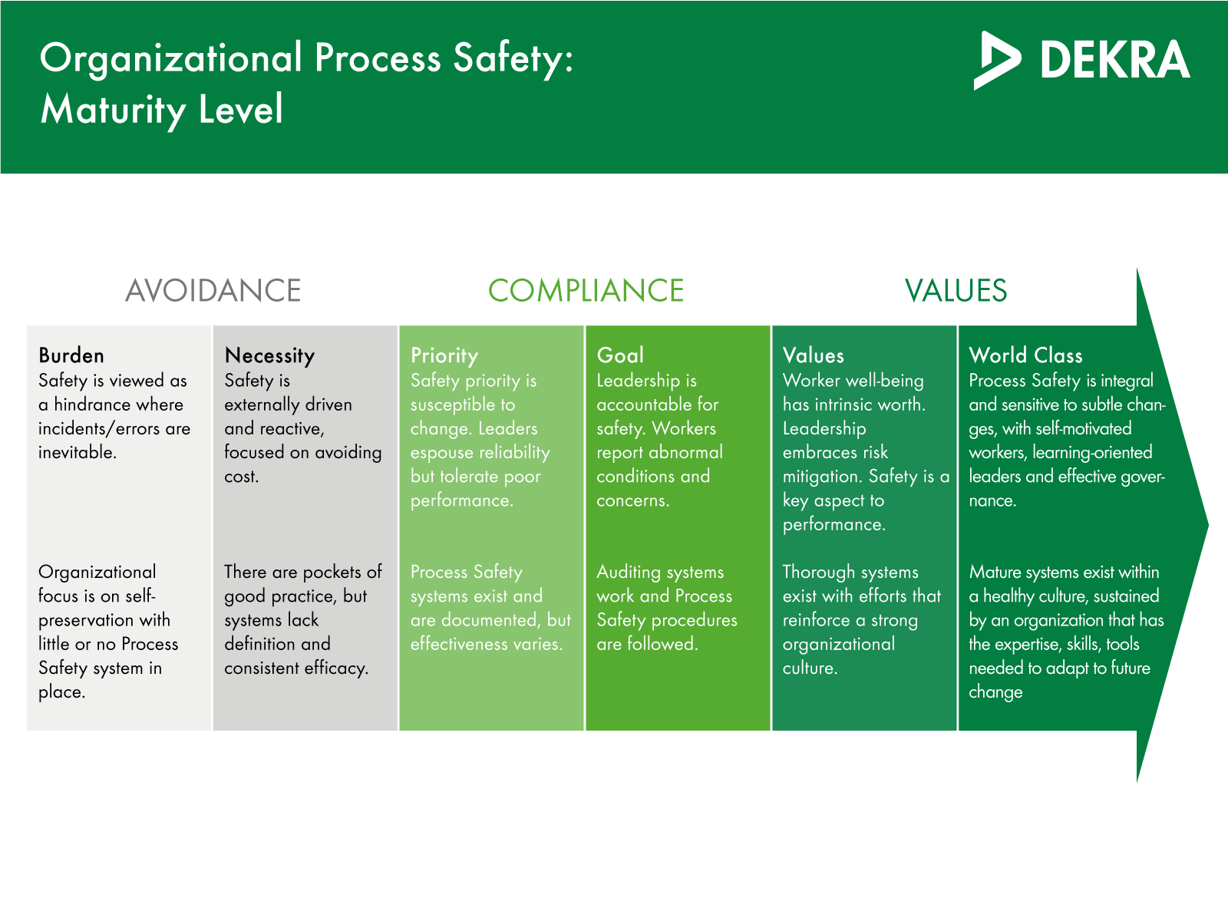

© 2019 DEKRA North America, Inc. or its subsidiaries. All rights reserved. All trademarks are owned by DEKRA North America, Inc. or its subsidiaries, reg. U.S. Pat. & Tm. Off. and other countries as listed on our website. No modifications, reproduction or use without written permission from DEKRA North America, Inc. or its subsidiaries.

*Figure 1: Maturity Scale Level*

Without getting into much detail, the assessment includes:

* A verification of the procedures, standards and registers documenting the process safety management of the site or organisation.
* A visit to the site during which a multidisciplinary team of experts perform different activities:
  + Observations of different elements of the plant that give a good representation of the process safety practices.
  + Face to face interviews with personnel at different levels of the organisation, including contractors. These interviews help also to determine the process safety practices but, most importantly, the culture at the site.

After completing these activities, the team of experts uses a scoring tool to determine the maturity level of the organisation in each of the seven workstreams and twenty elements. The scoring tool is based on a questionnaire for each element. Each question is scored from 1 to 4, based on the evidence observed in the documents provided and during the different activities at the site. The questions are chosen strategically to capture the key principles and essential features of each and every element. DEKRA has also developed very detailed scoring criteria to ensure consistency of results across teams of experts. Once all the questions of an element have been scored, the overall sum is mapped into the maturity level for this element.

Additionally, the assessment will identify the interventions needed for the optimal progress in maturity. Furthermore, the assessment will rank the interventions in order to prioritise actions tending to improve “weak” elements over those actions intended to improve already “strong” elements. The assessment will identify tailored Key Performance Indicators (KPIs) that will allow monitoring of progress in the implementation until the next assessment.

The OPS assessment methodology has been digitalised, thus allowing a very efficient workflow, from engagement with the site to delivery of results of the assessment. The digital tool includes of course the questionnaire, scoring criteria and the algorithm for mapping into maturity level. Furthermore, the tool allows to keep all the information together and readily available for the scoring, including material provided by the client, as well that gathered during the site visit, notes, pictures or videos.

The actions identified during the assessment need to be implemented by the organisation during the intervention phase, and the progress will be monitored using the KPIs identified in the assessment.

Finally, a new assessment will reset the picture to the new situation, thus starting the cycle again. The period between assessments is typically around two years and should never exceed five years.

The implementation of an OPS system is therefore a cyclic continuous improvement process, as shown in Figure 2.

*Figure 2: OPS Implementation Process*

* 1. Example of an OPS assessment

Figure 3 shows the summary of the results of the OPS assessment as applied to a case study, while Figure 3 shows maturity levels of every workstream. As can be seen, every one of the elements and workstreams are scored according to the scale in Figure 1. It is important to understand, at this point, that appropriate process safety management is a complex issue that cannot be captured by just a scalar score. However, although organisations often like to be given an overall score, it would not be meaningful as can be clearly seen in Figure 4: while some of the elements achieve reasonable maturity levels (e.g. asset integrity and reliability) others have ample room for improvement (e.g. operations discipline, process safety culture or workforce involvement).

The OPS digital tool provides many additional tables and charts, element by element and workstream by workstream. Benchmarking with other sites/organisations is also possible, after establishing a basis of comparison (business sector, geographical area…). These results:

* Allow the DEKRA experts to assess the current condition of process safety practice at the site/organisation.
* Provide a guidance in the design of an optimal roadmap for improvement.



*Figure 3:* Results of an OPS assessment

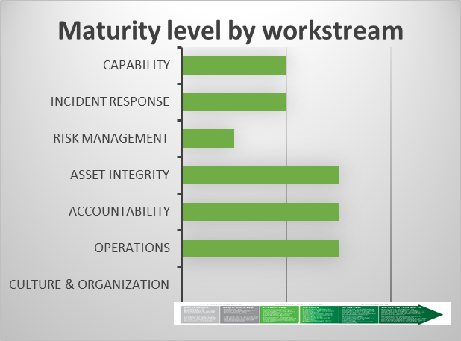

*Figure 4:* Maturity Level by workstream

Looking at Figure 3 and Figure 4 above we can start drawing some interesting conclusions. The assessment detects low scores in the following elements:

* Process knowledge management.
* Incident investigation.
* Hazard identification and risk analysis.
* Operations procedures.

And especially low scores in:

* Conduct of operations-Operations discipline.
* Process safety culture.
* Workforce involvement.

This is an example of a plant that suffered a severe incident, causing multiple fatalities. A few near hits occurred at similar plants of the same operator; one of them just a few months before. It seems clear that a proper incident investigation, sharing of the lessons learned and incorporation of those into risk analysis and operational procedures would have helped to prevent the incident. Learning lessons from past incidents and near hits seems quite an obvious thing to do. Yet, this practice often has ample room for improvement in industrial practice. Sometimes incidents or near hits are not investigated properly and with the appropriate depth, thus missing the opportunity to identify the true root causes and draw conclusions; sometimes near hits are not investigated at all, due to resource constraints! In other cases, the information is not diffused in an adequate manner (sometimes cultural issues are at play; people often don’t like to be exposed as “the one who had the incident”). Finally, in some cases the information exists, is published, but not incorporated. In other words, the lesson is there, but it is not learned.

Whatever the root causes, it is clear that a reliable system for drawing lessons learned from incidents and near hits at the site or the business at large is a key element in successfully managing process safety. Our case study did not have this capability and, therefore, it can be identified as a clear need for improvement.

As it has been stated, OPS was built under the basic assumption that the relationship between Organisational Capability and Culture is the glue that integrates an effective risk management program. Not surprisingly, this assessment clearly identifies a very low safety culture maturity level in the organisation, which was almost unanimously identified as one of the root causes of the incident.

Of course, proposing a roadmap for improvement of the maturity level would require a deeper understanding of the organisation. Here’s where the change towards the CARE Culture and the CARE Leadership programmes come to help. Nevertheless, the OPS methodology immediately suggests some actions that need to be put in place for improvement:

* Identify and correct cultural issues that underlie the failure to fulfil process safety responsibilities (e.g. why the organisation is tolerating sub-standard performances?). Review periodically the process safety culture of the organisation.
* Establish a program to conduct risk analyses, audits, management reviews, and so forth in accordance with credible, established schedules.
* Establish a program to investigate incidents and near hits and guarantee their diffusion to all concerned persons.
* Establish appropriate operational procedures, including those for abnormal situations. Clearly define safe operational limits and require adherence to them. Ensure that those authorising deviations from standard procedures are well aware of the risks and have a sense of vulnerability.
* Encourage teamwork and open communication.
* Encourage workers to act deliberately and stop if conditions do not match their expectations. Train workers when to involve others in risk analyses. Train workers on how to recognise hazards, and how to recognise when unknown hazards may be present. Establish and promote an environment that encourages workers to develop a thorough understanding of their process.
  1. Conclusions

DEKRA has developed Organisational Process Safety (OPS) as a methodology and digital tool to allow assessment and improvement of the process safety maturity of industrial sites and organisations.

The OPS assessment has identified the strengths and weaknesses of the process safety practice at the site and organisation in a case study. Out of the twenty elements of the model, the lowest scores were assigned to:

* Conduct of operations-Operations discipline.
* Process safety culture.
* Workforce involvement.

The application of OPS has also allowed some specific actions to be proposed which are designed to improve maturity level of the site and organisation. These actions emphasise mainly cultural issues such as promoting open communication, psychological safety, empower personnel from a safety point of view, and establish and enforce risk-based operational procedures. Some additional technical actions, such as incident investigations and to perform risk analyses are also proposed.

By improving maturity level of the organizations, in DEKRA we also realized that the sustainable and successful way of creating safe organizations goes through a learning curve. The capability of the learning (and listening) companies to create organizations “worth working for” is impressive, from either physical and psychological safety standpoint. DEKRA support the change through a programme that is capable to measure and address organizational change whilst engaging Hearts and Minds, making room from democratic, involving process of decision making; creating a Culture of CARE.