CHEMICAL ENGINEERING TRANSACTIONS  VOL. 91, 2022 | A publication of
The Italian Association
of Chemical Engineering
Online at www.cetjournal.it

Guest Editors: Valerio Cozzani, Bruno Fabiano, Genserik Reniers
Copyright © 2022, AIDIC Servizi S.r.l.
ISBN 978-88-95608-89-1; ISSN 2283-9216

Influence of liquid fill level on the blast created by a water BLEVE in a tubular geometry
Frederic Heymes^{a,*}, Anna G. Antonelli^{b}, Clement Chanutª, Christian Lopezª, Pol Hoorelbeke^{c}
ª Laboratory for risk sciences (LSR), IMT mines Alès, 30319 Ales, France
^{b}LISES Dipartimento di Ingegneria Civile, Chimica, Ambientale e dei Materiali, Alma Mater Studiorum —Università di Bologna, via Terracini n. 28, 40131 Bologna, Italy
^{c}Total Energies, Paris, France
frederic.heymes@mines-ales.fr

In this work, a series of water BLEVE experiments was carried out in order to measure the internal pressure change and the aerial overpressure close to the vessel. Water was superheated at 290°C and was contained in a tubular pipe with a rupture disk. The rupture disk allowed triggering BLEVE by sudden pressure drop. The discharge orifice was perfectly known and negligible mechanical energy was lost to rupture the disk. The liquid height was varied to investigate the influence of the ratio vapor / liquid on the aerial overpressure in the near field. Results showed several pressure peaks, the first one is the most intense and is independent from the liquid fill level. The impulse of this peak is however related to the liquid level. This is in contradiction with energy equivalence models and supports authors that consider the first pressure peak as resulting only from the vapor phase burst pressure. This conclusion is valid in near field with no total destruction of the vessel.
  - Introduction
A BLEVE event is the physical explosion of a pressurized vessel containing a superheated liquid that can be triggered by several causes, such as an external fire, the mechanical impact of a projectile, tank overfilling, and other less common events as the onset of runaway reactions and mechanical issues due to fatigue or corrosion. The catastrophic failure of the vessel can occur at operating conditions or when a deviation from the normal operations is experienced for the abovementioned causes. A critical requirement for a BLEVE to occur is the achievement of a liquid temperature far above its normal boiling point. Major accidents connected to BLEVE actually involved propane and LPG. Nevertheless, even high boiling substances like water, in severe conditions of pressure and temperature, can be affected by a BLEVE scenario. Among the worth mentioning historical BLEVE cases is the recent accident occurred in Bologna Italy in 2018. In this catastrophic event, the explosion was initiated by an external fire due to the collapse of a tanker filled with LPG with a truck full of flammable solvents. The effects of a BLEVE accident are primarily the generation of a blast, the ejection of fragments, and a powerful ground loading (Eyssette el al., 2021). For flammable compounds, other secondary effects can be added: fireball; pool fire or a gas explosion.
    - The boiling liquid vapour explosion (BLEVE)
BLEVE is a complex phenomenon and various definitions exist. Many scientific works can be found in the scientific literature about BLEVE. All authors agree on the fact that superheated liquid boils violently when a loss of containment causes a pressure drop in the vessel containing the liquid, leading the pressurized liquid to a superheated state. This violent boiling may result in the vessel destruction and one or several aerial overpressures. But there remain several points of discussion which foster supplementary research works.

- One point of discussion is about the level of superheat state that is required to produce a BLEVE. Certain authors such as (Reid, 1979) stated that the liquid needs to reach the superheat limit temperature in order to produce a BLEVE. Other authors suggest less restrictive superheat criteria and assume that the liquid needs only to reach a temperature above its boiling point at normal atmospheric pressure. This question allows thinking on which compounds can lead to a BLEVE.
- Another point of discussion is the way that thermodynamic energy contained in the vessel is converted into mechanical energy (blast, fragments). This question is crucial when predicting the consequences of a BLEVE. A large set of research was done on the blast creation.
- A last point, which is poorly understood currently, is the interaction between tank opening and liquid boiling. The tank failure and opening will trigger the pressure drop and violent boiling, while the latter one will produce supplementary expanding vapor that will push the tank walls and continue to tear the wall. Some considerations about 1-step or 2-steps BLEVE discussed the way a tank may fail during a BLEVE event (Laboureur et al., 2015).

    - Blast effect modelling
The key point when attempting to model the blast created by a BLEVE is the way that the thermodynamic energy contained in the vapour and/or the liquid phases is converted into blast, and which energy is lost to destroy the tank. Many models use energy equivalence and well-established scaling laws (e.g. TNT) for peak pressure prediction. These models usually necessitate the calculation of the available expansion energy based on different physical and thermodynamic assumptions. Table 1 summarizes several models from literature considering differently the energy in the vapour and/or liquid) phases.

Table 1: Summary of energy equivalence models for blast prediction

Author | Energy | Thermodynamic assumptions | Other assumptions
Brode, 1959 | vapour | constant volume transformation  ideal gas
Prugh, 1991 | vapour + liquid | adiabatic, isentropic expansion  ideal gas
Planas, 2004 | vapour + liquid | adiabatic, irreversible expansion  real gas | Tank destruction takes 40 to 80% of energy
Casal, 2006 | liquid | liquid superheat energy  both isentropic and irreversible processes | Tank destruction takes 40 to 80% of energy
Genova, 2008 | liquid | excess heat available in the liquid adiabatic expansion
CCPS, 2010 | Vapour + liquid | isentropic expansion  Real gas

A large scattering can be observed in the peak overpressures predictions (Hemmatian et al., 2017). In the groups of models based on ideal gas behaviour, the isothermal expansion model predicts greater BLEVE peak pressure than the constant volume energy model and the isentropic expansion model, since greater energy is estimated in the isothermal expansion model. The methods based on real gas behaviour and adiabatic irreversible expansion assumption (Planas-Cuchi et al., 2004; Casal and Salla, 2006) predict lower aerial overpressures that are much closer to real data obtained in experiments (Bubbico et al., 2008).

Recent works attempted to achieve accurate far-field or confined space blast pressure predictions by Computational Fluid Dynamics (CFD) simulations using the models developed by Van den Berg et al. (2004)) and Yakush (2016). However, these models assume that the blast results from the instantaneous phase change of liquid and vapour expansion, which is in contradiction with the statement of (Birk et al., 2018, 2020) who consider that the vapor expansion is the main source of shock wave generation while the liquid evaporation is not as fast as the vapor expansion and doesn’t contribute to the main shock. Li et al., 2020 made a further step and investigated if it is possible to determine the pressure peaks of BLEVE by simulating simultaneously or separately the vapor expansion and the liquid flashing. They concluded that summing vapor expansion and flashing liquid pressure peaks overestimates the experimental data, which is a conservative method. By considering separately vapor expansion and liquid flashing they observed a more realistic main pressure peak prediction; and were able to predict a third pressure peak due the flashing liquid, which was however not well correlated with the experimental data.
    - Objectives of this work
The two main methods to calculate the blast from a BLEVE (energy equivalence and CFD) require knowing how thermodynamic energy is converted into mechanical energy. A lack of experimental results highlighted why previous works required making strong assumptions on how the multiple overpressures are created.

This work aimed at providing experimental data to understand better how superheated liquid flashing contributes to the pressure peaks, by considering the influence of the liquid fill level. The burst pressure was hold constant to avoid any effect of superheating level, and the opening of the vessel was created by a rupture disk to avoid any difference of tank opening and to have little energy consumption for tank destruction. By this way, the only parameter that was varied was the energy contained in the liquid phase and the vapor phase. Aerial overpressures were measured at 12 locations near the vessel.
  - Experimental setup
The experimental materials and methods were detailed in (Heymes et al., 2019, 2020). The pressure vessel consisted in a vertical tube (internal diameter 139.76 mm, height 1.064 m) with a volume of 16.3L (Figure 1a), closed at the top by a rupture disk.
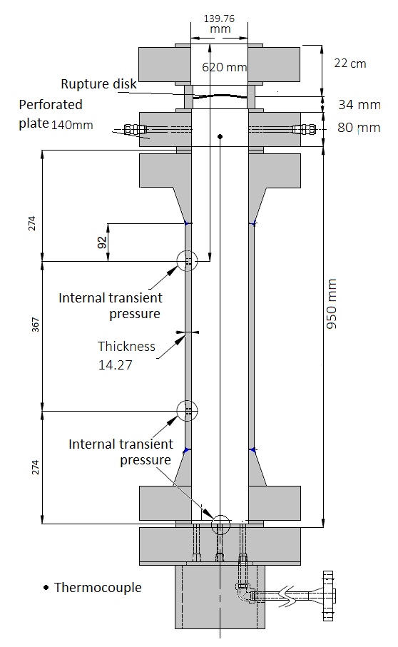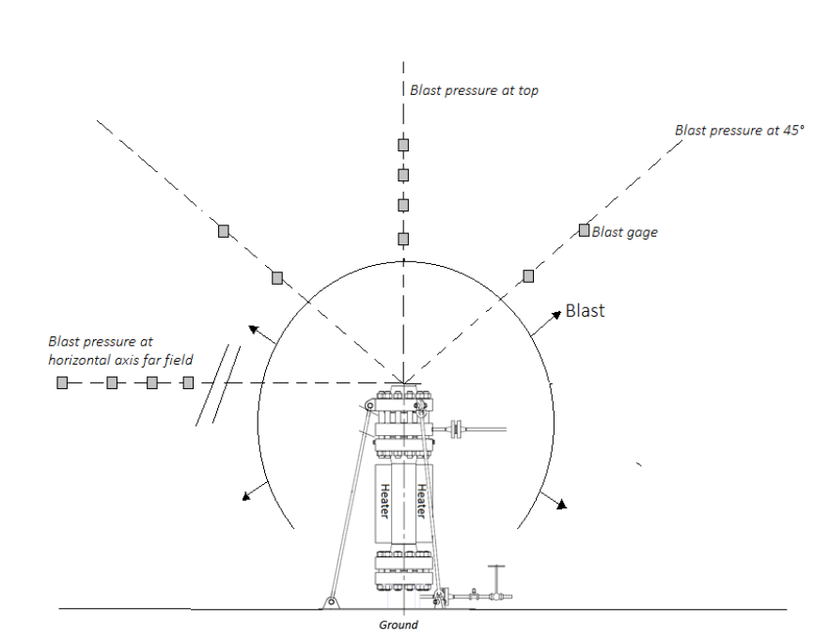
Figure 1: Experimental setup (1a, left) and location of the aerial overpressure gauges (1b, right)

The rupture disks failed at 76 bar (stainless steel 316). The temperature of liquid was 290°C, which is 190°C above the normal boiling point and is close to the superheat limit temperature (Heymes et al., 2020). Three high speed internal pressure sensors (Kistler 601C) and 24 thermocouples (type K) were set in the vessel to record internal parameters. A set of 12 aerial overpressure sensors (PCB 137A23) were put on three different axis at the exit of the vessel (Figure 1b): 4 sensors above the rupture disk on a vertical axis; 4 sensors on two 45° tilted axes pointing at the rupture disk and 4 sensors on an horizontal axis at the level of the prototype outlet. The distance between each sensor and the center of the rupture disk are given on Table 2. Sensors B1 to B8 can be considered as being in near field.

Table 2: Name and location of aerial overpressure gauges  Vertical Tilted Horizontal  Name Distance Name Distance Name Distance  B5 103 cm B1 60 cm B8 71 cm  B6 108 cm B2 116 cm B9 215 cm  B7 118 cm B3 68 cm B10 415 cm  B8 128 cm B4 106 cm B11 615 cm | 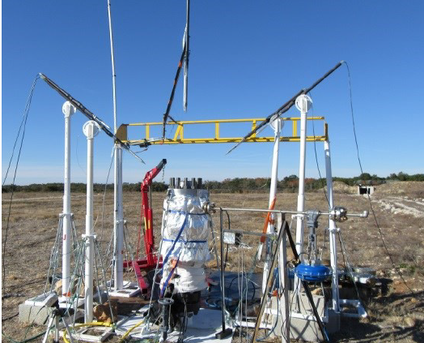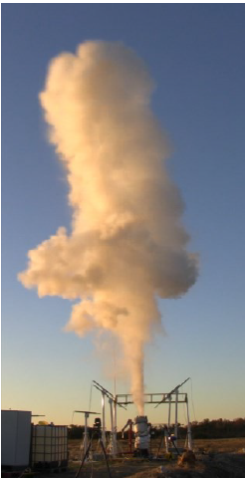  Figure 2: Picture of the setup (2a, left) and of the steam jet (2b, right)
The acquisition rate was set at 250 kHz for pressure data, and 60 Hz for temperature. The air was purged from vapor space before each test. Each test required one hour for heating, and resulted in the rupture disk failure and the ejection of a steam jet (Figure 2). The liquid was perfectly mixed at the moment of rupture as indicated by the internal thermocouples (Heymes et al., 2020).
  - Results and discussion
    - Aerial overpressure data
A typical aerial overpressure data is given on Figure 3. This data was recorded by sensor B4 (distance 106 cm) during a test with 9.5 kg of water; the disk ruptured at 76 bar. The data show clearly two pressure peaks, the first one being the more intense. Figure 4 shows experimental data recorded on sensor B3 (68 cm) and showing different filling levels. This figure shows that the first pressure peaks overlap perfectly. The second pressure peak is clearly lower than the main one; the maximum value is almost independent from the initial water mass. It has to be noted that the duration of the second pressure peak is much longer than the first one.

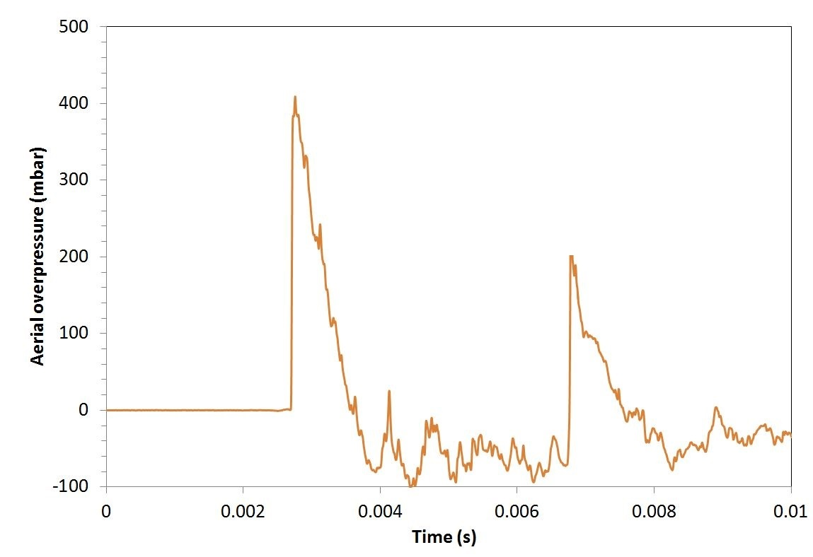  Figure 3: Typical pressure data | 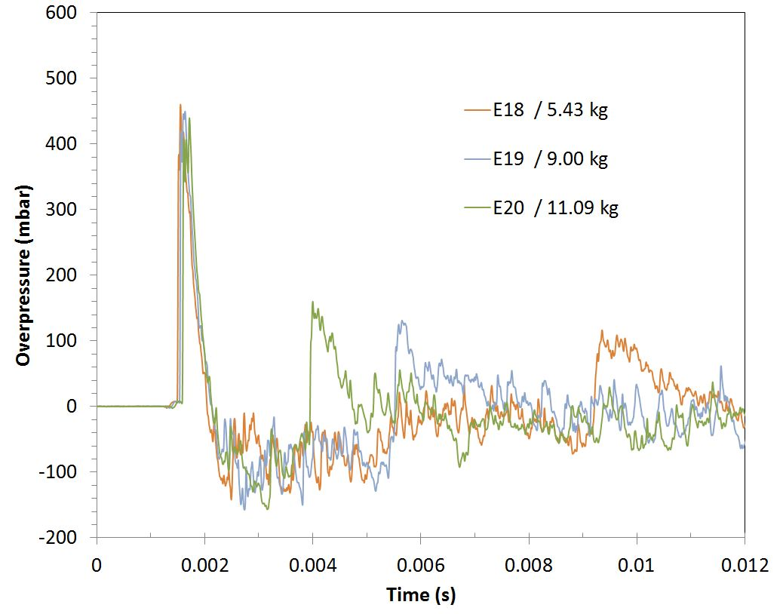  Figure 4: Comparison of pressure data vs fill level
    - Variation of the first shock intensity with liquid fill level
The data measured by the aerial overpressure gauges are plotted against the liquid fill level and are given on Figure 5 (vertical axis), Figure 6 (tilted axis) and Figure 7 (horizontal axis). Three tests are presented, corresponding to 3 different fill levels (at initial time). It has to be noted that the fill level was higher at rupture time due to thermal expansion of the liquid.

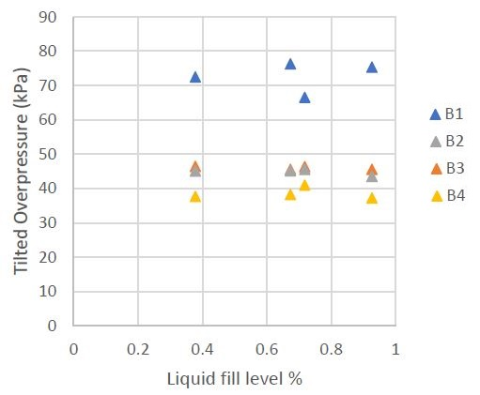  Figure 5: Influence of liquid fill level on aerial overpressure (vertical axis) | 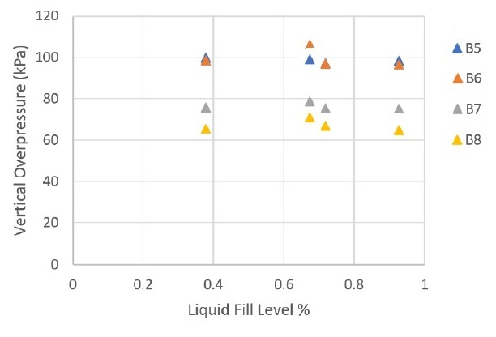  Figure 6: Influence of liquid fill level on aerial overpressure (tilted axis)

The results show clearly that the value of first pressure peak recorded at any location, on any axis, is independent from the liquid fill level. Correlatively, the first pressure peak value is also independent from the vapour space volume. Because of this observation, and since the thermodynamic state at rupture time (P=76 bat; T=290°C) was identical for all tests, in can be deduced that the first pressure peak intensity is neither linked with the vapour, nor the liquid nor the total energy of water at release time. This is in contradiction with scientific works considering that the blast created by BLEVE can be calculated by energy considerations and the use of scaling law such as the TNT model.
This does not make obsolete these models which apply in far field. Indeed, in this work, we are interested in the near field. (Birk el al., 2018; 2019) have already suggested that the pressure peaks in near field are only related to the vapour pressure at rupture time. This is in full agreement with our experimental results.
Another point of discussion is the vessel opening dynamics. Most of existing models aiming at predicting aerial overpressure were tested on a reduced number of experiments from the past like (Birk et al., 2007) or (Balke et al., 1999). These results were recorded on large scale tests with a total destruction of the vessel. In our tests, the tank remained intact and the opening area was constant. This could change the vapour release dynamics and the phase change dynamics. However, the small scale tests performed by (Birk et al., 2020) and resulting in a total destruction of the vessel highlighted that in near field, the pressure peaks were only related to the vapour pressure at rupture time.
    - Variation of the first shock impulse with liquid fill level
Impulse is the integral of pressure over the time interval; it is a dominant characteristic when calculating for example the blast load on a structure like a building. Impulse was poorly studied in the case of a BLEVE event.
In these tests, impulse of the first pressure peak was determined by data integration. Results are given on Figure 8. As expected, the impulse is a decreasing function of distance and seems to be related to the liquid quantity. The larger the vapor volume, the higher is the impulse.

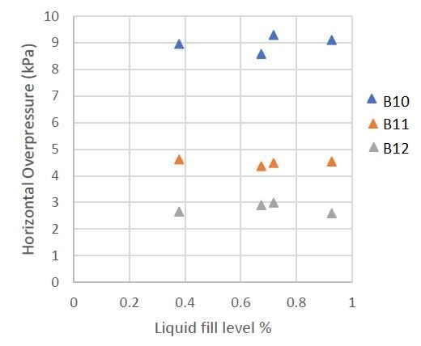  Figure 7: Influence of liquid fill level on aerial overpressure (horizontal axis) | 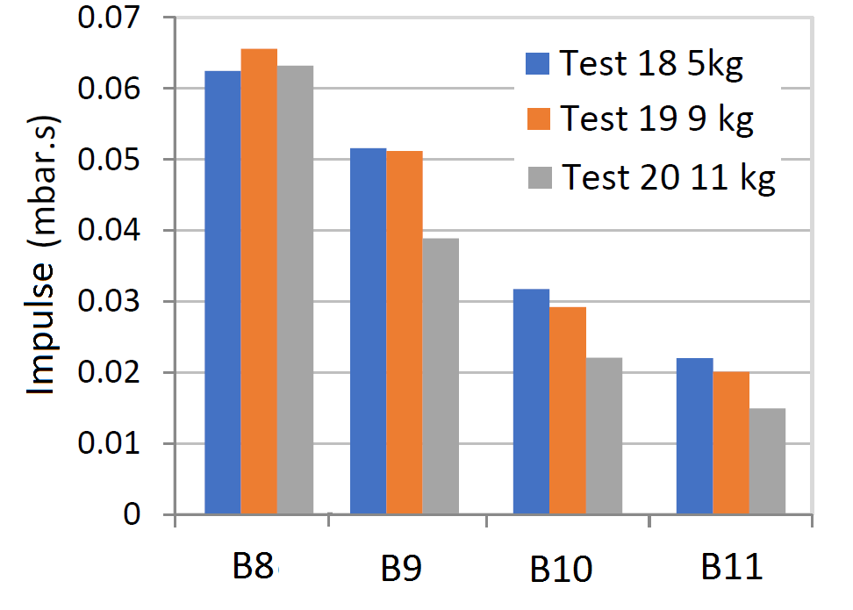  Figure 8: Variation of the first shock impulse with liquid fill level (horizontal axis)
Conclusions
Many models were developed to predict the blast created by a BLEVE. However, experimental data about BLEVE phenomenon are rare, and authors had to make strong assumption to design their models. According to the assumptions which are more or less close to reality, pressure peaks predictions are more or less conservative and a large scattering is observed. The choice of a model depends on the conservative safety margin that is wanted and on the simplicity of the model.
The experiences in this work highlighted that the filling level has no influence on the blast in near field; it is only related to the burst pressure. Therefore all models based on energy equivalence are not suited to predict blast in near field. Models based on the shock tube configuration or CFD models based on vapor expansion are better suited for that.
However, the setup was designed to remain intact after each test; there was no total destruction of the vessel. This could raise questions about the validity of these tests conclusions when compared to real accidents. The release area was constant and small in comparison with a complete flattening of a tank. The way the tank fails, and the way walls are distorted and torn has certainly a strong impact on the energy release. This is why some authors consider an empirical ratio of energy taken by the tank destruction. But in near field, in the early moments of tank destruction, the vapor expansion produces a blast which is already far when the tank is being flattened. It seems that the tank destruction is more probably involved during the second pressure peak creation, and the boiling of the liquid. The way the liquid boiling contributes to the second pressure peak is currently under investigation.
Acknowledgments
The authors are grateful to Total SA for supporting this research work, to the Institute for Risk Science team (namely Zacaria Essaidi, Christian Lopez, Laurent Aprin, Florian Dizier and Roland Eyssette for their help during the testing campaign, and the Camp des Garrigues military camp for access to the facility.

References
Balke, C., Heller, W., Konersmann, R., Ludwig, J., 1999, Study of the Failure Limits of a Railway Tank Car Filled with Liquefied Petroleum Gas Subjected to an Open Pool Fire Test. Federal Institute for Materials Research and Testing (BAM), Berlin, Germany.
Birk, A. M., Davison, C., & Cunningham, M., 2007, Blast overpressures from medium scale BLEVE tests. Journal of loss prevention in the process industries, 20(3), 194-206.
Birk A.M., Eyssette R., Heymes F., 2020, Analysis of BLEVE overpressure using spherical shock theory,
Process Safety and Environmental Protection, Volume 134, Pages 108-120
Birk, A. M., Eyssette, R., & Heymes, F., 2020, Analysis of BLEVE overpressure using spherical shock theory. Process Safety and Environmental Protection, 134, 108-120
Birk A.M., Heymes F., Eyssette R., Lauret P., Aprin L., Slangen P., 2018, Near-field BLEVE overpressure effects: The shock start model, Process Safety and Environmental Protection, Volume 116, Pages 727-736
Brode, H. L., Blast wave from a spherical charge, 1996, The Physics of Fluids, 217-229
Bubbico, R., & Marchini, M., 2008, Assessment of an explosive LPG release accident: A case study. Journal of Hazardous Materials, 155(3), 558-565.
Casal, J., & Salla, J. M., 2006, Using liquid superheating energy for a quick estimation of overpressure in BLEVEs and similar explosions. Journal of hazardous materials, 137 (3), 1321-1327.
CCPS, Guidelines for Vapor Cloud Explosion, Pressure Vessel Burst, BLEVE, and Flash Fire Hazards, Second Edition. Guidelines for Vapor Cloud Explosion, Pressure Vessel Burst, BLEVE, and Flash Fire Hazards, Second Edition (2010).
Eyssette, R., Heymes, F., & Birk, A. M, 2021, Ground loading from BLEVE through small scale experiments: Experiments and results. Process Safety and Environmental Protection, 148, 1098-1109.
Genova, B., Silvestrini, M., & Trujillo, F. L., 2008, Evaluation of the blast-wave overpressure and fragments initial velocity for a BLEVE event via empirical correlations derived by a simplified model of released energy. Journal of Loss Prevention in the Process Industries, 21(1), 110-117.
Hemmatian, B., Planas, E., & Casal, J., 2017, Comparative analysis of BLEVE mechanical energy and overpressure modelling. Process Safety and Environmental Protection, 106, 138-149.
Heymes, F., Lauret, P., Hoorelbeke, P., 2019, An Experimental Study of Water BLEVE, Chemical Engineering Transactions, Volume 77, 205-210.
Heymes, F., Lauret, P., Hoorelbeke, P., 2020, An Experimental Study of Water BLEVE, Process Safety and Environmental Protection, Volume 141, Pages 49-60
Laboureur D., Birk A.M., Buchlin J.M., Rambaud P., Aprin L., Heymes F., Osmont A., 2015, A closer look at BLEVE overpressure, Process Safety and Environmental Protection, Volume 95, 159–171.
Li J., Hao, H., Numerical study of medium to large scale BLEVE for blast wave prediction, Journal of Loss Prevention in the Process Industries, Volume 65, 2020
Planas-Cuchi, E., Salla, J.M., Casal, J., 2004, Calculating overpressure from BLEVE explosions, Journal of Loss Prevention in the Process Industries, Volume 17, 431–436.
Prugh, R. W., 1991, Quantitative evaluation of" bleve" hazards. Journal of Fire Protection Engineering, 3(1), 9-24.
Reid R.C., 1979, Possible mechanism for pressurized-liquid tank explosions or BLEVE’s, Science, Volume 203, 1263–1265.
Van den Berg, A.C., van der Voort, M.M., Weerheijm, J., Versloot, N.H.A., 2004, Expansion-controlled evaporation: a safe approach to BLEVE blast, Journal of Loss Prevention in the Process Industries, Volume 17, 397–405.
Yakush S.E., 2016, Model for blast waves of Boiling Liquid Expanding Vapor Explosions, International Journal of Heat and Mass Transfer, Volume 103,173-185

