CHEMICAL ENGINEERING TRANSACTIONS  VOL. 91, 2022 | A publication of
The Italian Association
of Chemical Engineering
Online at www.cetjournal.it

Guest Editors: Valerio Cozzani, Bruno Fabiano, Genserik Reniers
Copyright © 2022, AIDIC Servizi S.r.l.
ISBN 978-88-95608-89-1; ISSN 2283-9216

DEVELOPMENT OF A MULTIFUNCTIONAL AMPHIBIOUS PLATFORM FOR NEAR SHORE GEOGNOSTIC ACTIVITIES
Luca Pugiª, Enrico Mariottoni^{b}, Massimo Sacchetto^{b}, Marco Cocciª, Francesco Saverio Frilliciª, Lorenzo Berziª, Massimo Deloguª,Federico Rotiniª, Giovanni Savinoª, Marco Pieriniª, Enrico Boni^{c}
ªUniversity of Florence, Dept. Of Industrial Engineering, Via di Santa Marta 3, 50139, Firenze, Italy (luca.pugi@unifi.it)
^{b} MESA SRL, VIA Cervara, 101, 54100 - MASSA (MS) (amministrazione.mesa@gmail.com)
^{c}University of Florence, Dept. Of Information Engineering, Via di Santa Marta 3, 50139, Firenze, Italy (enrico.mariottoni@unifi.it)

  - Introduction
Development of Blue Economy is an important goal for a sustainable growth of mankind (Perissi et al. 2021). Exploration and inspection of bottom of coastal area also represent an important issue not only for the development of seabed activities (Levin et al., 2020) but also for the development of fundamental infrastructures like harbours (Masoli et al., 2020) or the generation of large eolic generators as example in Europe Buoncunto(2014) or in south America, Freitas (2016). Application of CPTWD (Cone Penetration Test While Drilling) techniques (Sacchetto et al.,2004) represent a valid approach to speed up the execution of geognostic prospection activities. However, the adoption of CPTWD has to be synergically coupled to a vector able to transport and support the CPTWD equipment in various environment with reasonable installation costs. In this work it is investigated to perform geognostic activities for near shore and very near shore application which corresponds to an operational depth between zero (amphibious, wet conditions) to about 20 meters. For this kind of environment, the usage of offshore equipment is not feasible, as example some authors propose walking bio inspired unit able to directly on sea bottom at high dept (Picardi et al.,2020). However, these solutions are not well suited to operate with very low depth or to carry with affordable costs, heavy equipment. Alternatively for swamp, marsh and other amphibious applications are often proposed system based on screw propellers such as the solutions that have been proposed for various sites (Cocks et al., 2019), (Green et al. 2021). Unfortunately, these solutions are probably ideal to operate in some specific environment, but they are totally unsuited to assure the motion on more compact grounds for prolonged distances, also they are poorly performing also in marine environments. Authors (Pugi et al., 2019) have some previous experiences on the design of special drilling machines so they propose the construction of a support boat/vehicle able to operate on various kind of soils for a drilling equipment that is in installed on a seabed that can be detached and stabilized on the sea bottom. In this work attention is focused on the design of the hydraulic plant aiming to properly control the various functions of the submerged seabed:
- Stabilization and Alignment of the drilling unit on the bottom which is performed by four hydraulic stabilizers as visible in figure 1.
- Drilling
- Advance of the drilling unit
In particular, the complete system is simulated through a complete digital twin able to reproduce all the complex interaction between multibody dynamics, hydraulic actuation, electronic control system. The model is developed using Amesim-Siemens Simcenter™.
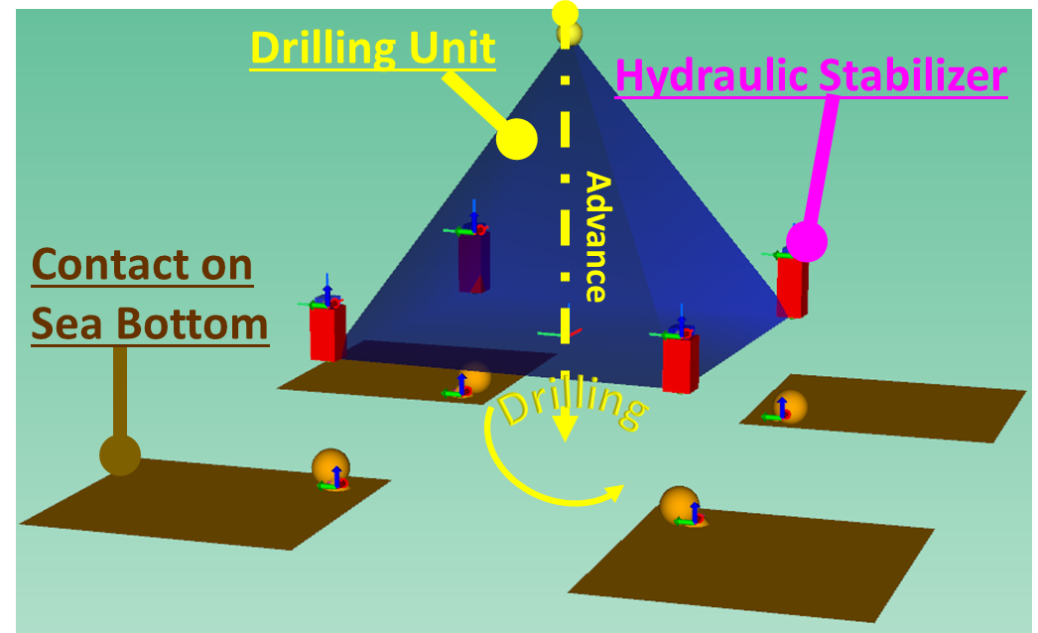
Figure 1: Simplified Scheme of the simulated drilling unit on the sea bottom
    - Main Features of Simulated Machine
Simulated drilling units must exert a maximum push-pull force of about five tons so its weight is constrained to be at least equal to the overcited vertical force. Involved advance speed are quite low (about 10⁻² m/s) so involved power is relatively low.
For what concern drilling parameters such as torque, rotation and advance speed of the drilling unit have been calculated using a model that has been developed on a previous STIGE project (Pugi et al, 2021): these parameters are quite variable according the kind of excavated material so the machine was designed to operate with a very wide range of drilling speed (0-140 rpm) and torques: the system must be able to assure very high drilling torques (over 1500-2000 kgm) at low speed (40-50rpm) still assuring a residual torque of about 500kgm at high speed (110 rpm) to preserve an high productivity of the system.
These high performances are assured by a couple of parallel connected hydraulic motors with a maximum total displacement of about 1354 cm³ (677cm³ each motor). For what concern the stabilizing features of the machine, the maximum slope of sandy bottom for which the machine is designed is limited and constrained by stability considerations (Ikeda, 1982) to no more than 15-20° degree. So, considering a base of the machine of about to meters the stabilization system has to recover a total quote which is not superior to about 50-60 cm.
Hydraulic power needed by the machine is provided by a powerpack which is installed on the support ship and transmitted to the seabed drilling machine with an umbilical connection. In this way the same powerpack can be used also to feed various subsystems like manipulators, cranes and amphibious propulsion systems of the support ship optimizing cost and encumbrances. Finally, the management on a surface boat of the powerpack is much easier. Currently the size of the hydraulic powerpack is able to provide about100kW of power thar is exerted through a shaft running with a constant speed of approximately 2000 rpm.
Considering a maximum operating depth of about 20-25 meter the length of the umbilical connection is supposed to be equivalent to about 30m. Management of a such umbilical connection should be really simplified if the number of adopted connections is minimized. Also, efficiency is an important issue considering the limited available power of the powerpack, losses introduced by long umbilical connections, optimization of total involved volumes of oil and consequently of tanks need to manage the plant.
For this reason, authors focused their attention on two possible plant configurations both aiming to optimize all these overcited tech. specifications:
- Three Pipes Layout: the simpler solution and probably the most efficient in terms of plant design and control
- Two Pipe Layout: using a particular load sensing layout is possible to minimize the number of hydraulic connections to a single hydraulic circuit (two pipes)
  - Three Pipes Layout
Most of the power needed for the drilling process (typically from 95% to 99%) is typically provided to the rotary motors of the drilling unit, As visible in the scheme of figure 2/a/b/c, to maximize transmission efficiency, a variable displacement pump is used to directly control the flow and consequently speed of the rotary unit. Pressurized oil is provided to the rotary using a pipe of relevant diameter (5/4”). All the other actuators (tool advance and stabilizers) to which are associated modest oil consumptions are instead connected in parallel to a pressurized pipe of lower diameter (1/2”-3/4”) that is feed by a variable displacement which is pressure controlled. A fixed pressure reference is fundamental for properly control with distributor valves all the connected actuators working in parallel. Oil from both flow and pressure-controlled circuit is then collected and returned to the main tank on the support ship by a single large diameter pipe (5/4”) minimizing the number of hydraulic umbilical connections to three pipes.
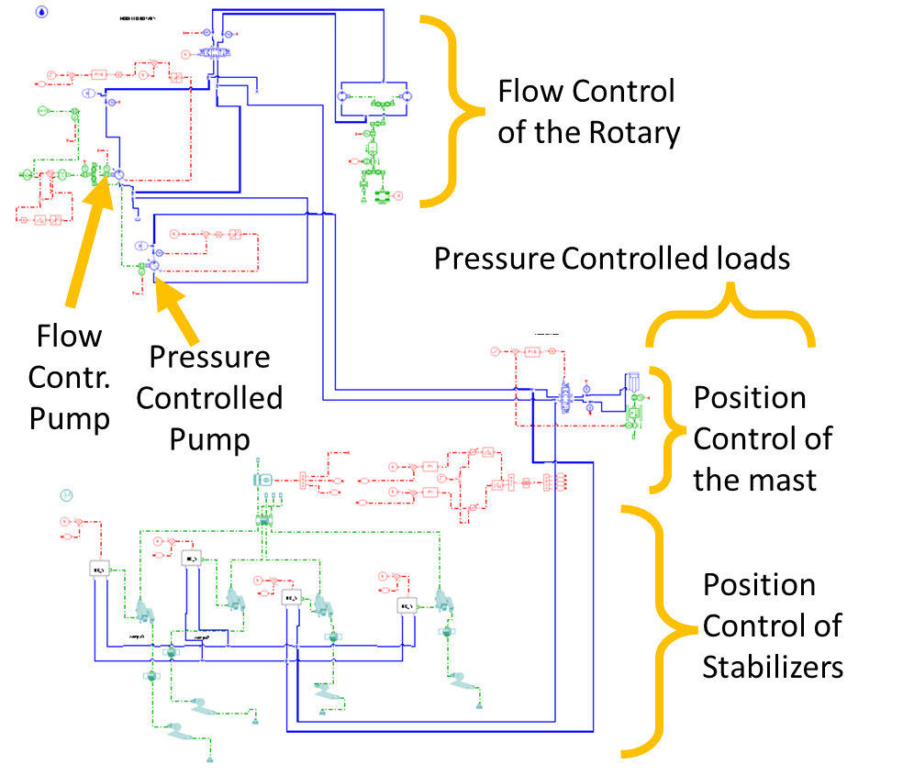 | 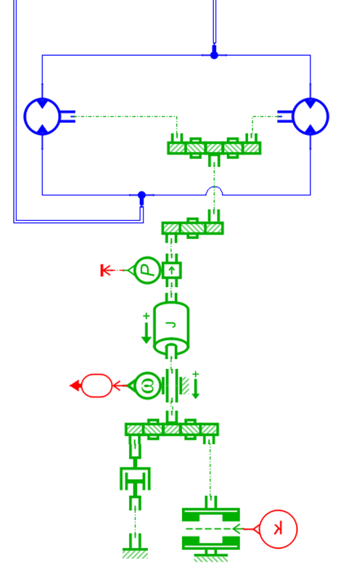 | 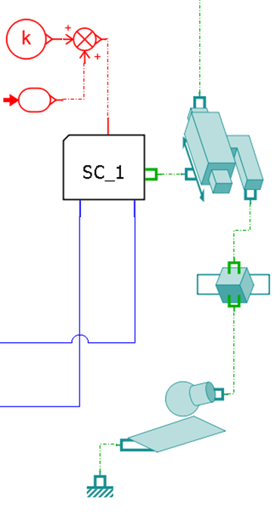
a) | b) | c)
Figure 2/a/b/c: simplified three pipe layout, a) complete Amesim-Siemens Simcenter™ Model of the Plant, b) detail of rotary model, detail of multibody model of the leg
Using the overcited model of the plant some preliminary simulations ar\e performed: various operational speed and torque conditions are simulated considering a maximum delivered power of about 100kW and the maximum displacement of both rotary motors. Some results in terms of balance power are shown in figure 3/a/b:in the first 30 seconds of simulation stabilizers are activated and the machine is properly aligned then a constant advance and drilling speed profile is started. Tests are repeated considering different cutting torques and speed; when high torques at low speed are required (figure 3/a) the system is very efficient and it able to deliver the maximum power with limited losses. Then when higher speed is required friction losses on pipes and valves increases reducing the overall efficiency of the system.
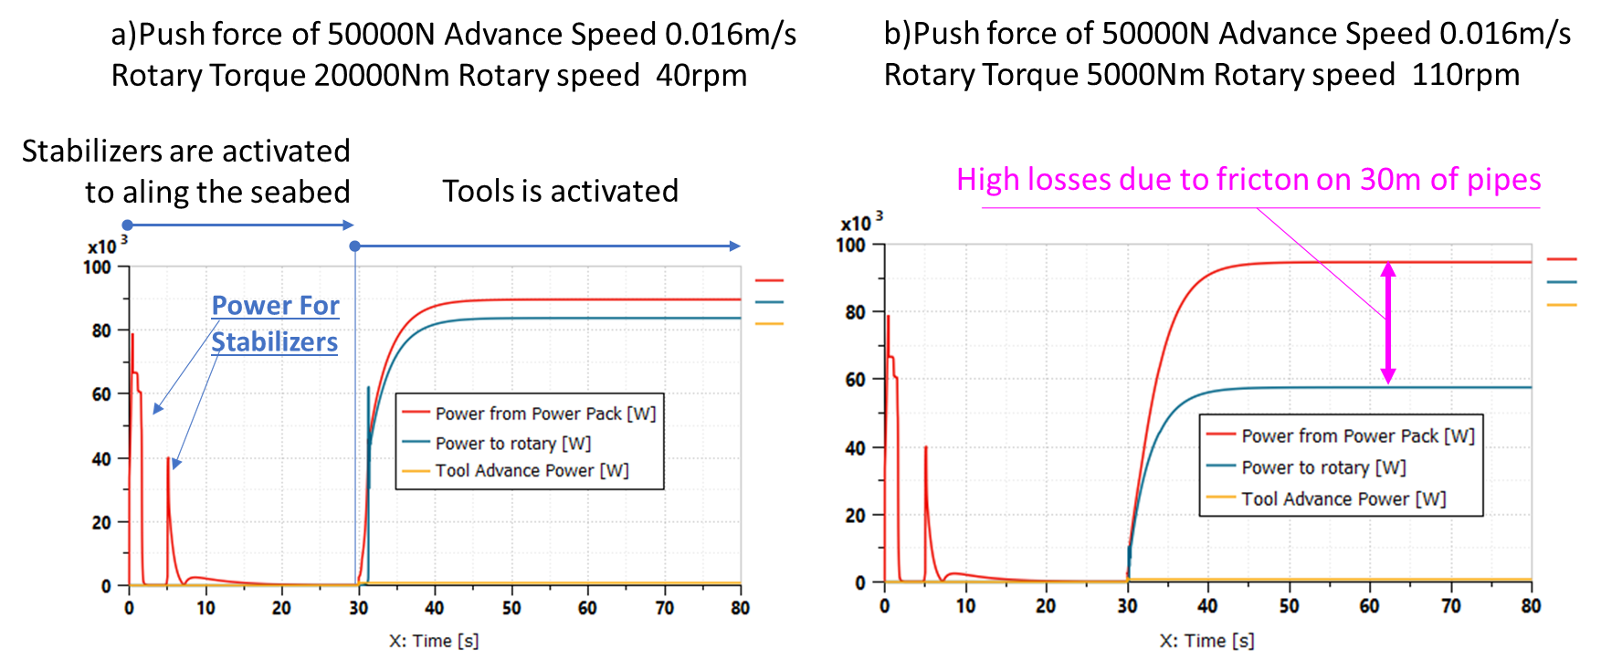
Figure 3/a/b: example of simulation results in terms of power balance between exerted power of the powerpack and loads, a) example with high torques at low speed, b)low torque at high speed.

    - Control of Stabilizers
Four vertical stabilizers visible in the scheme of figure 1 are used to properly align the seabed respect to the sea-bottom. The four stabilizers are placed on a square base whose side is equal to 2l where l is about 1m.
Alignment of the seabed is measured by an IMU (Inertial Measurement Unit) so roll and pitch angles are known (φ,θ). Since the system is controlled by a closed loop and rotation angle respect to desired aligned position are small the considered order of rotations has limited consequences. As visible in the scheme of figure 4 both roll and pitch angles are controlled by two independent PID loops which produce two corresponding corrections respectively called u_{φ} and u_{θ}. Each leg is supposed to be position controlled. Correction applied to the run of each actuator is defined Δx_{i} where the pedex i is adopted to indicate the i-th stabilizer leg (i=1..4).
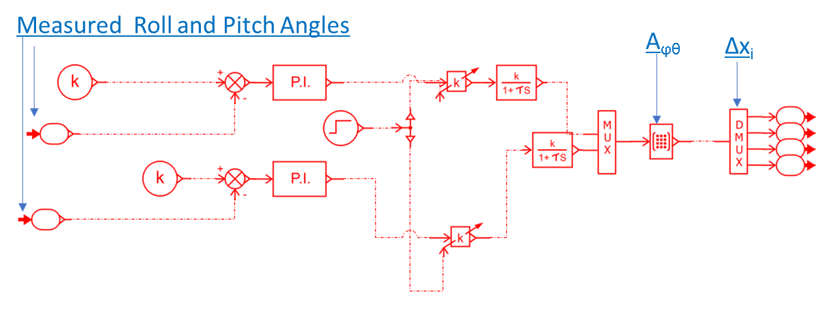
Figure 4: Stabilization Loop, simplified model is Siemens-Amesim-Simcenter™

Corrections Δx_{i} are calculated from u_{φ} and u_{θ} according (1) through a conversion/allocation matrix A_{φθ}
(1)
The reference position of each leg x_{ref_i} is calculated according (2) as the sum of the correction Δx_{i} and x₀, the half run of each actuator (since the run of each leg is 0.6[m] x₀ is equal to 0.3)
(2)
With this simple approach performed corrections are minimized respect to the limited run of each actuator in a very simple way. In figure 5/a/b some results concerning a simulation are shown: The seabed is posed near the sea bottom the stabilizers are extracted reaching the half run x₀. Since the bottom is irregular (four different perturbed heights of the bottom are chosen for each stabilizer) the algorithm, as visible in figure 5/a detect a misalignment of the seabed, correcting as visible in figure 5/b the length of each leg.

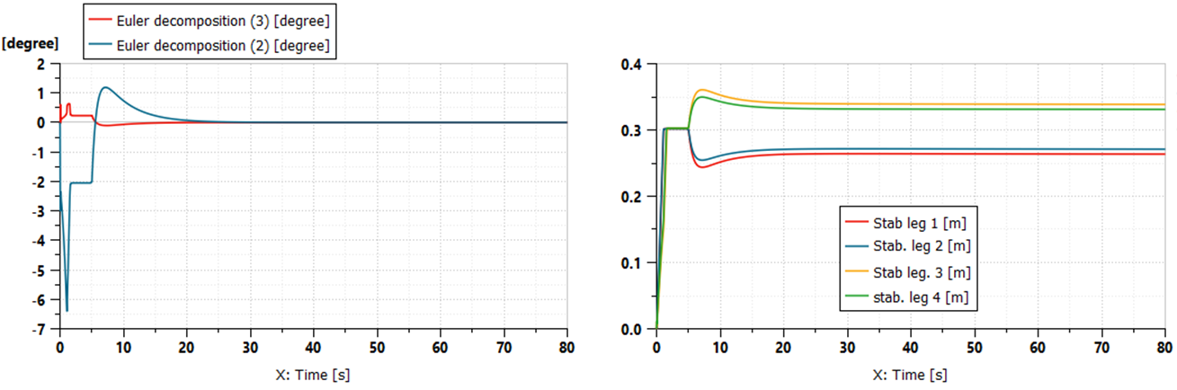
a) | b)
Figure 5/a/b: example of self-alignment sequence, a) measured roll and pitch angles, b)run of each stabiliz. leg
  - Two Pipe Layout
In this second layout a single variable displacement pump is used to feed the whole seabed so only two pipes (a pressurized one and a return/drain to tank) are used. The pump is controlled with a virtual/electronic load sensing since no additional hydraulic connections can be installed: pressures at both end of rotary units P_{a} and P_{b} are measured. The variable displacement pump is pressure controlled to maintain a reference pressure level P_{ref} which automatically adapted respect to loading conditions according (3)
(3)
In (3) P_{min} is a minimum pressure that must be assured for a proper minimal pressurization of the plant.
Rotation of speed of the rotary is controlled by a speed loop through the usage of a 4/3 distributor valve, but losses across the valve are minimized since pumping pressure P_{ref} is continuously optimized respect to loading conditions according (3). All the other actuators are connected to pressure-controlled pump that is installed on the seabed to provide a reference high level pressure to the other position-controlled actuators (drilling tool, advance and stabilizers). Power needed to this additional pump is provided by a part of the fluid sent from the main powerpack on the support ship, so according to the scheme of figure 6\a\b when both rotary and other actuators are working in parallel, pressure sensing on rotary also contribute to compensate the losses on shared pipes.
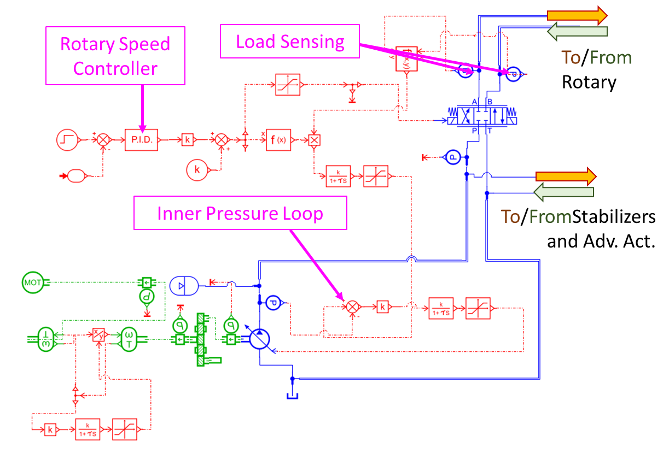 | 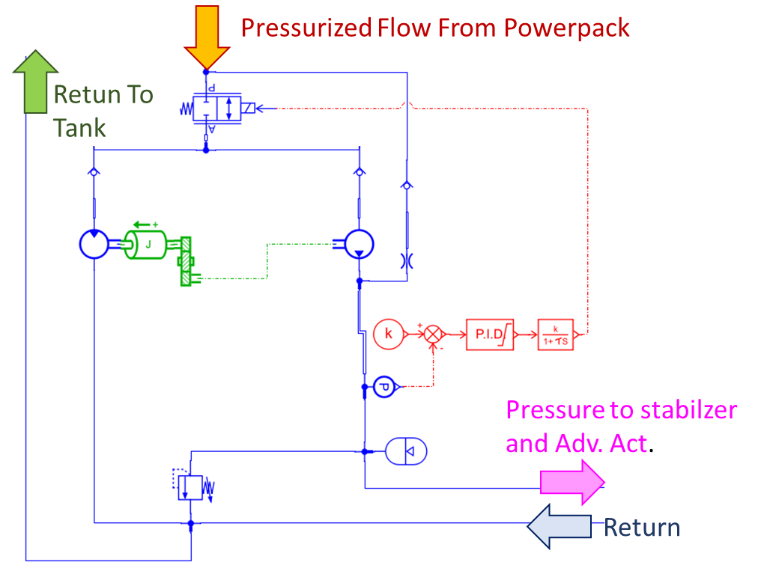
a) | b)
Figure 6/a/b: a)load sensing powerpack, (b) local pressurizing pump on the seabed

Proposed solution is verified considering different operational condition in terms of operating speed and torques of the rotary. In figure 7/a/b some results are shown: higher efficiency is reached with high operational torques at high speed since in this condition losses on pipes are substantially reduced. These calculations are performed with ideal pump and actuators, so real efficiency should be lower (probably from 10 to 20% lower).
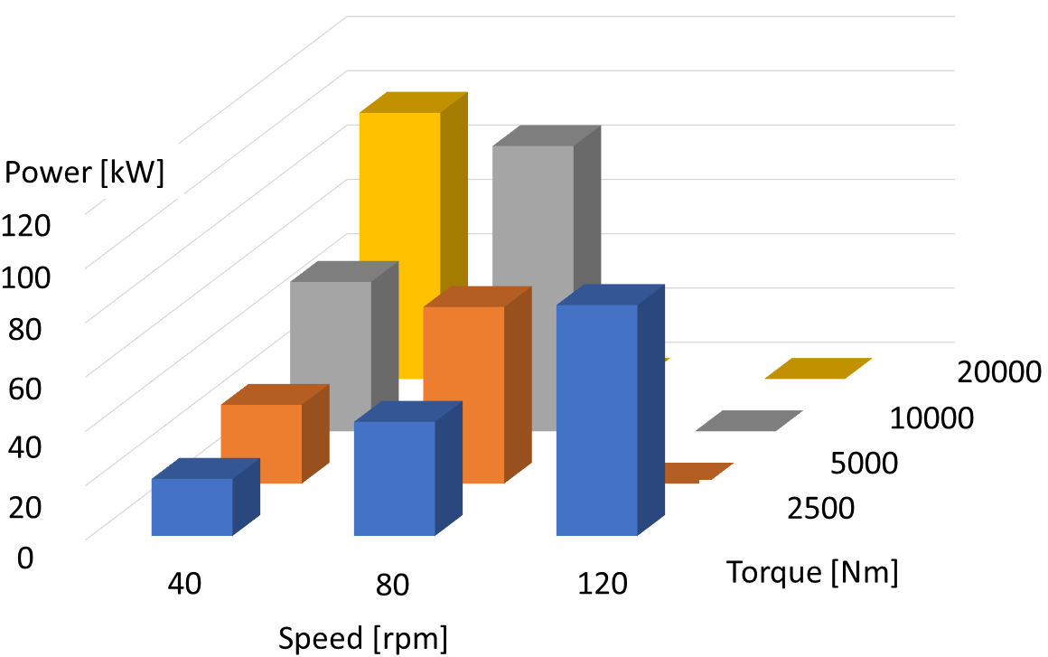 |  | 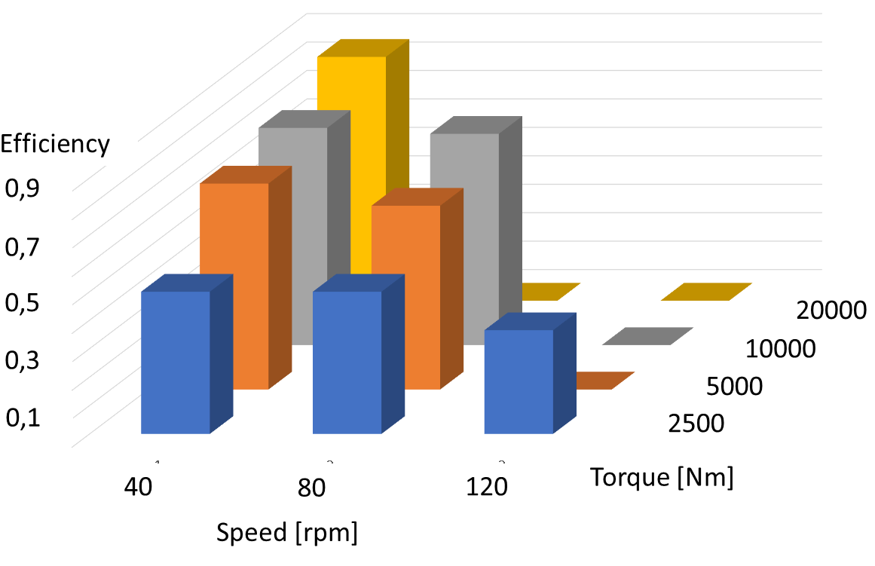
a) |  | b)
a) | b)
Figure 7/a/b: calculated power for powerpack(a) and efficiency(b)

Calibration and increased construction costs should penalize this second layout, but it should be considered the high simplification due to the elimination of one of the three pipes of the umbilical connection.
  - Conclusions and Future Developments
In this work it is investigated the optimal layout of the hydraulic plant that will be used to control a drilling seabed for nearshore installation of Eolic generators. In this work authors have been able to propose and preliminary simulate two different plant configurations that should be tested on the first prototype of the system that is currently in the construction phase.
After first commissioning authors are planning further activities related to a further calibration of models (Vedova, 2021)) that should be useful for a further refinement of a digital twin of the system for further optimization and test that are too risky or expensive to be performed in real operational conditions,
In this sense test it’s foreseen the application of HIL (Hardware In the Loop) techniques that some of the authors have applied in past research activities concerning safety relevant control systems (Pugi et al.2016).
Finally some further applications related to monitoring of harbours (Fornaro et al.,2021) and of submerged concrete structures (Gao et al.,2018).

Acknowledgments
This activity is a part of the project Proteus, financed by Regione Toscana, as a part of the Por Fesr 2014-2020.
Authors wish also thanks all the engineers and the technicians of project partners which are Mesa SRL(Leader of the project) and University of Florence (main scientific consultants) but also Ecoflash srl and BP Benassi srl
References
Buonocunto, Francesco Paolo.,2014, Acquisizione del Dato Geotecnico Sondaggi Geognostici e CPTU–Taranto Progetto Parco Eolico Società Beleolico.
Cocks, B. L. D.,2019, Mine fines dewatering trials using amphibious vehicles at the Tronox KZN Sands Fairbreeze Mine. In: Proceedings of the 22nd International Conference on Paste, Thickened and Filtered Tailings. Australian Centre for Geomechanics, 2019. p. 479-491
Freitas, Marcelo Motta de.,2016. GEOLOGICAL RISK EVALUATION IN THE EOLIC ENERGY PLANNING ON RIO GRANDE DO NORTE, BRAZIL. Mercator (Fortaleza), 2016, 15: 117-129.
Fornaro, A., Valtancoli, E., Argento, F., Rizzo, C., Grasso, A., De Gennaro, G.,2021,
Improvement of Sensor Technology for Monitoring Vocs in Harbour and Maritime Areas: Use Case and first Findings (2021) Chemical Engineering Transactions, 85, pp. 1-6. DOI: 10.3303/CET2185001
Gao, S., Tang, X.,2018,Impact mechanism of marine biofilm on concrete durability
(2018) Chemical Engineering Transactions, 64, pp. 613-618.DOI: 10.3303/CET1864103
Green, Marko, et al.,2021, Regolith Excavation Performance of a Screw‐Propelled Vehicle. Advanced Intelligent Systems, 2021, 2100125.
Ikeda, S. (1982). Incipient motion of sand particles on side slopes. Journal of the Hydraulics Division, 108(1), 95-114.
Levin, Lisa A.; AMON, Diva J.; LILY, Hannah,2020. Challenges to the sustainability of deep-seabed mining. Nature Sustainability, 2020, 3.10: 784-794.
Masoli, Carlo Alberto, et al. ,2020,Near‐shore geophysical and geotechnical investigations in support of the Trieste Marine Terminal extension. Near Surface Geophysics, 2020, 18.1-Quantitative Geophysical Characterisation of Marine Near‐Surface: 73-89.
Perissi, Ilaria; BARDI,2021, Ugo. The Future: The Blue Economy. The Empty Sea, 2021, 129.
Picardi, G., et al.,2020, Bioinspired underwater legged robot for seabed exploration with low environmental disturbance. Science Robotics, 2020, 5.42.
Pugi, L., Galardi, E., Pallini, G., Paolucci, L., Lucchesi, N.,2016, Design and testing of a pulley and cable actuator for large ball valves (2016) Proceedings of the Institution of Mechanical Engineers. Part I: Journal of Systems and Control Engineering, 230 (7), pp. 622-639. DOI: 10.1177/0959651816642093
Pugi, L., Delogu, M., Grasso, F., Berzi, L., Del Pero, F., Savi, R., Boni, E.,2019, Electrification of Directional Drilling Machines for Sustainable Trenchless Excavations (2019) Proceedings - 2019 IEEE International Conference on Environment and Electrical Engineering and 2019 IEEE Industrial and Commercial Power Systems Europe, EEEIC/I and CPS Europe 2019, art. no. 8783793, DOI: 10.1109/EEEIC.2019.8783793
Pugi, L., Berzi, L., Grasso, F., Savi, R., Vita, V. ,2021, Design and simulation of an electrified directional drilling machine (2021) International Journal of Mechanics and Control, 22 (1), pp. 17-29.
Sacchetto, Massimo, et al.,2004 CPTWD (Cone Penetration Test While Drilling) a new method for deep geotechnical surveys. Proc. ISC-2 on Geotechnical and Geophysical Site Characterization, Viana da Fonseca & Mayne, 2004, 1: 787.
Vedova, M.D.L.D.,2021, Numerical modelling and simulation for systems engineering applications: Novel methods in design, development, monitoring, diagnostics and prognostics (2021) International Journal of Mechanics and Control, 22 (1), pp. 1-2.

