CHEMICAL ENGINEERING TRANSACTIONS  VOL. 91, 2022 | A publication of
The Italian Association
of Chemical Engineering
Online at www.cetjournal.it

Guest Editors: Valerio Cozzani, Bruno Fabiano, Genserik Reniers
Copyright © 2022, AIDIC Servizi S.r.l.
ISBN 978-88-95608-89-1; ISSN 2283-9216

Refining the 3D printer set-up to reduce the environmental impact of the fused deposition modelling (FDM) technology
Antonella Patti^{a,}*, Stefano Acierno^{b}, Gianluca Cicalaª, Nunzio Tuccitto^{c}, Domenico Acierno^{d}
ª Department of Civil Engineering and Architecture (DICAr), University of Catania, Viale Andrea Doria 6,95125 Catania, Italy
^{b} Department of Engineering, University of Sannio, Piazza Roma 21, 82100 Benevento, Italy.
^{c} Department of Chemical Sciences, University of Catania, Viale A. Doria 6, 95125 Catania, Italy
^{d} CRdC Nuove Tecnologie per le Attività Produttive Scarl,Via Nuova Agnano 11, 80125, Naples, Italy
antonella.patti@unict.it
The major aspects affecting the environmental and health impact of the fused deposition modelling (FDM) are concerned with energy consumption, waste material, and emission of harmful by-products. To reduce pollution associated with 3D printing development, a study has been conducted to optimize operating temperatures, process times, and filament constituting material, with carefulness as the same characteristics may adversely affect the appearance and mechanical properties of 3D printed parts. In this regard, pellets of polylactide acid (PLA) have been extruded in a lab compounder to create a bio-based filament that was printed under various operating conditions, i.e., by changing layer thickness (0.14, 0.19, 0.29 mm), infill density (50, 70%, 100%), patter (linear, honeycomb, octangular), extruder temperature (from 180 to 220 °C). 3D printed specimens were examined using dynamic-mechanical analysis (DMA) by verifying the sample size and weight, as well as the printing time. Analysis on material viscosity at different testing temperatures was also performed to identify potential range of extruder temperatures, and limit printing attempts Finally, measurements of volatile organic compounds (VOC) emission have been conducted on thermally treated samples at temperatures of 70°C, 190°C, and 220°C, to gain information on potential quantity of pollution deriving from the extruded polymer, deposited layers on the heated plate, and potential residues in the printer.
  - Introduction
The fused deposition modelling (FDM) is one among the various methods belonging to the wide family of Additive Manufacturing (AM) technologies. It consists in a filament, of neat or filled polymer, melted and extruded through a nozzle, and deposited on a heated platform in a layer by layer manner (Patti, et al., 2021b). Even though FDM is considered a relatively eco-friendly technology when compared to traditional plastic material processing, however, this method has an environmental impact, as it consumes material and energy and emits semi-volatile organic components (SVCs) into the environment also by printing the most common polymers, such as acrylonitrile butadiene styrene (ABS) and polylactic acid (PLA). The main sources of emissions are the exit of high-temperature melted polymer from the die, as well as the presence of residues left in the nozzle. Printing speed and flow material have a small effect on emissions, whereas bed and extrusion temperatures are the leading contributor of energy consumption (Simon et al., 2018). The materials used in FDM technologies contribute significantly to the environmental impact. Recyclable materials could be adopted notwithstanding the uncertainty of final properties that may deteriorate compared to virgin resources (Patti, et al., 2021a), or design parameters, such as filling level and processing temperatures, could be optimized to allow the reduction of waste material and energy consumption (Suárez et al.). The effect of three infill densities (25, 50, and 75%), and three infill patterns (grid, tri-hexagon, and concentric) on tensile features of printed PLA-based objects has been examined by Rismalia et al. (2019). According to results, the concentric pattern with 75% in infill density had the highest tensile properties, and ultimate strength of 42.2 MPa. The mechanical properties of samples at 100% in infill density were not affected by the patter. Layer thickness and extruder temperature were discovered as determining factors in affecting the surface roughness of PLA samples produced by FDM: reducing the layer thickness and increasing the printing temperature resulted in a better surface quality. (Kovan et al., 2018)
In this framework, the study aimed to optimize the printing process of PLA-based filament by opportunely choosing technological parameters such as layer thickness, infill density, extruder temperature, and design pattern in view of reducing the used material and printing time, by checking the mechanical characteristics of final products. In addition, the material flow behaviour and VOC emissions at different temperatures have been investigated.

  - Material and methods
    - Material
For the investigation, pellets of PLA based polymer (cod. Ingeo™ Biopolymer 4032D, specific gravity 1.24 g/cc) were supplied by Natureworks. From the technical datasheet, this polymer is an ideal product for lamination and other packaging applications and can be converted into biaxially oriented films. Preliminary thermal analyses confirmed a melting point around 175°C and glass transition temperature of 65°C.

    - Filament preparation
Pellets were extruded in a twin-screw extruder (mod. KETSE 20/40 D), produced by Brabender (Duisburg Germany). According to technical data sheet, processing temperatures were established in the range of 180-210°C. In particular, the feed temperature was set at 180°C, the adapter and die temperatures were set at 200°C, the melting zone was set at 210°C, and a screw speed of 30 rpm was fixed. When the material came out from the die, it was stretched and cooled in air using a roller system. To achieve a nominal filament diameter of 1.75 mm for next extrusion in 3D printer, the stretching speed of the first drive system has been set at 1.5 rpm, that of the second drive has been fixed at 2.5 rpm.

    - Sample Preparation
The so-obtained filament was processed using fused deposition modeling (FDM) technology in a Zortax 3D printer (cod. M200) (Olsztyn, Polonia). Rectangular specimens suitable for dynamic mechanical analysis (DMA) testing, nominal size 2x6x26 mm³, were realized by varying extruder temperature, layer thickness, infill density and geometrical pattern. Table 1 contains a summary of chosen processing conditions for 3D printing. The other printing parameters were left at their default settings (printing speed, extruder flow rate, fan speed), or specific values were established: the bed temperature was fixed at 70°C, the retraction speed was kept at 36 mm/s, the retraction distance at 1.2 mm, the first layer gap at 0.39 mm, layers number of the top and bottom surfaces equal to 4. The nozzle diameter was 0.4 mm. Prior to the process and testing, the material was dried in an oven for 10 hours at 80 °C.
Table 1: Processing conditions for the filament printing
Extruder temperature (°C) | Layer thickness (mm) | Infill Density (%) | Pattern
210 | 0.14 | 100 | Linear
210 | 0.19 | 100 | Linear
210 | 0.29 | 100 | Linear
210 | 0.19 | 70 | Linear
210 | 0.19 | 50 | Linear
210 | 0.19 | 70 | Honeycomb
210 | 0.19 | 70 | Octangular
180 | 0.19 | 100 | Linear
190 | 0.19 | 100 | Linear
200 | 0.19 | 100 | Linear
220 | 0.19 | 100 | Linear

    - Characterization techniques
The linear viscoelastic characterization of filament was carried out in a rotational rheometer (mod. ARES-G2) supplied by TA Instruments (New Castle, DE, USA), with parallel plates, 25 mm in diameter, in the frequency range from 0.1 to 100 rad/s, strain of 1%, at 170, 190, and 210 ◦C, under air atmosphere (through the so-called “Frequency sweep tests”).
The dynamic-mechanical properties (DMA) of 3D printed parts were investigated using a Tritec 2000 machine, manufactured by Triton Technology Ltd. (Leicestershire, UK), in single cantilever mode, at 1 Hz frequency, and support distance of 12 mm, from room temperature to 70°C.
0.13 g of sample was placed in a glass container having a volume of 4 ml. The container was hermetically sealed and placed in an oven at 70°, 190° or 220° for 10 min up to 1 hr. The containers were thermalized at room temperature. The gas sensor (ZMOD4410, Renesans, RS Components) was placed near the opening of the container and the lid was removed after 10 seconds. The sensor response was calibrated with zero (air filtered with active carbon) and span with isobutylene (1 ppm) following a procedure given in (Li-Destri et al., 2020). Results are expressed as mg/m³ volatile organic compounds as released by the sensor without any further modification.

  - Experimental Results
    - Volatile Organic Components (VOC) emission
According to the work by (Wojtyła et al., 2017), heating the PLA material at higher temperatures up to 250°C, produces numerous organic compounds such as acetone, methyl-methacrylate, iso-butanol, cyclohexanone. During the thermal treatment of PLA, methyl-methacrylate and iso-butanol are the main emitted pollutants accounting 50 and 20%, respectively, of the total VOC (TVOC) emission. In the case of printing process, it is well-known that emissions initiate at the start of the glass transition and achieve the peak during filament melting (Ding et al., 2019). Taking into account these considerations, a small piece of PLA filament has been thermally treated at temperature of 70°C (close to the material glass transition temperature), at 190°C and 220°C (above the material melting, as potential working temperatures for the extruder). After thermal treatment TVOC release has been detected.
Figure 1a shows the signal trend of the volatile organic compounds detected by the sensor placed near the opening of the ampoule containing the polymer exposed to three different temperatures for 1 hour. The trend is quite similar in all conditions. As soon as the container is opened (at about 10 seconds), the sensor detects the puff of volatiles accumulated in it during the treatment in the oven. There is a significant difference in emission between the lower (70°C) and higher (190 and 220°C) temperatures in terms of the maximum peak of volatiles released from the ampoule. Although the curves at the higher temperatures are very similar in terms of maximum (instantaneous) emission, the integrated amount (figure 1b) released from the sample treated at the higher temperature is greater (1.7 times).

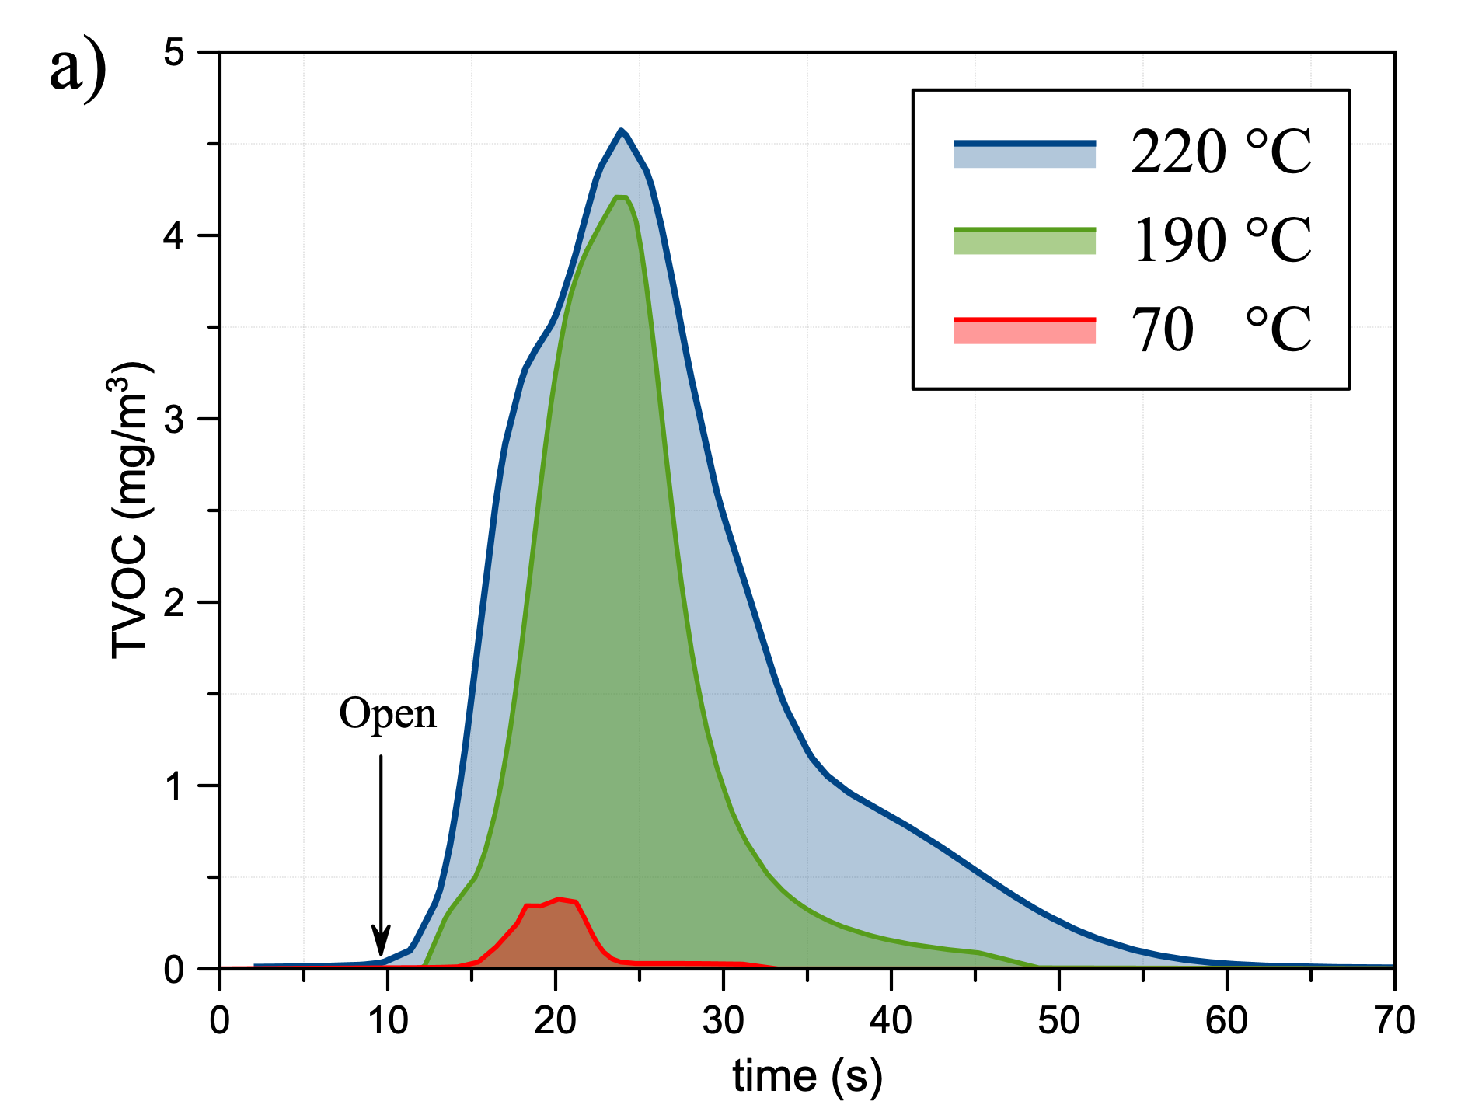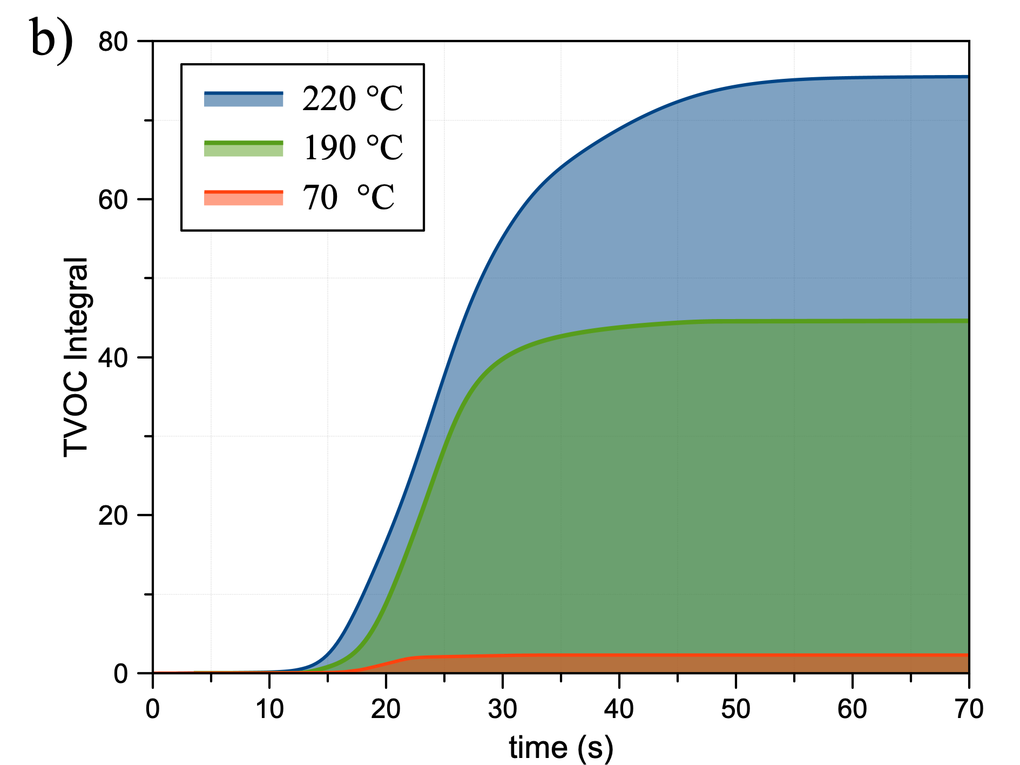
Figure 1: (a) TVOC emission of PLA piece (0.1 g) after thermal treatment at 70°C, 190°C, 220°C of 1 hr, respectively (b) Integral of VOC emission (mg/m3*s) as function of time (s).
It should be mentioned that measurements conducted after 10 min of thermal treatment were comparable to values found after 1 h.
    - Rotational Rheology
The analysis of material viscosity at the corresponding working temperatures could be useful to avoid various printing attempts, and reduce waste. The range of shear rates involved in the FDM of thermoplastics is between 10 to 2000 s⁻¹.(Sangroniz et al., 2021).
In Figure 2, the complex viscosity of PLA filament has been reported at various testing temperatures, by showing a Newtonian plateau especially for 210°C extended almost up to 100 rad/s.
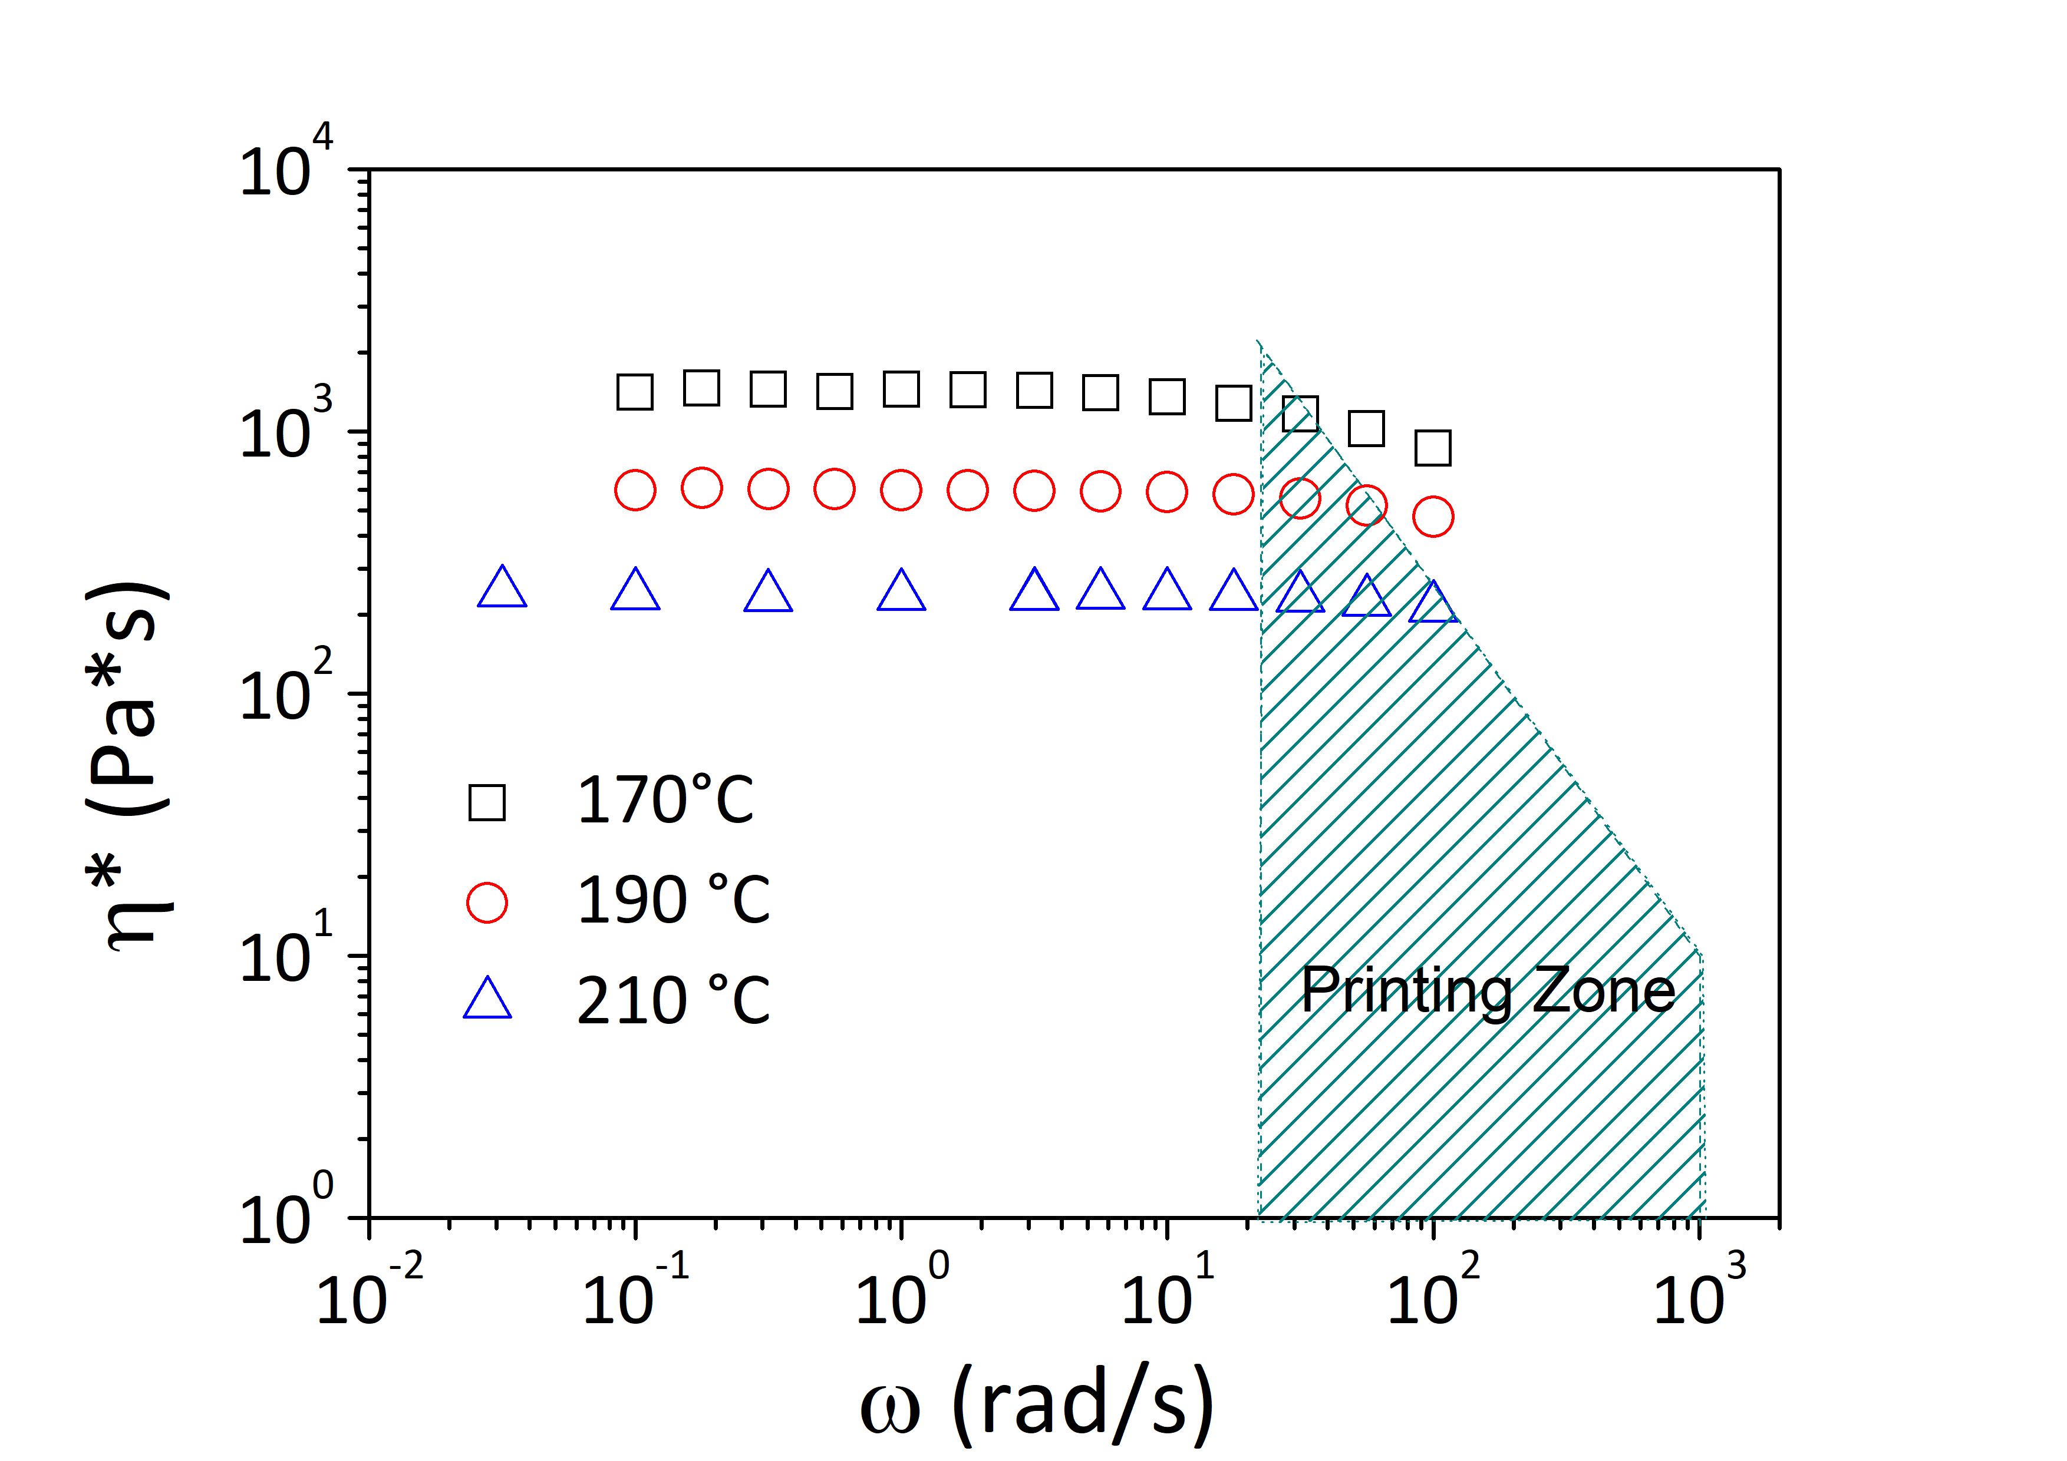
Figure 2: Complex viscosity vs frequency at 170, 190, 210°C. Printing zone evaluated in the range of printing speed between 0.1-150 mm/s, nozzle diameter of 0.4 mm in (Calafel et al., 2018).
Then, taking into account the required conditions for 3D printing, identified through the ‘printing zone’ in Figure 2 (Calafel et al., 2018), it can be observed that the complex viscosity of PLA polymer, particularly at a temperature of 190 and 210°C, fall within the required range for the extrusion through the nozzle. This was confirmed by a practical demonstration of printing conducted at 180 ° C which was not concretely feasible.

    - Dynamic mechanical analysis, measurements of sample weight and printing time
The thermo-mechanical characteristics of 3D printed parts have been analyzed by changing the extruder temperature from 190 to 220°C (Figure 3(a)). The sample weight and printing time for developed specimens were also reported. If on one side, the increasing the extruder temperature did not determine any changes in printing time and sample weight; on the other side, a weak increase of storage modulus (E’) seemed to be shown, as also attested, on the tensile strength by (Behzadnasab et al., 2020). When the nozzle head temperature was increased, the melt viscosity of printed polymer decreased (see “3.2 Rotational Rheology”), resulting in better diffusion of freshly extruded PLA molecules in the underlying layer. This led to a higher bonding between rows.
The effect of infill density on thermo-mechanical characteristics of 3D printed samples, their weight and the time required to print, has been reported in Figure 3 (b). As expected, the greater the filling, the larger the storage modulus, but also the greater the weight and the longer the printing time. However, 50% reduction in infill was not equivalent to the reduction in in printing time or sample weight. In fact, for specimens at 50% in infill density the weight decreased of 17% and the printing time of a few tens of seconds in comparison with samples at 100% infill. This poor effect of filling density was attributed to the small size of specimens and to the same number of layers composing the sides: together aspects contributed to make small the internal volume to be filled. In this way, the infill density of 50% was not so longer different than 100%. At 30°C, the storage modulus for samples at 50% and 100% of infill was equal to 8.5x10⁸ Pa and 1.05 x10⁹ Pa, respectively.
By changing the design pattern, choosing that available in machine setting, i.e., linear, honeycomb, octagonal, no strong differences could be detected by comparing thermo-mechanical features, printing time and sample weight of corresponding printed parts. As shown in Figure 3(c), curves of storage modulus (E’) as a function of testing temperature roughly overlapped. The one corresponding to octagonal pattern was slightly higher than the others. This could be due to the slightly higher amount of mass required to print an octagonal design, as attested by sample weight, or to particular orientation of polymer chains.
In terms of layer thickness (Figure 3(d)), increasing the value from 0.14 to 0.29 mm resulted in a significant reduction of the storage modulus in temperature range of 25°C to 50°C, as well as a significant decrease in sample weight (35%) and printing time (40%). Probably, the smaller the thickness layer, the stronger the bonding between the layers with higher propensity in bearing the load (Nugroho et al., 2018). In this condition (smaller layer thickness), keeping the same size and shape, more material was required to realize samples.
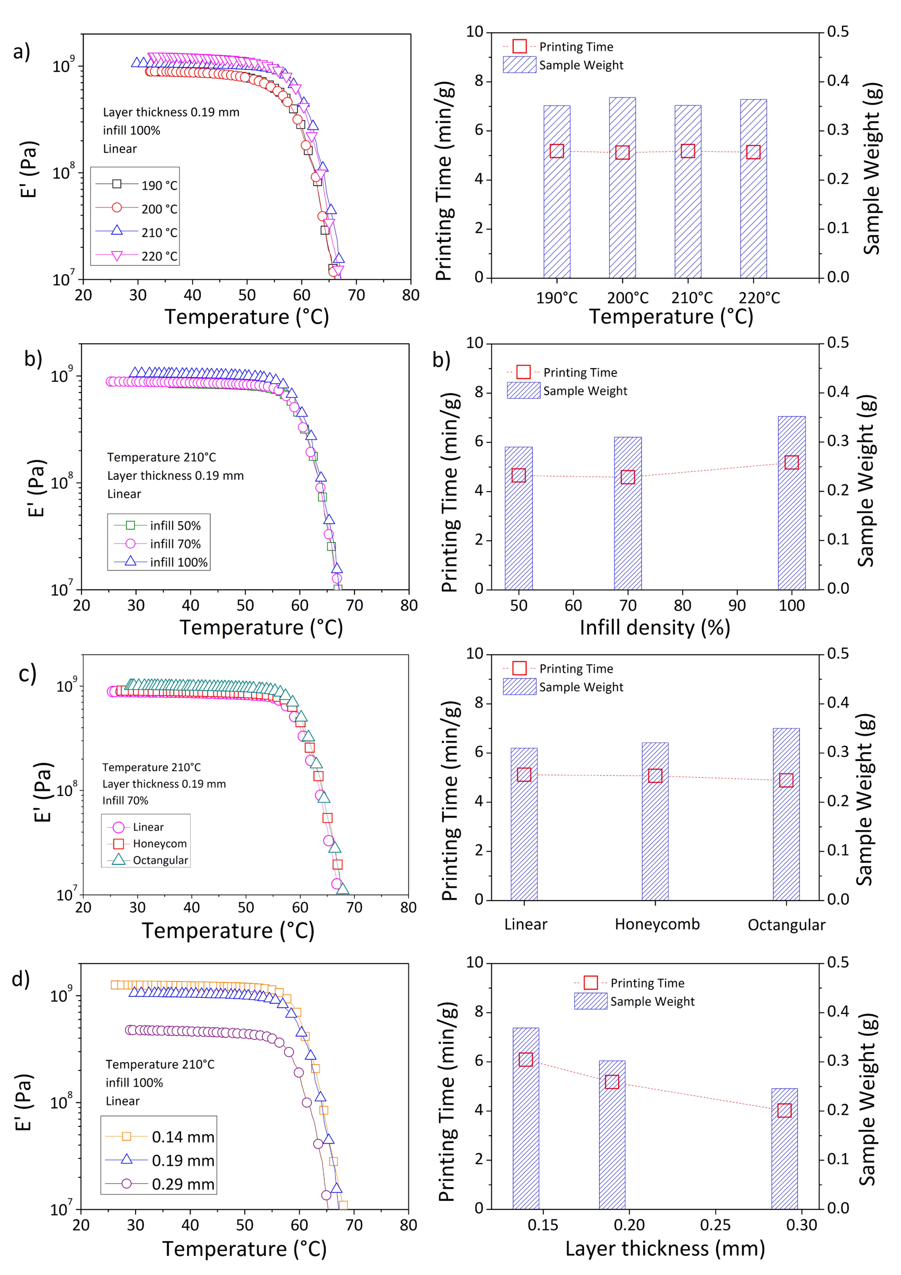
Figure 3: Effect of printing parameters on storage modulus (E’) against temperature, printing time and sample weight: (a) extruder temperature (190, 200, 210, 220°C); (b) infill density (50, 70, 100%); (c) design pattern (Linear, Honeycomb, Octangular); (d) layer thickness (0.14mm, 0.19 mm, 0.29 mm).
  - Conclusions
In this work, the influence of layer thickness, design patter, extruder temperature, infill density on thermo-mechanical characteristics of 3D printed PLA-based parts has been studied. To optimize the printing process, by reducing the involved material, and duration, changes in sample weight and printing time as function of different printing parameters have been also evaluated. Rheological behaviour and VOC emissions at different temperatures have been also investigated. Results allowed to identify flow characteristics suitable for the printing at temperature at least of 190°C. The storage modulus, as well as the sample mass and printing time resulted to be slightly affected by infill density, design pattern and extruder temperature. On the contrary, a strong effect of the layer thickness has been found on investigated properties. In this latter case, by increasing the layer thickness, lowest values in sample mass and processing time were achieved, but also a strong reduction of mechanical resistance. VOC emissions deriving from heating the polymer to 70 °C were found to be very small, especially compared than those measured at 190 °C, and even more so at 220 °C. So, it was concluded that the main source of pollution occurred during polymer processing at the extrusion temperature: the lower the extruder temperatures, the lower the volatiles release in the environment. Then, once melted filament has been deposited on the support, at temperature close to the polymer glass transition, the volatiles emitted could be considered negligible.
Acknowledgments
A. Patti wishes to thank the Italian Ministry of Education, Universities and Research (MIUR) in the framework of Action 1.2 “Researcher Mobility” of The Axis I of PON R&I 2014-2020 (E66C18001370007). S. Acierno and G. Cicala acknowledge the support of the Italian Ministry of University, project PRIN 2017, 20179SWLKA “Multiple Advanced Materials Manufactured by Additive technologies (MAMMA)”.
References
Behzadnasab, Morteza, Yousefi, Ali Akbar, Ebrahimibagha, Dariush and Nasiri, Farahnaz (2020), Effects of Processing Conditions on Mechanical Properties of PLA Printed Parts. Rapid Prototyping Journal, 26(2): 381–389.
Calafel, M. I., Aguirresarobe, R. H., Sadaba, N., Boix, M., Conde, J. I., Pascual, B. and Santamaria, A. (2018), Tuning the Viscoelastic Features Required for 3D Printing of PVC-Acrylate Copolymers Obtained by Single Electron Transfer-Degenerative Chain Transfer Living Radical Polymerization (SET-DTLRP). Express Polymer Letters, 12(9): 824–835.
Ding, Shirun, Ng, Bing Feng, Shang, Xiaopeng, Liu, Hu, Lu, Xuehong and Wan, Man Pun (2019), The Characteristics and Formation Mechanisms of Emissions from Thermal Decomposition of 3D Printer Polymer Filaments. Science of The Total Environment, 692: 984–994.
Kovan, V., Tezel, T., Topal, E.S. and Camurlu, H.E. (2018), Printing Parameters Effects on Surface Characteristics of £D Printed PLA Materials. Machines. Technologies. Materials., 12(7): 266–269.
Li-Destri, Giovanni, Menta, Dario, Menta, Carmelo and Tuccitto, Nunzio (2020), Effect of Unmanned Aerial Vehicles on the Spatial Distribution of Analytes from Point Source. Chemosensors, 8(3): 77.
Nugroho, A., Ardiansyah, R., Rusita, L. and Larasati, I. L. (2018), Effect of Layer Thickness on Flexural Properties of PLA (PolyLactid Acid) by 3D Printing. Journal of Physics: Conference Series, 1130(1): 012017.
Patti, Antonella, Cicala, Gianluca and Acierno, Stefano (2021a), Rotational Rheology of Wood Flour Composites Based on Recycled Polyethylene. Polymers, 13(14): 2226.
Patti, Antonella, Cicala, Gianluca, Tosto, Claudio, Saitta, Lorena and Acierno, Domenico (2021b), Characterization of 3D Printed Highly Filled Composite: Structure, Thermal Diffusivity and Dynamic-Mechanical Analysis. Chemical Engineering Transactions, 86: 1537–1542.
Rismalia, M., Hidajat, S. C., Permana, I. G.R., Hadisujoto, B., Muslimin, M. and Triawan, F. (2019), Infill Pattern and Density Effects on the Tensile Properties of 3D Printed PLA Material. Journal of Physics: Conference Series, 1402(4): 044041.
Sangroniz, Leire, Fernández, Mercedes, Partal, Pedro, Santamaria, Antxon, Antonio, Rafael, Gimeno, Balart, Moreno, Vicente Compañ, María Díez-Pascual, Ana, Serra, Angels, Velasco, Rebeca Hernandez and Mecerreyes, David (2021), Rheology of Polymer Processing in Spain (1995–2020). Polymers, 13(14): 2314.
Simon, Timothy R., Lee, Wo Jae, Spurgeon, Benjamin E., Boor, Brandon E. and Zhao, Fu (2018), An Experimental Study on the Energy Consumption and Emission Profile of Fused Deposition Modeling Process. Procedia Manufacturing, 26: 920–928.
Suárez, Luis and Domínguez, Manuel Sustainability and Environmental Impact of Fused Deposition Modelling (FDM) Technologies. available at https://doi.org/10.1007/s00170-019-04676-0 [12 April 2021].
Wojtyła, Szymon, Klama, Piotr and Baran, Tomasz (2017), Is 3D Printing Safe? Analysis of the Thermal Treatment of Thermoplastics: ABS, PLA, PET, and Nylon. Journal of Occupational and Environmental Hygiene, 14(6): D80–D85.

