 CHEMICAL ENGINEERING TRANSACTIONS  VOL. xxx, 2024 | A publication of  
The Italian Association
of Chemical Engineering
Online at www.cetjournal.it

Guest Editors: Valerio Cozzani, Bruno Fabiano, Genserik Reniers
Copyright © 2024, AIDIC Servizi S.r.l.
ISBN 979-12-81206-11-3; ISSN 2283-9216

Beyond HazOp: Modelling of HILP (High Intensity Low Probability) scenarios in hydrogen production and storage plants
Leonardo Michele Carluccio*, Andrea Gritti , Lorenzo Pellegrini
DEKRA Italia S.r.l., Via Fratelli Gracchi, 27, 20092 Cinisello Balsamo (MI) - Italia
*leonardomichele.carluccio@dekra.com

Hydrogen, as a versatile and sustainable energy carrier, plays a pivotal role in the global transition towards a low-carbon economy. However, the safe and efficient operation of hydrogen production plants is paramount to exploiting the full potential of this clean energy source.
This scientific article investigates typical HILP (High Intensity Low Probability) scenarios that can occur in hydrogen production plants and storage. The assessment is based on a HazOp (Hazard and Operability) study on a representative electrolysis unit.
The study has been conducted through a multidisciplinary approach, integrating knowledge from chemical engineering, process safety and risk analysis, focusing on consequence modelling, to understand root causes, potential impacts and mitigation strategies. Through the analysis of plant design and operation parameters, the article identifies common vulnerabilities in hydrogen production processes. The main accident scenarios explored include equipment failures and leaks, each with the potential to compromise plant safety and disrupt production.
Furthermore, the article analyses the dynamic interaction between technological progress and safety protocols in shaping the risk landscape of hydrogen production and storage facilities. The insights from this analysis help to propose possible risk management strategies, emphasising the importance of proactive safety measures, early detection systems and effective emergency response plans.
By elucidating the typical incident scenarios in hydrogen production plants, this article seeks to enhance industry awareness, facilitate knowledge sharing, and drive continuous improvement in the design, operation, and maintenance of hydrogen facilities. The findings presented herein offer valuable insights for engineers, researchers, and policymakers working towards the widespread adoption of hydrogen as a clean and sustainable energy solution.
  - Introduction
Industrial hydrogen production represents a promising energy solution, offering a pathway towards decarbonization across various sectors. However, realizing the potential of hydrogen necessitates a comprehensive understanding of its unique physical characteristics and the implementation of robust safety measures throughout production and storage processes. Unlike conventional fuels and gases, hydrogen possesses distinctive properties requiring specialized safety protocols to effectively mitigate potential hazards.
Hydrogen, being the lightest and most flammable gas, presents challenges in handling and containment. Its low ignition energy and wide flammability range make it highly sensitive to ignition, potentially leading to catastrophic consequences if not diligently managed. Additionally, hydrogen's high diffusivity enables rapid dispersal in the event of a leak, posing risks of ignition or asphyxiation in enclosed spaces. These inherent characteristics underscore the critical importance of adopting rigorous safety measures tailored to hydrogen's unique properties in industrial environments.
    - Ignition Energy and Flammability Range
The ignition energy of hydrogen typically ranges from 0.02 to 0.06 mJ (h2tools.org, 2024), depending on factors such as temperature, pressure, and mixture composition. Its low ignition energy makes hydrogen highly susceptible to ignition, even at relatively low energy inputs. Methane, the primary component of natural gas, has a higher ignition energy compared to hydrogen. The ignition energy of methane ranges from 0.3 to 0.7 mJ under standard conditions, approximately an order of magnitude larger than that of Hydrogen under similar conditions, as shown in Table 1.
Table 1: Ignition and combustion properties for air mixtures at 25 °C and 101.3 kPa for Hydrogen and Methane (ISO/TR 15916:2015)
Fuel | Lower flammability limit (% vol. fraction) | Upper flammability limit  (% vol. fraction) | Minimum ignition energy (mJ) | Laminar burning velocity (m/s)
Hydrogen H₂ | 4 | 77 | 0.017 | 2.70
Methane CH₄ | 5.3 | 17 | 0.271 | 0.37

Hydrogen possesses the NFPA 704's highest rating of 4 on the flammability scale (NFPA 704) because its flammability range is between 4% and 75% in air, as shown in Table 1.
    - Diffusivity
Hydrogen possesses a rapid diffusivity, approximately 3.8 times faster than natural gas. This means that when hydrogen is released, it quickly disperses until its concentration falls below flammable levels. Compared to helium, hydrogen rises twice as fast, and six times faster than natural gas, with speeds reaching nearly 45 mph (20m/s) (eere.energy.gov, 2024). Moreover, hydrogen released into the atmosphere quickly disperses through turbulent convection, drift, and buoyancy, thereby reducing the duration of the hazard. However, it's important to note that this rapid dispersion also facilitates the formation of gas mixtures within the extensive flammability and deniability limits. Hydrogen, as the lightest element, follows basic principles of physics and tends not to linger near leaks or individuals in open spaces unless confined. This means that for hydrogen to present a fire hazard, it must be contained. Industries must consider this factor when designing structures for hydrogen utilization, ensuring that the designs promote the upward and outward dispersion of hydrogen, thus reducing the likelihood of ignition.
    - Explosion, deflagration and detonation
An explosion can manifest in two primary forms: deflagration or detonation. Under certain conditions, if the deflagration proceeds rapidly, it has the potential to generate a blast wave akin to that produced by a detonation.
The process known as deflagration is characterized by the subsonic propagation of a flame into regions of unburnt mixtures, driven by intricate chemical reactions and heat and mass-transfer mechanisms. Essential prerequisites for this phenomenon include maintaining the concentration, pressure, and temperature of the unburnt medium within the flammability limits. In a stationary mixture in the open with no confinement, the flame will propagate with laminar or “smooth flow” at a burning velocity into the unburnt mixture in the order of 2 m/s to 3 m/s (which is about 10 times faster than for hydrocarbon flames). For hydrogen-air mixtures, the visible propagation velocity can be higher than the burning velocity. This can be caused by the expansion of hot combustion products behind the flame adding a convection velocity to the flame propagation velocity. Detonation of hydrogen-air mixtures can produce pressures as much as 20 times the initial pressure (for very short durations even more) and with reflection, pressures 50 times the initial pressure (ISO/TR 15916:2015).
Confinement significantly impacts the behavior of both deflagration and detonation. When an explosion occurs in a confined space, the pressure and temperature can rapidly increase due to the limited volume available for the expanding gases. This can lead to an acceleration of the deflagration process, potentially transitioning it to detonation. The confinement can also enhance the destructive power of the explosion by amplifying the pressure waves and increasing the overall energy release.
  - HILP hydrogen scenarios
In recent decades, with the ever-increasing strategic importance of hydrogen as an energy source and carrier, the safe handling of this element has become of crucial importance. In addition to technical and theoretical research, one of the most productive approaches employed by industries to enhance safety strategies for a particular technology involves the historical examination of its past applications. For instance, within the petrochemical sector, it is customary to draw insights from previous accidents to devise mitigation and prevention measures aimed at preventing recurrences and enhancing overall plant safety. Hence, it becomes crucial to gather and organize all accessible data concerning hydrogen-related accident scenarios throughout its supply chains, extending to its end uses. This comprehensive approach aims to improve understanding of hydrogen-related dynamics, aiding in the development of effective safety protocols. Additionally, it informs the creation of industry standards and regulations. There are many articles and databases in the literature that collect and analyse hydrogen-related accidents, starting with the study published in 1978 by the US Department of Energy (Zaloh et al., 2015), containing a review of around 400 hydrogen-related accidents that occurred between 1965 and 1977, up to more recent projects such as the HIAD 2.1 database (European Hydrogen Incident and Accident Database) (Melideo et al., 2017) funded by the European Commission (HySafe) and developed by the JRC. Precisely through an analysis of the case studies in the HIAD 2.1 database it was possible to define the statistical hierarchy of occurrence of possible accident events. As can be seen from the graph in Figure 1, the tendency of hydrogen to ignition is confirmed.
In the following paragraphs, building on this statistical evidence and supplementing it with a representative case study, characteristic modelling for accident scenarios involving hydrogen production and storage will be presented.

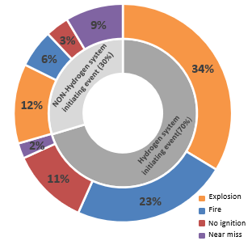
Figure 1 - Accident frequencies for hydrogen scenarios extrapolated from the HIAD 2.0 database.
    - Case Study
From the panorama described in the previous paragraph, the need emerged to find a case study that was representative of the industrial realities concerned by the use of hydrogen in terms of the processes involved and accident scenarios. Of all the processes, certainly that of hydrogen production through electrolysis using electricity from renewable sources is current and relevant in the modern scenario, committed to the ecological transition and decarbonisation, and equally relevant in terms of the processes and physical variables employed.
Furthermore, in order to provide a valid comparison for future accident modelling, which will become necessary with the increasing use of electrolysis-based technologies, this case study was selected because of the accident scenarios that emerged during its analysis, namely:
- Internal equipment explosion due to the formation of an explosive mixture inside the equipment;
- Explosion caused by a hydrogen release from the equipment.
In order to be as representative as possible, it was decided to adopt the contents of the TNO Purple Book (TNO “Purple Book”, 2005) and to consider the following for the three cases listed above:
- Partial rupture of the bigger pipeline connected to the equipment considered, in this case the storage tank of the system was considered (leak with an effective diameter of 10% of the nominal diameter);
- Total rupture of the bigger pipeline connected to the equipment considered;
- Catastrophic rupture of the equipment considered.
    - Consequence modelling: parameters
The parameters employed for the simulations conducted in this study are designed to encompass a broad spectrum of potential scenarios. All scenarios were simulated at a pressure of 30 bar and a temperature of 90°C, representing typical operating conditions for electrolysers processes (Pozio et al., 2021), the mass inventory utilized in the simulations was 50m³ of hydrogen. Furthermore, simulations were performed at different operating pressures and temperatures. However, the selected conditions represent the most adverse scenario, thus warranting their application in the case study. As reported in the next table, the weather conditions considered are atmospheric class 2F and 5D.
Table 2: Weather conditions
 | Wind velocity (m/s) | Pasquill stability classes | Description
2F | 2 | F | Moderately stable conditions
5D | 5 | D | Neutral conditions

The consequences of each scenario were modelled with a reference height of 1.5 m, commensurate with human scale. The horizontal outflow direction was selected to represent the case with the most significant effects, as it reflects the prevailing flow conditions. The software employed for consequence modelling is DNV PHAST 7.2 (Process Hazard Analysis Software Tool).
    - Consequence modelling: Partial bore and Full bore rupture
The comparative analysis of diffusivity, assessed under conditions equivalent to half of the Lower Flammable Limit (LFL), between hydrogen and methane reveals a clear predominance of hydrogen diffusion, as shown in Figure 2, highlighting a potentially increased risk of dispersion and consequent implications for industrial safety. Given hydrogen's propensity for rapid propagation, the probability of hazardous concentrations, potentially leading to explosive scenarios, escalates notably within confined environments. Furthermore, the higher diffusivity of hydrogen within the flammability range increases the probability of encountering an ignition source.
Comparing the data derived from diverse modelling approaches, it is evident that the hydrogen exhibits a greater diffusive trend, even in the full bore modelling scenario. Conversely, analysing the Jet fire scenario reveals a fundamentally comparable irradiation generated by both gases; indeed, it is noteworthy that in the case of a full bore rupture-generated jet fire, methane exhibits greater irradiation. This behaviour stems from the fact that the heat transfer and emissivity of a hydrogen flame are lower compared to a methane flame, due to the reduced concentration of radiative species such as soot, CO₂, and hydrocarbon radicals. In Table 3 is reported the results obtained from the consequence modelling.

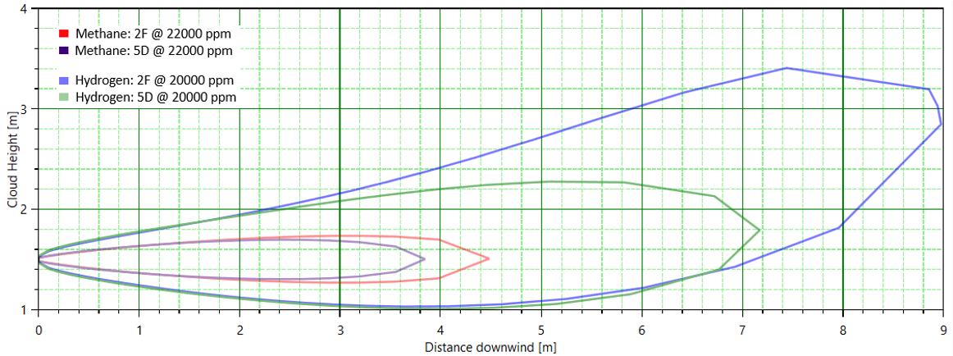
Figure 2: Hydrogen vs Methane concentration from a 5 mm leak
Table 3: Hydrogen vs Methane Jet fire scenario
Scenario |  | Weather conditions | Damage distances (m)
 |  |  | 12.5 (kW/m²) | 7 (kW/m²) | 5 (kW/m²) | 3 (kW/m²)
Hydrogen | Partial bore (5 mm) | 2F | 3.85 | 4.12 | 4.38 | 4.69
 |  | 5D | 4.31 | 4.55 | 4.67 | 4.88
 | Full bore (50 mm) | 2F | 35 | 40 | 43 | 50
 |  | 5D | 37 | 41 | 43 | 48
Methane | Partial bore (5 mm) | 2F | 3.98 | 4.27 | 4.40 | 4.62
 |  | 5D | 3.96 | 4.18 | 4.29 | 4.47
 | Full bore (50 mm) | 2F | 40 | 45 | 49 | 55
 |  | 5D | 41 | 46 | 49 | 54

The explosion scenario, particularly focusing on delayed detonation, is solely observed in full bore modelling due to the large quantities of gas released and their dispersion in the atmosphere; indeed, in partial rupture modelling, the requisite concentrations essential for initiating and sustaining explosive combustion are not reached. In the following table are reported the data obtain from the consequence modelling.
Table 4: Hydrogen vs Methane delayed explosion scenario
Scenario |  | Weather conditions | Damage distances  Maximum overpressure diameter (m)
 |  |  | 0.3 (bar) | 0.14 (bar) | 0.07 (bar) | 0.03 (bar)
Hydrogen | Full bore (50 mm) | 2F | 29 | 48 | 84 | 178
 |  | 5D | 24 | 41 | 71 | 151
Methane | Full bore (50 mm) | 2F | 15 | 25 | 44 | 93
 |  | 5D | 13 | 22 | 39 | 82

The data listed in the table and depicted in Figure 3, once again demonstrate the fundamental role played by hydrogen diffusivity. In the case of delayed detonation, the difference in behaviour between the two gases under examination is profound; hydrogen, diffusing rapidly, tends to gradually create a large mass of gas within the explosivity range over time, consequently resulting in explosions with significantly larger damage distances compared to methane. These effects will affect structures even far away from the blast site.
It is worth specifying that when we refer to delayed detonation in this article, we are necessarily referring to a scenario in which confinement is present to prevent total dispersion of the gas.

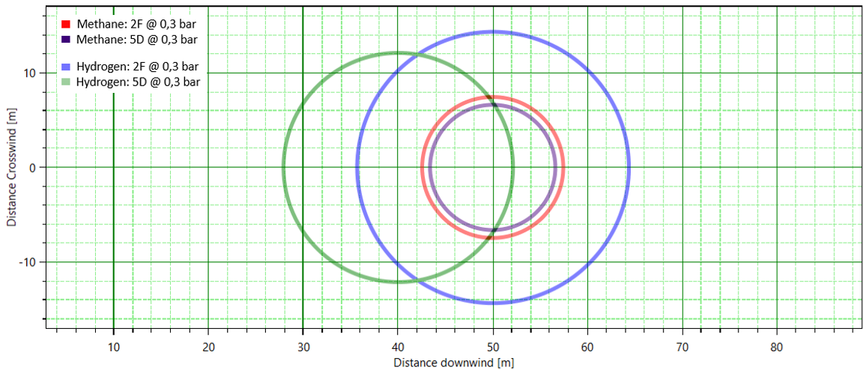
Figure 3: Hydrogen vs Methane late explosion scenario from a 50 mm leak

A further case study was modelled, as shown in Figure 4, analysing a flash fire scenario, which represents the incident event with the highest probability of occurrence given the properties of hydrogen. From the comparison between the two gases, hydrogen and methane, small differences in damage distances emerge, primarily due to the greater diffusivity of hydrogen. These differences tend to disappear when analysing the explosion as the incidental event, as the dynamics of the explosion are not affected by the diffusive differences of the two gases. In conclusion, from the conducted modelling, it emerges that hydrogen, as a substance, exhibits wider damage distances compared to methane only in the case of significant quantities released, specific to the conditions of the system under consideration. In the case of small unconfined leaks, the comparison with methane tends to methane in terms of hazardousness.

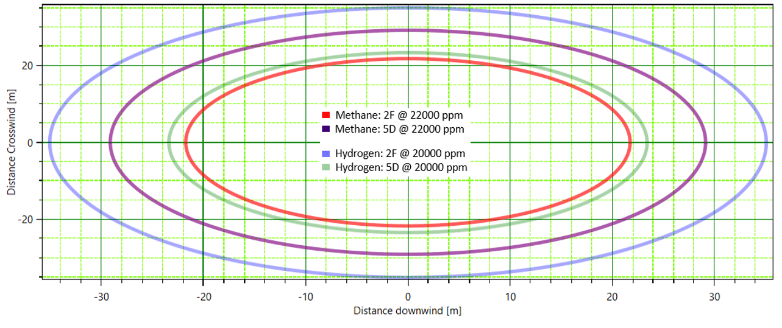
Figure 4: Hydrogen vs Methane Flash fire after a catastrophic rupture
  - Conclusions
In the initial phase of risk management, recognizing and understanding potential hazards is crucial. To support this understanding, potential accident scenarios for hydrogen-producing electrolysers were studied using consequence modelling analysis with the DNV PHAST 7.2 program. This study relied on the professional experience of the authors, though results may vary with different programs and assumptions. Thus, further accident modelling by the technical-scientific community is recommended to improve model accuracy and understanding of hydrogen-related accident phenomena.
Key conclusions from this study include the identification of jet fires and explosions as primary risks, underscoring the need for rigorous technical and organizational safeguards. Given hydrogen's wide flammability range, establishing inerting routines for equipment prior to startup and maintenance is imperative, supported by robust protocols and gas detection mechanisms for early hazard detection and swift safety measure implementation.
Ensuring the safe use of hydrogen requires prioritizing designs and procedures to mitigate potential accidents, including thorough hazard identification, inherently safe design principles, reducing flanged joints, careful material selection, and strategic facility placement based on risk assessments.
Material selection for hydrogen systems must consider both metallic and non-metallic options, addressing factors such as temperature impacts, hydrogen embrittlement, permeability, and compatibility with dissimilar metals. Integrating cautionary alerts for abnormal conditions and failures, along with safety instrumented systems, is essential for preventing hazards and ensuring timely personnel response.
Effective ventilation systems in indoor settings are crucial for diluting hydrogen leaks below the lower flammability limit. Managing ignition sources stringently, using ATEX-rated electrical and mechanical apparatuses, and implementing fire and gas detection systems with automatic blocking capabilities are also necessary to comprehensively mitigate hydrogen release consequences.
References
Gallandat N., Romanowicz K., Zuttel A., 2017, An Analytical Model for the Electrolyser Performance Derived from Materials Parameters
Hydrogen and fuel cells, 2024, www1.eere.energy.gov/hydrogenandfuelcells/pdfs/h2_safety_fsheet.pdf, (last access 15.2.2024).
Hydrogen Tools, 2022, www.h2tools.org (last access 12.02.2024).
ISO/TR 15916, 2015, Basic considerations for the safety of hydrogen system.
Melideo, D., Weidner Ronnefeld, E., Dolci, F. and Moretto, P., HIAD - Hydrogen Incident and Accident Database, In: 53rd ESReDA Seminar, 14-15 November 2017, Ispra, 53rd ESReDA Seminar, 2017, p. 326-336, JRC108666.
National Fire Protection Association, 2017, NFPA 704, Standard System for the Identification of the Hazards of Materials for Emergency Response
Pozio A., Bozza F., Nigliaccio G., Platter M., Monteleone G., 2021, Development perspectives on low-temperature electrolysis
TNO “Purple Book” Guidelines for Quantitative Risk Assessment, CPR 18E, Committee for the Prevention of Disasters, 1999.
Zalosh, Robert G., and Short, Thomas P.. Compilation and Analysis of Hydrogen Accident Reports. Final Technical Report. United States: N. p., 1978. Web. doi:10.2172/12138523.

