 CHEMICAL ENGINEERING TRANSACTIONS  VOL. xxx, 2024 | A publication of  
The Italian Association
of Chemical Engineering
Online at www.cetjournal.it

Guest Editors: Valerio Cozzani, Bruno Fabiano, Genserik Reniers
Copyright © 2024, AIDIC Servizi S.r.l.
ISBN 979-12-81206-11-3; ISSN 2283-9216

Concept Risk Analysis of a Full-Electric Passenger Catamaran Ferry Equipped with Hydrogen-Fuelled PEM Fuel Cell and Battery Systems.
Tommaso Coppola, Luca Micoli, Roberta Russo*, Vincenzo Sorrentino
University of Naples Federico II, Department of Industrial Enginneering, Via Claudio 21 80125 Naples (Italy)
roberta.russo5@unina.it
The work considers a zero-emission high-speed catamaran ferry equipped with a hybrid powertrain, based on a full-electric propulsion system, and its preliminary risk analysis. Globally, there is major attention on full-electric vessels to comply with the IMO regulations related to ship emissions and energy efficiency improvement, and the assessment of possible risks due to the installation of green technologies. This study aims to analyze the risk assessment for the implementation of an onboard fuel cell power generating system integrated with the propulsion plant and the energy storage to evaluate its arrangements with particular attention to the preliminary identification of hazardous areas. The passenger craft is 30 m in length and 10 m wide, and it is intended to operate on the Amalfi coast, carrying 220 passengers at a cruise speed of 20 knots. The power system consists of a proton-exchange membrane fuel cell (PEMFC) system, with a nominal power of 1600 kWe, a battery pack with a capacity of 400 kWh, a 750-kW electric motor, and their relative balance of the plant (BoP) subsystems. The PEM is fuelled by pure hydrogen stored in type IV cylinder vessels at 700 bars.
  - Introduction
In recent years, the transportation industry has been shifting towards more sustainable and eco-friendly solutions, and the passenger ferry sector is no exception. One of the most promising developments in this field is the rise of full-electric passenger ferries, which promises not only speed and efficiency but also sustainability, (Padolecchia D. et al and Coppola T. et al, 2023). However, the implementation of battery systems for electric ferries also comes with its own set of advantages and limitations, (Captain Joe Burgard Red and Joe Pratt, 2017). To explore alternative solutions, hydrogen Fuel Cell (FC) technology has emerged as a potential game-changer for marine transportation, (Ansaloni G. M. M et al.,2022). However, as with any new technology, there are risks involved, and a comprehensive risk analysis is essential to ensure safe and effective operations. This analysis encompasses various aspects, including the vessel's design and construction, operational considerations, and potential environmental impacts. In terms of design and construction, it is crucial to evaluate the structural integrity and stability of zero-emissions ships. These vessels typically incorporate innovative materials and propulsion systems, which may introduce new risks that need to be thoroughly assessed. Additionally, the integration of battery systems and electric propulsion requires careful consideration of fire safety measures and emergency response protocols. Operational considerations are equally important in mitigating risks associated with zero-emissions catamarans. The crew's training and experience in handling advanced technologies should be evaluated to ensure they are adequately prepared for any potential challenges. Furthermore, contingency plans must be developed to address power outages or other system failures that could impact the vessel's performance. Another key aspect of risk analysis involves the International Maritime Organization (IMO) Regulations and their Implications for Ship Emissions. IMO plays a crucial role in shaping regulations that govern ship emissions. As concerns about the environmental impact of maritime transportation continue to grow, it becomes imperative to comprehend the implications of these regulations set by IMO, including MSC.1/Circ. 1455, MSC.1/Circ. 1647, and MSC. 391(95). The IMO's focus on reducing greenhouse gas (GHG) emissions has resulted in the development of various measures aimed at controlling pollution from ships. One such measure is the Energy Efficiency Design Index (EEDI), which sets standards for new ships to ensure they meet specific energy efficiency requirements. Additionally, the IMO has implemented the Ship Energy Efficiency Management Plan (SEEMP), which encourages ship operators to adopt energy-efficient practices and improve their overall environmental performance. Compliance with these regulations not only helps reduce harmful emissions but also brings economic benefits to shipowners. Ships that meet or exceed the IMO's emission standards can enjoy reduced fuel consumption and lower operational costs. Moreover, adherence to these regulations enhances a company's reputation and demonstrates its commitment to sustainability, which can attract environmentally conscious customers and investors.
However, understanding and implementing IMO regulations is not without its challenges. Shipowners must navigate a complex regulatory landscape and invest in technologies and practices that align with the latest emission standards. Retrofitting existing vessels or building new zero-emissions ships can require substantial investments, posing financial risks for companies. Moreover, ensuring compliance with evolving regulations requires ongoing monitoring and data reporting, adding administrative burdens to ship operators (Maciej Tarkowski and Krystian Puzdrakiewicz; 2021).
  - Advancements in electric-powered passenger ferries
The recent surge in full-electric passenger ferries marks a notable transition towards more sustainable and environmentally friendly transportation options Cícero S. Postiglione et al. These vessels employ cutting-edge electric propulsion systems and battery technologies, substantially reducing emissions and noise pollution compared to traditional diesel-powered ships. Moreover, the adoption of full-electric technology has the potential to revolutionize the ferry industry by reducing operational costs and increasing efficiency. As the global focus sharpens on sustainability and clean energy, the ascent of full-electric passenger catamaran ferries emerges as a promising trend in transportation. Furthermore, these ferries require less maintenance and have lower operating costs due to the absence of complex mechanical systems inherent in conventional engines.
Several countries have already introduced electric vessels in their public transportation systems. For instance, Norway pioneered the world's first all-electric ferry, (Ampere, 2015), followed by Denmark, Finland, and Canada. The battery-powered vessel, with a capacity of 120 cars and 360 passengers, operates at approximately 10 knots and runs 365 days a year.
The growing appeal of full-electric passenger ferries stems from the dual advantages they offer, environmentally and economically (Masih M. R. et al., 2023). Advancements in battery technology enable these vessels to traverse longer distances without compromising speed or capacity. Additionally, electric vessels deliver a quieter and smoother ride for passengers, enhancing their comfort and enjoyment. Battery systems have emerged as a preferred power source for electric ferries due to their efficiency, reliability, and minimal maintenance requirements. Notably, one of their primary benefits is their silent operation, reducing noise pollution in coastal areas and presenting an environmentally friendly alternative for ferry transportation (Cícero S. et al, 2012).
However, battery systems do have limitations. Their restricted range poses a challenge for ferries covering long distances. To address this, operators must install larger battery banks or recharge batteries during operation, potentially increasing costs and reducing efficiency. Moreover, the weight of battery systems can affect the overall performance and stability of the ferry. Additionally, the production and disposal of batteries entail environmental impacts that must be factored in when assessing the sustainability of battery-powered ferries.
    - Exploring the potential of hydrogen fuel cell technology for ferries
Hydrogen (H₂) FC technology holds the potential to revolutionize the ferry industry. With the increasing demand for sustainable and eco-friendly transport options, ferries powered by FCs have emerged as a promising solution. A H₂-fuelled FC (H₂-FC), such as the Polymer Electrolyte Membrane FC (PEM), generates electricity by combining hydrogen and oxygen, producing only water and heat as by-products. This technology offers numerous advantages, including zero emissions, high efficiency, and low noise levels (Truong, HVA. et al. 2020). Furthermore, FC-powered ferries have the potential to provide a reliable and cost-effective alternative to diesel-powered vessels, thereby reducing their carbon footprint and operating costs. In fact, several initiatives are already underway, with some companies developing hydrogen-powered passenger ferries. Thus, exploring the potential of hydrogen FC technology for ferries is crucial in achieving a sustainable future for the maritime industry.
Exploring the potential of H₂-FC technology for ferries holds great promise in the pursuit of sustainable and eco-friendly transportation solutions. H₂-FCs have garnered attention as a viable alternative to traditional battery systems in the marine industry due to their ability to generate electricity without emitting harmful pollutants. In the context of passenger ferries, H₂-FCs offer several advantages. Firstly, they provide a longer range compared to batteries, allowing for extended journeys without the need for frequent recharging. Additionally, H₂-FCs can be refuelled relatively quickly, reducing downtime, and improving operational efficiency. Moreover, the use of H₂ as a fuel source eliminates concerns over battery weight and limited capacity, enabling the design of lighter and more spacious ferries.
However, there are challenges that need to be addressed before widespread implementation of H₂-FC technology on passenger ferries can be achieved. These include the availability and infrastructure for H₂ production and distribution, as well as ensuring the safety of onboard storage and handling of hydrogen gas. Despite these challenges, ongoing research, and development efforts in the field of H₂-FC technology are paving the way for its potential application in passenger ferry transportation. As advancements continue, it is hoped that H₂-powered ferries will significantly contribute to reducing GHG and creating a more sustainable future for marine transportation (Lagemann B. et al, 2021).
PEM technology holds promise for marine transportation, particularly passenger ferries. A PEM Operates at the average temperature of 80 °C and converts the chemical energy stored in H₂ directly into electricity through an electrochemical reaction. The utilization of PEM systems offers several advantages. Firstly, they exhibit high energy efficiency (up to 65%) compared to traditional marine Internal Combustion Engines (ICEs), resulting in reduced fuel consumption. Secondly, they operate silently and emit no harmful exhaust gases and GHG emissions, contributing to improved air quality in coastal areas. Additionally, PEMs boast a compact and lightweight design, with high power density (up to 2.5 kW/L), rendering them suitable for integration into vessels of various sizes and types (Wang Z., et al, 2024).
  - The case study: high speed catamaran ferry
The proposed passenger vessel has been designed to operate along the picturesque Amalfi Coast, offering a daily round trip on the Salerno-Capri route with scheduled stops at the ports of Vietri, Maiori, Amalfi, and Positano. Boasting a capacity to accommodate 220 passengers and a cruising speed of 20 knots, this vessel will cater to both commuters and tourists during the summer season. Main specifics of the power plant system components are listed in Table 1:
Table 1: Main Specifics of the power plant system’s components
Fuel cell system (Ballard.com, 2023)
Rated power (kW) | 200 | Weight (kg) | 1000
Minimum power (kW) | 55 | Dimensions L x W x H (mm) | 1209 x 747 x 2195
Peak fuel efficiency (%) | 53.5
Hydrogen Storage Vessel (Plasticomnium.com, 2023)
Vessel type | IV | Weight(kg) | 400
Operating pressure (bar) | 700 | Dimensions, cylinder L x D (mm) | 2700 x 750
Material | Carbon fibre | H₂ capacity (kg) | 35
Energy Storage System (Corvusenergy.com, 2023)
Type: | Li-ion based | Capacity (kWh) | 199
Gravimetric density (kg/Wh) | 5.96 | Weight (kg) | 1183

The propulsion system is an innovative all-electric design that incorporates a H₂-FC system, coupled with electric propulsion motors located in each demi-hull, an energy storage system (ESS) based on Li-ion battery packs, and a power management system (PMS). The ESS is specifically configured to provide additional energy during acceleration and maneuvering phases, allowing for optimized performance in the face of transient changes in load demand Truong, HVA et al, 2020. The design also facilitates excess power from the PEM being stored in the ESS during times of low demand, to be subsequently released and utilized when required during a rapid load increase. In line with regulations, the ESS capacity has been calculated to ensure a safe return to port in the event of FC failure. The block diagram of the proposed power plant is shown in Figure 1.

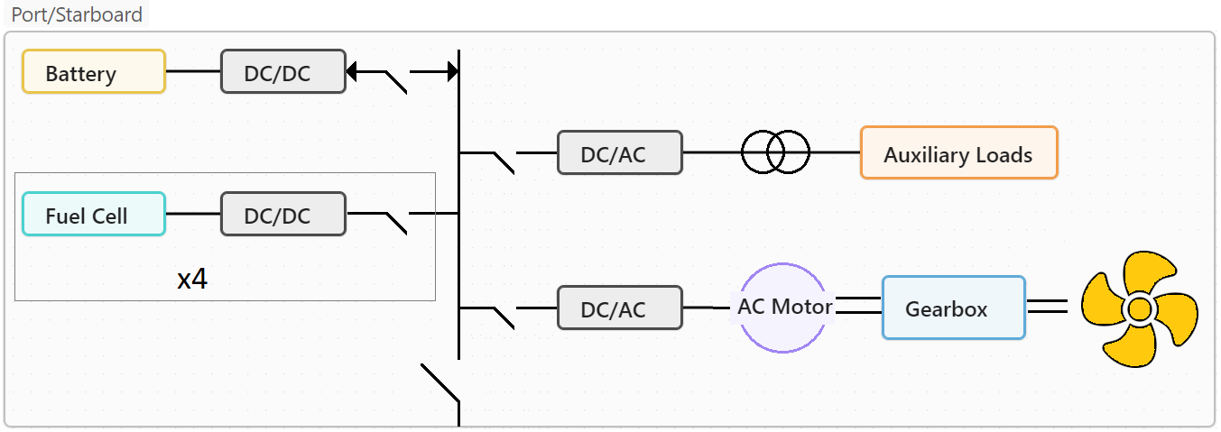
Figure 1: Block diagram of the full-electric power plant
According to the expected catamaran performances, the resulting power system will consist of 8 x PEMs (1600 kW), 2 x BPs (400 kWh), and 10 x H₂ tanks (352 kg of H₂). An average H₂ consumption rate of about 7.5 kg/h is expected. These components of the power system will be arranged separately on board.
The general arrangement for the vessel is provided in Figure 2. The ferry has a single main deck, which is accessed via ramps on the portside and starboard side of the ship. The ship will be controlled from a centrally located bridge. Two propulsion units, within each demi-hull, provide propulsive power and maneuvering. One storage arrangement was considered for the fuel storage tanks: at the upper deck level aft. The FC are located within a dedicated space aft of the main deck. In case of loss, the power generated by the FCs is augmented or replaced by power from the Li-ion batteries, which are in two separate compartments within the demi-hull. All venting of H₂ is via the vent mast aft at the highest point on the ferry. There are two bunker stations on the port side, both on the open deck.
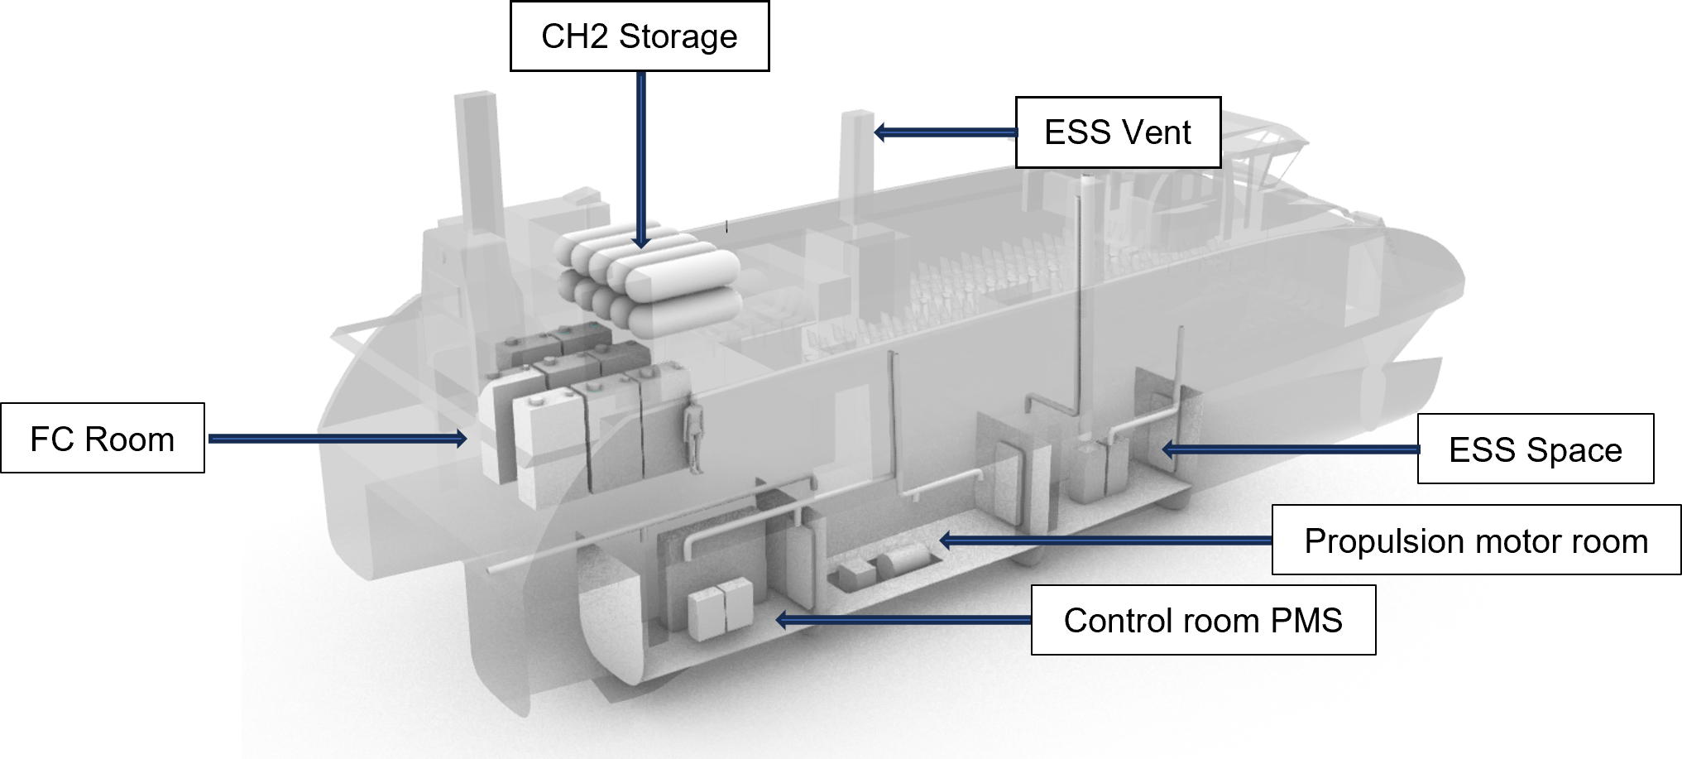
Figure 2: 3D rendering case study passenger ferry: location of the main power train components
The ferry’s key dimensions are listed as follow. Length overall: 39 m; length between perpendiculars: 29.6 m; breadth (moulded): 10 m; breadth (water line demi hull): 2.6 m; depth: 3.9 m; draught: 1.41 m; air draught (top of vent mast): 25 m; displacement: 125 t; material aluminium: 5083-H111 (Coppola T. e al 2023).
  - Risk assessment using hydrogen as marine fuel in the catamaran ferry
Major concerns related to hydrogen as a marine fuel are related to hydrogen’s flammability range, leakage, flame speed and detonation/deflagration issues. These issues require specific studies to understand the risks and additional safeguards that will need to be implemented to prevent or mitigate the major hazards.
Gaseous hydrogen is a non-toxic, non-corrosive, highly flammable and explosive gas with wide flammability limits, low minimum ignition energy, a fast-burning velocity and burns with a nearly invisible flame. It is colourless, odourless, tasteless and asphyxiant.
The HAZID studies identified preventive and mitigative safeguards and recommendations for various ship types.
While some safeguards stemmed from the IGF Code for methane as marine fuel, many of these safeguards are not found in the Code and are considered additional due to the inherent risks of hydrogen.
It must be noted that not all safeguards and recommendations listed in HAZID registers will apply to all ship types. Some are practical and of benefit, but others may require a further investigation of their merit.
However, they are all listed for consideration and may help to inform prescriptive requirements and develop inherently safer designs and arrangements. Importantly, the additional safeguards and recommendations will contribute to further risk reduction.
To ensure the safety of FC power installations and fuel storage arrangements, we have taken great care to identify potentially hazardous areas have taken, following the guidelines set out in MSC.1/Circ. 1647, the IGF Code, and DNV-RU-SHIP Pt.6 Ch.2 (Laursen, R. et al. 2023). During the concept phase, we made several design choices to minimize the risk of accidents or damage, (Captain Joe Burgard Red and Joe Pratt, 2017). These included placing compressed fuel vessels at least B/5 distance from the ship's side on an open deck and arranging the FC power installation in a ventilated enclosed space, with direct access from an open deck. We also made sure to create a venting mast for fuel release, which serves the FC space and tank connection room. In addition, great attention was paid to the safe locations of air inlets and outlets openings, ensuring that battery packs were segregated into two ventilated compartments placed in each hull. These compartments feature ventilation openings facing the open air on the upper deck, ensuring any unintended sea water ingress during a slamming event is avoided.
Figure 3 highlights the identified hazard zones. Overall, our approach prioritizes safety and responsible design, ensuring that our FC power installations and fuel storage arrangements meet the highest standards of safety and precision. With this innovative system, we can easily identify and prevent potential dangers, ensuring a safe and comfortable journey for all passengers onboard.
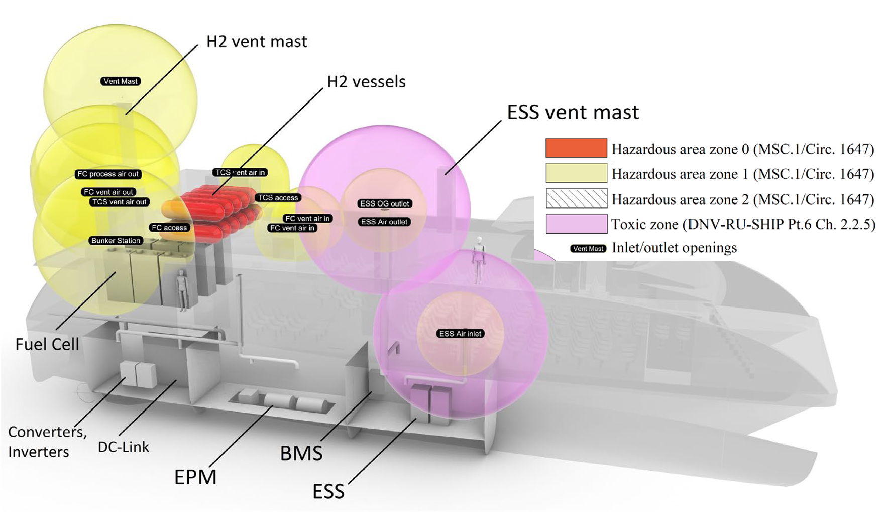
Figure 3: 3D rendering case study passenger ferry: hazard area identification
The vessel is designed in compliance with class and statutory regulations. Bunkering of H₂ fuel will occur using hoses at the bunker terminal and only during nighttime hours or when there are no passengers on board. A single pipeline is designated for the loading of high-pressure H₂ for tank refilling, while from the tanks to the FC system, the H₂ will maintain a consistent pressure of 20 bar. Any high-pressure piping must remain on the exposed deck and accessible from stations located outside the enclosed space. Enclosed space hydrogen piping must be double-walled, whereas single-walled piping can be employed on the exposed deck.
Fuel storage, preparation, supply, and venting will comply with the standards of the IMO IGF Code, except for cases in which H₂ usage differs. The H₂ fuel system will aim to avoid atmospheric release during operational conditions. However, releases may occur during emergencies. Relief valves will follow compliance according to the IGF Code and DNV Rules; the vent mast will be located at a single point, taking into consideration variables such as high-flow, high-pressure, and low-pressure during vented releases. In instances of gas shutdowns, the fuel lines will be purged using either nitrogen or helium.
The heating and cooling systems for fuel will aptly have an intermediate circuit, ensuring no contamination of the ship’s cooling water. While the PEM system will use a water/glycol medium for the heating/cooling circuit.
  - Conclusions
This study considered the preliminary design of a full-electric passenger catamaran ferry with a focus on the risk assessment for the onboard implementation of a PEM power generating system, integrated with a Li-ion-based battery system, fuelled by pure H₂ stored in type IV cylinder vessels at 700 bars and the preliminary identification of hazardous areas.
While there is practical experience from other industries with the use, generation and handling of hydrogen, there are limited regulations for its use as a marine fuel. This may be a barrier to its adoption, but there are established methods for approving ship designs, such as using the risk-based 'alternative design’ approval process. To facilitate the adoption of hydrogen, for example, classification societies have already started working on developing guidelines and setting requirements.
Major concerns related to H₂ as a marine fuel are related to its flammability range, leakage potential, flame speed, and detonation/deflagration issues. The work identified the hazards areas to preliminary understand the risks and additional safeguards that will need to be implemented to prevent or mitigate the major safety issues.
To conclude, for the shipping industry, hydrogen is a new fuel, which is also not commonly transported as cargo. However, it can be seen as a fuel with decarbonisation potential and since it has been produced and used in other industries, such as petrochemicals and automotive manufacturing, a first step would be to evaluate and possibly adopt some existing practices for marine application.
References
Ampere World’s First All-Electric Battery-Powered Ferry September 2014.
Ansaloni G. M. M., Bionda A. and Rossi M., 2022, EcoDesign strategies for zero-emission hydrogen fuel vessels scenarios," 2022 7th International Conference on Smart and Sustainable Technologies (SpliTech), Split / Bol, Croatia, pp. 1-6, doi: 10.23919/SpliTech55088.2022.9854279.
Captain Joe Burgard Red and Joe Pratt, 2017, Feasibility of a high speed, zero emission hydrogen fuel cell passenger ferry in the San Francisco Bay Sandia National Laboratories Bay Area Council Water Transit Committee January 25.
Cícero S. Postiglione, Daniel A. F. Collier, Bruno S. Dupczak, Marcelo L. Heldwein, Arnaldo J. Perin, 2012, Propulsion system for an all-electric passenger boat employing permanent magnet synchronous motors and modern power electronics; Electrical Systems for Aircraft, Railway and Ship Propulsion.
Coppola T., De Luca F., Gambardella S., Mancini S., Micoli L., Pensa C., Sorrentino V., 2023, Feasibility Study of a zero-emission Passenger Catamaran Ferry operating in Italian Coastal Island, High Speed Marine Vehicles, Naples
DNV 2023, Rules for the Classification of Ships, DNV-RU-SHIP.
IMO. MSC. 391(95) Adoption of the International Code of Safety for Ships using Gases or other Low-Flashpoint Fuels (IGF Code)-.
IMO. MSC.1/Circ. 1455. Guidelines for the Approval of Alternatives and Equivalents as Provided for in Various IMO Instruments. 24 June 2013.
IMO. MSC.1/Circ. 1647. Interim Guidelines for the Safety of Ships Using Fuel Cell Power Installations. 15 June 2022.
Lagemann B., Seidenberg T., Jürgenhake C., Erikstad S. O., and Roman D., 2021, System alternatives for modular, zero-emission high-speed ferries Paper presented at the SNAME International Conference on Fast Sea Transportation, Providence, Rhode Island, USA, October
Laursen, R.; Patel, H.; Dowling, M.; Sofiadi, D.; Ji, C.; Nelissen, D.; Király, J.; van der Veen, R.; Pang, E., (2023). Potential of Hydrogen as Fuel for Shipping, American Bureau of Shipping, CE Delft and Arcsilea Potential of Hydrogen as Fuel for Shipping EMSA European Maritime Safety Agency.
Maciej Tarkowski and Krystian Puzdrakiewicz; 2021, Connectivity Benefits of Small Zero-Emission Autonomous Ferries in Urban Mobility—Case of the Coastal City of Gda´nsk (Poland) Sustainability.
Masih M., Mehdi Z., Kenneth L. R., 2023, Techno-economic modelling of zero-emission marine transport with hydrogen fuel and superconducting propulsion system: Case study of a passenger ferry, International Journal of Hydrogen Energy, Volume 48, Issue 71, Pages 27427-27440, ISSN 0360-3199.
Padolecchia D., Savarese S., Marino A. and Bucci V., 2023, Electrification of a large catamaran water bus for everyday commuting in the Venice Lagoon, AEIT International Annual Conference (AEIT), Rome, Italy, 2023, pp. 1-6, doi: 10.23919/AEIT60520.2023.10330317.
Truong, HVA., Dao, HV., Do, TC., Ho, CM., To, XD., Dang, TD., & Ahn, KK. 2020 Mapping fuzzy energy management strategy for PEM Fuel Cell–Battery–Supercapacitor hybrid excavator. Energies, 13(13), 3387
Wang Z., Dong B., Li M., Ji Y., Han F., 2024, Configuration- of low carbon fuels green marine power systems in diverse ship types and applications, Energy Conversion and Management (302), 118139
www.ballard.com.
www.corvusenergy.com/.
www.plasticomnium.com/en/.

