CHEMICAL ENGINEERING TRANSACTIONS  VOL. , 2023 | A publication of
The Italian Association
of Chemical Engineering
Online at www.cetjournal.it

Guest Editors: David Bogle, Flavio Manenti, Piero Salatino
Copyright © 2023, AIDIC Servizi S.r.l.
ISBN 979-12-81206-04-5; ISSN 2283-9216

Improving the Sustainability of Acetone Recovery
Laszlo Hegely*, Ömer Faruk Karaman, Peter Lang
Department of Building Services and Process Engineering, Faculty of Mechanical Engineering, Budapest University of Technology and Economics, Műegyetem rkp. 3., H-1111 Budapest, Hungary
hegely.laszlo@gpk.bme.hu
The recovery of solvents from waste solvent mixtures is important both from an economic and environmental point of view. In this work, the recovery of acetone from an aqueous mixture containing small amounts of organic pollutants by batch distillation is studied. The organic pollutants are removed in a fore-cut, which is incinerated, but with a considerable loss of acetone. Acetone is obtained in the main cut, while the acetone content of the still residue is reduced by taking an after-cut. The still residue is treated biologically as wastewater. The effects of the operational parameters (reflux ratios of the steps, stopping criterion of taking the fore-cut) on different sustainability indicators are studied. These indicators include the profit of a batch, the specific energy demand, the CO₂ emission resulting from incineration and the generation of heating steam, wastewater generation and potential environmental impacts determined by the WAR algorithm. Based on the effects of the parameters, a new operational policy is proposed that has both a higher profit (by 39%) and lower environmental impacts (73% lower specific CO₂ emission) compared to the base case.
  - Introduction
Sustainability has become an increasingly important concept in recent years, driven by concerns over the depletion of natural resources and the impact of industrial processes on the environment. The chemical industry, in particular, has come under scrutiny for its significant energy consumption and resource usage, which has led to a growing interest in sustainability concepts in this sector. In response, the development of sustainable processes has become a priority for the chemical industry, with a focus on minimising energy demand and reducing the potential environmental impact of operations (Klemeš et al., 2011).
The use of specific, quantifiable sustainability metrics has become a key approach to evaluating and improving sustainability in the chemical industry. These metrics provide a framework for measuring and optimising sustainability outcomes, enabling companies to make informed decisions about their operations and develop more sustainable processes. The Center for Waste Reduction Technologies of the American Institute of Chemical Engineers and the Institution of Chemical Engineers proposed specific sustainability metrics (Figure 1) that can be applied to evaluate the sustainability of chemical production processes (Demirel, 2013).
Distillation is a method for separating liquid mixtures into their components based on differences in their volatilities. It is the one of the most frequently encountered separation methods in the chemical industry. However, it is a very energy-intensive process According to Kiss (2019), approximately 40% of the energy consumed by the chemical industry is attributed to distillation processes. Furthermore, the specific energy demand of the batch distillation (BD) processes is higher than that of continuous distillation. Therefore, reducing the energy demand of BD plays a crucial role in the sustainability of batch chemical processes.
The regeneration of waste solvent mixtures is usually performed by BD. If a mixture is not treated, it must usually be incinerated, and fresh solvent has to purchased. Thus, the recovery of solvents can be highly advantageous from both economic and environmental perspectives. It helps to reduce operational costs and material intensity while also minimizing waste and reducing the environmental impact of the process. Hence, waste solvent treatment by BD has the potential to improve the sustainability of chemical processes.
In this paper, the sustainability of acetone recovery from a waste solvent mixture by using BD is studied. Through a rigorous simulation, the effects of different operational parameters (reflux ratio of the steps, stopping criterion of the fore-cut) are explored on several sustainability metrics, including specific energy demand, CO₂ emission, wastewater generation, and other environmental impacts assessed by the WAR algorithm (Mallick et al., 1996). Moreover, the profit of one batch of the regeneration process is also evaluated.
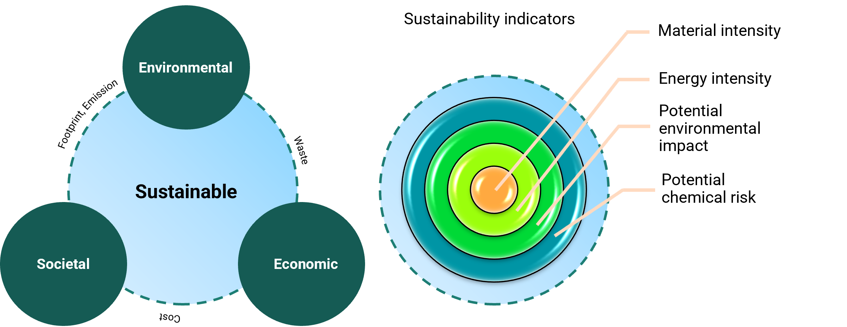
Figure 1: Sustainability concept and sustainability indicators.
  - Methodology
After the equilibrium conditions, the separation process and finally the calculation method is presented.
  - Vapor-liquid-liquid equilibrium (VLLE) conditions
In this work, acetone (C) was recovered from an aqueous waste solvent mixture by BD. The mixture contains small amounts of dichloromethane (DCM, A) and methyl tert-butyl ether (MTBE, B) as pollutants. The composition of the feed: 1 mass% A, 1% B, 49% C and 49% water (D). The purity requirements for the acetone product are: ≤0.1 mass% A, ≤0.1% B and ≤ 0.25% D.
Table 1 shows the measured boiling points of the pure components and azeotropes, as well as the azeotropic compositions in the order of increasing boiling point. The components form three minimum-boiling (A-D (heteroazeotrope), B-C, B-D) and one maximum-boiling (A-B) binary azeotropes, as well as a ternary saddle azeotrope (A-B-C). The azeotropes A-B-C and A-B were not found in the literature, but their existence is indicated by the vapor-liquid equilibrium calculations. Moreover, both A and D form tangent azeotrope with C at high C concentrations where the relative volatilities α_{A,C} and α_{C,D} are near to 1.0. Both the A-D and B-D mixtures have limited miscibility, but only A and D form a heteroazeotrope according to the calculations. The presence of D considerably increases both α_{A,C} and α_{B,C}.
The VLLE calculations were performed by UNIQUAC with binary interaction parameters taken from Nemeth et al. (2020) except for the binary mixtures of B (Table 2), which were either the built-in parameters of CHEMCAD or generated based on UNIFAC.
  - Separation process
The recovery of C was performed in a BD column with 25 theoretical trays (not including the reboiler and the condenser), operating at atmospheric pressure. The pressure drop of the column was 0.25 bar. The hold-up of the condenser was 45 dm³, that of the column 5 dm³/tray. The volume of the charge was 20 m³ (17,785.9 kg). The reboiler had a constant heat duty of Q_{r}=1800 MJ/h, provided with low-pressure (4 bar) heating steam. The steps of the process were as follows:
1. A and B were removed in a fore-cut, although with a considerable loss of C due to the existence of the B-C azeotrope. The fore-cut must be incinerated because of its impurity content. Taking of the fore-cut was finished when the B concentration of the instantaneous distillate decreases to a specified value: x_{D,B}≤Cr. The reflux ratio of the step (R₁) and Cr were operational parameters.
2. High purity C was obtained as a main cut, but due to the C-D tangent azeotrope a relatively high reflux ratio (R₂) was needed. The step was finished when the concentration of D in the main cut increased above 0.23% (to ensure that the maximum allowed value, 0.25% would not be surpassed).
3. The C content of the still residue (wastewater) was decreased to the necessary extent (0.2%) for biological purification by taking an after-cut, which was aqueous C with a high C content and it could be recycled to a next batch of the process to reduce the loss of C. The operational parameter of the step was its reflux ratio (R₃).
Table 1: The properties of the azeotropes formed by the components and the boiling points of the pure components (P= 1.013 bar) *P=1.0219 bar. #Calculated values
Component/  Azeotrope | T_{bp} (°C) | Composition (mass%)
 |  | A | B | C | D
A-D | 38.8 | 99.6 | - | - | 0.4
A | 40.0 | 100 | - | - | -
B-C* | 51.1 | - | 58.6 | 41.4 | -
B-D | 52.6 | - | 96 | - | 4
A-B-C# | 53.4 | 27 | 44 | 29 | -
B | 55.2 | - | 100 | - | -
A-B# | 55.24 | 9.3 | 90.7 | - | -
C | 56.2 | - | - | 100 | -
D | 100 | - | - | - | 100
Table 2: Binary interaction parameters of the mixtures of B
Component 1 | Component 2 | U₁₂-U₂₂, cal/mol | U₂₁-U₁₁, cal/mol | Source
A | B | -388.0172 | 376.2425 | UNIFAC
B | C | 381.1923 | -169.8641 | UNIFAC
B | D | 914.722 | 100.342 | Built-in
In the base case, the values of all the three reflux ratios were 6.0, while Cr=0.1 mass%. This Cr value was equal to the maximum allowed B content of the main cut ensuring that the main cut would fulfill the purity requirements.
  - Calculation method
The process was modelled with the professional flow-sheet simulator CHEMCAD 7. The column was a Batchcolumn module (Unit 1 in Figure 2), the cuts were collected in Batch Tanks (Units 2-4), and a Stream Reference (Unit 6) was used to copy the data of the still residue to stream 6.
Several sustainability indicators were determined. Additionally, a profit value was calculated to describe the economics of the process, which is defined as the value of the recovered acetone minus the cost of incineration of the fore-cut, the cost of the heating steam and that of the biological treatment of the still residue:
$$P= p_{p}∙m_{p}-p_{s}∙\frac{Q_{r}}{λ_{s}}∙t-p_{W}∙V_{w}-p_{inc}∙m_{fc}$$ | (1)
where p means price, m mass, t operation time, V volume and λ is latent heat of evaporation. Subscripts p, s, w, inc and fc represent the product, steam, wastewater treatment, incineration and fore-cut. The price of the C product (p_{p}): 1391 $/t (Echemi, 2023). The price of low-pressure steam (p_{s}): 99.16 $/t. The incineration price (p_{inc}): 74.9 $/t with an additional 2.12 $/t charged for every 0.1% when the chloride content of the waste is larger than 0.2% (Wien Energie, 2021). The price of wastewater treatment (p_{w}): 3.34 $/m³.
The specific energy demand (SED, MJ/kg), an indicator related to energy intensity, was defined as the heating energy required per functional unit (FU), here, 1 kg of product with the specified purity : SED=Q_{r}∙t/m_{p}.
The environmental impacts were expressed by multiple indicators, including the CO₂ emissions of the process. The total CO₂ emission (CO_{2,t}, kg) is the sum of the emission resulting from fuel combustion used to generate the heating steam (CO₂,_{HS}, kg) and the one generated by the incineration of the fore-cut (CO₂,_{inc}, kg). CO_{2,HS} was calculated by the method of Gadalla et al. (2005) assuming heavy oil as fuel. Stoichiometric equations of perfect combustion of the organic components of the fore-cut were used to estimate the CO_{2,inc.} The specific CO₂ emission (CO_{2,s}, kg/kg) was determined as the mass of CO₂ emitted per functional unit (CO_{2,t}/m_{p}).
The still residue was very dilute aqueous solution of C and was considered as wastewater subsequently treated by biological purification. Both the total mass of the wastewater generated (m_{w}) and specific wastewater generation (m_{ws}, kg/kg, mass of wastewater per FU) were used as indicators.
The potential environmental impacts of the waste streams, which are the incinerated fore-cut and the wastewater, were described by using the WAR (WAste Reduction) algorithm (Mallick et al., 1996). The algorithm calculates impacts in six main categories: ozone depletion, global warming, smog formation, acidification, human toxicity and ecotoxicity. The normalised impact scores (NIS, imp/kg) of the components with potential environmental impact are multiplied with their mass. The impacts so obtained are then summed in each category for both streams to calculate the total potential environmental impact (PEI_{t}, imp). The specific potential environmental impact (PEI_{s}, imp/kg, impact per FU) was also calculated.
The components having a potential impact are CO₂ and HCl in the incinerated fore-cut and C in the wastewater. The NIS values are given in Table 3 except for ozone depletion, whose value is zero for all components. HCl has the highest potential environmental impact per unit mass, while the values are similar for CO₂ and C. All three components have nonzero NIS values in the toxicity categories, while only one of them is relevant for global warming (CO₂), smog formation (C) and acidification (HCl).
Table 3: Normalised impact scores (NIS, imp/kg) of CO₂, HCl and acetone (C) (data from CHEMCAD).
Component | Impact category
 | Global warming | Smog formation | Acidification | Human toxicity | Ecotoxicity
CO₂ | 3.17∙10⁻⁴ | 0 | 0 | 3.24∙10⁻⁵ | 0.0903
HCl | 0 | 0 | 0.858 | 0.0416 | 0.797
C | 0 | 0.0366 | 0 | 1.21∙10⁻⁴ | 0.0628
First, the indicators presented were calculated for the base case, then sensitivity studies were performed to study the effect of the operational parameters (R₁, R₂, R₃ and Cr) on the indicators. Only one parameters was varied at a time. Finally, a modified technology was suggested based on the results of the sensitivity studies.
  - Results
The most important results of the base case are presented in Table 4. C is produced with a recovery of 60.8%. It contained only traces of A and very low amount of B, and its D content is also acceptable. The fore-cut had a C concentration of 90.0% indicating that a high amount of C is lost in the cut. The process was economical, its specific CO₂ emission and wastewater generation values were slightly higher than 1.5 kg/kg.
Table 4: Results of the base case and the modified technology.
Result | Base case |  |  | Modified operational policy |  |  | Change, %
m_{fc}. kg | 3,671 |  |  | 1,304 |  |  | -64.5
m_{p}, kg | 5,312 |  |  | 7,708 |  |  | 45.1
 | A | B | D | A | B | D
x_{p}, mass% | 0.000 | 0.007 | 0.232 | 0.000 | 0.038 | 0.236
t, h | 19.10 |  |  | 24.17 |  |  | 26.5
P, $ | 5,167 |  |  | 8,250 |  |  | 59.7
SED, MJ/kg | 6.47 |  |  | 5.64 |  |  | -12.8
CO_{2,s}, kg/kg | 1.614 |  |  | 0.433 |  |  | -73.2
m_{ws}, kg/kg | 1.604 |  |  | 1.074 |  |  | -33.0
PEI_{s}, imp/kg | 0.209 |  |  | 0.0809 |  |  | -61.3
In the sensitivity studies, R₁ was changed from 1 to 20, R₂ from 5 to 10, R₃ from 0.25 to 10, while Cr from 0.1% to 1.22%. Figure 2a shows the effect of the reflux ratios on the profit. As a function of R₁, P increased monotonously since m_{fc} decreased and m_{p} increased strongly. Although, t also increased leading to an increase in steam cost, this was not enough to balance the increase of profit. The change in the cost of biological treatment was negligible. It is likely that at even higher R₁ values, P either becomes constant or reaches a maximum due to m_{fc} and m_{p} becoming constant, but reflux ratios above 20 are very rarely applied in industrial practice. As a function of R₂, P had a maximum at its base case value (R₂=6.5). At lower R₂ values, m_{p} became very low, while at higher values, the increasing cost of steam led to a decrease in P. P decreased as a function of increasing R₃ because of an increase in the amount of wastewater, but the change in P was not significant. On the increase of Cr, P increased (Figure 2b) since less fore-cut and more main cut was taken. It was not possible to increase Cr further than 1.22% since the B concentration in the main cut became higher than its maximal allowed value.
SED did not change significantly as a function of R₁ (Figure 2a), but it had a minimum at R₁=4.5. This is explained by the fact that both m_{p} and t increase in a similar degree on the increase of R₁. As a function of R₂, there was a minimum in SED at the base case value (R₂=6). SED was virtually independent of R₃. On the increase of Cr, SED decreased due to the increase of m_{p} (Figure 2b).
Although CO_{2,HS} increased as R₁ increased, CO_{2,inc} decreased to a greater extent, leading to a reduction of the total CO₂ emission. As m_{p} also increased, CO_{2,s} decreased on the increase of R₁ (Figure 2e). By varying R₂, only CO_{2,HS} changed. Since t had a minimum at R₂=5.5 so did CO_{2,t}. CO_{2,s} also showed a minimum but at R₂=6.5. The CO₂ emission was virtually independent of R₃. On the increase of Cr, CO_{2,t} decreased due to decreasing m_{fc}. Thus, CO_{2,s} also showed a decrease (Figure 2f).
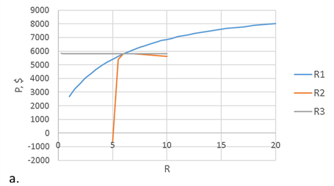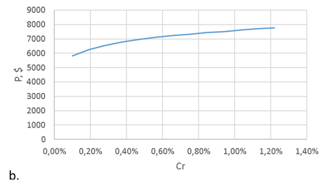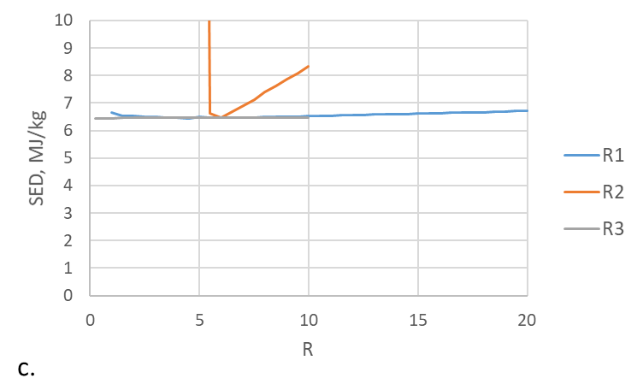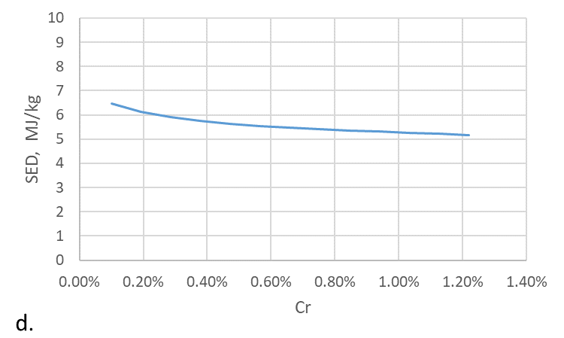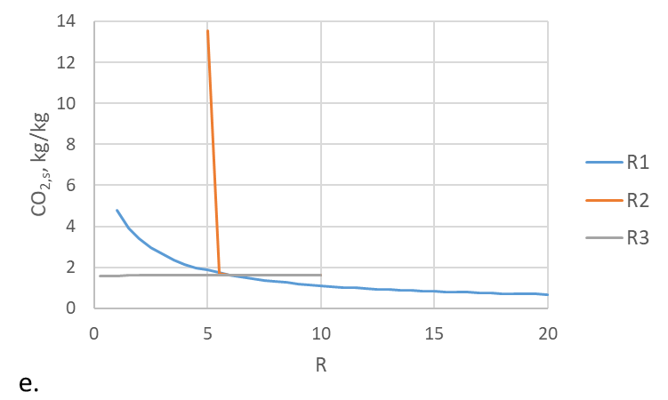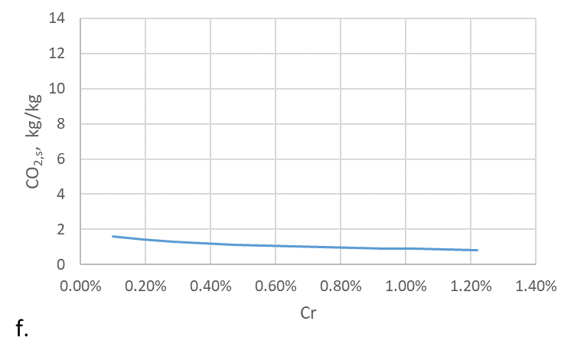
Figure 2: The effect of operational parameters on selected indicators: a. reflux ratios on P, b. Cr on P, c. reflux ratios on SED, d. Cr on SED, e. reflux ratios on CO_{2,s}, f. Cr on CO_{2,s}
As D was mostly removed in the still residue, the change of m_{w} was limited. It increased slightly on the increase of R₁ and R₂; it was independent of Cr. Only R₃ had a significant effect; its increase made m_{w} higher. The change in m_{ws} was thus dominated by m_{p}. m_{ws} decreased on the increase of all variables except R₃.
PEI_{t} was determined by the fore-cut since less than 0.5% of the total impact comes from the wastewater. The most important impact was the ecotoxicity of CO₂ but the acidification potential, human and ecotoxicity of HCl were also considerable. PEI_{t} decreased on the increase of R₁ and Cr and it was practically independent of R₂ and R₃. Due to the determining influence of CO_{2,inc} and m_{p}, PEI_{s} behaved similarly to CO_{2,s} (except in the case of R₂). It decreased on the increase of all variables except R₃, which had no effect on it.
Based on the results, changes were suggested to increase the profit and decrease SED and the values of the environmental indicators: R₁ and Cr should be as high, R₃ as low as possible, while R₂ was selected as 6.5 where CO_{2,s} had a minimum and P was close to its maximum. The simulation was repeated with these values (Table 4). C was obtained with a recovery of 88.2%. The A content of the product was negligible; its B content was higher than in the base case, but below its maximal value. m_{fc} was greatly reduced (by 65%) and thus m_{p} increased (by 45%). t also increased but only to a lower extent (by 26%). Therefore, the profit increased by 60% and SED decreased by 13%. The reduced amount of fore-cut led to a decrease in CO_{2,t} and PEI_{t}, while a further decrease of CO_{2,s} and PEIs (by 73 and 61%, respectively) was caused by the increase of m_{p}.
  - Conclusion
The effects of varying the operational parameters (reflux ratios of the steps and stopping criterion of the fore-cut (Cr)) on different sustainability indicators of a batch distillation solvent recovery process were studied. Acetone (C) was recovered from an aqueous waste solvent mixture containing dichloromethane and methyl tert-butyl ether, as well. The components form multiple azeotropes. The organic pollutants were removed in a fore-cut with considerable loss of C. C was obtained as main cut, while wastewater was obtained as still residue after taking an after-cut. The fore-cut was incinerated, while the wastewater was sent to biological purification.
The following indicators were studied: the profit of a batch (P), specific energy demand (SED), specific CO₂ emission (CO_{2,s}) resulting from incineration and the generation of heating steam, specific wastewater generation (m_{ws}) and specific potential environmental impacts (PEI_{s}) determined by the WAR algorithm. On the increase of the reflux ratio of the fore-cut (R₁), P increased, SED hardly changed but had a minimum at 4.5, while CO_{2,s}, m_{ws} and PEI_{s} decreased. The increase of Cr made P higher and decreased the other indicators. As a function of the reflux ratio of the main cut (R₂), P, SED and CO_{2,s} had a maximum at 6.0, 6.0 and 6.5, respectively. Both m_{ws} and PEI_{s} decreased on the increase of R₂. The increase of the reflux ratio of the after-cut (R₃) only had a significant effect on m_{ws}, increasing its value. Based on these results, a modified operational policy was proposed, which had a considerably (by 60%) higher profit and lower environmental impacts at the same time than the base case. The new policy’s CO_{2,s}, m_{ws} and PEI_{s} values were lower by 73, 33 and 61%, respectively.
It must be noted that the new policy is not optimal with respect to any of the indicators, meaning that even further improvements would be possible in the indicators studied, including by taking two fore-cuts and recycling the second one to a next batch.
Nomenclature
CO_{2,HS} – CO₂ emission of heating steam, kg
CO_{2,inc} – CO₂ emission of incineration, kg
CO_{2,s} – specific CO₂ emission, kg/kg
CO_{2,t} – total CO₂ emission, kg
Cr – stopping criterion of the fore-cut, mass%
m_{fc} – mass of fore-cut, kg
m_{p} – mass of product (main cut), kg
m_{w} – mass of wastewater, kg
m_{ws} – specific wastewater generation, kg/kg
NIS – normalised impact score, imp/kg
P – profit, $
p_{inc} – price of incineration, $/t
p_{p} – price of product (acetone), $/t
p_{s} – price of heating steam, $/t
p_{w} – price of biological purification, $/m³
PEI_{s} – specific potential env. impact, imp/kg
PEI_{t} – total potential environmental impact, imp
Q_{r} – reboiler heat duty, MJ/h
R₁ – reflux ratio of fore-cut
R₂ – reflux ratio of main cut
R₃ – reflux ratio of after-cut
SED – specific energy demand, MJ/kg
t – duration of the process, h
T_{bp} – boiling point, °C
U₁₂-U₂₂ – binary interaction parameter, cal/mol
U₂₁-U₁₁ – binary interaction parameter, cal/mol
V – volume, m³
x_{D,B} – B concentration in distillate, mass%
x_{p} – product composition, mass%
α_{A,C} – relative of volatility of A and C
α_{C,D} – relative of volatility of C and D

Acknowledgements
The research was funded by the National Research, Development, and Innovation Fund of Hungary under Grants TKP2021-EGA-02, FK-143059, by the János Bolyai Research Scholarship of the Hungarian Academy of Sciences, and by the ÚNKP-22-5-BME-325 New National Excellence Program of the Ministry for Culture and Innovation from the source of the National Research, Development and Innovation Fund.
References
Demirel Y., 2013, Sustainable Operations for Distillation Columns, Chemical Engineering and Process Techniques, 1, 1005.
Echemi, 2023, Acetone Market Price & Analysis, ECHEMI Digital Technology Co., Ltd. < www.echemi.com/productsInformation/pid_Rock3929-acetone.html> accessed 13.03.2023.
Gadalla M.A., Olujic Z., Jansens P.J., Jobson M., Smith R., 2005, Reducing CO₂ emissions and energy consumption of heat-integrated distillation systems, Environmental Science and Technology, 39, 6860.
Kiss A.A., 2019, Rethinking energy use for a sustainable chemical industry, Chemical Engineering Transactions, 76, 13–18.
Klemeš J., Friedler F., Bulatov I., Varbanov P., 2011, Sustainability in the Process Industry: Integration and Optimization. McGraw-Hill Companies, Inc., New York, USA.
Mallick S.K., Cabezas H., Bare J.C., Sikdar S.K., 1996, A pollution reduction methodology for chemical process simulators, Industrial & Engineering Chemistry Research, 35, 4128-4138.
Wien Energie, 2021, Price list, Service Definitions, General Terms and Conditions, Wien Energie GmbH, Vienna, Austria.

